Non-invasive transdermal delivery of biomacromolecules with fluorocarbon-modified chitosan for melanoma immunotherapy and transdermal vaccines

Wenjun Zhu¹, Ting Wei^{1,2}, Qiutong Jin^{1,2}, Jiaqi Lu^{1,2}, Jun Xu¹, Yu Chao¹, Muchao Chen¹, Jiafei Zhu¹, Qian Chen^{*1}, and Zhuang Liu^{*1,2}

1, Institute of Functional Nano & Soft Materials (FUNSOM), Collaborative Innovation Center of Suzhou Nano Science and Technology, Jiangsu Key Laboratory for Carbon-based Functional Materials and Devices, Soochow University, Suzhou 215123, China
2, Suzhou InnoBM Pharmaceutics Co. Ltd., Suzhou, Jiangsu, 215213, China

* zliu@suda.edu.cn, chenqian@suda.edu.cn

Methods
1. Materials, cell lines and animal models
Chitosan (DD% ≥95%) was purchased from Aladdin Industrial Co. (Shanghai, China), N-(3-(Dimethylamino)propyl)-N-ethylcarbodiimide hydrochloride crystalline (EDC) and N-hydroxysuccinimide (NHS) were provided by JK Chemical Company (Beijing, China). Phosphate-buffered saline (PBS) was obtained from Beijing Solarbio Science Technology Co., Ltd. SARS-CoV-2 Spike protein was purchased from Sino Biological. Murine melanoma tumor cell line B16F10 cells were cultured under standard conditions recommended by the American Type Culture Collection (ATCC). Female C57BL/6 mice (6-8 weeks) were purchased from Nanjing Pengsheng Biological Technology Co. All animal studies were conducted with the protocols approved by Soochow University Laboratory Animal Center.

2. Synthesis of fluorocarbon modified chitosan
Perfluoroheptanoic acid (27.5 μmol, 100 mg) was dissolved in dimethyl sulfoxide (DMSO, Sangon Biotech) and then mixed with EDC (78 mg, 1.5 equiv) and NHS (47.43 mg, 1.5 equiv) under stirring in the dark at room temperature for 0.5 h to obtain activated perfluoroheptanoic acid. Then, CS (200 mg) was dissolved in 1% acetic acid solution, mixed dropwise with activated perfluoroheptanoic acid and stirred in the dark for 12 h to synthesize FCS. The obtained FCS was purified by dialyzing in double-distilled water using dialysis bag (MWCO 3500 Da, Technologies Co.) for 48 h. Then, the samples were lyophilized, and the degree of substitution of conjugated fluoroalkyl substituents on each CS was characterized by ninhydrin colorimetry followed the well evidenced procedure, and analyzed using the microplate reader (Variskan, THERMO). The 19F NMR (Bruker AV III 600 spectrometers) of FCS (5.0 mg) dissolved in 600 μL of D₂O containing 1.0 mg of CF₃COOH was also applied for the calculation of conjugated fluoroalkyl substituents.

3. Preparation of FCS based nanocomplexes
The synthesized FCS was mixed with IgG in deionized water at different weight ratios (from 1:4 to 4:1) for 0.5 h to prepare FCS/IgG nanocomplexes. FCS/aPDL1, FCS/aCTLA4, FCS/OVA and FCS/S1 were prepared in the same way. The UV–visible absorbance spectra of various complexes was recorded by a PerkinElmer Lambda 750 ultraviolet–visible–NIR spectrophotometer (PerkinElmer, USA). The size, zeta-potential, and dispersibility index of the obtained nanocomplexes were detected by the Zetasizer Nano ZS (Malvern Instrument). Transmission electron microscopy (FEI TECNAI G2) was applied to observe the morphology of representative nanocomplexes.

4. Transdermal delivery efficiency
The transdermal delivery ability of FCS was investigated using Franz diffusion cell system. The Franz diffusion system was purchased from Huanghai Ltd. Shanghai. Fresh mice back skins were collected and added between the donor and receptor chamber. Samples were collected from the receptor chamber at different time points and the same volume of PBS was added into the receptor chamber to remain the volume unchanged. The final permeation rate was calculated by the formula:
$Peameation Rate \left(\%\right)=( VCn+\sum_{i=1}^{n-1}{\left(ViCi\right)})/A*100\%$
V is the volume of the receptor chamber (7 mL), Vi is the volume of the samples collected at each time point (0.4 mL)，Cn is the concentration of FITC in the receptor chamber at each time point, Ci is the concentration of the collected samples at the n-1 time point, and A is the feeding concentration of FITC.

5. Preparation of FCS based transdermal creams
The synthesized FCS/IgG or other FCS/protein nanocomplexes were dropped onto the surface of blank cream (Aquaphor®, mainly petrolatum) with a mass ratio at 1:1. Then, they were gently mixed up with each other. The transparent blank cream would turn into milk-like cream, which was then applied onto the mouse skin for transdermal applications.

6. ¹²⁵I labeling and its stability assay.
IgG was labeled with ¹²⁵I by the standard chloramine-T oxidation method. Briefly, IgG, Na¹²⁵I and chloramine-T were mixed at 37 ºC for 10 min under slight shaking. The synthesized ¹²⁵I-IgG was washed by 10 kDa ultrafiltration for three times. To determine radiolabeling stability, ¹²⁵I-IgG was mixed with serum for 24 h at 37 °C. Portions of the mixture were sampled at different time intervals and filtered by 10 kDa ultrafiltration. The radioactivities retained on the filters were detected by a gamma counter (PerkinElmer) to calculate radiolabeling stability.

7. In vivo treatment for melanoma
The B16F10 melanoma tumor model was established by subcutaneous injection of 2 × 10⁶ B16F10 cells into the right flank of each female C57BL/6 mouse. The mice were randomly divided into five groups when their tumor volumes reached about 50 mm³. Each group was treated with the equal dose of aPDL1 and aCTLA4 (m(ab) = 20 μg each mouse). The tumors of mice were swiped with different FCS cream for 12 hours, and covered by Transparent film (3M) to avoid the influence of mice lick. The size of tumor was measured by a caliper every two days: Volume = (length ×width²)/2.

8. Immunofluorescence staining
For in vitro immunofluorescence staining, HACAT cells were incubated in a 24-well plate to form single cell layer. Then, FCS/IgG was added and incubated for another 12 hours. After removing FCS-IgG, the HACAT cells were fixed by 4% paraformaldehyde, blocked by 5% BSA and stained with anti-ZO-1 antibody. One hour later, the cells were stained with secondary antibody and 4, 6-diamidino-2-phenylindole (DAPI). After mounting, slices were imaged by a confocal fluorescence microscope (Leica SP5). For in vivo immunofluorescence staining, B16F10 tumors and skin were collected from mice at different time points after swiped with different cream and embedded in a temperature-responsive OCT gels for immunofluorescence staining with different antibodies including anti-Keraten 14 and anti-ZO-1. After washing the primary antibodies, the tumor slides were stained with fluorescently labeled secondary antibodies and DAPI. After mounting, the tumor slices were imaged by the confocal fluorescence microscope (Leica SP5).

9. Analysis of T cells in different organs
Spleens, tumors and lymph nodes were collected and homogenized into single cell suspensions following the standard protocol. Then, these cells were stained with different antibodies according to the standard protocol. DCs in lymph nodes were stained with anti-CD11c-FITC (Biolegend, Cat. 117305), anti-CD80-APC (Biolegend, Cat. 104713) and anti-CD86-PE (Biolegend, Cat. 105007). Suspensions of tumors and spleens were stained with anti-CD3-FITC (Biolegend, Cat. 100203), anti-CD4-APC (Biolegend, Cat. 100411) and anti-CD8a-PE (Biolegend, Cat. 100707). To further analyze helper T cells in tumors, the suspension was stained with anti-CD3-FITC (Biolegend, Cat. 100203), anti-CD4-APC (Biolegend, Cat. 100411), anti-Foxp3-PE (Biolegend, Cat. 126403) antibodies according to the manufacturer’s protocols. For the analysis of memory T cells, peripheral blood was collected from mice 40 days after the first tumor elimination, and stained with anti-CD3-FITC (eBioscience, Cat. 11-0031), anti-CD8-PerCP-Cy5.5 (eBioscience, Cat. 45-0081), anti-CD44-PE (eBioscience, Cat. 12-0441) and anti-CD62L-APC (eBioscience, Cat. 17-0621). All these antibodies used in our experiments were diluted by ∼ 200 times.

10. S1 specific antibody titer
The S1 specific antibody titer was measured by a standard indirect ELISA (iELISA) method. Briefly, ninety-six-well ELISA plates (Nunc, Thermo) were coated overnight with 1 ng per well of the S1 protein in coating buffer. The plates were then blocked with 200 μl of ELISA assay buffer (Thermo) and incubated at room temperature for 2 hours. Each serum sample was tested in duplicate at a dilution of 1:100 in ELISA assay buffer (Thermo), in which 100 µl was then added into the wells of each plate for 2 h incubation at room temperature. The horseradish peroxidase (HRP)-conjugated goat anti-mouse IgG (1:10000, Abcam) was added for 1 h incubation at room temperature. Then, 100 µl TMB solution (Thermo) was added into each well. After 15 min incubation, 100 μl 2 M H₂SO₄ solution was added to stop the reaction. The absorbance of each well was read by the at 450 nm wavelength (PerkinElmer). The threshold was defied as double of the average absorbance in untreated group. The last dilution of a sample which is just larger than the threshold is defined as the antibody titer of this sample.

Supporting Figures

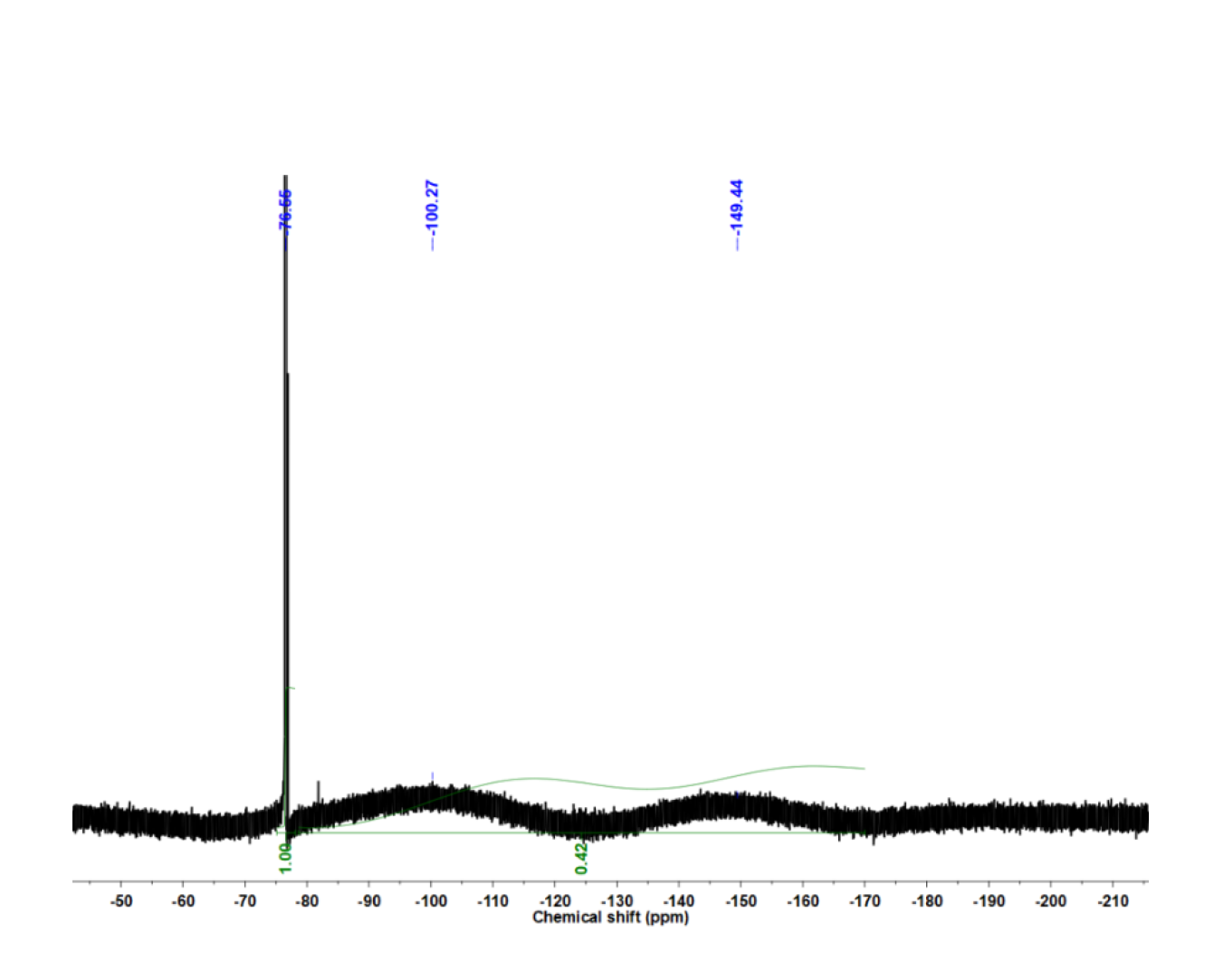
Figure S1. The 19F NMR spectra of FCS.

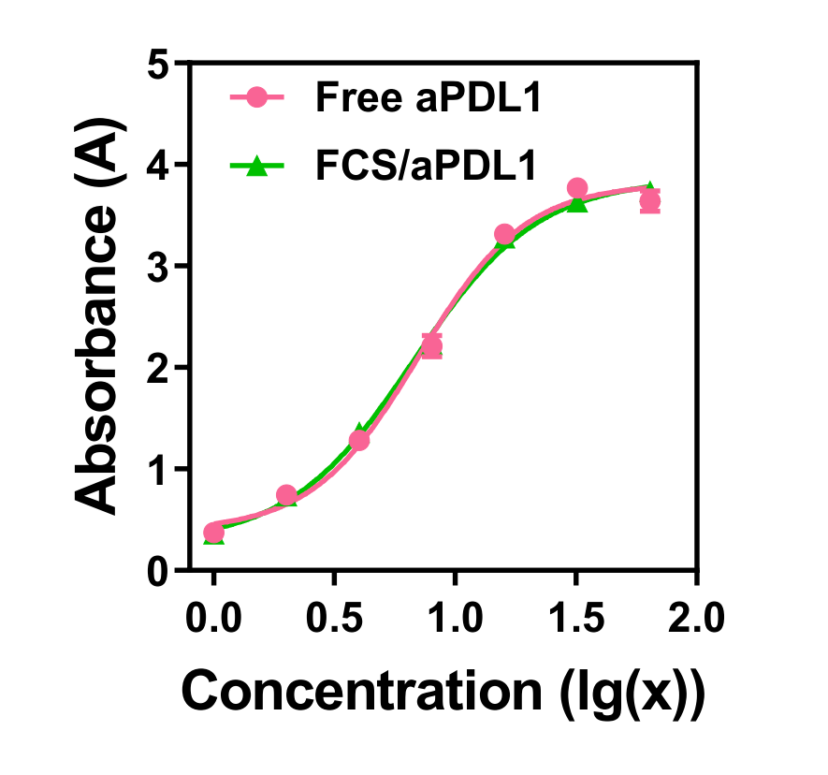
Figure S2. The relative binding affinity measured by the standard indirect ELISA (iELISA) asssay of aPDL1 with or without FCS.

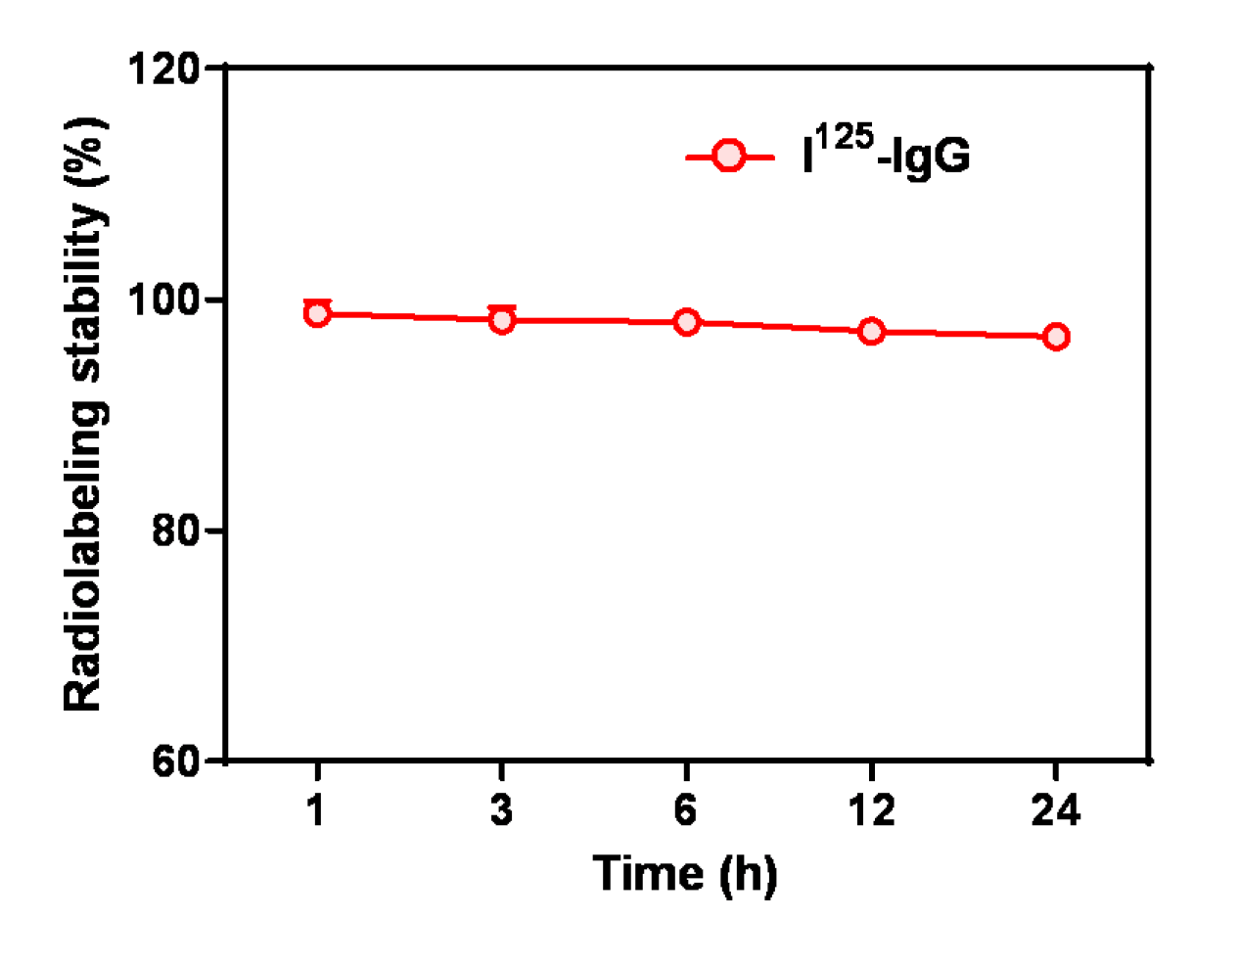
Figure S3. Radiolabeling stability of ¹²⁵ I-IgG after incubation in serum at 37 ºC for different periods of time.

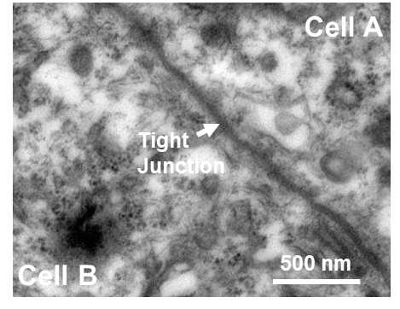
Figure S4. TEM image of normal mouse skin, showing the tight junction between epidermis.

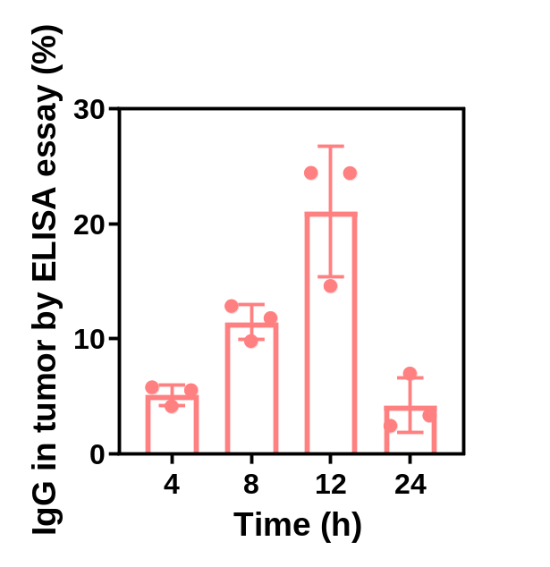
Figure S5. Statistical analysis of the accumulation of FCS/IgG in the tumors at different time points according to the ELISA essay by IgG specific binding.

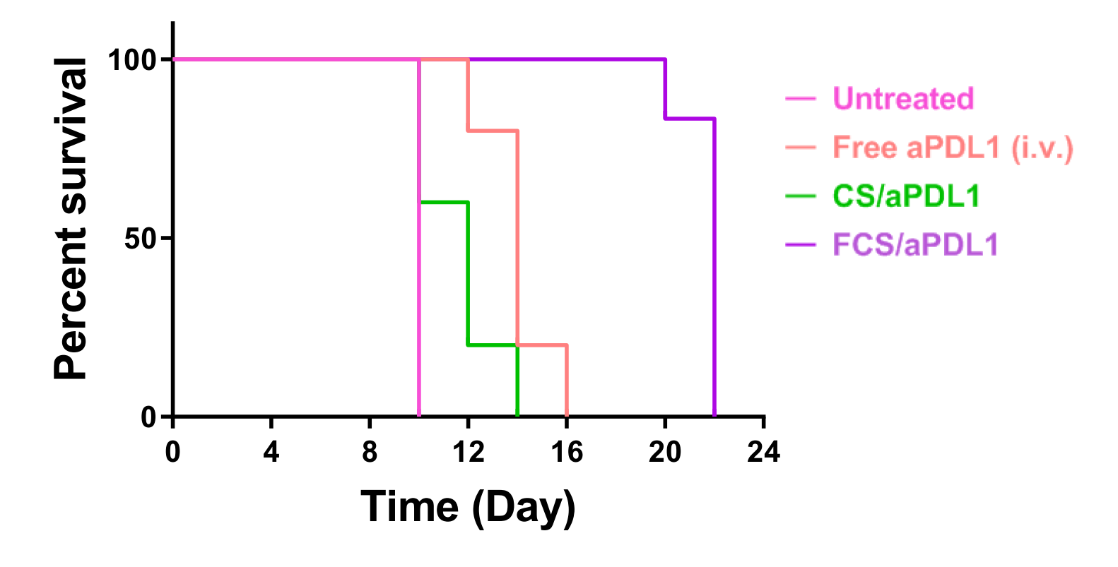
Figure S6. Survival of mice in different groups. Mice were regarded as dead when they were truly dead or their tumor size was larger than 1,000 mm³.

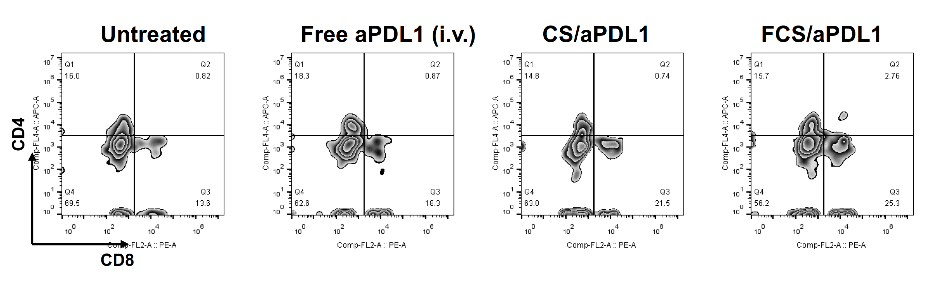
Figure S7. Representative flow cytometric plots of (Figure 3f) CD4⁺ T cells and CD8⁺ T cells in local tumors after different treatments.

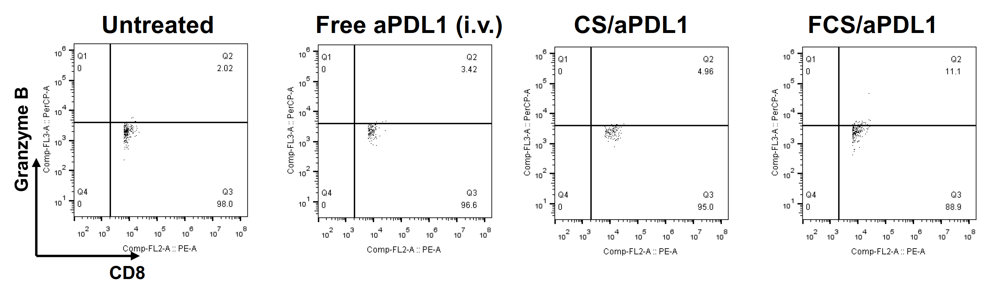
Figure S8. Representative flow cytometric plots of (Figure 3g) Granzyme B⁺CD8⁺ T cells in local tumors after different treatments.

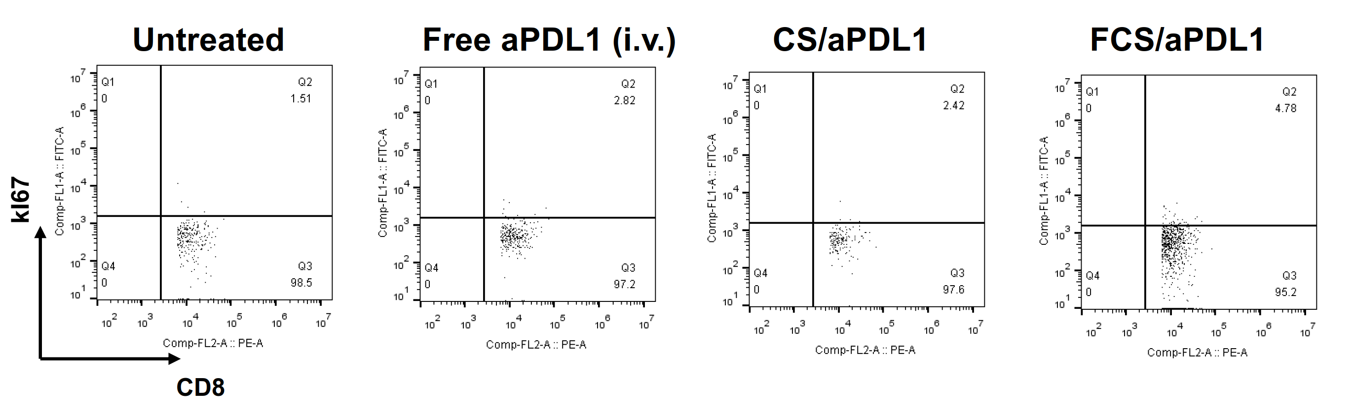
Figure S9. Representative flow cytometric plots of (Figure 3h) Ki67⁺CD8⁺ T cells in local tumors after different treatments.

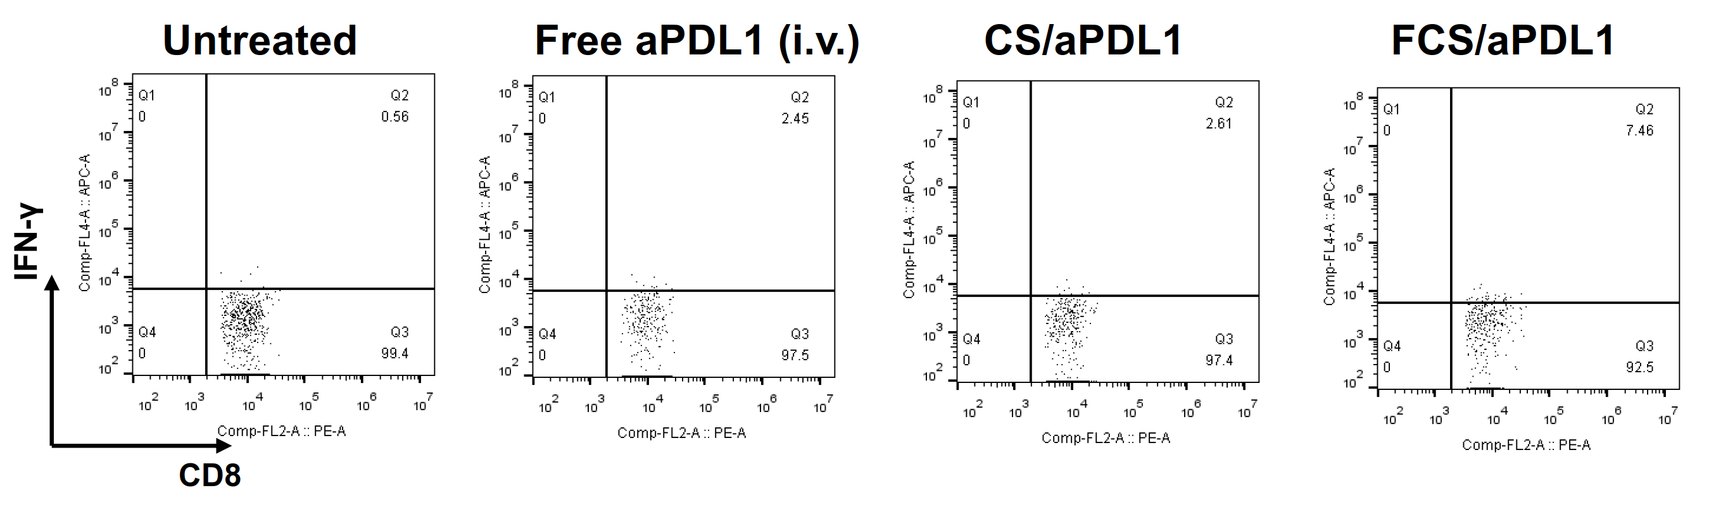
Figure S10. Representative flow cytometric plots of (Figure 3i) IFN-γ⁺CD8⁺ T cells in local tumors after different treatments.

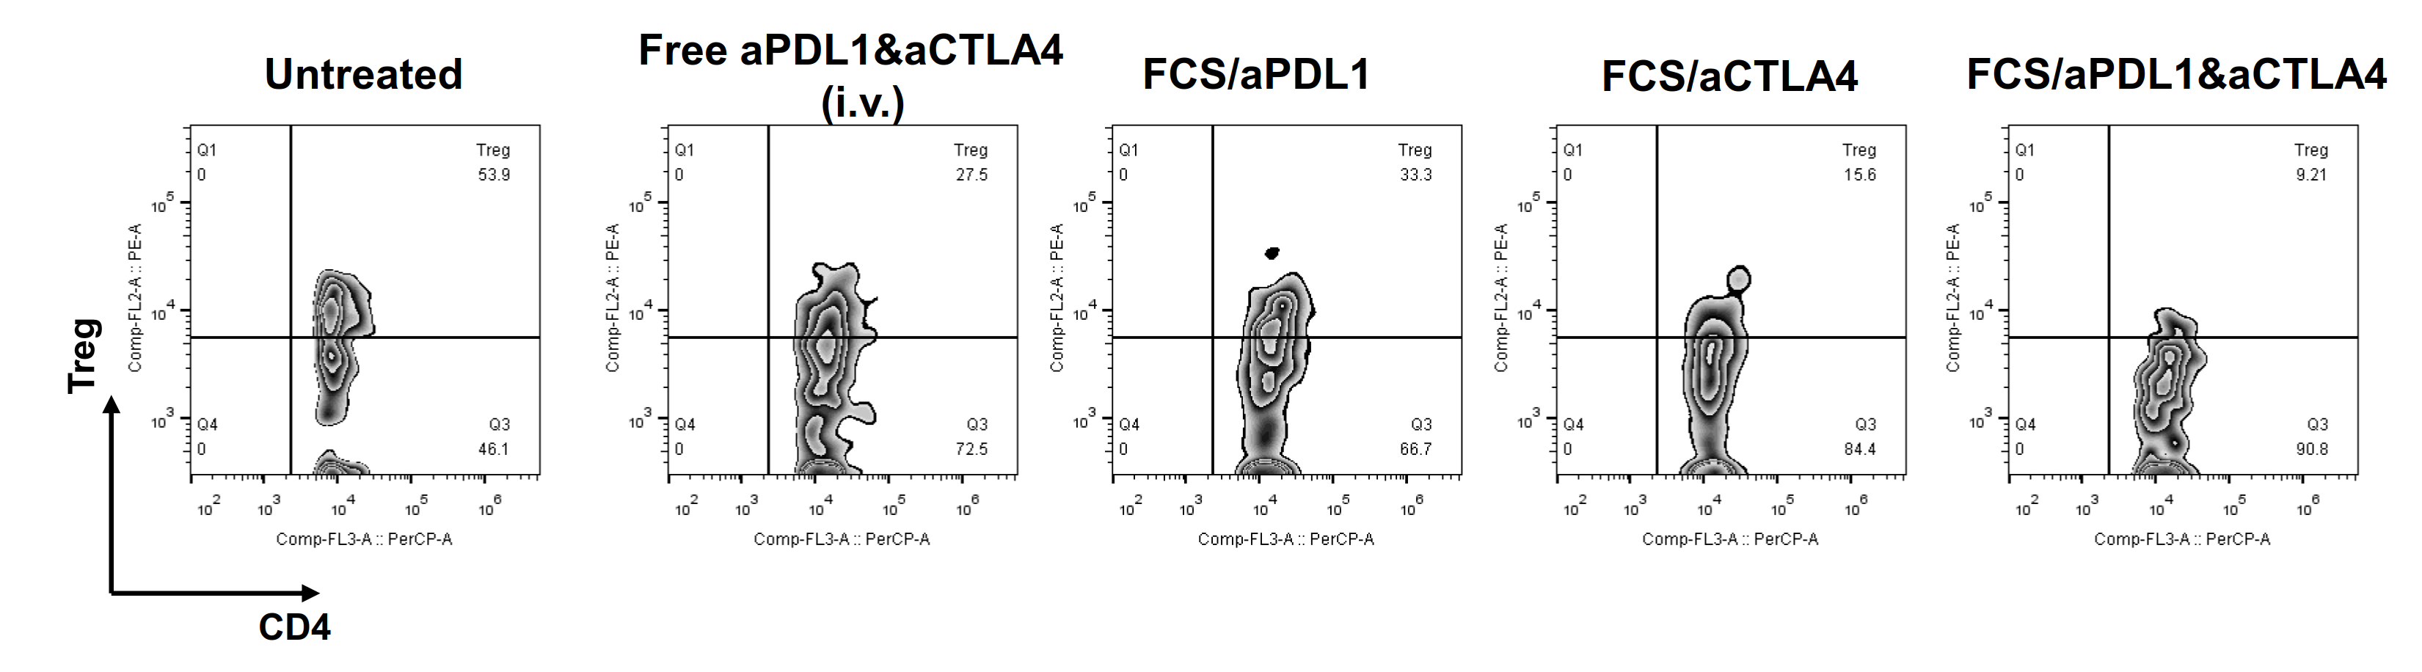
Figure S11. Representative flow cytometric plots of (Figure 4j) regulatory T cells in the distant tumors after different treatments.

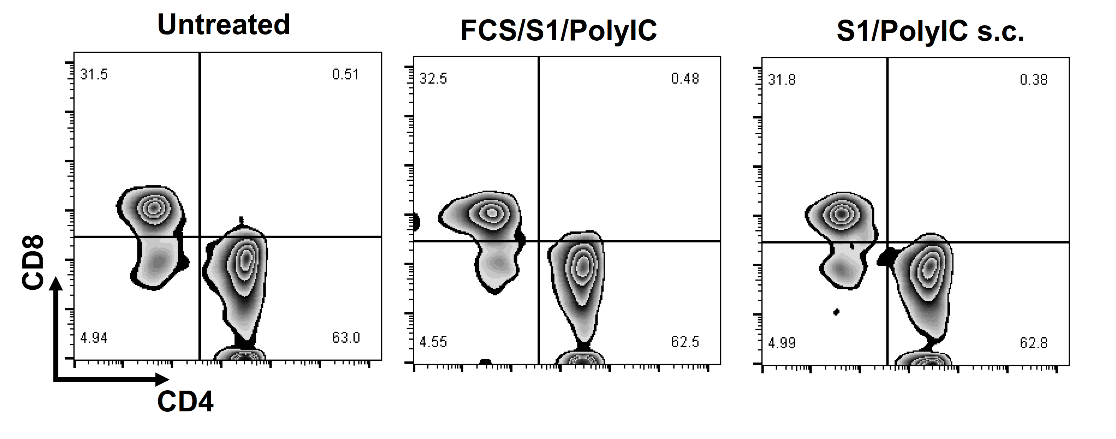
Figure S12. Representative flow cytometric plots of (Figure 5g) CD4⁺ T cells and (Figure 5h) CD8⁺ T cells in spleens after different administrations on day 28.
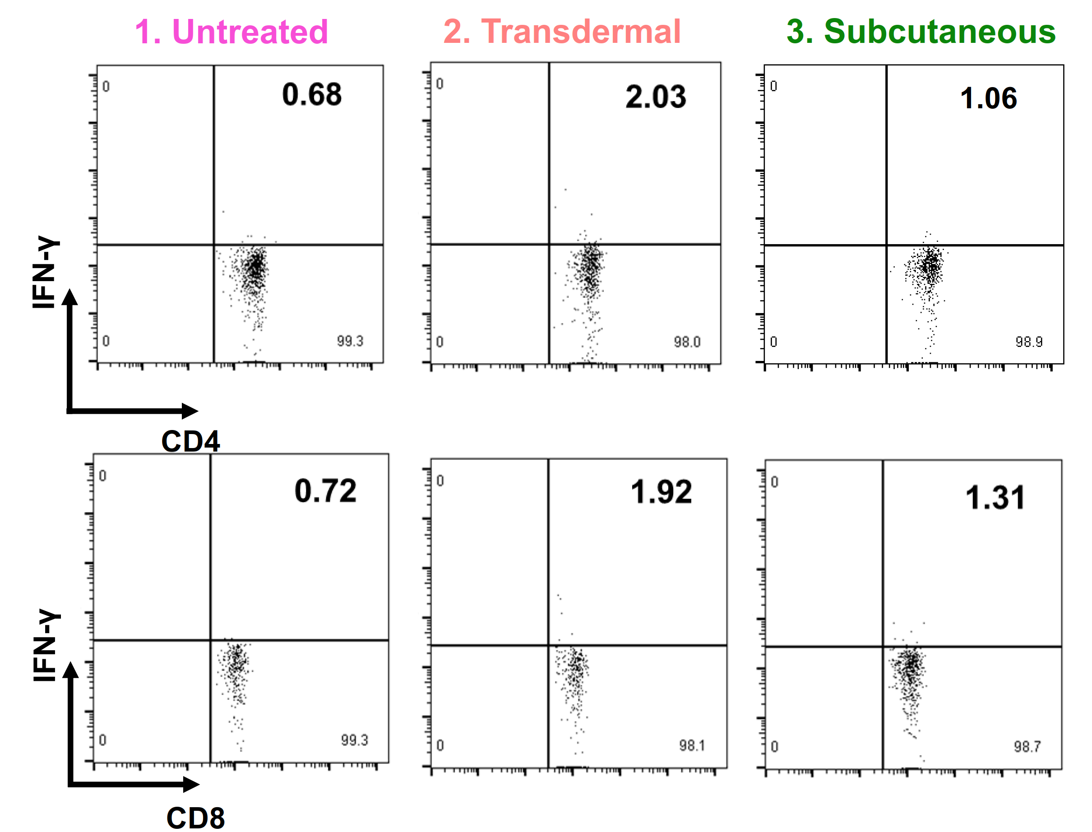

Figure S13. Representative flow cytometric plots of (Figure 5i) IFN-γ⁺ CD4⁺ T cells and (Figure 5j) IFN-γ⁺CD8⁺ T cells in spleens after different administrations on day 28.

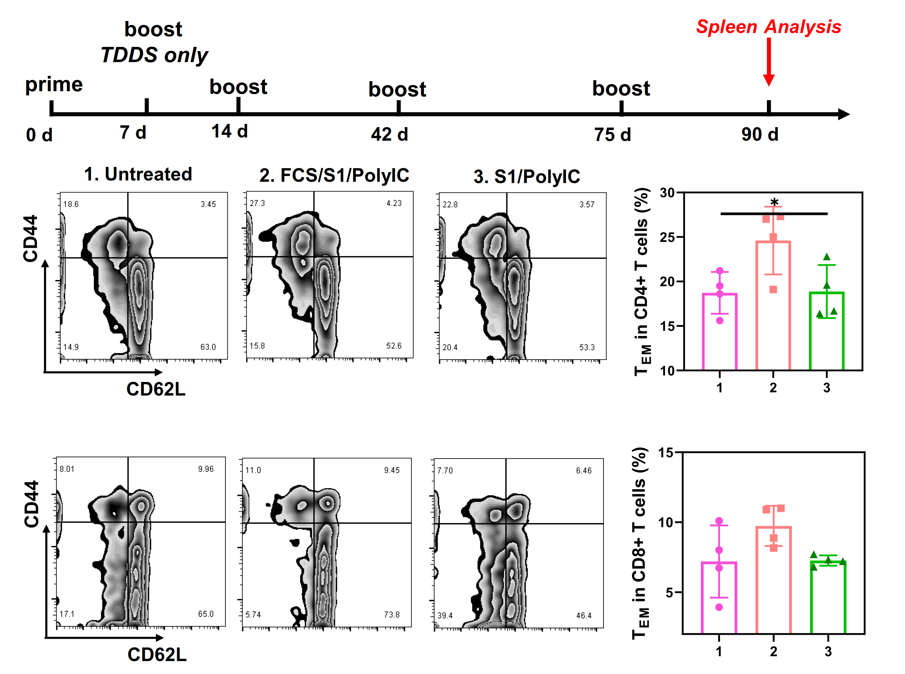
Figure S14. The long-term adaptive immune effect of mice after different vaccination administrations. Splenic lymphocytes were collected 90 days post administrations and stained with FITC-CD3, PE-CD44, APC-CD62L and PERCP-CD4 or PERCP-CD8. The CD44+CD62L- cells in both CD4+ and CD8+ T cells are effector memory CD4+ and CD8 T+ cells, respectively.

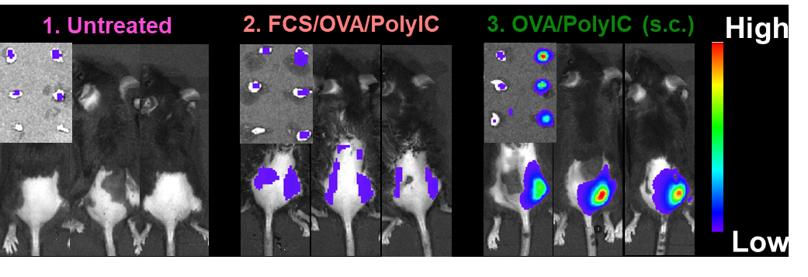
Figure S15. Representative in vivo and ex vivo fluorescent images of OVA-Cy5.5 in lymph nodes with different administration routes. It was illustrated that the FCS-based subcutaneous group showed relatively high lymph node accumulation at 24 hours post administration.

