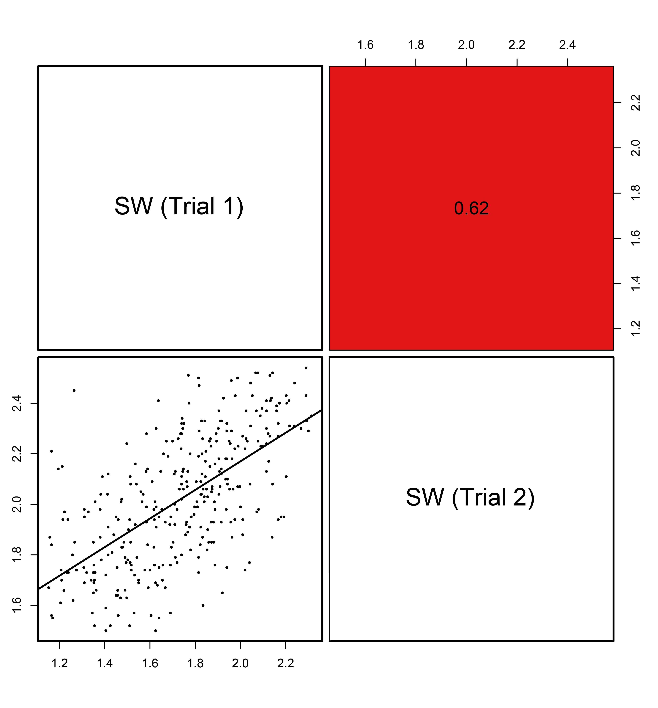
Fig. S2 Correlation coefficients (r) of SW in B. napus between Trial 1 and Trial 2. SW, 1000-seed weight.

