SUPPLEMENTARY MATERIAL

Population-Based Input Function for TSPO quantification and Kinetic Modeling with [¹¹C]-DPA-713
- Demographic and Genotype Information of all Subjects involved in the Study
Table S1: Demographic information of all the PD patients and healthy volunteers (HV) included in this study
Patient ID |  | Gender | Age (years) |  | Weight (Kg) |  | Height (m) | BMI | Group |  | Genotype
S1 |  | male | 67 |  | 80.38 |  | 1.70 | 27.81 | PD |  | MAB
S2 |  | male | 58 |  | 86.80 |  | 1.78 | 27.40 | PD |  | HAB
S3 |  | male | 62 |  | 75.00 |  | 1.80 | 23.15 | PD |  | MAB
S4 |  | male | 70 |  | 65.30 |  | 1.75 | 21.26 | PD |  | HAB
S5 |  | male | 61 |  | 56.79 |  | 1.78 | 17.98 | PD |  | HAB
S6 |  | male | 62 |  | 73.60 |  | 1.72 | 24.88 | PD |  | HAB
S7 |  | female | 54 |  | 61.90 |  | 1.61 | 23.79 | PD |  | MAB
S8 |  | male | 67 |  | 78.00 |  | 1.78 | 24.62 | PD |  | MAB
S9 |  | male | 67 |  | 83.91 |  | 1.73 | 28.13 | PD |  | HAB
S10 |  | female | 64 |  | 72.57 |  | 1.78 | 22.96 | PD |  | HAB
S11 |  | female | 60 |  | 47.17 |  | 1.60 | 18.42 | PD |  | HAB
S12 |  | male | 62 |  | 102.30 |  | 1.63 | 38.71 | PD |  | MAB
S13 |  | male | 58 |  | 79.38 |  | 1.80 | 24.50 | HV |  | MAB
S14 |  | male | 50 |  | 81.65 |  | 1.68 | 28.93 | HV |  | HAB
S15 |  | male | 28 |  | 77.11 |  | 1.85 | 22.53 | HV |  | HAB
S16 |  | male | 38 |  | 63.50 |  | 1.68 | 22.50 | HV |  | HAB
S17 |  | male | 41 |  | 84.82 |  | 1.75 | 27.70 | HV |  | MAB
S18 |  | male | 48 |  | 78.93 |  | 1.63 | 29.71 | HV |  | HAB
Average |  |  | 56.50 |  | 74.95 |  | 1.72 | 25.28
SD |  |  | 11.41 |  | 12.59 |  | 0.07 | 4.75
 | Number (male, female) |  |  | Average Age (years) |  | Average weight (Kg) |  | Average height (m) |  | Average BMI
PD-MAB | 5 (4, 1) |  |  | 62.40 ± 5.32 |  | 79.52 ± 14.60 |  | 1.70 ± 0.09 |  | 27.60 ± 6.46
PD-HAB | 7 (5, 2) |  |  | 63.3 ± 4.55 |  | 68.8 ± 15.43 |  | 1.74 ± 0.07 |  | 22.70 ± 4.33
HV-MAB | 2 (2) |  |  | 49.5 ± 12.02 |  | 82.1 ± 3.85 |  | 1.78 ± 0.04 |  | 26.10 ± 2.26
HV-HAB | 4 (4) |  |  | 41 ± 10.13 |  | 75.3 ± 8.08 |  | 1.71 ± 0.10 |  | 25.92 ± 3.94

- Test-retest repeatability and Importance of Gray Matter (GM) Normalization
The V_{T} estimates in the retest studies exhibited positive bias (ranging from 20 to 30%) compared to those deduced from the test studies (Figure S1A), where all the differences lie above the zero line (systematic bias). This systematic bias between test and retest V_{T} estimates could potentially be compensated for by normalization with the corresponding values of the GM, resulting in a bias within ±5% for all brain regions (Figure S1B). The LOA also reduced with GM normalization (from ~70% to ~20%).
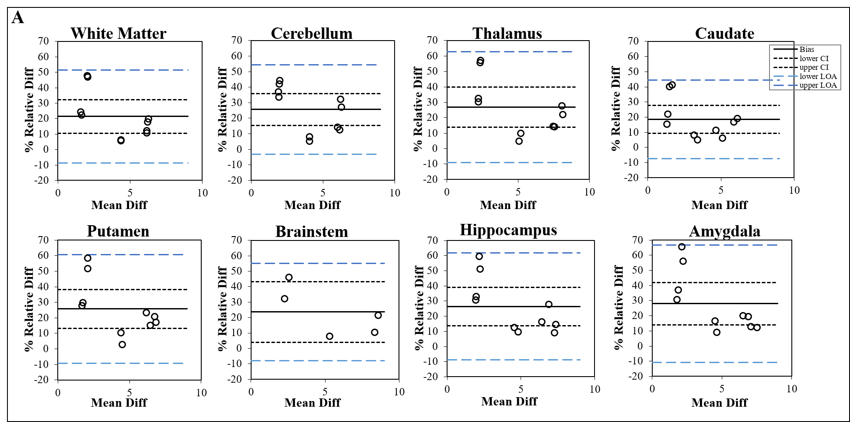
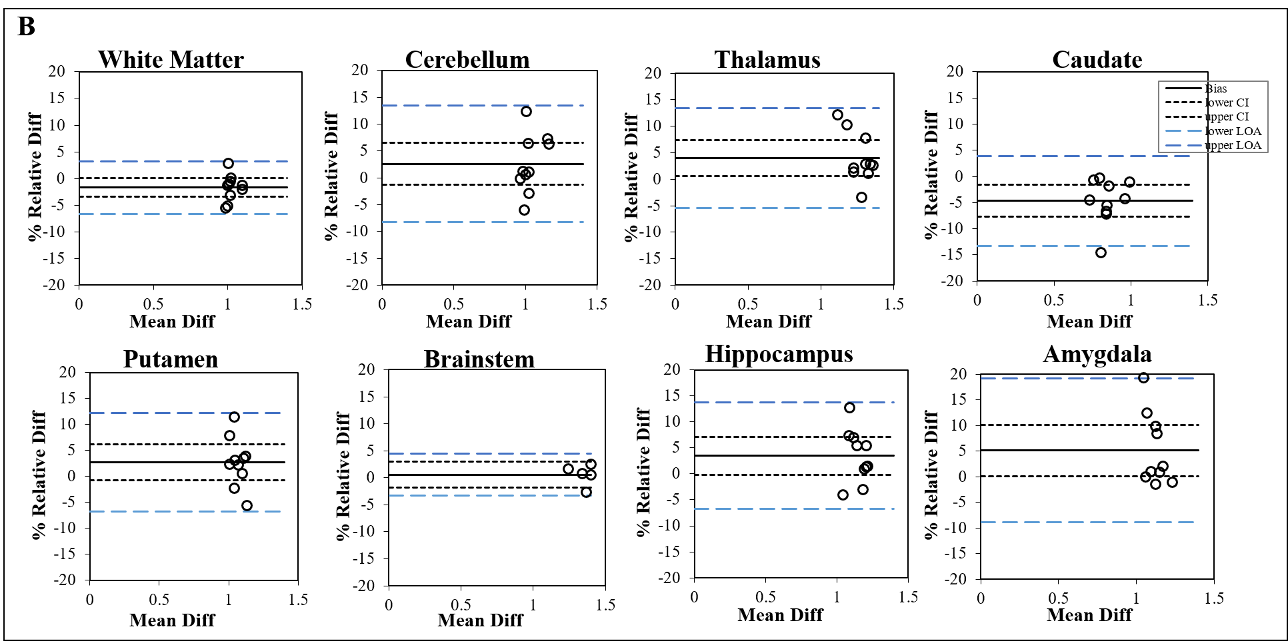
Figure S1 Bland-Altman plot comparing the test-retest repeatability of Vt estimates for all selected brain regions of interest: (A) without GM normalization and (B) with GM normalization respectively. The solid line is the mean % bias between test and retest V_{T} estimate, while the doted and dashed lines represent the %CI and %LOA respectively

- Comparison of input functions between HV and PD subjects based on genotype

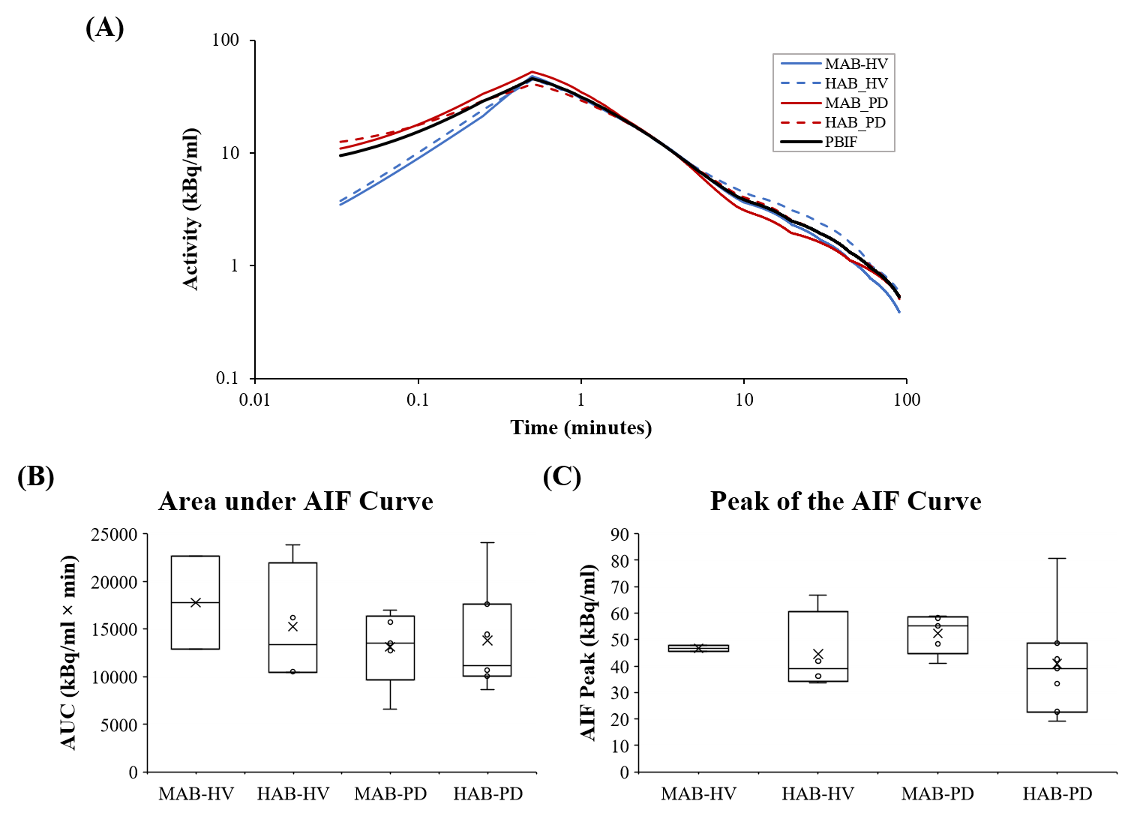
Figure S2: Comparison between the PSAIF of healthy volunteers (HV) and Parkinson’s disease (PD) patients based on genotype. Log transformation was applied on the plot A, and it shows the average PSAIF for each group. Plots B and C show the box plots for the individual subjects in each group. The results demonstrate no substantial differences in the peak and the tail of the IFs across the groups. Therefore, all IFs were used to estimate the PBIF (shown in black).

- Generation of PBIF and Evaluation of Normalization Technique

In order to reduce the influence of subject-induced variation on the generated PBIF, each of the metabolite-corrected PSAIFs was normalized separately by three methods: (a) Weight_{subject}$×$ Dose_{Injected} (b) the corresponding AUC, and (c) Weight_{subject}$×$AUC, yielding three PBIFs for the study. Figure S3 shows the overlaid normalized PSAIFs (Figure S3A) and the resulting PBIF generated after normalizing each PSAIF by Weight_{subject}$×$AUC (Figure S3B).
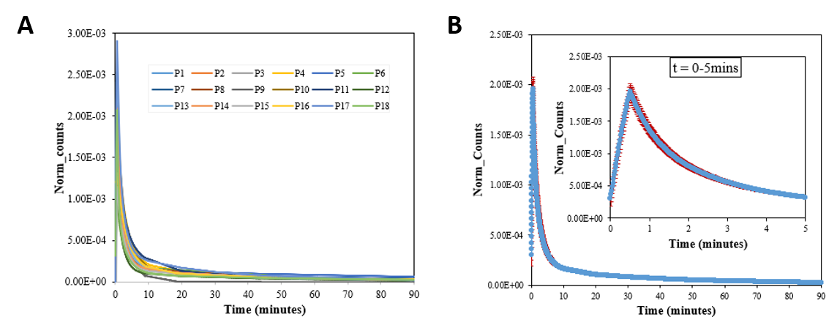
Figure S3 Overlaid normalized PSAIFs from all 18 patients (A) and the resulting PBIF generated by normalization with Weight_{subject}$×$AUC (B). The zoomed PBIF over the first 5 minutes is also shown. In (b), the blue points are the mean PBIF while the red points are the standard error of the mean (SEM)

