Supplementary Information

S1. Calibrating Power in the Waveguide
In order to calibrate the power in the waveguide, we measure the end-to-end power transmission through the setup and the device under test. We measure the input power right before the objective lens we use for focusing on the sample grating couplers and measure the output power scattered from the output grating into a single mode fiber. We assume that the in-coupling and out-coupling efficiencies are equal, and we have negligible waveguide loss for sub mm long waveguides. Using such a procedure we extract the input and output coupling efficiency as 0.1% each. In this way we have a good order of magnitude estimate of the power coupled into the waveguide.

S2. Atomic Frequency Comb Preparation

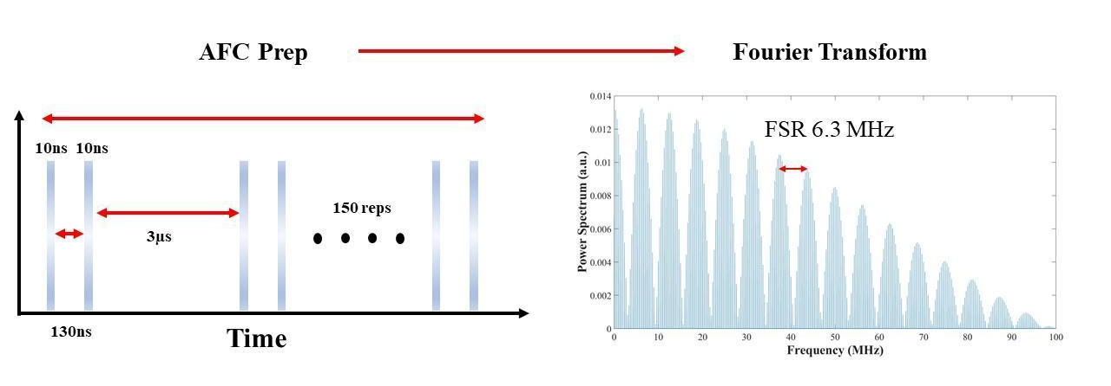
Figure S1. The schematic on the left shows a time domain representation of the pulse sequence for preparing an atomic frequency comb. The figure on the right demonstrates a Fourier transform of the same pulse sequence representing a frequency comb in the Fourier space.

To prepare the atomic frequency comb, we send a series of 10 ns long pulse pairs separated by the programmable storage time (130 ns in Fig S1). The wait time between the pulse pairs is 3 µs, which is long compared to coherence time of the ions. We use a series of 150 repetitions to burn a series of spectral holes. The Fourier transform of this pulse sequence consist of a series of frequency peaks separated by 6.3 MHz. This results in a spectral hole every 6.3 MHz which matches well with the experimentally observed free spectral range.

