Optimization of fermentation conditions for recombinant lipase expression at small scale using response surface methodology for preliminary production in two bioreactor platforms.
Angela Liliana Meza López¹, Alejandro Acosta-González¹, Ingrid Yamile Pulido Manrique¹, Rosa Erlide Prieto¹, Carlos Jiménez Junca^{1*}
¹Engineering Faculty, Bioprospecting Research Group, Universidad de La Sabana, 140013, Chía, Colombia.
*Correspondence: carlos.jimenez@unisabana.edu.co
Supplementary information: Additional File 1.
Table S1. Independent variables and levels of the Box Behnken experimental design.
Run | Glycerol Design |  |  | Sorbitol Design |  |  | Glycine Design |  |  | Response Variable
Run | Temperature (°C) | Agitation rate (rpm) | Glycerol Concentration (Molar) | Temperature (°C) | Agitation rate (rpm) | Sorbitol Concentration (Molar) | Temperature (°C) | Agitation rate (rpm) | Glycine Concentration (Molar) | Specific Enzyme activity (U/mg)
1 | 0 (15) | 0 (150) | 0 (0,4) | 0 (15) | 0 (150) | 0 (0,4) | 0 (15) | 0 (150) | 0 (0,07)
2 | 1 (25) | 0 (150) | -1 (0,1) | 1 (25) | 0 (150) | -1 (0,1) | 1 (25) | 0 (150) | -1 (0,03)
3 | 0 (15) | 0 (150) | 0 (0,4) | 0 (15) | 0 (150) | 0 (0,4) | 0 (15) | 0 (150) | 0 (0,07)
4 | 0 (15) | -1 (110) | -1 (0,1) | 0 (15) | -1 (110) | -1 (0,1) | 0 (15) | -1 (110) | -1 (0,03)
5 | 0 (15) | 1 (250) | 1 (0,7) | 0 (15) | 1 (250) | 1 (0,7) | 0 (15) | 1 (250) | 1 (0,1)
6 | 0 (15) | 0 (150) | 0 (0,4) | 0 (15) | 0 (150) | 0 (0,4) | 0 (15) | 0 (150) | 0 (0,07)
7 | 0 (15) | 0 (150) | 0 (0,4) | 0 (15) | 0 (150) | 0 (0,4) | 0 (15) | 0 (150) | 0 (0,07)
8 | -1 (5) | 1 (250) | 0 (0,4) | -1 (5) | 1 (250) | 0 (0,4) | -1 (5) | 1 (250) | 0 (0,07)
9 | 1 (25) | -1 (110) | 0 (0,4) | 1 (25) | -1 (110) | 0 (0,4) | 1 (25) | -1 (110) | 0 (0,07)
10 | 1 (25) | 0 (150) | 1 (0,7) | 1 (25) | 0 (150) | 1 (0,7) | 1 (25) | 0 (150) | 1 (0,1)
11 | 0 (15) | -1 (110) | 1 (0,7) | 0 (15) | -1 (110) | 1 (0,7) | 0 (15) | -1 (110) | 1 (0,1)
12 | 1 (25) | 1 (250) | 0 (0,4) | 1 (25) | 1 (250) | 0 (0,4) | 1 (25) | 1 (250) | 0 (0,07)
13 | 0 (15) | 0 (150) | 0 (0,4) | 0 (15) | 0 (150) | 0 (0,4) | 0 (15) | 0 (150) | 0 (0,07)
14 | -1 (5) | -1 (110) | 0 (0,4) | -1 (5) | -1 (110) | 0 (0,4) | -1 (5) | -1 (110) | 0 (0,07)
15 | 0 (15) | 1 (250) | -1 (0,1) | 0 (15) | 1 (250) | -1 (0,1) | 0 (15) | 1 (250) | -1 (0,03)
16 | -1 (5) | 0 (150) | 1 (0,7) | -1 (5) | 0 (150) | 1 (0,7) | -1 (5) | 0 (150) | 1 (0,1)
17 | -1 (5) | 0 (150) | -1 (0,1) | -1 (5) | 0 (150) | -1 (0,1) | -1 (5) | 0 (150) | -1 (0,03)

Table S2. ANOVA Test to evaluate the effect of temperature on the specific growth rates of E. coli.
Source | DF | Adj SS | Adj MS | F-Value | P-Value
Temperature | 2 | 0.028366 | 0.014183 | 842.56 | 0.000
Error | 3 | 0.000051 | 0.000017
Total | 5 | 0.028417

Table S3. Dunnet Test for optical density (O.D. 600 nm) at the three different flasks Schott, 3 L shaken Erlenmeyer and 2 L Bioreactor
FLASK | N | Mean | Grouping
SCHOT (control) | 2 | 0.64350 | A
BIOREACTOR | 2 | 0.62300 | A
ERLENMEYER | 2 | 0.6053 | A
Means not labeled with the letter A are significantly different from the control level mean.

Table S4. ANOVA Test to evaluate the effect of osmolytes on recombinant lipase activity
Source | Enzyme Activity |  |  |  |  |  | Specific Lipase Activity
Source | DF | Adj SS | Adj MS | F-Value | P-Value |  | DF | Adj SS | Adj MS | F-Value | P-Value
Osmolyte | 3 | 223 | 74.338 | 20.7 | 0.000 |  | 3 | 2225.7 | 741.89 | 11.18 | 0.003
Error | 8 | 28.73 | 3.591 |  |  |  | 8 | 530.9 | 66.36
Total | 11 | 251.7 |  |  |  |  | 11 | 2756.6

Table S5. Dunnet Test to determine the effect of osmolytes on recombinant lipase activity.
Osmolyte | Enzyme activity |  |  |  | Specific Lipase Activity
Osmolyte | N | Mean | Grouping |  | N | Mean | Grouping
Control (control) | 3 | 12.818 | A |  | 3 | 61.846 | A
Glycine | 3 | 23.39 |  |  | 3 | 74.86 | A
Glycerol | 3 | 17.491 |  |  | 3 | 68.78 | A
Sorbitol | 3 | 12.972 | A |  | 3 | 38.9
Means not labeled with the letter A are significantly different from the control level mean.

Table S6. ANOVA of independent variables on specific lipase activity for glycerol, sorbitol and glycine model. (*) Asterisk indicates a significant effect (p<0.05).
Factors | Glycerol Design
Factors | Sum of squares | df | Mean | F-value | p-value
Model | 181371,3 | 9,0 | 20152,4 | 4,850 | 0,04 *
A-Temperature (°C) | 47523,9 | 1,0 | 47523,9 | 11,438 | 0,01 *
B-Agitation Rate (rpm) | 37465,7 | 1,0 | 37465,7 | 9,018 | 0,02 *
C-Glycerol Concentration (M) | 16440,4 | 1,0 | 16440,4 | 3,957 | 0,100
AB | 5725,7 | 1,0 | 5725,7 | 1,378 | 0,293
AC | 3235,3 | 1,0 | 3235,3 | 0,779 | 0,418
BC | 2980,6 | 1,0 | 2980,6 | 0,717 | 0,436
A² | 1328,2 | 1,0 | 1328,2 | 0,320 | 0,596
B² | 67309,0 | 1,0 | 67309,0 | 16,201 | 0.01*
C² | 3267,5 | 1,0 | 3267,5 | 0,786 | 0,416
Residual | 20773,7 | 5,0 | 4154,7
Lack of Fit | 19985,4 | 3,0 | 6661,8 | 16,902 | 0,056
Pure Error | 788,3 | 2,0 | 394,1
Cor Total | 202145,0 | 14,0
 | R² = 0.89, adjusted R² = 0.71
Factors | Sorbitol Design
Model | 109195,7 | 9,0 | 12132,9 | 5,306 | 0,040 *
A-Temperature (°C) | 44220,7 | 1,0 | 44220,7 | 19,340 | 0,007 *
B-Agitation Rate (rpm) | 15228,9 | 1,0 | 15228,9 | 6,660 | 0,049 *
C-Sorbitol Concentration (M) | 588,8 | 1,0 | 588,8 | 0,258 | 0,633
AB | 8492,6 | 1,0 | 8492,6 | 3,714 | 0,112
AC | 1,8 | 1,0 | 1,8 | 0,001 | 0,979
BC | 112,4 | 1,0 | 112,4 | 0,049 | 0,833
A² | 22048,1 | 1,0 | 22048,1 | 9,643 | 0,027
B² | 4029,7 | 1,0 | 4029,7 | 1,762 | 0,242
C² | 863,5 | 1,0 | 863,5 | 0,378 | 0,566
Residual | 11432,6 | 5,0 | 2286,5
Lack of Fit | 11020,4 | 3,0 | 3673,5 | 17,823 | 0,054
Pure Error | 412,2 | 2,0 | 206,1
Cor Total | 120628,3 | 14,0
 | R² = 0.90, adjusted R² = 0.73
Factors | Glycine Design
Model | 37246,1 | 3,0 | 12415,4 | 3,521 | 0,052
A-Temperature (°C) | 11495,2 | 1,0 | 11495,2 | 3,260 | 0,098
B-Agitation Rate (rpm) | 25551,9 | 1,0 | 25551,9 | 7,246 | 0.02*
C-Glycine Concentration (M) | 190,4 | 1,0 | 190,4 | 0,054 | 0,821
Residual | 38787,1 | 11,0 | 3526,1
Lack of Fit | 36397,1 | 9,0 | 4044,1 | 3,384 | 0,249
Pure Error | 2390,0 | 2,0 | 1195,0
Cor Total | 76033,2 | 14,0
R² = 0.55, adjusted R² = 0.43

Table S7. Dunnet test for validation of glycerol and sorbitol models.
Osmolyte | Enzyme activity |  |  |  | Specific lipase activity
Osmolyte | N | Mean | Grouping |  | N | Mean | Grouping
Control | 3 | 54.5 | A |  | 3 | 253.13 | A
Glycerol | 3 | 51.71 | A |  | 3 | 466.3
Sorbitol | 3 | 45.08 |  |  | 3 | 269.6 | A
Means not labeled with the letter A are significantly different from the control level mean

Table S8. Recombinant lipase yield in soluble and non-soluble fraction obtained from wet biomass in E. coli BL21(DE3) at the optimal culture conditions.
Osmolyte | Soluble Fraction
Osmolyte | Recombinant Lipase (mg) | Wet Biomass (mg) | Recombinant Lipase Yield (%)
Glycerol | 0,13 | 140 | 0,09
Sorbitol | 0,06 | 210 | 0,03
Osmolyte | Non-Soluble Fraction
Osmolyte | Recombinant Lipase (mg) | Wet Biomass (mg) | Recombinant Lipase Yield (%)
Glycerol | 1,94 | 140 | 1,39
Sorbitol | 1,67 | 210 | 0,79

Table S9.ANOVA test for optical density (O.D. 600 nm) at the three different flasks Schott, 3 L shaken Erlenmeyer and 2 L Bioreactor
Source | DF | Adj SS | Adj MS | F-Value | P-Value
FLASK | 2 | 0.001466 | 0.000733 | 2.43 | 0.236
Error | 3 | 0.000904 | 0.000301
Total | 5 | 0.002369

Table S10. ANOVA Test for CFU/mL bacterial growth at the three different flasks schott, 3 L shaken erlenemeyer and 2 L Bioreactor
Source | DF | Adj SS | Adj MS | F-Value | P-Value
FLASK | 2,00 | 0.10 | 0.05 | 746.46 | 0.000
Error | 3,00 | 0.00 | 0.00
Total | 5,00 | 0.10

Table S11. Dunnet Test for CFU/mL bacterial growth at the three different flasks schott, 3 L shaken Erlenmeyer and 2 L Bioreactor
FLASK | N | Mean | Grouping
SCHOT (control) | 2 | 824.545 | A
ERLENMEYER | 2 | 843.610
BIOREACTOR | 2 | 812.053
Means not labeled with the letter A are significantly different from the control level mean.

Table S12. ANOVA Test to evaluate the effect of flasks on specific lipase activity at the three different flasks schott, 3 L shaken Erlenmeyer and 2 L Bioreactor
Source | DF | Adj SS | Adj MS | F-Value | P-Value
Flask | 2 | 11738 | 5869.1 | 12.88 | 0.034
Error | 3 | 1367 | 455.7
Total | 5 | 13105

Table S13. Dunnet Test to evaluate which flask did show significative differences in the specific lipase activity at the three different flasks schott, 3 L shaken Erlenmeyer and 2 L Bioreactor
Flask | N | Mean | Grouping
SCHOTT (control) | 2 | 455.7 | A
ERLENMEYER | 2 | 421.22 | A
BIOREACTOR | 2 | 349.511
Means not labeled with the letter A are significantly different from the control level mean

Table S14. Table that represents the sampling time for: A. Relative band density of lipase in SDS-PAGE. B. Enzyme activity curve for lipase. Samples from T1-T14 are equivalent to a specific hour corresponding to each culture temperature
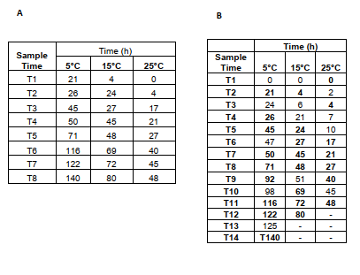
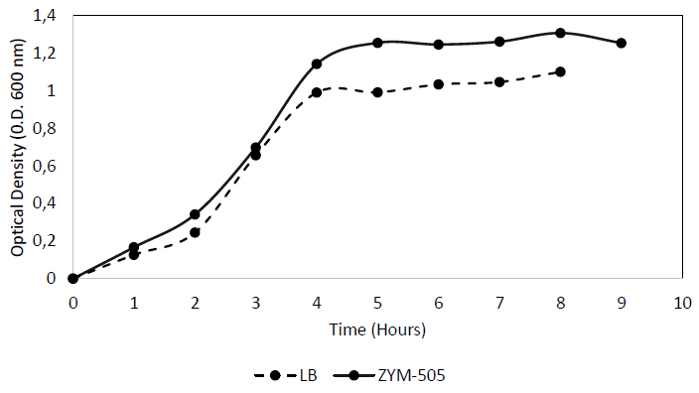
Figure 1S. Growth curves for E. coli BL21(DE3) inoculum. The growth in LB (Dash Line) and ZYM-505 (Solid line) medium was compared by optical density at 600 nm for 8 hours.

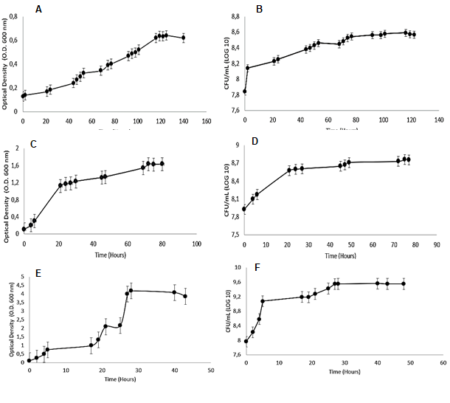

Figure 2S. Growth curves at different temperatures 5°C, 15°C and 25°C for E. coli BL21(DE3). Growth curves for optical density and CFU/mL at A-B. 5°C. C-D. 15°C E-F. 25°C. The agitation rate of 110 rpm was used for all growth curves. Error bars are represented as standard error.

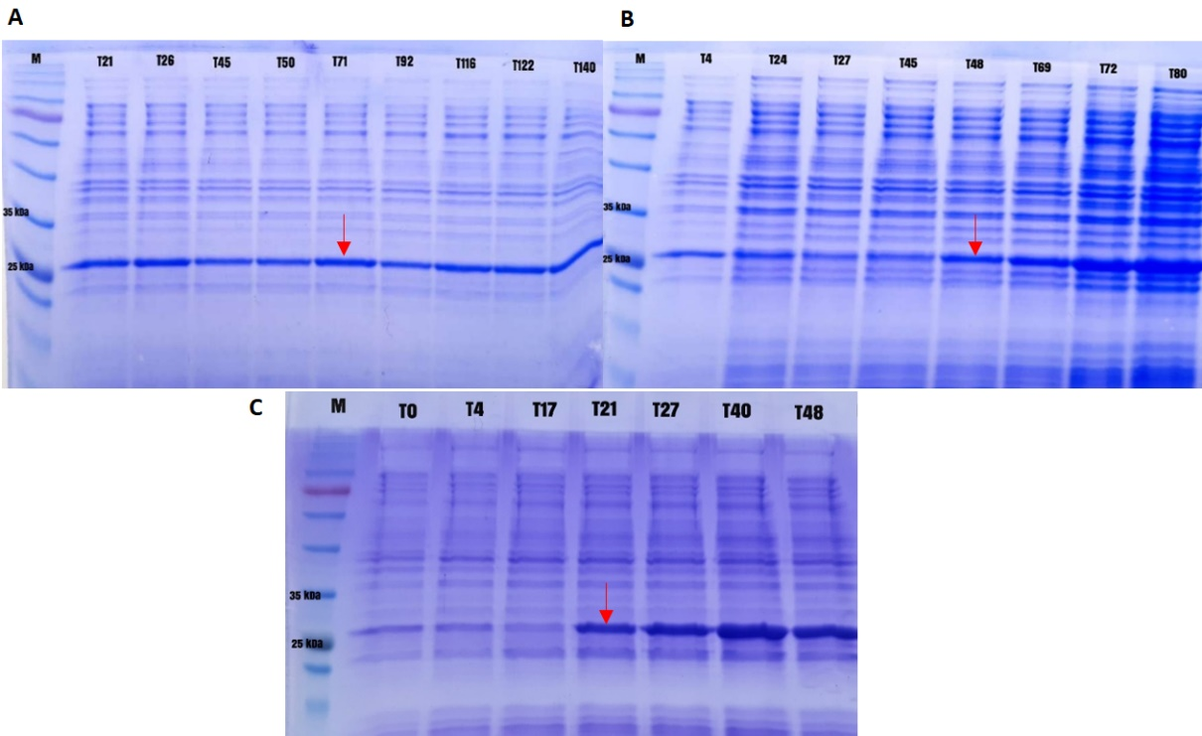

Figure 3S. SDS-PAGE analysis of total extract of recombinant lipase for each sampling time in growth curves at A. 5°C, B. 15°C and C. 25°C. Red arrows show the expressed lipase.
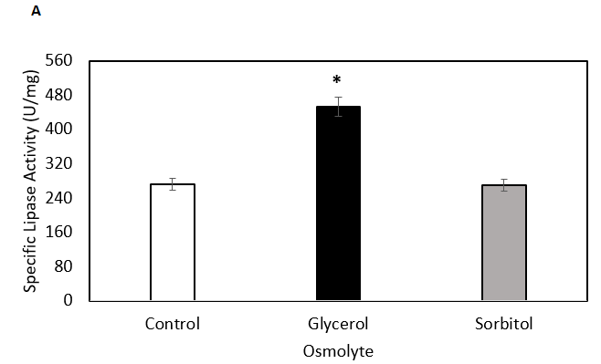
Figure 4S. Validation of optimal fermentation conditions for glycerol and sorbitol models. A. Specific Lipase Activity obtained from E. coli BL21 (DE3) grown at 5°C, 110 rpm in the presence of glycerol and sorbitol osmolytes at 0.1 and 0.26 M, respectively. All experiments were compared with the control group where no osmolyte was added. Error bars are presented in percentage. (*) Asterisks indicate significant differences with the control group.

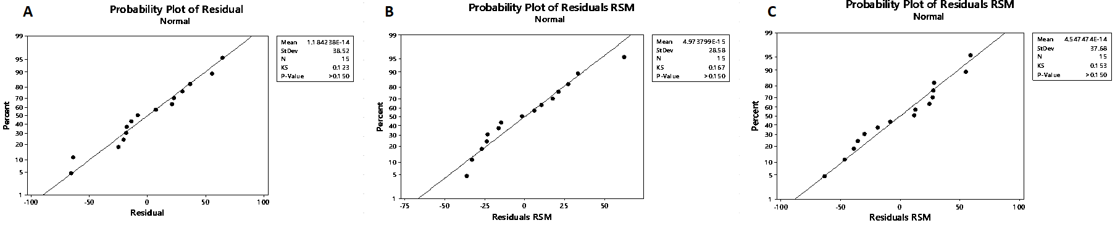
for A. Glycerol design. B. Sorbitol design. C. Glycine design.
Figure 5S. Normal (%) probability plot of the Standardized residuals. Normal probability plot showing the standardized residuals normally distributed and following the line of regression 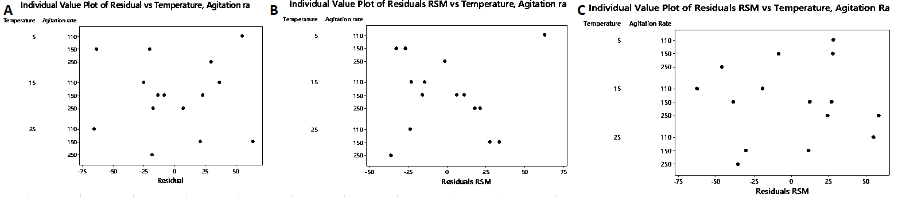
Figure 6S. Test of Homoscedasticity of Residuals (Scatter Plot for Homoscedasticity). Data do not form any clustering or systematic pattern, the assumption of the homoscedasticity is met for A. Glycerol design. B. Sorbitol design. C. Glycine design.

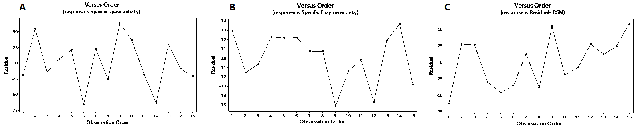
Figure 7S. Test of Independence (Residuals versus order). The data are randomly scattered around zero with no patterns. The residuals are independent from one other for A. Glycerol design. B. Sorbitol design. C. Glycine design. A slight dependence is seen in the Sorbitol Design.

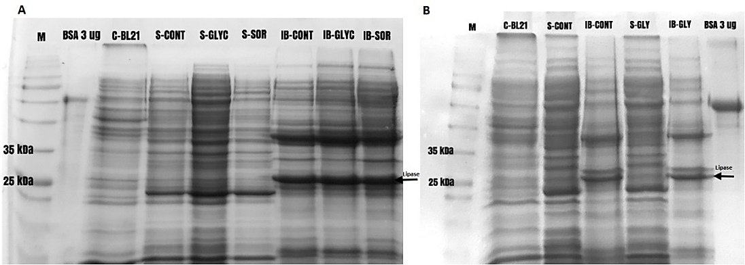
Figure 8S. SDS-PAGE protein gel of soluble and non-soluble fractions for glycerol, sorbitol and glycine models. Gel with soluble and non-soluble fractions for the control group (without osmolyte) and cultures with glycerol and sorbitol. M: Molecular Marker. C-BL21 (Control strain). S-CONT: Soluble fraction of control group. IB- CONT: Insoluble fraction for control group. S-GLYC Soluble fraction for glycerol. S-SOR: Soluble fraction for sorbitol. IB- CONT: Insoluble fraction for control group. IB-GLYC: Insoluble fraction for glycerol. IB-SOR: Insoluble fraction for sorbitol. BSA: Bovine serum albumin at 3 μg used as a standard protein. The arrows indicate the expressed lipase.

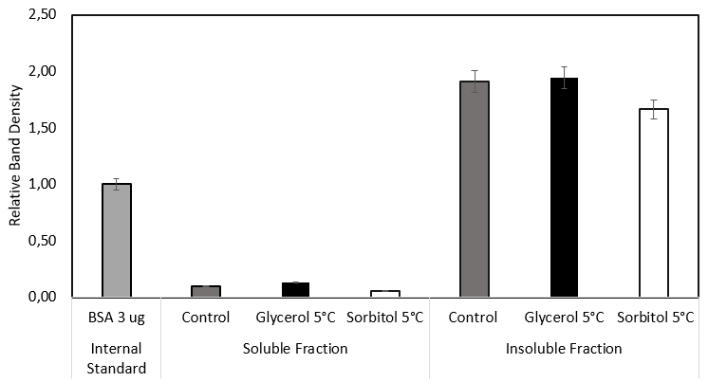
Figure 9S. Densitometric analysis for optimized glycerol, sorbitol and glycine models. Relative band density (From Figure 8) for recombinant lipase produced by E. coli BL21 (DE3) in optimized cultured supplemented with glycerol, sorbitol and glycine. Band density for soluble and non-soluble fractions are exhibited. Black bars: Glycerol and sorbitol model. White bars: Glycine model. Error bars are presented in percentage.

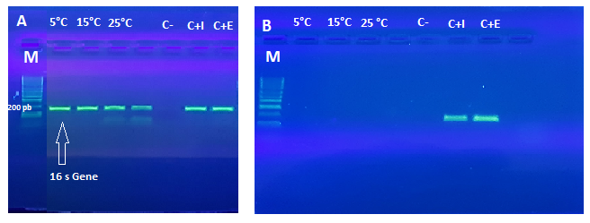
Figure 10S. 16 s PCR of total RNA samples before and after DNAse Treatment. A. RNA samples at 5°C, 15°C and 25°C showing the amplification of the contaminant 16s gene. B. RNA samples at 5°C, 15°C and 25°C after treatment with DNAse, showing no amplification of 16s gene. C-: Negative control. C+I: Internal Positive Control (Target sample no treated with DNAse). C+E: External Positive Control (DNA from P. aeruginosa). M: Molecular Marker. The size of amplicon was 180 pb. Sample RNA concentration loaded to the gel was 1 μg.

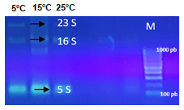
Figure 11S. RNA integrity of target samples on DEPC agarose gel. Total RNA extracted from 5°C, 15°C and 25°C samples were run at 90V for 30 min to check the presence of 23 S, 16 S and 5S.

