Supplementary Material

Stratigraphical reassessment of Grotta Romanelli sheds light on Middle-Late Pleistocene palaeoenvironments, sea-level history and human settling in the Mediterranean
Pierluigi Pieruccini¹, Luca Forti^{2,3*}, Beniamino Mecozzi^{4*}, Alessio Iannucci⁴, Tsai-Luen Yu^{5,6}, Chuan-Chou Shen^{6,7}, Fabio Bona^{2,8}, Giuseppe Lembo⁹, Brunella Muttillo¹⁰, Raffaele Sardella⁴ & Ilaria Mazzini¹¹
¹ Dipartimento di Scienze della Terra, Università di Torino, Via Valperga Caluso, 35, 10125 Turin, Italy
² Dipartimento di Scienze della Terra "A. Desio", Università degli Studi di Milano, Via L. Mangiagalli 34. 20133, Milan, Italy
³ Consiglio Nazionale delle Ricerche (CNR), Istituto di Geoscienze e Georisorse, Via G. Moruzzi 1 56124 Pisa, Italy
⁴ Dipartimento di Scienze della Terra, “Sapienza” Università di Roma, Piazzale Aldo Moro 5, 00185 Rome, Italy
⁵ Marine Industry and Engineering Research Center, National Academy of Marine Research, Kaohsiung 806, Taiwan, ROC
⁶ High-Precision Mass Spectrometry and Environment Change Laboratory (HISPEC), Department of Geosciences, National Taiwan University, Taipei 10617, Taiwan, ROC
⁷ Research Center for Future Earth, National Taiwan University, Taipei 10617, Taiwan, ROC
⁸ Museo Civico dei Fossili di Besano, Via Prestini 5, Besano, 21050, Italy
⁹ Ministero dell’Istruzione, Ferrara, Italy
¹⁰ Dipartimento degli Studi Umanistici, Università di Ferrara, Via Paradiso, 12, 44121 Ferrara, Italy
¹¹ Consiglio Nazionale delle Ricerche (CNR), Istituto di Geologia Ambientale e Geoingegneria, Area della Ricerca di Roma 1, Monterotondo (Rome), 00015, Italy

*Corresponding author's e-mail: luca.forti@unimi.it; beniamino.mecozzi@uniroma1.it

Supplementary Material 1. The history of Grotta Romanelli and the origin of its paradigm.
Grotta Romanelli was discovered by Ulderigo Botti during the 1870s (1), but the first excavation campaigns were carried out by Paolo Emilio Stasi during the earlier 1900s (2). Stasi identified the upper complex, called “Terre Brune”, and the lower complex, called “Terre Rosse”. Both complexes included artifacts and vertebrate fauna assemblages. Based on lithic artifacts found in the “Terre Brune”, Stasi recognized the first evidence of the Upper Palaeolithic in the Italian Peninsula (2). The paleontological findings from “Terre Brune'' played an important role on the evolution of the European Equinae, since Regàlia established a new species, Equus hydruntinus, a name strongly related to the Apulian territory; the Latin name hydruntinus means from “Otranto” (a town in the Salentine Peninsula) (3). In 1914, Gian Alberto Blanc began pioneering fieldwork activities in the cave, applying scientific systematic methods in archeological/paleontological deposits for the first time (4,5). Blanc described a more detailed stratigraphic sequence confirming the presence of two main complexes, from top to bottom: the “Terre Brune'', consisting of five levels (E-A) bearing Upper Paleolithic artifacts and vertebrate fauna, and the lower complex. There, he identified a sequence formed by the “Terre Rosse” (level G), bearing Middle Palaeolithic artifacts and vertebrate fauna, a stalagmitic layer (level H), a bone breccia (level I), and a beach deposit (level K) referred to the Tyrrhenian Stage (Marine Isotopic subStage 5e) (4,5). These two complexes were separated by the level F, a thick stalagmitic layer (4,5). Following Blanc’s interpretation, the deposition of the sedimentary succession started during the early Late Pleistocene, where the upper levels (E-A) were attributed generically to Upper Palaeolithic. Radiocarbon dating performed at the end of 1950 attributed the “Terre Brune '' to the Upper Pleistocene-Early Holocene boundary (6,7,8,9). G.A. Blanc died on December 31, 1966 (10), and, probably, had no time to publish other considerations on the age of the upper complex and its implications for archaeological and paleontological findings. The two speleothems (levels H and F) were radiometrically dated after Blanc’s death: level H yielded an apparent age of < 69,000 years BP, and level F was dated to 40,000 ± 3250 years BP, today corresponding to part of MIS 4 and MIS 3 (11,12,13). These radiometric data confirmed the chronology of the lower part of the succession previously proposed by Blanc. The fieldwork activities continued up to the 1970s coordinated by Cardini with the support of the Italian Institute of Human Paleontology (IsIPU) (14). The stratigraphic succession described by Blanc (4,5) and the age of the Grotta Romanelli infilling deposits constituted a reference for the archaeological and paleontological studies in the Mediterranean for about 100 years (15,16) as well as the sea-level changes models for the region, although already debated under the morpho-stratigraphic point of view (20,21).
Supplementary Material 2. Micromorphology
During the excavations in 2018 and 2019 a total number of 17 samples for thin sections were taken (Fig.S2). Other 10 samples have been taken in 2021 and still under preparation. The preliminary work on the already processed samples focussed on the definition of the microfacies to be associated to the sedimentary facies defined at macro-and meso-scale.
The main microfacies characteristics are summarized below:
Unsorted mixed with anthropogenic constituents – This microfacies is found both in ISU 3 and 5 and it is made of unsorted, coarse sands to silts, mainly subrounded to angular quartz grains and subordinately coarse sands sized limestone lithorelicts mixed within a massive to crumby clay-silty groundmass. The anthropogenic constituents are made of burnt, partially burn or unburnt bone and charcoal fragments (microphoto a and b (ISU3), g (ISU5); Fig. S3).
Plane parallel bedded – This microfacies is made of alternating coarse- to fine-sands laminae with silty and clay laminae, forming couplets with fining-upward trends (microphoto d (ISU3), e (ISU5), Fig. S3). Occasionally the bedding is emphasized by the presence of elongated fragments of bones or charred vegetal remains (microphoto h (ISU5), Fig. S3).
Cross-bedded – This microfacies has the same compositional characteristics of the previous one but with less organic constituents such as bones and charred organic materials. Moreover, it is very common in ISU5 (microphoto f (ISU5), Fig. S3) whereas almost absent for ISU3.
Biological activity – This microfacies is found only in ISU3 and it is characterised by abundant rounded or channel- and chamber-like biological voids affecting an unsorted mix of sandy to silty sized quartz grains and limestone lithorelicts supported by a massive clay-silty groundmass. Charcoals and bone fragments are alco common (microphoto c (ISU3) Fig. S3).
Supplementary figures

Supplementary Fig. S1
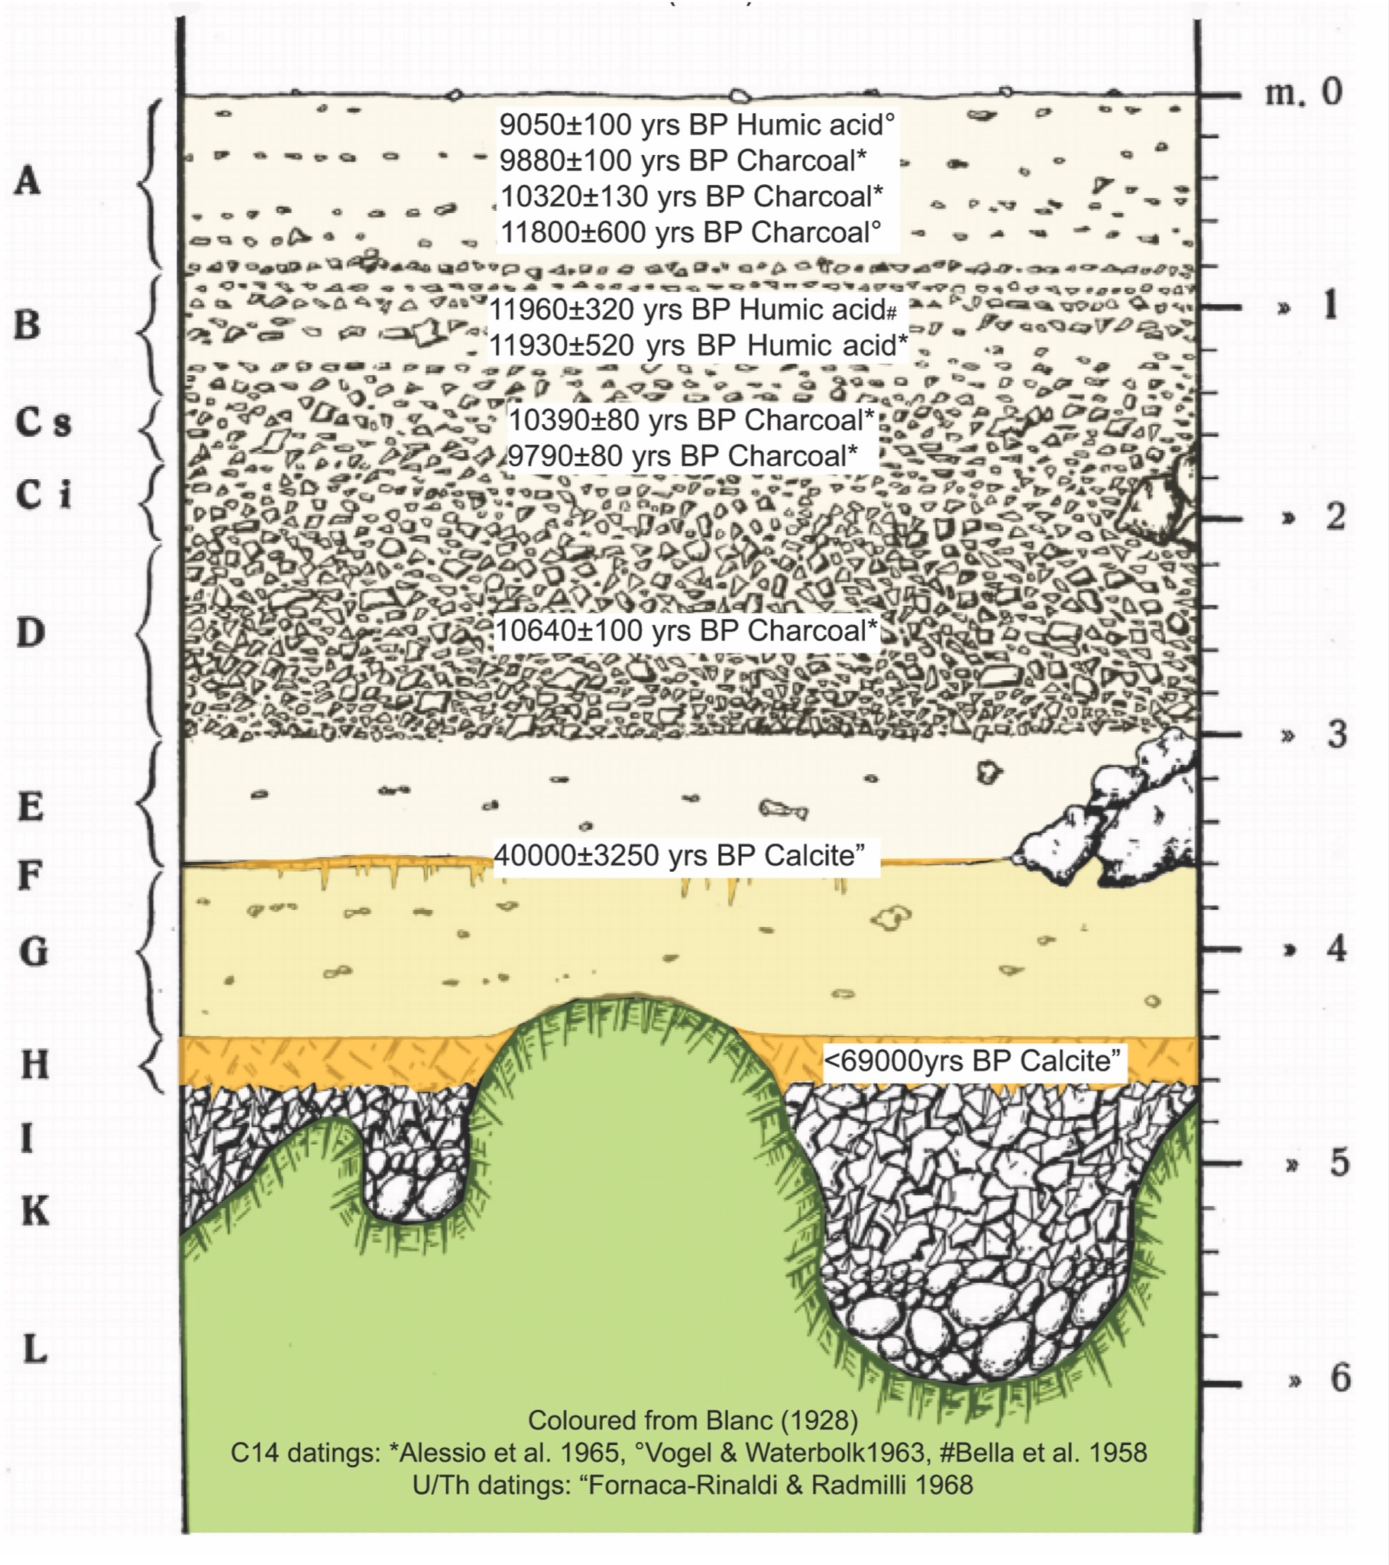
Figure S1. Stratigraphic log of Grotta Romanelli infilling deposit (modified by 5) with the results of radiocarbon and U/Th dating carried out in previous works (references in the main text).

Supplementary Fig. S2
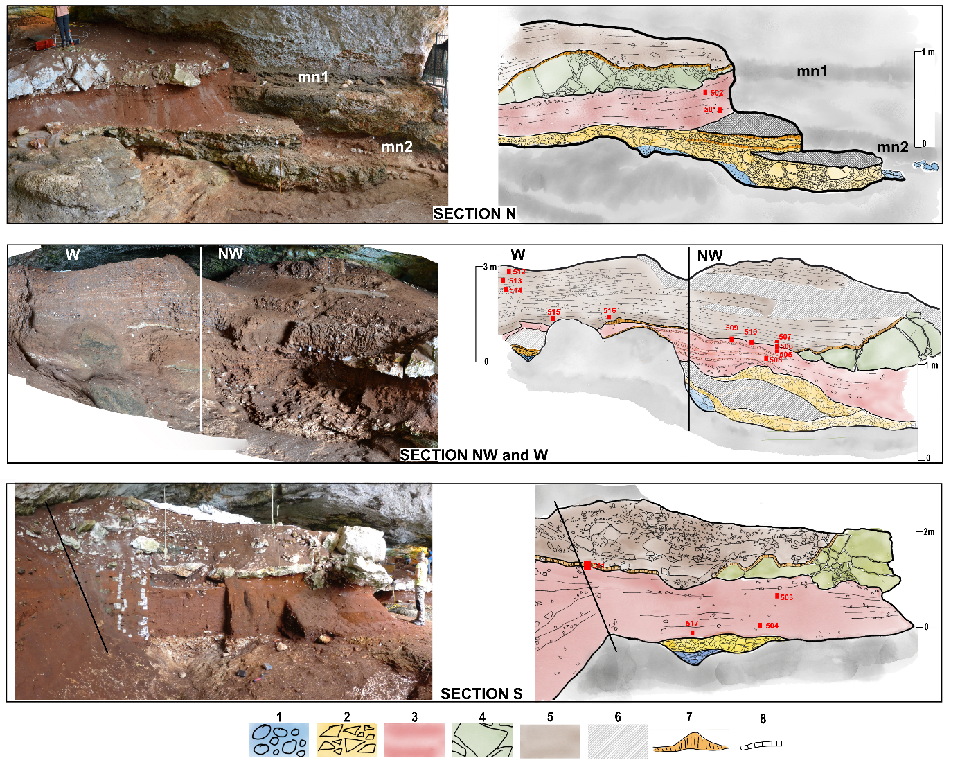
Figure S2. Positioning of the samples for micromorphology collected during the 2018-2019 excavation campaign. For legend refers to Fig. 3 in the main text.

Supplementary Fig. S3
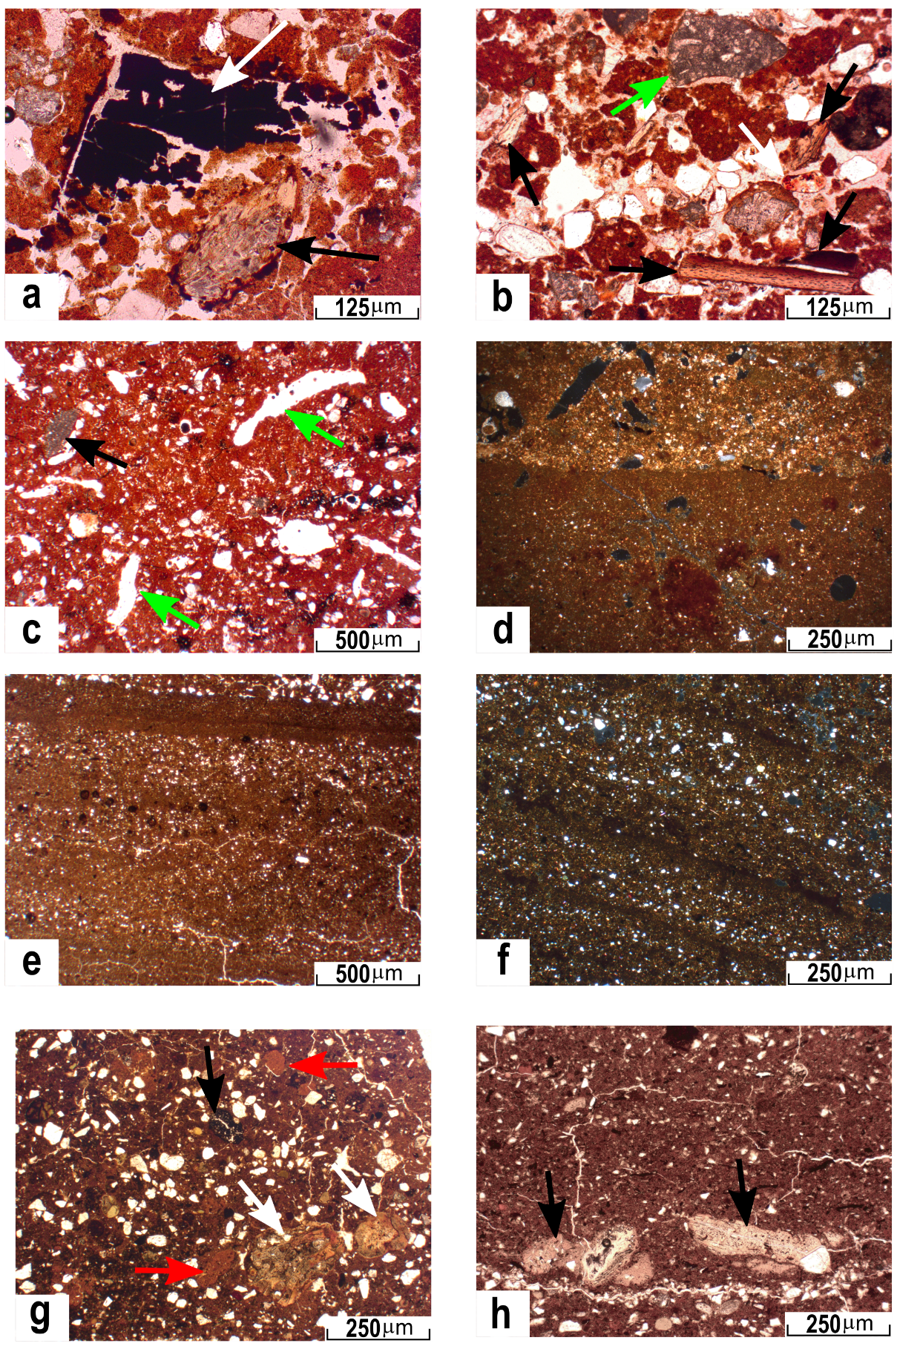
Figure S3. Selection of microphotographs of thin sections from ISU3 and ISU5. PPL-Plane Polarized light XPL – Cross polarized light. For location and numbering of the samples see Fig. S2.
PPL, ISU3 (504): anthropogenic elements: charcoal fragment (white arrow) and partially phosphatised burnt bone (black arrow) (a).
PPL, ISU3 (501): unsorted mixed microfacies, quartz grains locally burnt (white arrow) with coarser unweathered limestone lithorelicts (green arrow) and burnt bones ((black arrows) (b)
PPL, ISU3 (503): massive microfacies with abundant biological features such as channel and voids (green arrows), rare limestone rock-fragments (black arrow) and blackish Fe-Mn masses (c).
XPL, ISU3 (508): plane parallel bedded laminated microfacies with alternating clays-dominated laminae (bottom) and sandy silty laminae (top) (d).
PPL, ISU5 (506): horizontally bedded laminae (e).
XPL, ISU5 (514): cross-bedded laminated microfacies (f).
PPL ISU5 (516): unsorted massive microfacies with abundant colluviated features derived from the erosion of I-SU3 (red arrows), burnt partially phosphatized bones and phosphatic nodules (white arrows) and rounded charcoal grains (green arrows) (g).
PPL, ISU5 (516): plane parallel bedding locally includes coarse partially burnt bone fragments (black arrows) oriented parallel to the laminae (h).
Supplementary Table S1

Sample ID | Type | Description | ²³⁸U |  | ²³²Th |  | d²³⁴U |  | [²³⁰Th/²³⁸U] |  | ²³⁰Th/²³²Th |  | Age (yr ago) |  | Age (yr BP) |  | d²³⁴U initial
Sample ID | Type | Description | 10-9g/g ª |  | 10-12g/g |  | measuredª |  | activity^{c} |  | atomic (x 10-6) |  | uncorrected |  | corrected ^{c,d} |  | corrected ^{b}
GRN108 | Stalagmite | top ISU4 and bottom ISU5 | 469,4 | ± 1,9 | 0,6748 | ± 0,0062 | -36,1 | ± 5,9 | 0,3157 | ± 0,0048 | 3620 | ± 63 | 43.381 | ± 882 | 43.296 | ± 882 | -40,9 | ± 6,7
GRB345 | Flowstone | top ISU4 and bottom ISU5 | 488,41 | ± 0,58 | 9502 | ± 26 | 4,1 | ± 1,5 | 0,4975 | ± 0,0024 | 421,6 | ± 2,3 | 74.565 | ± 555 | 73.981 | ± 609 | 5,0 | ± 1,8
GRG280 | Flowstone | top ISU4 and bottom ISU5 | 354,60 | ± 0,68 | 6,994 | ± 0,029 | 6,1 | ± 2,1 | 0,6491 | ± 0,0039 | 542,6 | ± 3,8 | 112.790 | ± 1270 | 112.506 | ± 1286 | 8,4 | ± 2,9
GRN172 | Flowstone | top ISU2 | 5572 | ± 11 | 2564 | ± 117 | 52,6 | ± 2,4 | 0,929 | ± 0,044 | 33,3 | ± 2,2 | 223.616 | ± 35468 | 218.820 | ± 34265 | 98 | ± 12
GRG247 | Flowstone | within ISU2 | 924,8 | ± 1,2 | 532 | ± 12 | 49,1 | ± 1,9 | 1,029 | ± 0,028 | 29,5 | ± 1,0 | 365.777 | ± 93882 | 359.965 | ± 87386 | 136 | ± 55
GR17013 | Flowstone | bedrock bottom ISU2 | 1050,5 | ± 1,6 | 301,8 | ± 5,0 | 87,9 | ± 1,8 | 1,062 | ± 0,021 | 60,9 | ± 1,6 | 327.702 | ± 39927 | 325.003 | ± 39053 | 220 | ± 31

Table S1. Uranium and Thorium isotopic compositions and ages for stalagmite/flowstone samples collected from Grotta Romanelli by MC-ICPMS, Thermo Electron Neptune, at NTU.
Analytical errors are 2s of the mean.
ª[²³⁸U] = [²³⁵U] x 137.818 (±0.65‰) (17); d²³⁴U = ([²³⁴U/²³⁸U] activity - 1) x 1000. ^{b}d²³⁴Uinitial corrected was calculated based on ²³⁰Th age (T), i.e., d²³⁴Uinitial = d²³⁴Umeasured X el234*T, and T is corrected age.
^{c}[²³⁰Th/²³⁸U] activity = 1 - e-l230T + (d²³⁴Umeasured/1000)[l230/(l230 - l234)](1 - e-(l230 - l234) T), where T is the age.Decay constants are 9.1705 x 10-6 yr-1 for ²³⁰Th, 2.8221 x 10-6 yr-1 for ²³⁴U (18), and 1.55125 x 10-10 yr-1 for ²³⁸U (19)
^{d}Age corrections, relative to 1950 AD, were calculated using an estimated atomic ²³⁰Th/²³²Th ratio of 1.67 (± 100%) x 10-6.

Data Availability Statement
All data generated or analysed during this study are included in this published article (and its supplementary information files).

References
1 Botti, U. Sulla scoperta di ossa fossili in Terra d’Otranto. Boll. Regio Com. Geol. 1, 7–8 (1874).
2 Stasi, P.E. & Regàlia, E. Grotta Romanelli stazione con faune interglaciali calde e di steppa. Nota preventiva. Soc.It. Antropol. 1, 17–81 (1904).
3 Regàlia, E. Sull’Equus (Asinus) hydruntinus Regàlia della Grotta di Romanelli (Castro, Lecce) Arch. Antropol. Etnol. 37, 375–390 (1907).
4 Blanc, G. A. Grotta Romanelli I. Stratigrafia dei depositi e natura e origine di essi. Arch. Antropol. Etnol. 50, 1–39 (1920).
5 Blanc, G.A. Grotta Romanelli II. Dati ecologici e paletnologici. Arch. Antropol. Etnol. 58, 1–49 (1928).
6 Bella, F., Blanc, A.C., Blanc, G.A. & Cortesi, C. Una prima datazione con il carbonio 14 della formazione pleistocenica di Grotta Romanelli (Terra d’Otranto). Quaternaria 5, 87–94 (1958).
7.Vogel, J. C. & Waterbolk, H.T. Groningen radiocarbon dates IV. Radiocarbon 5, 63–202 (1963).
8 Alessio, M., Bella, F. & Cortesi, C. University of Rome carbon14 dates II. Radiocarbon 6, 77–90 (1964).
9. Alessio, M., Bella, F., Bachecchi, F. & Cortesi, C. University of Rome Carbon-14 dates III. Radiocarbon 7, 213–222 (1965).
10. Fornaseri M. & Gian Alberto Blanc. La Chimica e l’Industria, 49, 3–5 (1967).
11 Fornaca-Rinaldi, G. Il metodo 230Th/238U per la datazione di stalattiti e stalagmite. Boll. di Geofis. Teor. ed Appl. 10, 3–14 (1968a).
12 Fornaca-Rinaldi, G. 230Th/234Th dating of cave concretions. Earth & Planet. Sci. Lett. 5, 120–122 (1968b).
13 Fornaca-Rinaldi, G. & Radmilli, A. M. Datazione con il metodo 230Th/238U di stalagmiti contenute in depositi musteriani. Atti Soc. Toscana Sci. Nat. 75 (1), 639–646 (1968).
14 Cardini, L. & Biddittu, I. Attività scientifica dell’Istituto Italiano di Paleontologia Umana della sua fondazione. Quaternaria 9, 385–408 (1967).
15 Sardella, R. et al. Grotta Romanelli (Southern Italy, Apulia): legacies and issues in excavating a key site for the Pleistocene of the Mediterranean. Riv. It. Paleont. Strat. 124 (2), 247–264 (2018).
16 Sardella, R. et al. Grotta Romanelli (Lecce, Southern Italy) between past and future: new studies and perspectives for an archaeo-geosite symbol of the Palaeolithic in Europe. Geoheritage 11 (4), 1413–1432. https://doi.org/10.1007/s12371-019-00376-z (2019).
17 Hiess, J., Condon, D. J., McLean, N., & Noble, S. R. ²³⁸U/²³⁵U systematics in terrestrial uranium-bearing minerals. Science 335 (6076), 1610-1614. 10.1126/science.1215507 (2012).
18 Cheng, H. et al. Improvements in ²³⁰Th dating, ²³⁰Th and ²³⁴U half-life values, and U–Th isotopic measurements by multi-collector inductively coupled plasma mass spectrometry. Earth Plan. Sci. Let. 371, 82-91. https://doi.org/10.1016/j.epsl.2013.04.006 (2013)
19 Jaffey, A. H., Flynn, K. F., Glendenin, L. E., Bentley, W. T., & Essling, A. M. Precision measurement of half-lives and specific activities of U 235 and U 238. Physical Review C 4 (5), 1889 (1971)
20. Mastronuzzi, G., Quinif, Y., Sansò, P. & Selleri, G. Middle-Late Pleistocene polycyclic evolution of a stable coastal area 1620 (southern Apulia, Italy). Geomorphology, 86(3–4), 393–408. https://doi.org/10.1016/j.geomorph.2006.09.014 (2007).
21. Antonioli, F. et al. Morphometry and elevation of the last interglacial tidal notches in tectonically stable coasts of the Mediterranean Sea. Earth-Sci. Rev. 185, 600–623. https://doi.org/10.1016/j.earscirev.2018.06.017 (2018).

