Alginate encapsulation of micro-cuttings in endangered Satureja khuzistanica species: a promising method for obtaining genetically stable plants with high rosmarinic acid content
Journal name: Plant cell Tissue and Organ Culture

Roya Asadi¹, Mohammad Reza Abdollahi^{1*}, Sayyed Saeed Moosavi¹, Asghar Mirzaie-Asl²

¹ Department of Agronomy and Plant Breeding, Faculty of Agriculture, Bu-Ali Sina University, P.O.Box 657833131, Hamedan, Iran
² Department of Agricultural Biotechnology, Faculty of Agriculture, Bu-Ali Sina University, Hamedan, Iran

* Corresponding author
Position of the Corresponding Author: Associate. Professor
E-mail: m.abdollahi@basu.ac.ir
ORCID ID: https://orcid.org/0000-0002-9237-2420
Tel: +989188177385
Fax: +988134424012
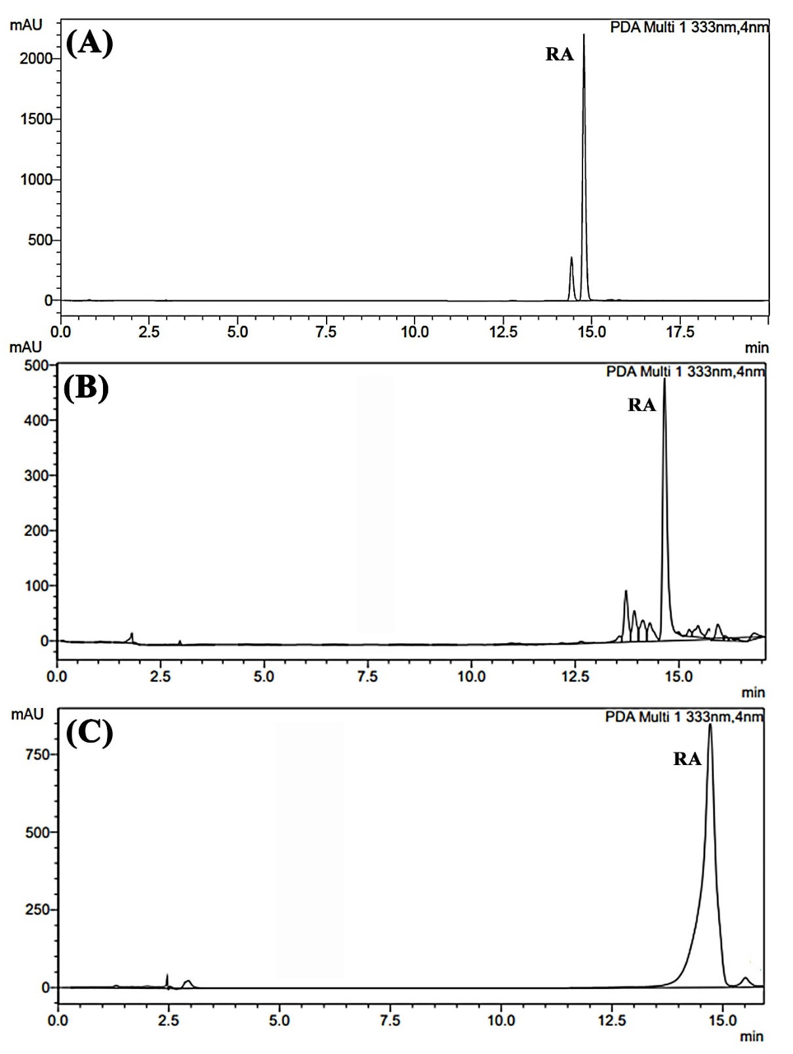
Fig S1. HPLC chromatograms (330 nm) of (A) the authentic standard of rosmarinic acid, (B) hydromethanolic extract of Satureja khuzistanica plants derived from natural seeds, and (C) plants derived from nodal segment culture.

