Table 1: Biological activity data of the molecules.
Sl. No. | Drug name | Structures | IC₅₀  (µM) | pIC₅₀  (µM) | Reference
1 | Ebselen | 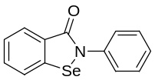 | 0.67 | 0.173 | [10]
2 | Disulfiram | 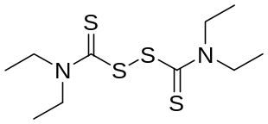 | 9.35 | -0.970 | [10]
3 | Tideglusib | 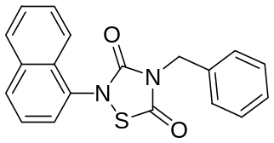 | 1.55 | -0.190 | [10]
4 | Carmofur | 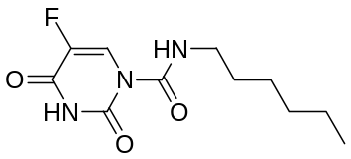 | 1.82 | -0.260 | [10]
5 | Shikonin | 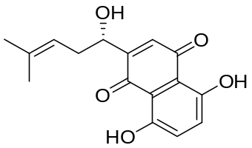 | 15.75 | -1.197 | [10]
6 | 11a | 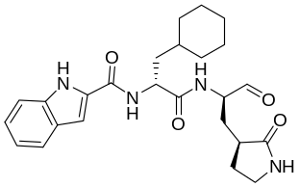 | 0.053 | 1.275 | [18]
7 | 11b | 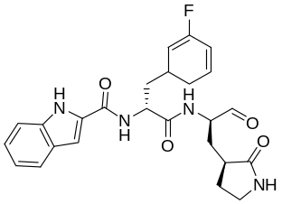 | 0.04 | 1.397 | [18]
8 | 11r | 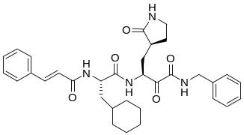 | 0.18 | 0.744 | [19]
9 | 13a | 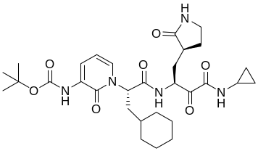 | 2.39 | -0.378 | [19]
10 | 13b  (alpha-ketoamide) | 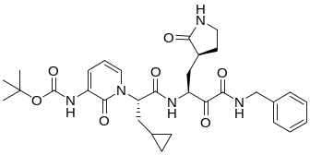 | 0.67 | 0.173 | [19]
11 | Simeprevir | 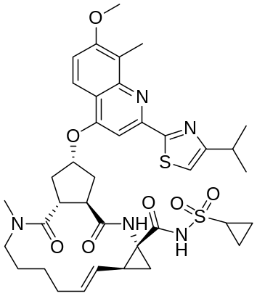 | 13.74 | -1.137 | [20]
12 | Boceprevir | 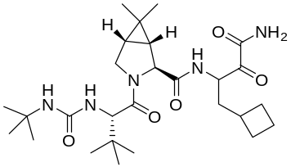 | 4.13 | -0.615 | [20]
13 | Narlaprevir | 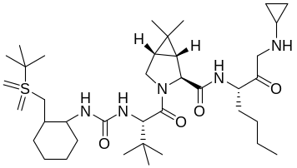 | 5.73 | -0.758 | [20]
14 | MG-132 | 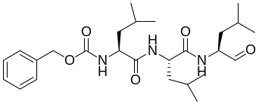 | 3.9 | -0.591 | [20]
15 | Calpeptin | 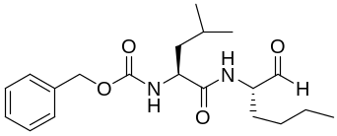 | 10.69 | -1.028 | [20]
16 | Calpain inhibitor I (ALLN) | 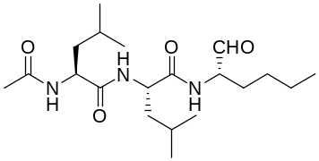 | 8.6 | -0.934 | [20]
17 | MG-115 | 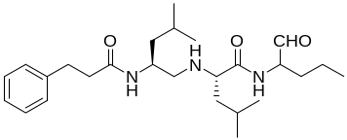 | 3.14 | -0.496 | [20]
18 | Calpain inhibitor II (ALLM) | 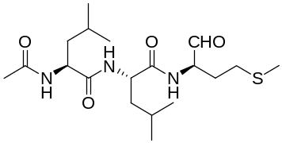 | 0.97 | 0.013 | [20]
19 | Calpain inhibitor XII | 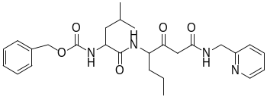 | 0.45 | 0.346 | [20]
20 | PSI | 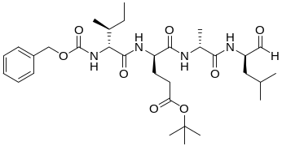 | 10.38 | -1.016 | [20]
21 | Baicalin | 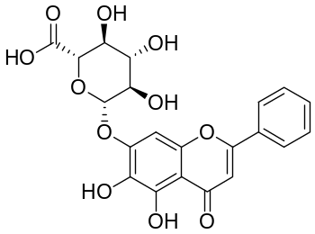 | 6.41 | -0.806 | [21]
22 | Baicalein | 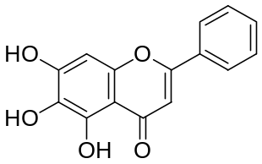 | 0.94 | 0.026 | [21]
23 | Chloroquine (Rac) | 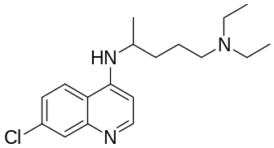 | 1.801 | -0.255 | [22]
24 | S-Chloroquine | 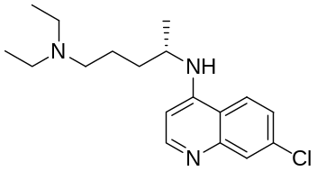 | 1.761 | -0.245 | [22]
*25 | R-Chloroquine | 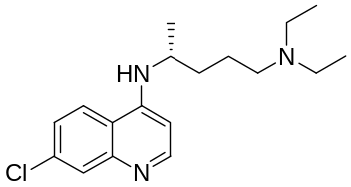 | 1.975 | -0.295 | [22]
26 | Hydroxychloroquine (Rac) | 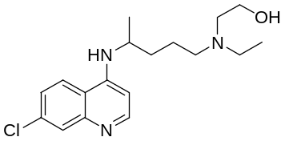 | 1.752 | -0.243 | [22]
27 | S-Hydroxychloroquine | 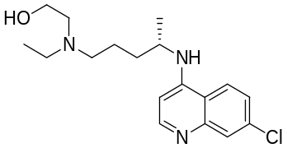 | 1.444 | -0.159 | [22]
28 | R-Hydroxychloroquine | 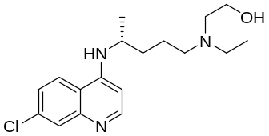 | 2.445 | -0.388 | [22]
29 | Azithromycin | 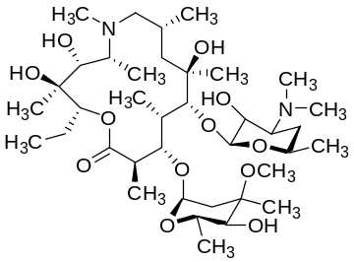 | 15.75 | -1.197 | [22]
30 | Ivermectin | 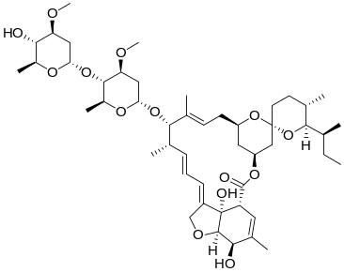 | 2.8 | -0.447 | [23]
31 | N1 | 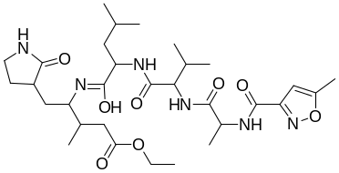 | 1.11 | -0.045 | [18]
32 | N3 | 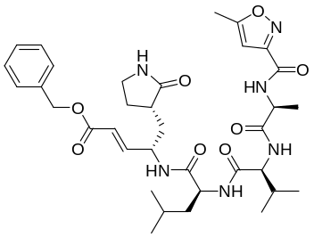 | 125 | -2.096 | [10]
33 | N9 | 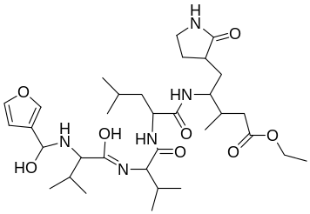 | 0.9 | 0.045 | [18]
34 | UAWJ243 | 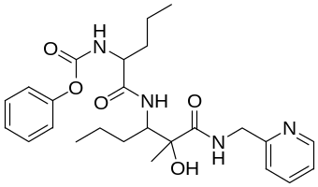 | 0.41 | 0.387 | [24]
35 | UAWJ246 | 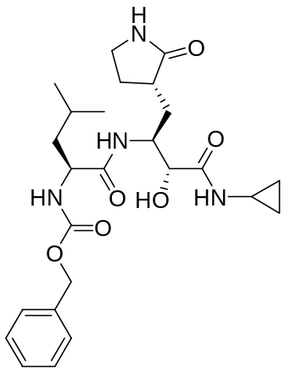 | 0.045 | 1.346 | [24]
36 | UAWJ247 | 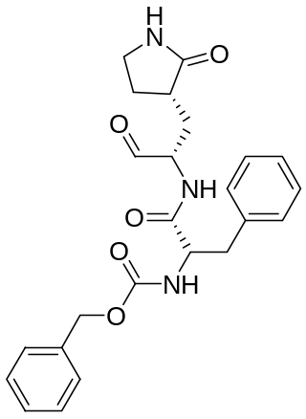 | 0.045 | 1.346 | [24]
37 | UAWJ248 | 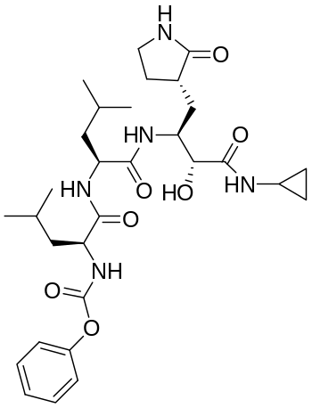 | 0.042 | 1.376 | [24]
38 | Manidipine | 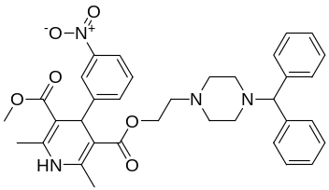 | 4.8 | -0.681 | [25]
39 | lercanidipine | 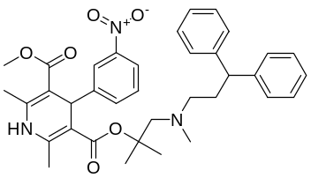 | 16.2 | -1.209 | [25]
40 | Bedaquiline | 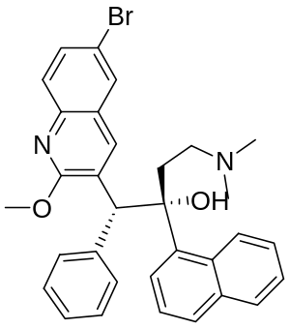 | 18.7 | -1.271 | [25]

Table 5: External data set along with modeled structural descriptors, observed and predicted activities
Sl. No. | Comp.  name | Structures | Modeled parameters |  |  |  | Observed pIC₅₀ | Pred pIC₅₀
Sl. No. | Comp.  name | Structures | ATSC7v | maxHB  int10 | VR1_Dzi | Mins  CH3 | Observed pIC₅₀ | Pred pIC₅₀
41 | GC373 | 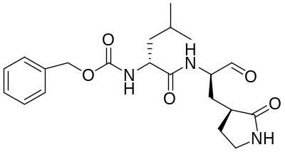 | 203.915 | 5.084 | 400.922 | 1.927 | 0.397 | 0.329
42 | GC376 | 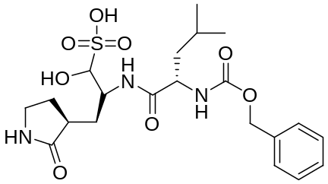 | -229.929 | 5.150 | 351.878 | 1.831 | 0.721 | 0.210
43 | GC376 derivative 6a | 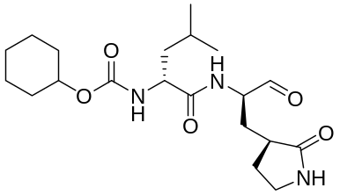 | -30.378 | 5.050 | 289.682 | 1.952 | 0.086 | 0.258
44 | GC376 derivative 6c | 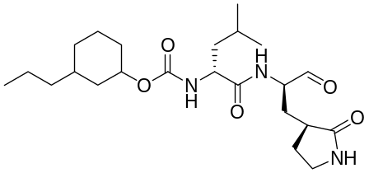 | 136.772 | 5.085 | 529.136 | 1.962 | 0.552 | 0.242
45 | GC376 derivative 6e | 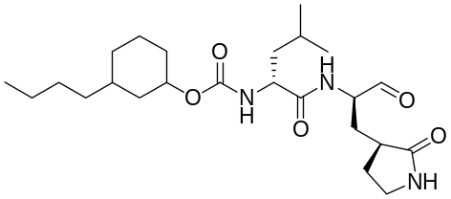 | 160.877 | 5.089 | 404.174 | 1.965 | 0.769 | 0.298
46 | GC376 derivative 6h | 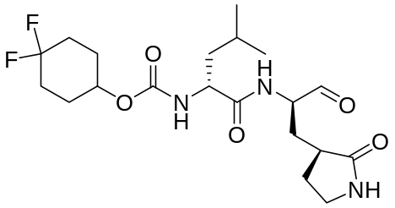 | 34.737 | 5.135 | 8217.574 | 1.871 | 0.366 | -2.605
47 | GC376 derivative 6j | 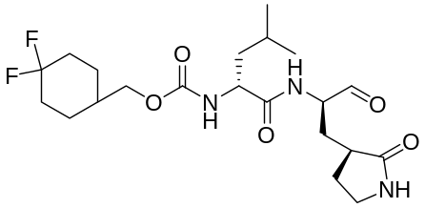 | 133.887 | 5.100 | 402.192 | 1.884 | 0.318 | 0.317
48 | GC376 derivative 7a | 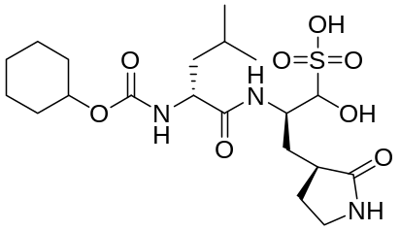 | -429.898 | 5.115 | 331.929 | 1.856 | 0.187 | 0.119
49 | GC376 derivative 7c | 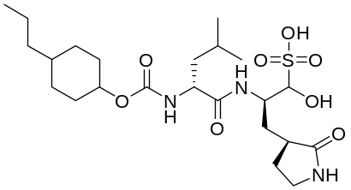 | -13.570 | 5.135 | 1383.37 | 1.864 | 0.638 | -0.094
50 | GC376 derivative 7e | 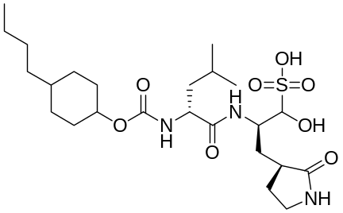 | -115.938 | 5.137 | 499.692 | 1.866 | 0.698 | 0.188
51 | GC376 derivative 7h | 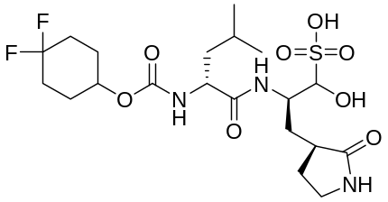 | -383.017 | 5.201 | 468.35 | 1.775 | 0.387 | 0.130
52 | GC376 derivative 7j | 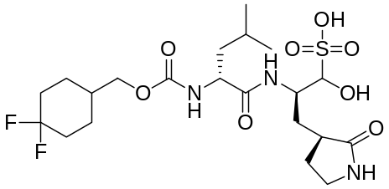 | -275.647 | 5.166 | 911.423 | 1.787 | 0.346 | 0.001
53 | Walrycin B | 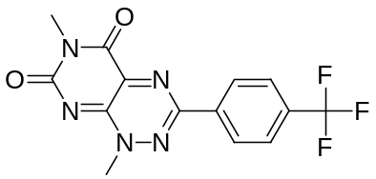 | -413.339 | 0 | 196.972 | 1.260 | 0.585 | -0.406
54 | AMG-837 | 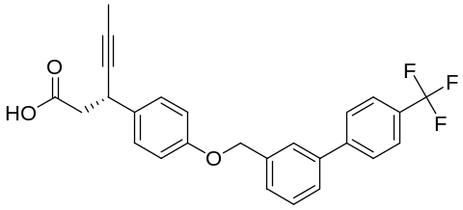 | -144.346 | 0 | 312.661 | 1.671 | -1.382 | -0.481
55 | Z-DEVD-FMK (Caspase-3 Inhibitor) | 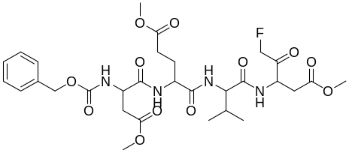 | -628.969 | 5.508 | 2468.365 | 1.041 | -0.833 | -0.406
56 | Z-FA-FMK | 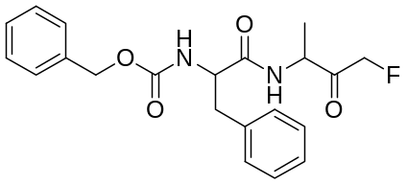 | 311.686 | 0 | 278.213 | 1.395 | -1.055 | -0.179
57 | LLL-12 | 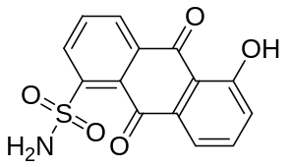 | -269.232 | 0 | 189.301 | 0 | -0.993 | 0.101
58 | DA-3003-1 | 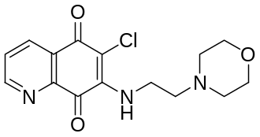 | -221.67 | 0 | 228.057 | 0 | -0.419 | 0.107
59 | CAY-10581 | 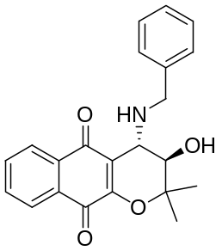 | -418.67 | 0 | 376.209 | 1.719 | -0.963 | -0.636
60 | Fascaplysin | 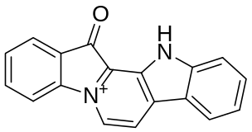 | 108.049 | 0 | 198.823 | 0 | -0.998 | 0.256
61 | β-Lapachone | 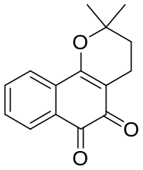 | -948.459 | 0 | 179.88 | 2.000 | -1.124 | -0.886
62 | Sepantronium bromide | 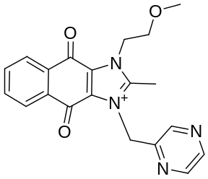 | -1466.7 | 0 | 1948.568 | 1.612 | -1.133 | -1.621
63 | NSC95397 | 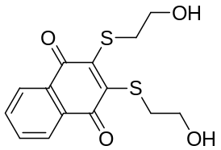 | -1377.94 | 0 | 214.219 | 0 | -1.253 | -0.372
64 | 4E1RCat | 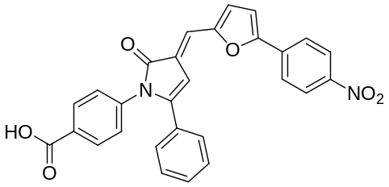 | 157.9256 | 0 | 405.7154 | 0 | -1.261 | 0.201214
65 | TBB | 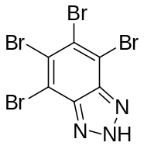 | 0 | 0 | 268.491 | 0 | -1.311 | 0.185
66 | GW-0742 | 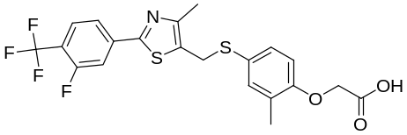 | 91.393 | 0 | 379.674 | 1.881 | -1.347 | -0.481
67 | Agaric acid | 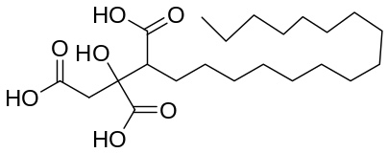 | 3.916 | 0 | 270.743 | 2.222 | -1.371 | -0.597
68 | MK0893 | 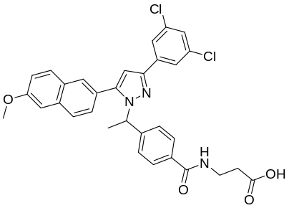 | -315.615 | 0 | 456.294 | 1.674 | -1.386 | -0.607
69 | SU 16f | 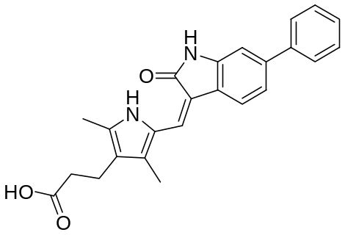 | -925.42 | 8.139 | 335.422 | 1.931 | -1.397 | 0.351
70 | Penta-O-galloyl-Beta-D-glucose hydrate | 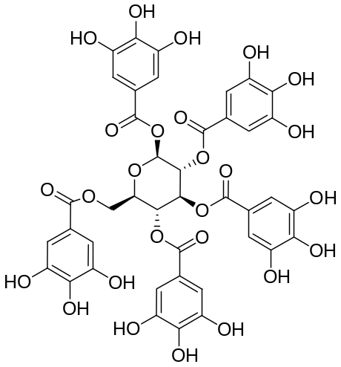 | -456.249 | 6.948 | 1050.838 | 0 | -1.443 | 0.781
71 | SP100030 | 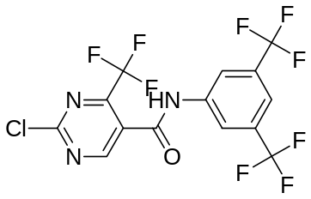 | 46.220 | 0 | 235.287 | 0 | -1.460 | 0.217
72 | Anacardic acid | 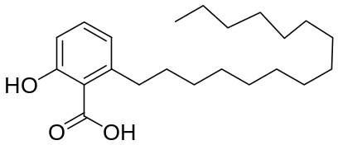 | 48.263 | 0 | 241.401 | 2.258 | -1.042 | -0.581
73 | Adomeglivant | 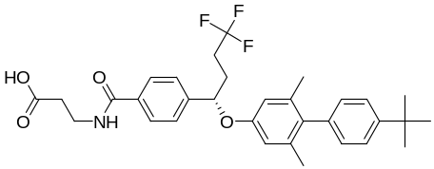 | 476.373 | 6.011 | 515.548 | 1.953 | -1.282 | 0.536
74 | Eltrombopag olamine | 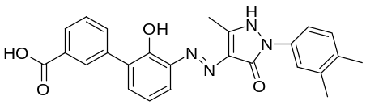 | -513.675 | 0 | 441.005 | 1.723 | -1.332 | -0.702
75 | GSK-3965 | 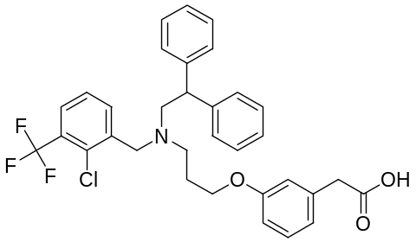 | -390.592 | 1.420 | 399.888 | 0 | -1.332 | 0.193
76 | GW5074 | 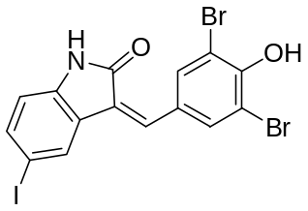 | 531.705 | 0 | 261.699 | 0 | -1.332 | 0.411
77 | Hexachlorophene | 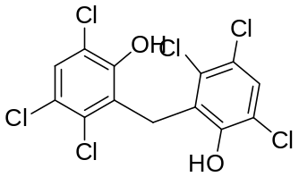 | -115.812 | 0 | 499.692 | 0 | -1.332 | 0.051
78 | MK-886 | 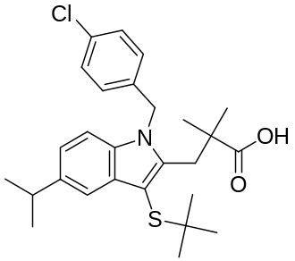 | -1415.59 | 0 | 519.189 | 1.866 | -1.332 | -1.160
79 | MG149 | 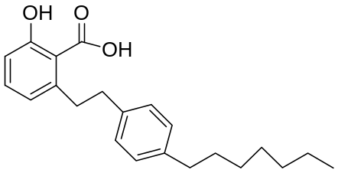 | 262.264 | 0 | 343.371 | 2.231 | -1.432 | -0.519

