Links between Northern Hemisphere abrupt cooling events and Southeastern US hydroclimate: evidence from new speleothem isotope records

Medina-Elizalde Martín., Stefan Perritano, Matthew DeCesare, Josué Polanco-Martinez, Gabriela Serrato-Marks, David McGee and Joe Lambert, Raymond Bradley

Supplementary information

Figures S1-S7
Tables S1-S4 (included as separate excel files)

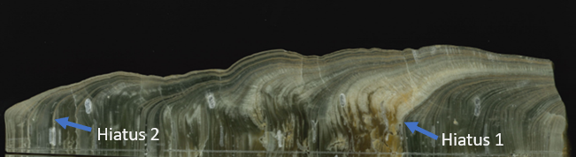
Younger Dryas
section
Early to Mid-Holocene section
Late-Holocene

Figure S1. War Eagle (WE) stalagmite (34 cm long) collected from War Eagle (WE) cave located in Jackson County, Alabama. The two hiatuses are indicated: Hiatus 1 (10.8-9.4 ka BP), Hiatus 2 (4.3-2.6 ka BP).

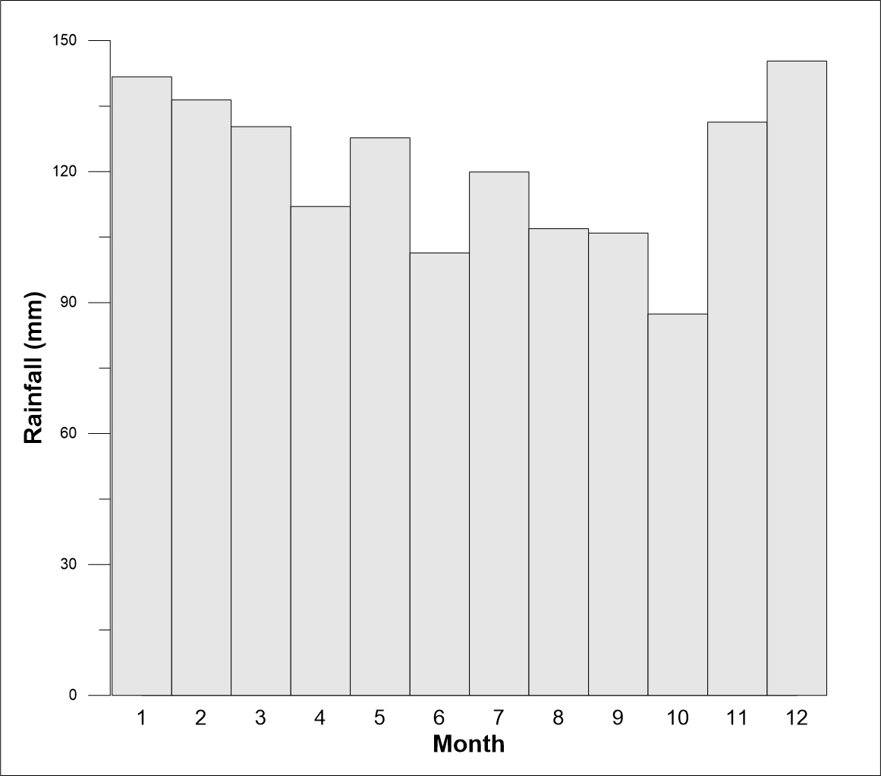

Fig. S2. Historical monthly rainfall amount data for the period 1981-2010 from Scottsboro, Alabama. Month numbers 1 to 12 correspond to the months Jan to Dec consecutively (data from www.ncdc.noaa.gov).
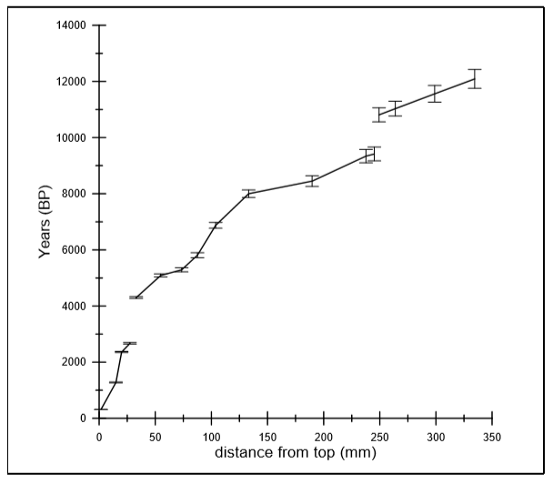
Figure S3. U-Th ages versus distance from the top. Lines correspond to linear regression lines used to build the chronology of WE stalagmite specimen. Age uncertainties ranged from ±15 to ±110 years with a mean of ±40 years (2σ).

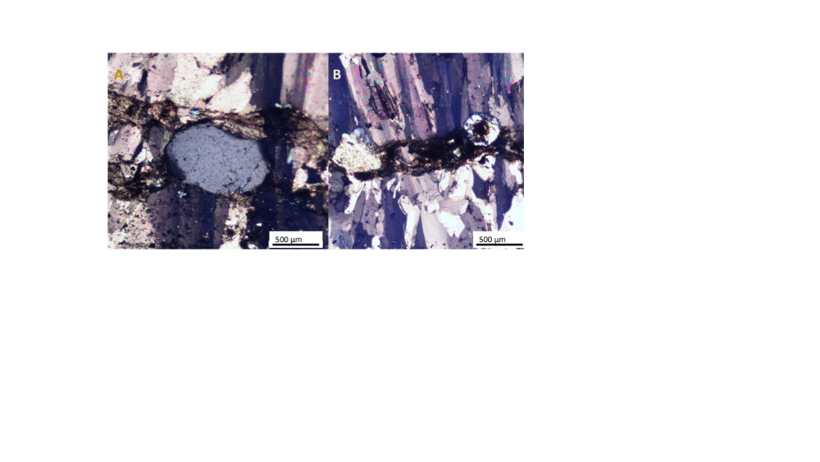

Figure S4. XPL photograph of Hiatus 1 (panel A) and Hiatus 2 (panel B). A tectosilicate appears between two distinct boundaries within Hiatus 1 and a sponge spicule is embedded within Hiatus 2.
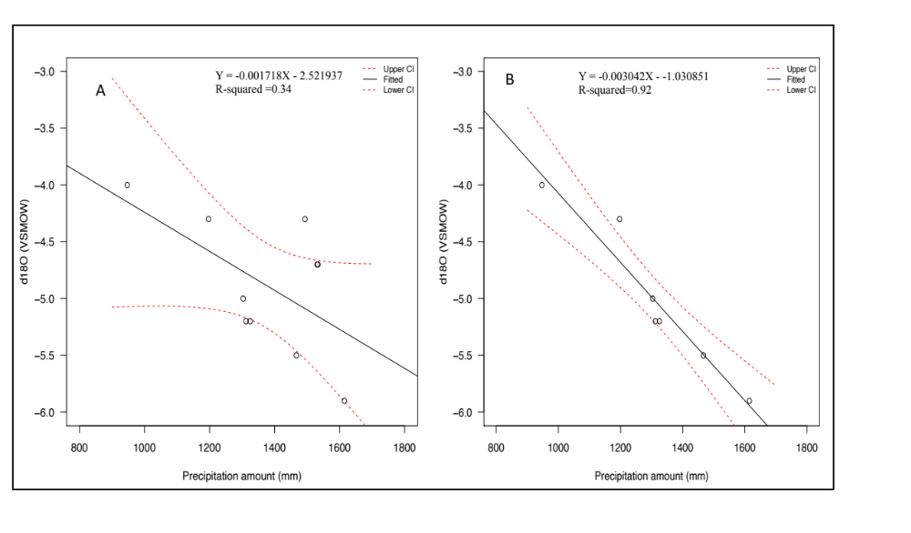
Figure S5. Annual amount-weighted δ¹⁸O composition of precipitation versus annual precipitation amount (Data collected at the University of Alabama, in Tuscaloosa, spanning the time interval between 2005 and 2015) (Dhungana and Aharon, 2019; Lambert and Aharon, 2010). The ten-year instrumental data (A) suggests a modest amount effect on interannual timescales whereas removal of three “outlier” years (B) suggests a stronger amount effect on interannual timescales. Confidence intervals represent the 90% level (red dotted lines). The slopes of the linear regressions of A and B overlap within a 90% confidence interval and are statistically significantly different from zero. Panel A, slope range = -0.003317095, -0.0001197538], Panel B slope range =-0.00382629, -0.002258674.

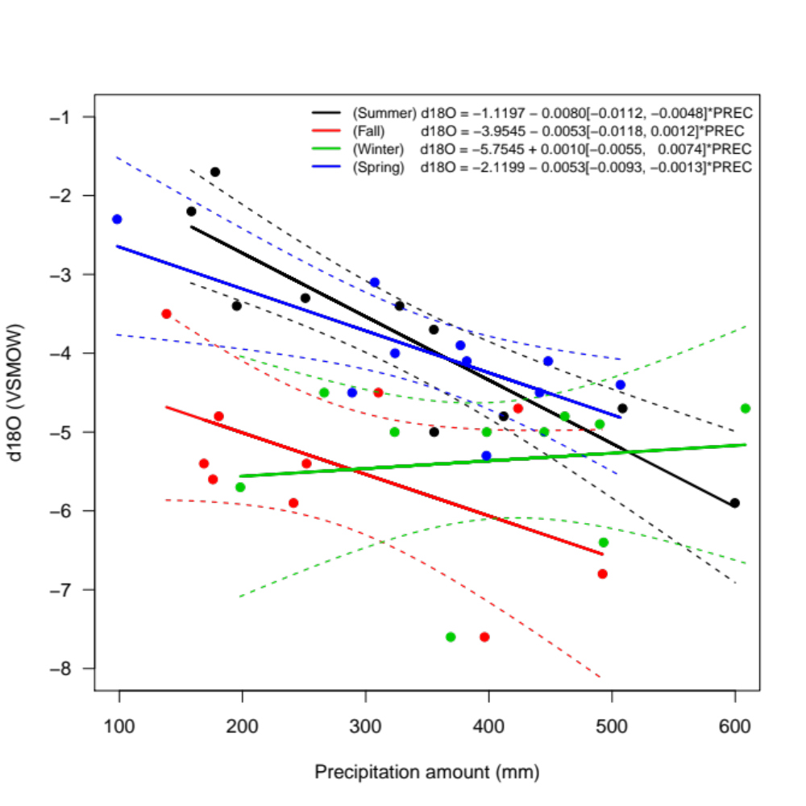
Figure S6. Monthly amount-weighted δ¹⁸O composition of precipitation versus monthly precipitation amount per season based on ten-year instrumental data collected at the University of Alabama, Tuscaloosa from year 2005 to 2015 (Dhungana and Aharon, 2019; Lambert and Aharon, 2010). A statistically significant relationship between precipitation amount and precipitation δ¹⁸O is observed only during summer season interannually (black line, slope =-0.0112, -0.0048, 95% confidence interval, CI) and spring season (blue line, slope =-0.0093, -0.0013‰ per mm, 95% CI). No statistically significant relationship is observed during the fall (red line, slope= -0.0118, +0.0012‰ per mm, 95% CI), and winter (green line, slope =-0.0055, +0.0074‰ per mm, 95% CI). Winter precipitation δ¹⁸O varies the least interannually with average seasonal δ¹⁸O compositions of -5.3± 0.9‰ (1 SD). Summer precipitation δ¹⁸O in contrast shows the most positive δ¹⁸O average and the largest interannual amplitude variability (-3.8± 1.2‰). We note that the most positive winter precipitation δ¹⁸O value of -4.5‰ is significantly more negative and does not overlap with the most positive summer δ¹⁸O values (-1.6 ‰ to -3.6‰, n=6 years) whereas summer rainfall δ¹⁸O can be as negative (-4.6‰ to -5.9‰, n=4 years) as typical winter δ¹⁸O values (-5.3± 0.9‰). Finally, we highlight the potential negative isotopic influence of tropical cyclones during the summer season, as exemplified by our direct analysis of Hurricane Michael rainfall (March, 2019) with a δ¹⁸O composition of -11.2 ‰.

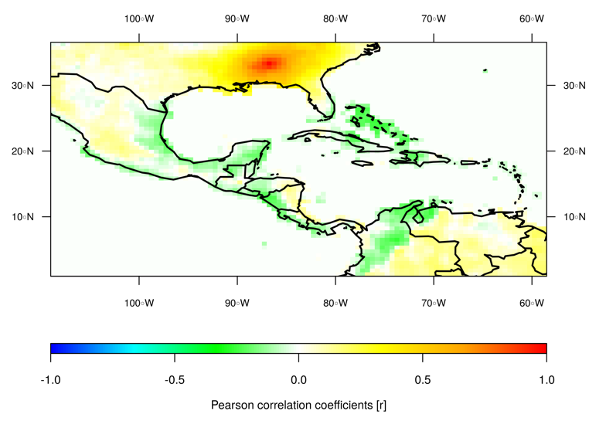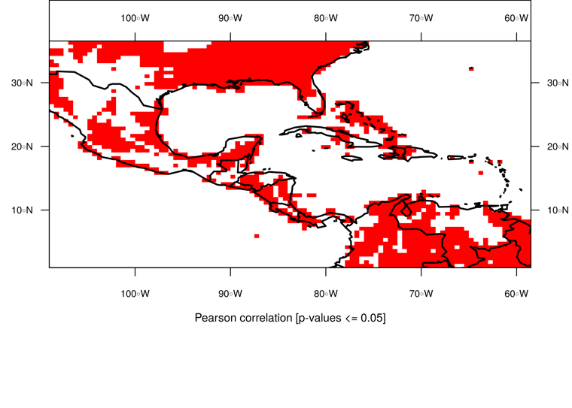
Figure S7. Spatio-temporal correlation analysis of summer precipitation (monthly values from 1901 to 2013) and with a spatial coverage of 0.5° latitude by 0.5° longitude) at the location (34°31′N, 86°11′W) (War Eagle Cave, Alabama). Location of War Eagle Cave indicated with light blue star. The precipitation data set comes from the GPCC Global Precipitation Climatology Centre and is available from https://psl.noaa.gov/data/gridded/data.gpcc.html. The map was created using the R software (R Core Team., 2013).

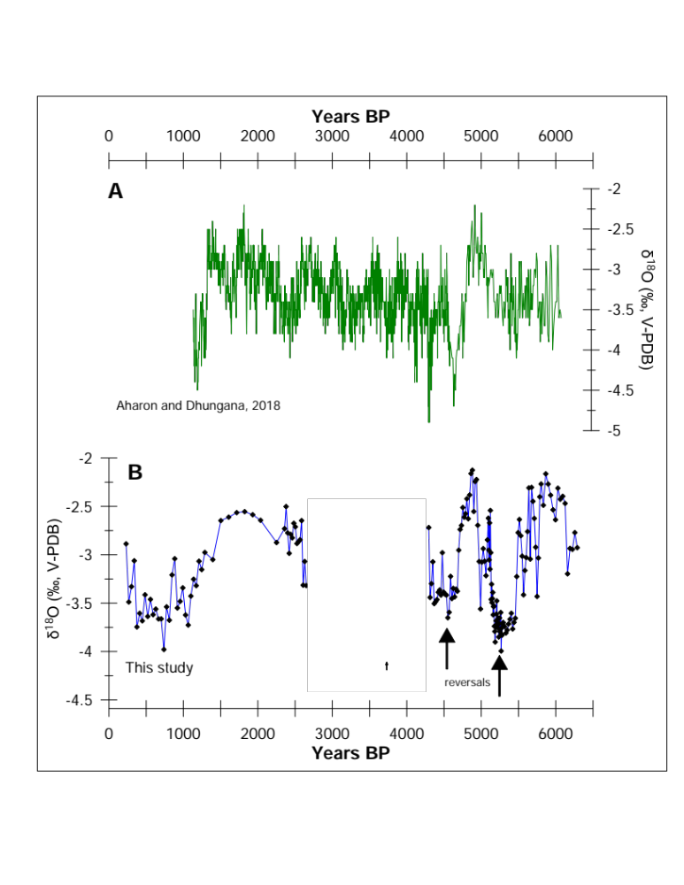
Figure S8. Comparison between Mid-Holocene and Late-Holocene sections of the WE stalagmite δ¹⁸O record and the stalagmite δ¹⁸O record from DeSoto caverns, both located in northern Alabama (Aharon and Dhungana, 2017). Negative isotopic excursions (reversals) are indicated with arrows.

References:

Aharon, P., and Dhungana, R., 2017, Ocean-atmosphere interactions as drivers of mid-to-late Holocene rapid climate changes: Evidence from high-resolution stalagmite records at DeSoto Caverns, Southeast USA: Quaternary Science Reviews, v. 170, p. 69-81.
Dhungana, R., and Aharon, P., 2019, Stable isotopes and trace elements of drip waters at DeSoto Caverns during rainfall-contrasting years: Chemical Geology, v. 504, p. 96-104.
Lambert, J. W., and Aharon, P., 2010, Oxygen and hydrogen isotopes of rainfall and dripwater at SeSoto Caverns (Alabama, USA); Key to understanding past variability of moisture transport from the Gulf of Mexico: Geochimica Et Cosmochimica Acta, v. 74, no. 3, p. 846-861.
R Core Team., 2013, R: A language and environment for statistical computing. R Foundation for Statistical Computing, Vienna, Austria.

