Article title:
Variation in number and position of rDNA loci is one of the driving forces in the diversification and speciation in Nigella (Ranunculaceae)
Fatemeh Orooji¹, Ghader Mirzaghaderi^{1*}, Yi-Tzu Kuo², Jörg Fuchs²
¹ Department of Agronomy and Plant Breeding, Faculty of Agriculture, University of Kurdistan, Postal code 66177–15175, Sanandaj, Iran
² Leibniz Institute of Plant Genetics and Crop Plant Research (IPK), 06466 Gatersleben, Stadt Seeland, Germany
* Corresponding author (Email: gh.mirzaghaderi@uok.ac.ir)

Supplementary figures
Figure S1. Worldwide distribution of Nigella species
References
Raab-Straube, E. von, Hand, R., Hörandl, E. and Nardi, E. (2014) Ranunculaceae. – In: Euro+Med Plantbase.
Zohary, M. (1983) The genus Nigella (Ranunculaceae) — a taxonomic revision. Pl Syst Evol 142, 71–105.
Zohary, M. (1966) Flora Palaestina1, 190–195. — Jerusalem: Israel Acad. Sciences and Humanities.
Tutin, T. G. (1964) Nigella. — In Tutin, T. G., & al. (Eds.): Flora Europaea1, 209–210. — Cambridge: Univ. Press.

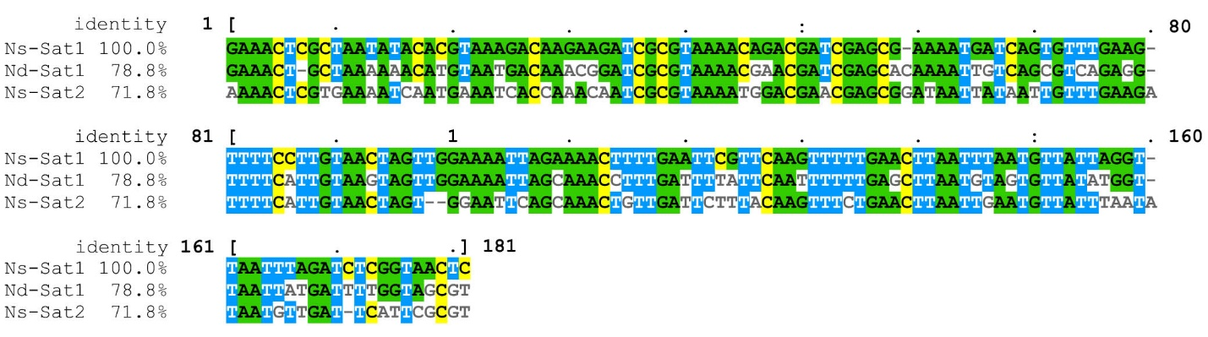
Figure S2. Alignment of the 178 bp, AT-rich (68% for Ns-Sat1) centromeric repeat monomers in N. sativa (Ns-Sat1 and Ns-Sat2) and N. damascena (Nd-Sat1).

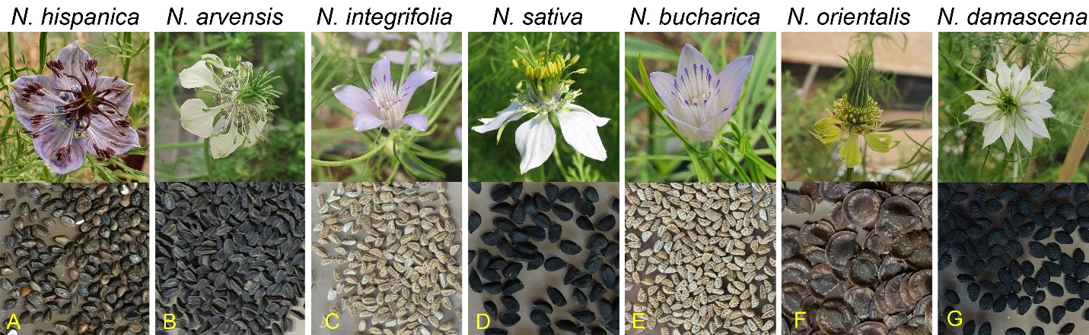
Figure S3. Flower and seed morphology and rDNA loci distribution of the studied species

