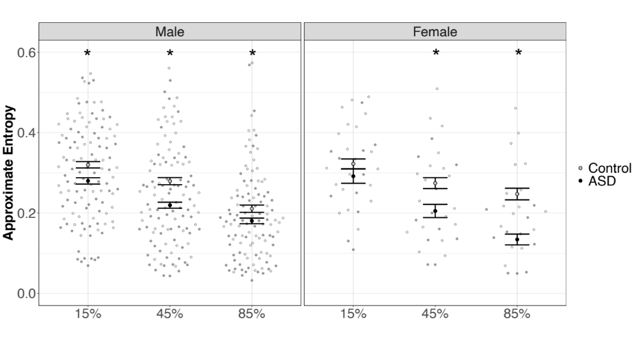
Supplementary Figure 1. Approximate entropy is reduced in males with ASD compared to control males across all force levels. Entropy is reduced in females with ASD compared to control females at 45 and 85% MVC, but not at 15% MVC. Error bars reflect standard error of the mean. *p < .05.
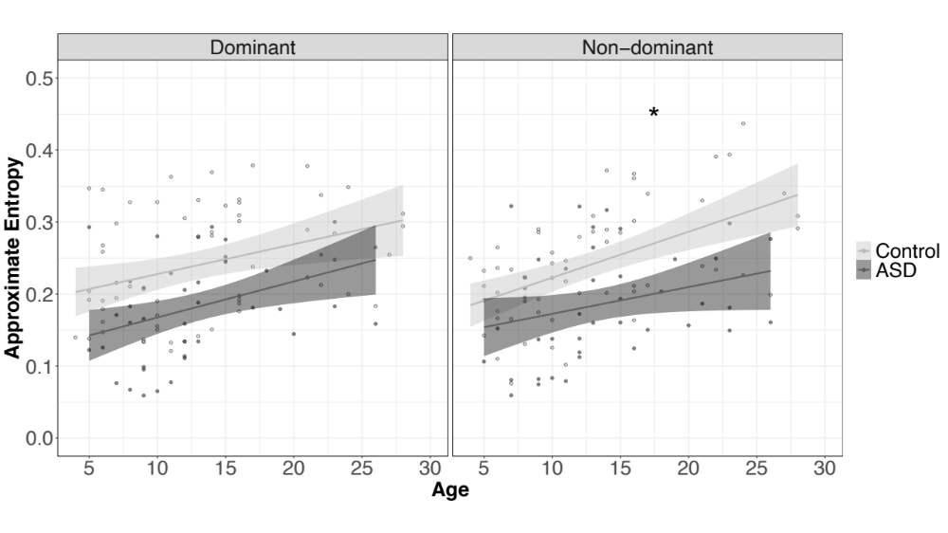
Supplementary Figure 2. Control participants show increased age-associated improvements in ApEn relative to ASD in the non-dominant hand only. Error bars reflect standard error of the mean. *slopes differ between groups

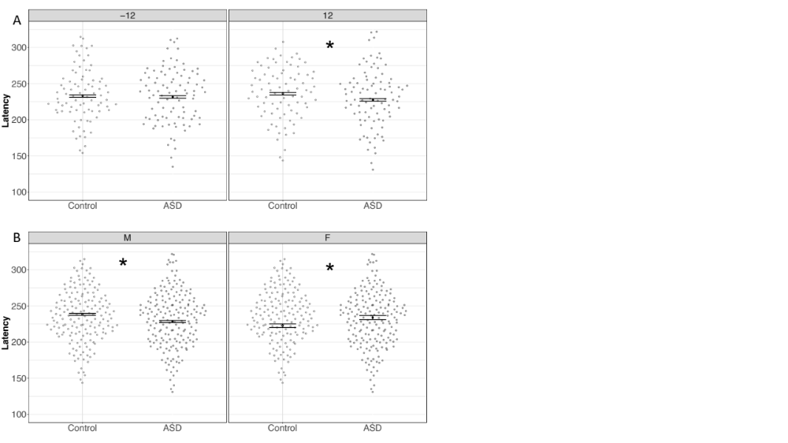
Supplementary Figure 3. Saccade latency differs between groups as a function of target direction and sex. A) Saccade latencies are reduced in individuals with ASD for rightward, but not leftward targets. B) Saccade latencies are reduced in males with ASD relative to male control participants. Saccade latencies are increased in females with ASD relative to female control participants. Error bars reflect standard error of the mean. *p < .05.

