E-Supplementary:
DNA extraction
200 mg sample was homogenized with 1 ml extraction buffer, pH 8.0 (200 mmol/L Tris-HCl, 200 mmol/L NaCl, 100 mmol/L EDTA-Na₂, and 2% SDS), and 30 µL of 20 mg/mL proteinase K (Sigma‐Aldrich, St. Louis, USA), and incubated at 56 ℃ for 6 to 10 h until there were no obvious blocks. Then, the sample was left to cool at room temperature. 1 mL tris-saturated phenol were added to the lysate and slowly mixed upside down for 10 min, centrifugated at 12,000 g, 4 ℃ for 10 min. Aspirating supernatant and adding the same volume Solution Ⅰ (tri-saturated phenol : chloroform : isoamyl alcohol = 25 : 24 : 1), slowly mixing upside down for 10 min, centrifugating at 12,000 g, 4 ℃ for 10 min. Aspirating supernatant and adding the same volume Solution Ⅱ (chloroform : isoamyl alcohol = 24 : 1), slowly mixing upside down for 10 min, centrifugating at 12,000 g, 4 ℃ for 5 min. Aspirating supernatant and adding double volume pre-cooled (-20 ℃) absolute ethanol, slowly mixing upside down for 2 min before centrifugating at 12,000 g, 4 ℃ for 5 min. Abandoning supernatant and adding 1 mL 75% ethanol to wash the precipitation, and then abandoning supernatant after centrifugating at 12,000 g, 4 ℃ for 3 min. 30 µL to 50 µL TE buffer (10 mmol/L Tris-HCl, 0.5 mmol/L EDTA-Na2) was added to dissolve the DNA after ethanol evaporation at room temperature.

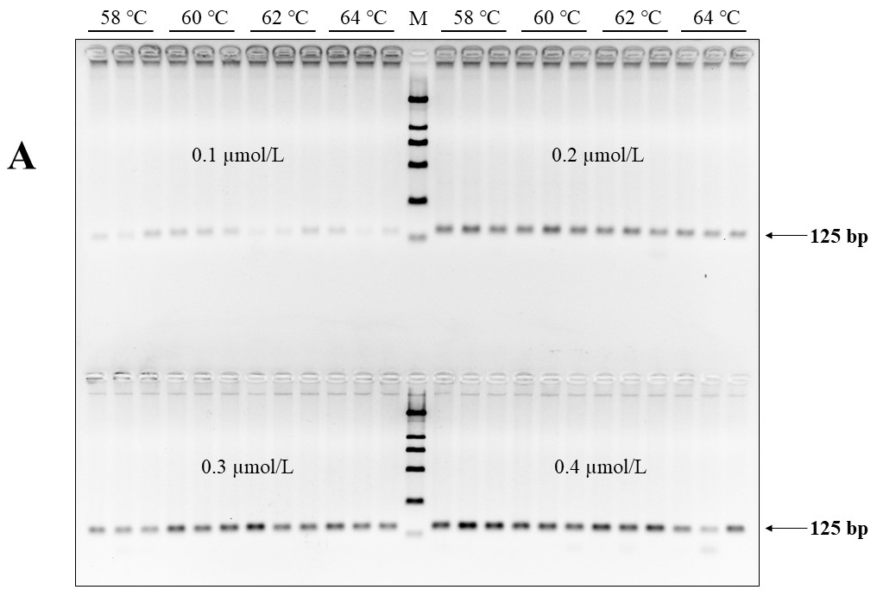
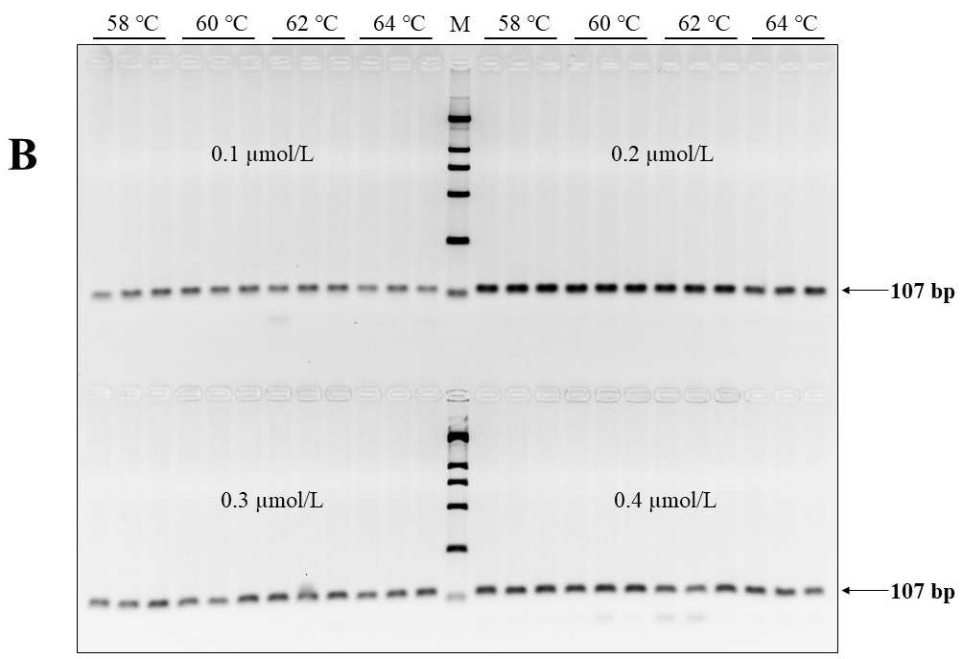
Fig. S1
Optimization of PCR system. The concentrations of universal primer pair were set as 0.1 µmol/L, 0.2 µmol/L, 0.3 µmol/L, and 0.4 µmol/L to amplify the target fragment of cattle (A) and sheep (B), and annealing temperatures were set as 58 ℃, 60 ℃, 62 ℃, and 64 ℃, respectively. M, Molecular weight marker 100-2,000 bp gradient. Molecular sizes are indicated by the arrows. The pictures are reverse images of the 2.5% agarose gels.

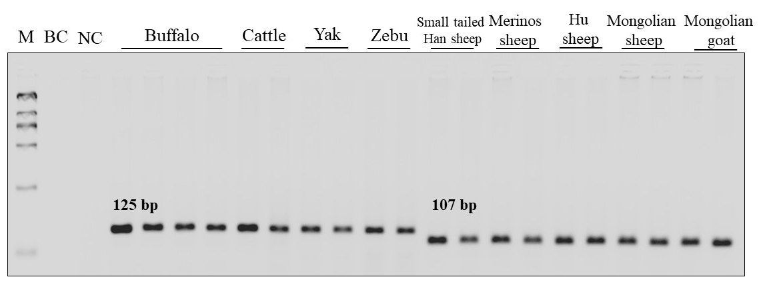
Fig. S2
Conservation test of universal primer pair designed on the novel universal target DNA sequence with bovine and ovine/caprine DNA samples from different species/breeds and individuals. M, Molecular weight marker 100-2,000 bp gradient; BC, blank control; NC, negative control. Molecular sizes are indicated. The pictures are reverse images of the 2.5% agarose gels.

