Supplementary Information
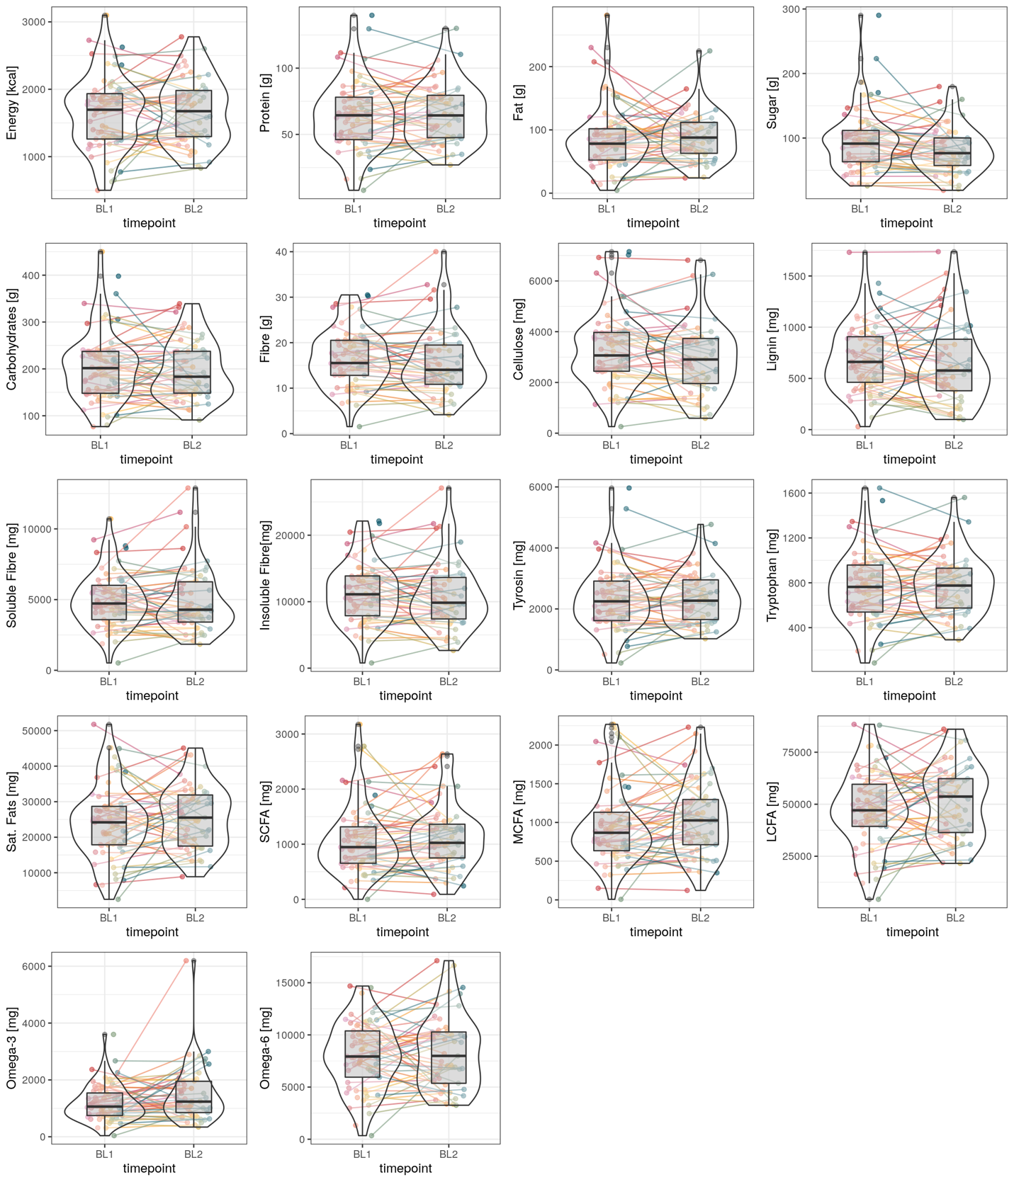
SI Figure 1: Computed nutrient values plotted across two timepoints for FFQ 7 days. Transparent lines are colour-coded by the individual.

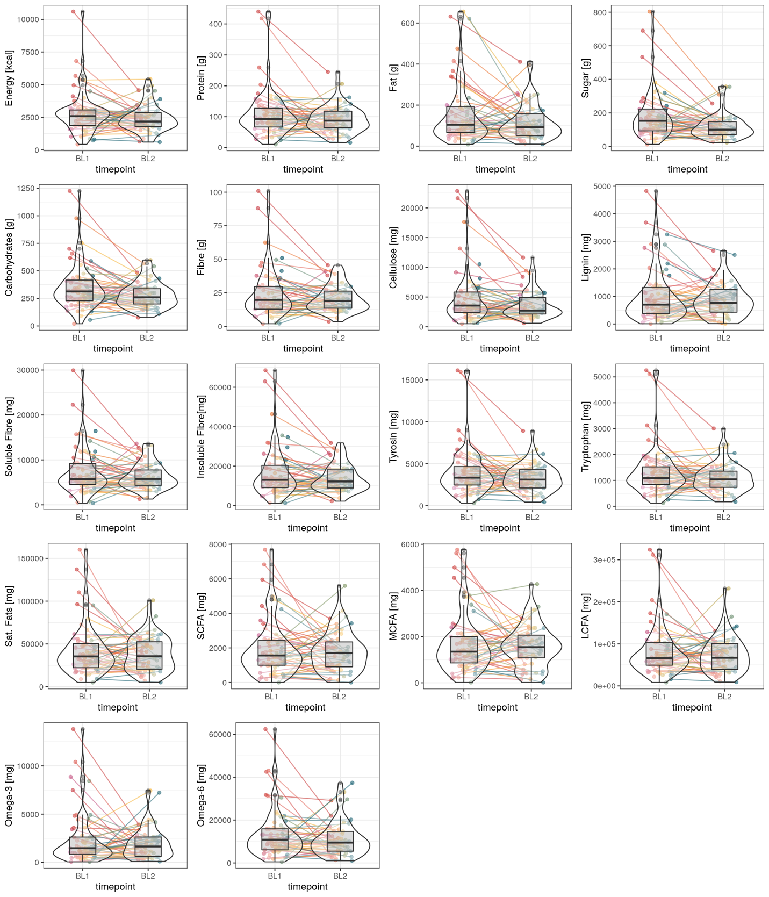
SI Figure 2: Computed nutrient values plotted across two timepoints for FFQ 24 hours. Individual lines are colour-coded by individual.
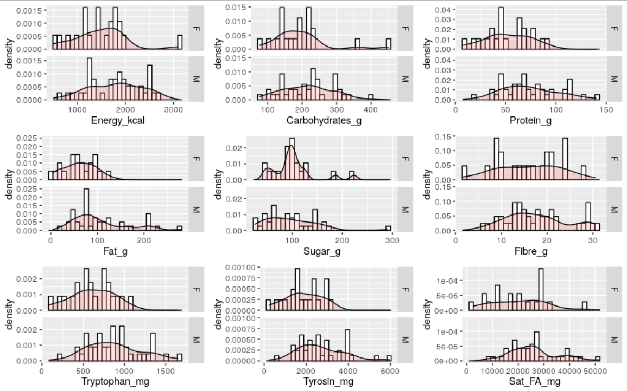
SI Figure 3: Distribution for nutrient levels by sex. BL1 measures only for 60 individuals.

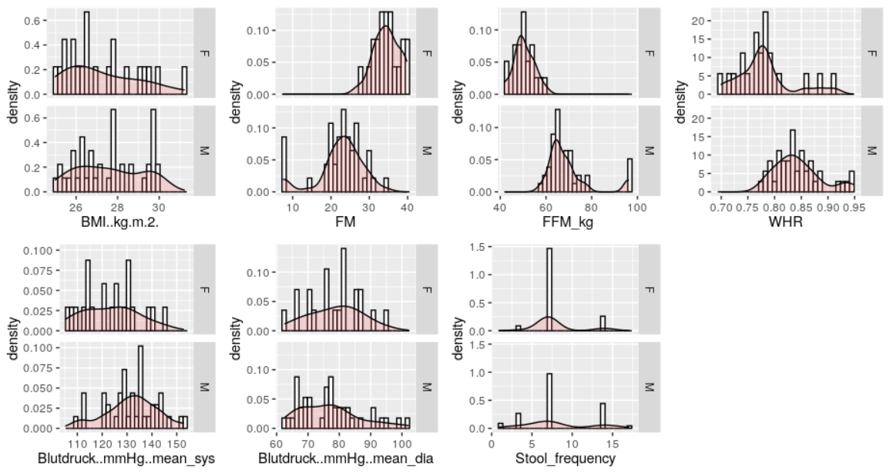
SI Figure 4: Distribution for anthropometric markers by sex (BMI, body fat mass (%), lean body mass (kg), WHR, mean systolic and diastolic blood pressure, stool frequency). BL1 measures only for 60 individuals.

SI Table 1: Anthropometric and serum marker information for a cross-sectional sample of adult men. HFS = High Fat and Sugar Group, LFS = Low Fat and Sugar Group. P-values are indicated for standard 2-sample t.test for numeric variables and for chi-squared tests of independence for categorical variables.
GREADT Sample biomarkers by DFS Group
 | HFS | LFS | P-value
 | (n=35) | (n=41) | P-value
factor(Diet)
OMN | 32 (91.4%) | 27 (65.9%) | 0.0168
VEG | 3 (8.6%) | 14 (34.1%)
Glucose [mmol/l]
Mean (SD) | 5.30 (0.447) | 5.17 (0.449) | 0.199
Median [Min, Max] | 5.26 [4.49, 6.67] | 5.07 [4.22, 6.31]
HbA1c [mmol/mol]
Mean (SD) | 33.5 (2.55) | 32.0 (3.05) | 0.0272
Median [Min, Max] | 33.4 [28.3, 37.9] | 32.2 [22.8, 37.2]
HbA1c [%]
Mean (SD) | 5.21 (0.233) | 5.08 (0.279) | 0.0271
Median [Min, Max] | 5.21 [4.74, 5.62] | 5.10 [4.24, 5.55]
Insulin [pmol/l]
Mean (SD) | 31.1 (17.6) | 31.8 (21.0) | 0.877
Median [Min, Max] | 24.1 [14.1, 78.4] | 26.7 [8.50, 114]
Cholesterol [mmol/l]
Mean (SD) | 4.25 (0.733) | 4.25 (0.755) | 0.964
Median [Min, Max] | 4.27 [2.71, 5.77] | 4.15 [2.95, 6.19]
Triglycerides [mmol/l]
Mean (SD) | 1.05 (0.616) | 1.02 (0.561) | 0.859
Median [Min, Max] | 0.850 [0.430, 3.70] | 0.840 [0.400, 2.91]
HDL [mmol/l]
Mean (SD) | 1.55 (0.312) | 1.47 (0.308) | 0.28
Median [Min, Max] | 1.49 [0.960, 2.72] | 1.43 [0.900, 2.20]
LDL [mmol/l]
Mean (SD) | 2.51 (0.644) | 2.63 (0.662) | 0.419
Median [Min, Max] | 2.49 [1.23, 3.93] | 2.65 [1.43, 4.18]
LDLQUO
Mean (SD) | 0.652 (0.185) | 0.599 (0.218) | 0.259
Median [Min, Max] | 0.650 [0.312, 1.11] | 0.539 [0.307, 1.27]
Leptin [ng/ml]
Mean (SD) | 2.67 (1.63) | 2.63 (2.14) | 0.927
Median [Min, Max] | 2.20 [0.200, 8.20] | 2.30 [0.200, 11.2]
hsCRP [mg/l]
Mean (SD) | 0.908 (1.59) | 0.772 (1.11) | 0.673
Median [Min, Max] | 0.420 [0.150, 8.18] | 0.380 [0.150, 5.24]
IL6 [pg/ml]
Mean (SD) | 3.01 (1.65) | 2.50 (0) | 0.0786
Median [Min, Max] | 2.50 [2.50, 11.3] | 2.50 [2.50, 2.50]
TNF-a [pg/ml]
Mean (SD) | 0.700 (0.220) | 0.672 (0.158) | 0.538
Median [Min, Max] | 0.613 [0.367, 1.45] | 0.662 [0.347, 1.01]
fT3 [pmol/l]
Mean (SD) | 5.59 (0.600) | 5.51 (0.659) | 0.599
Median [Min, Max] | 5.46 [4.46, 6.97] | 5.41 [3.61, 6.97]
fT4 [pmol/l]
Mean (SD) | 16.5 (2.58) | 16.5 (1.94) | 0.902
Median [Min, Max] | 16.3 [12.3, 23.8] | 16.6 [12.4, 21.2]
TSH [mU/l]
Mean (SD) | 1.95 (0.729) | 1.97 (0.700) | 0.885
Median [Min, Max] | 1.81 [0.844, 3.75] | 1.92 [0.939, 3.99]
Tryptophan [umol/l]
Mean (SD) | 35.5 (5.82) | 33.8 (5.40) | 0.218
Median [Min, Max] | 34.4 [26.5, 50.2] | 33.4 [24.6, 46.1]
Tyrosine [umol/l]
Mean (SD) | 55.4 (9.32) | 53.2 (12.7) | 0.375
Median [Min, Max] | 53.8 [40.6, 84.3] | 50.9 [35.3, 97.8]

SI Table 2: Computed nutrient intake for a cross-sectional sample of adult men for FFQ 30 days. OMN = Omnivorous, VEG = Vegetarian. P-values are indicated for standard 2-sample t.test for numeric variables and for chi-squared tests of independence for categorical variables.
DEGS FFQ Monthly Nutrient Intake by Diet Group
 | OMN | VEG | P-value
 | (n=59) | (n=17) | P-value
factor(DFS_Group)
HFS | 32 (54.2%) | 3 (17.6%) | 0.0168
LFS | 27 (45.8%) | 14 (82.4%)
mean daily portion [g]
Mean (SD) | 4390 (1560) | 4560 (1640) | 0.71
Median [Min, Max] | 4320 [1280, 8370] | 4200 [2060, 8290]
Energy [kcal]
Mean (SD) | 2180 (798) | 1780 (673) | 0.0459
Median [Min, Max] | 2140 [697, 4050] | 1820 [666, 3220]
Protein [g]
Mean (SD) | 87.4 (33.8) | 75.5 (46.8) | 0.34
Median [Min, Max] | 85.5 [28.0, 160] | 62.7 [23.0, 213]
Fat [g]
Mean (SD) | 104 (50.0) | 63.5 (30.0) | <0.001
Median [Min, Max] | 97.3 [32.7, 245] | 55.8 [19.2, 139]
Sugar [g]
Mean (SD) | 112 (57.6) | 86.3 (35.6) | 0.0314
Median [Min, Max] | 100 [25.2, 342] | 78.2 [33.1, 153]
Carbohydrates [g]
Mean (SD) | 260 (101) | 220 (93.6) | 0.14
Median [Min, Max] | 245 [79.4, 584] | 227 [46.2, 454]
Fiber [g]
Mean (SD) | 25.9 (11.9) | 29.0 (11.7) | 0.335
Median [Min, Max] | 23.4 [8.69, 62.1] | 26.7 [12.0, 53.8]
Cellulose [mg]
Mean (SD) | 4850 (2650) | 5230 (2440) | 0.588
Median [Min, Max] | 4200 [1010, 13100] | 4780 [1660, 10800]
Lignin [mg]
Mean (SD) | 1260 (801) | 1790 (772) | 0.02
Median [Min, Max] | 1100 [194, 5320] | 1890 [528, 3400]
Soluble Fiber [mg]
Mean (SD) | 7500 (3180) | 7930 (3460) | 0.652
Median [Min, Max] | 7060 [2200, 16400] | 7310 [3110, 15800]
Insoluble Fiber [mg]
Mean (SD) | 18000 (8570) | 20200 (8250) | 0.341
Median [Min, Max] | 16000 [5700, 44700] | 17300 [8040, 36900]
Sat. FA [mg]
Mean (SD) | 35100 (16400) | 26200 (13800) | 0.0332
Median [Min, Max] | 31800 [9620, 87000] | 23600 [4780, 62000]
Tryptophan [mg]
Mean (SD) | 1030 (404) | 891 (587) | 0.368
Median [Min, Max] | 1000 [317, 1990] | 742 [276, 2680]
Tyrosine [mg]
Mean (SD) | 3220 (1310) | 2870 (2080) | 0.519
Median [Min, Max] | 3100 [962, 6060] | 2350 [796, 9100]
SCFA [mg]
Mean (SD) | 1590 (912) | 1400 (1210) | 0.56
Median [Min, Max] | 1420 [47.2, 3810] | 1080 [127, 4990]
MCFA [mg]
Mean (SD) | 1360 (745) | 1080 (844) | 0.231
Median [Min, Max] | 1100 [123, 3470] | 830 [125, 3380]
LCFA [mg]
Mean (SD) | 69700 (31400) | 52400 (23600) | 0.0189
Median [Min, Max] | 63500 [20700, 172000] | 50000 [13000, 101000]
Omega-3 [mg]
Mean (SD) | 4130 (9100) | 1150 (600) | 0.0153
Median [Min, Max] | 1660 [550, 61500] | 1010 [331, 2400]
Omega-6 [mg]
Mean (SD) | 11200 (5350) | 9060 (5520) | 0.16
Median [Min, Max] | 10800 [3330, 28400] | 7530 [2600, 24800]

SI Table 3: Anthropometric and serum marker information for a cross-sectional sample of adult men. OMN = Omnivorous, VEG = Vegetarian. P-values are indicated for standard 2-sample t.test for numeric variables and for chi-squared tests of independence for categorical variables.
Greadt Sample biomarkers by Diet Group
 | OMN | VEG | P-value
 | (n=59) | (n=17) | P-value
factor(DFS Group)
HFS | 32 (54.2%) | 3 (17.6%) | 0.0168
LFS | 27 (45.8%) | 14 (82.4%)
Glucose [mmol/l]
Mean (SD) | 5.26 (0.466) | 5.11 (0.381) | 0.194
Median [Min, Max] | 5.26 [4.22, 6.67] | 5.07 [4.49, 6.10]
HbA1c [mmol/mol]
Mean (SD) | 33.0 (2.72) | 31.6 (3.35) | 0.147
Median [Min, Max] | 33.3 [26.7, 37.9] | 31.7 [22.8, 36.0]
HbA1c [%]
Mean (SD) | 5.17 (0.249) | 5.05 (0.307) | 0.147
Median [Min, Max] | 5.20 [4.59, 5.62] | 5.05 [4.24, 5.44]
Insulin [pmol/l]
Mean (SD) | 32.6 (20.3) | 27.6 (15.6) | 0.282
Median [Min, Max] | 25.7 [8.50, 114] | 23.3 [10.7, 65.3]
Cholesterol [mmol/l]
Mean (SD) | 4.33 (0.770) | 3.97 (0.558) | 0.0402
Median [Min, Max] | 4.31 [2.71, 6.19] | 3.98 [2.95, 5.06]
Triglycerides [mmol/l]
Mean (SD) | 1.05 (0.632) | 0.975 (0.371) | 0.526
Median [Min, Max] | 0.850 [0.400, 3.70] | 0.880 [0.400, 1.90]
HDL [mmol/l]
Mean (SD) | 1.54 (0.309) | 1.40 (0.299) | 0.1
Median [Min, Max] | 1.44 [0.960, 2.72] | 1.43 [0.900, 2.09]
LDL [mmol/l]
Mean (SD) | 2.63 (0.688) | 2.41 (0.490) | 0.161
Median [Min, Max] | 2.67 [1.23, 4.18] | 2.49 [1.60, 3.44]
LDLQUO
Mean (SD) | 0.629 (0.211) | 0.604 (0.182) | 0.63
Median [Min, Max] | 0.621 [0.312, 1.27] | 0.612 [0.307, 1.04]
Leptin [ng/ml]
Mean (SD) | 2.71 (1.91) | 2.44 (1.95) | 0.618
Median [Min, Max] | 2.40 [0.200, 11.2] | 1.60 [0.200, 6.90]
hsCRP [mg/l]
Mean (SD) | 0.812 (1.28) | 0.912 (1.60) | 0.814
Median [Min, Max] | 0.450 [0.150, 8.18] | 0.150 [0.150, 5.24]
IL6 [pg/ml]
Mean (SD) | 2.80 (1.29) | 2.50 (0) | 0.0788
Median [Min, Max] | 2.50 [2.50, 11.3] | 2.50 [2.50, 2.50]
TNF-a [pg/ml]
Mean (SD) | 0.684 (0.205) | 0.689 (0.122) | 0.902
Median [Min, Max] | 0.613 [0.347, 1.45] | 0.711 [0.475, 0.923]
fT3 [pmol/l]
Mean (SD) | 5.53 (0.652) | 5.59 (0.559) | 0.696
Median [Min, Max] | 5.42 [3.61, 6.97] | 5.45 [4.66, 6.97]
fT4 [pmol/l]
Mean (SD) | 16.3 (2.03) | 17.4 (2.73) | 0.119
Median [Min, Max] | 16.3 [12.3, 23.5] | 16.6 [12.4, 23.8]
TSH [mU/l]
Mean (SD) | 2.00 (0.726) | 1.82 (0.644) | 0.316
Median [Min, Max] | 1.95 [0.844, 3.99] | 1.88 [0.939, 3.25]
Tryptophan [umol/l]
Mean (SD) | 35.1 (5.76) | 32.8 (4.82) | 0.102
Median [Min, Max] | 34.3 [24.6, 50.2] | 31.5 [27.7, 43.1]
Tyrosine [umol/l]
Mean (SD) | 54.9 (11.1) | 51.9 (11.9) | 0.365
Median [Min, Max] | 52.5 [36.2, 97.8] | 49.0 [35.3, 79.6]

