Supplementary data
Analysis of SARS-CoV-2 interactions with the Vero cell lines by scanning electron microscopy
Zuzana Malá^{1*}, Marek Vojta¹, Jan Loskot¹, Radek Sleha², Bruno Ježek³, Josef Zelenka⁴
¹Department of Physics, Faculty of Science, University of Hradec Králové, Rokitanského 62, 500 03 Hradec Králové, Czech Republic
²Department of Epidemiology, University of Defence in Brno, Třebešská 1575, 500 05 Hradec Králové, Czech Republic
³Department of Recreology and Tourism, University of Hradec Králové, Rokitanského 62, 500 03 Hradec Králové, Czech Republic
⁴Department of Recreology and Tourism, University of Hradec Králové, Rokitanského 62, 500 03 Hradec Králové, Czech Republic
*Corresponding authors: zuzana.mala@uhk.cz, Department of Physics, Faculty of Science, University of Hradec Králové, Rokitanského 62, 500 03 Hradec Králové, Czech Republic

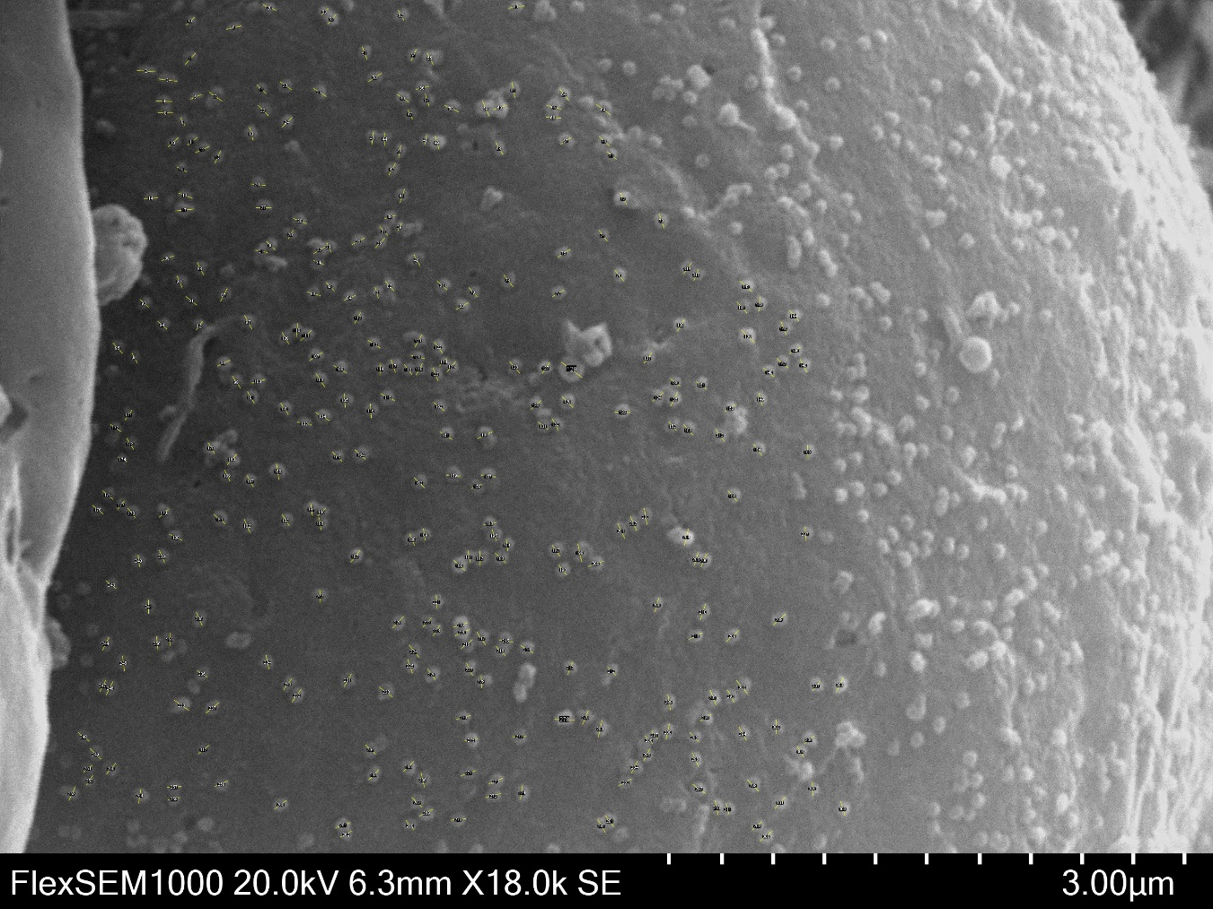
ImageA, accelerating voltage: 20 kV, magnification: 18,000×, pixel dimensions: 2,560×1,802 px, scale: 2.757 nm/px, 315 virions processed

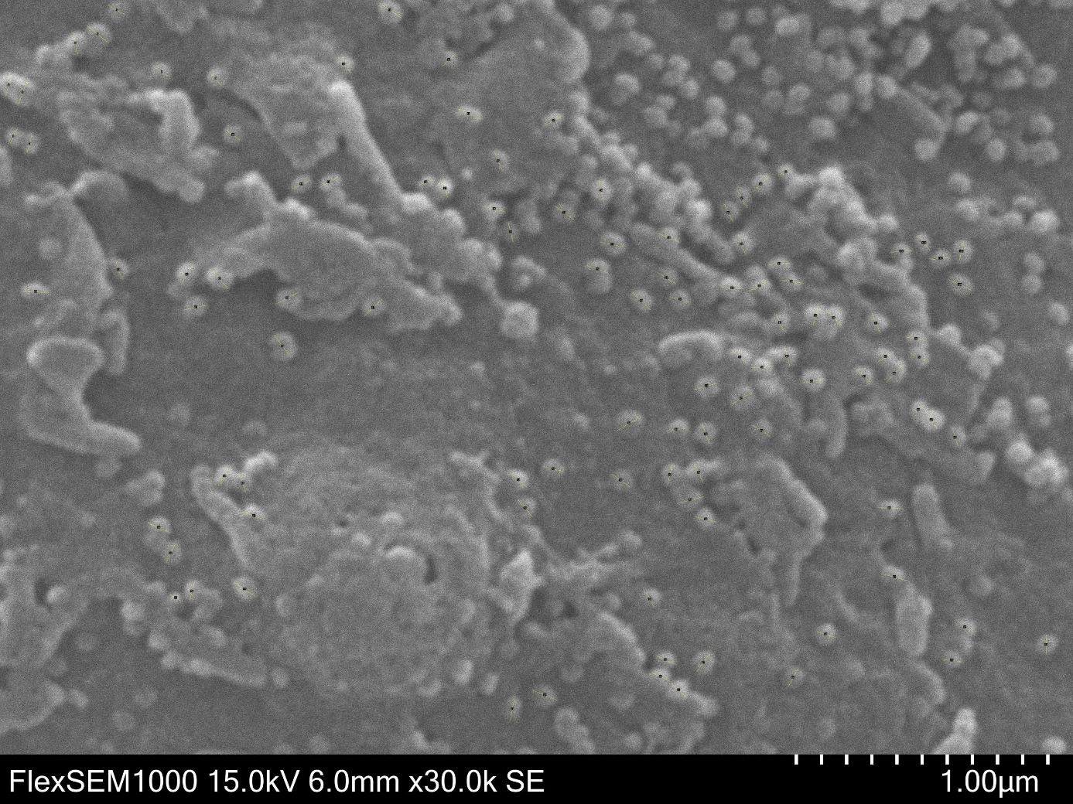
ImageB, accelerating voltage: 15 kV, magnification: 30,000×, pixel dimensions: 5,120×3,604 px, scale: 0.833 nm/px, 104 virions processed
Obrázek 2IMage B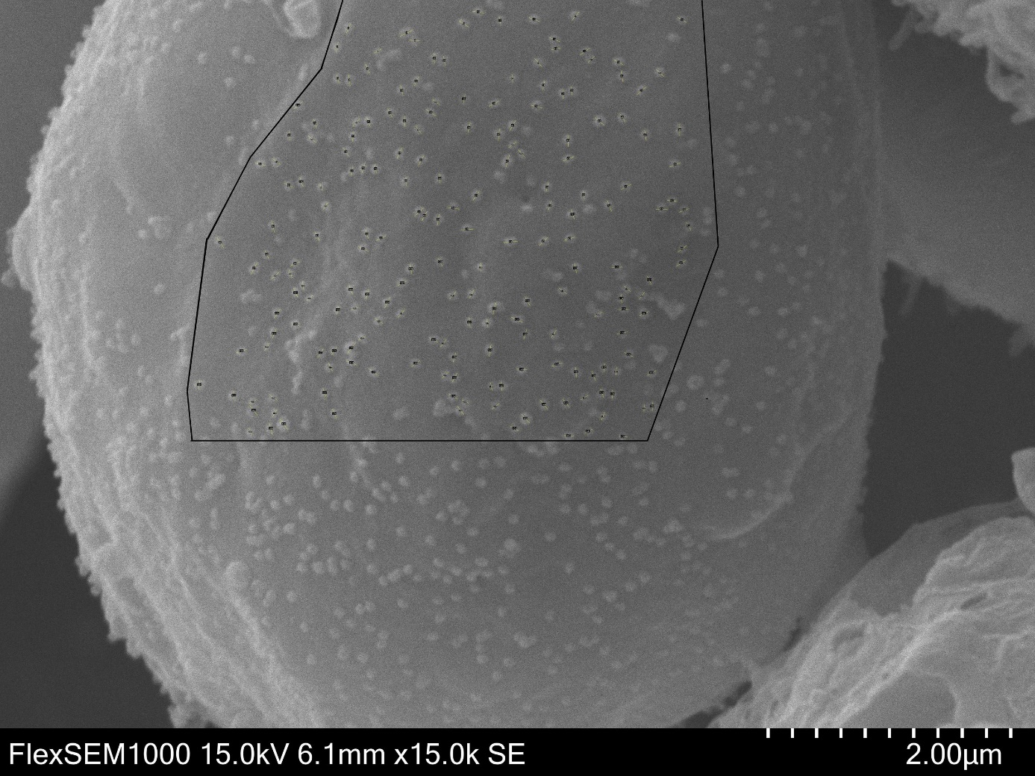
ImageC, accelerating voltage: 15 kV, magnification: 15,000×, pixel dimensions: 5,120×3,604 px, scale: 1.665 nm/px, 196 virions processed

