Supplementary Tables
Table S1. Environmental parameters measured in sediments from each sampling site - Moinho (MOIR1-R3), Navigator (NAVR1-R3) and Tróia (TROIAR1-R3). Granulometric parameters (%) are Gravel, Sand and Fine fraction (FF). The elemental analysis (w%) are organic matter (OM), Total Nitrogen and Carbon (TN and TC), Inorganic Nitrogen and Carbon (IN and IC), and Organic Nitrogen and Carbon (ON and OC). Sal – salinity.

 | MOIR1 | MOIR2 | MOIR3 | NAVR1 | NAVR2 | NAVR3 | TROIAR1 | TROIAR2 | TROIAR3
Gravel | 3.78 | 1.94 | 1.11 | 3.76 | 2.38 | 4.91 | 0.01 | 0.05 | 0.14
Sand | 14.23 | 12.82 | 23.31 | 77.63 | 74.6 | 83.7 | 86.9 | 89.7 | 60.5
FF | 81.99 | 85.24 | 75.58 | 18.61 | 23.01 | 11.38 | 13.09 | 10.17 | 39.37
OM | 11.65 | 11.48 | 10.34 | 2.97 | 2.76 | 5.39 | 7.39 | 6.99 | 6.18
TN | 0.16 | 0.17 | 0.16 | 0.04 | 0.05 | 0.04 | 0.06 | 0.08 | 0.11
TC | 1.47 | 1.39 | 1.52 | 0.67 | 0.75 | 0.56 | 0.65 | 0.89 | 1.12
IN | 0.06 | 0.05 | 0.02 | 0.01 | 0.02 | 0.01 | 0.02 | 0.02 | 0.03
IC | 0.26 | 0.20 | 0.16 | 0.25 | 0.21 | 0.19 | 0.12 | 0.17 | 0.16
OC | 1.22 | 1.2 | 1.35 | 0.42 | 0.54 | 0.38 | 0.53 | 0.71 | 0.95
ON | 0.10 | 0.12 | 0.14 | 0.03 | 0.03 | 0.02 | 0.04 | 0.05 | 0.08
Sal | 29.7 | 29.47 | 30.24 | 34.7 | 34.4 | 35 | 36.5 | 34.8 | 34.5

Table S2. Alpha diversity descriptors (Observed OTUs, Chao1, Shannon, Simpson and Pielou’s Evenness) calculated for each sampling site (MOIR1-R3; NAVR1-R3; TROIAR1-R3).

 | Observed | Chao1 | Shannon | Simpson | Pielou's Evenness
MOIR1 | 375 | 375 | 7.91 | 0.996 | 0.93
MOIR2 | 500 | 500 | 8.25 | 0.996 | 0.93
MOIR3 | 485 | 485 | 8.22 | 0.996 | 0.92
NAVR1 | 448 | 448 | 8 | 0.995 | 0.91
NAVR2 | 575 | 575 | 8.56 | 0.996 | 0.93
NAVR3 | 473 | 473 | 8.27 | 0.995 | 0.93
TROIAR1 | 501 | 501 | 8.3 | 0.995 | 0.92
TROIAR2 | 521 | 521 | 8.46 | 0.996 | 0.94
TROIAR3 | 344 | 344 | 7.8 | 0.993 | 0.93

Table S3. Kruskal-Wallis test: Alpha diversity significance between groups, for each site (Moinho, Navigator, Tróia), p<0.05.

 |  | H | p-value | q-value
All goups |  | 0.8 | 0.670
Group 1 | Group 2
Moinho (n=3) | Navigator (n=3) | 1.190 | 0.275 | 0.825
Troia (n=3) | Moinho (n=3) | 0.827 | 0.827
Navigator (n=3) | Troia (n=3) | 0.047 | 0.827 | 0.827

Table S4: One- way PERMANOVA test with "Sites" (3 level fixed) for all variables analysed. Bold values represent significant differences between sites (NAV, MOI, TROIA), (p≤0.05).

Source of variation | Degree of freedom | Sum squares | Mean square | Pseudo-F | P(perm) | Unique perms | P(MC)
Nematode total density
Site | 2 | 4742.9 | 2371.5 | 2.8302 | 0.012 | 273 | 0.015
Residual total | 6 | 5027.4 | 837.9
Total | 8 | 9770.3
Number of genera
Site | 2 | 1583 | 791.51 | 4.8494 | 0.055 | 172 | 0.053
Residual total | 6 | 979.31 | 163.22
Total | 8 | 2562.3
Shannon-Wiener index
Site | 2 | 164.96 | 82.482 | 2.9409 | 0.115 | 273 | 0.113
Residual total | 6 | 168.28 | 28.046
Total | 8 | 333.24
Margalef index
Site | 2 | 1235.9 | 617.93 | 6.0071 | 0.046 | 275 | 0.038
Residual total | 6 | 617.21 | 102.87
Total | 8 | 1853.1
Trophic composition
Site | 2 | 2927.7 | 1463.8 | 7.1508 | 0.0029 | 280 | 0.0064
Residual total | 6 | 1228.3 | 204.71
Total | 8 | 4156
ITD -1
Site | 2 | 261.08 | 130.54 | 1.7498 | 0.246 | 276 | 0.249
Residual total | 6 | 447.6 | 74.601
Total | 8 | 708.68
MI
Site | 2 | 47.797 | 23.899 | 3.8445 | 0.064 | 271 | 0.085
Residual total | 6 | 37.297 | 6.2162
Total | 8 | 85.094

Table S5. Diversity descriptors of nematode assemblages from each sampling site (MOIR1-R3, NAVR1-R3, TROIAR1-R3).
Samples | S | d | H'(log.) | ITD⁻¹ | MI
MOIR1 | 9 | 0.8624 | 1.207 | 2.3 | 2.4
MOIR2 | 13 | 1.228 | 1.708 | 2.2 | 2.2
MOIR3 | 12 | 1.17 | 1.223 | 1.7 | 2.1
NAVR1 | 14 | 1.509 | 1.361 | 2 | 2.7
NAVR2 | 18 | 2.321 | 2.182 | 3 | 2.4
NAVR3 | 21 | 2.861 | 2.299 | 2.7 | 2.3
TROIAR1 | 16 | 1.751 | 1.875 | 2.7 | 2.3
TROIAR2 | 12 | 1.35 | 1.588 | 2.7 | 2.2
TROIAR3 | 11 | 1.258 | 1.458 | 2.1 | 2.3
(S) genera, (d) Margalef, (H) Shannon (logo based); (ITD⁻¹) reciprocal Index Trophic Diversity and (MI) Maturity Index.

Supplemental Figures
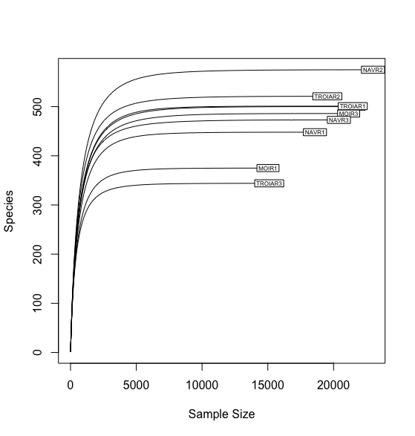

Figure S1. Rarefaction curve of reads clustered in OTUs each sampling site Moinho (MOIR1-R3), Navigator (NAVR1-R3) and Tróia (TROIAR1-R3).
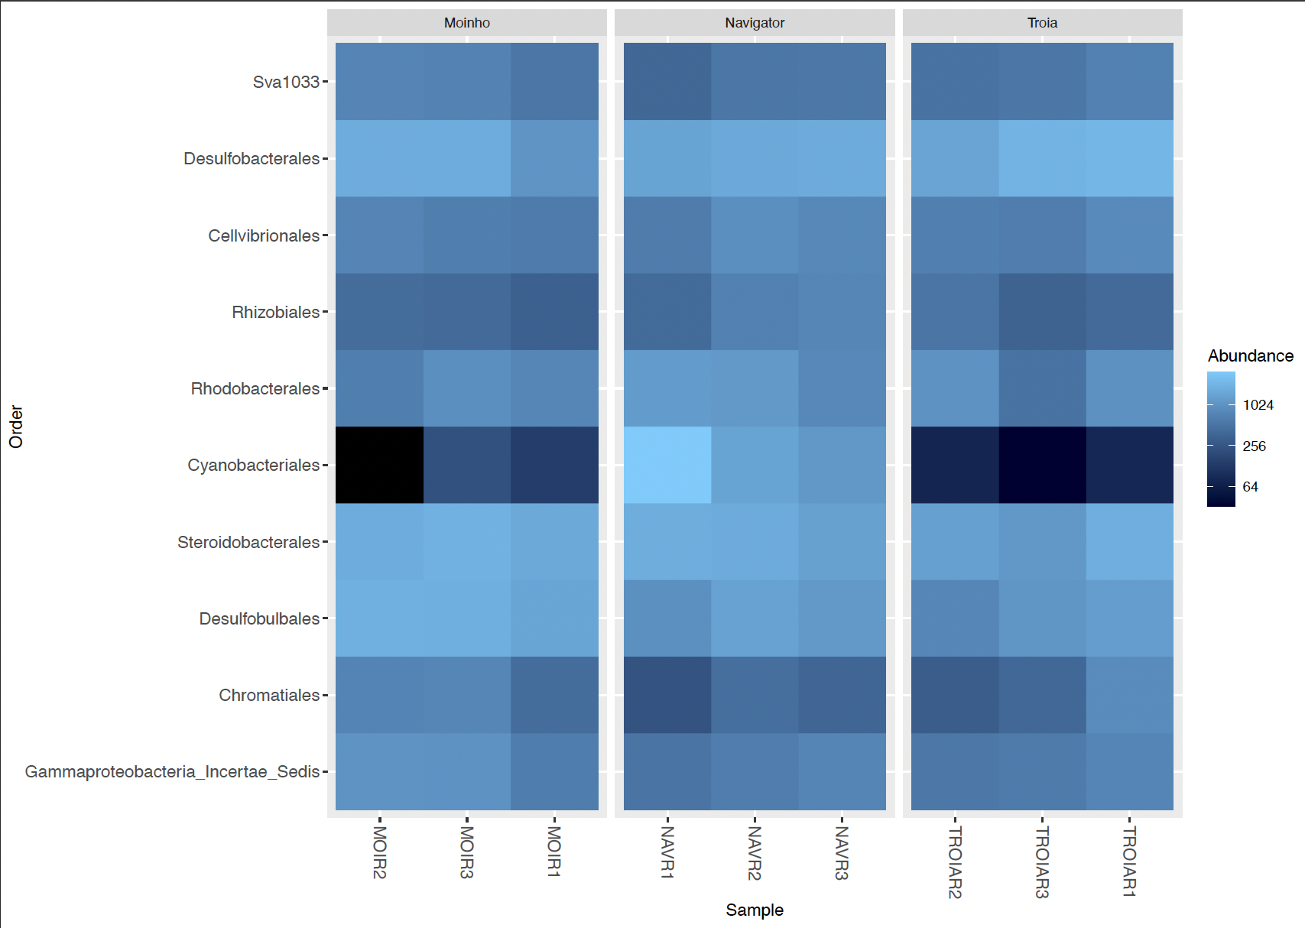
Figure S2. Heatmap of the relative abundance of the top 10 orders represented in the microbial communities of each site Moinho (MOIR1-R3); Navigator (NAVR1-R3) and Tróia (TROIAR1-R3).
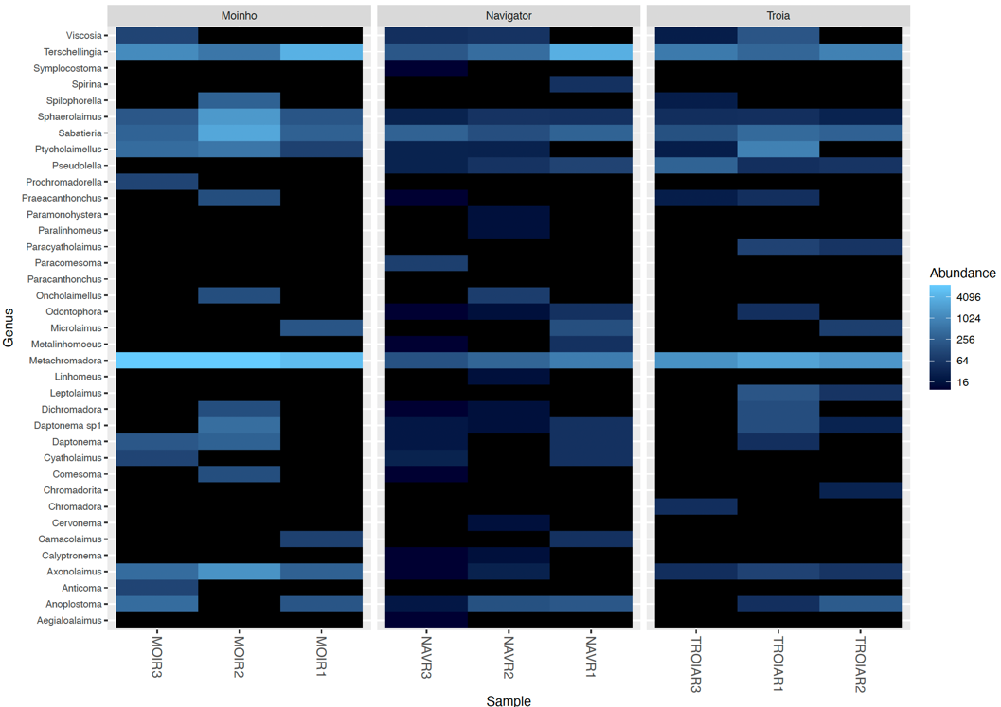
Figure S3. Heatmap showing the density at Genus-level of nematode communities in each site Moinho (MOIR1-R3); Navigator (NAVR1-R3) and Tróia (TROIAR1-R3).

