Table 1. List of plant secondary metabolites and Binding energies
S.NO: | Compound | Chemical Structure | Binding affinity
1 | Quercetin | 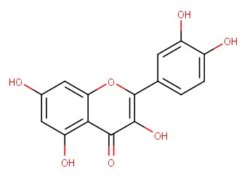 | -6.9
2 | Myricetin | 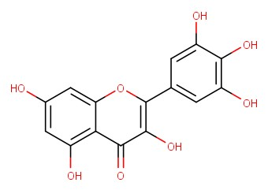 | -6.5
3 | Epigallocatechin | 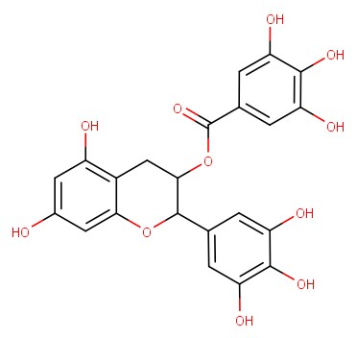 | -6.5
4 | Eupalitin | 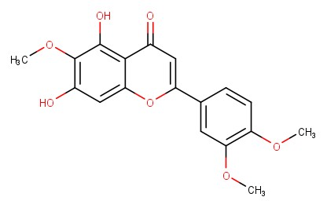 | -6.4
5 | Laurifolin | 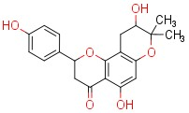 | -6.4
6 | Naringenin | 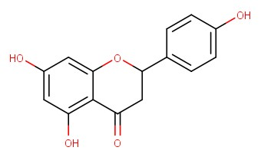 | -6.2
7 | Aromadendrin | 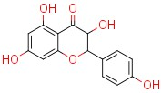 | -6.0
8 | Arjunone | 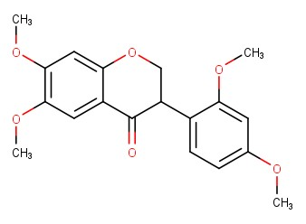 | -6.0
9 | Andrographolide | 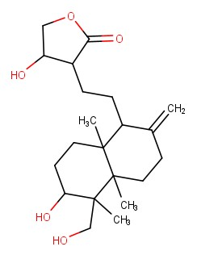 | -5.9
10 | Boeravinone G | 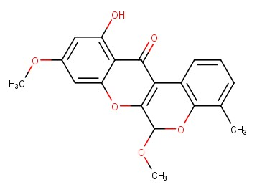 | -5.8
11 | Curcumin | 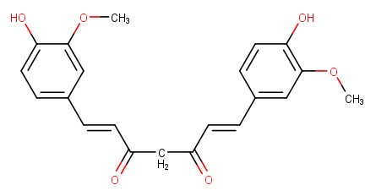 | -5.8
12 | Tartaric acid  (co-crystal) | 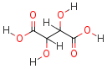 | -4.7

Table 2. List of designed scaffolds and Binding energies.
S.NO: | Compound | Chemical Structure | Binding affinity
1 | Quercetin hydrazide | 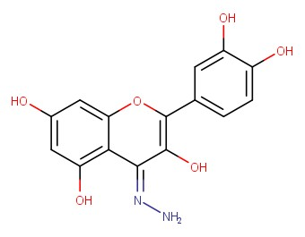 | -6.7
2 | Quercetin imine | 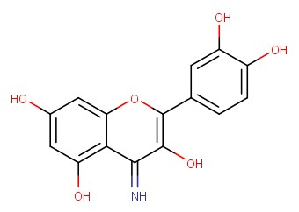 | -6.5
3 | Quercetin oxime | 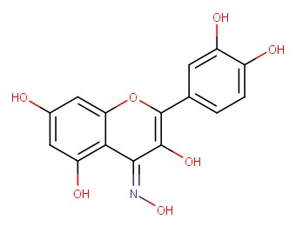 | -5.6

Table 3. Synthesized metal complexes
S. No | Compound | Synthesized metal complex
1 | QM1 | 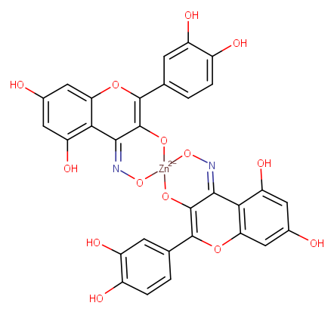
2 | QM2 | 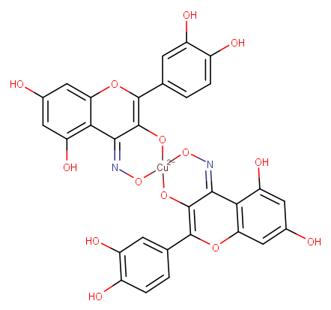
3 | QM3 | 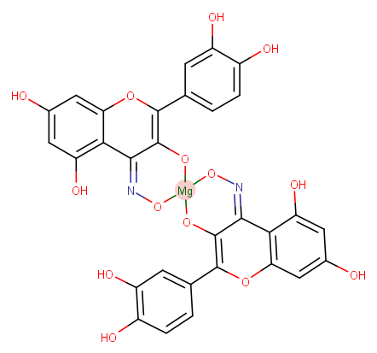
4 | QM4 | 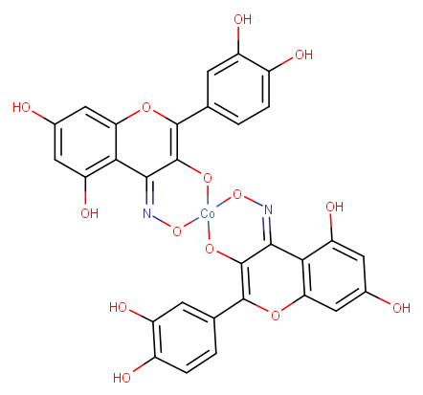
5 | QM5 | 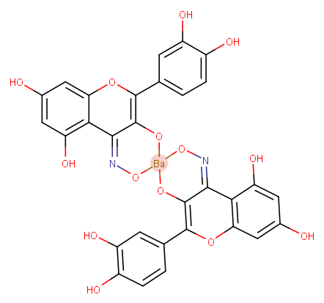
6 | QM6 | 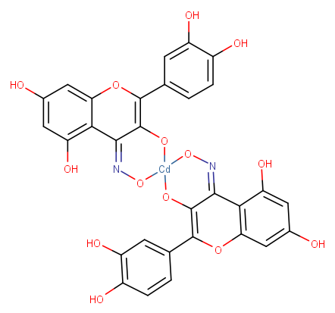
7 | QM7 | 