Supplementary Figure 1: Absolute concentration (µg/m³) and concentration ratio (HFO/DF) of compounds identified during online gas phase analysis in HFO and DF exposure aerosols.
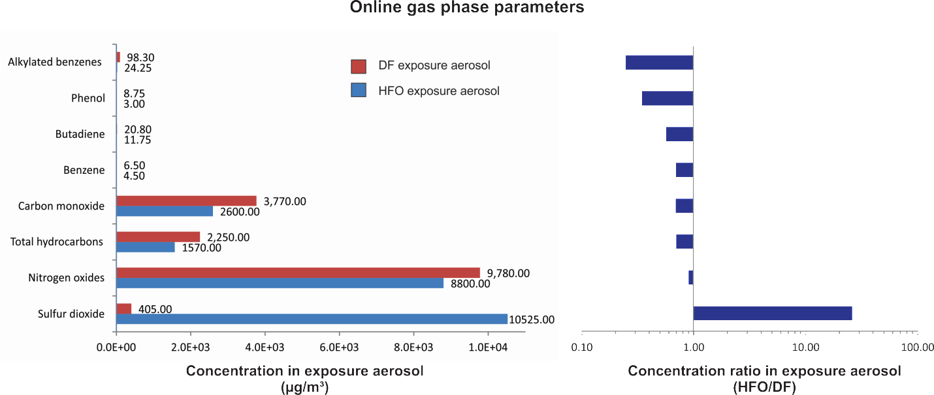

Supplementary Figure 2: Absolute concentration (µg/m³) and concentration ratio (HFO/DF) of various compound classes and summed values in HFO and DF exposure aerosols.
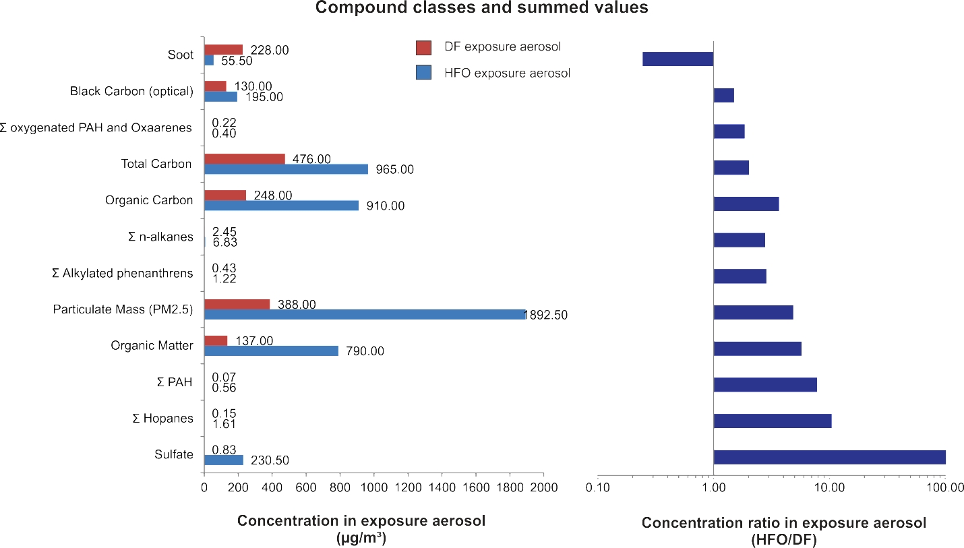

Supplementary Figure 3: Absolute concentration (µg/m³) and concentration ratio (HFO/DF) of various polycyclic aromatic hydrocarbons (PAH) in HFO and DF exposure aerosols.
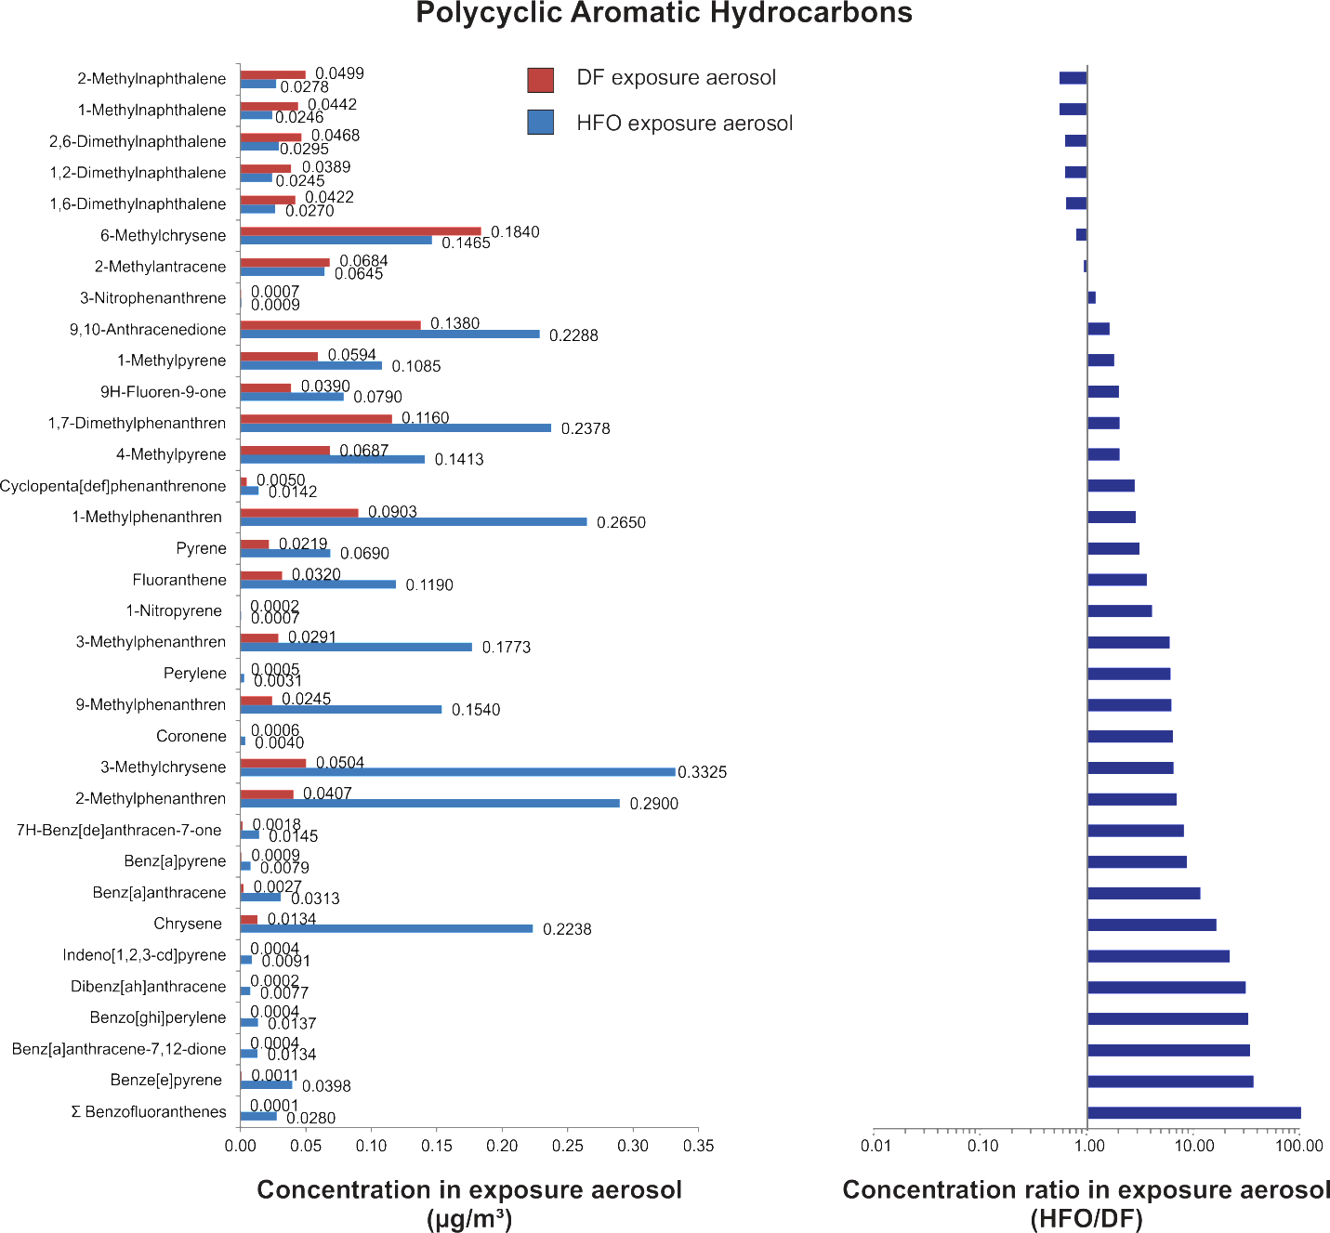

Supplementary Figure 4: Absolute concentration (µg/m³) and concentration ratio (HFO/DF) of Alkanes and Hopanes (PAH) in HFO and DF exposure aerosols.
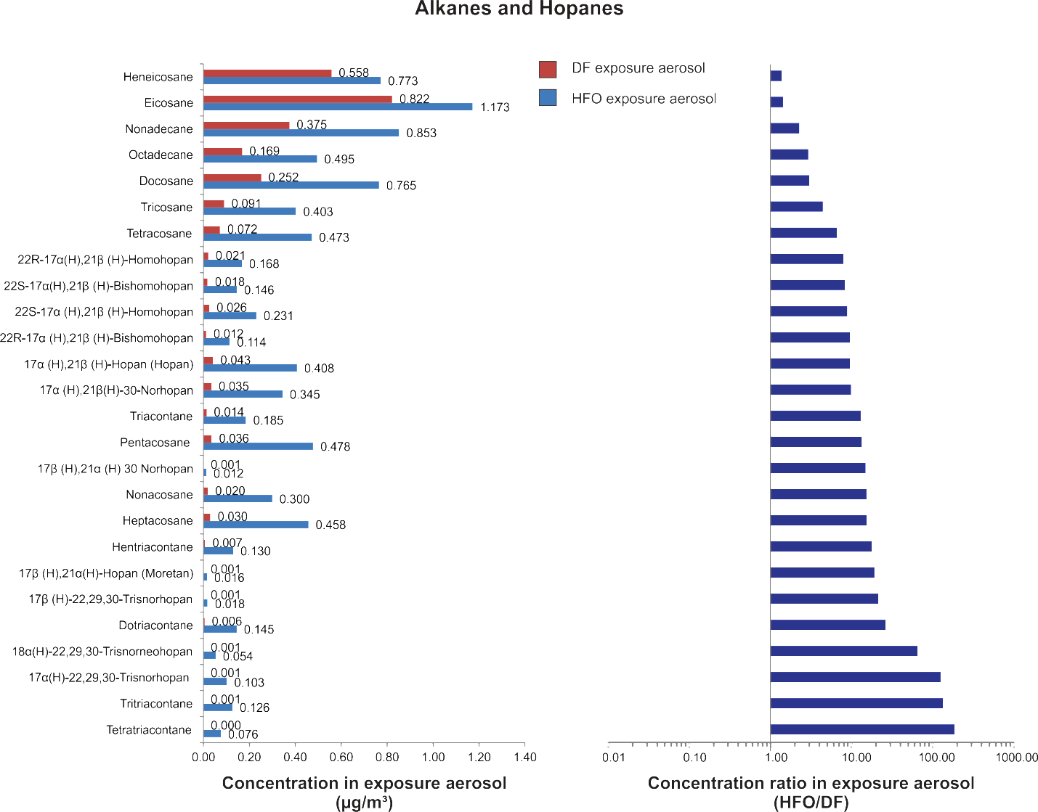

Supplementary Figure 5: Absolute concentration (µg/m³) and concentration ratio (HFO/DF) of Carbonyl compounds in HFO and DF exposure aerosols.
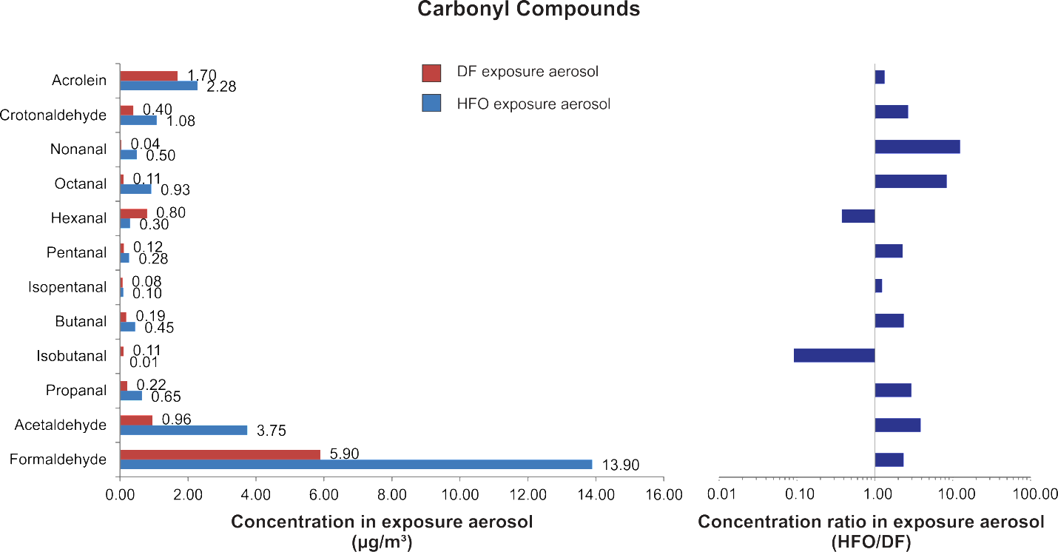

Supplementary Figure 6: Absolute concentration (µg/m³) and concentration ratio (HFO/DF) of various elements in HFO and DF exposure aerosols.
