Supplementary INFORMATION
Supplementary Figure 1 The therapeutic effect of GA was investigated using a mouse model of AD. Sixteen 23-months-old female transgenic APP/PS1 mice (GA, n = 9 and controls, n = 7) were used for this study. a. The implanted mini-osmotic pump (ALZET, model 1004) plus ALZET Brain Infusion Kit 3 were examined by necropsy. b. Retrieved mini-osmotic pumps were opened by removing the outer membrane to check if all reagents were delivered.
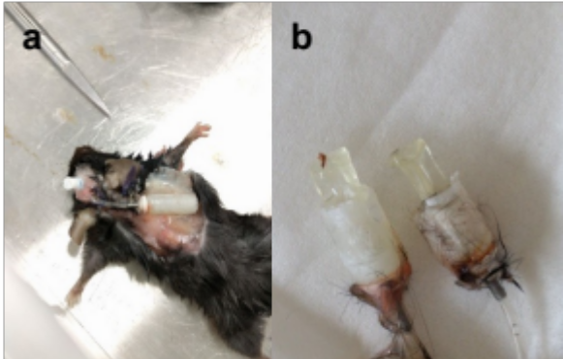

Supplementary Figure 2 Quality controls for mouse behavioural studies. Quality controls for behavioural studies. a. Total distance moved was used as a quality control for mice underwent open field test. There was no difference found between GA and controls. b. In social stage 1 (habituation), a normal mouse spends equal time in left or right chamber. There was no side preference found for either group. Results are presented as group means with standard error of the mean (SEM).
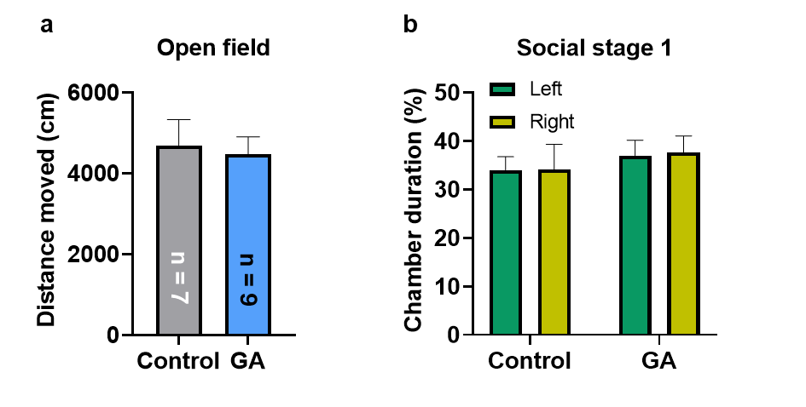

Supplementary Figure 3 Methods to quantify and analyze immunohistochemical staining. We examined sagittal sections of mouse brains using immunohistochemical staining for Aβ plaques and microglial cells. We analyzed Aβ IHC with whole mount view (4X) by dissecting the brain section into hippocampal area (a) and cortical area (c). Aβ plaque structures were then isolated and analyzed in b and d. We also analyzed microglial IHC sections (20X) by extracting numerical parameters of branched structure of microglia.
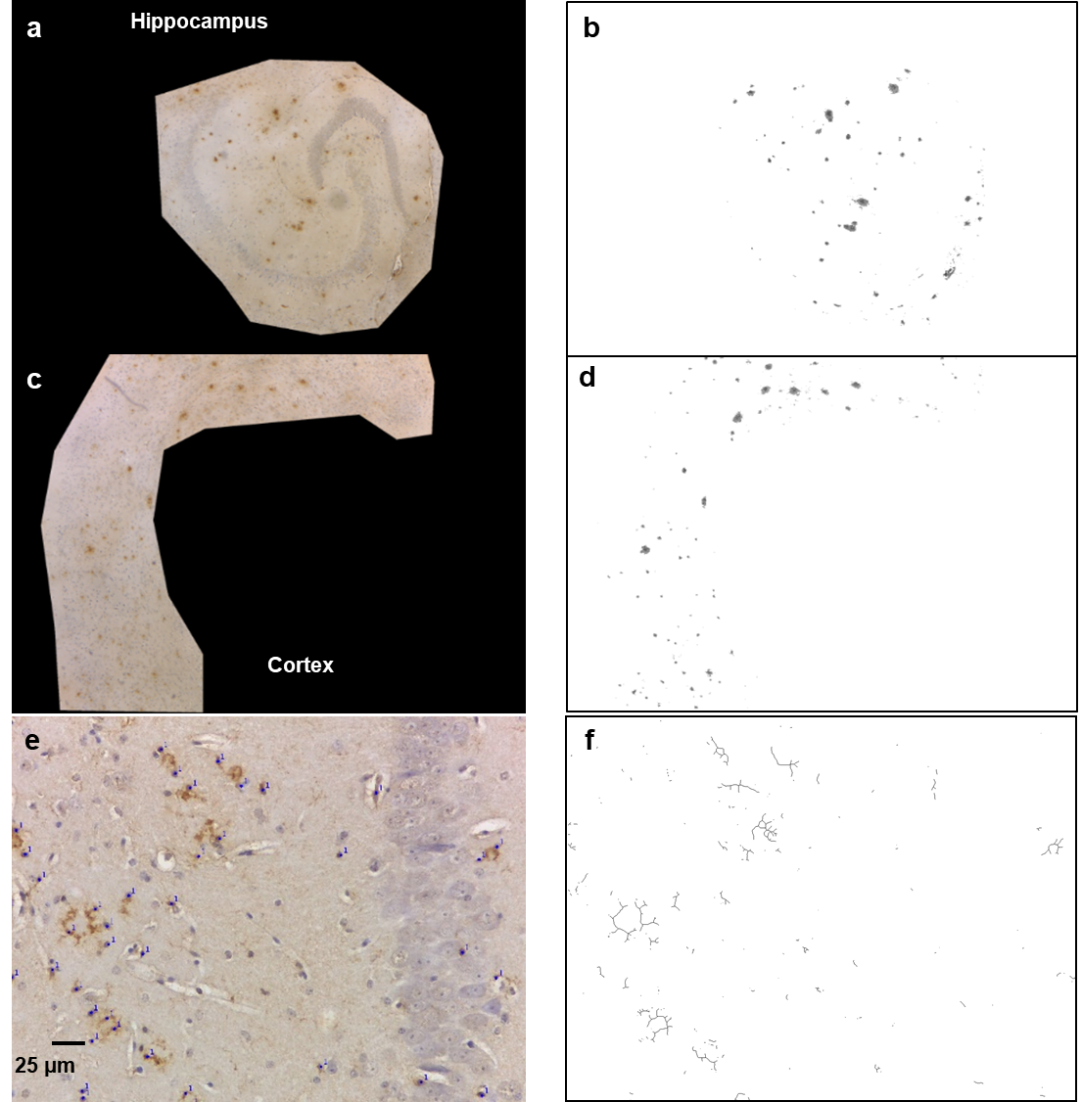

Supplementary Figure 4 Etching ring shape Aβ plaques in GA treated mouse brain slices. After GA treatment, microglia tightly associated with Aβ plaques. Some plaques showed a clear center of circle (arrows). In contrast with GA treated mouse brains, Aβ plaques within the control mouse brains had lower level of microglia infiltration and less profound in center-etching (arrow). Mouse brain slices were immunohistochemically stained with anti-Aβ mAb (clone 1E8). Magnification X40.
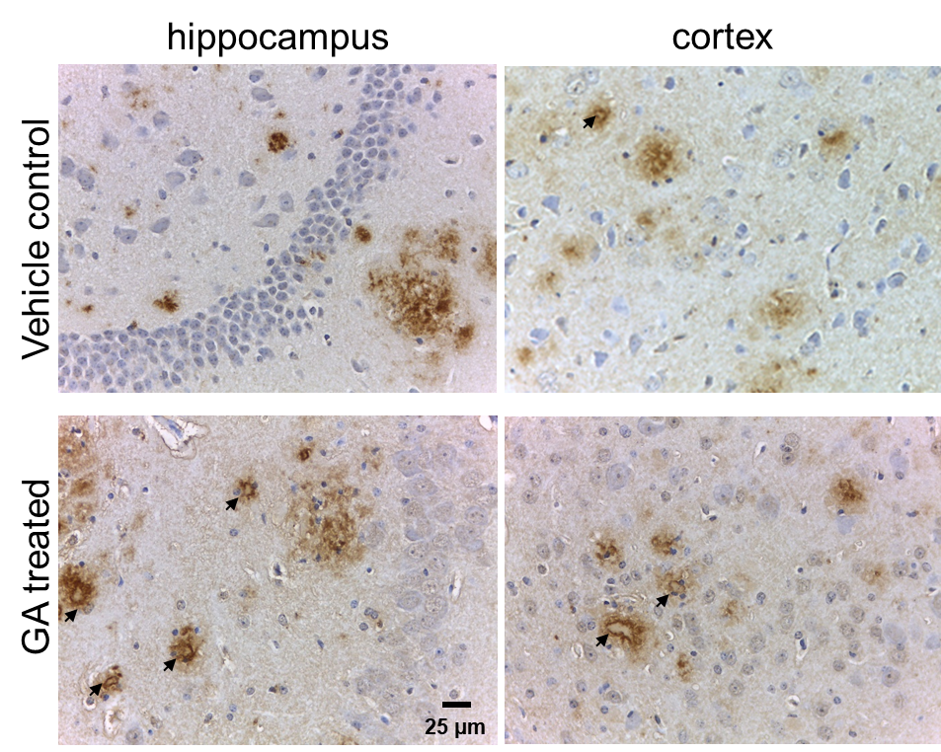

Supplementary Figure 5 Preliminary pharmacokinetic experiment of glatiramer acetate (GA). Alexa488 (A&B) or Alexa647 (c&d) labelled glatiramer acetate (GA, 10 mg) was injected directly into the cerebral ventricle, and cerebrospinal fluid (a&c), anticoagulant blood and urine (b&d) were collected in the following 3-4 days. GA concentration in the samples was determined by comparing the detected fluorescent intensity against the respective standard curve.
