Supplementary Methods

Processing of RNA-seq. Sequencing reads were aligned to the human reference genome (GRCh38 primary_assembly) with gene annotation from GENCODE (version 27) by STAR software (1). The number of reads assigned to a gene was counted by using FeatureCounts (2) considering strand specificity. t-SNE was performed using the R package Rtsne (3), with TPM (transcripts per million reads) values. Statistical tests for differential expression between tumor and matched normal tissues were done by using DESeq2 (4) with a regression model that has patient information as a covariate.

RNA editing call. We developed a computational pipeline to call RNA editing sites from strand-specific RNA-seq. First, the following reads were filtered to reduce potential technical errors in identification of RNA editing sites: (i) reads were suspected as PCR duplication by Picard markduplicates, (ii) reads had more than 10 nucleotides composing homopolymers, where a homopolyer was defined as 4 or more contiguous same nucleotides, (iii) reads had any insertion or deletion, (iv) reads had more than or equal to 5 nucleotides that were clipped by aligner. Second, mismatches relative to the reference genome were identified in the uniquely-mapped reads. Third, for every genomic site that has any mismatch whose sequencing quality is greater than 20 (phred score), the sequencing reads were counted separately for the reference sequence or mismatches. Fourth, filter sites if mismatches were found closer to either 5’ or 3’ sequencing ends (<=5 nucleotides) in more than half number of reads with mismatches. Also, if there were multiple alternative alleles, keep the sites only when there is a major alternative allele such that the major has at least 5 sequencing reads and more than two times of sequencing reads than any other alternative alleles. Finally, if a site has more than or equal to 3 sequencing reads for an alternative allele and does not overlap with SNP, it was called as a potential RNA editing site whose type is determined by considering strand information.

Bioinformatic analyses. Gene annotation was based on NCBI RefSeq Gene. Repeat annotation was according to UCSC RMSK track. Gene ontology (GO) analysis was performed by using R package, GOstats (5) for the genes whose mean TPM values were greater than 1 in either tumor or normal tissues per a pathology. The terms whose FDR-adjusted p-value is less than 0.1 were called as over-represented terms.

1. A. Dobin, et al., STAR: ultrafast universal RNA-seq aligner. Bioinformatics 29, 15–21 (2013).
2. Y. Liao, G. K. Smyth, W. Shi, featureCounts: an efficient general purpose program for assigning sequence reads to genomic features. Bioinformatics 30, 923–930 (2014).
3. L. van der Maaten, G. Hinton, Visualizing Data using t-SNE. J. Mach. Learn. Res. 9, 2579–2605 (2008).
4. M. I. Love, W. Huber, S. Anders, Moderated estimation of fold change and dispersion for RNA-seq data with DESeq2. Genome Biol. 15, 550 (2014).
5. S. Falcon, R. Gentleman, Using GOstats to test gene lists for GO term association. Bioinforma. Oxf. Engl. 23, 257–258 (2007).

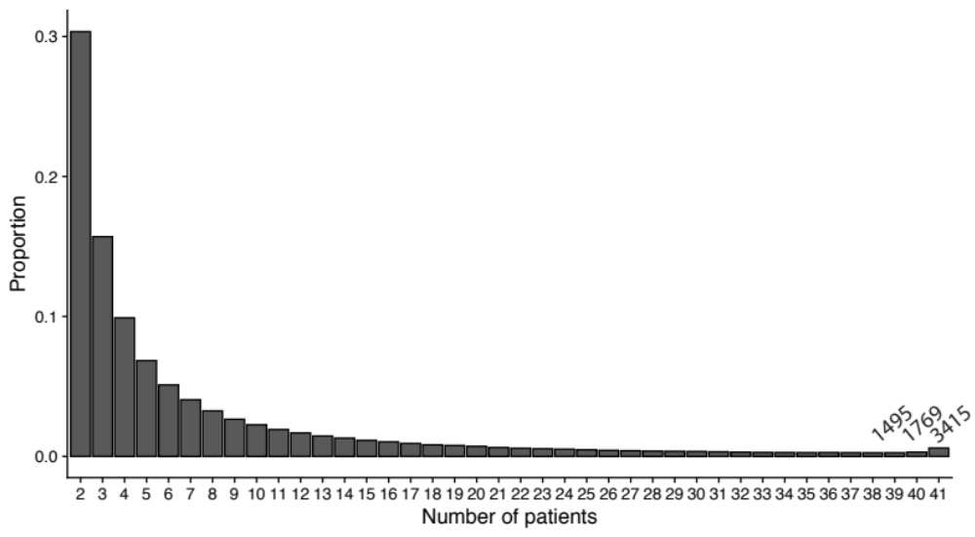

Supplementary Figure 1. The proportions of A-to-I editing sites that were shared by patients. Proportion (y-axis) is the number of A-to-I editing sites observed by the specified number of patients (x-axis) divided by the total number of A-to-I editing sites (571,774). The numbers of A-to-I editing sites found by 39, 40 and 41 numbers of patients were labelled for detailed information.

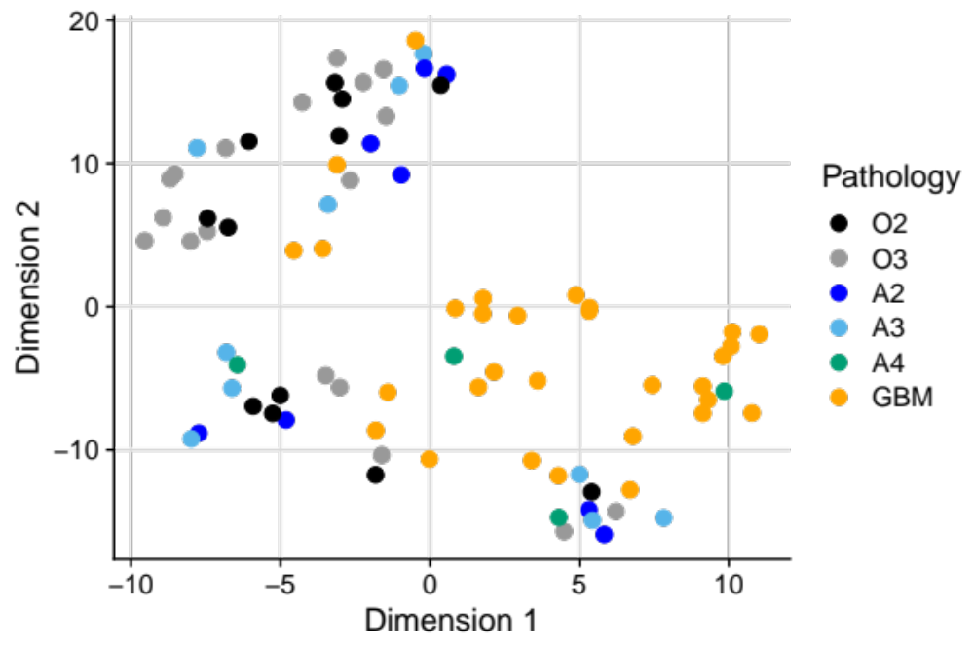

Supplementary Figure 2. Clustering analysis of samples. t-SNE were performed with gene expression levels to check clustering of the samples in the current dataset. Glioblastoma (GBM) and grade 2 oligodendroglioma (O2) are located at distinct regions of the plot, which is a representative example of heterogeneities of brain tumors according to pathologies.

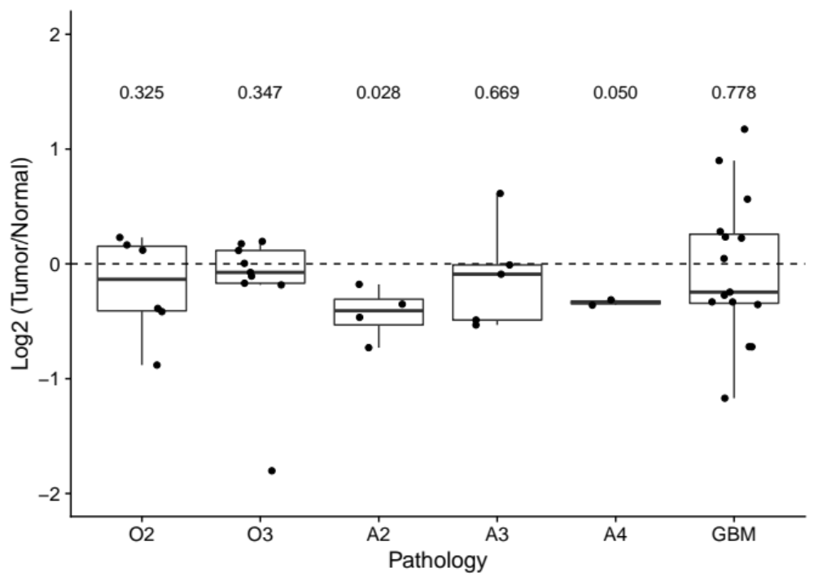

Supplementary Figure 3. Fold change of RNA polymerase III gene (POLR3A). Fold changes (Tumor/Normal) of TPM (transcripts per million) in log2 scale were plotted. A dot is a single patient. P-values of comparing tumor and matched normal tissues by the linear regression controlling patient-specific effects were indicated at top.

Supplementary table 1. Table of the samples in the current dataset. Tissue is an indicator of either normal tissue or tumor tissue of a sample, Pathology is an acronym of diagnosis: grade 2 oligodendroglioma IDH mutant and 1p/19q-codeleted (O2), grade 3 oligodendroglioma IDH mutant and 1p/19q-codeleted (O3), grade 2 IDH mutant astrocytoma (A2), grade 3 IDH mutant astrocytoma (A3), grade 4 IDH mutant astrocytoma (A4), and glioblastoma (GBM). TotalNum is the total number of sequencing reads.

Patient ID | Tissue | Sample ID | Pathology | TotalNum
Case_1 | Normal | N35 | O2 | 50313037
Case_1 | Tumor | T35 | O2 | 94090964
Case_2 | Normal | N37 | O2 | 90531827
Case_2 | Tumor | T37 | O2 | 76628565
Case_3 | Normal | N38 | O2 | 50590460
Case_3 | Tumor | T38 | O2 | 64829220
Case_44 | Normal | N54 | O2 | 62044812
Case_44 | Tumor | T54 | O2 | 54938487
Case_45 | Normal | N55-2 | O2 | 60034724
Case_45 | Tumor | T55 | O2 | 61563871
Case_46 | Normal | N48-1 | O2 | 62895363
Case_46 | Tumor | T56 | O2 | 62420477
Case_35 | Normal | N43-1 | O3 | 60582037
Case_35 | Tumor | T43-1 | O3 | 63068587
Case_36 | Normal | N44 | O3 | 59085907
Case_36 | Tumor | T44 | O3 | 53676699
Case_37 | Normal | N45-2 | O3 | 62174446
Case_37 | Tumor | T45 | O3 | 62150861
Case_38 | Normal | N46-2 | O3 | 62130572
Case_38 | Tumor | T46 | O3 | 62763517
Case_39 | Normal | N47-2 | O3 | 65538920
Case_39 | Tumor | T47 | O3 | 62946268
Case_4 | Normal | N31 | O3 | 98035122
Case_4 | Tumor | T31 | O3 | 81794210
Case_41 | Normal | N49 | O3 | 62444495
Case_41 | Tumor | T49 | O3 | 60964164
Case_5 | Normal | N32 | O3 | 94141757
Case_5 | Tumor | T32 | O3 | 86403961
Case_6 | Normal | N33 | O3 | 52257079
Case_6 | Tumor | T33 | O3 | 68905794
Case_42 | Normal | N51-1 | A2 | 63867364
Case_42 | Tumor | T51 | A2 | 72218243
Case_43 | Normal | N52 | A2 | 64875912
Case_43 | Tumor | T52 | A2 | 62947903
Case_7 | Normal | N1 | A2 | 50969978
Case_7 | Tumor | T1 | A2 | 78539368
Case_8 | Normal | N2 | A2 | 62777288
Case_8 | Tumor | T2 | A2 | 54624154
Case_11 | Normal | N7 | A3 | 59067885
Case_11 | Tumor | T7 | A3 | 56972487
Case_13 | Normal | N8 | A3 | 51155356
Case_13 | Tumor | T8 | A3 | 57100211
Case_19 | Normal | N17 | A3 | 60538741
Case_19 | Tumor | T17 | A3 | 73814874
Case_31 | Normal | N39 | A3 | 61264620
Case_31 | Tumor | T39 | A3 | 62880242
Case_33 | Normal | N41 | A3 | 60107576
Case_33 | Tumor | T41 | A3 | 56105186
Case_26 | Normal | N26 | A4 | 54138088
Case_26 | Tumor | T26 | A4 | 61944670
Case_27 | Normal | N27 | A4 | 57152911
Case_27 | Tumor | T27 | A4 | 61199405
Case_10 | Normal | N6 | GBM | 64771502
Case_10 | Tumor | T6 | GBM | 67438698
Case_17 | Normal | N12 | GBM | 62066884
Case_17 | Tumor | T12 | GBM | 50837787
Case_18 | Normal | N13 | GBM | 62002377
Case_18 | Tumor | T13 | GBM | 56367364
Case_20 | Normal | N18 | GBM | 88276825
Case_20 | Tumor | T18 | GBM | 58559093
Case_21 | Normal | N19 | GBM | 73101680
Case_21 | Tumor | T19 | GBM | 51738071
Case_22 | Normal | N20 | GBM | 64839051
Case_22 | Tumor | T20 | GBM | 56363802
Case_23 | Normal | N22 | GBM | 53564250
Case_23 | Tumor | T22 | GBM | 84523167
Case_24 | Normal | N24 | GBM | 65677054
Case_24 | Tumor | T24 | GBM | 69636477
Case_25 | Normal | N25 | GBM | 61976660
Case_25 | Tumor | T25 | GBM | 71737747
Case_28 | Normal | N14 | GBM | 52334098
Case_28 | Tumor | T14 | GBM | 74045443
Case_29 | Normal | N16 | GBM | 84490686
Case_29 | Tumor | T16 | GBM | 56338203
Case_30 | Normal | N21 | GBM | 51827007
Case_30 | Tumor | T21 | GBM | 58218272
Case_32 | Normal | N40 | GBM | 58642093
Case_32 | Tumor | T40 | GBM | 51066242
Case_34 | Normal | N42-1 | GBM | 64671576
Case_34 | Tumor | T42 | GBM | 60589929
Case_9 | Normal | N4 | GBM | 66208530
Case_9 | Tumor | T4 | GBM | 56983635

Supplementary table 2. The perturbed A-to-I editing sites that are shared by two pathologies of glioma. Comparison is the list of two pathologies in comparison, Pos is the genomic coordinate (hg38) of A-to-I editing site, exonic indicates whether the site is found in exons (1: found, 0: not), alu represents whether the site is found in Alu element (1: found, 0: not).

Comparison | Pos | Exonic | Alu
O2,O3 | chr4:157336727 | 1 | 0
O2,O3 | chr6:42888301 | 1 | 1
O2,O3 | chr6:42889240 | 1 | 1
O2,O3 | chr12:68843267 | 1 | 0
O2,O3 | chr13:102269626 | 0 | 1
O2,O3 | chr15:24982731 | 1 | 1
O2,A3 | chr1:155883460 | 1 | 1
O2,A3 | chr1:160142551 | 1 | 1
O2,A3 | chr4:157336727 | 1 | 0
O2,A3 | chr6:52995696 | 1 | 0
O2,A3 | chr12:68843241 | 1 | 0
O2,A3 | chr15:24983232 | 1 | 1
O2,A3 | chr17:19188061 | 1 | 0
O2,A3 | chr19:23359502 | 1 | 1
O2,GBM | chr19:23359502 | 1 | 1
O2,GBM | chr20:5195158 | 1 | 0
O3,A2 | chr1:52825748 | 1 | 1
O3,A2 | chr2:77265622 | 0 | 0
O3,A2 | chr2:77434940 | 0 | 0
O3,A2 | chr3:62438132 | 1 | 0
O3,A2 | chr3:85259683 | 0 | 0
O3,A2 | chr4:157336985 | 0 | 0
O3,A2 | chr4:157336986 | 0 | 0
O3,A2 | chr4:157360142 | 1 | 0
O3,A2 | chr5:157309800 | 1 | 0
O3,A2 | chr6:42888313 | 1 | 1
O3,A2 | chr8:10451928 | 0 | 0
O3,A2 | chr10:78037967 | 1 | 0
O3,A2 | chr10:78037971 | 1 | 0
O3,A2 | chr11:105933968 | 1 | 0
O3,A2 | chr13:110900008 | 0 | 1
O3,A2 | chr15:24982676 | 1 | 1
O3,A2 | chr15:24983281 | 1 | 1
O3,A2 | chr15:24983613 | 1 | 1
O3,A2 | chr20:8527472 | 0 | 0
O3,A2 | chrX:24077208 | 1 | 1
O3,A2 | chrX:74225196 | 0 | 1
O3,A3 | chr1:52825748 | 1 | 1
O3,A3 | chr2:8722799 | 1 | 1
O3,A3 | chr2:37100515 | 0 | 0
O3,A3 | chr2:61529066 | 0 | 1
O3,A3 | chr2:77434940 | 0 | 0
O3,A3 | chr2:77435760 | 0 | 0
O3,A3 | chr2:99195873 | 1 | 1
O3,A3 | chr3:62438132 | 1 | 0
O3,A3 | chr3:85259683 | 0 | 0
O3,A3 | chr3:116271372 | 0 | 0
O3,A3 | chr3:192705460 | 0 | 0
O3,A3 | chr4:76943076 | 0 | 1
O3,A3 | chr4:157336727 | 1 | 0
O3,A3 | chr4:157336985 | 0 | 0
O3,A3 | chr4:157336986 | 0 | 0
O3,A3 | chr4:157360142 | 1 | 0
O3,A3 | chr5:147769764 | 0 | 0
O3,A3 | chr5:157309800 | 1 | 0
O3,A3 | chr6:28977737 | 0 | 0
O3,A3 | chr6:42888241 | 1 | 1
O3,A3 | chr6:42888313 | 1 | 1
O3,A3 | chr6:42888432 | 1 | 1
O3,A3 | chr6:101889827 | 1 | 0
O3,A3 | chr6:101924714 | 1 | 0
O3,A3 | chr6:101924755 | 0 | 0
O3,A3 | chr6:101926741 | 0 | 0
O3,A3 | chr6:101926759 | 0 | 0
O3,A3 | chr6:101926768 | 0 | 0
O3,A3 | chr6:159679850 | 1 | 1
O3,A3 | chr7:38724686 | 1 | 1
O3,A3 | chr7:38724705 | 1 | 1
O3,A3 | chr7:88169181 | 0 | 0
O3,A3 | chr7:102637153 | 1 | 1
O3,A3 | chr7:146132069 | 0 | 0
O3,A3 | chr7:146151354 | 0 | 0
O3,A3 | chr8:10451928 | 0 | 0
O3,A3 | chr8:81700705 | 0 | 1
O3,A3 | chr10:78037967 | 1 | 0
O3,A3 | chr10:78037971 | 1 | 0
O3,A3 | chr11:105933968 | 1 | 0
O3,A3 | chr12:50930661 | 1 | 1
O3,A3 | chr12:50930713 | 1 | 1
O3,A3 | chr12:50930843 | 1 | 1
O3,A3 | chr12:51511641 | 1 | 1
O3,A3 | chr12:57585977 | 1 | 0
O3,A3 | chr12:68843244 | 1 | 0
O3,A3 | chr13:32538620 | 1 | 0
O3,A3 | chr13:102134996 | 0 | 1
O3,A3 | chr13:107577198 | 0 | 0
O3,A3 | chr13:107838535 | 0 | 0
O3,A3 | chr13:110900008 | 0 | 1
O3,A3 | chr14:50992510 | 0 | 1
O3,A3 | chr14:50995138 | 0 | 1
O3,A3 | chr15:24982664 | 1 | 1
O3,A3 | chr15:24982702 | 1 | 1
O3,A3 | chr15:24983281 | 1 | 1
O3,A3 | chr15:24983613 | 1 | 1
O3,A3 | chr15:24983668 | 1 | 1
O3,A3 | chr17:19188056 | 1 | 0
O3,A3 | chr20:8527472 | 0 | 0
O3,A3 | chr20:17962784 | 1 | 0
O3,A3 | chr22:24573787 | 1 | 1
O3,A3 | chr22:25725099 | 1 | 1
O3,A3 | chr22:25725118 | 1 | 1
O3,A3 | chrX:24077208 | 1 | 1
O3,A3 | chrX:74225196 | 0 | 1
O3,A3 | chrX:123465111 | 1 | 0
O3,A3 | chrX:152189847 | 1 | 0
O3,A3 | chr22:25725008 | 1 | 1
O3,GBM | chr1:45609992 | 0 | 1
O3,GBM | chr1:52825748 | 1 | 1
O3,GBM | chr1:160142726 | 1 | 1
O3,GBM | chr2:77435783 | 0 | 0
O3,GBM | chr2:99195873 | 1 | 1
O3,GBM | chr2:216502242 | 0 | 1
O3,GBM | chr3:15072894 | 1 | 1
O3,GBM | chr3:45680425 | 1 | 1
O3,GBM | chr3:62438132 | 1 | 0
O3,GBM | chr3:192705460 | 0 | 0
O3,GBM | chr4:157336985 | 0 | 0
O3,GBM | chr4:157360142 | 1 | 0
O3,GBM | chr5:65668353 | 1 | 1
O3,GBM | chr5:80627474 | 1 | 1
O3,GBM | chr5:147769764 | 0 | 0
O3,GBM | chr5:157309800 | 1 | 0
O3,GBM | chr6:42888224 | 1 | 1
O3,GBM | chr6:42888241 | 1 | 1
O3,GBM | chr6:101924714 | 1 | 0
O3,GBM | chr6:101926741 | 0 | 0
O3,GBM | chr6:159680691 | 1 | 1
O3,GBM | chr7:38724686 | 1 | 1
O3,GBM | chr7:44832777 | 0 | 1
O3,GBM | chr7:44832881 | 0 | 1
O3,GBM | chr8:10451928 | 0 | 0
O3,GBM | chr8:47977073 | 1 | 1
O3,GBM | chr8:56069384 | 0 | 1
O3,GBM | chr9:89012071 | 1 | 0
O3,GBM | chr10:78037967 | 1 | 0
O3,GBM | chr10:78037971 | 1 | 0
O3,GBM | chr11:68093217 | 0 | 1
O3,GBM | chr11:93735605 | 0 | 1
O3,GBM | chr11:105933968 | 1 | 0
O3,GBM | chr12:49764502 | 1 | 0
O3,GBM | chr12:51511663 | 1 | 1
O3,GBM | chr12:62518163 | 0 | 0
O3,GBM | chr12:64448989 | 1 | 1
O3,GBM | chr13:107577198 | 0 | 0
O3,GBM | chr15:24982664 | 1 | 1
O3,GBM | chr15:24982702 | 1 | 1
O3,GBM | chr15:24983278 | 1 | 1
O3,GBM | chr15:24983613 | 1 | 1
O3,GBM | chr15:24983677 | 1 | 1
O3,GBM | chr15:41298663 | 1 | 1
O3,GBM | chr15:41302238 | 1 | 1
O3,GBM | chr15:41305287 | 1 | 1
O3,GBM | chr17:31535190 | 1 | 1
O3,GBM | chr17:50964425 | 1 | 1
O3,GBM | chr20:17962784 | 1 | 0
O3,GBM | chr22:24573787 | 1 | 1
O3,GBM | chr22:24574654 | 1 | 1
O3,GBM | chrX:46604581 | 1 | 1
O3,GBM | chrX:77828120 | 1 | 1
O3,GBM | chrX:115938215 | 0 | 1
O3,GBM | chrX:123465111 | 1 | 0
O3,GBM | chrX:152189847 | 1 | 0
A2,A3 | chr1:52825748 | 1 | 1
A2,A3 | chr2:77354006 | 0 | 0
A2,A3 | chr2:77354011 | 0 | 0
A2,A3 | chr2:77434940 | 0 | 0
A2,A3 | chr3:62438132 | 1 | 0
A2,A3 | chr3:85259683 | 0 | 0
A2,A3 | chr4:157336723 | 1 | 0
A2,A3 | chr4:157336783 | 0 | 0
A2,A3 | chr4:157336984 | 0 | 0
A2,A3 | chr4:157336985 | 0 | 0
A2,A3 | chr4:157336986 | 0 | 0
A2,A3 | chr4:157360142 | 1 | 0
A2,A3 | chr5:157309800 | 1 | 0
A2,A3 | chr6:42888313 | 1 | 1
A2,A3 | chr7:38724732 | 1 | 1
A2,A3 | chr8:10451928 | 0 | 0
A2,A3 | chr10:78037967 | 1 | 0
A2,A3 | chr10:78037971 | 1 | 0
A2,A3 | chr11:105933968 | 1 | 0
A2,A3 | chr12:62518152 | 0 | 0
A2,A3 | chr13:102135095 | 0 | 1
A2,A3 | chr13:107791921 | 0 | 1
A2,A3 | chr13:110900008 | 0 | 1
A2,A3 | chr15:24982719 | 1 | 1
A2,A3 | chr15:24983216 | 1 | 1
A2,A3 | chr15:24983281 | 1 | 1
A2,A3 | chr15:24983545 | 1 | 1
A2,A3 | chr15:24983613 | 1 | 1
A2,A3 | chr20:8527472 | 0 | 0
A2,A3 | chrX:24077208 | 1 | 1
A2,A3 | chrX:74192066 | 0 | 0
A2,A3 | chrX:74225196 | 0 | 1
A2,A3 | chrX:74275046 | 0 | 0
A2,GBM | chr1:52825748 | 1 | 1
A2,GBM | chr2:77354011 | 0 | 0
A2,GBM | chr2:95825438 | 1 | 0
A2,GBM | chr2:231047420 | 1 | 0
A2,GBM | chr3:62438132 | 1 | 0
A2,GBM | chr4:157336783 | 0 | 0
A2,GBM | chr4:157336985 | 0 | 0
A2,GBM | chr4:157360142 | 1 | 0
A2,GBM | chr5:157309800 | 1 | 0
A2,GBM | chr8:10451928 | 0 | 0
A2,GBM | chr10:78037967 | 1 | 0
A2,GBM | chr10:78037971 | 1 | 0
A2,GBM | chr11:105933968 | 1 | 0
A2,GBM | chr12:62518152 | 0 | 0
A2,GBM | chr13:107791921 | 0 | 1
A2,GBM | chr15:24983613 | 1 | 1
A2,GBM | chr17:67338610 | 1 | 1
A3,GBM | chr1:8614653 | 1 | 0
A3,GBM | chr1:52825748 | 1 | 1
A3,GBM | chr2:77354011 | 0 | 0
A3,GBM | chr2:99195873 | 1 | 1
A3,GBM | chr3:62438132 | 1 | 0
A3,GBM | chr3:117538290 | 0 | 0
A3,GBM | chr3:192705460 | 0 | 0
A3,GBM | chr4:21464714 | 1 | 0
A3,GBM | chr4:21761194 | 0 | 1
A3,GBM | chr4:128037472 | 1 | 1
A3,GBM | chr4:157336783 | 0 | 0
A3,GBM | chr4:157336985 | 0 | 0
A3,GBM | chr4:157360142 | 1 | 0
A3,GBM | chr5:147769764 | 0 | 0
A3,GBM | chr5:157309800 | 1 | 0
A3,GBM | chr6:42888241 | 1 | 1
A3,GBM | chr6:101889814 | 1 | 0
A3,GBM | chr6:101924714 | 1 | 0
A3,GBM | chr6:101926697 | 0 | 0
A3,GBM | chr6:101926741 | 0 | 0
A3,GBM | chr7:38724686 | 1 | 1
A3,GBM | chr7:44832684 | 0 | 1
A3,GBM | chr8:10451928 | 0 | 0
A3,GBM | chr10:78037967 | 1 | 0
A3,GBM | chr10:78037971 | 1 | 0
A3,GBM | chr10:82535080 | 0 | 1
A3,GBM | chr11:105933968 | 1 | 0
A3,GBM | chr12:62518152 | 0 | 0
A3,GBM | chr12:76079384 | 0 | 1
A3,GBM | chr13:45516236 | 1 | 0
A3,GBM | chr13:107577198 | 0 | 0
A3,GBM | chr13:107791921 | 0 | 1
A3,GBM | chr13:107791924 | 0 | 1
A3,GBM | chr14:50993497 | 0 | 1
A3,GBM | chr14:50994203 | 0 | 1
A3,GBM | chr15:24970442 | 0 | 1
A3,GBM | chr15:24970505 | 0 | 1
A3,GBM | chr15:24982664 | 1 | 1
A3,GBM | chr15:24982702 | 1 | 1
A3,GBM | chr15:24983613 | 1 | 1
A3,GBM | chr15:25028165 | 0 | 1
A3,GBM | chr17:57972468 | 1 | 0
A3,GBM | chr19:23359502 | 1 | 1
A3,GBM | chr20:17962784 | 1 | 0
A3,GBM | chr22:24573787 | 1 | 1
A3,GBM | chrX:74275058 | 0 | 0
A3,GBM | chrX:74276556 | 0 | 1
A3,GBM | chrX:123465111 | 1 | 0
A3,GBM | chrX:152189847 | 1 | 0

Supplementary table 3. Result of gene ontology analysis for the genes with the perturbed A-to-I editing in gliomas.

Pathology | GOBPID | Term | Pvalue
O3 | GO:0035249 | synaptic transmission, glutamatergic | 7.85E-05
O3 | GO:0099541 | trans-synaptic signaling by lipid | 0.0001105
O3 | GO:0099542 | trans-synaptic signaling by endocannabinoid | 0.0001105
O3 | GO:0051641 | cellular localization | 0.0001391
O3 | GO:0035235 | ionotropic glutamate receptor signaling pathway | 0.00015903
O3 | GO:0007215 | glutamate receptor signaling pathway | 0.0001641
O3 | GO:0098917 | retrograde trans-synaptic signaling | 0.00016419
O3 | GO:0050890 | cognition | 0.0003167
O3 | GO:0045921 | positive regulation of exocytosis | 0.00045281
O3 | GO:0051179 | localization | 0.00051995
O3 | GO:0017157 | regulation of exocytosis | 0.00055935
O3 | GO:0007158 | neuron cell-cell adhesion | 0.00067867
A2 | GO:0006810 | transport | 0.00011097
A2 | GO:0051234 | establishment of localization | 0.00016147
A2 | GO:0051179 | localization | 0.00049029
A2 | GO:0055085 | transmembrane transport | 0.00049954
A2 | GO:0007268 | chemical synaptic transmission | 0.00056386
A2 | GO:0098916 | anterograde trans-synaptic signaling | 0.00056386
A2 | GO:1904062 | regulation of cation transmembrane transport | 0.00057256
A2 | GO:0051649 | establishment of localization in cell | 0.00058625
A2 | GO:0099537 | trans-synaptic signaling | 0.00061224
A2 | GO:0099536 | synaptic signaling | 0.00065066
A2 | GO:0051641 | cellular localization | 0.00068014
A2 | GO:0034762 | regulation of transmembrane transport | 0.00070722
A2 | GO:0098655 | cation transmembrane transport | 0.00087275
A2 | GO:0006812 | cation transport | 0.00102764
A2 | GO:0035235 | ionotropic glutamate receptor signaling pathway | 0.00144546
A2 | GO:0007215 | glutamate receptor signaling pathway | 0.00168349
A2 | GO:1903421 | regulation of synaptic vesicle recycling | 0.00172148
A2 | GO:0043269 | regulation of ion transport | 0.00185452
A2 | GO:0032412 | regulation of ion transmembrane transporter activity | 0.00185851
A2 | GO:0031338 | regulation of vesicle fusion | 0.00186816
A2 | GO:0022898 | regulation of transmembrane transporter activity | 0.00206386
A2 | GO:0034765 | regulation of ion transmembrane transport | 0.00229564
A2 | GO:0051049 | regulation of transport | 0.00242421
A2 | GO:0032409 | regulation of transporter activity | 0.00252091
A2 | GO:0097553 | calcium ion transmembrane import into cytosol | 0.00252357
A2 | GO:0050804 | modulation of chemical synaptic transmission | 0.00267147
A2 | GO:0099177 | regulation of trans-synaptic signaling | 0.00270213
A2 | GO:0072657 | protein localization to membrane | 0.00279865
A2 | GO:0070588 | calcium ion transmembrane transport | 0.00309016
A2 | GO:0060402 | calcium ion transport into cytosol | 0.00333782
A2 | GO:2000310 | regulation of NMDA receptor activity | 0.00344315
A2 | GO:0060401 | cytosolic calcium ion transport | 0.00439144
A2 | GO:0034220 | ion transmembrane transport | 0.00545273
A2 | GO:0032879 | regulation of localization | 0.00572044
A2 | GO:2001257 | regulation of cation channel activity | 0.00585085
A3 | GO:0042391 | regulation of membrane potential | 1.15E-05
A3 | GO:0007268 | chemical synaptic transmission | 2.46E-05
A3 | GO:0098916 | anterograde trans-synaptic signaling | 2.46E-05
A3 | GO:0007215 | glutamate receptor signaling pathway | 2.78E-05
A3 | GO:0099537 | trans-synaptic signaling | 3.01E-05
A3 | GO:0099536 | synaptic signaling | 3.49E-05
A3 | GO:0043269 | regulation of ion transport | 6.20E-05
A3 | GO:2000310 | regulation of NMDA receptor activity | 7.62E-05
A3 | GO:0060078 | regulation of postsynaptic membrane potential | 0.00010026
A3 | GO:0006812 | cation transport | 0.00010679
A3 | GO:0034765 | regulation of ion transmembrane transport | 0.0001148
A3 | GO:0034220 | ion transmembrane transport | 0.0001572
A3 | GO:0071109 | superior temporal gyrus development | 0.00017233
A3 | GO:0035235 | ionotropic glutamate receptor signaling pathway | 0.00017626
A3 | GO:0021932 | hindbrain radial glia guided cell migration | 0.00017768
A3 | GO:0071804 | cellular potassium ion transport | 0.0003039
A3 | GO:0071805 | potassium ion transmembrane transport | 0.0003039
A3 | GO:0015672 | monovalent inorganic cation transport | 0.0004156
A3 | GO:0048813 | dendrite morphogenesis | 0.00045318
A3 | GO:0051179 | localization | 0.00047318
A3 | GO:0043113 | receptor clustering | 0.00053689
A3 | GO:0021535 | cell migration in hindbrain | 0.00058192
A3 | GO:0098655 | cation transmembrane transport | 0.00059707
A3 | GO:0034762 | regulation of transmembrane transport | 0.00061452
A3 | GO:0051641 | cellular localization | 0.00066545
A3 | GO:0006813 | potassium ion transport | 0.0007062
A3 | GO:1904062 | regulation of cation transmembrane transport | 0.00092252
A3 | GO:0035418 | protein localization to synapse | 0.00097256
A3 | GO:0021942 | radial glia guided migration of Purkinje cell | 0.00101615
A3 | GO:0006814 | sodium ion transport | 0.00110979
A3 | GO:0035637 | multicellular organismal signaling | 0.00115613
A3 | GO:0006811 | ion transport | 0.00124213
A3 | GO:1900449 | regulation of glutamate receptor signaling pathway | 0.0013167
A3 | GO:0055085 | transmembrane transport | 0.00135854
A3 | GO:2001222 | regulation of neuron migration | 0.00150984
A3 | GO:0008090 | retrograde axonal transport | 0.00158188
A3 | GO:0030242 | autophagy of peroxisome | 0.00167892
A3 | GO:0099601 | regulation of neurotransmitter receptor activity | 0.00174337
A3 | GO:0051640 | organelle localization | 0.00183257
A3 | GO:0099504 | synaptic vesicle cycle | 0.00198275
A3 | GO:0051649 | establishment of localization in cell | 0.0020051
A3 | GO:0120039 | plasma membrane bounded cell projection morphogenesis | 0.00214802
A3 | GO:0070507 | regulation of microtubule cytoskeleton organization | 0.0022889
A3 | GO:0048858 | cell projection morphogenesis | 0.00230395
A3 | GO:0051668 | localization within membrane | 0.00231699
A3 | GO:0098693 | regulation of synaptic vesicle cycle | 0.00237847
A3 | GO:0048489 | synaptic vesicle transport | 0.00241338
A3 | GO:0097480 | establishment of synaptic vesicle localization | 0.00241338
A3 | GO:0042297 | vocal learning | 0.0024966
A3 | GO:0051661 | maintenance of centrosome location | 0.0024966
A3 | GO:0098596 | imitative learning | 0.0024966
A3 | GO:0098598 | learned vocalization behavior or vocal learning | 0.0024966
A3 | GO:0016358 | dendrite development | 0.00261637
A3 | GO:0030001 | metal ion transport | 0.00269243
A3 | GO:0006836 | neurotransmitter transport | 0.00269678
A3 | GO:0016079 | synaptic vesicle exocytosis | 0.00274768
A3 | GO:2001257 | regulation of cation channel activity | 0.00283024
A3 | GO:0001964 | startle response | 0.00287235
A3 | GO:0007269 | neurotransmitter secretion | 0.00305834
A3 | GO:0032990 | cell part morphogenesis | 0.00312822
A3 | GO:0099643 | signal release from synapse | 0.00317754
A3 | GO:0030534 | adult behavior | 0.00345639
A3 | GO:0098597 | observational learning | 0.00346505
A3 | GO:0060079 | excitatory postsynaptic potential | 0.00362995
A3 | GO:0097479 | synaptic vesicle localization | 0.00369023
A3 | GO:1903421 | regulation of synaptic vesicle recycling | 0.00370306
GBM | GO:0051649 | establishment of localization in cell | 4.66E-05
GBM | GO:0051234 | establishment of localization | 4.78E-05
GBM | GO:0006810 | transport | 5.36E-05

Supplementary table 4. Result of gene ontology analysis for the genes with the perturbed circular RNA expression.

Pathology | GOBPID | Term | Pvalue
A2 | GO:0006996 | organelle organization | 2.66E-10
O3 | GO:0006996 | organelle organization | 1.29E-07
A2 | GO:0016043 | cellular component organization | 4.16E-07
A2 | GO:0071840 | cellular component organization or biogenesis | 4.86E-07
A2 | GO:0006325 | chromatin organization | 3.49E-06
A3 | GO:0006996 | organelle organization | 6.06E-06
A3 | GO:0016043 | cellular component organization | 6.85E-06
A2 | GO:0099175 | regulation of postsynapse organization | 8.03E-06
O3 | GO:0006325 | chromatin organization | 1.01E-05
A3 | GO:0051172 | negative regulation of nitrogen compound metabolic process | 1.34E-05
A2 | GO:0051276 | chromosome organization | 1.45E-05
O3 | GO:0043412 | macromolecule modification | 1.64E-05
A3 | GO:0006325 | chromatin organization | 1.79E-05
A3 | GO:0071840 | cellular component organization or biogenesis | 2.15E-05
O3 | GO:0006464 | cellular protein modification process | 2.23E-05
O3 | GO:0036211 | protein modification process | 2.23E-05
A3 | GO:0045934 | negative regulation of nucleobase-containing compound metabolic process | 2.60E-05
A2 | GO:0051128 | regulation of cellular component organization | 3.23E-05
A3 | GO:0016584 | nucleosome positioning | 3.38E-05
A2 | GO:0120036 | plasma membrane bounded cell projection organization | 3.85E-05
O3 | GO:0043087 | regulation of GTPase activity | 4.52E-05
A2 | GO:0099173 | postsynapse organization | 4.70E-05
O3 | GO:0018193 | peptidyl-amino acid modification | 5.20E-05
A2 | GO:0030030 | cell projection organization | 7.20E-05
A2 | GO:0043547 | positive regulation of GTPase activity | 7.96E-05
O3 | GO:0051276 | chromosome organization | 8.17E-05
A3 | GO:0031324 | negative regulation of cellular metabolic process | 8.52E-05
A2 | GO:0000226 | microtubule cytoskeleton organization | 8.59E-05
A2 | GO:0018193 | peptidyl-amino acid modification | 8.61E-05
A2 | GO:0050773 | regulation of dendrite development | 0.00010923
O3 | GO:0043547 | positive regulation of GTPase activity | 0.00011167
A2 | GO:0007010 | cytoskeleton organization | 0.00012012
A3 | GO:0051253 | negative regulation of RNA metabolic process | 0.00012295
A3 | GO:0043087 | regulation of GTPase activity | 0.0001246
A2 | GO:0016570 | histone modification | 0.00012922
A2 | GO:0006282 | regulation of DNA repair | 0.00013808
A2 | GO:0043087 | regulation of GTPase activity | 0.00014411
A2 | GO:0031122 | cytoplasmic microtubule organization | 0.00014443
A2 | GO:0033043 | regulation of organelle organization | 0.00014542
A2 | GO:0051052 | regulation of DNA metabolic process | 0.00015233
A3 | GO:0051276 | chromosome organization | 0.00016049
A2 | GO:0006259 | DNA metabolic process | 0.00017233
A2 | GO:0048699 | generation of neurons | 0.00017831
A2 | GO:0018105 | peptidyl-serine phosphorylation | 0.00017919
A2 | GO:0016482 | cytosolic transport | 0.00018447
A2 | GO:0016569 | covalent chromatin modification | 0.00018492
A2 | GO:0016358 | dendrite development | 0.00018522
A3 | GO:1903507 | negative regulation of nucleic acid-templated transcription | 0.00018844
A3 | GO:1902679 | negative regulation of RNA biosynthetic process | 0.00019181
A2 | GO:0007026 | negative regulation of microtubule depolymerization | 0.00019354
A2 | GO:0006974 | cellular response to DNA damage stimulus | 0.00019716
A2 | GO:0030182 | neuron differentiation | 0.0001985
A2 | GO:0006281 | DNA repair | 0.00020025
O3 | GO:0043297 | apical junction assembly | 0.00021364
A3 | GO:0010558 | negative regulation of macromolecule biosynthetic process | 0.00023465
A2 | GO:1905874 | regulation of postsynaptic density organization | 0.00023779
A2 | GO:0070925 | organelle assembly | 0.00029582
A2 | GO:0006464 | cellular protein modification process | 0.00029625
A2 | GO:0036211 | protein modification process | 0.00029625
O3 | GO:0018105 | peptidyl-serine phosphorylation | 0.00030931
O3 | GO:0032446 | protein modification by small protein conjugation | 0.00031144
O3 | GO:0070830 | bicellular tight junction assembly | 0.00034556
A2 | GO:0031114 | regulation of microtubule depolymerization | 0.0003472
A2 | GO:0043412 | macromolecule modification | 0.00035055
A3 | GO:0060080 | inhibitory postsynaptic potential | 0.00038296
A2 | GO:0018209 | peptidyl-serine modification | 0.00038391
O3 | GO:0120192 | tight junction assembly | 0.000404
A3 | GO:0048523 | negative regulation of cellular process | 0.00040755
A3 | GO:0022011 | myelination in peripheral nervous system | 0.00043246
A3 | GO:0032292 | peripheral nervous system axon ensheathment | 0.00043246
A2 | GO:0022008 | neurogenesis | 0.00044167
A3 | GO:0031327 | negative regulation of cellular biosynthetic process | 0.00044495
O3 | GO:0033043 | regulation of organelle organization | 0.00046577
A2 | GO:0010975 | regulation of neuron projection development | 0.00046646
GBM | GO:0051151 | negative regulation of smooth muscle cell differentiation | 0.00048007
A3 | GO:0010605 | negative regulation of macromolecule metabolic process | 0.0004882
A3 | GO:0043547 | positive regulation of GTPase activity | 0.00048849
A2 | GO:0031175 | neuron projection development | 0.00049836
A2 | GO:0070830 | bicellular tight junction assembly | 0.00050211
A2 | GO:0048666 | neuron development | 0.00050896
O3 | GO:0018205 | peptidyl-lysine modification | 0.00051651
A2 | GO:0045664 | regulation of neuron differentiation | 0.00052038
A2 | GO:0006302 | double-strand break repair | 0.0005239
O3 | GO:0120193 | tight junction organization | 0.00054497
GBM | GO:0001570 | vasculogenesis | 0.00056064
A2 | GO:0120192 | tight junction assembly | 0.00056822
A2 | GO:0097106 | postsynaptic density organization | 0.00057892
O3 | GO:0051056 | regulation of small GTPase mediated signal transduction | 0.00058633
O3 | GO:0045184 | establishment of protein localization | 0.00060543
A2 | GO:0050807 | regulation of synapse organization | 0.00060709
A3 | GO:0009890 | negative regulation of biosynthetic process | 0.00061179
GBM | GO:0065004 | protein-DNA complex assembly | 0.00065593
A3 | GO:0009893 | positive regulation of metabolic process | 0.00067845
O3 | GO:0000226 | microtubule cytoskeleton organization | 0.00067982
A3 | GO:0014044 | Schwann cell development | 0.00068927
O3 | GO:0051649 | establishment of localization in cell | 0.00068979
A2 | GO:0022604 | regulation of cell morphogenesis | 0.00069755
A3 | GO:0032502 | developmental process | 0.00069811
A2 | GO:0120193 | tight junction organization | 0.00072054
A2 | GO:0099504 | synaptic vesicle cycle | 0.00072127
A3 | GO:0051128 | regulation of cellular component organization | 0.00072548
A2 | GO:0048856 | anatomical structure development | 0.00073979
A2 | GO:0120035 | regulation of plasma membrane bounded cell projection organization | 0.00078455
A2 | GO:0099084 | postsynaptic specialization organization | 0.00078762
A3 | GO:0019219 | regulation of nucleobase-containing compound metabolic process | 0.00078921
A2 | GO:0007399 | nervous system development | 0.00080629
A2 | GO:0043242 | negative regulation of protein complex disassembly | 0.00082072
GBM | GO:0031324 | negative regulation of cellular metabolic process | 0.00086192
A3 | GO:2000113 | negative regulation of cellular macromolecule biosynthetic process | 0.00088184
A2 | GO:0048814 | regulation of dendrite morphogenesis | 0.00092083
A2 | GO:0050803 | regulation of synapse structure or activity | 0.00092653
A2 | GO:0120031 | plasma membrane bounded cell projection assembly | 0.00093475
A2 | GO:0043085 | positive regulation of catalytic activity | 0.00095556
A2 | GO:0031344 | regulation of cell projection organization | 0.00095604
A2 | GO:0080135 | regulation of cellular response to stress | 0.00097962
A3 | GO:0031323 | regulation of cellular metabolic process | 0.00098185
A2 | GO:0007017 | microtubule-based process | 0.00101447
A2 | GO:0000729 | DNA double-strand break processing | 0.00103099
A3 | GO:0050794 | regulation of cellular process | 0.00104305
GBM | GO:0044260 | cellular macromolecule metabolic process | 0.00105345
A3 | GO:0045892 | negative regulation of transcription, DNA-templated | 0.00107905
A2 | GO:0048468 | cell development | 0.00110957
GBM | GO:0051171 | regulation of nitrogen compound metabolic process | 0.00121108
A3 | GO:0048856 | anatomical structure development | 0.00122653
A2 | GO:0043297 | apical junction assembly | 0.00123995
A2 | GO:0060271 | cilium assembly | 0.00124497
A2 | GO:0030031 | cell projection assembly | 0.00125987
GBM | GO:0071824 | protein-DNA complex subunit organization | 0.00127878
A2 | GO:0043112 | receptor metabolic process | 0.00128007
A2 | GO:0033182 | regulation of histone ubiquitination | 0.00131985
A2 | GO:0048813 | dendrite morphogenesis | 0.00134472
A3 | GO:0061038 | uterus morphogenesis | 0.00135025
A3 | GO:1903527 | positive regulation of membrane tubulation | 0.00135025
A2 | GO:0031111 | negative regulation of microtubule polymerization or depolymerization | 0.00136692
A3 | GO:0099558 | maintenance of synapse structure | 0.00137289
A3 | GO:0051171 | regulation of nitrogen compound metabolic process | 0.0013891
A3 | GO:0051641 | cellular localization | 0.00139101
GBM | GO:0048261 | negative regulation of receptor-mediated endocytosis | 0.00140154
A3 | GO:0007368 | determination of left/right symmetry | 0.0014359
A2 | GO:0060998 | regulation of dendritic spine development | 0.00149596
A2 | GO:1901879 | regulation of protein depolymerization | 0.00149596
A3 | GO:0048519 | negative regulation of biological process | 0.00151395
A2 | GO:0032147 | activation of protein kinase activity | 0.00151898
A3 | GO:0045935 | positive regulation of nucleobase-containing compound metabolic process | 0.00153538
A2 | GO:0007019 | microtubule depolymerization | 0.00155089
A2 | GO:0016189 | synaptic vesicle to endosome fusion | 0.00158929
A2 | GO:0033183 | negative regulation of histone ubiquitination | 0.00158929
A2 | GO:1901314 | regulation of histone H2A K63-linked ubiquitination | 0.00158929
A2 | GO:1901315 | negative regulation of histone H2A K63-linked ubiquitination | 0.00158929
A2 | GO:0009893 | positive regulation of metabolic process | 0.00159773
A3 | GO:0060255 | regulation of macromolecule metabolic process | 0.0016584
A2 | GO:0022607 | cellular component assembly | 0.00166819
A2 | GO:0044093 | positive regulation of molecular function | 0.00173029
A2 | GO:0032502 | developmental process | 0.00173317
A2 | GO:0099151 | regulation of postsynaptic density assembly | 0.00178373
A3 | GO:0048869 | cellular developmental process | 0.00179238
A3 | GO:0071103 | DNA conformation change | 0.00183814
A3 | GO:0014037 | Schwann cell differentiation | 0.00187068
GBM | GO:0080090 | regulation of primary metabolic process | 0.00187693
A3 | GO:0009892 | negative regulation of metabolic process | 0.00188964
A2 | GO:0044782 | cilium organization | 0.00191074
A2 | GO:0031098 | stress-activated protein kinase signaling cascade | 0.00192262
A2 | GO:0051960 | regulation of nervous system development | 0.00193132
A2 | GO:0033554 | cellular response to stress | 0.00197282
A2 | GO:0007275 | multicellular organism development | 0.00205669
A3 | GO:0019222 | regulation of metabolic process | 0.00214757
A2 | GO:0048523 | negative regulation of cellular process | 0.00217043
A2 | GO:0022406 | membrane docking | 0.00217575
A2 | GO:1901880 | negative regulation of protein depolymerization | 0.0021951
A2 | GO:0046777 | protein autophosphorylation | 0.0022014
GBM | GO:0034622 | cellular protein-containing complex assembly | 0.00221732
A2 | GO:0045934 | negative regulation of nucleobase-containing compound metabolic process | 0.00224729
GBM | GO:2000112 | regulation of cellular macromolecule biosynthetic process | 0.00227611
A3 | GO:0031325 | positive regulation of cellular metabolic process | 0.00229169
A2 | GO:0009966 | regulation of signal transduction | 0.00230349
A2 | GO:0033044 | regulation of chromosome organization | 0.00232651
A3 | GO:0009566 | fertilization | 0.00232679
A3 | GO:0009855 | determination of bilateral symmetry | 0.00232679
A3 | GO:0099173 | postsynapse organization | 0.00232984
A2 | GO:0099150 | regulation of postsynaptic specialization assembly | 0.00233764
A2 | GO:0150052 | regulation of postsynapse assembly | 0.00233764
A3 | GO:0080090 | regulation of primary metabolic process | 0.00236801
A2 | GO:0043244 | regulation of protein complex disassembly | 0.00241001
GBM | GO:0034248 | regulation of cellular amide metabolic process | 0.0024118
A2 | GO:0050767 | regulation of neurogenesis | 0.00242459
GBM | GO:0051150 | regulation of smooth muscle cell differentiation | 0.00243609
GBM | GO:0051443 | positive regulation of ubiquitin-protein transferase activity | 0.00243609
A3 | GO:0009799 | specification of symmetry | 0.00246211
A3 | GO:0051130 | positive regulation of cellular component organization | 0.00252226
GBM | GO:0060255 | regulation of macromolecule metabolic process | 0.00262034
A3 | GO:0051052 | regulation of DNA metabolic process | 0.00268579
A2 | GO:0070727 | cellular macromolecule localization | 0.00270317
GBM | GO:0031323 | regulation of cellular metabolic process | 0.00274425
GBM | GO:0001944 | vasculature development | 0.00275387
GBM | GO:0072358 | cardiovascular system development | 0.00297862
A2 | GO:0021535 | cell migration in hindbrain | 0.00298703
A2 | GO:0061000 | negative regulation of dendritic spine development | 0.00298703
A3 | GO:0072659 | protein localization to plasma membrane | 0.00307579
A2 | GO:0010792 | DNA double-strand break processing involved in repair via single-strand annealing | 0.00312976
A2 | GO:0048752 | semicircular canal morphogenesis | 0.00312976
A2 | GO:0097118 | neuroligin clustering involved in postsynaptic membrane assembly | 0.00312976
A2 | GO:1903527 | positive regulation of membrane tubulation | 0.00312976
A3 | GO:0022604 | regulation of cell morphogenesis | 0.00314427
A3 | GO:0051054 | positive regulation of DNA metabolic process | 0.00327137
GBM | GO:0010556 | regulation of macromolecule biosynthetic process | 0.00328956
A3 | GO:0010216 | maintenance of DNA methylation | 0.00330849
A3 | GO:0097151 | positive regulation of inhibitory postsynaptic potential | 0.00330849
A3 | GO:0098828 | modulation of inhibitory postsynaptic potential | 0.00330849
A3 | GO:1903525 | regulation of membrane tubulation | 0.00330849
A2 | GO:2001020 | regulation of response to DNA damage stimulus | 0.00337963
A2 | GO:0016574 | histone ubiquitination | 0.00338589
A2 | GO:0072659 | protein localization to plasma membrane | 0.00339935
A2 | GO:0010558 | negative regulation of macromolecule biosynthetic process | 0.00359017
A2 | GO:0051130 | positive regulation of cellular component organization | 0.00371209
A2 | GO:0044085 | cellular component biogenesis | 0.00371582
A2 | GO:1904889 | regulation of excitatory synapse assembly | 0.00373682
A2 | GO:0099068 | postsynapse assembly | 0.00376536
A2 | GO:0031399 | regulation of protein modification process | 0.00380418
A2 | GO:0034613 | cellular protein localization | 0.00383487
A2 | GO:2001251 | negative regulation of chromosome organization | 0.00386536
GBM | GO:0043170 | macromolecule metabolic process | 0.00394545
GBM | GO:0090049 | regulation of cell migration involved in sprouting angiogenesis | 0.00394576
GBM | GO:0034645 | cellular macromolecule biosynthetic process | 0.00404648
GBM | GO:0034508 | centromere complex assembly | 0.00415838
A2 | GO:0006338 | chromatin remodeling | 0.00425082
A2 | GO:0051053 | negative regulation of DNA metabolic process | 0.00431775
A2 | GO:0007163 | establishment or maintenance of cell polarity | 0.00432685
A2 | GO:0031401 | positive regulation of protein modification process | 0.00446479
A2 | GO:0031323 | regulation of cellular metabolic process | 0.00447624
A2 | GO:0048812 | neuron projection morphogenesis | 0.00449887
A2 | GO:0140056 | organelle localization by membrane tethering | 0.00457272
A2 | GO:0099558 | maintenance of synapse structure | 0.00459144
A2 | GO:0051641 | cellular localization | 0.00461311
A2 | GO:0000726 | non-recombinational repair | 0.00489562
GBM | GO:0010594 | regulation of endothelial cell migration | 0.00497368
GBM | GO:0009892 | negative regulation of metabolic process | 0.00500879
GBM | GO:0042692 | muscle cell differentiation | 0.00503075
A2 | GO:0051493 | regulation of cytoskeleton organization | 0.005051
GBM | GO:0051148 | negative regulation of muscle cell differentiation | 0.0050608
GBM | GO:0072359 | circulatory system development | 0.00513527
A2 | GO:0016584 | nucleosome positioning | 0.00513631
A2 | GO:0045002 | double-strand break repair via single-strand annealing | 0.00513631
A2 | GO:0070535 | histone H2A K63-linked ubiquitination | 0.00513631
A2 | GO:0099532 | synaptic vesicle endosomal processing | 0.00513631
GBM | GO:0031326 | regulation of cellular biosynthetic process | 0.00514032
A2 | GO:0000289 | nuclear-transcribed mRNA poly(A) tail shortening | 0.00547961

