Additional file 2. Supplement figure and figure legends
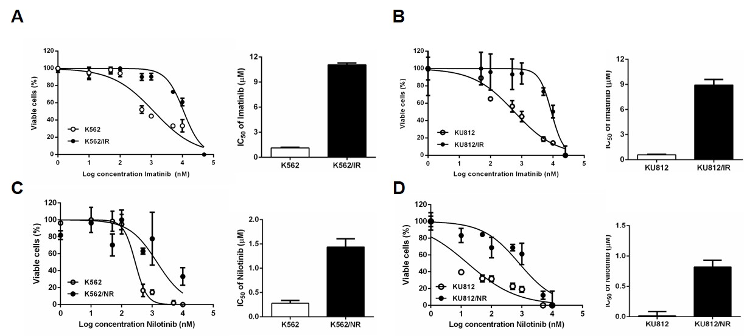

Fig. S1. TKI insensitivity in imatinib- and nilotinib-resistant CML cells. (A-D) Cell viability was compared in CML parental cells and TKI-resistant cells (K562/IR, KU812/IR, K562/NR, and KU812/NR) exposed to increasing doses of imatinib or nilotinib for 48 h. Graphs represent the mean ± SD of the IC₅₀ in three independent experiments.

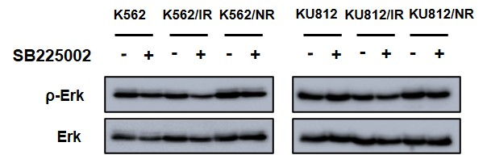

Fig. S2. Expression of Erk after SB225002 treatment. Western blot assays were performed to examine Erk and p-Erk levels in TKI-sensitive and -resistant CML cells after treatment with SB225002 for 24 h.

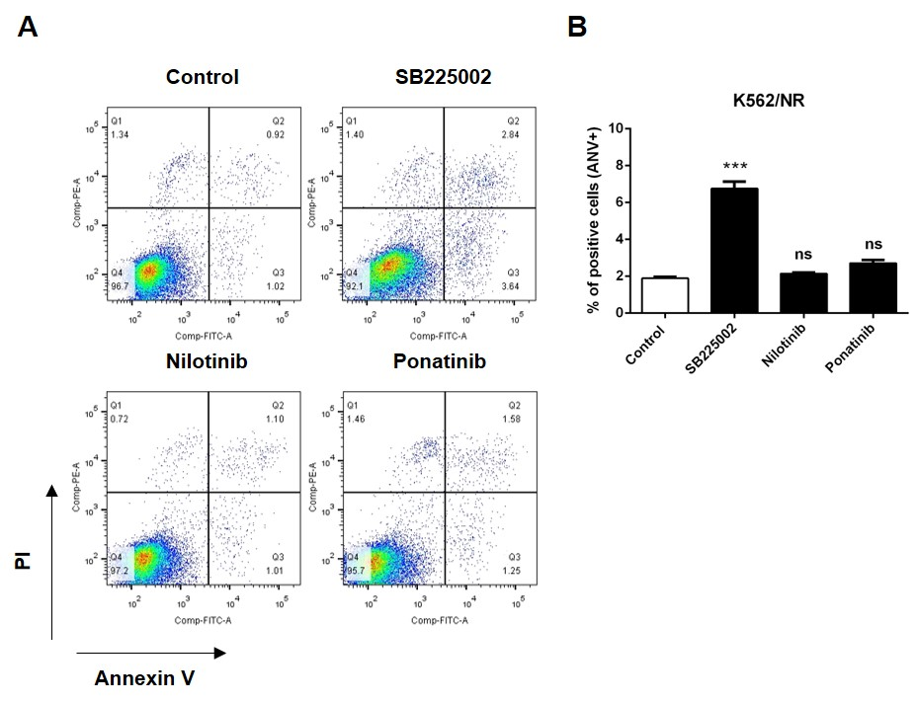

Fig. S3. Cell death in nilotinib-resistant K562 cells. K562/NR cells were treated with 1 µM SB225002, 20 nM nilotinib, or 50 nM ponatinib for 48 h. Following treatment, apoptotic cells were detected using annexin V/PI staining.

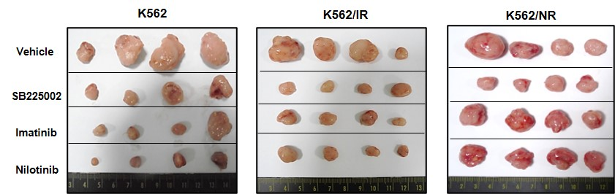

Fig. S4. Effect of drugs on tumor size in a mouse xenograft model. Images of tumors excised from each group of mice on day 21 after K562, K562/IR, and K562/NR cell transplantation.

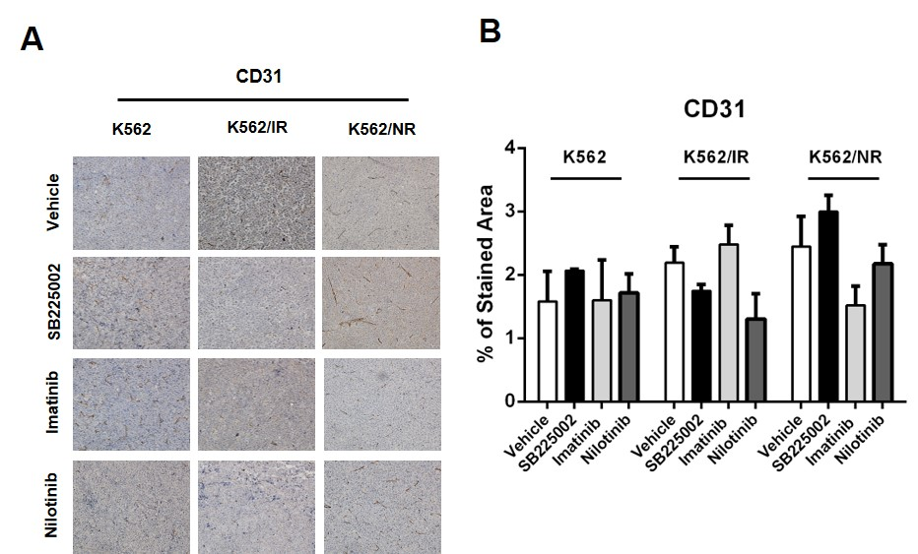

Fig. S5. Expression of angiogenesis markers in a mouse xenograft model. Immunohistochemistry staining to detect CD31 in K562, K562/IR, and K562/NR xenograft models. Graphs represent the quantification of the stained area. Data are represented as the mean ± SD.

