Supplementary figures:
Figure S1: Visualization of protein levels in the different lesions for proteins known to be involved in the Warburg effect.
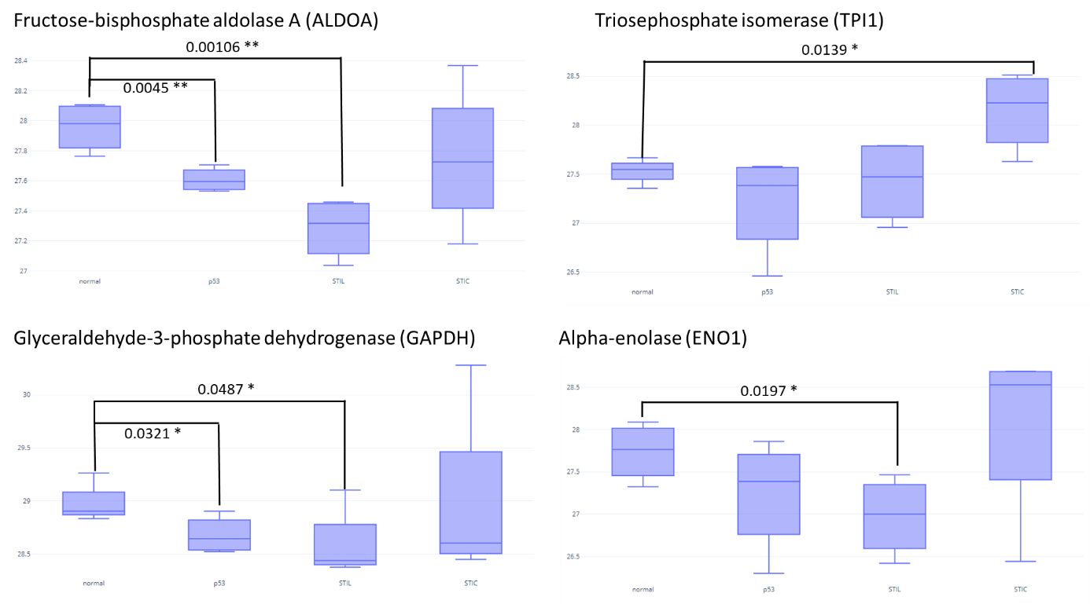
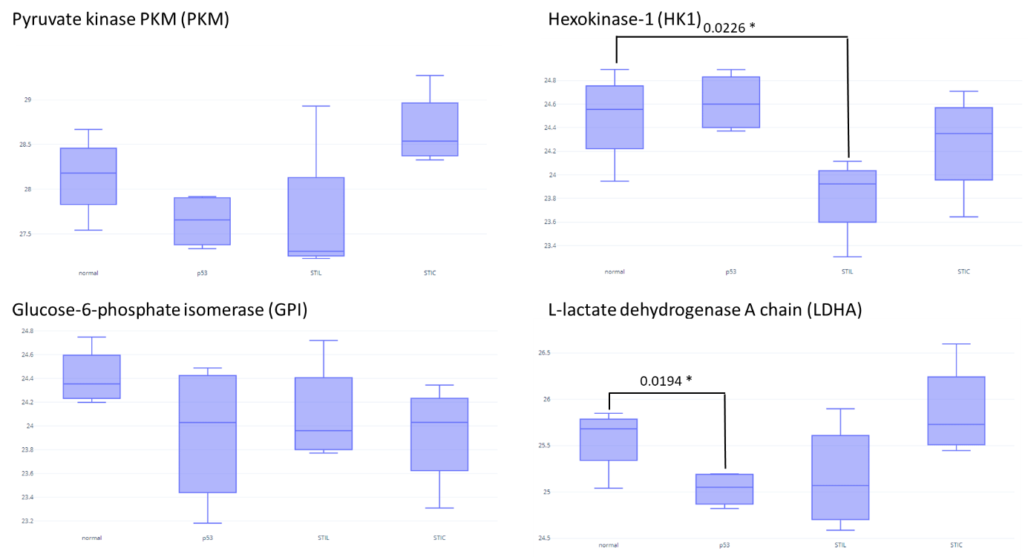
Figure S1: Visualization of protein levels in the different lesions for proteins known to be involved in the Warburg effect. Log(LFQ) values were used for the representation of Fructose-bisphosphate aldolase A (ALDOA), Triosephosphate isomerase (TPI1), Glyceraldehyde-3-phosphate dehydrogenase (GAPDH), Alpha-enolase (ENO1), Pyruvate kinase PKM (PKM), Hexokinase-1 (HK1), Glucose-6-phosphate isomerase (GPI) and L-lactate dehydrogenase A chain (LDHA). A t-test is used to compare the value between normal tissue and each lesion. P-value is represented by stars (*** p < 0.001, ** p < 0.01 , * p < 0.05 no star for p > 0.05).

