Supplementary Figure 2 Cytokines Array map (A). Images of the chemiluminescence signals on membranes (B)
A
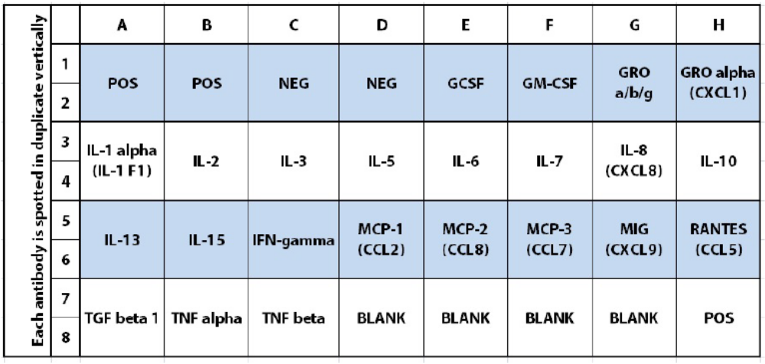
B
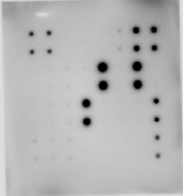
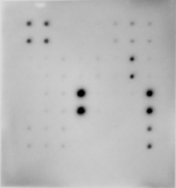
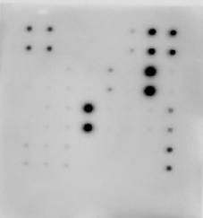
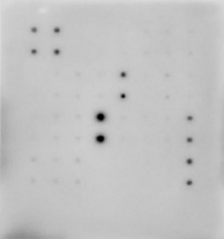
1 2 3 4 5
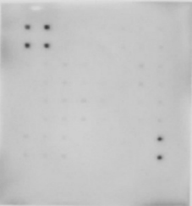

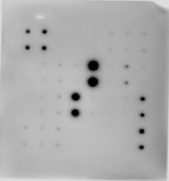
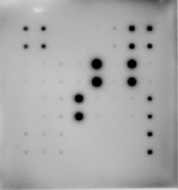
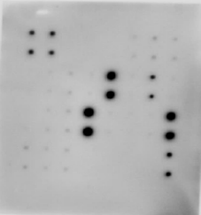
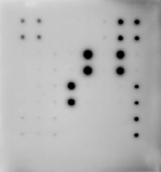
6 7 8 9 10
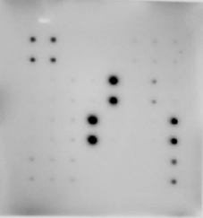

- Uncultured medium sample as negative control.
- Supernatant of LC5 cells monoculture.
- Supernatant of Capan-1 monoculture.
- Supernatant of PL-45 monoculture.
- Supernatant of Capan-1 and LC5 direct coculture.
- Supernatant of PL45 and LC5 direct coculture.
- Supernatant of LC5 cells cultured with Capan-1 conditioned medium.
- Supernatant of LC5 cells cultured with PL-45 conditioned medium.
- Supernatant of Capan-1 cells cultured with LC5 conditioned medium.
- Supernatant of PL-45 cells cultured with LC5 conditioned medium.

