Supplementary Information

Search Strategy
EMBASE (1422): & Cochrane (35):

(ErbB Receptors.mp. or exp epidermal growth factor receptor/ or exp epidermal growth factor receptor kinase inhibitor/ or EPIDERMAL GROWTH FACTOR Receptor*.mp. or exp protein tyrosine kinase inhibitor/ or TKI*.mp. or Erlotinib.mp. or exp erlotinib/ or Tarceva.mp. or Gefitinib.mp. or exp gefitinib/ or Iressa.mp. or icotinib.mp. or exp icotinib/ or Conmana.mp. or Afatinib.mp. or exp afatinib/ or Giotrif.mp. or Dacomitinib.mp. or dacomitinib/ or Vizimpro.mp. or Osimertinib.mp. or exp osimertinib/ or Tagrisso.mp. or EGFR TKI.mp. or EGFR tyrosine kinase inhibitor.mp. or epidermal growth factor receptor tyrosine kinase inhibitor*.mp. or epidermal growth factor receptor TKI.mp.)
and
(Receptors, Vascular Endothelial Growth Factor.mp. or exp vasculotropin receptor/ or VEGF.mp. or exp vasculotropin inhibitor/ or Vascular Endothelial Growth Factor inhibitor*.mp. or Vascular Endothelial Growth Factor*.mp. or bevacizumab.mp. or bevacizumab/ or avastin.mp. or ranibizumab.mp. or ranibizumab/ or Lucentis.mp. or exp lapatinib/ or lapatinib.mp. or sunitinib.mp. or exp sunitinib/ or sorafenib.mp. or exp sorafenib or axitinib.mp. or exp axitinib/ or exp lapatinib plus pazopanib/ or exp pazopanib/ or pazopanib.mp. or ramucirumab.mp. or exp ramucirumab/ or Cyramza.mp. or aflibercept.mp. or exp aflibercept/ or vandetanib.mp. or vandetanib/ or cediranib.mp. or exp cediranib/ or motesanib.mp. or exp motesanib/ or naquotinib.mp. or exp naquotinib/ or VEGF inhibitor*.mp. or exp vasculotropin receptor 2/ or VEGFR2 antagonist.mp. or VEGFR2 inhibitor*.mp.)
and
(exp lung cancer/ or Lung.mp. or exp lung carcinogenesis/ or exp lung/ or exp lung carcinoma/ or exp non small cell lung cancer/ or thoracic.mp. or pulmonary.mp. or lung neoplasms.mp. or exp lung tumor/)

Limit: Exclude Medline journals

PubMed (1929):

(ErbB Receptors[mh] OR EPIDERMAL GROWTH FACTOR Receptor*[tw] OR EGFR[tw] OR EPIDERMAL GROWTH FACTOR RECEPTOR inhibitor*[tw] OR TKI*[tw] OR tyrosine kinase inhibitor*[tw] OR Erlotinib[tw] OR Tarceva[tw] OR Gefitinib[tw] OR Iressa[tw] OR icotinib[tw] OR Conmana[tw] OR Afatinib[tw] OR Giotrif[tw] OR Dacomitinib[tw] OR Vizimpro[tw] OR Osimertinib[tw] OR Tagrisso[tw] OR EGFR TKI[tw] or EGFR tyrosine kinase inhibitor[tw] OR epidermal growth factor receptor tyrosine kinase inhibitor*[tw] OR epidermal growth factor receptor TKI[tw])
AND
(Receptors, Vascular Endothelial Growth Factor[mh] OR VEGF[tw] OR Vascular Endothelial Growth Factor inhibitor*[tw] OR Vascular Endothelial Growth Factor*[tw] OR bevacizumab[tw] OR avastin[tw] OR ranibizumab[tw] OR Lucentis[tw] OR lapatinib[tw] OR sunitinib[tw] OR sorafenib[tw] OR axitinib[tw] OR pazopanib[tw] OR ramucirumab[tw] OR Cyramza[tw] OR aflibercept[tw] OR vandetanib[tw] OR cediranib[tw] OR motesanib[tw] OR naquotinib[tw] OR VEGF inhibitor*[tw] OR VEGFR2 inhibitor*[tw] OR VEGFR2 antagonist[tw])
AND
(Lung[tw] OR thoracic[tw] OR pulmonary[tw] OR lung neoplasms[mh])

Figure S1: Progression Free Survival (PFS) Hazard Ratios of prespecified subgroups
- PFS by Age
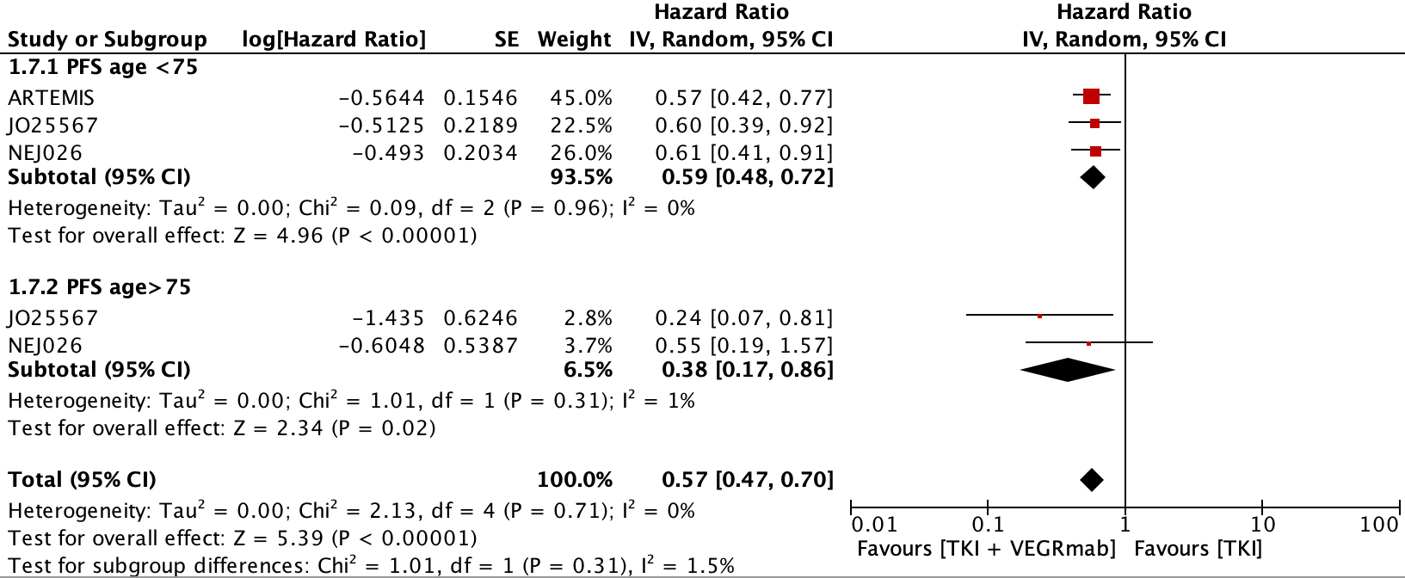
- PFS by Gender
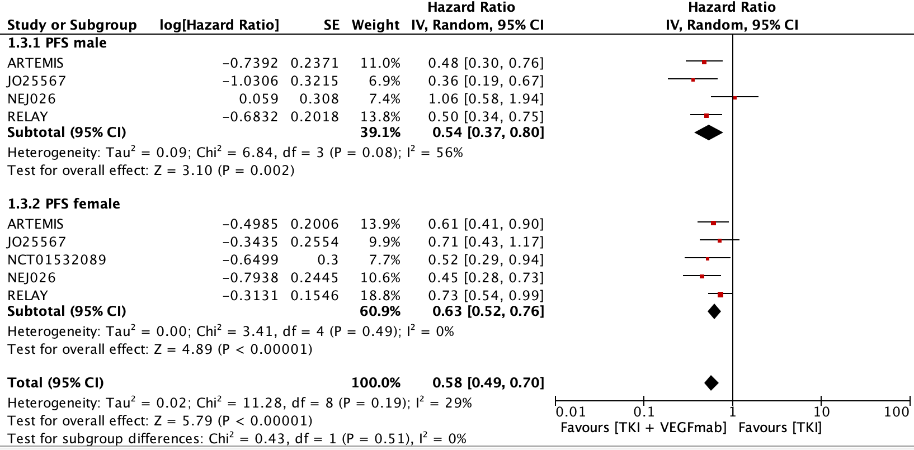
- PFS by Smoking Status
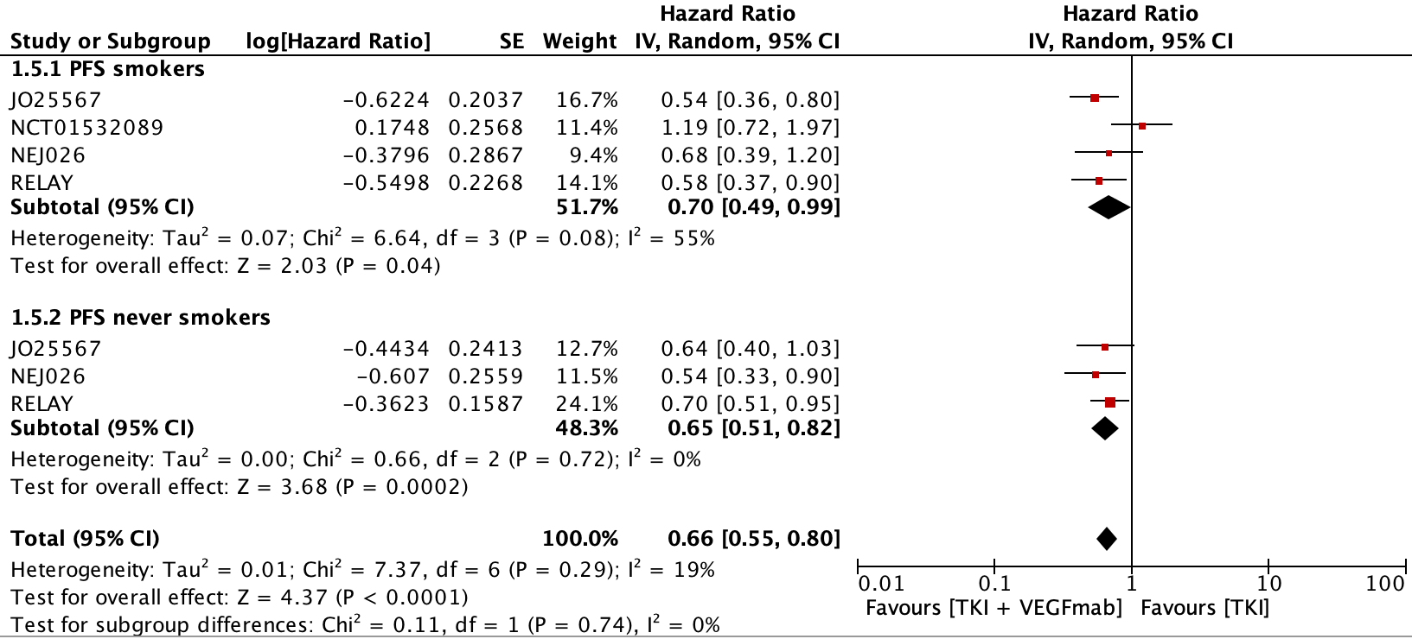

- PFS by ECOG Status
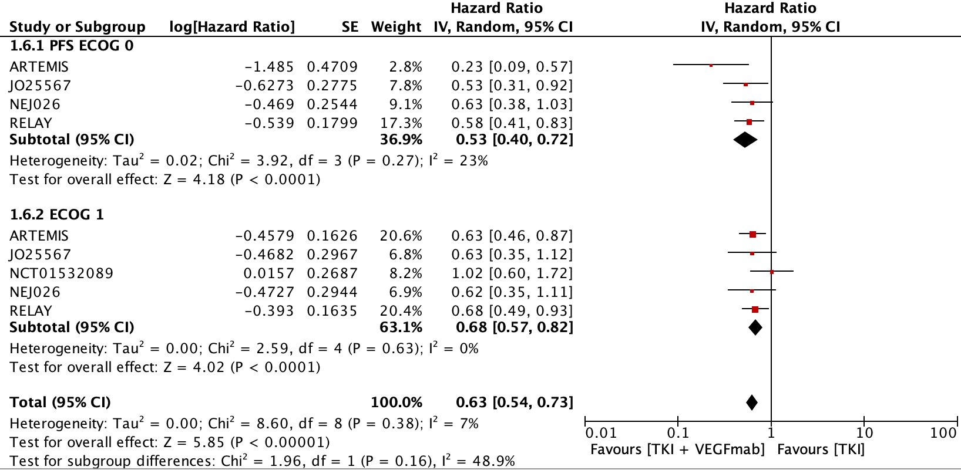
- PFS by EGFR Mutation Status
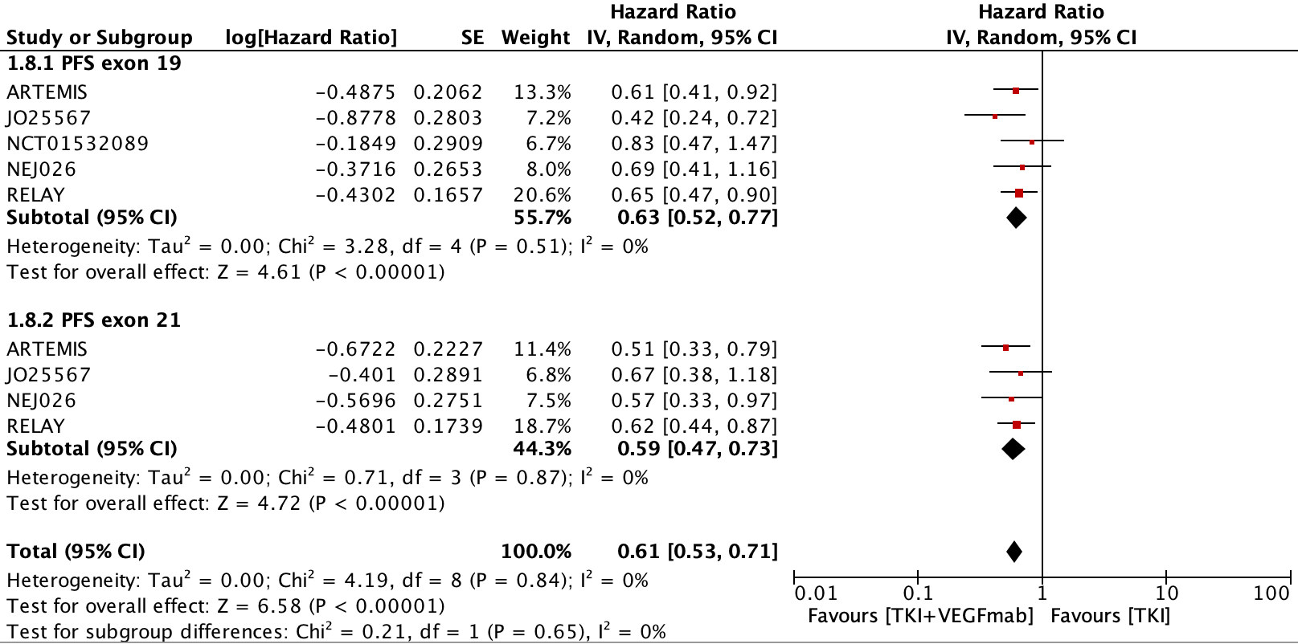
- PFS by Presence or Absence of Intracranial Disease
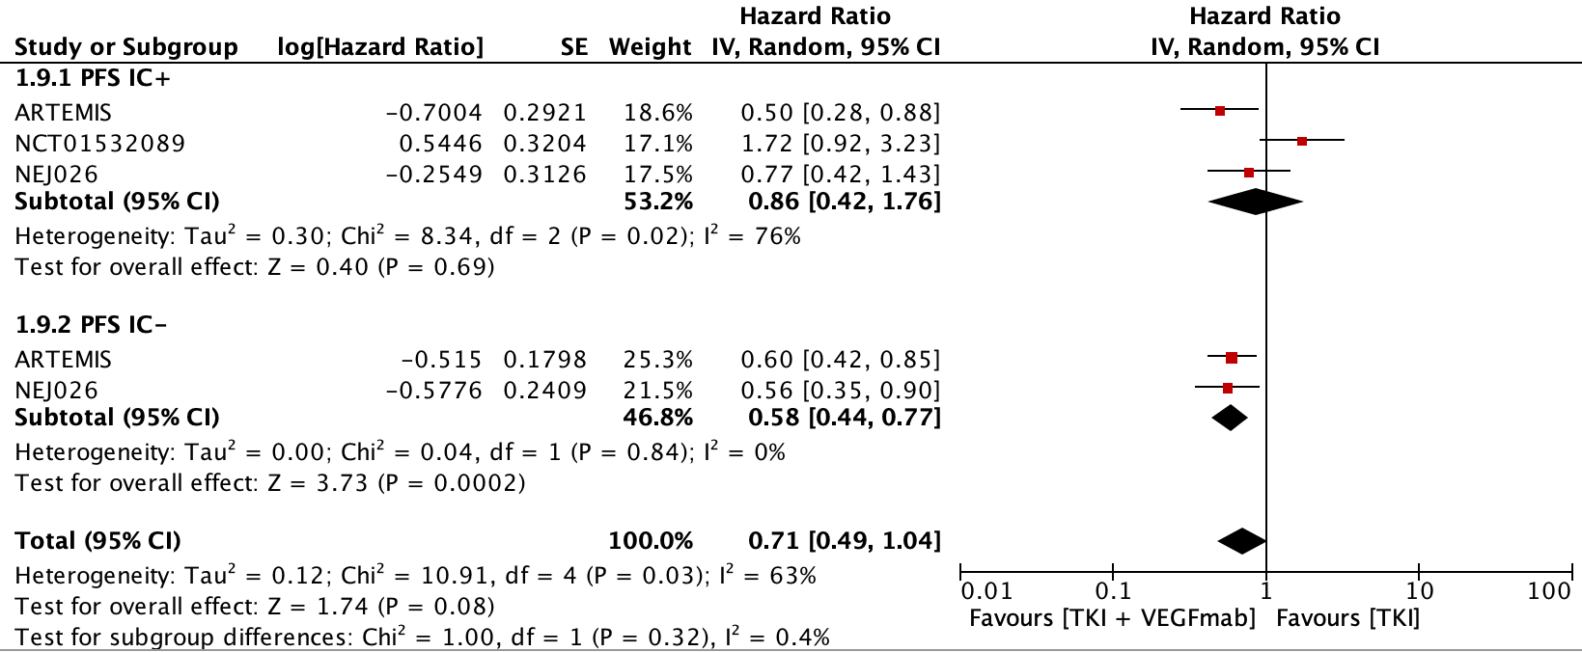

Figure S2: Overall Response Rate Odds Ratio between combination therapy and EGFR TKI alone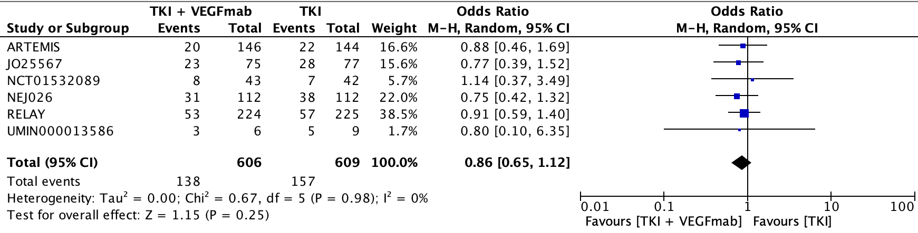
Figure S3: Disease Control Rate Odds Ratio between combination therapy and EGFR TKI alone 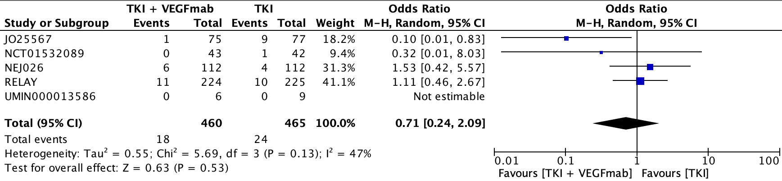
Figure S4: Adverse Events Odds Ratios between combination therapy and EGFR TKI alone
- Any Grade 3 or Higher Adverse Event OR
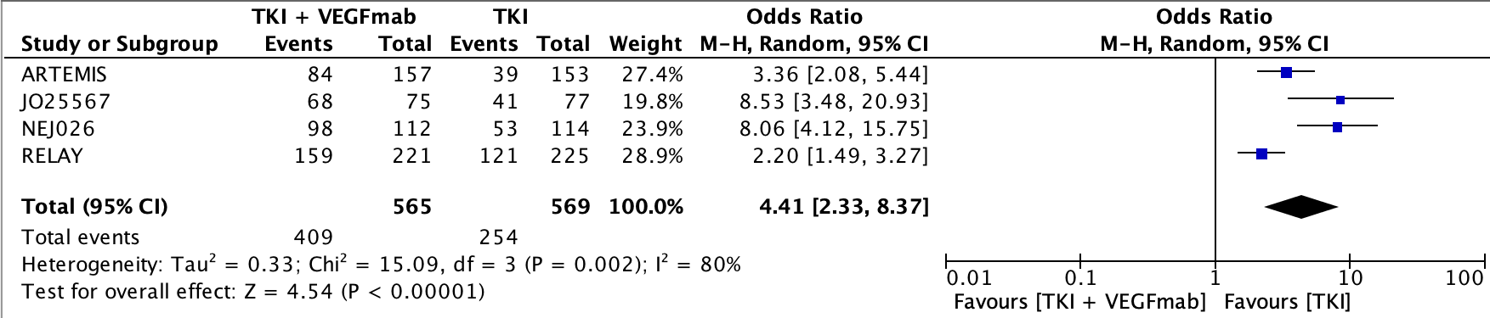
- Grade 3 or Higher Proteinuria OR
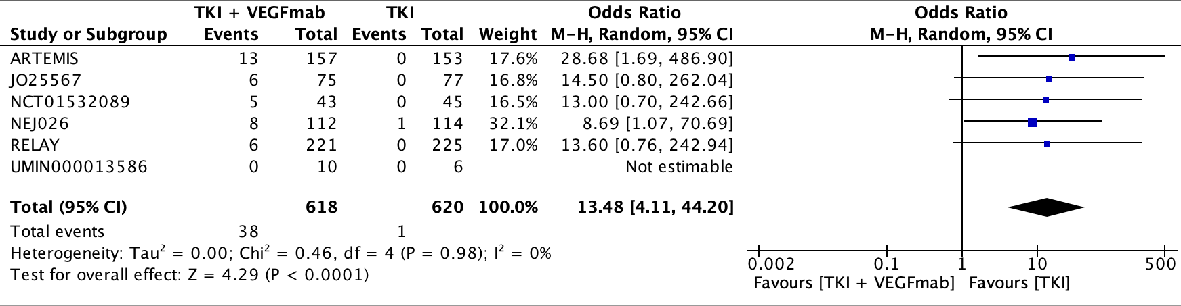
- Grade 3 or Higher Hypertension OR
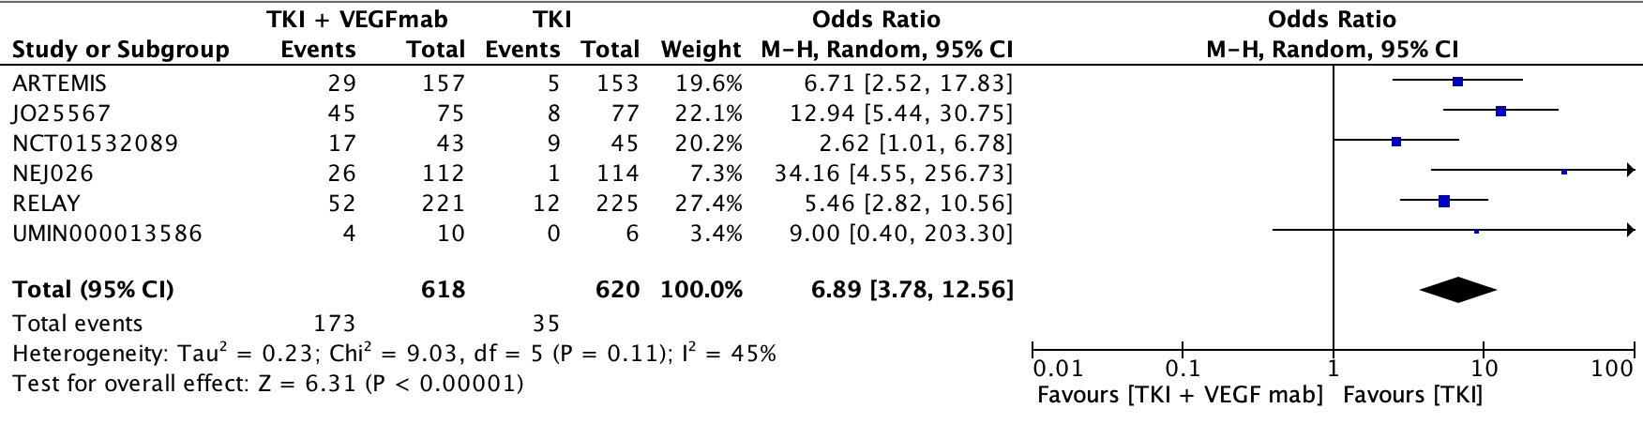

- Grade 3 or Higher Diarrhea OR
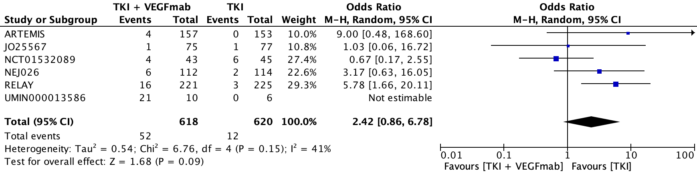
- Grade 3 or Higher Dermatitis OR
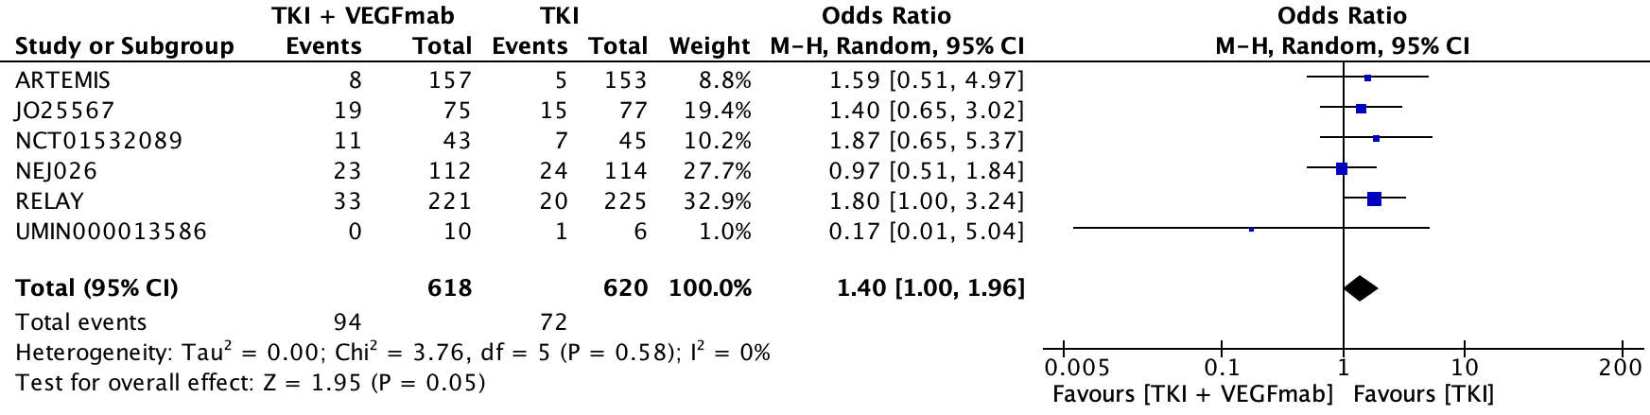
- Grade 3 or Higher Bleeding OR
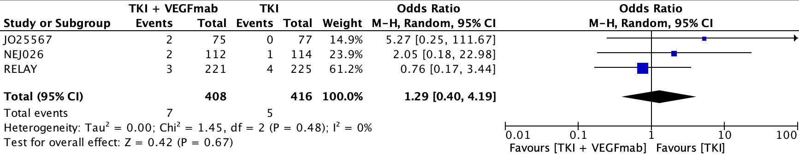
- Grade 3 or Higher Stomatitis OR
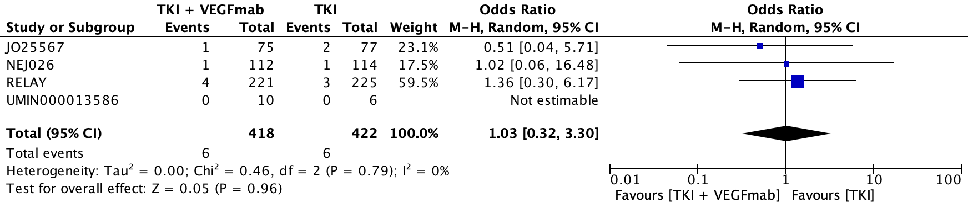
- Grade 3 or Higher AST OR
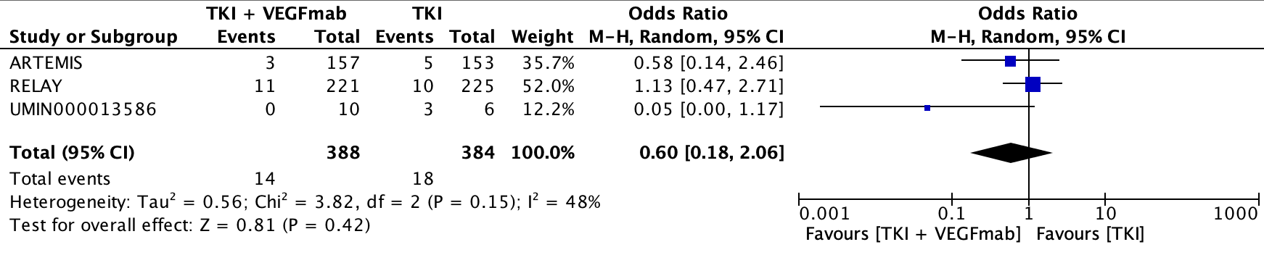

Table S1: Risk of Bias Table
Study | Random Sequence Generation | Allocation Concealment | Blinding of Participants/Physicians | Blinding of Outcome Assessment | Incomplete Outcome Data | Selective Reporting
RELAY | Low | Low | Low | Low | Low | Low
NCT0153089 | Low | Low | High | Unknown | Low | Low
NEJ026 | Low | Low | High | Unknown | Low | High
BAGEL | Low | Unknown | High | Unknown | Low | Low
ARTEMIS | Low | Unknown | High | Unknown | Low | High
JO25567 | Low | Low | High | Low | Low | Low

Table S2: Odds Ratio (OR) comparing combined EGFR-TKI and VEGF inhibition versus EGFR-TKI alone.
Outcome | OR (95% CI)
ORR | 0.86 (0.65 – 1.12)
DCR | 0.71 (0.24 – 2.09)

Table S3: GRADE of Recommendation
Certainty Assessment |  |  |  |  |  |  | Certainty | Importance
No of studies | Study design | Risk of bias | Inconsistency | Indirectness | Imprecision | Other considerations | Certainty | Importance
PFS
5 | Randomized trials | Not serious | Serious | Not serious | Not serious | None | MODERATE | IMPORTANT
OS
4 | Randomized trials | Not serious | Not serious | Not serious | Serious | None | MODERATE | IMPORTANT
ORR
6 | Randomized trials | Not serious | Not serious | Not serious | Serious | None | MODERATE | IMPORTANT
DCR
5 | Randomized trials | Not serious | Not serious | Not serious | Serious | None | MODERATE | IMPORTANT

