Table S1 Primers
Primer name | Sequence (5’-3’)
tpiA-up-s |  | CCCGGGGATCCTCTAGAGATCCGGCGCGCCGAGCTTTG
tpiA-up-a |  | GCAGCTCCAGCCTACATTTAATTCTCCACGCTACTTAAGCG
tpiA-FRT-s | TAAATGTAGGCTGGAGCTGCTTCG
tpiA-FRT-a | AAAAGCGGAATTCCGGGGATCCGTCGA
tpiA-down-s | ATCCCCGGAATTCCGCTTTTCCCGGCGGC
tpiA-down-a | CATGCCTGCAGGTCGACGATTAACGCTGCTGCCGCGGG
mgsA- up-s | CCCGGGGATCCTCTAGAGATCTTTGGCGAAGGGGACTGC
mgsA- up-a | AGCCTACATCGAACCGCGATCACGGC
mgsA-FRT-s | ATCGCGGTTCGATGTAGGCTGGAGCTGCTTCG
mgsA-FRT-a | GAAAATATTCCGGGGATCCGTCGA
mgsA-down-s | CGGATCCCCGGAATATTTTCATTCCGCATTTTGACC
mgsA-down-a | CATGCCTGCAGGTCGACGATAGGATAAAAAAACCCGCTAATGC
gldA- up-s | CCCGGGGATCCTCTAGAGATCGGAGATGTACGCCGCCG
gldA- up-a | CAGCCTACATCCAGAGCAAAACAAAACACCC
gldA-FRT-s | TTTGCTCTGGATGTAGGCTGGAGCTGCTTCG
gldA-FRT-a | AGGAATCGAAATTCCGGGGATCCGTCGA
gldA-down-s | TCCCCGGAATTTCGATTCCTCCTCGATGACC
gldA-down-a | CATGCCTGCAGGTCGACGATTGGGATGTACTGCCGCGC
dhaD-up-s | CCCGGGGATCCTCTAGAGATTCAGACAGCAAAGCGAGATAGAGC
dhaD-up-a | CTACATTCGCGGTGGCTAAACCG
dhaD-FRT-s | TTTAGCCACCGCGAATGTAGGCTGGAGCTGCTTCG
dhaD-FRT-a | GTGAAAGGAATTCCGGGGATCCGTCGA
dhaD-down-s | ATCCCCGGAATTCCTTTCACCCTCAAATAAGTGC
dhaD-down-a | CATGCCTGCAGGTCGACGATTCCGTTGGAGAAGGTTCGATG
gapC-up-s | CCCGGGGATCCTCTAGAGATATTTACGATCGCTTCGTCAACC
gapC-up-a | AGCTCCAGCCTACAGTGAACGGCGGACAGCCT
gapC-FRT-s | GTTCACTGTAGGCTGGAGCTGCTTCG
gapC-FRT-a | GAGAATATCCATTCCGGGGATCCGTCGA
gapC-down-s | TCCCCGGAATGGATATTCTCCGGTTGGTAAAACG
gapC-down-a | CATGCCTGCAGGTCGACGATCTGCAGGGATCTCGCCAGC
gapA-up-s | CCCGGGGATCCTCTAGAGATTCACCGCCGCGATATCGC
gapA-up-a | CCAGCCTACAGTTGAGATGAAAAAGTAATCTGTAAGAGC
gapA -FRT-s | TCATCTCAACTGTAGGCTGGAGCTGCTTCG
gapA -FRT-a | GGTGGAATATATTCCGGGGATCCGTCGA
gapA-down-s | TCCCCGGAATATATTCCACCAGCTATTTGTTAGTGAA
gapA-down-a | CATGCCTGCAGGTCGACGATATGCCGTGGGAGCTGTCG
hdpA-s | TTCACACAGGAAACAGAATTCATGACAGTGAACATTTCATATCTGACC
hdpA-a | TCCGCCAAAACAGCCAAGCTTCTAGTCAGTGAACTGCTGCTCATCT
pDK6-s | CGCTACGGCGTTTCACTTC
pDK6-a | CCAATACGCAAACCGCCTC
pMD18-T-s | ATCGTCGACCTGCAGGCA
pMD18-T-a | ATCTCTAGAGGATCCCCGGGT

Figure S1
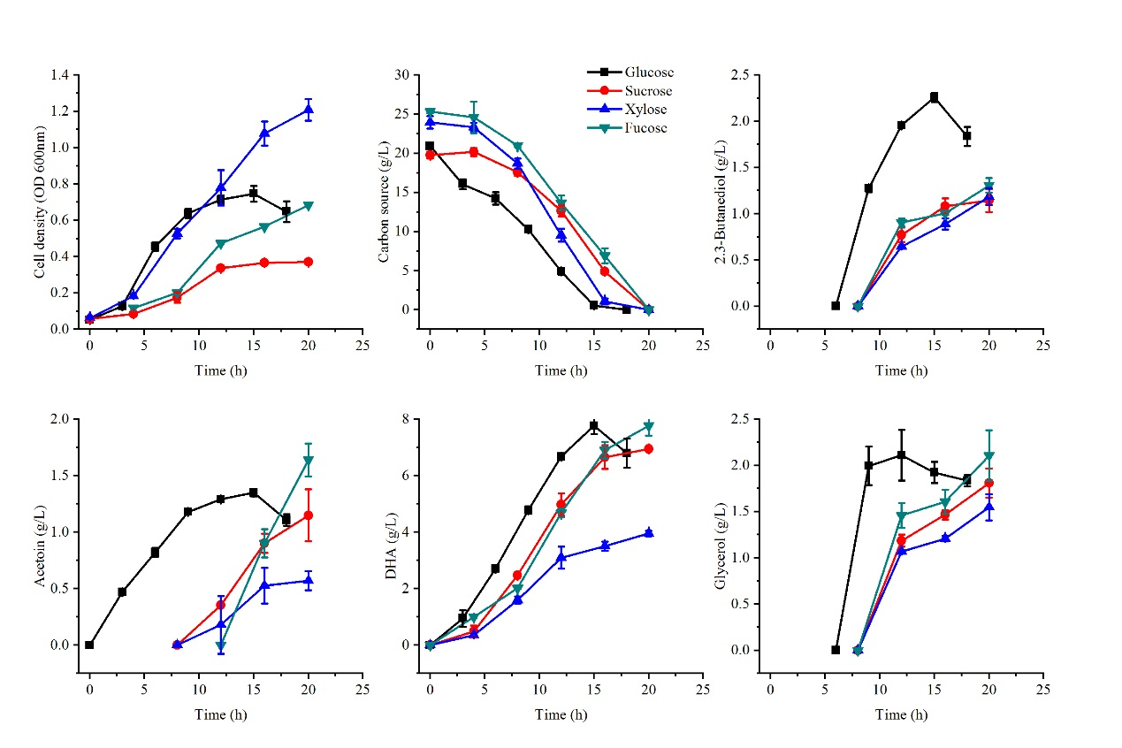
Figure 1S. Growth and product formation of Kp ΔptiA-ΔDHAK-hdpA in shake flasks with different carbon sources. Data points are the average of n = 3; error bars represent standard error about the mean.
Figure S2
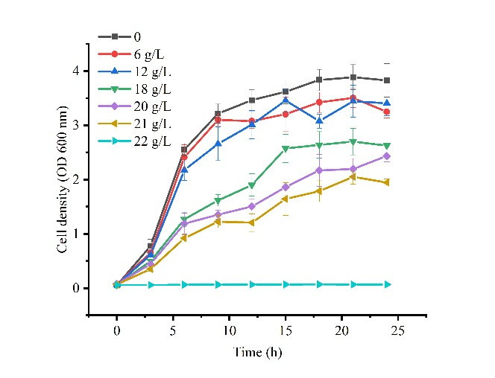
Figure S2. Inhibition of the growth of K. pneumoniae by DHA. K. pneumoniae was grown in shake flasks with DHA added in the LB medium. Data points are the average of n = 3; error bars represent standard error about the mean

