SUPPLEMENTARY DATA
New 5-LOX and 15-LOX inhibitors isolated from red sea derived brown alga Sarragassum cinnerum: an in silico-supported study

Sami I. Alzarea^{1≠}, Abeer H. Elmaidomy^{2≠}, Hani Saber³, Arafa Musa^{4,5}, Mohammad M. Al-Sanea⁶, Ehab M. Mostafa^{4,5}, Omnia Magdy Hendawy^{1,7}, Khayrya A. Youssif⁸, Abdullah S. Alanazi⁹, Metab Alharbi¹⁰, Ahmed M. Sayed^{11*}, Usama Ramadan Abdelmohsen^{12,13*}
¹Department of Pharmacology, College of Pharmacy, Jouf University, Sakaka, Aljouf 72341, Saudi Arabia
²Department of Pharmacognosy, Faculty of Pharmacy, Beni-Suef University, Beni-Suef 62511, Egypt

³Department of Botany and Microbiology, Faculty of Science, South Valley University, 83523, Qena, Egypt

⁴Department of Pharmacognosy, College of Pharmacy, Jouf University 72341, Sakaka, Saudi Arabia

⁵Department of Pharmacognosy, Faculty of Pharmacy, Al-Azhar University, Cairo, 11371, Egypt

⁶Department of Pharmaceutical Chemistry, College of Pharmacy, Jouf University 72341, Sakaka, Saudi Arabia

⁷Clinical Pharmacology Department, Faculty of Medicine, Beni-Suef University, Egypt

⁸Department of Pharmacognosy, Faculty of Pharmacy, Modern University for Technology and Information, Cairo, Egypt
⁹Clinical Pharmacy Department, College of Pharmacy, Jouf University, Sakaka, Aljouf 72341, Saudi Arabia
¹⁰Department of Pharmacology and Toxicology, College of Pharmacy, King Saud University, P.O. Box 2457, Riyadh, 11451, Saudi Arabia.
¹¹Department of Pharmacognosy, Faculty of Pharmacy, Nahda University, 62513, Beni-Suef, Egypt
¹²Department of Pharmacognosy, Faculty of Pharmacy, Minia University, Minia 61519, Egypt
¹³Department of Pharmacognosy, Faculty of Pharmacy, Deraya University, 7 Universities Zone, New Minia 61111, Egypt

*Corresponding authors: AMS: Department of Pharmacognosy, Faculty of Pharmacy, Nahda University, 62513, Beni-Suef, Egypt, ahmed.mohamed.sayed@nub.edu.eg; URA: Department of Pharmacognosy, Faculty of Pharmacy, Minia University, Minia 61519, Egypt, usama.ramadan@mu.edu.eg.
≠ Those authors have equally contributed
ABSTRACT
Sargassum is a brown algal genus inhabiting tropical region. Metabolomic profiling of Sarragassum cinnerum “Sargassaceae”, dereplicated eleven compounds 1-11, further phytochemical investigation afforded two new aryl cresol 12-13, along with eight known compounds 14-21. Both new metabolites along with 19 showed moderate in vitro antiproliferative activity against HEPG2, MCF7, and CACO2. Molecular targets of the bioactive compounds using a pharmacophore-based virtual screening, predicts 5-LOX and 15-LOX as the most probable target linked to their observed antiproliferative activity. The validation step revealed 12 and 13 inhibited 5-LOX more prudentially than 15-LOX, while 19 showed a convergent inhibitory activity toward both enzymes. Further in-depth in silico analysis revealed the molecular interactions inside both enzymes active sites and explained the varying inhibitory activity for 12, and 13 toward 5-LOX and 15-LOX. Taken together, unique metabolites in S. cinnerum had potential anticancer activity supported with in-silico investigations to facility drug discovery and development processes.

Keywords: Sarragassum cinnerum, metabolic profiling, aryl cresols, docking, 5- LOX, 15-LOX, virtual screening, in silico.

List of Contents
Table S1. | Dereplicated metabolites from LC-HRESIMS analysis of Sarragassum cinnerum
Figure S1. | LC-HRESIMS Chromatogram of the dereplicated metabolites of Sarragassum cinnerum (positive)
Figure S2. | LC-HRESIMS Chromatogram of the dereplicated metabolites of Sarragassum cinnerum (negative)
Figure S3. | 1H NMR spectrum of compound 12 measured in DMSO-d₆ at 400 MHz
Figure S4. | DEPT-Q NMR spectrum of compound 12 measured in DMSO-d₆ at 100 MHz
Figure S5. | HSQC spectrum of compound 12 measured in DMSO-d₆
Figure S6. | HMBC spectrum of compound 12 measured in DMSO-d₆
Figure S7. | HRESIMS spectrum of compound 12
Figure S8. | 1H NMR spectrum of compound 13 measured in DMSO-d₆ at 400 MHz
Figure S9. | DEPT-Q NMR spectrum of compound 13 measured in DMSO-d₆ at 100 MHz.
Figure S10. | HSQC spectrum of compound 13 measured in DMSO-d₆
Figure S11. | HMBC spectrum of compound 13 measured in DMSO-d₆
Figure S12. | HRESIMS spectrum of compound 13
Figure S13. | 1H NMR spectrum of compound 14 measured in DMSO-d₆ at 400 MHz
Figure S14. | DEPT-Q NMR spectrum of compound 14 measured in DMSO-d₆ at 100 MHz.
Figure S15. | 1H NMR spectrum of compound 15 measured in DMSO-d₆ at 400 MHz
Figure S16. | DEPT-Q NMR spectrum of compound 15 measured in DMSO-d₆ at 100 MHz
Figure S17. | 1H NMR spectrum of compound 16 measured in DMSO-d₆ at 400 MHz
Figure S18. | DEPT-Q NMR spectrum of compound 16 measured in DMSO-d₆ at 100 MHz
Figure S19. | 1H NMR spectrum of compound 17 measured in DMSO-d₆ at 400 MHz
Figure S20. | DEPT-Q NMR spectrum of compound 17 measured in DMSO-d₆ at 100 MHz
Figure S21. | 1H NMR spectrum of compound 18 measured in CD₃OD-d₄ at 400 MHz
Figure S22. | DEPT-Q NMR spectrum of compound 18 measured in CD₃OD-d₆ at 100 MHz
Figure S23. | 1H NMR spectrum of compound 19 measured in CD₃OD-d₄ at 400 MHz
Figure S24. | DEPT-Q NMR spectrum of compound 19 measured in CD₃OD-d₆ at 100 MHz
Figure S25. | 1H NMR spectrum of compound 20 measured in DMSO-d₆ at 400 MHz
Figure S26. | DEPT-Q NMR spectrum of compound 20 measured in DMSO-d₆ at 100 MHz
Figure S27. | 1H NMR spectrum of compound 21 measured in D₂O at 400 MHz
Figure S28. | DEPT-Q NMR spectrum of compound 21 measured in D₂O at 100 MHz

Table S1. Dereplicated metabolites from LC-HRESIMS analysis of Sarragassum cinnerum
No. | Metabolites name | Original source | MF | RT(min.) | m/z
1 | (5R,7S,8S)-Communiol A | Sargassum spp. | C₁₁H₂₀O₄ | 3.76288 | 215.1283
2 | Hedaol A | Sargassum spp. | C₁₈H₃₀O₂ | 6.7354 | 277.2162
3 | Arachidonic acid | Sargassum pallidum | C₂₀H₃₄O₂ | 6.6166 | 307.2624
4 | Sargachromanol A | Sargassum siliquastrum | C₂₂H₃₀O₃ | 5.3686 | 343.2276
5 | 2-Geranylgeranyl-6-methylbenzoquinone | Sargassum micracanthum. | C₂₇H₃₈O₂ | 4.4710 | 395.2950
6 | 24-Ethylcholesta-4,24(28)-dien-3,6-dione | Sargassum carpophyllum | C₂₉H₄₄O₂ | 6.5544 | 425.3420
7 | Saringosterone | Sargassum asperfolium | C₂₉H₄₆O₂ | 6.6324 | 427.3576
8 | Nahocol A | Sargassum siliquastrum | C₂₉H₄₂O₆ | 6.6773 | 487.3060
9 | 24xi-Hydroperoxy-24-vinylcholesterol | Sargassum carpophyllum | C₂₉H₄₈O₃ | 6.5615 | 445.3682
10 | Sargathunbergol A | Sargassum thunbergii | C₂₇H₃₈O₆ | 5.7502 | 459.2749
11 | 1-O-(11-Hexadecenoyl)-3-0-(6'-sulfo-a-D-quinovopyranosyl) glycerol | Sargassum hemiphyllum | C₂₅H₄₆O₁₁S | 4.4836 | 553.2681

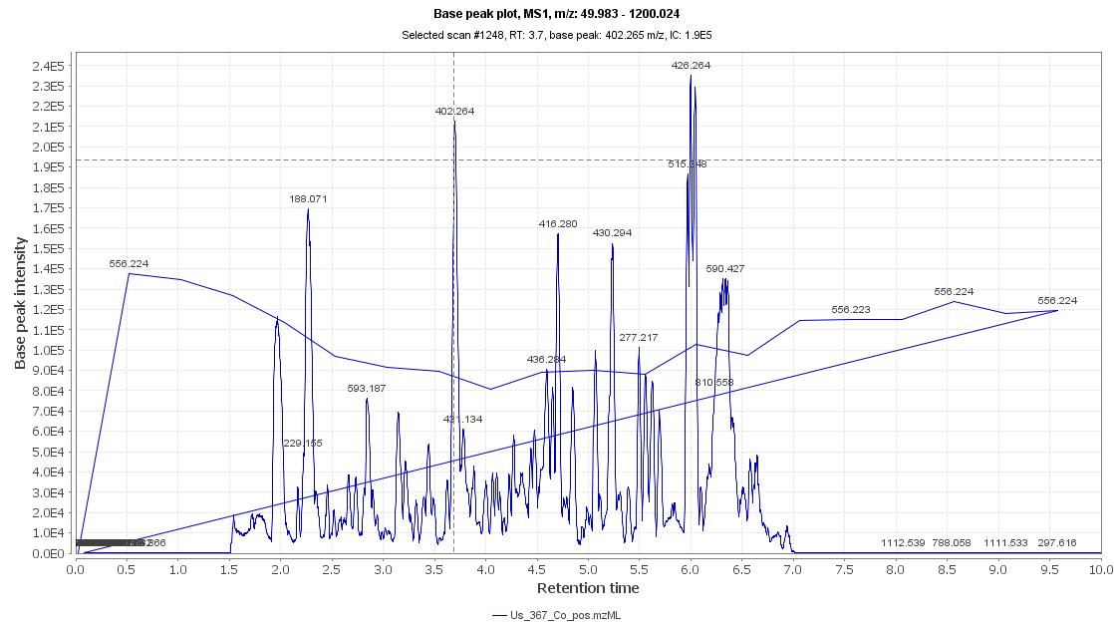
Figure S1. LC-HRESIMS Chromatogram of the dereplicated metabolites of Sarragassum cinnerum (positive)
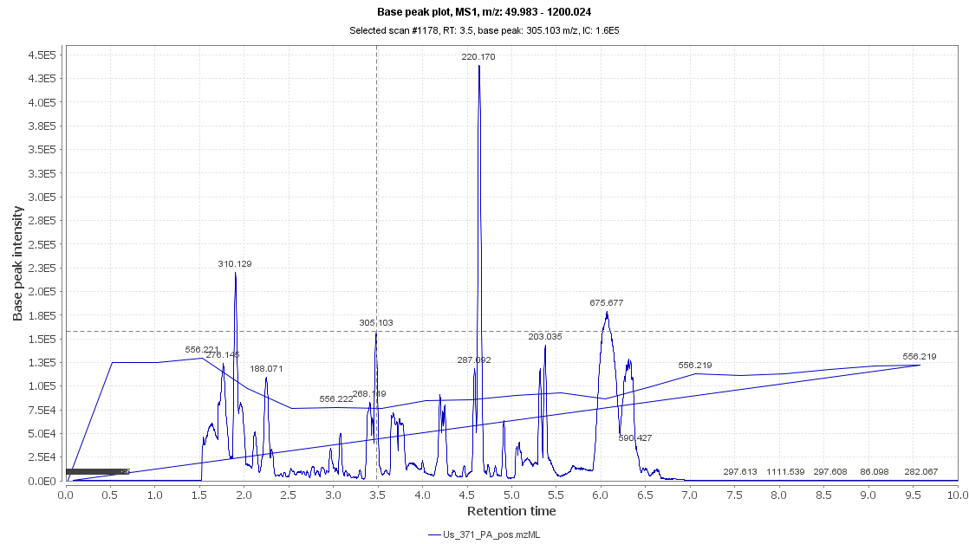
Figure S2. LC-HRESIMS Chromatogram of the dereplicated metabolites of Sarragassum cinnerum (negaive)

Figure S3. 1H NMR spectrum of compound 12 measured in DMSO-d₆ at 400 MHz

Figure S4. DEPT-Q NMR spectrum of compound 12 measured in DMSO-d₆ at 100 MHz.

Figure S5. HSQC spectrum of compound 12 measured in DMSO-d₆

Figure S6. HMBC spectrum of compound 12 measured in DMSO-d₆

Figure S7. HRESIMS spectrum of compound 12

Figure S8. 1H NMR spectrum of compound 13 measured in DMSO-d₆ at 400 MHz

Figure S9. DEPT-Q NMR spectrum of compound 13 measured in DMSO-d₆ at 100 MHz.

Figure S10. HSQC spectrum of compound 13 measured in DMSO-d₆

Figure S11. HMBC spectrum of compound 13 measured in DMSO-d₆

Figure S12. HRESIMS spectrum of compound 13

Figure S13. 1H NMR spectrum of compound 14 measured in DMSO-d₆ at 400 MHz

Figure S14. DEPT-Q NMR spectrum of compound 14 measured in DMSO-d₆ at 100 MHz.
Figure S15. 1H NMR spectrum of compound 15 measured in DMSO-d₆ at 400 MHz
Figure S16. DEPT-Q NMR spectrum of compound 15 measured in DMSO-d₆ at 100 MHz
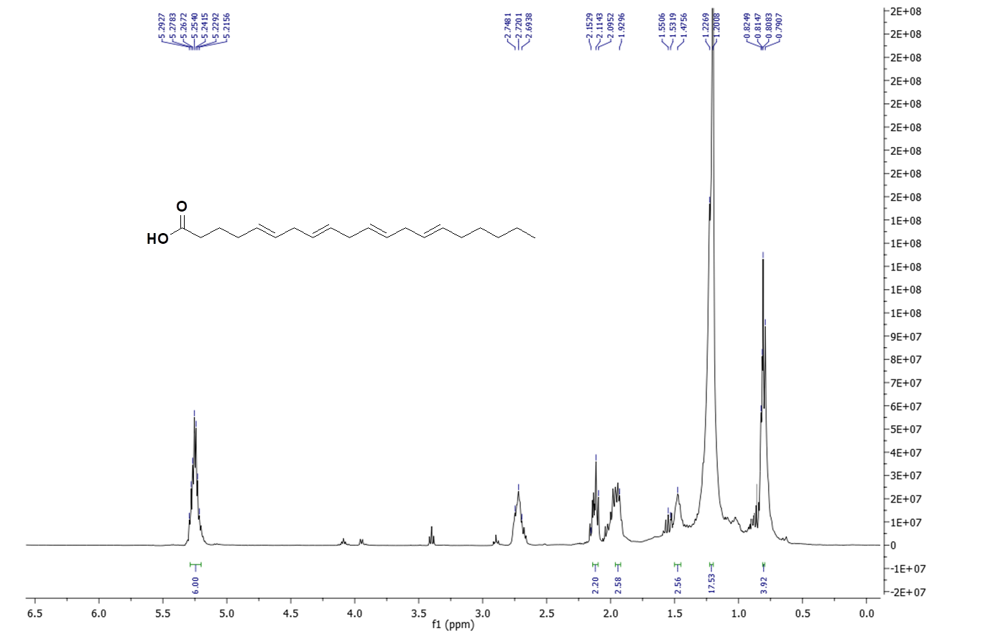
Figure S17. 1H NMR spectrum of compound 16 measured in DMSO-d₆ at 400 MHz
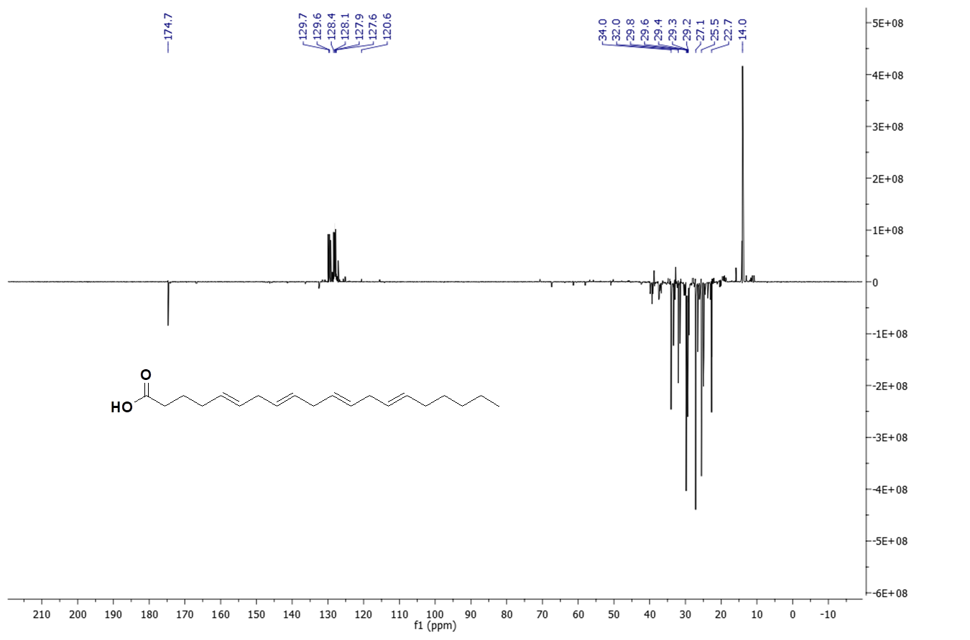
Figure S18. DEPT-Q NMR spectrum of compound 16 measured in DMSO-d₆ at 100 MHz
Figure S19. 1H NMR spectrum of compound 17 measured in DMSO-d₆ at 400 MHz
Figure S20. DEPT-Q NMR spectrum of compound 17 measured in DMSO-d₆ at 100 MHz
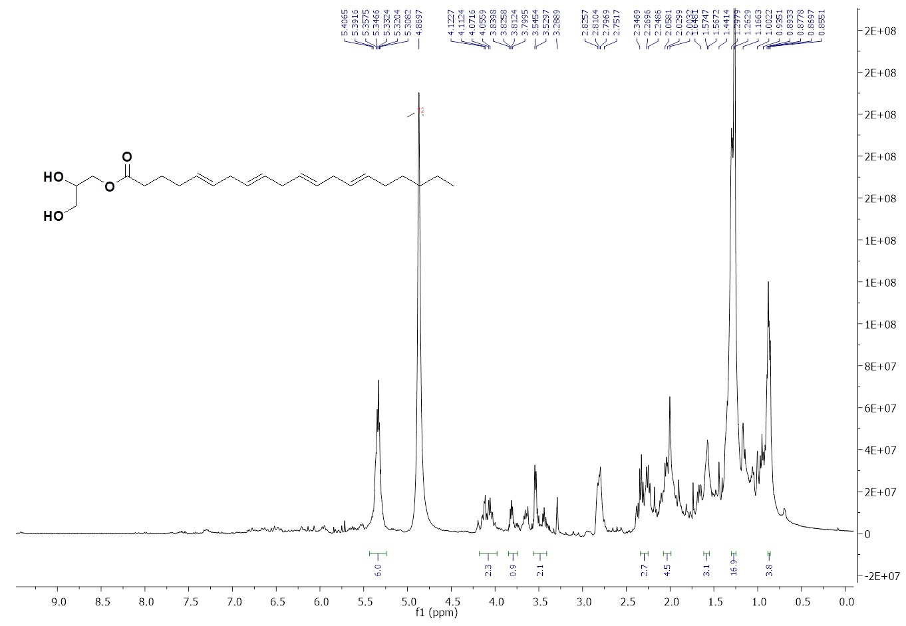
Figure S21. 1H NMR spectrum of compound 18 measured in CD₃OD-d₄ at 400 MHz
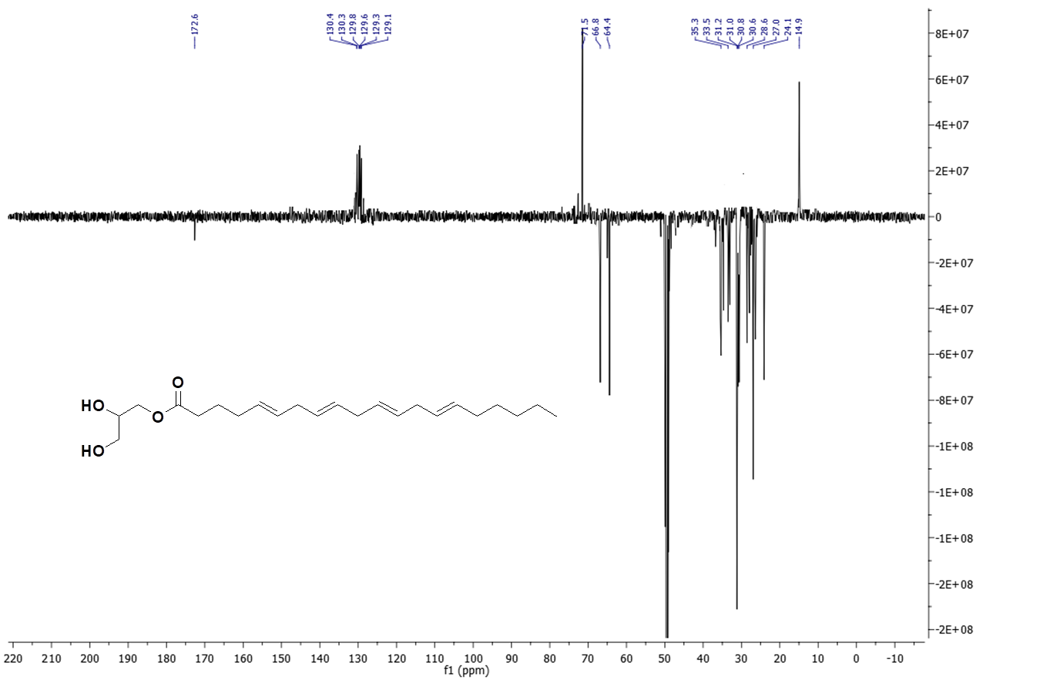
Figure S22. DEPT-Q NMR spectrum of compound 18 measured in CD₃OD-d₆ at 100 MHz
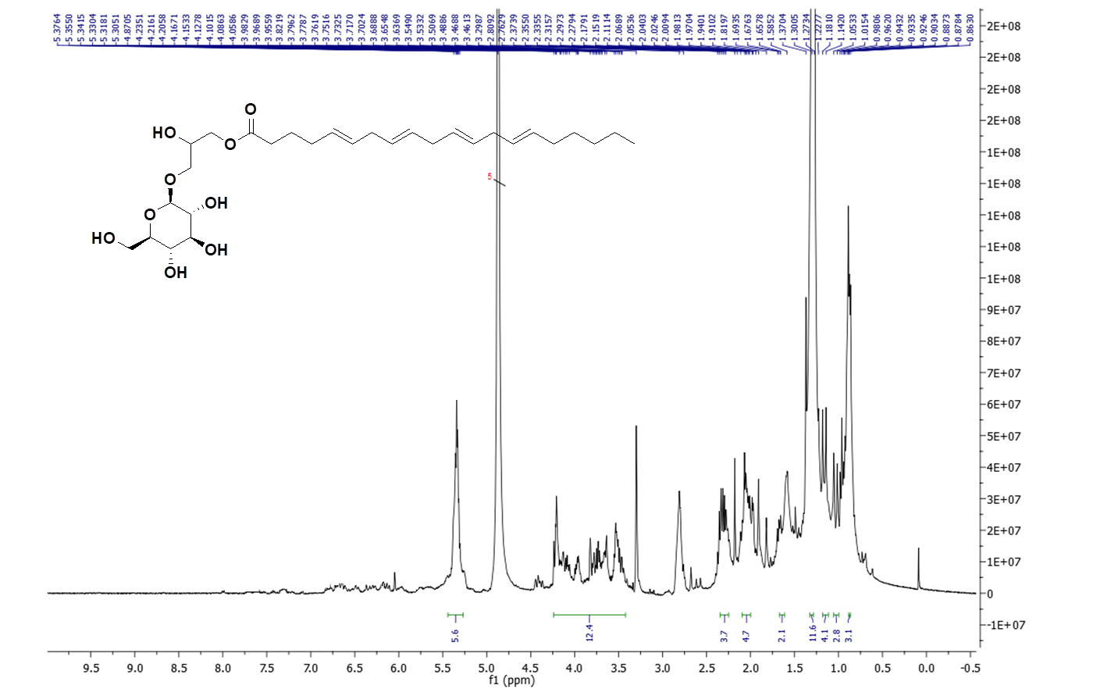
Figure S23. 1H NMR spectrum of compound 19 measured in CD₃OD-d₄ at 400 MHz
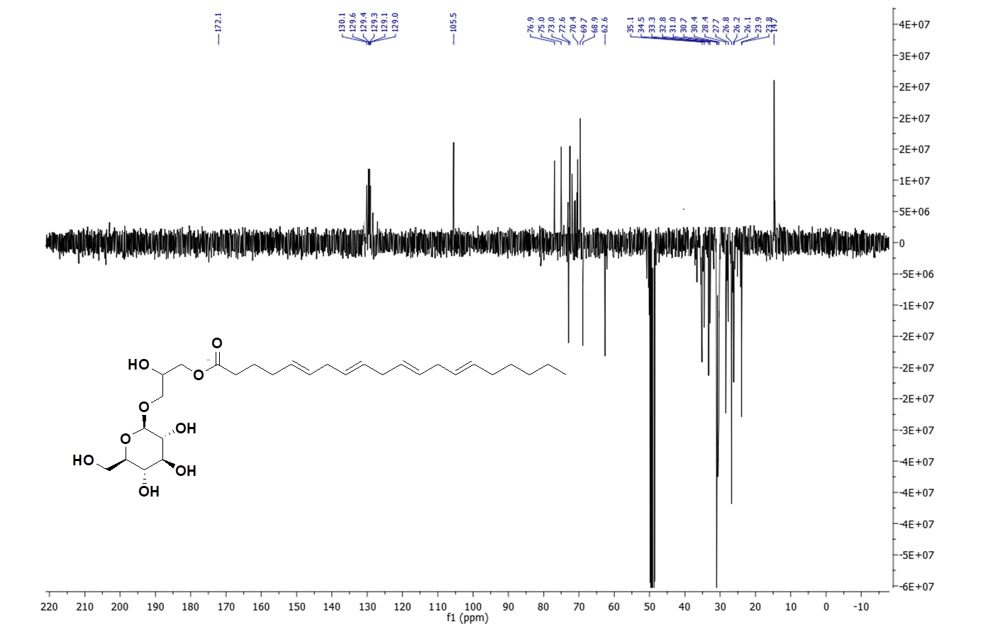
Figure S24. DEPT-Q NMR spectrum of compound 19 measured in CD₃OD-d₆ at 100 MHz
Figure S25. 1H NMR spectrum of compound 20 measured in DMSO-d₆ at 400 MHz
Figure S26. DEPT-Q NMR spectrum of compound 20 measured in DMSO-d₆ at 100 MHz
Figure S27. 1H NMR spectrum of compound 21 measured in D₂O at 400 MHz
Figure S28. DEPT-Q NMR spectrum of compound 21 measured in D₂O at 100 MHz

