Comparison of experimental and quantum chemical studies of the effect of different functionalities of graphene oxide/polymer composites onto selective CO₂ capture

Branislav Stankovic^{a,b}, Iranzu Barbarinª, Oihane Sanz,ª Radmila Tomovska^{a,c,*} and Fernando Ruipérez^{d,*}
ªPOLYMAT and Departamento de Química Aplicada, Facultad de Ciencias Químicas, University of the Basque Country UPV/EHU, Joxe Mari Korta Zentroa, Tolosa Hiribidea, 72, 20018 Donostia-San Sebastián, Spain;
^{b}Faculty of Physical Chemistry, University of Belgrade, Studentski Trg 12-16, Belgrade, 11050 Republic of Serbia
^{c}IKERBASQUE, Basque Foundation for Science, María Díaz de Haro 3, 48013 Bilbao, Spain
^{d}POLYMAT and Physical Chemistry Department, Faculty of Pharmacy, University of the Basque Country, 01006 Vitoria-Gasteiz, Spain

Content:
- Figure S1. Optimized geometry of the GO
- Figure S2. Optimized geometry of the MMA/BA/Am + CO₂ complex
- Figure S3. Optimized geometry of the MMA/BA/AEMH + CO₂ complex
- Figure S4. Optimized geometry of the MMA/BA/BS + CO₂ complex
- Figure S5. Optimized geometry of the MMA/BA/MClA + CO₂ complex
- Figure S6. Optimized geometry of the MMA/BA/GMA + CO₂ complex
- Figure S7. (a) Optimized geometry of the MMA/BA/HEMA + CO₂ complex. (b) Geometry of the copolymer without CO₂
- Figure S8. Optimized geometry of the MMA/BA/NaSS + CO₂ complex
- Figure S9. Optimized geometry of the GO/MMA/BA/GMA + CO₂ complex
- Figure S10. Optimized geometry of the GO/MMA/BA/AEMH + CO₂ complex
- Figure S11. Optimized geometry of the GO/MMA/BA/NaSS + CO₂ complex
- Figure S12. Optimized geometry of the GO/MMA/BA/HEMA + CO₂ complex
- Figure S13. Optimized geometry of the GO/MMA/BA/AEMH + N₂ complex
- Figure S14. Optimized geometry of the GO/MMA/BA/NaSS + N₂ complex
- Figure S15. Optimized geometry of the GO/MMA/BA/HEMA + N₂ complex
- Figure S16. Optimized geometry of the GO/MMA/BA/GMA + N₂ complex
- Figure S17. TGA curves of the functionalized GO-polymer composites
- Table S1. CO₂ and N₂ adsorption by the neat functionalized polymers and functionalized GO-polymer composites obtained at T = 25 ºC and P = 1 atm

1. Figures:
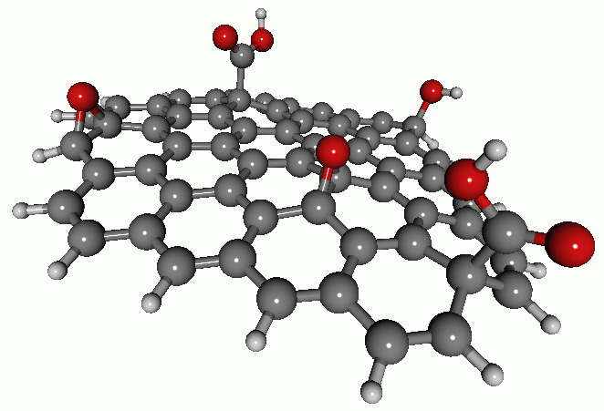
Figure S1. Optimized geometry of the GO
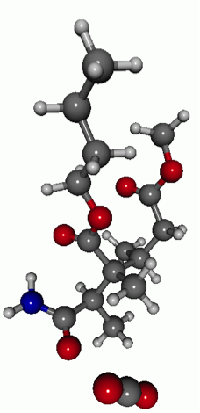
Figure S2. Optimized geometry of the MMA/BA/Am + CO₂ complex

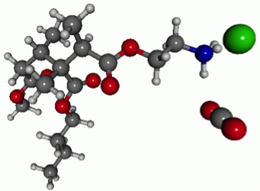
Figure S3. Optimized geometry of the MMA/BA/AEMH + CO₂ complex

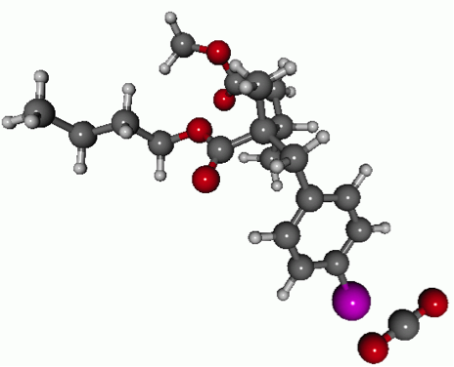
Figure S4. Optimized geometry of the MMA/BA/BS + CO₂ complex

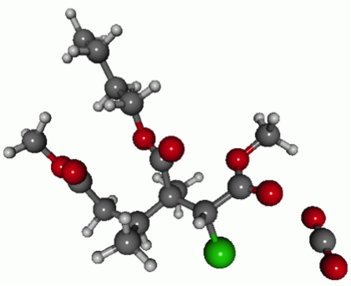
Figure S5. Optimized geometry of the MMA/BA/MClA + CO₂ complex

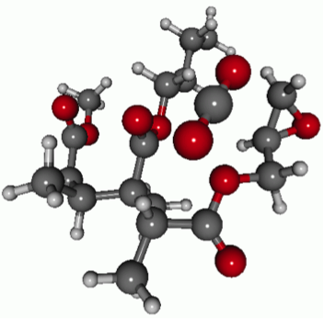
Figure S6. Optimized geometry of the MMA/BA/GMA + CO₂ complex

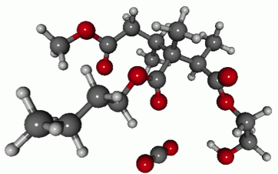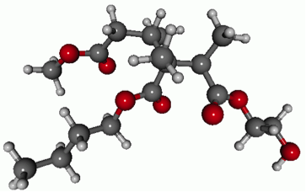
Figure S7. (a) Optimized geometry of the MMA/BA/HEMA + CO₂ complex. (b) Geometry of the copolymer without CO₂

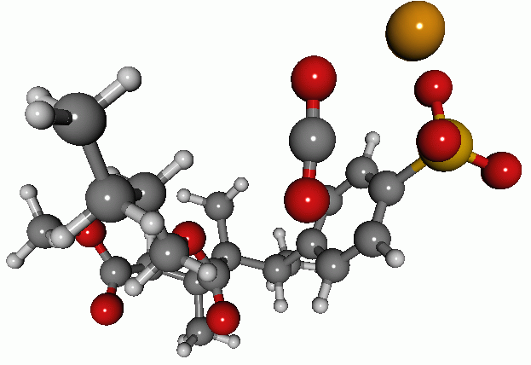
Figure S8. Optimized geometry of the MMA/BA/NaSS + CO₂ complex

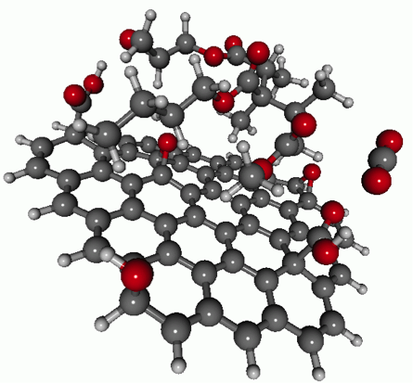
Figure S9. Optimized geometry of the GO/ MMA/BA/GMA + CO₂ complex

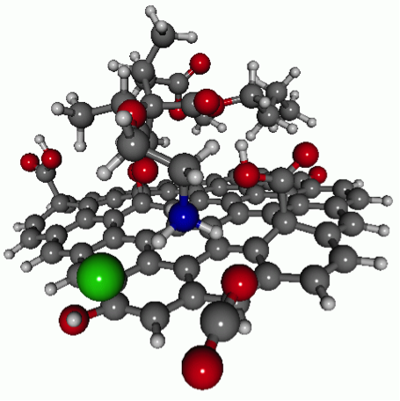
Figure S10. Optimized geometry of the GO/ MMA/BA/AEMH + CO₂ complex

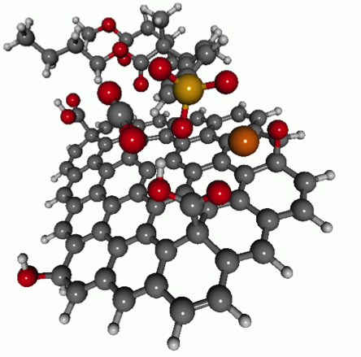
Figure S11. Optimized geometry of the GO/ MMA/BA/NaSS + CO₂ complex
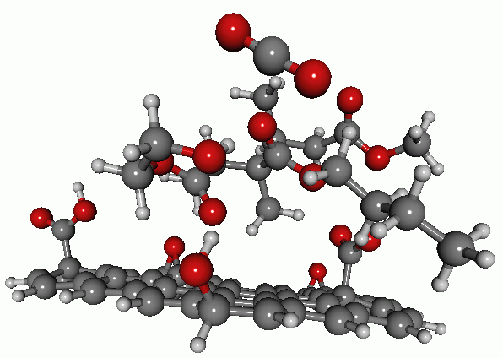
Figure S12. Optimized geometry of the GO/MMA/BA/HEMA + CO₂ complex

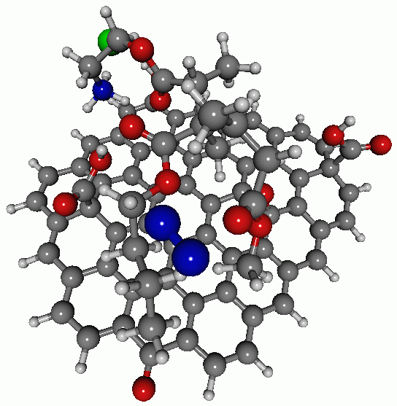
Figure S13. Optimized geometry of the GO/MMA/BA/AEMH + N₂ complex

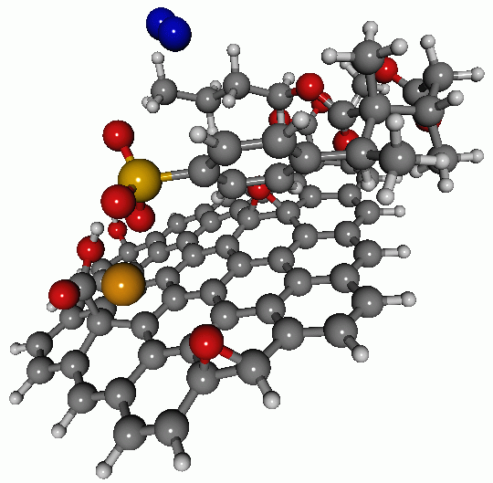
Figure S14. Optimized geometry of the GO/MMA/BA/NaSS + N₂ complex

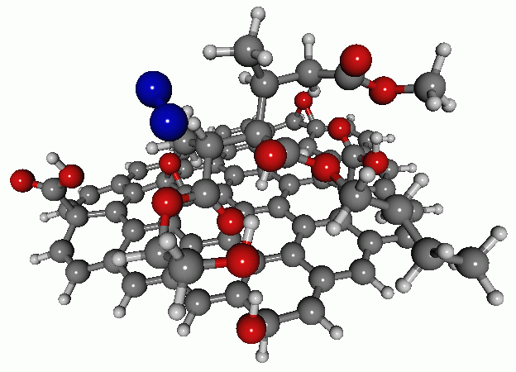
Figure S15. Optimized geometry of the GO/MMA/BA/HEMA + N₂ complex

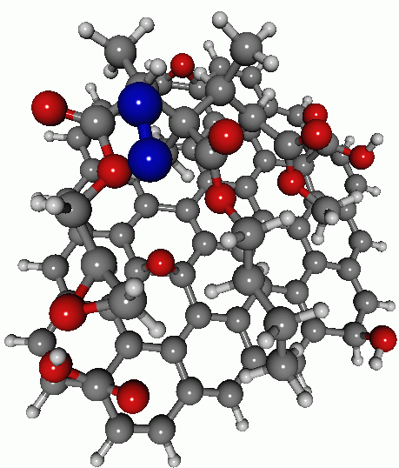
Figure S16. Optimized geometry of the GO/MMA/BA/GMA + N₂ complex

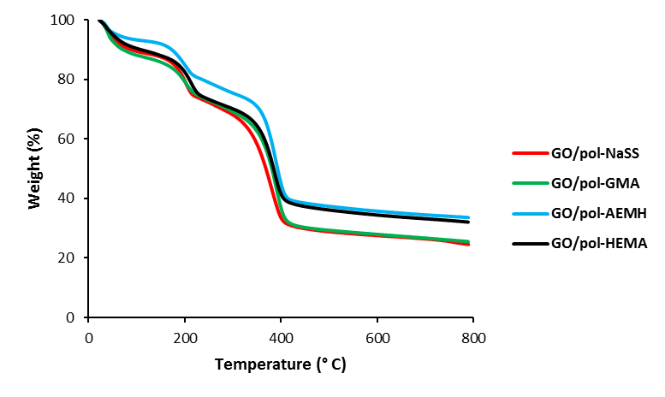
Figure S17. TGA curves of the functionalized GO-polymer composites

2. Tables:

Table S1. CO₂ and N₂ adsorption by the neat functionalized polymers and functionalized GO-polymer composites obtained at T=25ºC and P=1 atm

Composite | CO₂ adsorption  (mmol/g) |  | N₂ adsorption (mmol/g)
Composite | Neat polymer | GO/polymer | GO/polymer
GO/pol-NaSS | 0.067 | 0.67 | 0.60
GO/pol-GMA | 0.057 | 0.61 | 0.61
GO/pol-AEMH | 0.062 | 0.40 | 0.34
GO/pol-HEMA | 0.076 | 1.11 | 0.74

