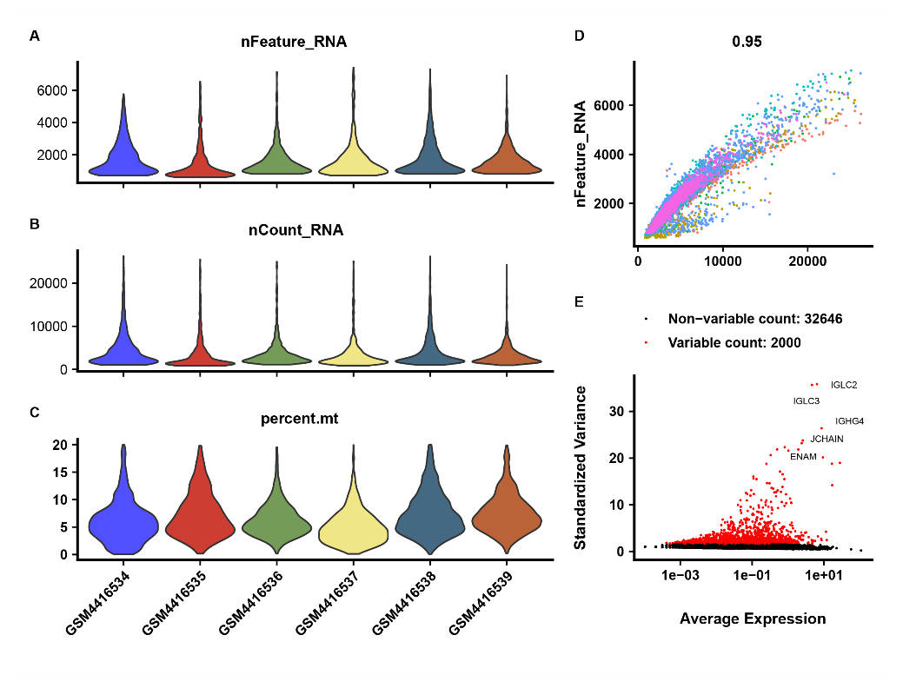
Figure S1 Single cell RNA-seq data quality control
A-C. violin diagram respectively shows that after cell quality control screening, (A). nFeature_RNA quantity in 6 samples, (B). nCount_RNA count in 6 samples, (C). mitochondrion proportion distribution in 6 samples; D. Correlation analysis between nFeature and nCount; E. The scatter plot shows the top 2000 genes (red dots) in the data, among which the labeled genes are the top 5 genes.

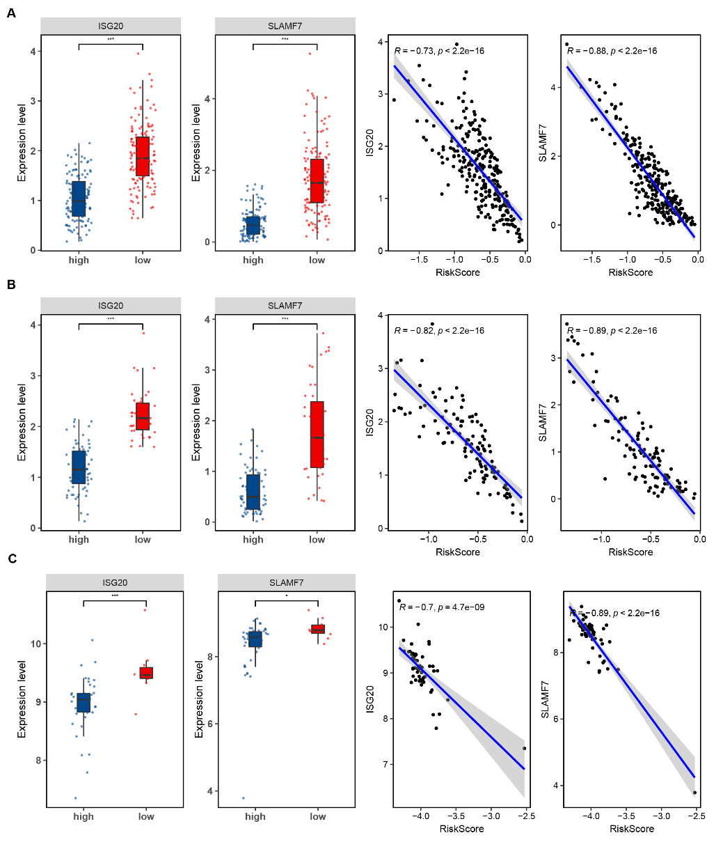

Figure S2 relationship between genes and risk score
A. Expression of ISG20 and SLAMF7 genes in high and low risk groups (left, box plot) and correlation with RiskScore (right, scatter plot) in the training set; B. Expression of ISG20 and SLAMF7 genes in high and low risk rating groups (left, box plot) and correlation with RiskScore (right, scatter plot); C. External verification focused on the expression of ISG20 and SLAMF7 genes in high and low risk groups (left, box diagram) and the correlation with RiskScore (right, scatter diagram).

