Supporting information
Synthesis and in vitro SAR evaluation of natural vanillin-based chalcones tethered quinolines as antiplasmodial agents
Nitin H. Andhare^{[a,c,e]}, Mohammad Anas^{[b]}, Sumit K. Rastogi^{[a,c]}, Ashan Manhas^{[b]}, Yogesh Thopate^{[a,c]}, Kumkum Srivastava,^{[b]} Niti Kumar^{[b]} and Arun K Sinha*^{[a,c,d]}
[a] Medicinal and Process Chemistry Division, CSIR-Central Drug Research Institute, Sector 10, Jankipuram Extension, Sitapur Road, Lucknow (226031) India.
[b] Molecular Microbiology and Immunology, CSIR-CDRI, Sector 10, Jankipuram Extension, Sitapur Road, Lucknow. 226031, India.
[c] Academy of Scientific and Innovative Research (AcSIR), Ghaziabad. 201002, India.
[d] Present address: Kohlan University, Chaibasa, West Singhbhum, Jharkhand. 833201, India.
[e] Present address: College of Pharmacy, Seoul National University, Seoul, 08826, South Korea

Content:
- Representative NMR Spectra of synthesized chalcones 2-11
- Representative HRMS Spectra of synthesized chalcones 12-16

Representative Spectra of synthesized chalcones
¹H NMR for compound 3
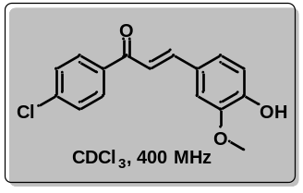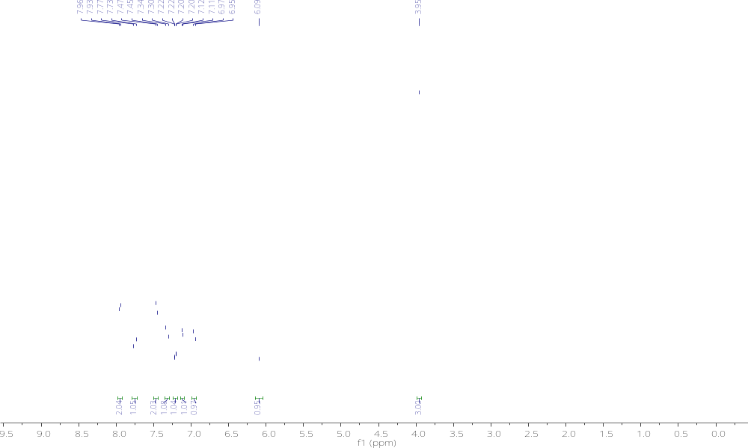

¹³C NMR for compound 3
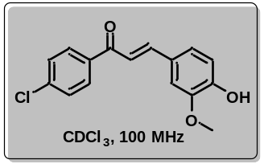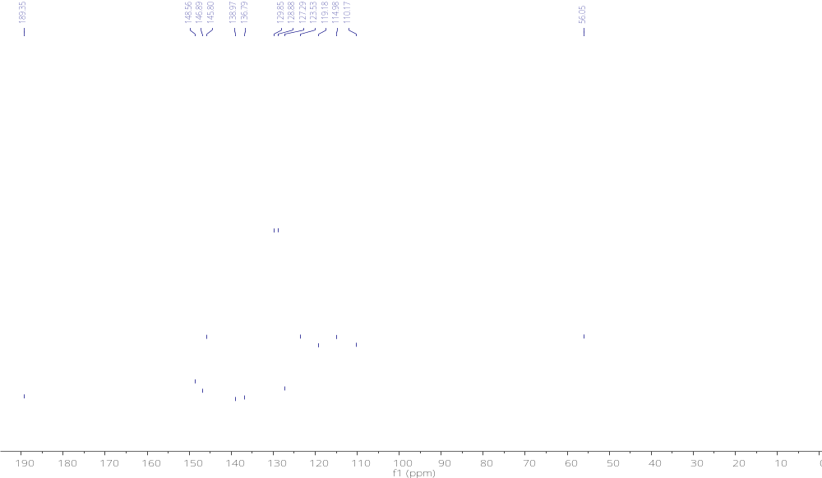

¹HNMR for compound 4
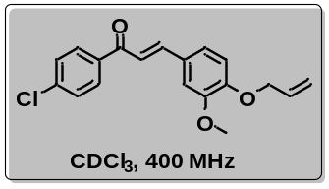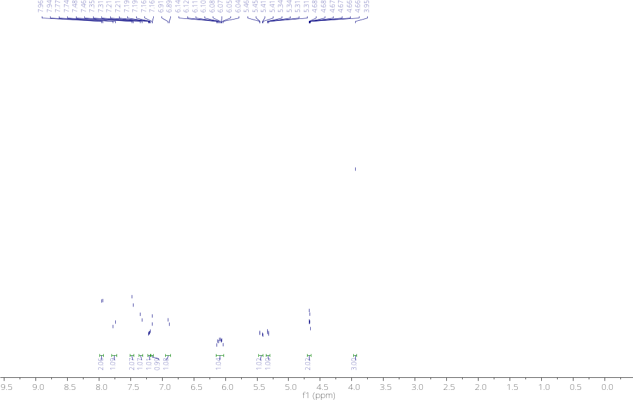

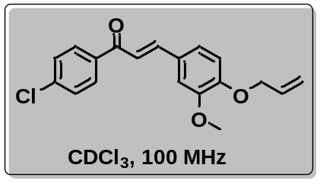¹³C NMR for compound 4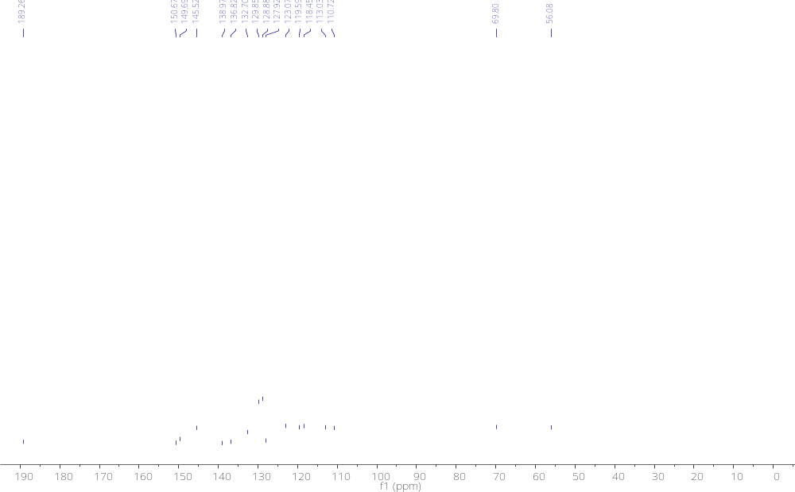

¹H NMR for compound 3c
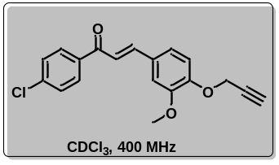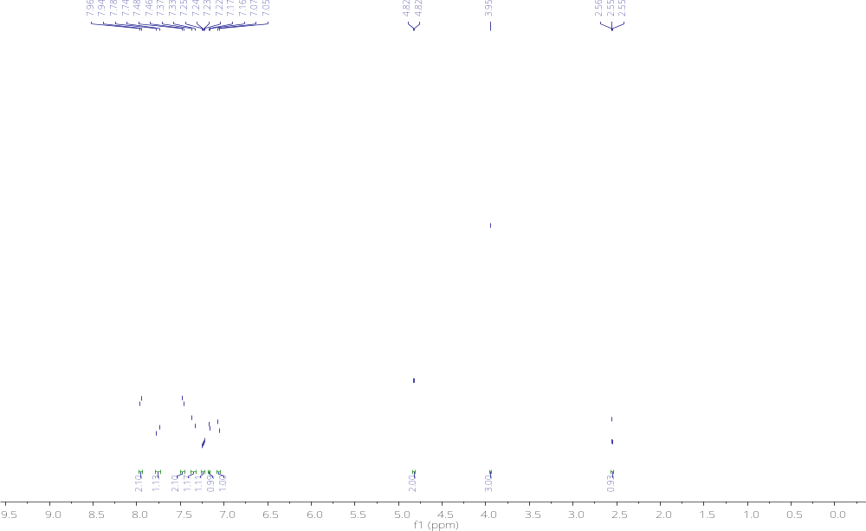

¹³C NMR for compound 3c
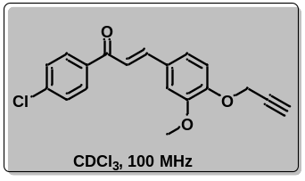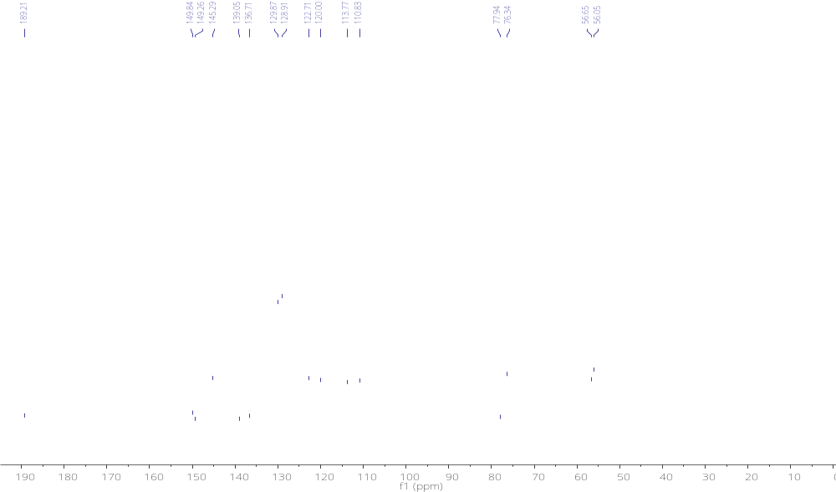

¹H NMR for compound 3e
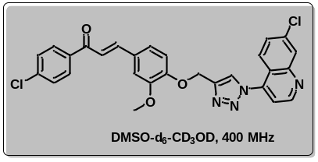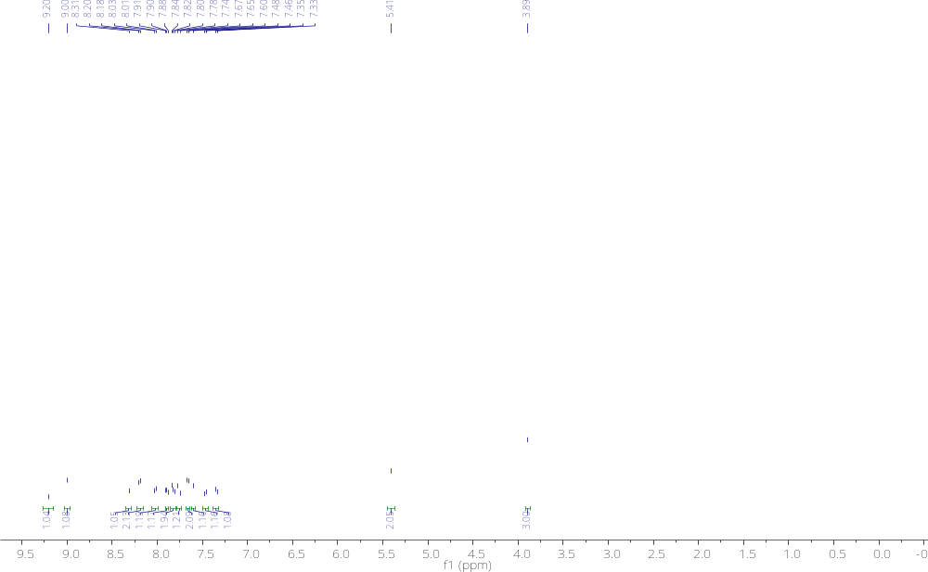

¹³C NMR for compound 3e
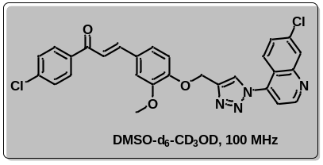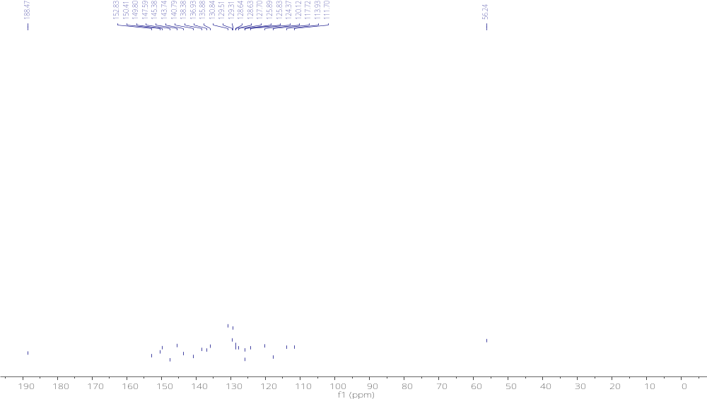

¹H NMR for compound 6
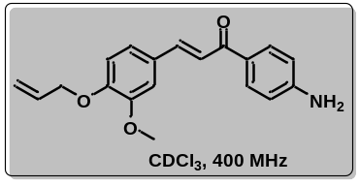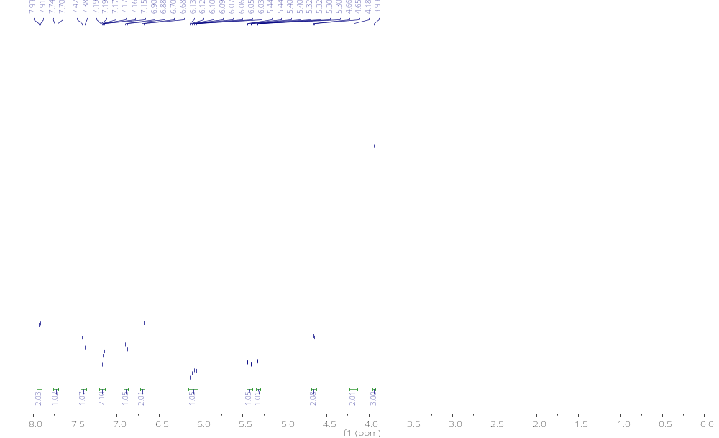

¹³C NMR for compound 6
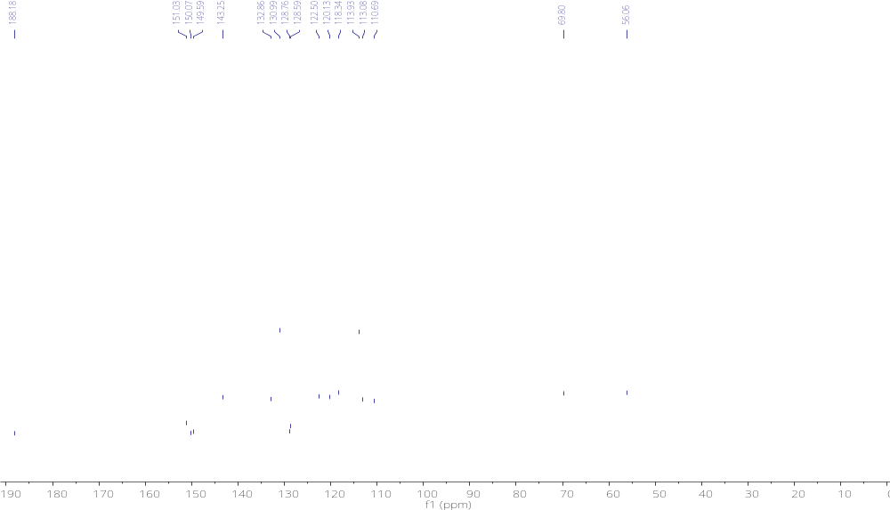

¹H NMR for compound 7
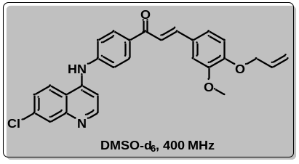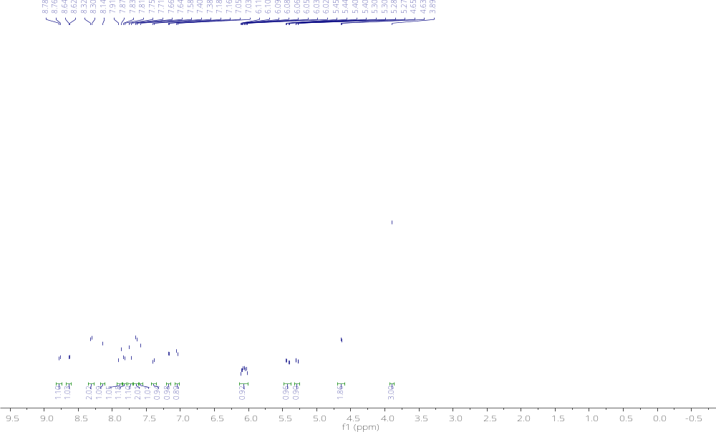

¹³C NMR for compound 7
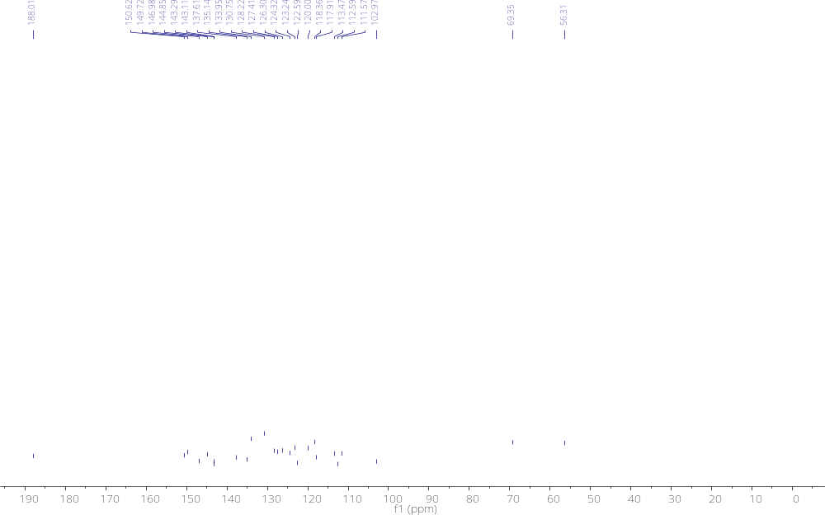

¹H NMR for compound 14b
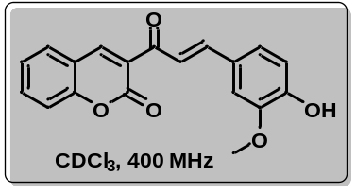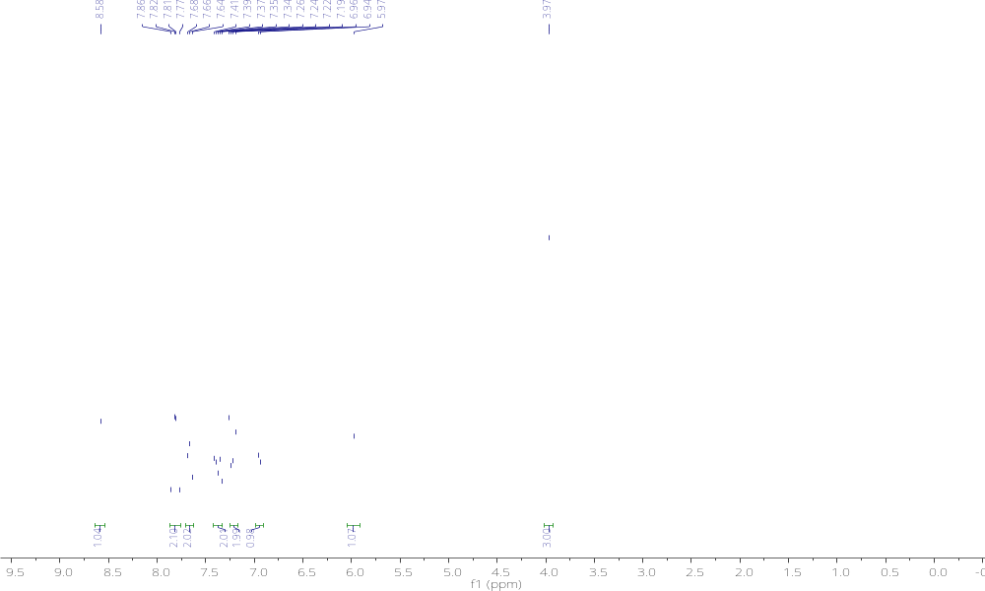

¹³C NMR for compound 14b
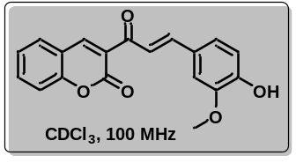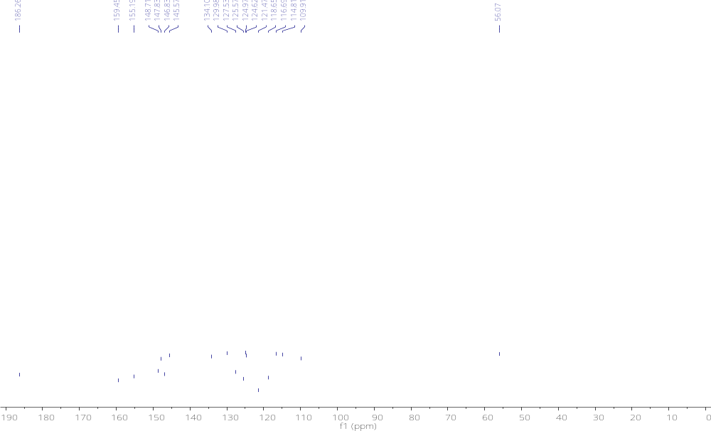

¹H NMR for compound 16
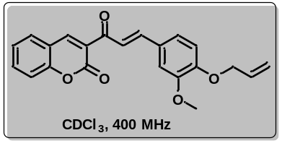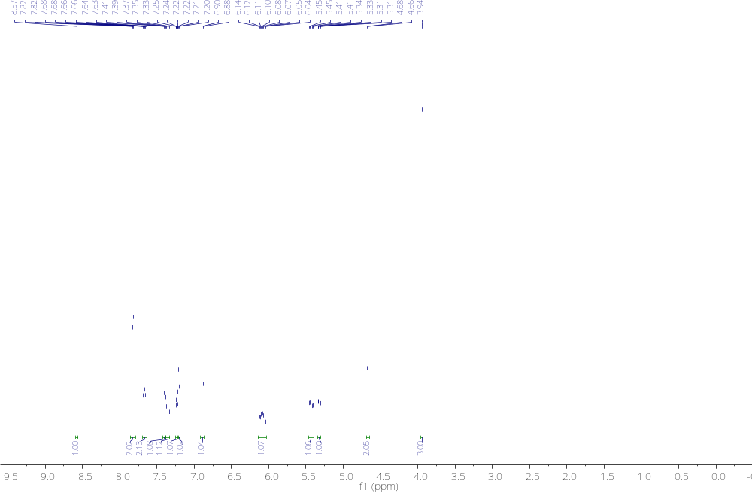

¹³C NMR for compound 16
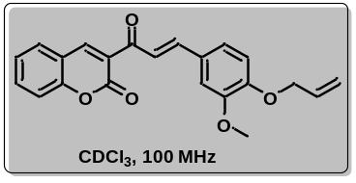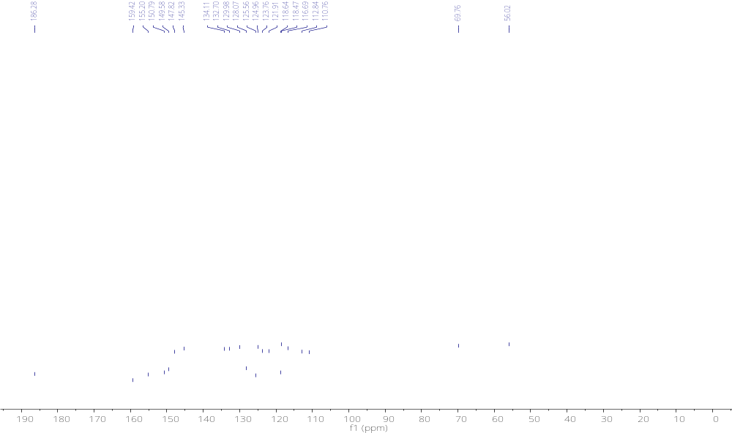

¹H NMR for compound 17a
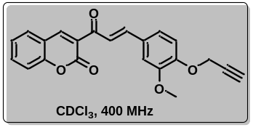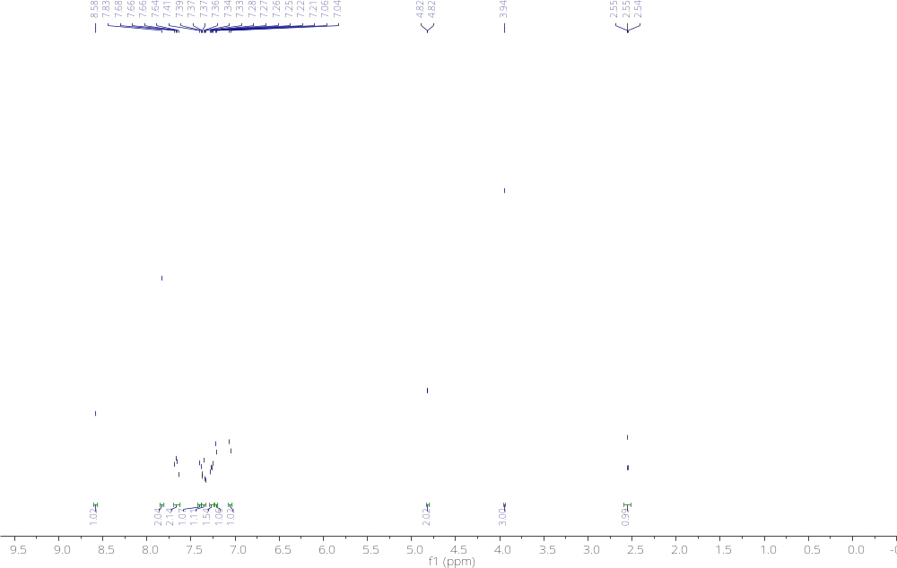

¹³C NMR for compound 17a
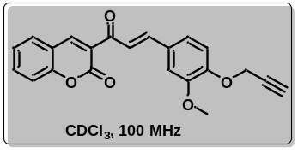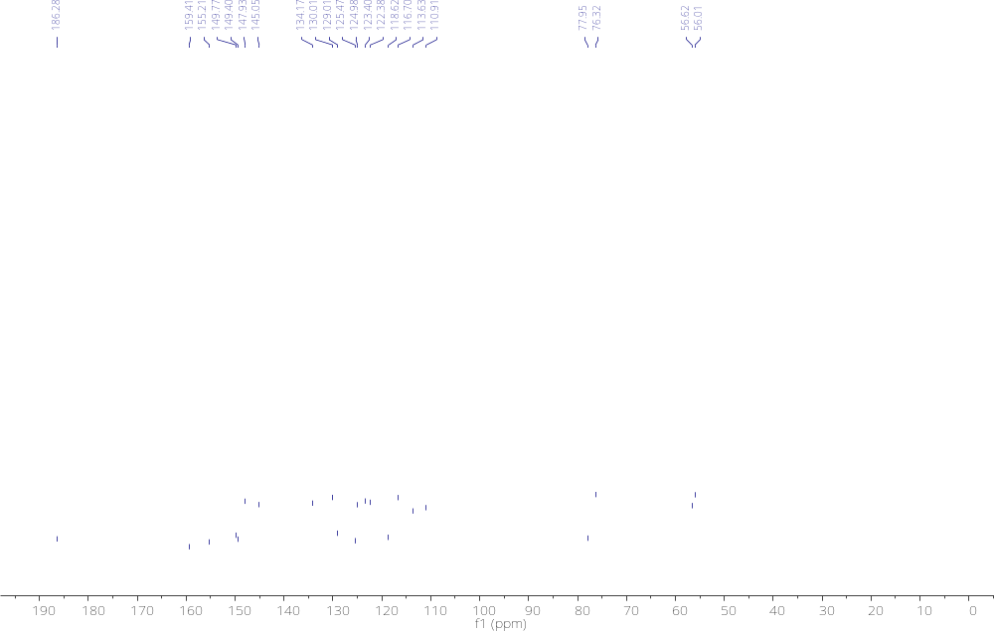

¹H NMR for compound 19
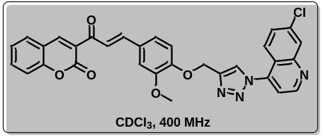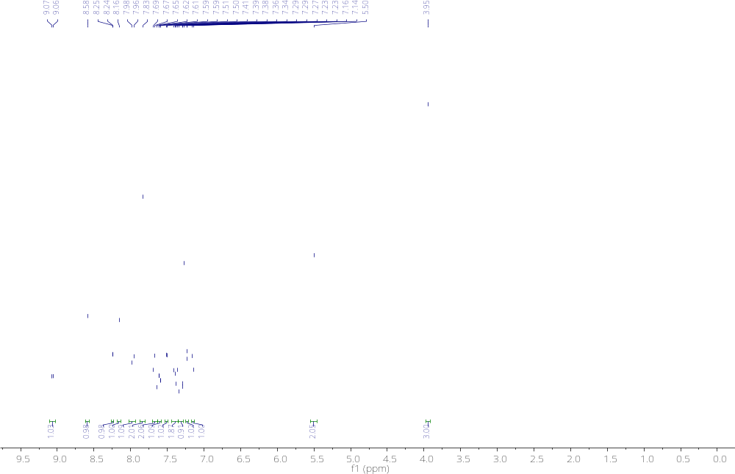

¹³C NMR for compound 19
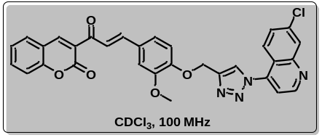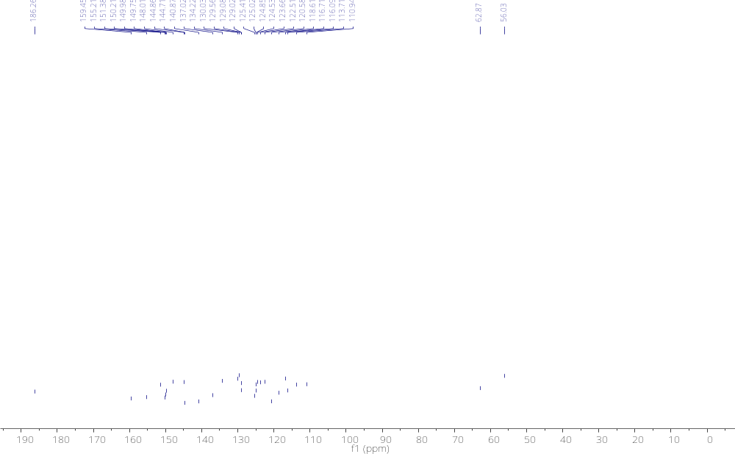

HRMS Spectras
HRMS for compound 3
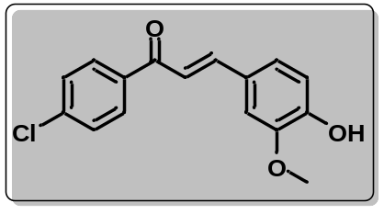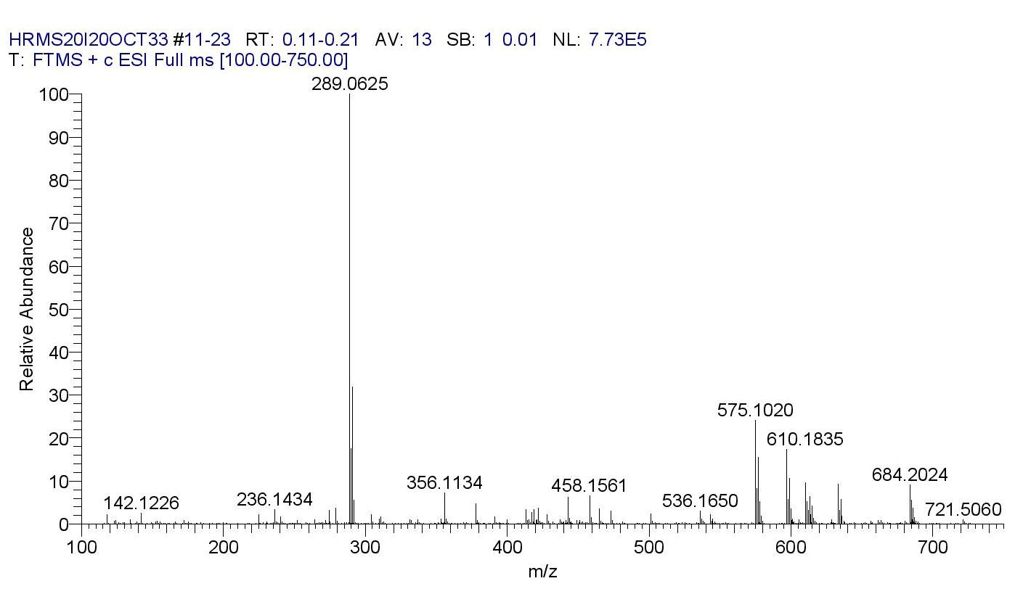

HRMS for compound 4
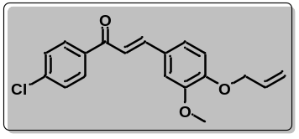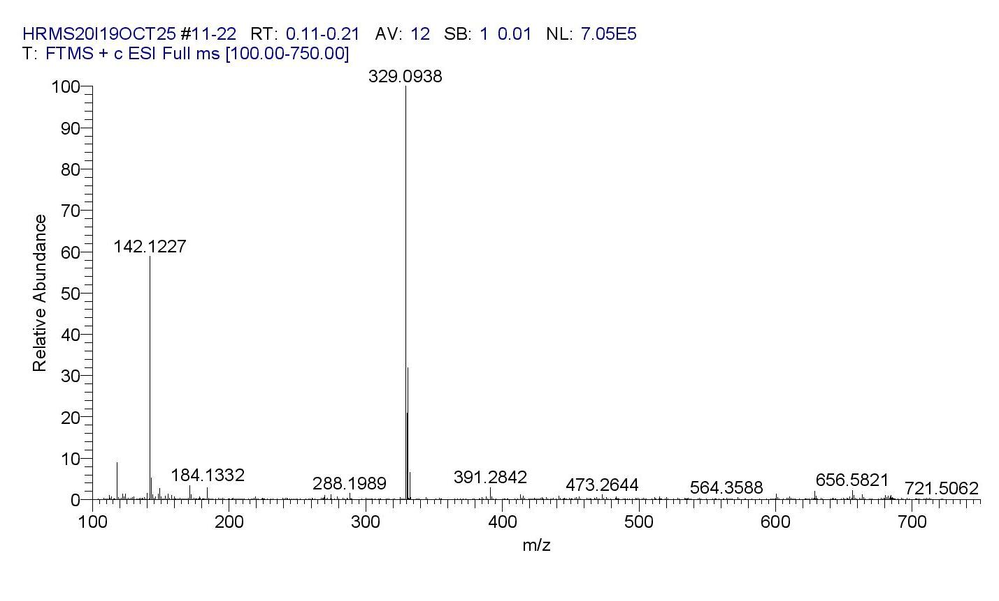

HRMS for compound 3c
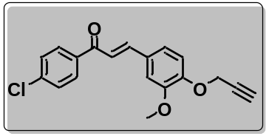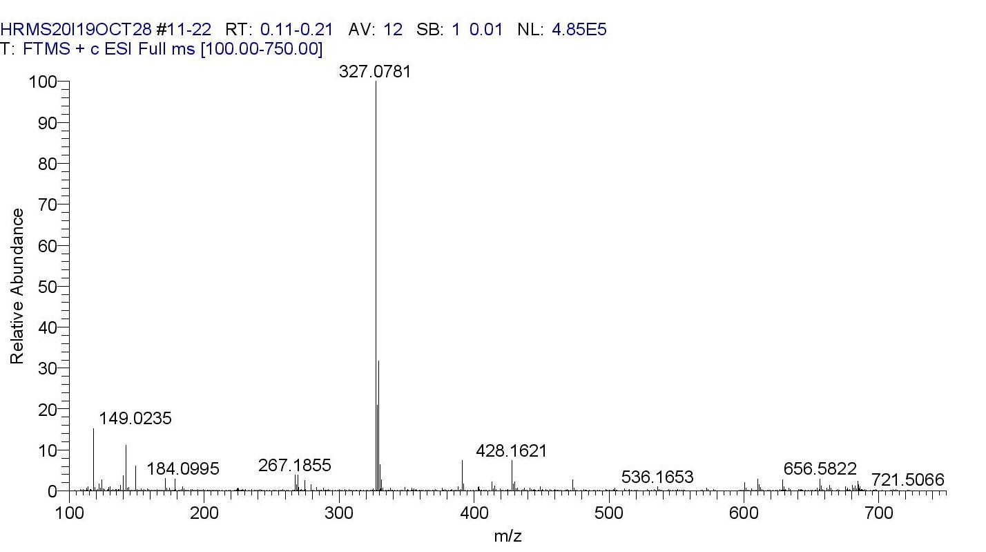

HRMS for compound 3d
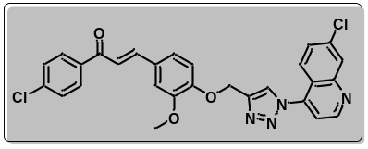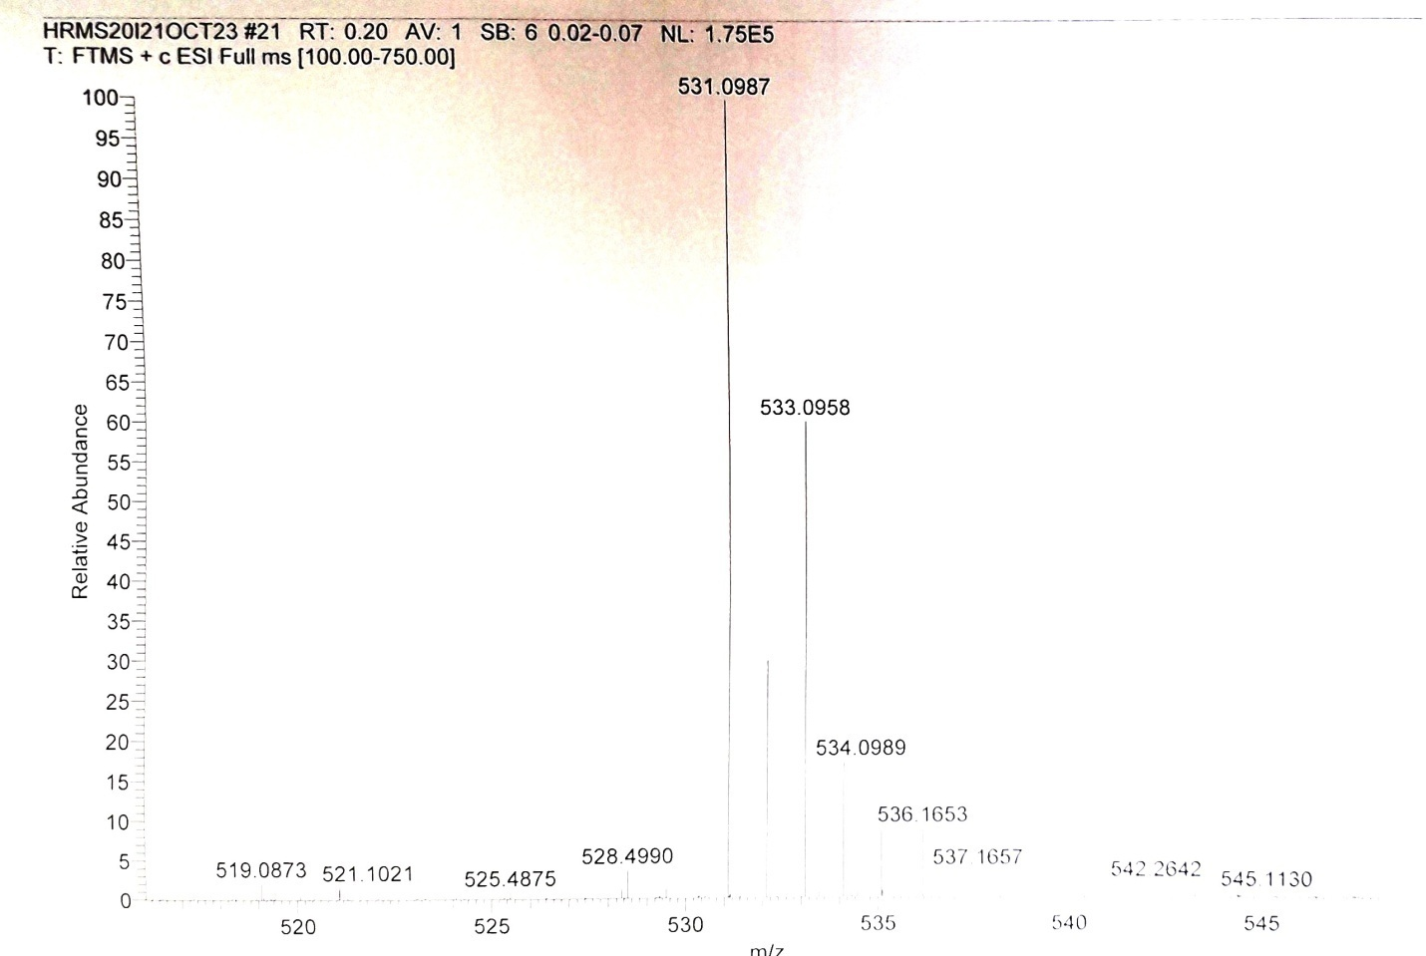

HRMS for compound 6
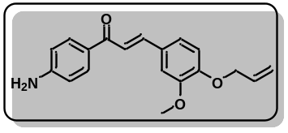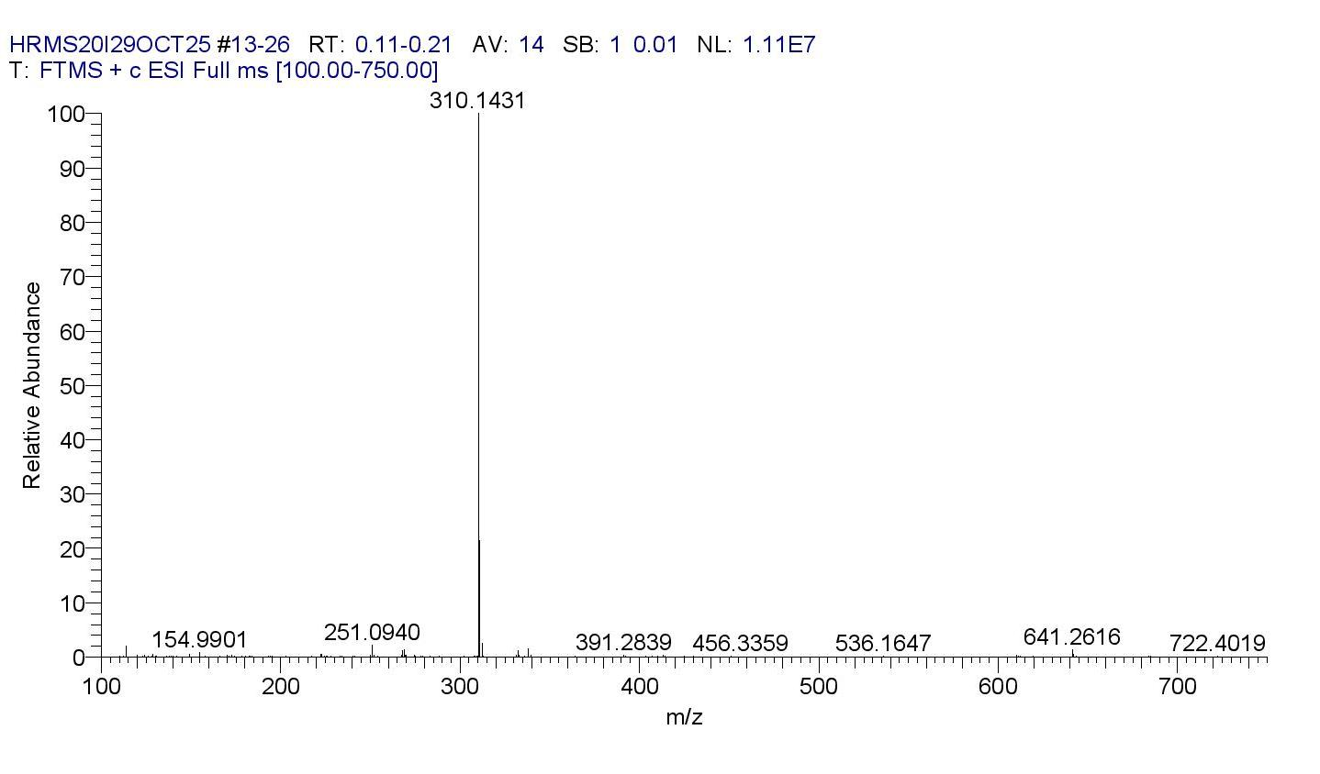

HRMS for compound 7
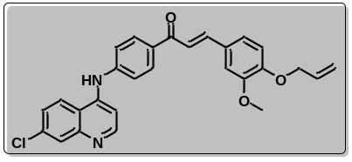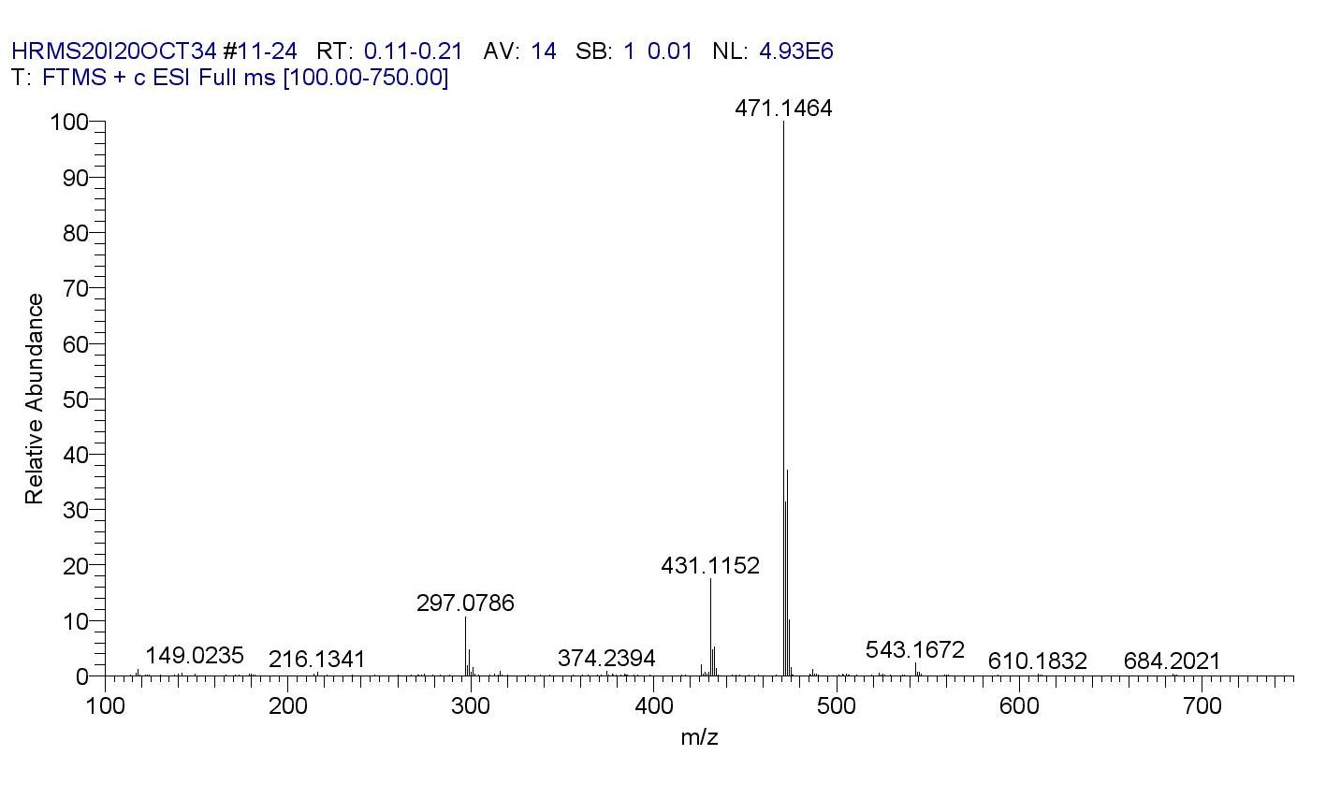

HRMS for compound 14b
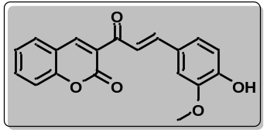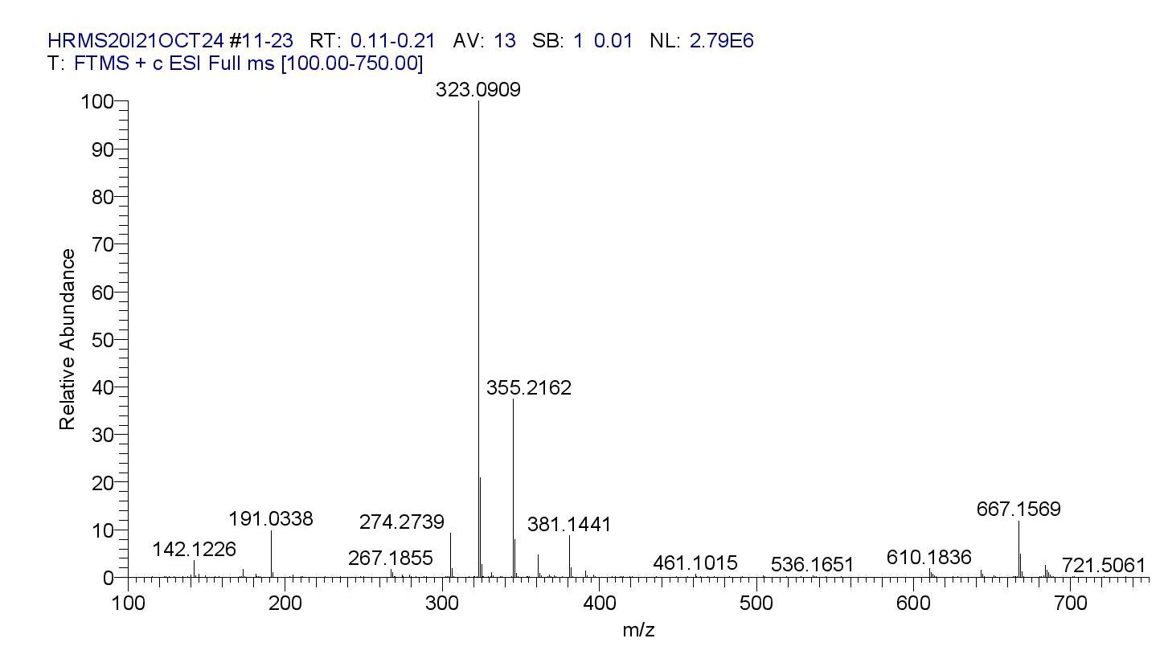

HRMS for compound 16
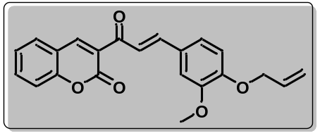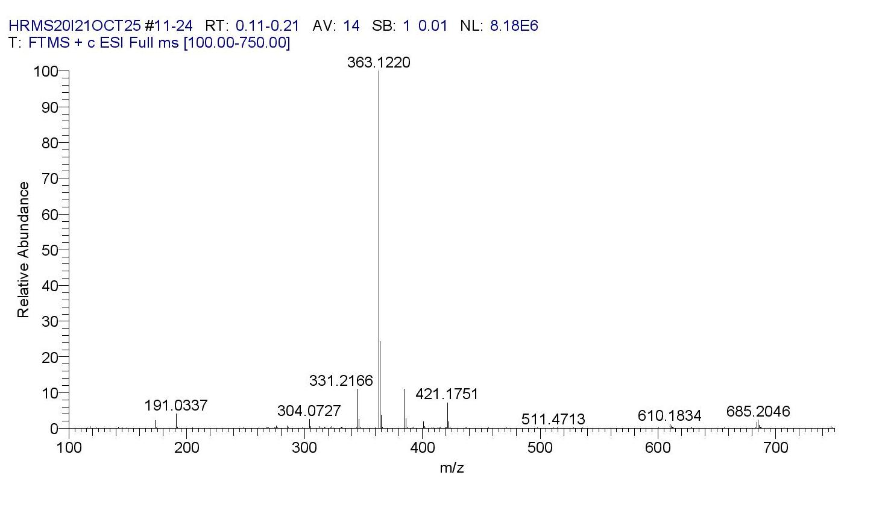
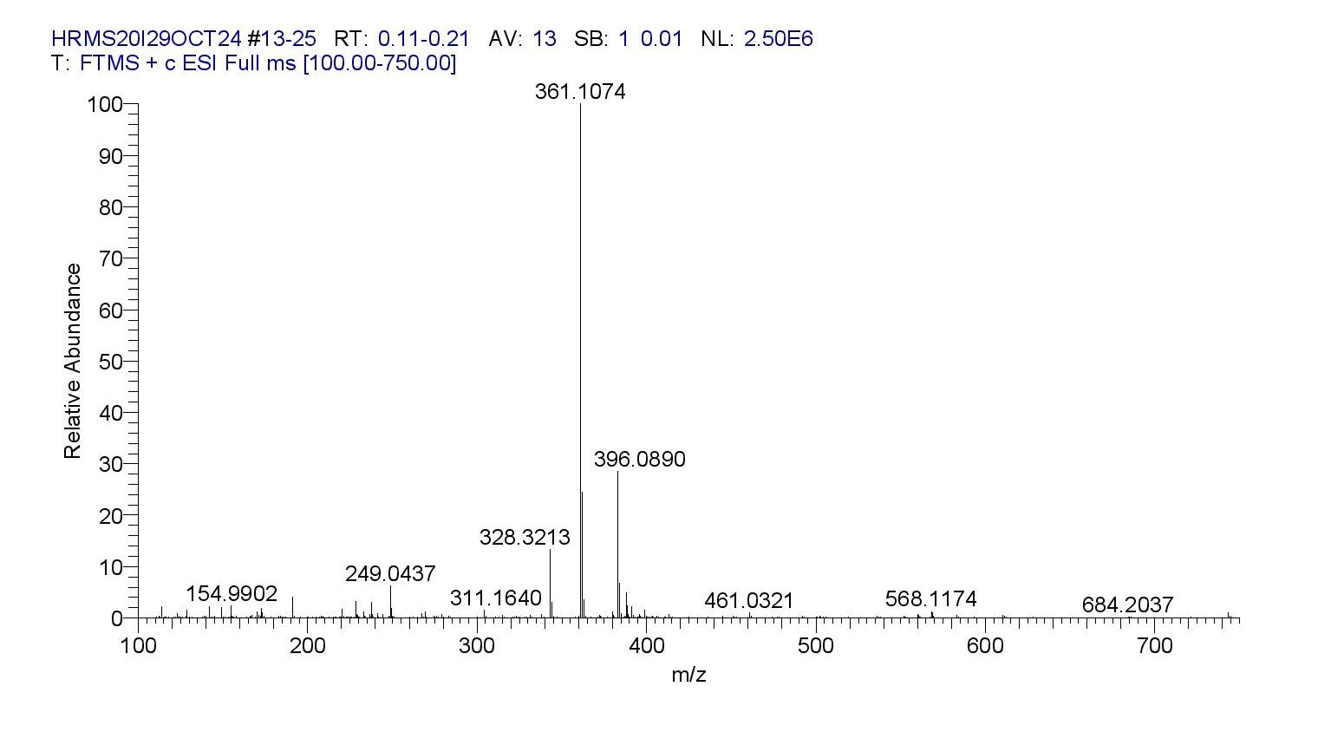
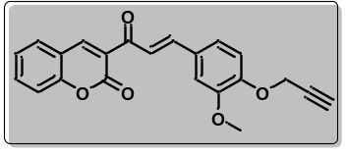HRMS for compound 17

