Supporting Information

Pseudocapacitive lithium-rich disordered rocksalt vanadium oxide with 3D lithium-ion transport pathways for high-performance lithium-ion capacitor

Han Zhaoª, Minghao Huaª, Chongxing Liª, Tong Liª, Yuying Qinª, Shuxian Zhangª, Xiaohang Lin* ª, Longwei Yinª, Rutao Wang*^{a,b},

ªKey Laboratory for Liquid-Solid Structural Evolution and Processing of Materials, Ministry of Education, School of Materials Science and Engineering, Shandong University, Ji’nan 250061, China
E-mail: rtwang@sdu.edu.cn; lxh12345@sdu.edu.cn
^{b}Suzhou Institute of Shandong University, Suzhou 215123, China
Han Zhao and Minghao Hua contributed equally to this work

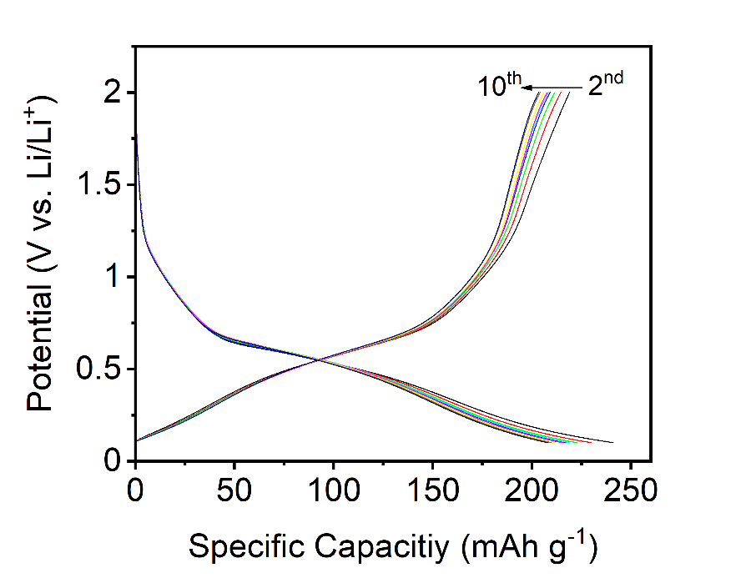
Fig. S1. Charging/discharging curves of DRX-Li₃V₂O₅ from 2nd to 10th cycles at a current density of 0.1 A g⁻¹.

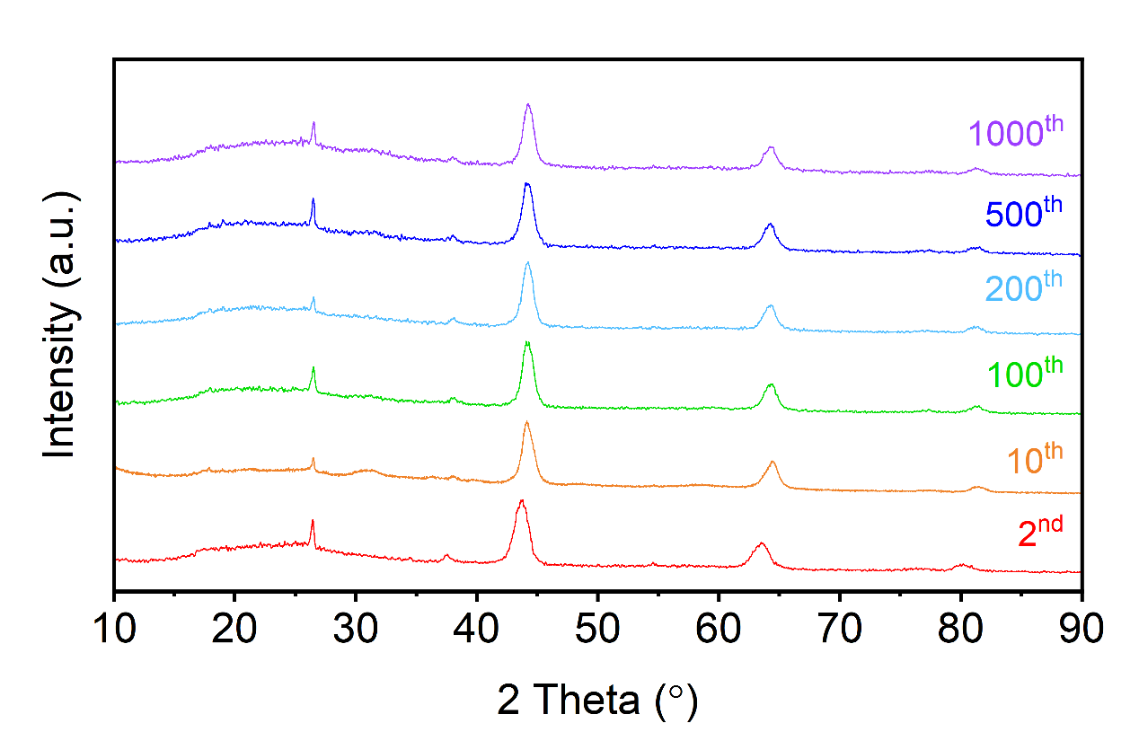
Fig. S2. Ex-situ XRD curves of DRX-Li₃V₂O₅ anode at 0.1 V cycled after 2 cycles under a charge/discharge current density of 0.1 A g⁻¹ and long cycles (10, 100, 200, 500 and 1000) under a charge/discharge current density of 1 A g⁻¹.

Fig. S3. TEM image of DRX-Li₃V₂O₅ anode showing the bulk-morphology.

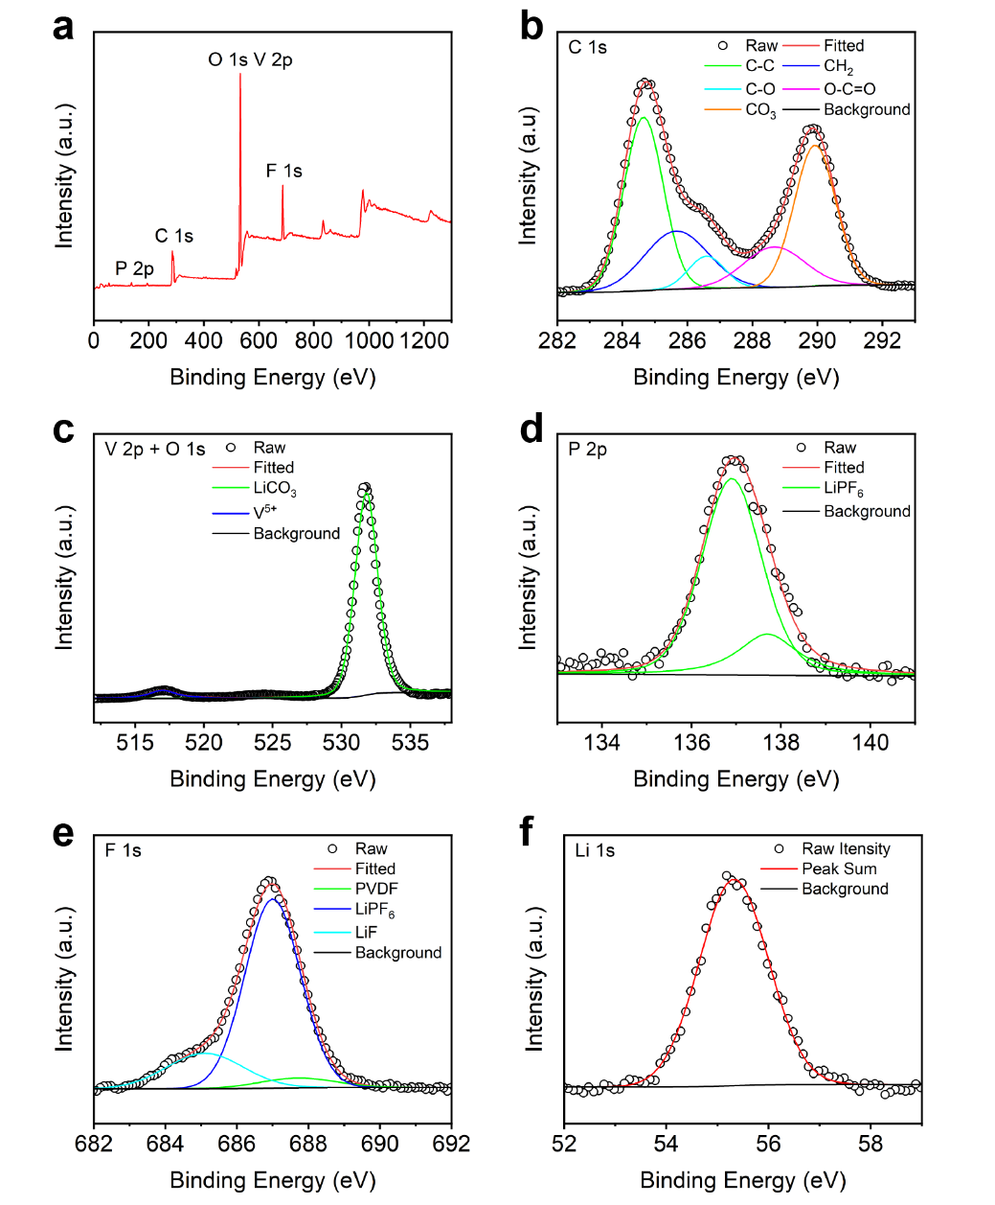
Fig. S4. XPS spectra of DRX-Li₃V₂O₅ anode after 10 cycles. a Survey spectrum. b C 1s. c V 2p + O 1s. d P 2p. e F 1s. f Li 1s.

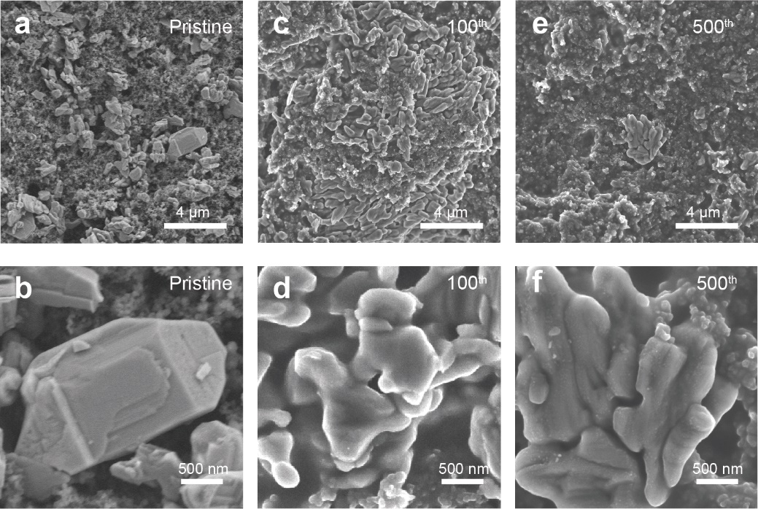
Fig. S5. a and b SEM images of V₂O₅ electrode. c, d and e, f SEM images of DRX-Li₃V₂O₅ electrode cycled at 100th and 500th, respectively.

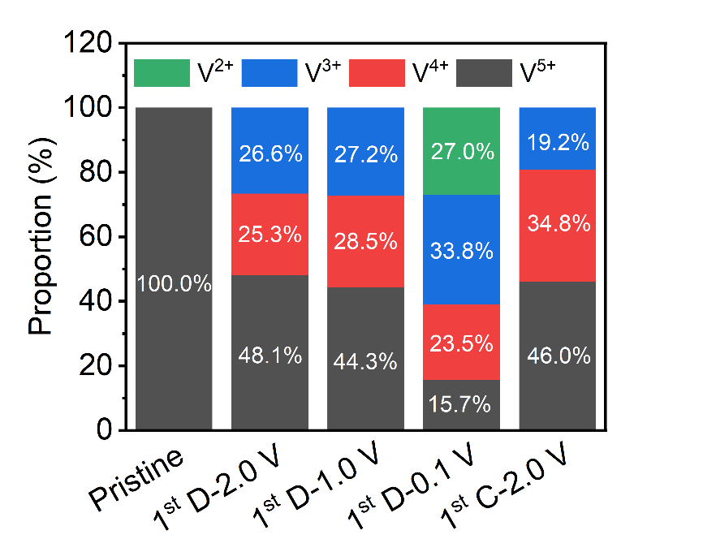
Fig. S6. The proportions of different valances of V atom of pristine V₂O₅ electrode and followed DRX-Li₃V₂O₅ electrode during the initial cycling state.

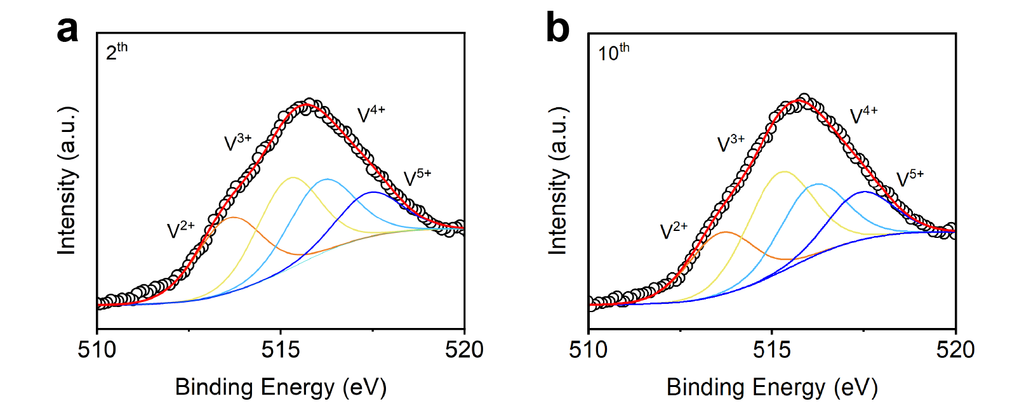
Fig. S7. The V 2p XRS spectra for the electrode discharged to 0.1 V in the a 2st cycle and b 10th cycle.

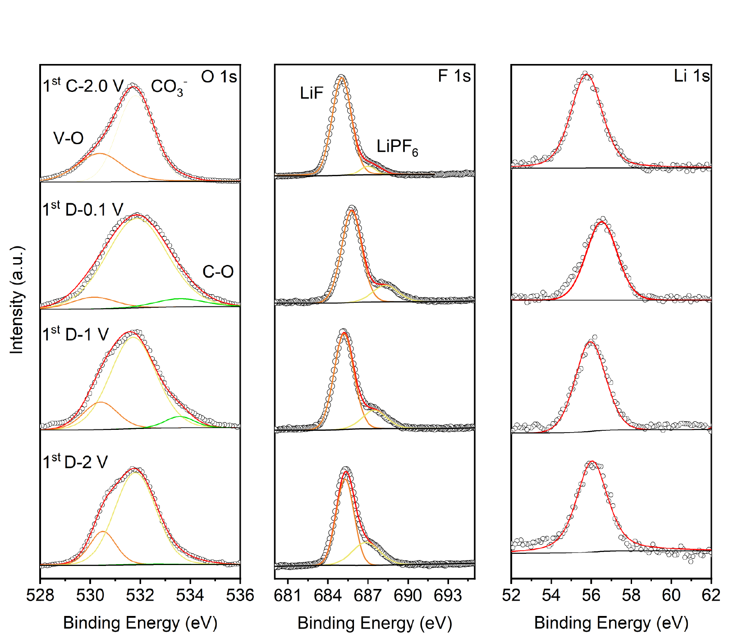
Fig. S8. Ex-situ XPS spectra curves of DRX-Li₃V₂O₅ anode during the different charging/discharging states: O 1s, F 1s, Li 1s.

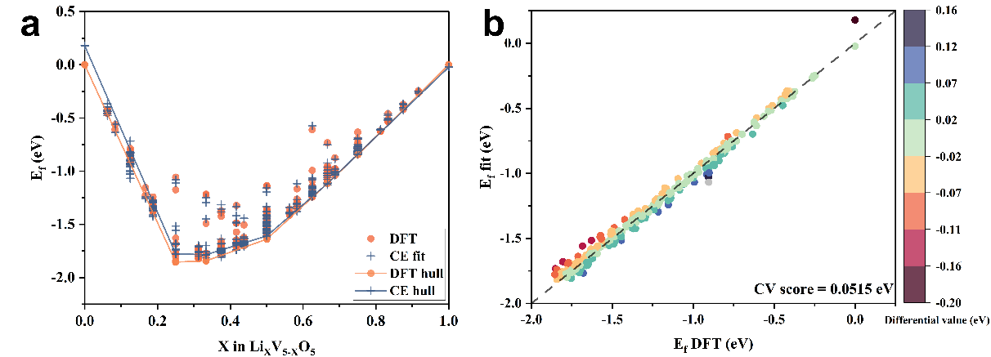
Fig. S9. Cluster expansion results for Li_{x}V_{5-x}O₅ system. a Formation energies per site of Li_{x}V_{5-x}O₅ calculated by DFT, shown in filled orange circles. Corresponding formation energies fitted from the cluster expansion (CE) method are shown as bule crosses. The ground state configurations are connected by an orange line for DFT calculated formation energies, and the ground state configurations from CE method are represented by a blue line. b Predicted formation energies using CE approach versus energies obtained by DFT calculation, which show the predictive power of the fitted cluster expansion models. The different color mappings represent the difference value between the DFT energies and the CE predicted energies. CE predicted energies show the good agreement with DFT calculations.

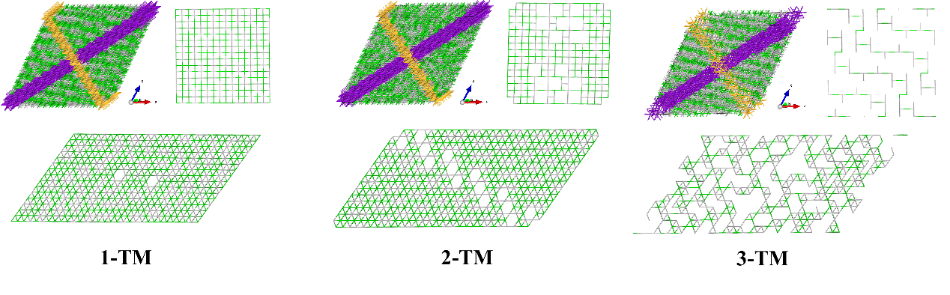
Fig. S10. Representative Monte Carlo-simulated structures of Li_{x}V_{5-x}O₅ (x=3) at 300 K. Each structure of 1-TM, 2-TM, 3-TM only shows the atoms contained in the corresponding tetrahedral type. Yellow and purple areas indicate the locations of the slices in the whole structure. The green line indicates bonding to the Li site, and the gray line indicates bonding to the V site.

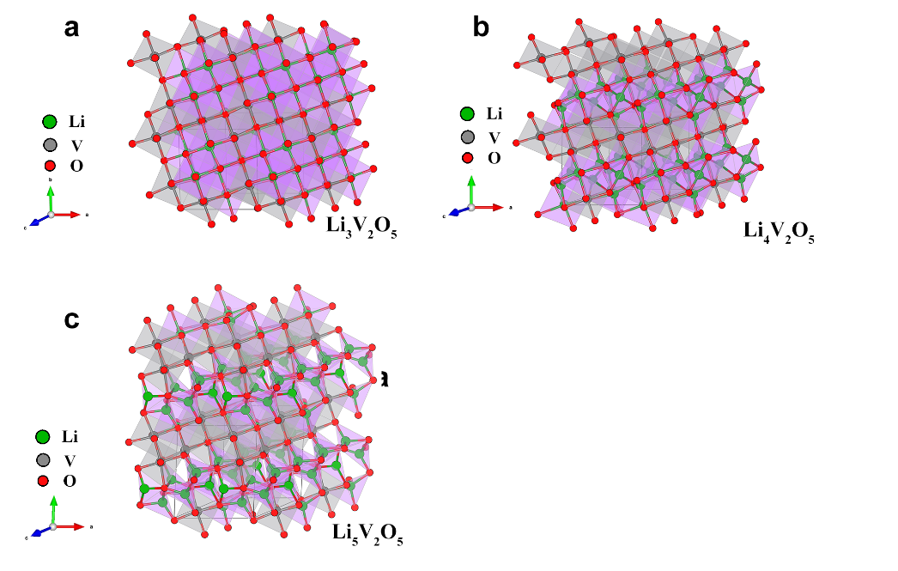
Fig. S11. The most stable crystal structures of Li_{3+x}V₂O₅ used to investigate the electronic properties by DFT calculations: a Li₃V₂O₅, b Li₄V₂O₅, and c Li₅V₂O₅.

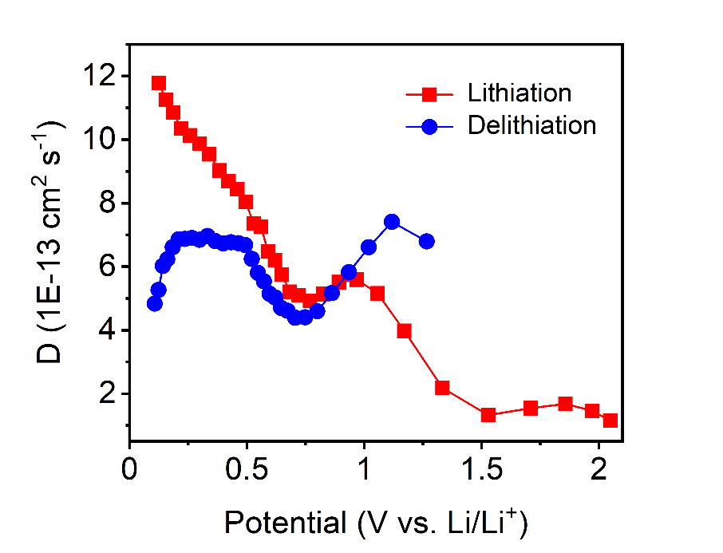
Fig. S12. The Li⁺ diffusion coefficient at respective charge and discharge potentials by GITT method.

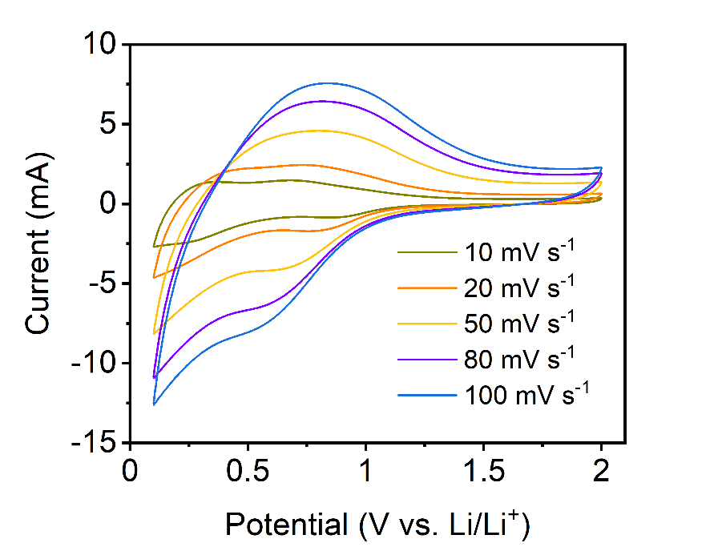
Fig. S13. CV curves of DRX-Li₃V₂O₅ anode at the scan rates ranging from 20 to 100 mV s⁻¹.

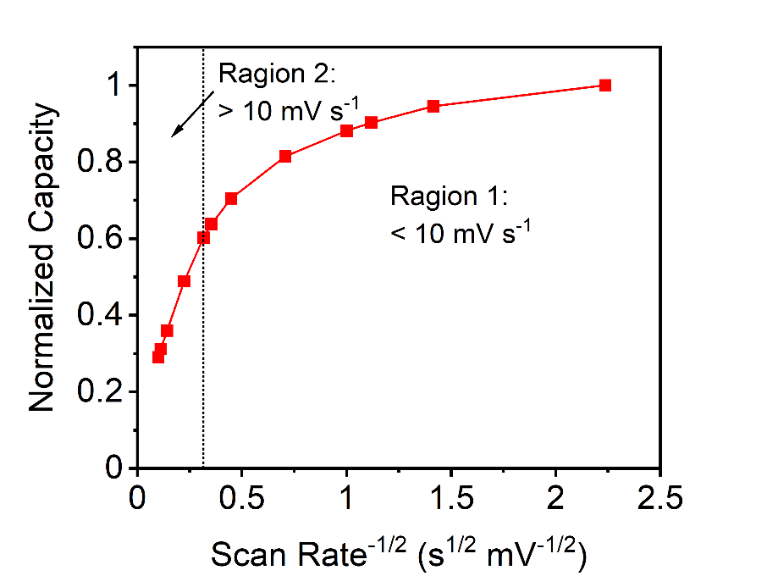
Fig. S14. Normalized capacity versus scan rate of DRX-Li₃V₂O₅ anode.

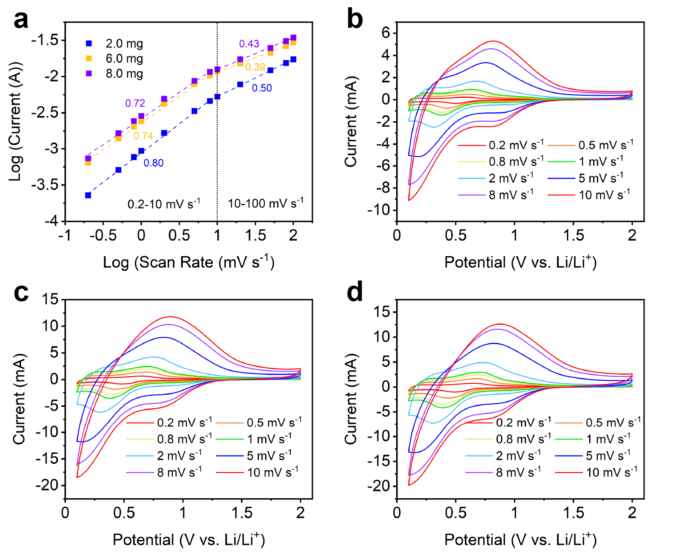
Fig. S15. a The anodic b-value for DRX-Li₃V₂O₅ anode with different mass loadings and CV curves of b 2.0 mg, c 6.0 mg and d 8.0 mg.

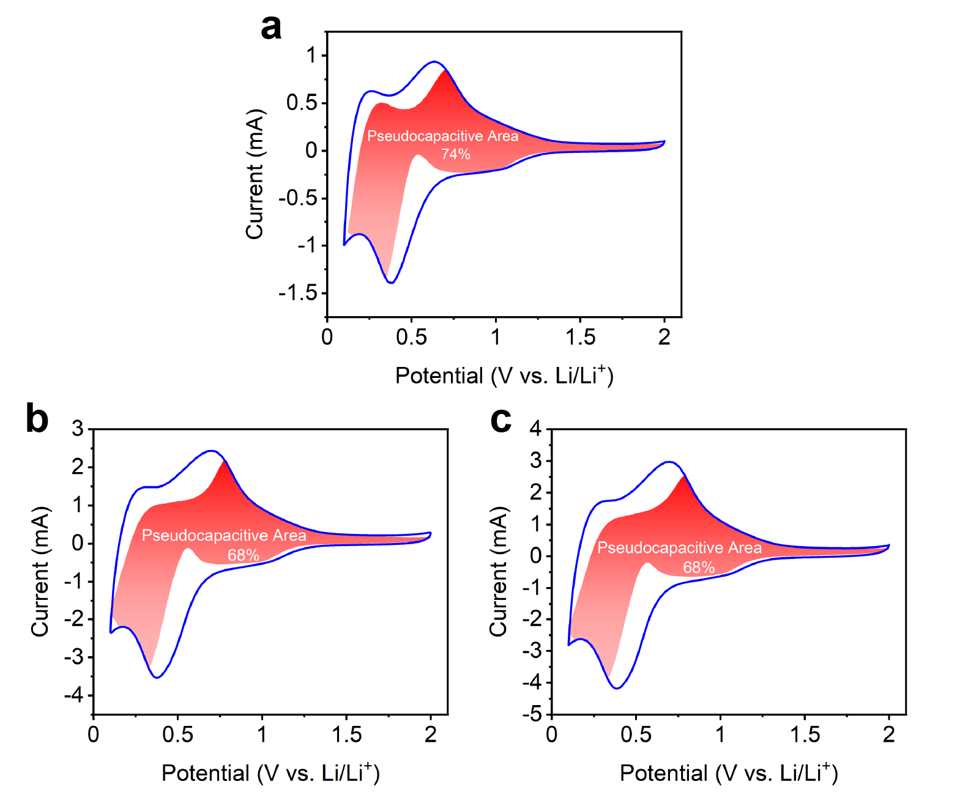
Fig. S16. Contribution ratios of the capacitive charge versus scan rate for DRX-Li₃V₂O₅ bulk electrode with the different mass loading of a 2.0 mg, b 6.0 mg, and c 8.0 mg.

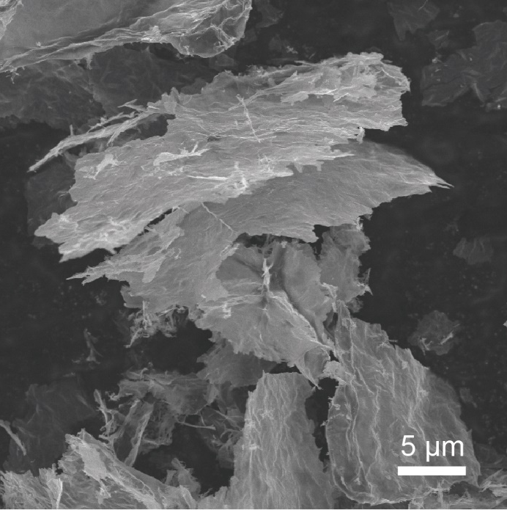
Fig. S17. SEM image of V₂O₅ nanosheet.

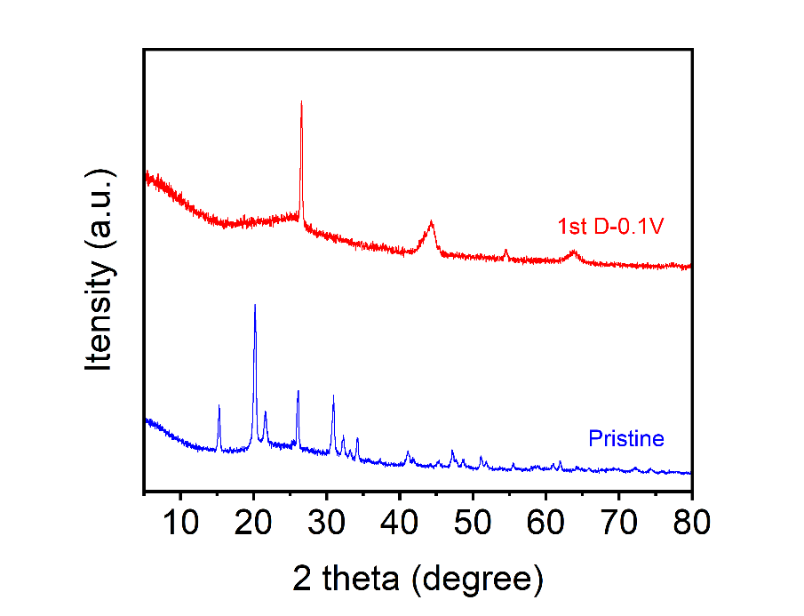
Fig. S18. XRD patterns of pristine V₂O₅ nanosheet and the DRX-Li₃V₂O₅ nanosheet discharged to 0.1 V (vs Li/Li⁺).

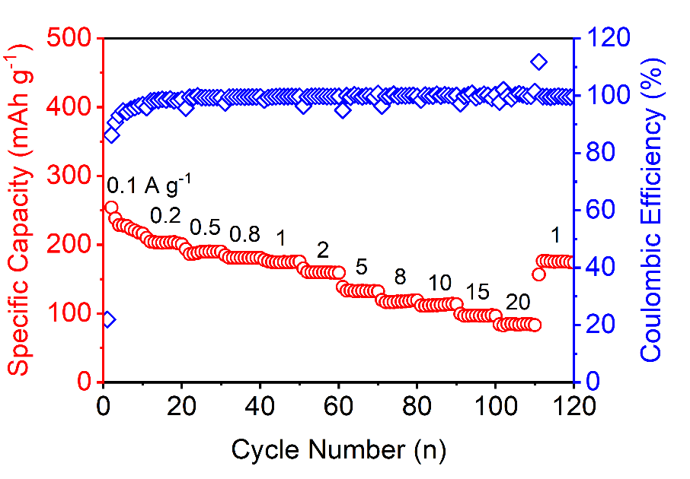
Fig. S19. The rate capability from 0.1 to 20 A g⁻¹ for DRX-Li₃V₂O₅ nanosheet anode with a mass loading of 2 mg.

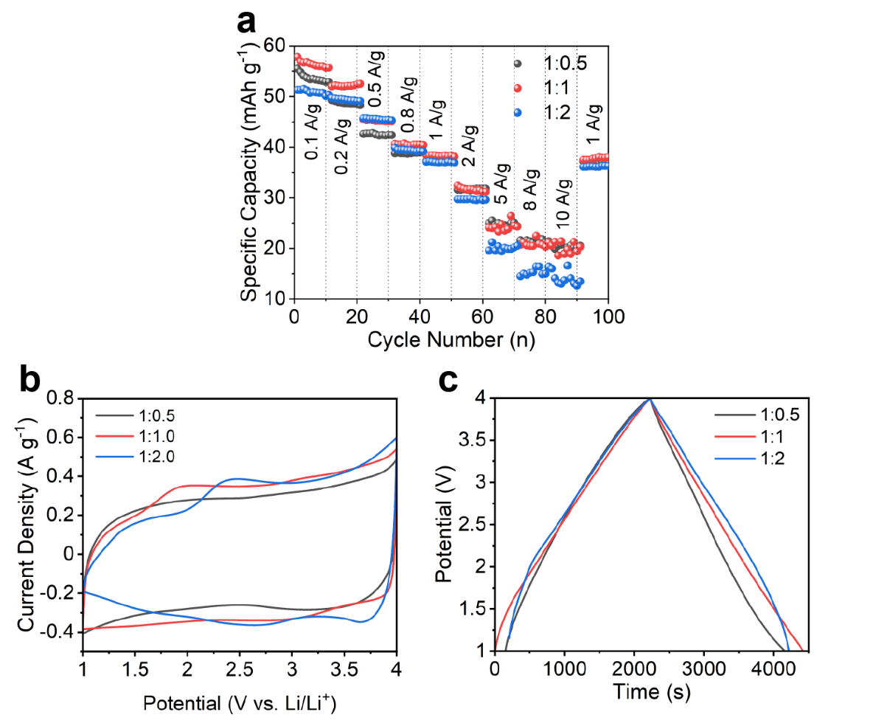
Fig. S20. The electrochemical performance of as-fabricated LICs with the different anode/cathode mass ratios: a rate capability from 0.1 to 10 A g⁻¹, b CV curves at 5 mV s⁻¹, c charge/discharge curves at 0.1 A g⁻¹.

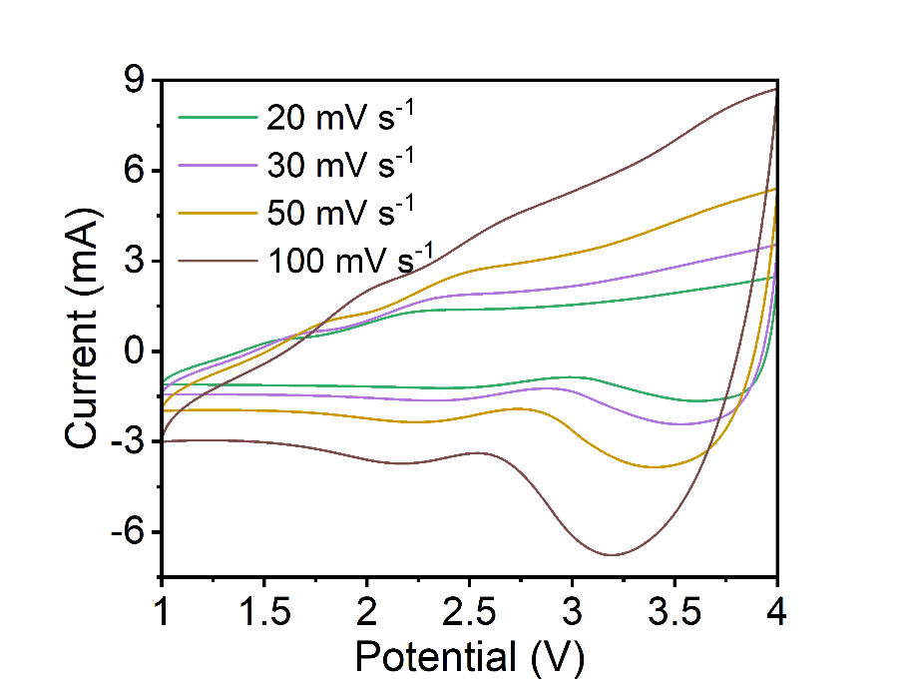
Fig. S21. CV curves of DRX-Li₃V₂O₅//PDPC LIC under the different scan rates ranging from 20 to 100 mV s⁻¹.

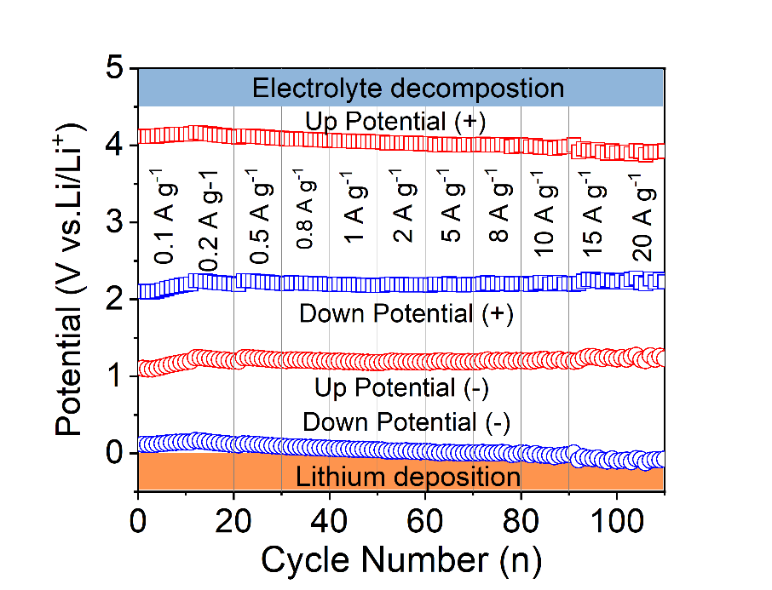
Fig. S22. The up and down potentials for anode and cathode under the different charge/discharge rates recorded from a three-electrode Swagelok cell.

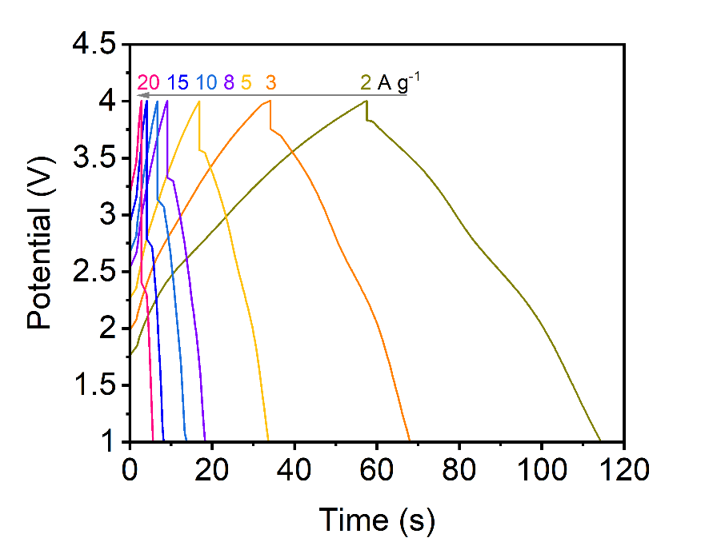
Fig. S23. Charge/discharge curves of DRX-Li₃V₂O₅//PDPC LIC under the different current density ranging from 2 to 20 A g⁻¹.

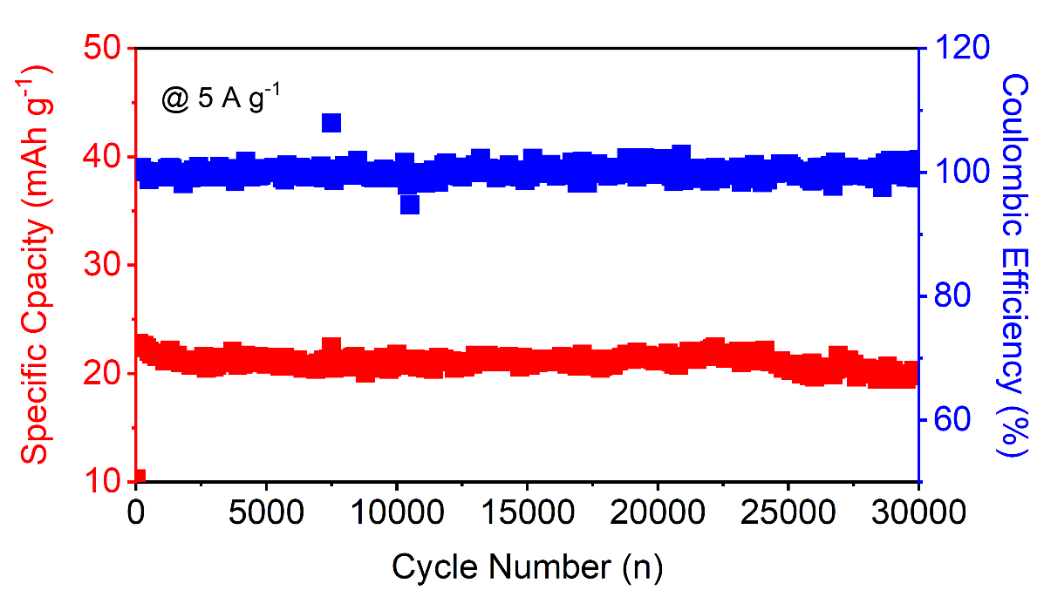
Fig. S24. Long-term cycling performance of DRX-Li₃V₂O₅//PDPC LIC at 5 A g⁻¹.

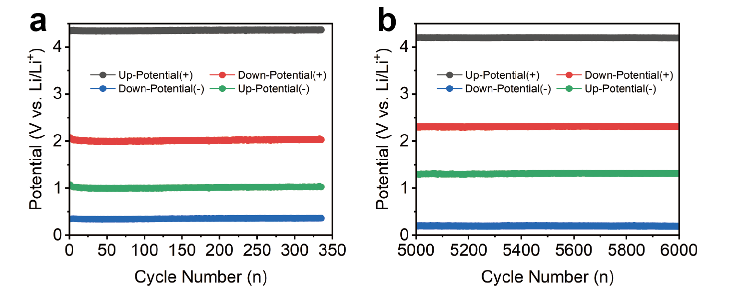
Fig. S25. The up and down potentials for positive PDPC electrode and negative DRX-Li₃V₂O₅ electrode during the long-term cycling at 2 A g⁻¹ recorded from a three-electrode Swagelok cell.

