Fig. S2-1 Screen of SSR marker of Hi01c04 corresponding to Fig.4 Dw1
Fig. S2-2 Screen of SSR marker of Hi04a08 corresponding to Fig.4 Dw1
Fig. S2-3 Screen of SSR marker of CH03a09 corresponding to Fig.4 Dw1
Fig. S2-4 Screen of SSR marker of Hi07d11 corresponding to Fig.4 Dw2
Fig. S2-5 Screen of SSR marker of CH02d08 corresponding to Fig.4 Dw2

Fig. S2-6 Screen of InDel marker of T51 corresponding to Fig.6 A (Left 1-24; Right 25-30)

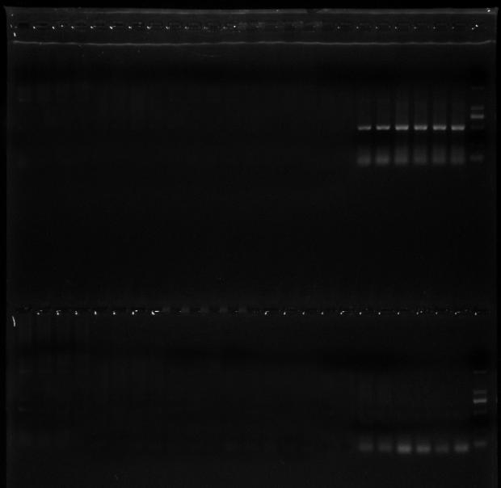
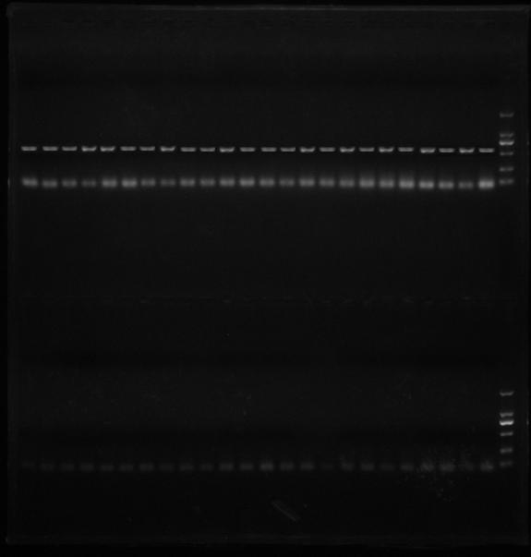

Fig. S2-7 Screen of InDel marker of C10 corresponding to Fig.6 A (Left 1-24; Right 25-30)
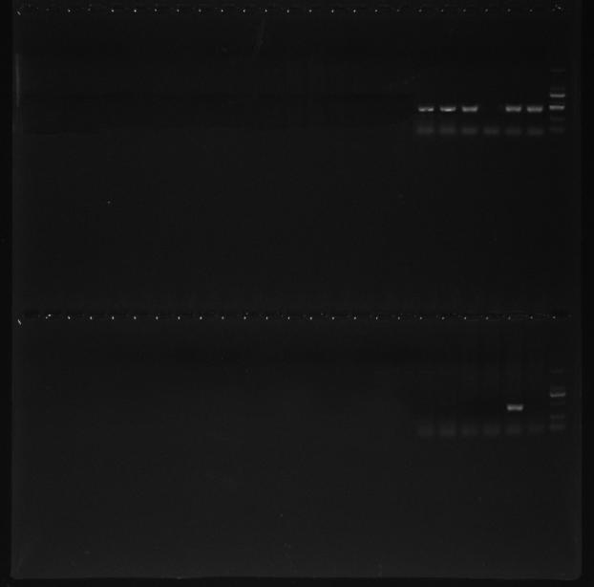
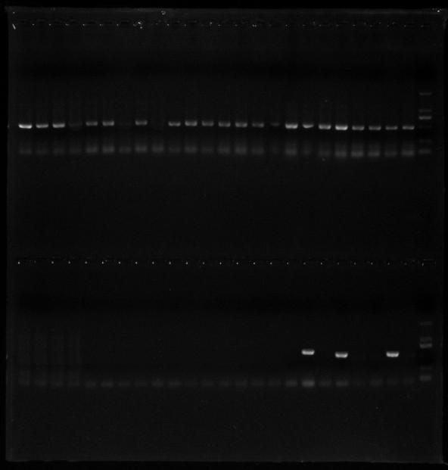

Fig. S2-8 Screen of InDel marker of A80 corresponding to Fig.6 A (Left 1-24; Right 25-30)
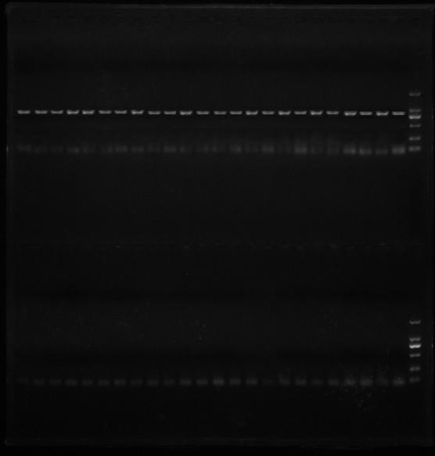

Fig. S2-9 Screen of InDel marker of B06 corresponding to Fig.6 A (Left 1-24; Right 25-30)
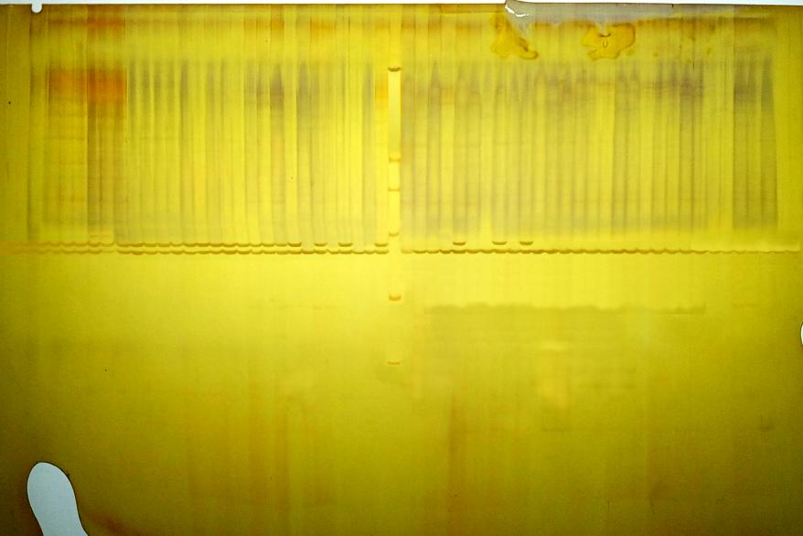

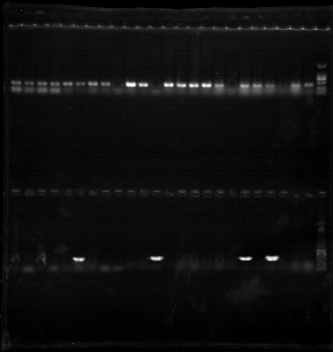
Fig. S2-10 Screen of InDel marker of I87 corresponding to Fig.6 B
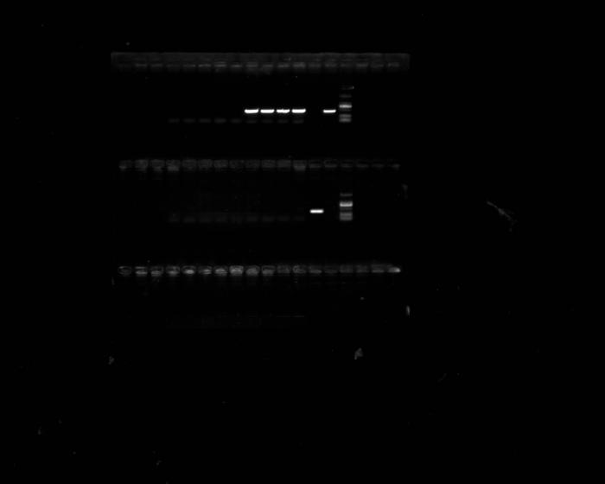

Fig. S2-11 Screen of InDel marker of P59 corresponding to Fig.6 B (Left 1-24; Right 25-30)
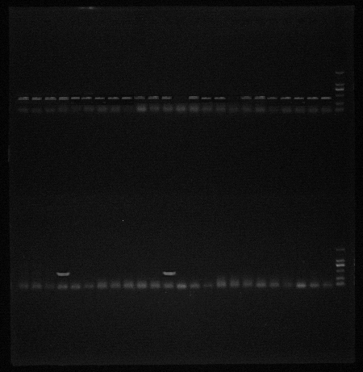

Fig. S2-12 Screen of InDel marker of J53 corresponding to Fig.6 B (Left 1-24; Right 25-30)
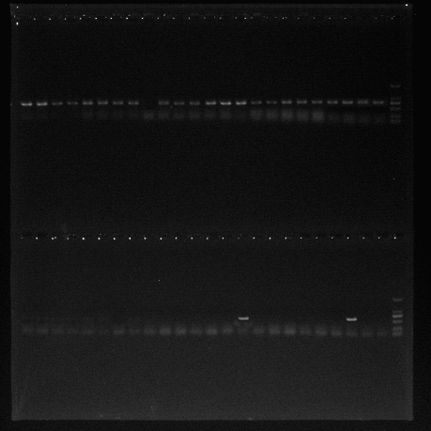

Fig. S2-13 Screen of InDel marker of E16 corresponding to Fig.6 B (Left 1-24; Right 25-30)

Fig. S2-14 Screen of InDel marker of L17 corresponding to Fig.6 B (Left 1-24; Right 25-30)

Fig. S2-15 Screen of InDel marker of H16 corresponding to Fig.6 B (Left 1-24; Right 25-30)
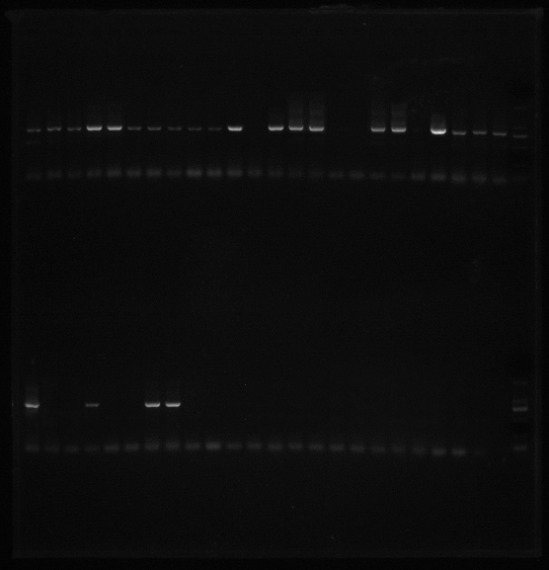

Fig. S2-16 Screen of InDel marker of D26 corresponding to Fig.6 B (Left 1-24; Right 25-30)
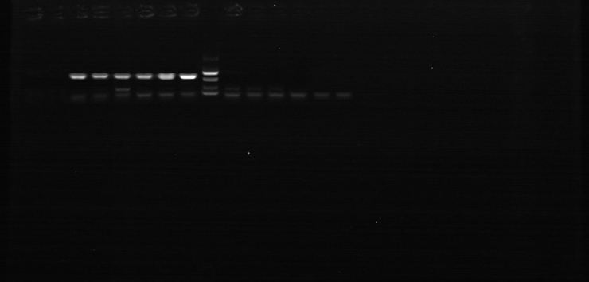

Fig. S2-17 Screen of InDel marker of F45 corresponding to Fig.6 B (Left 1-24; Right 25-30)
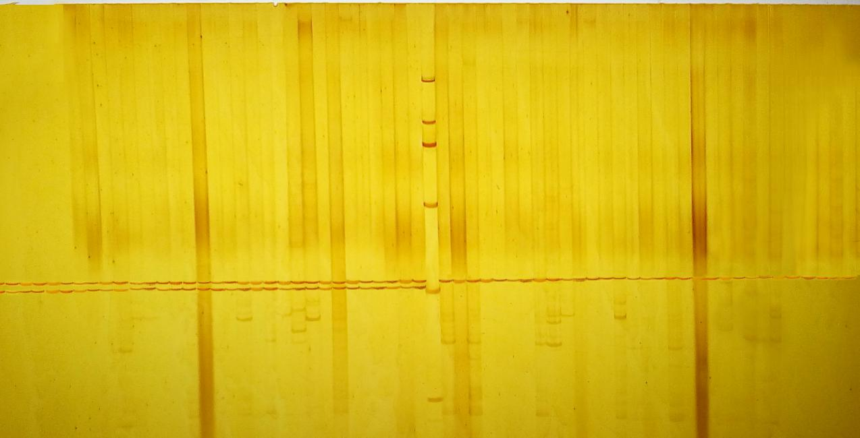

Fig. S2-18 Screen of InDel marker of M90 corresponding to Fig.6 B

