Supplementary Information for:

Directed evolution for soluble and active periplasmic expression of bovine enterokinase in Escherichia coli
Weiluo Lee, Subhas Pradhan, Cheng Zhang, Niccolo Venanzi, Weina Li, Stephen Goldrick, Paul A. Dalby

S1. EK_{L} sequence
A

B
10 20 30 40 50
IVGGSDSREG AWPWVVALYF DDQQVCGASL VSRDWLVSAA HCVYGRNMEP
60 70 80 90 100
SKWKAVLGLH MASNLTSPQI ETRLIDQIVI NRHYNKRRKN NDIAMMHLEM
110 120 130 140 150
KVNYTDYIQP ICLPEENQVF PPGRICSIAG WGALIYQGST ADVLQEADVP
160 170 180 190 200
LLSNEKCQQQ MPEYNITENM VCAGYDAGGV DSCQGDSGGP LMCQENNRWL
210 220 230
LAGVTSFGYQ CALPNRPGVY ARVPRFTEWI QSFLH

Figure S1. Sequence elements for EK_{L} expression, including numbering system for nucleobases and amino acid residues. A) Sequence elements included a T7 promoter (T7 promo), lac operator (lac op), ribosomal binding site (rbs), pelB signal peptide (pelB), Cny bovine enterokinase light chain (EK_{L}), and His6x affinity tag. For example, a variant with the following notation, P5’L/V15Q; t16a [T7 promo], g127t [pelB], c166t [EK_{L}] indicates a Pro to Leu mutation at position 5 of the pelB sequence, and a Val to Gln mutation at position 15 of the EK_{L} sequence. The DNA level mutations are numbered contiguously, and the sequence elements in brackets indicate the location of each mutated base. B) Cny bovine EK_{L} protein sequence.

S2. Consensus sequence analysis
A multiple alignment of 250 sequences was generated based on a BLAST (Ye et al 2006) search with Cny enterokinase light chain sequence as the query, and then aligned using ClustalW (Thompson et al 1994). Consensus sequences were generated (Figure 2) in PFAAT (Caffrey et al. 2007). Buried residues and proline residues in loop regions, also avoiding the active site, were considered for mutation to give the potential mutation sites shown in Table S1.

Caffrey DR, Dana, PH, Mathur V, Ocano M, Hong EJ, Wang YE, Somaroo S, Caffrey BE, Potluri S, Huang ES (2007) PFAAT version 2.0: a tool for editing, annotating, and analyzing multiple sequence alignments. BMC. Bioinformatics. 8:381.

Thompson JD, Higgins DG, Gibson TJ (1994) CLUSTAL W: improving the sensitivity of progressive multiple sequence alignment through sequence weighting, position-specific gap penalties and weight matrix choice. Nucleic Acids Res 22:4673–4680

Ye J, McGinnis S, Madden TL (2006) BLAST: improvements for better sequence analysis. Nucleic Acids Res 34:W6–W9
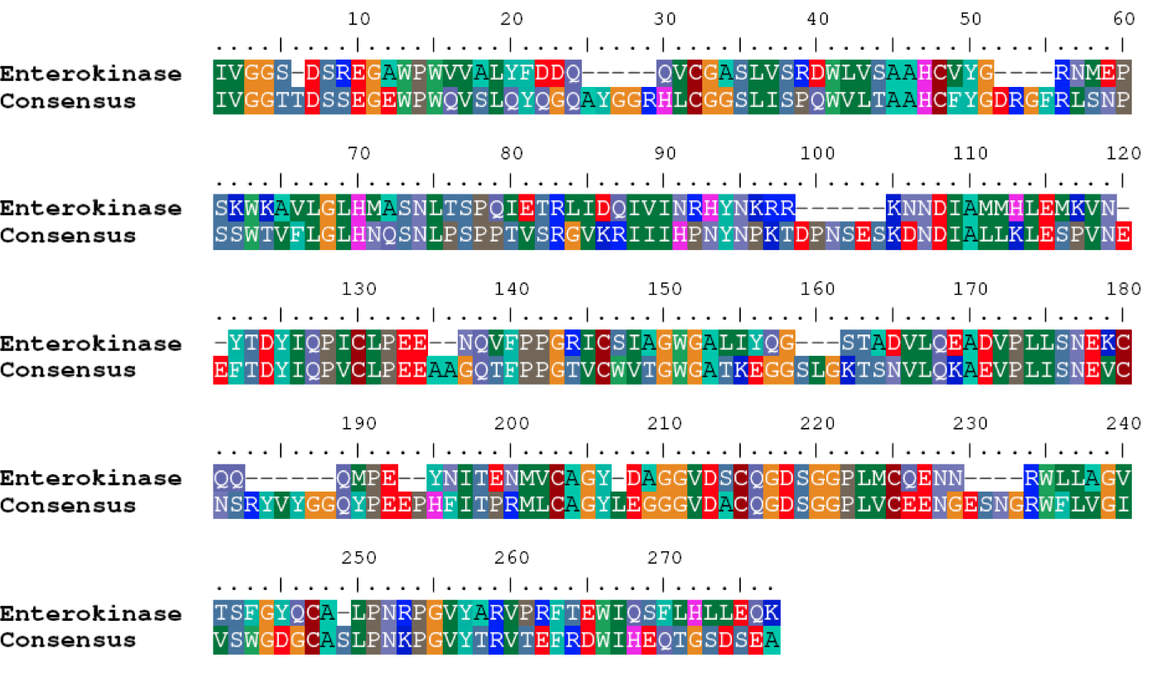
Figure S2. Enterokinase sequence aligned to the consensus sequence. Sequences were obtained via BLAST search. 250 sequences were used to generate a multiple sequence alignment in Clustal W, and a consensus sequence generated using PFAAT. Residues have been shaded depending on residue similarity to significant changes between the two sequences.

Residue position | Cny EK residue | Consensus Mutation | Alignment numbering
15 | V | Q | 16
17 | A | S | 18
28 | A | G | 29
33 | R | P | 39
36 | L | V | 42
37 | V | L | 43
38 | S | T | 44
43 | V | F | 49
55 | A | V | 65
69 | Q | P | 79
82 | R | P | 92
101 | K | P | 117
128 | I | V | 148
168 | E | P | 199
202 | A | V | 238
Table S1: Potential mutation sites identified from the consensus sequence. Alignment numbering is taken from Figure S2.

S3. Initial consensus mutant analysis of expression and activity
Cells expressing the pelB-fused Chinese northern yellow Cny-EK_{L} (UniProtKB Q6B4R4) EK_{L} protein sequence (pelBcnyEK) or consensus mutant variants, were grown at 37 ⁰C to OD₆₀₀ 0.8 in 400 mL LB with 40 μg/mL kanamycin in 2.5 L shake flasks, induced at OD₆₀₀ of 0.8, with 0.15 mM IPTG and then grown at 30 ⁰C for 7 hours.

For the soluble fraction analysis, 200 mL of the cultures were centrifuged at 2400 x g, then resuspended in 20 mL 20 mM Tris, 5 mM EDTA and 30% sucrose at pH 8 to extract the periplasmic fraction by osmotic shock. The solution was incubated on ice for 20 minutes before centrifugation at 8500g for 25 minutes. The supernatant (sucrose fraction) was saved for analysis and the pellet resuspended in 20 mL of 5 mM MgCl₂. This solution rapidly expands the cells via osmosis, rupturing the outer membrane and releasing periplasmic proteins. This solution was then incubated on ice for a further 15 minutes before a second centrifugation at 8500g for 25 minutes. The supernatant was collected (periplasmic fraction) and both the sucrose and periplasmic fractions were dialysed into reaction buffer (70 mM Tris, 2 mM CaCl₂, 50 mM NaCl at pH 8) for analysis of EK activity. For the insoluble fraction analysis, 200 mL cell cultures were centrifuged at 2400g, resuspended in 10 mL 20 mM Tris, 0.5 M NaCl, 5 mM EDTA, pH 8, then lysed by sonication. Soluble and insoluble fractions were separated by centrifugation at 8000g for 30 minutes at 4 °C.

The total activity of each fraction was determined from cleavage of the GD4K-na fluorogenic substrate using a FLUOstar OPTIMA microwell plate spectrophotometer (BMG Labtech, UK), 340 nm excitation and 420 nm emission to monitor initial rates. Reactions were initiated by auto-injection of 10μL/well of 1.25 mM GD4K-na substrate pre-dissolved in the reaction buffer, giving final reaction conditions of 0.0625 mM GD4K-na, 70 mM Tris-HCl, 2 mM CaCl₂, 50 mM NaCl, pH 8 at 25 °C.

SDS-PAGE densitometry was carried out with 12.5 % Tris-Glycine pre-cast gels (Invitrogen Ltd.). Protein samples were prepared by first mixing 50μL sample with 50μL 2x Laemli sample buffer and then heated to 99 °C for 15 minutes before cooling to room temperature. 5 μL of sample was loaded into each well with 5 μL of PageRuler Prestained Protein Ladder (Fermentas Life Sciences) as a marker. Additionally, 5μL/well of 0.125mg/mL BSA and 0.03125mg/mL BSA were loaded as reference protein standards for comparison purposes.
Gels were run with Tris-Glycine buffer (stored as 10x buffer: 144 g/L Glycine, 30 g/L Tris-base and 10 g/L SDS) at 100 V for 120 minutes. Gels were stained in 150 mL of Coomasie blue (50 % methanol, 10 % acetic acid and 0.5g/L brilliant blue) for 30-45 minutes. Gels were destained in 100mL of destaining reagent (40 % methanol and 10 % acetic acid) for 20-30 minutes and repeated as required. Gels were stored in pure water before being visualized using a Gel-Doc IT Imaging System (UVP Bioimaging Systems, Inc.). Densitometry analysis was carried out using Labworks V4.5 (UVP Inc., Media Cybernetics Inc.).

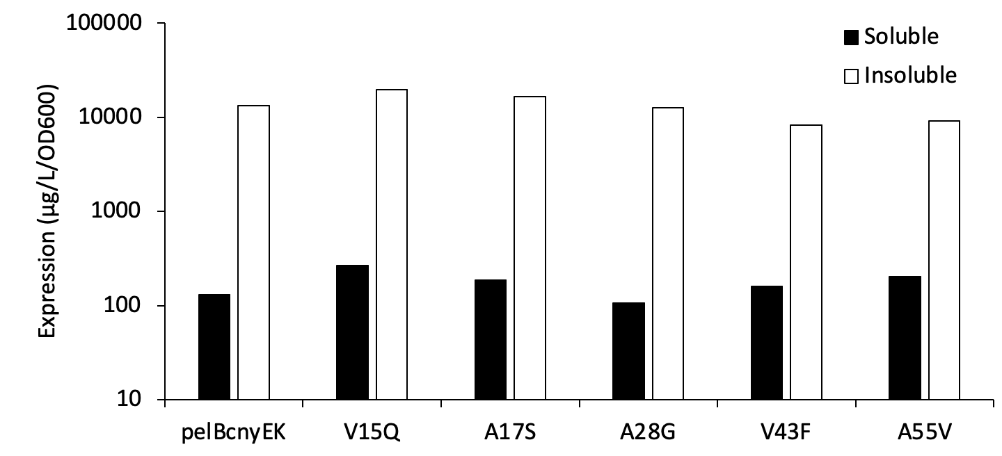(a)
(b)
Figure S3. Soluble and insoluble expression levels (a), and total activity (b) of WT and rationally designed variants of cnyEK. Variants were expressed (n=1) in E. coli BL21 DE3 at 30 °C in shake flasks. Expression levels were determined by SDS-PAGE densitometry. Expression and total activity are normalised to the final cell OD600, while the total activity is converted to a per cell value using OD₆₀₀ of 1 as equivalent to 10⁹ cells.

S4. Directed evolution libraries and analysis

Table S2 – Random mutations discovered and used in DNA-shuffling libraries
Library & Description | Mutation(s) | Gene | Primer Sequence (5’ – 3’)
L1: mutations derived from bottom-tiered variants | A141V | EK_{L} | atctatcaaggaagtactgtggatgtgttacaggaggcg
L1: mutations derived from bottom-tiered variants | E115D | EK_{L} | caaccaatttctctgccggatgaaaaccaggtcttccca
L1: mutations derived from bottom-tiered variants | P162S | EK_{L} | aaatgtcagcaacagatgagcgaatataacattacggaa
L1: mutations derived from bottom-tiered variants | R8H | EK_{L} | gtagggggctctgattcgcatgagggggcatggccgtgg
L2: mutations derived from bottom-tiered variants | A11T | EK_{L} | tctgattcgcgtgaggggacctggccgtggcaggtggct
L2: mutations derived from bottom-tiered variants | I135V | EK_{L} | gccggctggggagcgcttgtgtatcaaggaagtactgcg
L2: mutations derived from bottom-tiered variants | N91S | EK_{L} | aacaaacgccgtaaaaacagcgatattgccatgatgcac
L2: mutations derived from bottom-tiered variants | Y175F | EK_{L} | aatatggtatgcgcagggtttgatgccggtggcgttgac
L3: mutations derived from middle-tiered variants | E99D | EK_{L} | attgccatgatgcacttagatatgaaagtgaactatacg
L3: mutations derived from middle-tiered variants | H235N | EK_{L} | tggattcagtctttcctcaacgcggccgcactcgagcac
L3: mutations derived from middle-tiered variants | I125V | EK_{L} | gtcttcccaccaggtcgcgtgtgttccatagccggctgg
L3: mutations derived from middle-tiered variants | I70V | EK_{L} | aatctgacgagcccgcaagtggagacgcgacttatcgac
L3: mutations derived from middle-tiered variants | M100T | EK_{L} | gccatgatgcacttagaaaccaaagtgaactatacggat
L4: mutations derived from top-tiered variants | G27D | EK_{L} | gatgatcaacaggtctgcgatgcctctttagtgtctcgt
L4: mutations derived from top-tiered variants | M48K | EK_{L} | tgtgtgtacggccgtaacaaagaaccgtcaaaatggaag
L4: mutations derived from top-tiered variants | M96L | EK_{L} | aacaatgatattgccatgctgcacttagaaatgaaagtg
L4: mutations derived from top-tiered variants | N169D | EK_{L} | gaatataacattacggaagatatggtatgcgcagggtat
L4: mutations derived from top-tiered variants | R124G | EK_{L} | caggtcttcccaccaggtggcatctgttccatagccggc
L5: mutations derived from top-tiered variants | K156R | EK_{L} | cccctgctgtcgaatgaacgttgtcagcaacagatgccc
L5: mutations derived from top-tiered variants | L74F | EK_{L} | ccgcaaatcgagacgcgatttatcgaccaaatagtaatt
L5: mutations derived from top-tiered variants | M100K | EK_{L} | gccatgatgcacttagaaaaaaaagtgaactatacggat
L5: mutations derived from top-tiered variants | S127T | EK_{L} | ccaccaggtcgcatctgtaccatagccggctggggagcg
L5: mutations derived from top-tiered variants | S38T | EK_{L} | tctcgtgattggctggtgaccgcagcgcactgtgtgtac
L6: expression or secretion-related mutations only | c9t | T7 promo | tcccgcgaaattaatacgattcactataggggaattgtg
L6: expression or secretion-related mutations only | L4’R | pelB | atacatatgaaatacctgcggccgaccgctgctgctggt
L6: expression or secretion-related mutations only | t41a | lac op | aattgtgagcggataacaaatcccctctagaaataattt
L7: expression or secretion-related mutations only | c125t | pelB (silent) | gaccgctgctgctggtctgttgctcctcgctgcccagcc
L7: expression or secretion-related mutations only | a12g | T7 promo | cgcgaaattaatacgactcgctataggggaattgtgagc
L7: expression or secretion-related mutations only | M20’I | pelB | tcgctgcccagccggcgatagccattgtagggggctctg
L7: expression or secretion-related mutations only | t42c | lac op | aattgtgagcggataacaatccccctctagaaataattt
L7: expression or secretion-related mutations only | t41c | lac op | aattgtgagcggataacaactcccctctagaaataattt
L8: expression or secretion-related mutations | c13a | T7 promo | gcgaaattaatacgactcaatataggggaattgtgagcg
L8: expression or secretion-related mutations | a79g | rbs | ttgtttaactttaagaaggggatatacatatgaaatacc
L8: expression or secretion-related mutations | Q17’H | pelB | tgctgctcctcgctgcccatccggcgatggccattgtag
L9: remaining Mutations from lower, mid, and top-tiered variants | K54R | EK_{L} | atggaaccgtcaaaatggcgtgcagtactggggttgcac
 | K86R | EK_{L} | attaatccgcactataaccgtcgccgtaaaaacaatgat
L10: “remaining mutations” set1 (from variants ≥ 1.2x improved over V15Q or V15Q/C112S) | A129T | EK_{L} | ggccgtatttgcagcattaccggctggggcgcgctga
 | A141T | EK_{L} | ggcagcaccaccgatgtgctg
 | A141T/D142F | EK_{L} | ggcagcaccacctttgtgctgcagga
 | P5’L | pelB | tacatatgaaatacctgctgctgaccgctgctgctggtc
 | D142F | EK_{L} | ggcagcaccgcgtttgtgctgcagga
 | D21N | EK_{L} | caggtggcgctgtattttaacgatcagcaggtgtgcggc
 | D21N/D22E | EK_{L} | caggtggcgctgtattttaacgaacagcaggtgtgcggcgcg
 | D22E | EK_{L} | gtggcgctgtattttgatgaacagcaggtgtgcggcgcg
 | G27S | EK_{L} | cagcaggtgtgcagcgcgagcctggt
 | I111V | EK_{L} | accgattatattcagccggtgagcctgccggaagaaaac
 | I128V | EK_{L} | ccgggccgtatttgcagcgtggcgggctggggcgcgctg
 | I128V/A129T | EK_{L} | ccgggccgtatttgcagcgtgaccggctggggcgcgctga
 | I135S | EK_{L} | ggctggggcgcgctgagctatcagggcagcacc
 | I135S/Q137R | EK_{L} | ggggcgcgctgagctatcgtggcagcacc
 | I135T | EK_{L} | ggctggggcgcgctgacctatcagggcagcacc
 | I135T/Q137R | EK_{L} | ggggcgcgctgacctatcgtggcagcacc
 | L191I | EK_{L} | ggcgatagcggcggcccgattatgtgccaggaaaacaac
 | L200M | EK_{L} | caggaaaacaaccgttggatgctggcgggcgtgaccagc
 | N165D | EK_{L} | cagcagatgccggaatatgatattaccgaaaacatggtg
 | P214L | EK_{L} | ggctatcagtgcgcgctgctgaaccgtccgggcgtgtat
 | Q137R | EK_{L} | tgatttatcgtggcagcacc
 | Q160L | EK_{L} | aacgaaaaatgccagcagctgatgccggaatataacatt
 | Q24L | EK_{L} | gatcagctggtgtgcggcgcgagcctg
 | Q24L/G27S | EK_{L} | gatcagctggtgtgcagcgcgagcctggtgagccgt
 | R8P | EK_{L} | gtgggcggcagcgatagcccggaaggcgcgtggccgtgg
 | S63N | EK_{L} | ctgggcctgcatatggcgaacaacctgaccagcccgcag
 | t25a, t16a | lac op, T7 promo | taatacgactcactaaaggggaatagtgagcggataacaattcc
 | V180A | EK_{L} | ggctatgatgcgggcggcgcggatagctgccagggcgat
 | Y84H | EK_{L} | attgtgattaacccgcatcataacaaacgtcgtaaaaac
 | t16a | T7 promo | taatacgactcactaaaggggaattgtgagcgg

Table S3 – EK_{L} variants used for HITS-shuffling in libraries L11 and L12.
Library & Description | Variant ID | pelB-EK Protein Mutations;  DNA Mutations
L11: DNA-shuffling of top 2 variants from libraries L1 – L6 & L8 – L9 | WLEK0240 | V15Q/S38T/L74F/M100K/C112S/S127T
 | WLEK0245 | V15Q/I70V/M100T/C112S/I125V/H235N
 | WLEK0294 | V15Q/S38T/L74F/M100K/C112S/S127T/P162S
 | WLEK0306 | V15Q/S38T/L74F/C112S/A141V/P162S
 | WLEK0324 | V15Q/S38T/L74F/M100K/C112S/S127T
 | WLEK0335 | V15X/E99D/C112S/I125V/H235N
 | WLEK0336 | V15Q/S38T/L74F/M100K/C112S/S127T
 | WLEK0341 | V15Q/S38T/L74F/M100K/C112S/S127T
 | WLEK0353 | V15Q/S38T/L74F/M100K/C112S/S127T
 | WLEK0356 | V15Q/S38T/C112S/R124G/I135V/Y175F
 | WLEK0362 | V15Q/S38T/L74F/M100K/C112S/S127T/N169D
 | WLEK0374 | V15Q/S38T/L74F/M100K/C112S/S127T
 | WLEK0407 | V15Q/S38T/L74F/C112S
 | WLEK0427 | V15Q/M96L/C112S/R124G/N169D
 | WLEK0439 | V15Q/M96L/C112S
 | WLEK0479 | V15Q/S38T/C112S
L12: DNA-shuffling of additional top variants from libraries L1 – L4, L7, L10 and L11 | WLEK0244 | V15Q/I70V/E99D/C112S/I125V/H235N
 | WLEK0297 | P5'L/V15Q/C112S/Y175F
 | WLEK0342 | R8H/V15Q/C112S
 | WLEK0380 | V15Q/C112S/I135V/Y175F
 | WLEK0403 | V15Q/M48K/M96L/C112S/R124G
 | WLEK0415 | V15Q/M96L/C112S/R124G/N169D
 | WLEK0484 | V15Q/S38T/L74F/M100K/C112S/S127T/P162S
 | WLEK0503 | P5'L/V15Q/S38T/L74F/M100K/C112S/S127T/V180A;  t16a [T7 promo.]
 | WLEK0538 | P5'L/V15Q/C112S/Q160L/L191I
 | WLEK0549 | P5'L/V15Q/C112S/I135S/L200M
 | WLEK0553 | V15Q/C112S; c125t [pelB, silent]

Table S4 – Mutagenic primers used to shuffle with EK_{L} variant fragments from library L12
Library & Description | Mutation(s) | Gene | Primer Sequence (5’ – 3’)
L13: DNA-shuffling of L12 variants spiked with fragments encoding mutations observed previously at low frequency, and six newly observed random mutations. | T6'I | pelB | acctgctgccgatcgctgctgctg
 | I111V | EK_{L} | acggattacattcaaccagtgtctctgccggaagaaaac
 | E99A | EK_{L} | attgccatgatgcacttagcgatgaaagtgaactatacg
 | c68t | rbs | attttgtttaattttaagaagga
 | I128V/A129T | EK_{L} | ccaggtcgcatctgttccgtgaccggctggggagcgctt
 | I128V | EK_{L} | ccaggtcgcatctgttccgtggccggctggggagcgctt
 | I135T | EK_{L} | ccggctggggagcgcttacctatcaaggaagtact
 | g21a/a23t | lac op | cgactcactatagggaatttgtgagcggataacaattcccc
 | a23t | lac op | cgactcactataggggatttgtgagcggataacaattcccc
 | a81c | rbs | ctttaagaaggagctatacatatgaaatacctgctgcc
 | t69a | rbs | gaaataattttgtttaacattaagaaggagatatac
 | t71c | rbs | gaaataattttgtttaacttcaagaaggagatatacatatg
 | I75V | EK_{L} | gagacgcgacttgtggaccaaatagtaattaat
 | G27S | EK_{L} | gatgatcaacaggtctgcagcgcctctttagtgtctcgt
 | a5g | T7 promo. | gcgaaattaatgcgactcactat
 | A141T | EK_{L} | ggaagtactaccgatgtgttacaggaggcg
 | A141T/D142F | EK_{L} | ggaagtactacctttgtgttacaggaggcggat
 | D142F | EK_{L} | ggaagtactgcgtttgtgttacaggaggcggat
 | P214L | EK_{L} | gggtatcagtgtgcgttgctgaaccgtccaggtgtttat
 | A129T | EK_{L} | ggtcgcatctgttccataaccggctggggagcgctt
 | a76g | Rbs | gtttaactttaagagggagatatacatatgaaatacc
 | Q24L/G27S | EK_{L} | tattttgatgatcaactggtctgcagcgcctcttta
 | Q24L | EK_{L} | tattttgatgatcaactggtctgcggcgcctcttta
 | g21a | lac op. | tcactatagggaaattgtgagcg
 | I135T/Q137R | EK_{L} | tggggagcgcttacctatcgtggaagtact
 | Q137R | EK_{L} | tggggagcgcttatctatcgtggaagtact

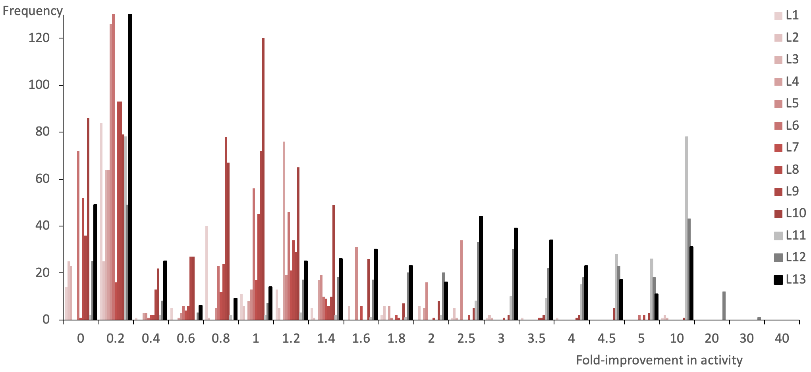

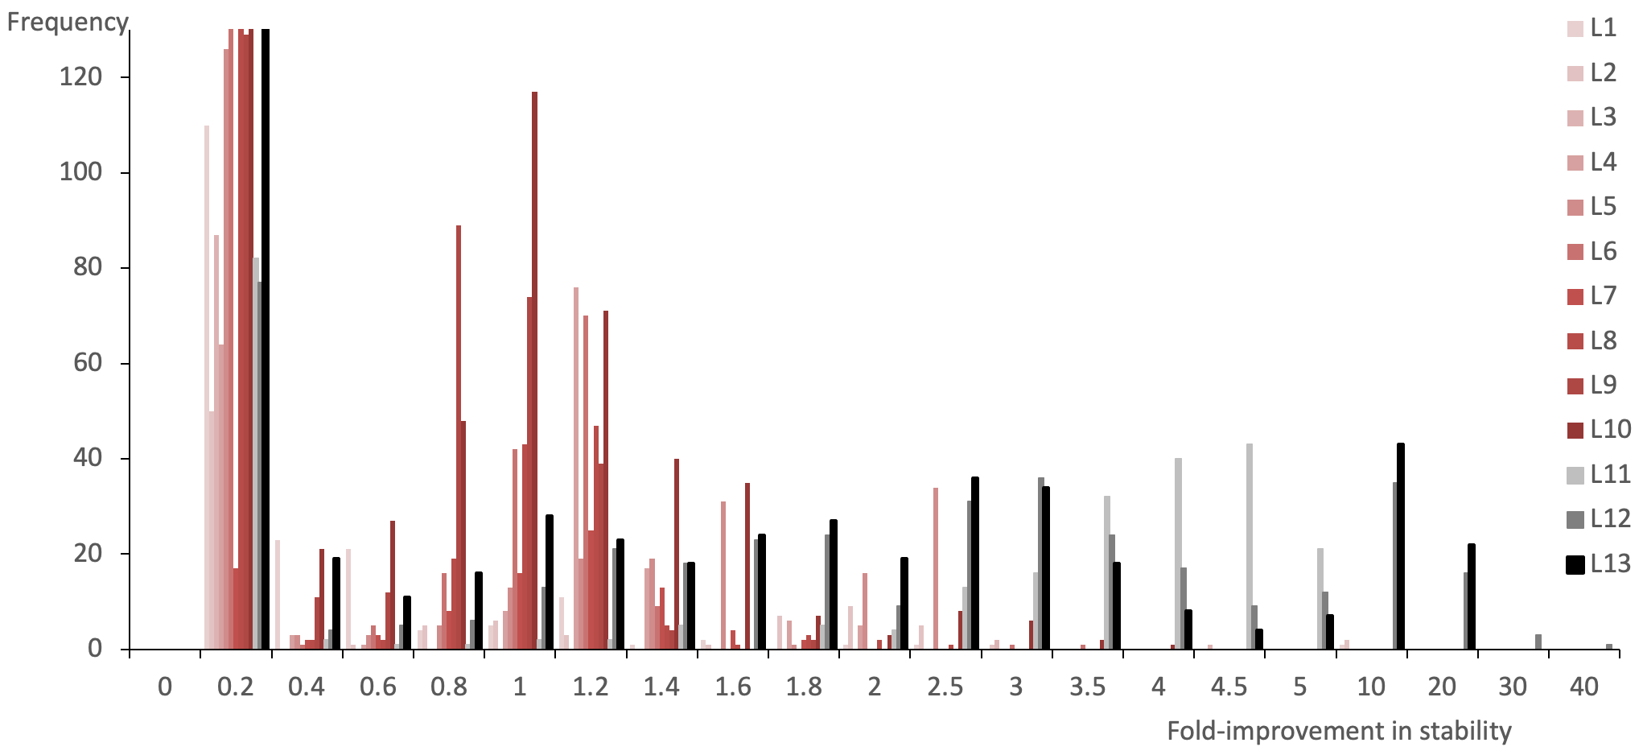

Figure S4. Distribution of improvements in A) activity and B) stability from each shuffling library (L1-L13). First-round shuffling libraries L1-L10 are shown in red shades, and rarely led to variants with >2-fold improvement in activity or stability. Second to fourth-round shuffling libraries L11-L13 are shown in black shades. Each progressively led to more variants with higher (>2.5-fold) activity and stability improvements. All improvements are relative to the V15Q/R82P/C112S parent. Y-axes are clipped at frequency = 130 in both plots to clearly visualise populations with >0.4-fold improvement.

Table S5 – 321 unique EK_{L} variants discovered and their corresponding protein mutations.
Variant ID | Protein mutations (pelB-EK_{L}-His6x) | DNA Mutations
WLEK0294 | V15Q/S38T/L74F/R82P/M100K/C112S/S127T/P162S
WLEK0296 | V15Q/R82P/C112S/P162S
WLEK0297 | P5'L/V15Q/R82P/C112S/Y175F
WLEK0298 | V15Q/R82P/N91S/C112S/I135V/Y175F | g127t [PelB,silent]
WLEK0303 | V15Q/R82P/M96L/C112S
WLEK0305 | S5F/V15Q/V56I/R82P/C112S
WLEK0306 | V15Q/S38T/L74F/R82P/C112S/A141V/P162S
WLEK0309 | V15Q/R82P/C112S/Y175F | c166t [EK]
WLEK0316 | Q17'H/V15Q/R82P/C112S
WLEK0321 | V15Q/R82P/C112S/I135V/Y175F
WLEK0322 | A11T/V15Q/R82P/C112S/I135V/Y175F
WLEK0323 | A11T/V15Q/R82P/C112S/I135V/Y175F
WLEK0324 | V15Q/S38T/L74F/R82P/M100K/C112S/S127T
WLEK0327 | V15Q/I75V/R82P/M96L/C112S/N169D | a377g,a440c,a659g
WLEK0328 | V15Q/R82P/C112S | g26a,t41c [lac op]; a79g [rbs]
WLEK0330 | V15Q/S38T/L74F/R82P/M100K/C112S/E115D/A141V/P162S
WLEK0333 | V15Q/M48K/R82P/C112S/Y175F
WLEK0334 | V15Q/R82P/C112S/I135V/Y175F
WLEK0335 | V15Q/I70V/R82P/E99D/C112S/I125V/H235N
WLEK0342 | R8H/V15Q/R82P/C112S
WLEK0343 | V15Q/R82P/C112S/E115D | g274a [EK]
WLEK0346 | V15Q/R82P/C112S/Y175F
WLEK0347 | V15Q/I70V/R82P/E99D/C112S/I125V/H235N
WLEK0348 | V15Q/R82P/C112S | t41a [lac op]
WLEK0349 | V15Q/R82P/C112S/V149I | c871t
WLEK0350 | L4'R/V15Q/R82P/C112S | t41a [lac op]
WLEK0358 | V15Q/R82P/C112S/I135V | c238t [EK]
WLEK0362 | V15Q/S38T/L74F/R82P/M100K/C112S/S127T/N169D
WLEK0369 | V15Q/R82P/C112S/R124G/I135V/Y175F
WLEK0389 | V15Q/M48K/R82P/C112S
WLEK0391 | V15Q/P50S/R82P/C112S
WLEK0393 | V15Q/R82P/C112S/R124G
WLEK0394 | V15Q/R82P/C112S/P224L
WLEK0395 | V15Q/R82P/C112S/N169D/M170del | a659g,t663g, g664del
WLEK0396 | V15Q/S38T/R82P/M100K/C112S
WLEK0397 | V15Q/S38T/R82P/C112S/S127T
WLEK0399 | V15Q/R82P/C112S/S127T/K156R | g18a
WLEK0403 | V15Q/M48K/R82P/M96L/C112S/R124G
WLEK0404 | V15Q/M48K/R82P/M96L/C112S
WLEK0405 | V15Q/R82P/C112S/N169D
WLEK0406 | L13'F/V15Q/G27D/R82P/C112S/R124G/N169D
WLEK0408 | V15Q/S38T/L74F/R82P/M100K/C112S/K156R
WLEK0409 | V15Q/S38T/L74F/R82P/M100K/C112S
WLEK0410 | V15Q/R82P/C112S/S127T | g316a [EK]
WLEK0411 | V15Q/L74F/R82P/C112S/S127T/K156R
WLEK0414 | V15Q/R82P/K86R/C112S | t528g [EK]
WLEK0415 | V15Q/R82P/M96L/C112S/R124G/N169D
WLEK0418 | V15Q/V43M/R82P/C112S
WLEK0419 | V15Q/S38T/L74F/R82P/C112S/K156R
WLEK0420 | V15Q/S38T/R82P/C112S/K156R
WLEK0421 | V15Q/L74F/R82P/M100K/C112S/S127T/K156R
WLEK0422 | V15Q/R82P/M100K/C112S/K156R | g613a [EK]
WLEK0423 | V15Q/T66M/R82P/C112S/K156R
WLEK0424 | V15Q/T66M/R82P/K156R
WLEK0430 | V15Q/R82P/C112S
WLEK0433 | V15Q/R82P/E99A/M100K/C112S/K156R
WLEK0435 | V15Q/S38T/L74F/R82P/M100K/C112S/S127T
WLEK0440 | V15Q/M48K/R82P/C112S/R124G/N169D
WLEK0443 | V15Q/S38T/R82P/C112S
WLEK0444 | T6'I/V15Q/S38T/R82P/M100K/C112S
WLEK0445 | V15Q/L74F/R82P/M100K/C112S
WLEK0446 | V15Q/R82P/C112S/S127T
WLEK0447 | V15Q/S38T/L74F/R82P/M100K/C112S/S127T | c409t [EK]
WLEK0448 | V15Q/S38T/L74F/R82P/M100K/C112S/S127T | c409t [EK]
WLEK0450 | V15Q/K54R/R82P/K86R/C112S
WLEK0452 | V15Q/R82P/C112S/R124G/N169D
WLEK0453 | V15Q/M48K/R82P/C112S/R124G/N169D/H242'Y
WLEK0454 | V15Q/R33C/R82P/C112S/R124G
WLEK0456 | V15Q/S38T/L74F/R82P/C112S | g610a [EK]
WLEK0457 | V15Q/L74F/R82P/M100K/C112S/S127T/K156R
WLEK0458 | V15Q/R82P/C112S/K156R
WLEK0460 | V15Q/R82P/C112S/P150S | t41a [lac op]
WLEK0463 | V15Q/R82P/M96L/C112S/N169D
WLEK0466 | V15Q/G27D/R82P/C112S/N169D/H245'N | g358a [EK]
WLEK0467 | V15Q/S38T/L74F/R82P/C112S/K156R/H246'*
WLEK0468 | V15Q/S38T/R82P/M100K/C112S/K156R
WLEK0470 | V15Q/R82P/C112S/H241'Y
WLEK0472 | V15Q/R82P/C112S/P150T
WLEK0473 | V15Q/M48K/R82P/C112S | g181a [EK]
WLEK0474 | V15Q/K54R/R82P/K86R/R88C/C112S
WLEK0477 | V15Q/S32T/R82P/C112S
WLEK0482 | V15Q/D76N/R82P/M100K/C112S/K156R
WLEK0485 | V15Q/S38T/L74F/R82P/M100T/C112S/I125V/H235N
WLEK0486 | V15Q/S38T/L74F/R82P/M100K/C112S/S127T/P162S/H235N | g367a [EK]
WLEK0487 | V15Q/S38T/R82P/C112S/R124G/I135V/Y175F
WLEK0488 | V15Q/S38T/L74F/R82P/M100K/C112S/S127T/P162S/H235N
WLEK0490 | V15Q/S38T/L74F/R82P/M100K/C112S/S127T | c289t [EK];
WLEK0491 | V15Q/S38T/L74F/R82P/C112S/S127T
WLEK0492 | V15Q/S38T/L74F/R82P/M100K/C112S/S127T
WLEK0494 | V15Q/S38T/L74F/R82P/M100K/C112S/S127T/V204M/H235N
WLEK0495 | V15Q/S38T/I70V/R82P/E99D/C112S/S127T/N169D
WLEK0496 | V15Q/S38T/L74F/R82P/C112S/S127T
WLEK0498 | P5'L/V15Q/S38T/L74F/R82P/M100K/C112S/S127T/V180A | t16a [T7 promo];
WLEK0499 | V15Q/S38T/L74F/R82P/E99D/C112S/I125V/N169D
WLEK0500 | V15Q/S38T/L74F/R82P/M100K/C112S/S127T/Y175F
WLEK0501 | V15Q/S38T/R82P/M100T/C112S/I125V/H235N
WLEK0502 | V15Q/S38T/L74F/R82P/M100K/C112S/S127T/N169D
WLEK0505 | V15Q/S38T/L74F/R82P/M100K/C112S/S127T/V204M/H235N
WLEK0507 | V15Q/S38T/L74F/R82P/M100K/C112S/S127T/N169D/L191I/L200M
WLEK0508 | V15Q/S38T/L74F/R82P/M100K/C112S/S127T/N169D/L191I/L200M | t718c,t724g,t733c,a736g,t755c,a757g,t763c [EK]
WLEK0509 | V15Q/S38T/I70V/R82P/C112S
WLEK0511 | V15Q/S38T/L74F/R82P/C112S
WLEK0512 | V15Q/S38T/R82P/M100K/C112S/S127T
WLEK0513 | V15Q/S38T/L74F/R82P/M100K/C112S/S127T/N169D/L200M
WLEK0514 | V15Q/S38T/R82P/M100K/C112S/S127T
WLEK0515 | V15Q/S38T/R82P/E99D/C112S/I125V/P214S/H235N
WLEK0516 | V15Q/I70V/R82P/M100T/C112S/I125V/H246'* | c890t,a891g,c892a [His];
WLEK0517 | V15Q/S38T/L74F/R82P/M100K/C112S/S127T/N169D
WLEK0518 | V15Q/S38T/L74F/R82P/M100K/C112S/Q160L
WLEK0520 | V15Q/R82P/M96L/C112S/S127T
WLEK0521 | V15Q/S38T/L74F/R82P/M100K/C112S/S127T/I135S/G179S
WLEK0522 | V15Q/S38T/L74F/R82P/M100K/C112S/A141V/P162S
WLEK0523 | P5'L/V15Q/R82P/M100K/C112S/S127T/N169D/L191I
WLEK0524 | V15Q/S38T/R82P/C112S | c670t [EK];
WLEK0526 | V15Q/S38T/L74F/R82P/M100K/C112S/S127T/Q160L
WLEK0528 | V15Q/S38T/L74F/R82P/M100K/C112S/Q160L/V180A/L191I/L200M
WLEK0529 | V15Q/R82P/M96L/C112S/R124G
WLEK0530 | V15Q/S38T/L74F/R82P/M100K/C112S/A141V/P162S
WLEK0536 | V15Q/I70V/R82P/M100K/C112S/S127T
WLEK0538 | P5'L/V15Q/R82P/C112S/Q160L/L191I
WLEK0539 | V15Q/R82P/M100K/C112S/S127T
WLEK0540 | V15Q/R82P/C112S/Q160L/N169D/H246'* | c890t,a891g,c892a [His];
WLEK0541 | V15Q/I70V/R82P/M100T/C112S/I125V/N169D | g21a [lac op];
WLEK0542 | V15Q/L74F/R82P/M100K/C112S/S127T
WLEK0546 | V15Q/I75V/R82P/M96L/C112S/N169D
WLEK0547 | V15Q/R82P/C112S/Q160L/V180A/H246'* | c890t,a891g,c892a [His];
WLEK0550 | P5'L/V15Q/R82P/C112S/Q160L/N165D/H246'* | c68t [rbs]; c890t,a891g,c892a [His];
WLEK0551 | P5'L/V15Q/R82P/C112S/Q160L
WLEK0552 | V15Q/R82P/C112S | t42c [lac op]; c125t [PelB];
WLEK0553 | V15Q/R82P/C112S | c125t [PelB];
WLEK0554 | P5'L/V15Q/R82P/C112S/L200M | t25a [lac op];
WLEK0555 | P5'L/V15Q/R82P/C112S
WLEK0556 | V15Q/R82P/E99D/C112S/S127T/N169D | g583a [EK];
WLEK0557 | M20'I/V15Q/R82P/C112S | c125t [PelB];
WLEK0558 | P5'L/V15Q/D22E/R82P/C112S/Q160L | t16a [T7 promo]; t25a [lac op];
WLEK0559 | V15Q/R82P/C112S/Q160L
WLEK0563 | R8H/V15Q/L74F/R82P/M100K/C112S | c238t [EK];
WLEK0564 | V15Q/R82P/C112S | c323t [EK];
WLEK0566 | V15Q/R82P/C112S/V180A
WLEK0570 | V15Q/R82P/C112S/Q160L/N165D
WLEK0571 | V15Q/R82P/C112S
WLEK0573 | P5'L/V15Q/R82P/C112S | t16a [T7 promo]; t25a [lac op];
WLEK0575 | V15Q/R82P/C112S | t42c [lac op]; c125t [PelB];
WLEK0576 | P5'L/V15Q/D21N/R82P/C112S/L200M
WLEK0580 | P5'L/V15Q/D21N/R82P/C112S/V180A/L200M
WLEK0581 | V15Q/R82P/C112S/V180A/L200M
WLEK0583 | V15Q/R82P/M96L/C112S/R124G/N169D/R222Q
WLEK0585 | V15Q/R82P/C112S/L200M
WLEK0586 | V15Q/R82P/C112S | t25a [lac op];
WLEK0588 | V15Q/R82P/C112S/L200M | c130t [PelB];
WLEK0592 | V15Q/R82P/C112S | t42c [lac op]; c125t [PelB];
WLEK0598 | V15Q/D21N/R82P/C112S/L191I/L200M
WLEK0601 | V15Q/S63N/R82P/C112S
WLEK0603 | V15Q/R82P/C112S | t42c [lac op];
WLEK0604 | V15Q/R82P/C112S | a12g [T7 promo]; t42c [lac op]; c125t [PelB];
WLEK0606 | P5'L/R8H/V15Q/R82P/C112S | t16a [T7 promo];
WLEK0610 | M20'I/V15Q/R82P/C112S | a12g [T7 promo]; t42c [lac op]; c125t [PelB];
WLEK0611 | V15Q/L74F/R82P/C112S | c374t [EK];
WLEK0615 | P5'L/V15Q/D21N/D22E/R82P/C112S
WLEK0621 | V15Q/R82P/C112S/Q160L/P162S | c436t,t625c [EK]
WLEK0622 | V15Q/R82P/Y84H/C112S/Q160L
WLEK0623 | V15Q/R82P/C112S | a12g [T7 promo]; t42c [lac op];
WLEK0624 | P5'L/V15Q/D22E/R82P/C112S
WLEK0625 | V15Q/D22E/R82P/C112S
WLEK0627 | V15Q/R82P/R88H/C112S
WLEK0628 | P5'L/V15Q/R82P/C112S/V180A/L191I
WLEK0629 | V15Q/D21N/D22E/R82P/C112S/L200M
WLEK0630 | P5'L/V15Q/D22E/S63N/R82P/C112S | t16a [T7 promo]; t25a [lac op]; a223g,c229g,c334t,c340g,t346c,g352c,a550c [EK]
WLEK0631 | V15Q/R82P/C112S | c229t [EK]
WLEK0632 | P5'L/V15Q/R82P/C112S | g80t [rbs];
WLEK0633 | M20'I/V15Q/R82P/C112S | a12g [T7 promo]; t42c [lac op];
WLEK0637 | P5'L/V15Q/R82P/Y84H/C112S | t16a [T7 promo]; t25a [lac op];
WLEK0638 | V15Q/R82P/C112S/T167M | c654t [EK];
WLEK0639 | M20'I/V15Q/R82P/C112S | a12g [T7 promo];
WLEK0641 | V15Q/R82P/C112S/Q158H/Q160L | c640g [EK]
WLEK0642 | P5'L/V15Q/R82P/Y84H/C112S | g352c,t397c,c403t,c415t [EK]
WLEK0644 | P5'L/V15Q/R82P/Y84H/C112S/L200M
WLEK0650 | P5'L/V15Q/V43M/R82P/C112S | t25a [lac op];
WLEK0652 | V15Q/S29F/S38T/L74F/R82P/M100K/C112S/S127T
WLEK0653 | V15Q/R82P/M96L/C112S/Q158*
WLEK0654 | M20'I/V15Q/R82P/C112S/G130D | t42c [lac op];
WLEK0663 | V15Q/R82P/M96L/C112S/R124G/G188D
WLEK0666 | M20'I/V15Q/R82P/C112S/S182N | a12g [T7 promo]; t42c [lac op];
WLEK0673 | V15Q/R82P/C112S/L239'H/E240'L/H241'L/H242'F/H243'I/H244'K/H245'I/H246'Q
WLEK0674 | P5'L/V15Q/S38T/L74F/R82P/M100K/C112S/S127T | g226a [EK];
WLEK0675 | P5'L/V15Q/S38T/R82P/C112S | g226a [EK];
WLEK0676 | P5'L/V15Q/S38T/L74F/R82P/M100K/C112S/S127T/V180A | g226a,c685g,t688c,c697t [EK];
WLEK0679 | P5'L/V15Q/S38T/L74F/R82P/M100K/C112S/S127T/V180A | c685g,t688c,c697t [EK];
WLEK0683 | P5'L/V15Q/S38T/L74F/R82P/M100K/C112S/S127T/V180A | g226a,c511t,c685g,t688c,c697t [EK];
WLEK0684 | V15Q/S38T/L74F/R82P/M100K/C112S/S127T/Y175F/H235N
WLEK0685 | P5'L/V15Q/S38T/L74F/R82P/M100K/C112S/I135V/Y175F | g226a [EK];
WLEK0686 | V15Q/M48K/R82P/M96L/C112S/I135S/L200M | t556g,c640g,t755c,a757g [EK];
WLEK0691 | A16'P/V15Q/S38T/I75V/R82P/E99A/I111V/C112S/A129T/I135T | t69a [rbs];
WLEK0692 | V15Q/S38T/M48K/R82P/C112S/I135S/L200M | t556g,c640g,t755c,a757g [EK];
WLEK0693 | P5'L/A19'S/V15Q/S38T/L74F/R82P/M100K/C112S/S127T/Y175F | g226a [EK]
WLEK0694 | V15Q/S38T/R82P/C112S/Q160L | a631g,c640g,g706a [EK];
WLEK0695 | V15Q/S38T/L74F/R82P/M100K/C112S/S127T | g226a [EK];
WLEK0696 | P5'L/V15Q/M48K/R82P/M96L/C112S/I135S | g148t [PelB]; t556g [EK];
WLEK0697 | V15Q/S38T/L74F/R82P/M100K/C112S/I135S/Y175F | t556g,c640g [EK];
WLEK0699 | P5'L/A19'V/V15Q/R82P/E99A/C112S/A129T/I135S | a23t [lac op]; t71c [rbs]; c125t [PelB]; t556g [EK];
WLEK0700 | V15Q/I75V/R82P/M96L/E99A/C112S/I128V/A129T/I135T
WLEK0702 | V15Q/S38T/L74F/R82P/M100K/C112S/S127T/P162S | t16a [T7 promo];
WLEK0703 | V15Q/S38T/L74F/R82P/C112S/I135V | g226a [EK];
WLEK0705 | V15Q/S38T/L74F/R82P/M100K/C112S/S127T/L200M | t453a,g454a,c640g,t755c,a757g [EK];
WLEK0706 | P5'L/V15Q/S38T/L74F/R82P/C112S/Q160L | t16a [T7 promo]; a631g,c640g [EK];
WLEK0707 | V15Q/I70V/R82P/M96L/C112S/I135S | t556g [EK];
WLEK0708 | P5'L/A16'P/V15Q/S38T/I75V/R82P/E99A/C112S/I128V/I135T/Q137R/Q160L | a23t [lac op]; t71c [rbs]; a631g,c640g [EK];
WLEK0709 | P5'L/V15Q/R82P/C112S/I135S | t205g,c208g,t556g,c640g [EK];
WLEK0710 | V15Q/S38T/R82P/C112S/Y175F
WLEK0711 | P5'L/V15Q/R33H/R82P/C112S/I135S/Q160L/Y175F | t205g,c208g,t556g,a631g,c640g [EK];
WLEK0713 | V15Q/Q24L/R82P/E99A/C112S/I128V/A129T/I135T/Q137R/H235N | t71c [rbs];
WLEK0715 | V15Q/Q24L/G27S/S38T/R82P/E99A/C112S/S127T/Q137R/L200M | t755c,a757g [EK];
WLEK0716 | V15Q/S38T/L74F/R82P/C112S/Y175F | c374t [EK];
WLEK0717 | T6'I/V15Q/Q24L/R82P/C112S/A129T/I135T | messy[T7 promo]; g21a,a23t [lac op]; a76g [rbs]; c125t [PelB];
WLEK0719 | V15Q/S38T/L74F/R82P/M100K/C112S/S127T/P162S | c235t [EK];
WLEK0721 | P5'L/A16'P/V15Q/R82P/E99A/C112S/A129T/Q160L | a23t [lac op]; t69a,a81c [rbs]; a631g [EK];
WLEK0722 | P5'L/V15Q/S38T/L74F/R82P/C112S/Y175F | t16a [T7 promo]; g226a [EK];
WLEK0727 | P5'L/V15Q/R82P/M100K/C112S/S127T | t205g,c208g,g370t [EK];
WLEK0728 | V15Q/M48K/R82P/M96L/C112S/Q160L/Y175F | a631g,c640g,g760a [EK];
WLEK0729 | V15Q/S38T/R82P/C112S/Y175F | g226a [EK];
WLEK0732 | P5'L/V15Q/R82P/C112S/I135S | g74a [rbs]; t205g,c208g,t556g,c640g [EK];
WLEK0733 | P5'L/V15Q/I70V/R82P/C112S/I135S/N169D | t556g [EK];
WLEK0734 | V15Q/S38T/I75V/R82P/E99A/C112S/I128V/I135T/Y175F
WLEK0735 | P5'L/V15Q/R82P/C112S/I135S/L200M | c104t, t205g,c208g,t556g,c640g,t755c,a757g [EK];
WLEK0736 | V15Q/S38T/L74F/R82P/M100K/C112S/S127T/V180A | g226a,c685g,t688c,c697t [EK];
WLEK0737 | P5'L/V15Q/S38T/T66M/L74F/R82P/M100K/C112S/S127T/P162S | t205g,c208g,g226a [EK];
WLEK0738 | P5'L/V15Q/R82P/C112S/I135S | t556g,c640g [EK];
WLEK0739 | V15Q/L74F/R82P/M100K/C112S/I135V/H235N
WLEK0740 | P5'L/A16'V/V15Q/S38T/L74F/R82P/M100K/C112S/S127T/V180A | g226a,c685g,t688c,c697t [EK];
WLEK0741 | P5'L/V15Q/S38T/L74F/R82P/M100K/C112S/S127T/V180A | t16a [T7 promo]; g226a,c685g,t688c,c697t [EK];
WLEK0743 | P5'L/V15Q/R82P/M96L/C112S/I135V/Y175F | t205g,c208g [EK];
WLEK0745 | P5'L/V15Q/R82P/C112S/I135S/Q160L/L200M | t556g,a631g,c640g,t755c,a757g [EK];
WLEK0746 | P5'L/V15Q/R82P/R88S/C112S/I135S | g199a,t556g,c640g [EK];
WLEK0747 | P5'L/V15Q/R82P/C112S/I135S/L200M | t205g,c208g,t556g,c640g,t755c,a757g [EK];
WLEK0748 | V15Q/S38T/L74F/R82P/M100K/C112S/S127T/V180A | g226a,g613a,c685g,t688c,c697t [EK];
WLEK0749 | P5'L/V15Q/I70V/R82P/M100K/C112S/S127T/P162S
WLEK0750 | V15Q/S38T/R82P/M96L/C112S/S127T/P162S
WLEK0752 | A16'P/V15Q/G27S/S38T/R82P/E99A/I111V/C112S/I128V/A129T | t69a [rbs]; c125t [PelB];
WLEK0753 | V15Q/S38T/L74F/R82P/M96L/C112S/R124G/N169D
WLEK0754 | P5'L/V15Q/R82P/C112S/I135S | t205g,c208g,t556g,c640g [EK];
WLEK0755 | V15Q/Q24L/G27S/I75V/R82P/E99A/C112S/I135T | a23t [lac op]; t71c [rbs];
WLEK0756 | V15Q/S38T/L74F/R82P/C112S/Q160L/L191I | c374t,a631g,c640g,t709c,t718c,t724g,t733c,a736g [EK];
WLEK0758 | P5'L/V15Q/S38T/L74F/R82P/M100K/C112S/R124G | g226a,c640g [EK];
WLEK0759 | V15Q/R82P/C112S/I135S/N169D | t205g,c208g,t556g [EK];
WLEK0760 | V15Q/S38T/L74F/R82P/C112S/I135V/P162S | g226a [EK];
WLEK0761 | P5'L/V15Q/R82P/C112S/I135S | t205g,c208g,c535t,c554t,t556g,c640g [EK];
WLEK0762 | P5'L/V15Q/R82P/C112S/I135S | t16a [T7 promo]; t205g,c208g,t556g [EK];
WLEK0763 | V15Q/I70V/R82P/C112S/I135S | t556g,c640g [EK];
WLEK0764 | R8H/V15Q/Q24L/R82P/E99A/C112S/I128V/A129T/I135T | t71c [rbs];
WLEK0765 | P5'L/V15Q/I70V/R82P/E99D/C112S/I125V/H235N | a451t [EK];
WLEK0766 | P5'L/V15Q/M48K/R82P/M96L/C112S/R124G
WLEK0767 | P5'L/V15Q/S38T/L74F/R82P/R88C/M100K/C112S/S127T/N169D | t16a [T7 promo]; g226a [EK];
WLEK0768 | P5'L/V15Q/I70V/R82P/E99D/C112S/I135V/Y175F | a451t [EK];
WLEK0771 | P5'L/A7'T/V15Q/M48K/R82P/M96L/C112S/R124G
WLEK0772 | P5'L/V15Q/S38T/R82P/C112S/R124G/V180A/H235N | t16a [T7 promo]; g226a,c685g,t688c,c697t [EK];
WLEK0774 | P5'L/L14'F/V15Q/R82P/M96L/C112S/R124G/Y175F | t205g,c208g [EK];
WLEK0775 | V15Q/L74F/R82P/M100K/C112S/S127T/P162S/H235N
WLEK0776 | V15Q/R82P/C112S/Q160L | a631g,c640g [EK];
WLEK0778 | V15Q/Q24L/G27S/R82P/E99A/C112S/I128V/A129T/Q137R | a23t [lac op]; t71c [rbs];
WLEK0779 | V15Q/R82P/M96L/C112S/R124G/N169D
WLEK0780 | V15Q/R82P/E99A/C112S/I128V/I135T/Q137R/N169D/L191I/H235N | t69a [rbs]; t709c,t718c,t724g,t733c,a736g [EK];
WLEK0781 | V15Q/G27S/I75V/R82P/E99A/C112S/I128V/A129T/I135T/V180A | c640g,c685g,t688c,c697t [EK];
WLEK0783 | V15Q/R82P/M100K/C112S/S127T/P162S
WLEK0784 | P5'L/V15Q/Q24L/R82P/M96L/C112S/R124G/L200M | c640g,t755c,a757g [EK];
WLEK0785 | P5'L/V15Q/S38T/R82P/M96L/C112S/R124G/I135V/Y175F/L200M | t16a [T7 promo]; t755c,a757g [EK];
WLEK0786 | V15Q/S38T/L74F/R82P/M100K/C112S/S127T/P162S | g77a [rbs];
WLEK0787 | T6'I/V15Q/Q24L/R82P/E99A/C112S/A129T/I135T/D142F | g21a,a23t [lac op];
WLEK0789 | P5'L/V15Q/R82P/C112S/I135V/Y175F
WLEK0790 | V15Q/R82P/C112S/I135S/L200M | t556g,c640g,t755c,a757g [EK];
WLEK0792 | P5'L/V15Q/R82P/C112S/I128V/A129T | g21a,a23t [lac op]; t71c [rbs];
WLEK0793 | P5'L/V15Q/R82P/C112S/S127T/P162S | g30a [lac op]; t205g,c208g [EK];
WLEK0794 | P5'L/V15Q/R82P/M96L/C112S/S127T/V180A/L200M | t205g,c208g,g655a,c685g,t688c,c697t,t755c,a757g [EK];
WLEK0795 | V15Q/I70V/R82P/E99D/C112S/I125V | a451t [EK];
WLEK0796 | V15Q/I70V/R82P/C112S/Y175F
WLEK0797 | P5'L/V15Q/R82P/C112S/R124G/N169D | t205g,c208g [EK];
WLEK0799 | P5'L/V15Q/R82P/C112S/S127T/P162S
WLEK0802 | A16'P/V15Q/G27S/I70V/R82P/E99D/C112S/I125V/H235N | g21a,a23t [lac op]; g304a,a451t [EK]
WLEK0803 | P5'L/V15Q/R82P/C112S/Y175F | t205g,c208g,g790a [EK];
WLEK0804 | P5'L/V15Q/R82P/C112S
WLEK0806 | P5'L/V15Q/R82P/C112S/Q160L/L191I | t16a [T7 promo]; a631g,c640g,t709c,t718c,t724g,t733c,a736g [EK];
WLEK0807 | V15Q/R82P/C112S/I135V
WLEK0808 | P5'L/V15Q/I70V/R82P/E99D/C112S/I125V/Y175F | t205g,c208g,a451t, [EK];
WLEK0810 | P5'L/V15Q/R82P/C112S/I135V/Y175F | t16a [T7 promo];
WLEK0814 | P5'L/V15Q/R82P/M100K/C112S/R124G/L200M | g124a [PelB]; t755c,a757g [EK];
WLEK0815 | P5'L/V15Q/R82P/E99D/C112S/I135V/Y175F | a451t [EK];
WLEK0816 | P5'L/V15Q/R82P/C112S/Q160L/L191I | a631g,c640g,t709c,t718c,t724g,t733c,a736g [EK];
WLEK0818 | V15Q/Q24L/L74F/R82P/I111V/C112S/I125V/I135T/Q137R/H235N | g21a,a23t [lac op]; t69a [rbs];
WLEK0819 | V15Q/I70V/R82P/C112S/Q160L/L191I | a631g,c640g,t709c,t718c,t724g,t733c,a736g [EK];
WLEK0820 | P5'L/V15Q/R82P/C112S/Y175F | g331a [EK];
WLEK0821 | P5'L/V15Q/R82P/C112S/I128V/Q160L/L191I | t205g,c208g,a631g,c640g,t709c,t718c,t724g,t733c,a736g [EK];
WLEK0826 | P5'L/V15Q/R82P/C112S/I135V/P162S
WLEK0827 | V15Q/R82P/M100K/C112S/V180A | t453a,g454a,c685g,t688c,c697t [EK];
WLEK0828 | V15Q/Q24L/G27S/I75V/R82P/E99A/C112S/A129T/L191I | g21a,a23t [lac op]; t71c [rbs]; t724g [EK];
WLEK0829 | V15Q/Q24L/I70V/I75V/R82P/C112S/I135S/D142F/L200M | a23t [lac op]; t69a [rbs]; t205g,c208g,t556g,t755c,a757g [EK];
WLEK0830 | V15Q/I70V/R82P/E99D/C112S/R124G/N169D | t16a [T7 promo]; a451t [EK];
WLEK0831 | V15Q/Q24L/I70V/I75V/R82P/I111V/C112S/I135S/Q137R/L200M | g21a,a23t [lac op]; t71c [rbs]; t556g,t755c,a757g [EK];
WLEK0833 | V15Q/R82P/E99A/C112S/I128V/I135T/D142F/N169D/ | a23t [lac op]; t71c [rbs];
WLEK0834 | P5'L/A16'P/V15Q/G27S/R82P/E99A/I111V/C112S/I128V/Y175F | t71c [rbs];
WLEK0835 | P5'L/V15Q/R82P/C112S/I135S/A147V/L200M | t205g,c208g,t556g,c640g,t755c,a757g [EK];
WLEK0836 | P5'L/V15Q/R82P/M96L/C112S/I135S/R216H | t556g,c640g [EK];
WLEK0837 | V15Q/Q24L/G27S/S38T/L74F/R82P/E99A/C112S/I128V/I135T/D142F | g21a,a23t [lac op]; a76g [rbs]; c125t [PelB]; c640g [EK];
WLEK0838 | P5'L/V15Q/G27S/I75V/R82P/M100K/I111V/C112S/I128V/A129T/Y175F/L200M | t69a,a81c [rbs]; t709c,t755c,a757g [EK];
WLEK0839 | P5'L/V15Q/R82P/C112S/P162S
WLEK0840 | V15Q/D22N/Q24L/I75V/R82P/C112S/I128V/A129T/I135T/D142F/Y175F | t16a [T7 promo]; t71c [rbs]; t205g,c208g [EK];
WLEK0841 | P5'L/V15Q/A40S/I70V/R82P/M96L/C112S/R124G/N169D
WLEK0842 | P5'L/V15Q/Q24L/G27S/R82P/E99A/C112S/I128V/A129T/D142F | t69a [rbs]; c125t [PelB];
WLEK0843 | P5'L/V15Q/R82P/C112S/P162S | t16a [T7 promo];
WLEK0845 | P5'L/V15Q/L74F/R82P/E99D/C112S/I135V/M170I/Y175F | a451t,g664t [EK];
WLEK0846 | V15Q/M48K/L74F/R82P/E99A/I111V/C112S/D142F/P214L
WLEK0847 | V15Q/G27S/R82P/C112S | t16a [T7 promo]; a76g [rbs]; c125t [PelB];
WLEK0848 | V15Q/Q24L/G27S/R82P/C112S/I128V/I135S/L200M/P214L | a23t [lac op]; t205g,c208g,t556g,t755c,a757g [EK];
WLEK0849 | P5'L/V15Q/R82P/E99A/C112S/I128V/I135S/D142F/Q160L/P214L | g21a,a23t [lac op]; t71c [rbs]; t556g,a631g,c640g [EK];
WLEK0850 | P5'L/V15Q/R82P/C112S/I125V/A173V/H235N
WLEK0851 | P5'L/V15Q/R82P/C112S/P114S/I135V/Y175F | c208t [EK];
WLEK0852 | V15Q/Q24L/G27S/R82P/I111V/C112S/I125V/A129T/D142F | t69a [rbs];
WLEK0853 | T6'I/V15Q/R82P/E99A/K101N/C112S/I128V/I135T/A141T/D142F/N169D | t71c [rbs];
WLEK0854 | V15Q/Q24L/G27S/R82P/I111V/C112S/I125V/A129T/D142F/Q160L/Y175F/N169D | t69a [rbs];
WLEK0855 | V15Q/I70V/R73STOP/R82P/E99D/C112S/I125V/H235N | a451t [EK];
WLEK0856 | P5'L/V15Q/A28V/R82P/C112S/Y175F
WLEK0857 | V15Q/G27S/R82P/E99T/C112S/A129T/I135V/A141T/D142F | t71c [rbs];
WLEK0858 | T6'I/A16'P/V15Q/Q24L/R82P/C112S/I125V/I135T/D142F/V180A/P214L | t69a,a81c [rbs]; c125t [PelB]; c685g,t688c,c697t [EK];

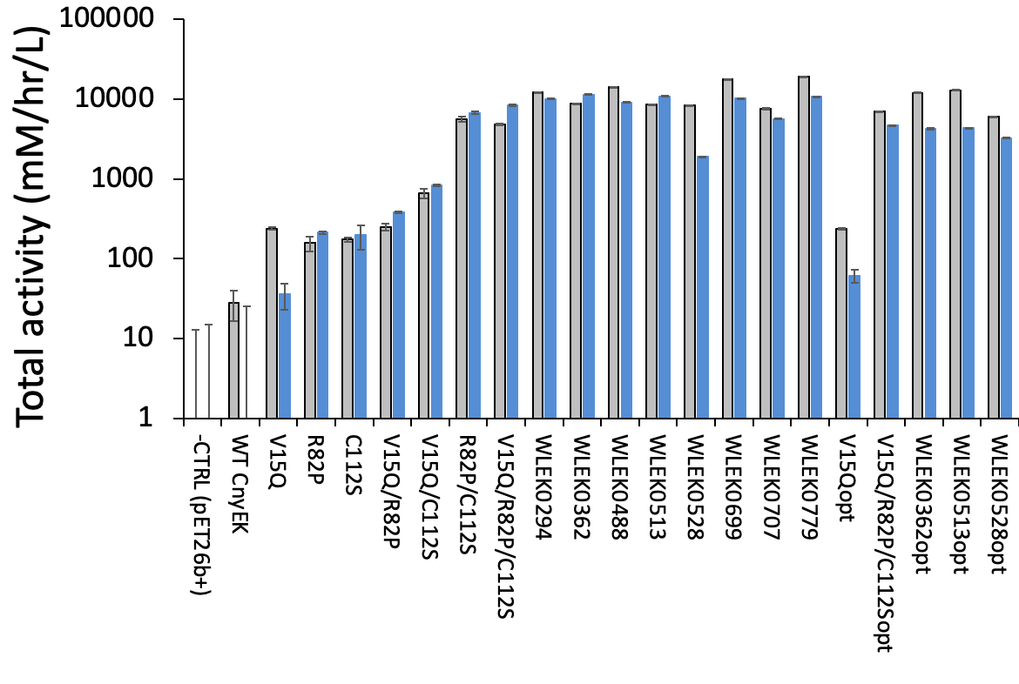
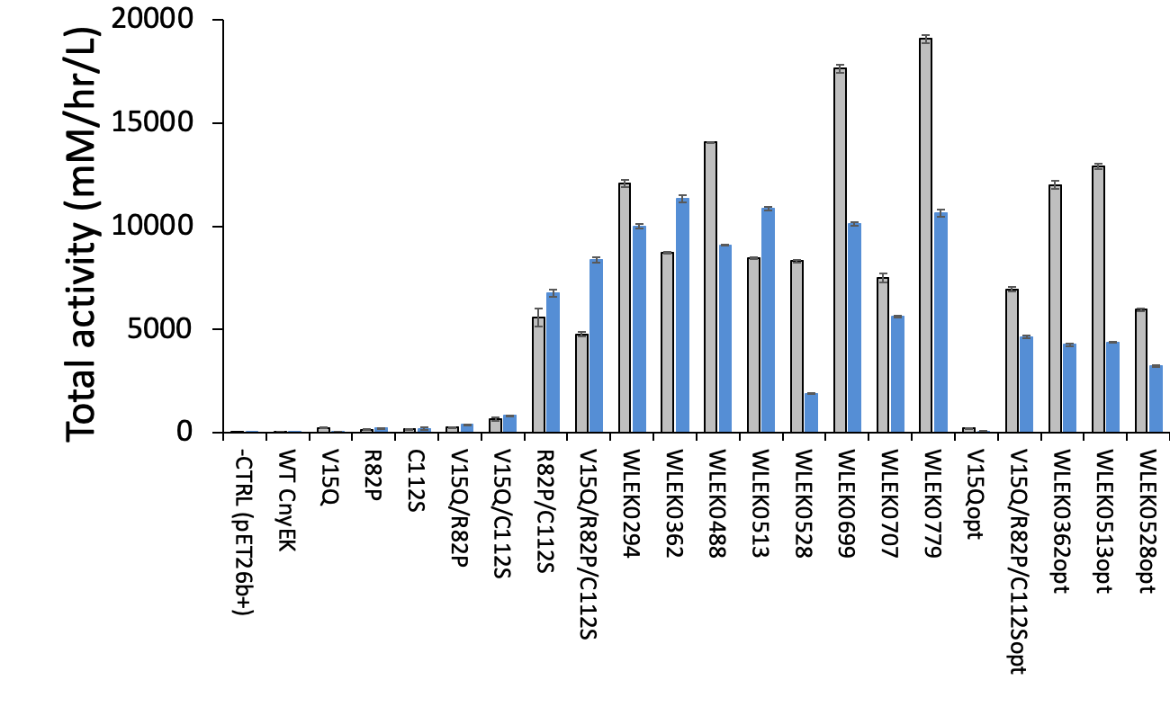

Figure S5. Evolution of total activity in the variants retested after expression at 30 °C (grey bars) and 37 °C (blue bars). The same data are plotted as A) log-scale activity and B) linear-scale activity, to allow comparisons across the full range

Partial least squares regression.
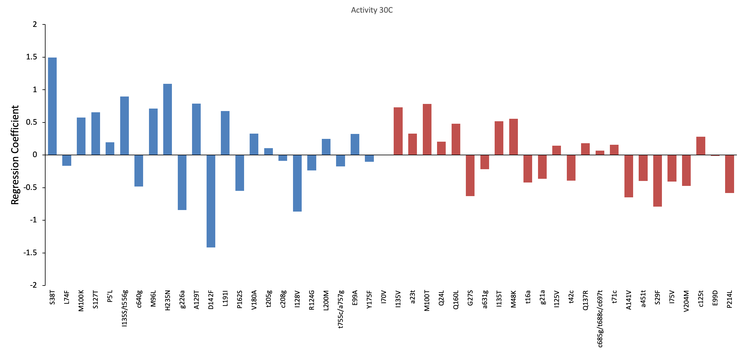A
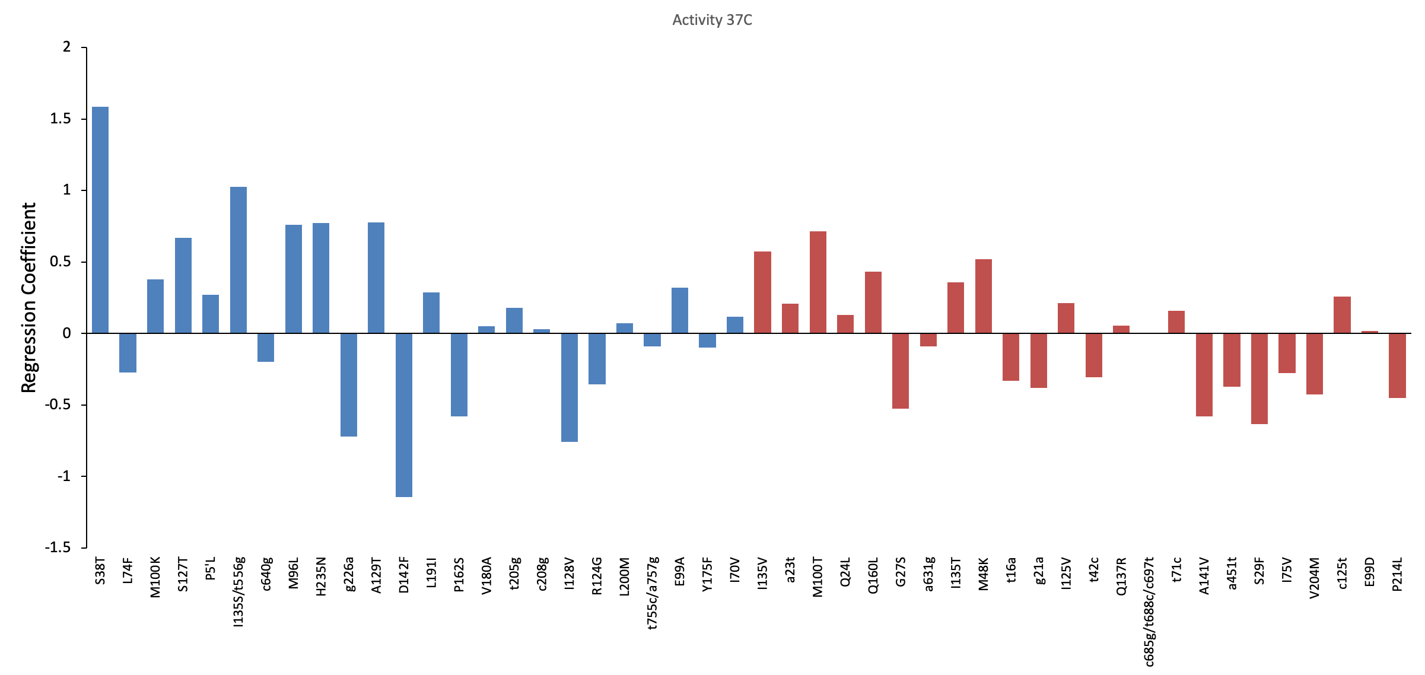B

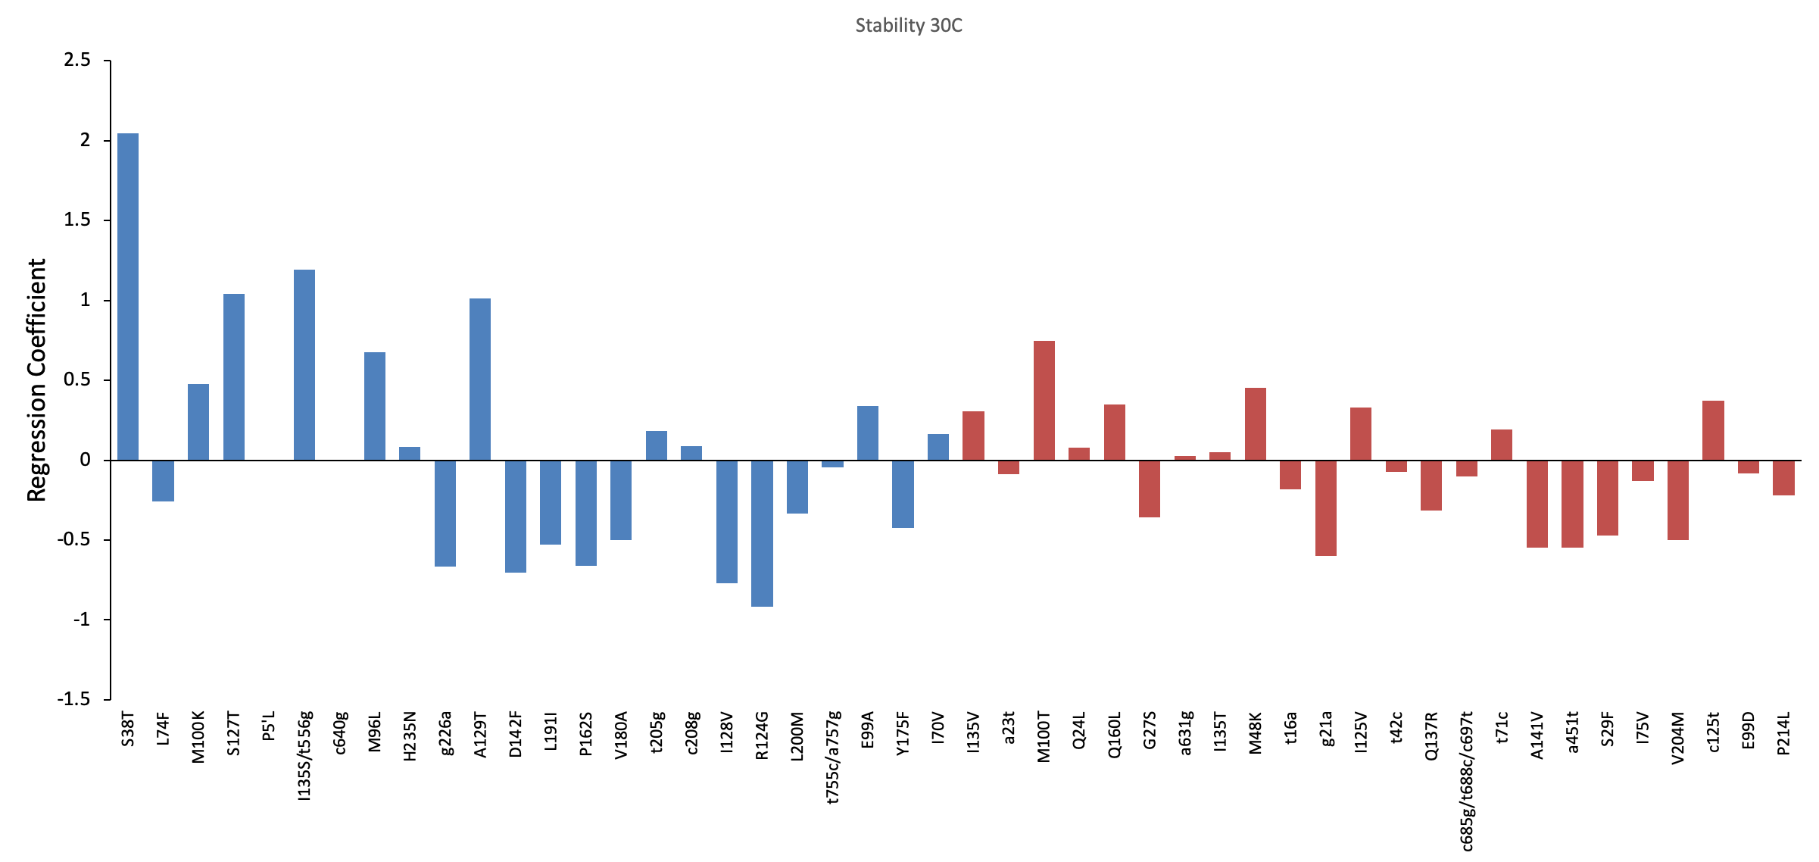C
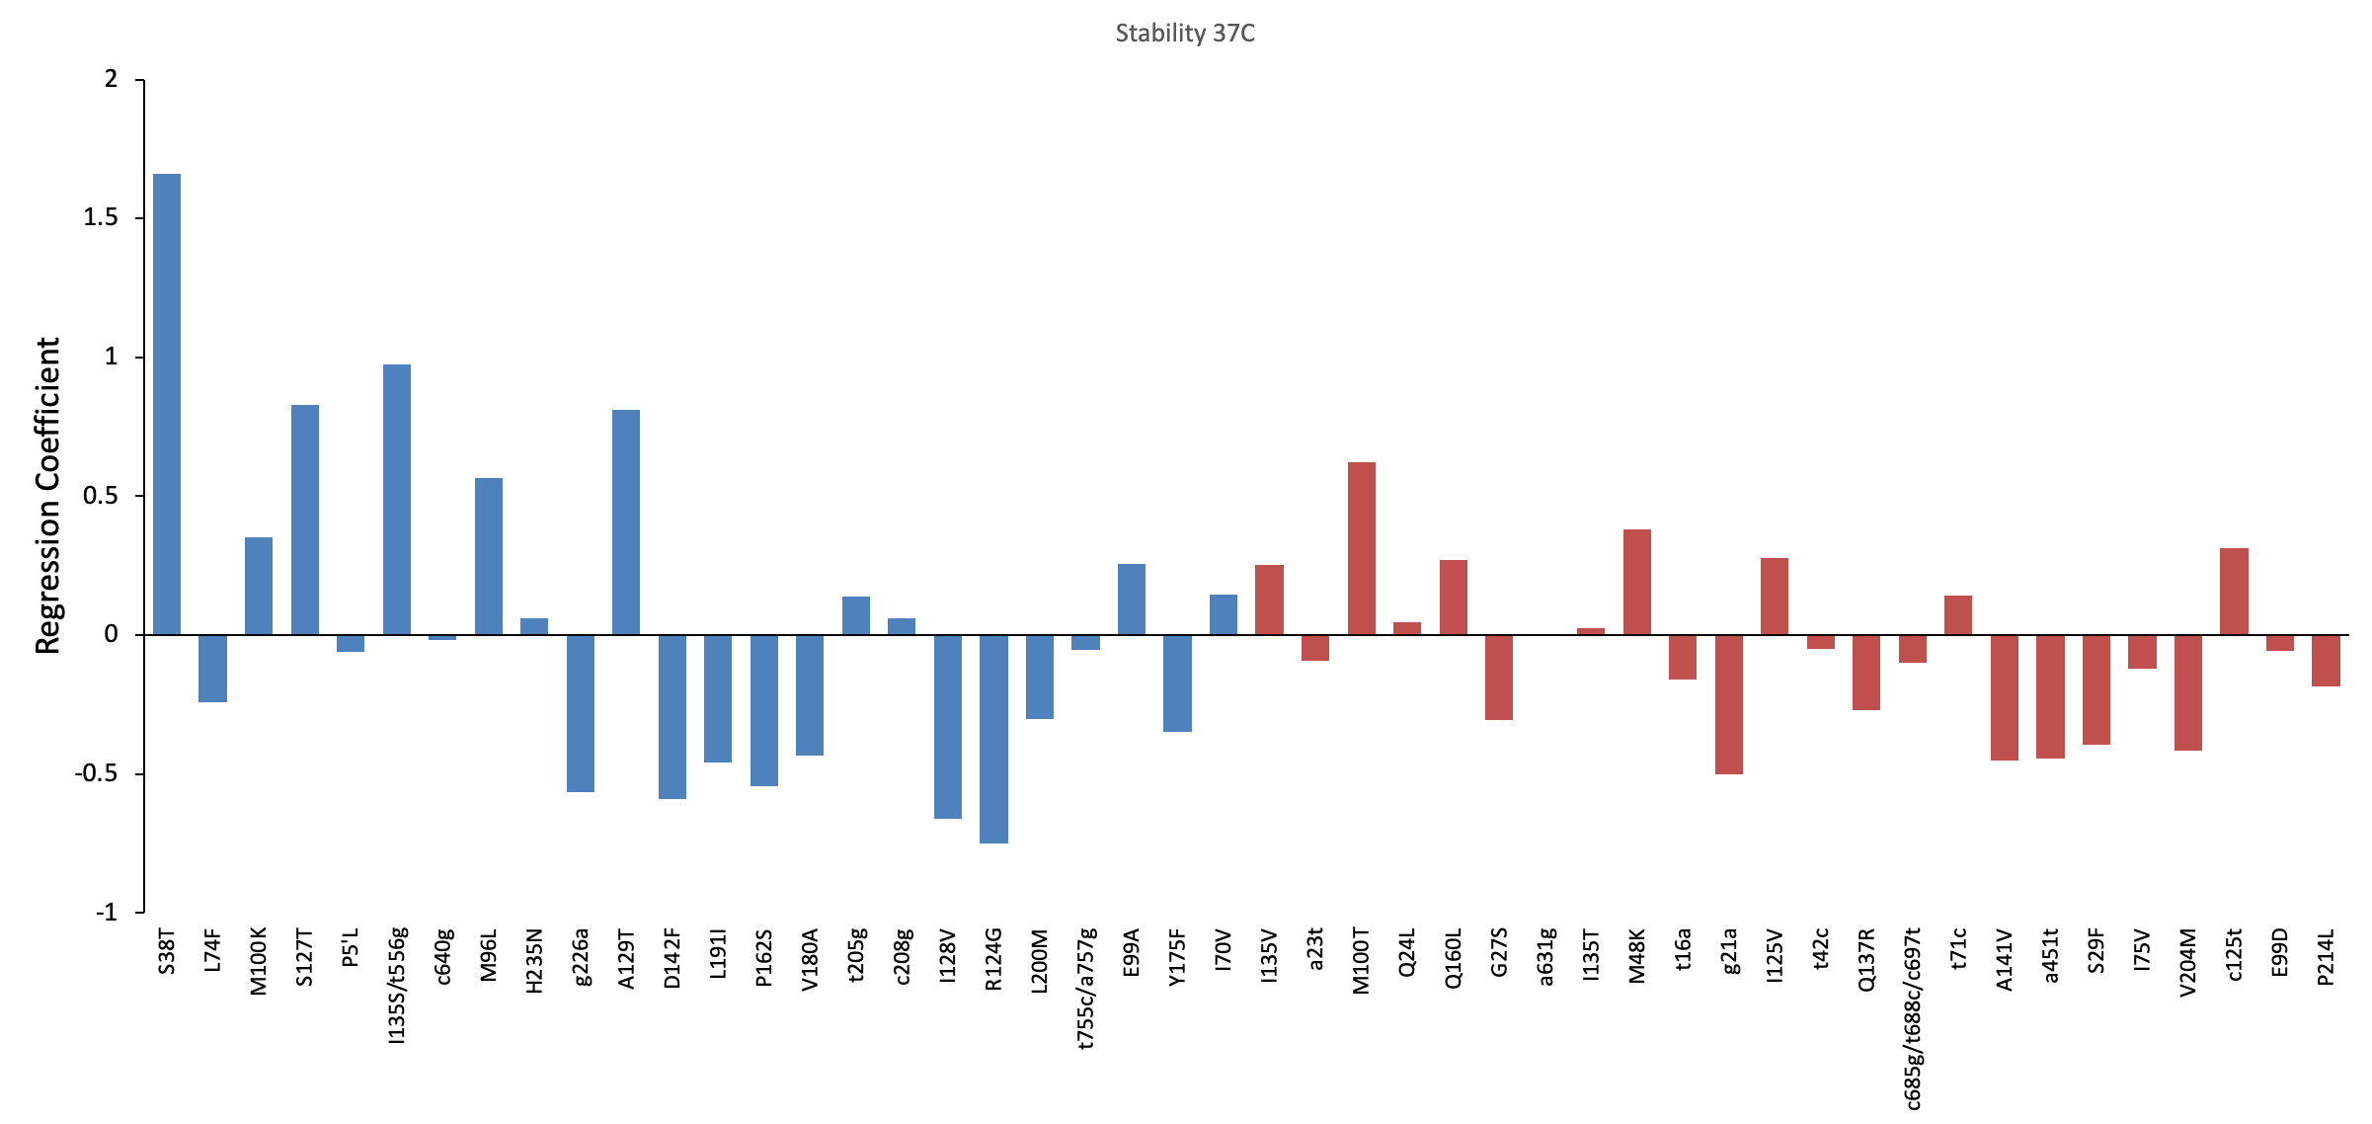D

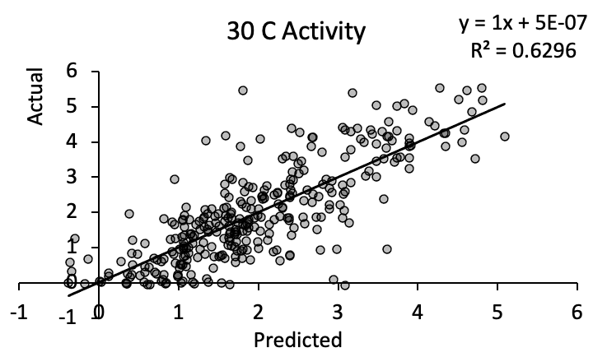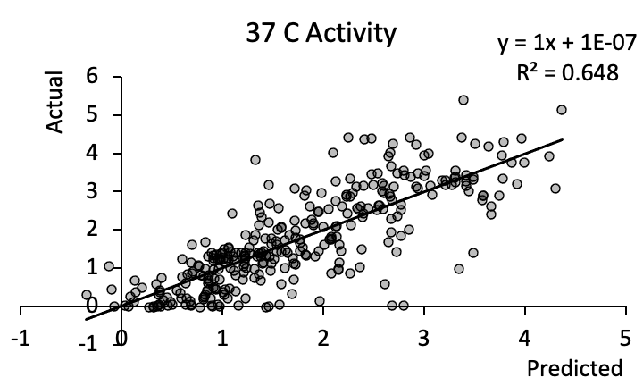
E F
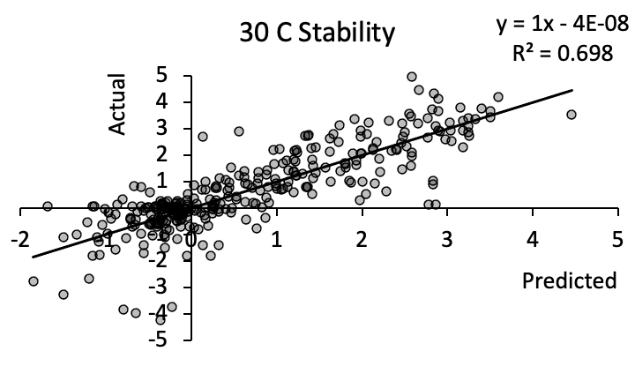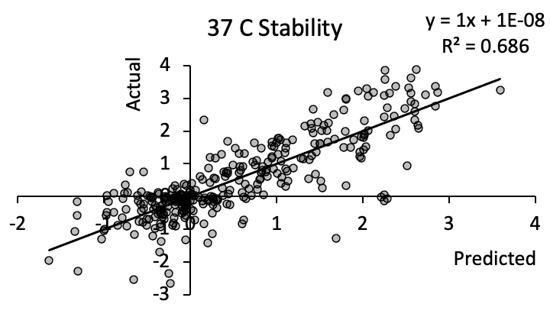
G H

Figure S6. Partial least squares regression models for the effects of mutations on EK_{L} variant properties. A-D: Coefficients for each mutation for each response. Mutations are ordered by significance according to their corresponding variable importance in projection (VIP) values from significant (blue, 6.3-1.0) to less significant (red, 1.0-0.6). Mutations with VIP<0.6 are not shown.
E-H: Comparison of predicted responses to actual responses for the 321 variants.
Plots represent each of the four responses of: (A,E) total activity when expressed at 30 °C; (B,F) total activity when expressed at 37 °C; (C,G) residual activity after pre-incubation at 50 °C for 2 hours, when expressed at 30 °C; (D,H) residual activity after pre-incubation at 50 °C for 2 hours, when expressed at 37 °C.
SDS-PAGE densitometry for selected evolved variants
SDS-PAGE densitometry was carried out with 12.5 % Tris-Glycine pre-cast gels (Invitrogen Ltd.). Protein samples were prepared by first mixing 50 μL sample with 50 μL 2x Laemli sample buffer and then heated to 99 °C for 15 minutes before cooling to room temperature. 5 μL of sample was loaded into each well with 5 μL of PageRuler Prestained Protein Ladder (Fermentas Life Sciences) as a marker. For clarified lysate analysis, 5 μL/well of 20-fold concentrated clarified lysate samples were loaded whereas 20μL/well of Ni-affinity purified fractions and STI-affinity purified fractions were loaded. Additionally, 5 μL/well of 0.125 mg/mL BSA and 0.03125 mg/mL BSA were loaded as reference protein standards for comparison purposes. The protein gels were run with 1x Novex Tris-Glycine buffer (Thermo Fisher Scientific, UK) at 125 V for 120 minutes in XCell SureLock Mini-Cell (Invitrogen, UK) electrophoresis chambers. Gels were stained in sufficient volume of Coomasie blue (50% methanol, 10% acetic acid, and 0.5 g/L brilliant blue) for 30 – 45 minutes. Following, gels were de-stained in 100mL of de-staining reagent (40% methanol and 10% acetic acid) for 20-30 minutes and repeated as required. Gels were either visualised using a Gel-Doc IT Imaging System (UVP, UK) or visualized using a scanner after drying using a gel-drying kit.

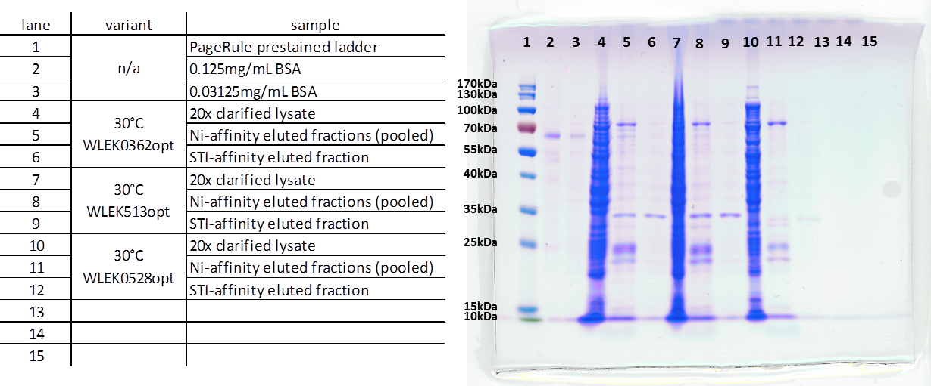
Figure S7. Example SDS-PAGE analyses of EK_{L} variants expressed at 30 °C. WLEK0362opt, WLEK0513opt, WLEK0528opt protein samples include 20-fold concentrated clarified lysates, pooled Ni-affinity elution fractions, and the STI-affinity elution fraction with highest EKL activity. The purified EK_{L} protein is in the band at just below the 35 kDa marker. Densitometry confirmed EK_{L} expression levels at approx. 1.5 mg/L, comparable to the 1.4 mg/L (WLEK0513) and 1.3 mg/L (WLEK0362) measured via enzyme activity. A single gel is shown within a single unedited image, other than adjusting brightness and contrast evenly for the whole image.

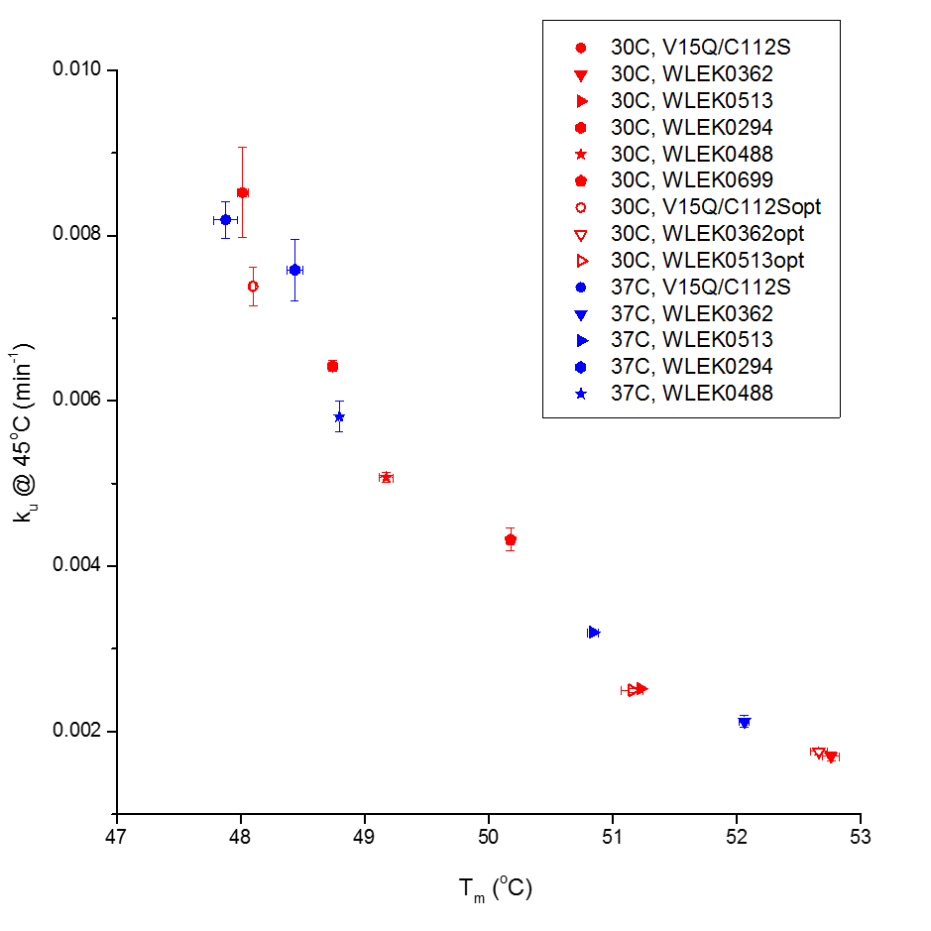
Figure S8. Relationship between unfolding rates of EK_{L} variants at 45 °C and their transition midpoints for thermal denaturation (T_{m}), expressed at either 30 °C or 37 °C.

A
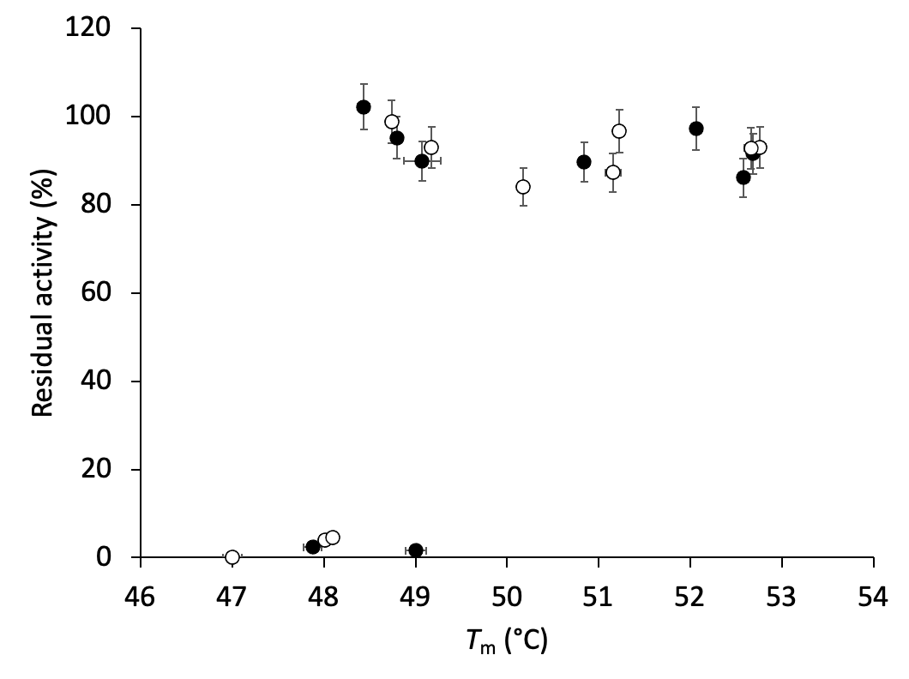

B
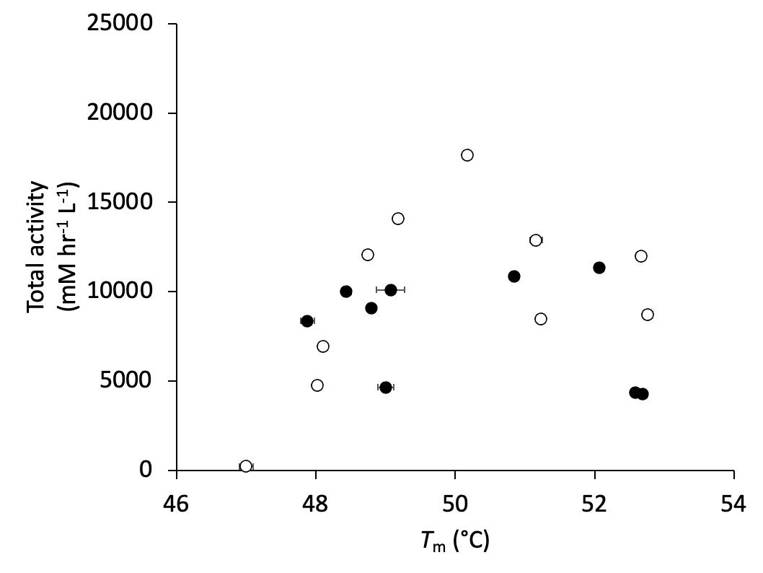
Figure S9. Relationship between T_{m} for purified variants and their stability and total activity measured in clarified lysates. A) Stability as measured from residual activity after incubation for 2 hours at 50 °C. B) Total activity measured from clarified lysates with 0.0625 mM substrate. Variants were obtained by expression at (¡) 30 °C or (l) 37 °C. All error bars are standard errors of the mean.

