Supplementary Information

Synergistic effect of tumor chemo-immunotherapy induced by leukocyte-hitchhiking thermal-sensitive micelles

Jing Qi,¹ Feiyang Jin,¹ Yuchan You,¹ Yan Du,¹ Di Liu,¹ Xiaoling Xu,¹ Jun Wang,¹ Luwen Zhu,¹ Minjiang Chen, ¹ Gaofeng Shu,² Liming Wu,^{3, *} Jiansong Ji ^{2, *} and Yongzhong Du^{1, *}

¹ Institute of Pharmaceutics, College of Pharmaceutical Sciences, Zhejiang University, 866 Yu-Hang-Tang Road, Hangzhou, 310058, China.
² Key Laboratory of Imaging Diagnosis and Minimally Invasive Intervention Research, Lishui Hospital of Zhejiang University, Lishui, 323000, China.
³ Department of Hepatobiliary and Pancreatic Surgery, The First Affiliated Hospital, Zhejiang University School of Medicine, Hangzhou 310003, China.

Corresponding Authors:
Yongzhong Du, E-mail: duyongzhong@zju.edu.cn, Phone: +86-571-88208435
Jiansong Ji, E-mail: lschrjjs@163.com, Phone: +86-578-2285011
Liming Wu, E-mail: wlm@zju.edu.cn

Content Page
Supplementary methods. S3
Scheme S1. Synthesis route of NTA-PEG-p-(AAm-co-AN) and the illustration of the introduction of E-selectin onto the surface of micelles. S4
Figure S1. The ¹H-NMR spectra of p-(AAm-co-AN), PEG, PEG-p-(AAm-co-AN) and NTA- PEG-p-(AAm-co-AN). S5
Figure S2. The particle size and potential of ES-DSM as E-selectin modifications increased. S6
Figure S3. Biocompatibility of blank micelles, DSM and ES-DSM to leukocytes. S7
Figure S4. Positive percentage of leukocytes after intravenous injection of DSM or ES-DSM for different time was calculated based on Figure 1l. S8
Figure S5. Flow cytometry detection of 4T1 cells exposed to free Nile red or Nile red-loaded micelles with (+) or without (-) hyperthermia. S9
Figure S6. 4T1 cell viabilities after exposure to a series of concentrations of blank micelles for 48h. S10
Figure S7. Detection of MHC Ⅱ on DCs after co-incubation with tumor cells. S11
Figure S8. Detection of MHC Ⅱ on DCs after co-incubation with tumor cells in the presence of NECA. S12
Figure S9. Analysis of CD4⁺ Foxp3⁺ T cells in the ternary co-incubation system. S13
Figure S10. Analysis of CD4⁺ Foxp3⁺ T cells in the ternary co-incubation system containing NECA.
S14
Figure S11. Average fluorescence intensity of ICG-loaded micelles and ES-modified ICG-loaded micelles in tumor and other major organs 24 h after intravenous injection. S15
Figure S12. Curves showing the changes of tumor volume of individual mouse after various treatments. S16
Figure S13. Microscopic images of H&E-stained cross-sections of the tumors at the end of observation. S17
Figure S14. Evaluation of the mature DCs in tumors after different treatments in 4T1 tumor models.
S18
Figure S15. Evaluation of the mature DCs in sentinel lymph nodes (SLNs) after different treatments in 4T1 tumor models. S19
Figure S16. Evaluation of T cells in PBMC and spleen after different treatments in 4T1 tumor models. S20
Figure S17. Positive percentage of T cells in tumor calculated based on Figure 6a and b. S21
Figure S18. Immunohistochemistry was used to examine the levels of CD69 and perforin in 4T1 tumor sections. S22
Figure S19. Hemolysis assay. S23
Figure S20. Microscopic images of H&E-stained cross-sections of major organs at the end of observation. S24
References S25
Supplementary methods.
The ability of micelles to chelate Ni²⁺. 3mg of NTA-PEG-p-(AAm-co-AN) was dispersed in 1mL of water and treated by probe ultrasound for 30 rounds, stirring at 25°C for 0.5h. Then 0.45mg of NiCl₂·H₂O was added and the mixture was stirred for anther 2h. After dialyzing against water (MWCO: 3.5 kDa) to remove the excess Ni²⁺ and lyophilizing, the Ni²⁺ content in the micelles was detected by Inductively Coupled Plasma Mass Spectrometry (ICP-MS) (NexION300X, PerkinElmer, USA). The NTA-PEG-p-(AAm-co-AN) without NiCl₂·H₂O served as a control.
Biocompatibility of micelles on leukocytes. To obtain the leukocytes, the blood of mice was taken by excising eyeballs and the leukocytes were isolated by the mouse peripheral blood leukocyte separation kit (Solarbio, China). The cytotoxicity of blank micelles to leukocytes was measured by CCK-8 assay. Briefly, leukocytes were suspended in RPMI 1640 medium and seeded in 96-well plate at a density of 1×10⁴ cells per well and then exposed to blank micelles at a series of concentrations (0, 100, 200, 400, 800, 1000μg/mL) for different time (1, 2, 4, 8h). Subsequently, 10μL of CCK-8 solution was added and incubated for 1h, followed by measuring the absorbance of each well by microplate reader at 450nm. . Cell viability was calculated in reference to negative cells without exposure to test agents. All of experiments were repeated thrice.
The cytotoxicity of ES-DSM to leukocytes was then tested. The leukocytes were seeded in 96-well plate at a density of 1×10⁴ cells per well and exposed to ES-DSM at different DOX concentrations (6.5, 12.5, 25, 31.5, 37.5μg/mL) for various time (1, 2, 4, 8h). The cell viabilities were measured by CCK-8 assay. All of experiments were repeated thrice.
The chemotaxis and penetration ability of leukocytes were investigated by transwell migration assay (pore size of transwell polycarbonate membrane was 8µm). Briefly, leukocytes were exposed to DSM or ES-DSM at a DOX concentration of 37.5μg/mL for 8h. After washing thrice by PBS, the leukocytes were suspended in RPMI 1640 medium added to the upper chamber of transwell which had been attached by HUVECs. The lower chamber of transwell was filled with RPMI 1640 medium containing chemokines (10ng/mL of CXCL2 and 100ng/mL of CXCL12). After 4h of incubation, the leukocytes in the lower chamber were observed by microscope, then the leukocytes were collected and the numbers were counted by cytometry. The transwell percentage was calculated by the formula: Transwell%=N_{lower champer}/N_{total}×100%. Simultaneously, mice were intravenously injected with DSM or ES-DSM and the leukocytes were isolated after 24h. The chemotaxis and penetration ability of the isolated leukocytes were also analyzed by transwell as mentioned above, and the transwell percentage was calculated too.
Hemolysis assay. The in vitro hemolysis assay was conducted according to a previous studies.^{4, 5} Fresh mice blood samples stabilized by ethylenediaminetetraacetic acid were obtained and then RBCs were isolated from serum by centrifugation at 1500rpm for 15min. After being washed five times with saline, the purified blood was diluted to a 2% RBC suspension and then 0.5mL of the RBC suspension was added to 1.5mL Eppendorf tubes and mixed with the following agents: (1) 0.5mL of saline as a negative control, (2) 0.5mL of pure water as a positive control, (3) 0.5mL of blank micelles (M) at 2mg/mL, (4) 0.5mL of E-selectin modified blank micelles (ES-M) at 2mg/mL, (5) 0.5mL of DSM at a micelle concentration of 2mg/mL and (6) 0.5mL of ES-DSM at a micelle concentration of 2mg/mL. All the mixtures were vortexed and kept at room temperature for 3h. Finally, the mixtures were centrifuged at 8000 rpm for 5 min and the absorbance of the supernatants was determined at 541 nm using an ultraviolet spectrophotometer. The percent hemolysis of RBCs was calculated as follows: percent hemolysis (%) = (A_{sample} − A_{negative})/(A_{positive} − A_{negative}) × 100%.
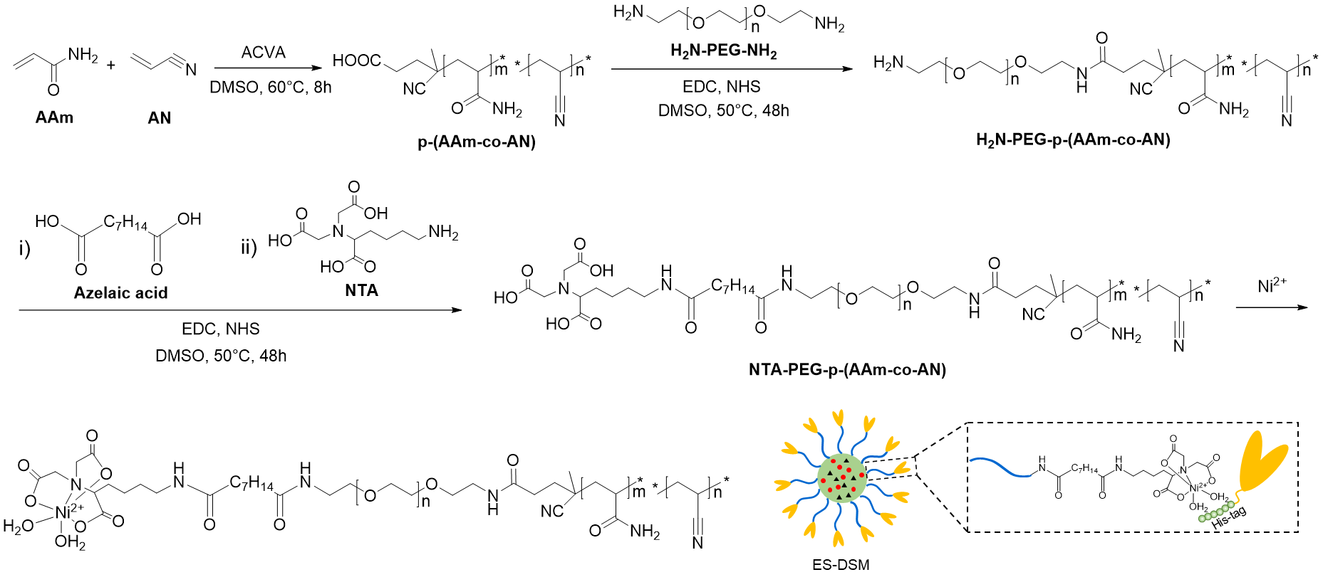
Scheme S1. Synthesis route of NTA-PEG-p-(AAm-co-AN) and the illustration of the introduction of E-selectin onto the surface of micelles.

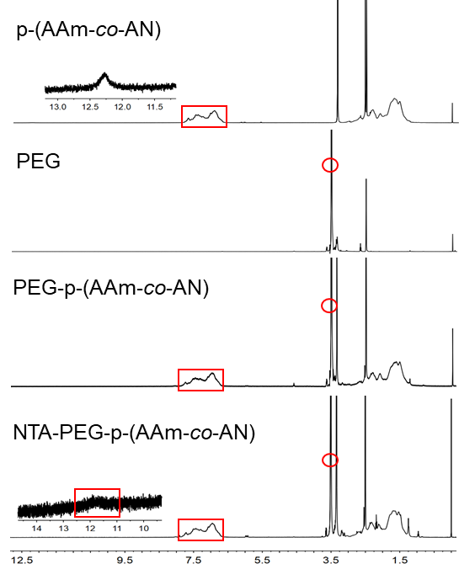
Figure S1. The ¹H-NMR spectra of p-(AAm-co-AN), PEG, PEG-p-(AAm-co-AN) and NTA- PEG-p-(AAm-co-AN).

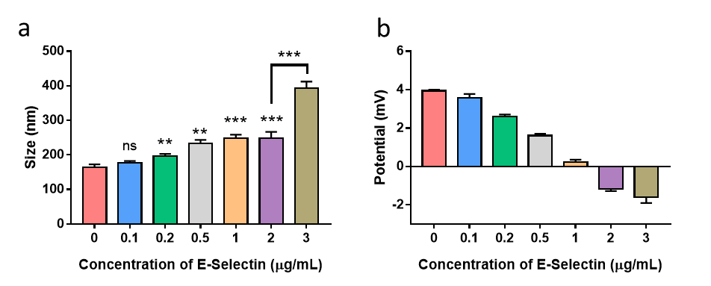
Figure S2. The particle size and potential of ES-DSM as E-selectin modifications increased.

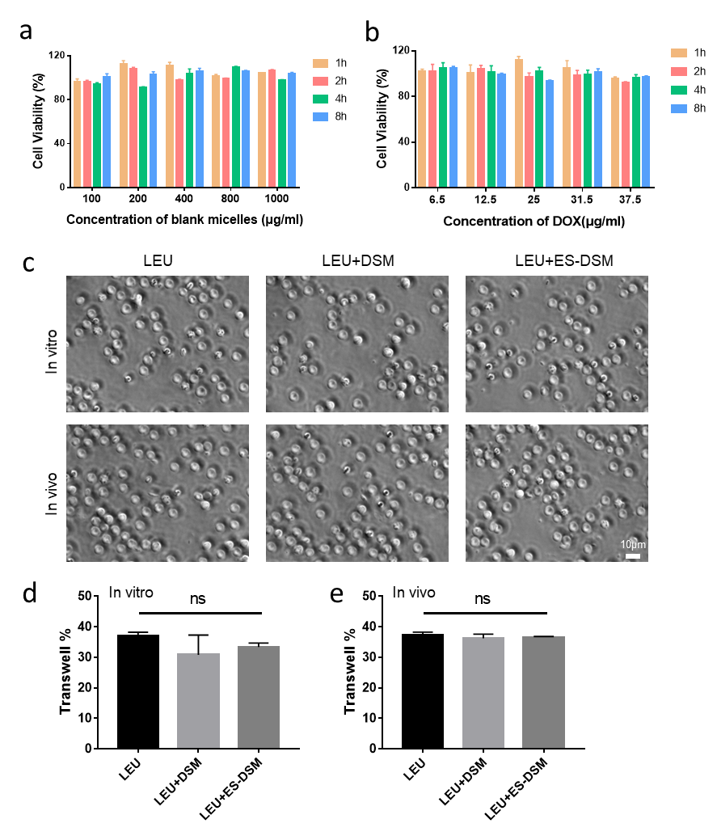
Figure S3. Biocompatibility of blank micelles, DSM and ES-DSM to leukocytes. (a) Leukocyte viabilities after exposure to a series of concentrations of blank micelles for different periods. (b) Leukocyte viabilities after exposure to ES-DSM at different DOX concentrations for various time. (c) Images of leukocytes (LEU) transported in the lower chamber of the transwell system in the presence of CXCL2 and CXCL12. (d) The transwell percentage of LEU after incubation with DSM or ES-DSM in vitro was calculated based on c). (e) The transwell percentage of LEU isolated form mice after intravenous injection of DSM or ES-DSM in vivo was calculated based on c).

Figure S4. Positive percentage of leukocytes after intravenous injection of DSM or ES-DSM for different time was calculated based on Figure 1l.

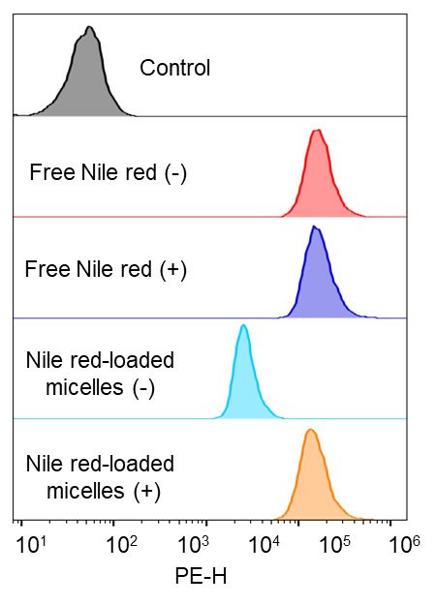
Figure S5. Flow cytometry detection of 4T1 cells exposed to free Nile red or Nile red-loaded micelles with (+) or without (-) hyperthermia.

Figure S6. 4T1 cell viabilities after exposure to a series of concentrations of blank micelles for 48h.

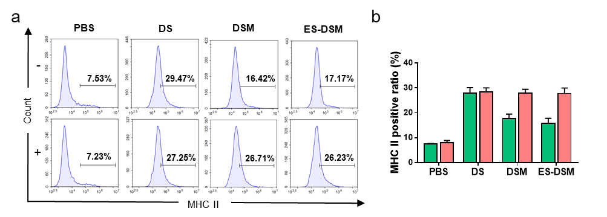
Figure S7. Detection of MHC Ⅱ on DCs after co- incubation with tumor cells. (a) Flow cytometry analysis of MHC Ⅱ on DCs. (b) Ratios of MHC Ⅱ positive DCs calculated based on a).

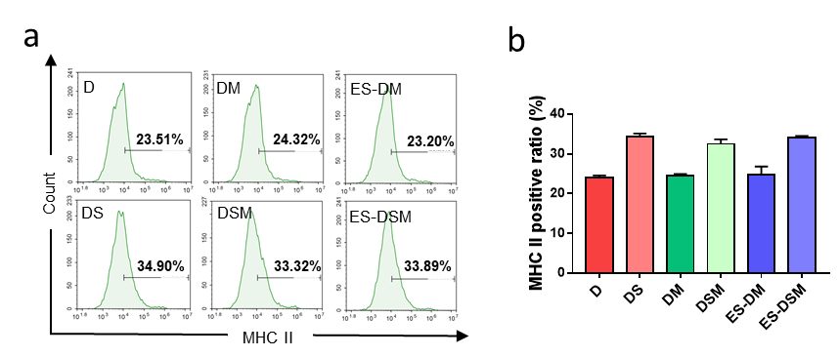
Figure S8. Detection of MHC Ⅱ on DCs after co-incubation with tumor cells in the presence of NECA. (a) Flow cytometry analysis of MHC Ⅱ on DCs. (b) Ratios of MHC Ⅱ positive DCs calculated based on a).

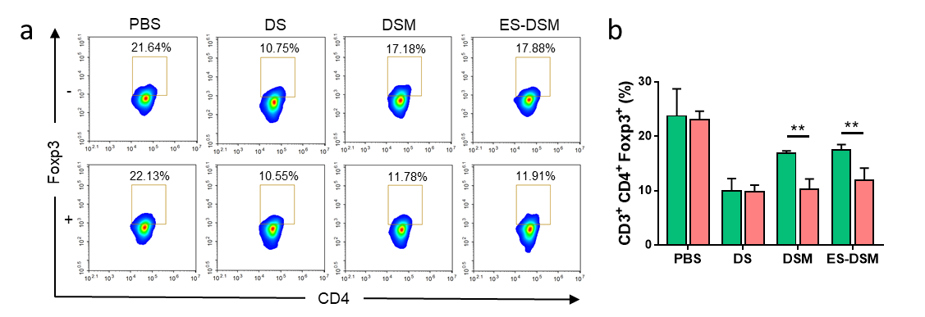
Figure S9. Analysis of CD4⁺ Foxp3⁺ T cells in the ternary co-incubation system. (a) Flow cytometry analysis of the percentages of CD4⁺ Foxp3⁺ T cells after co-incubating with tumor cells and DCs. (b) Ratios of CD4⁺ Foxp3⁺ T cells calculated based on a).

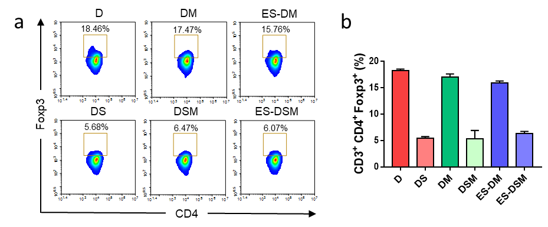
Figure S10. Analysis of CD4⁺ Foxp3⁺ T cells in the ternary co-incubation system containing NECA. (a) Flow cytometry analysis of the percentages of CD4⁺ Foxp3⁺ T cells after co-incubating with tumor cells and DCs with the existence of NECA. (b) Ratios of CD4⁺ Foxp3⁺ T cells calculated based on a).

Figure S11. Average fluorescence intensity of ICG-loaded micelles and ES-modified ICG-loaded micelles in tumor and other major organs 24 h after intravenous injection.

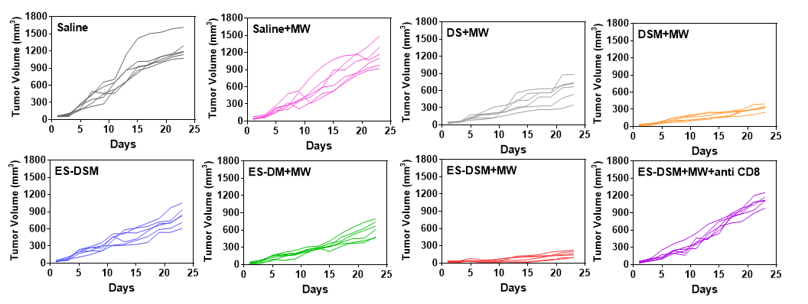
Figure S12. Curves showing the changes of tumor volume of individual mouse after various treatments.

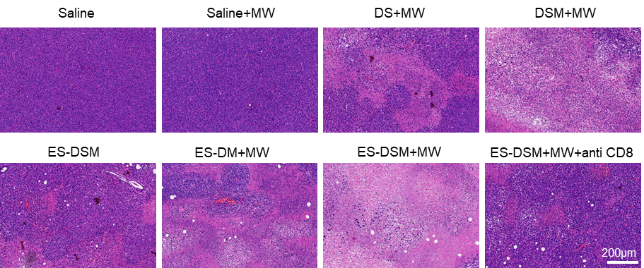
Figure S13. Microscopic images of H&E-stained cross-sections of the tumors at the end of observation.

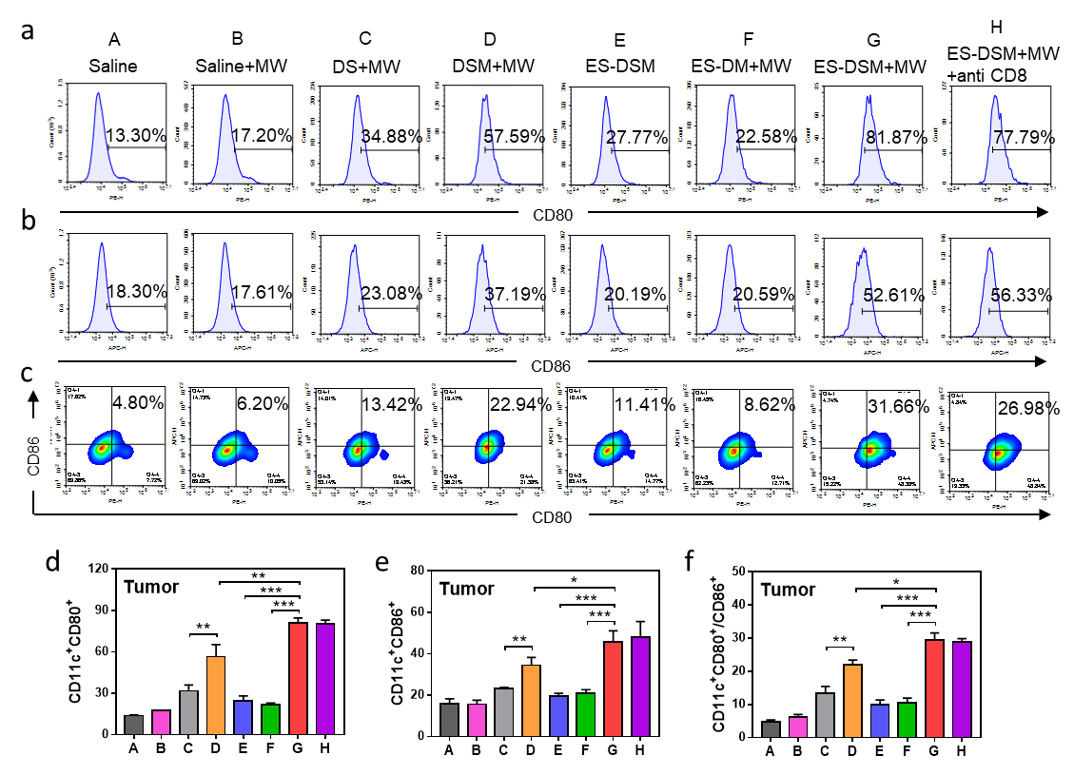
Figure S14. Evaluation of the mature DCs in tumors after different treatments in 4T1 tumor models. Flow cytometry analysis of the ratios of a) CD80⁺, b) CD86⁺ and c) CD80⁺CD86⁺ DCs in tumors. The percentages of d) CD80⁺, e) CD80⁺ and f) CD80⁺CD86⁺ DCs calculated based on a), b) and c), respectively.

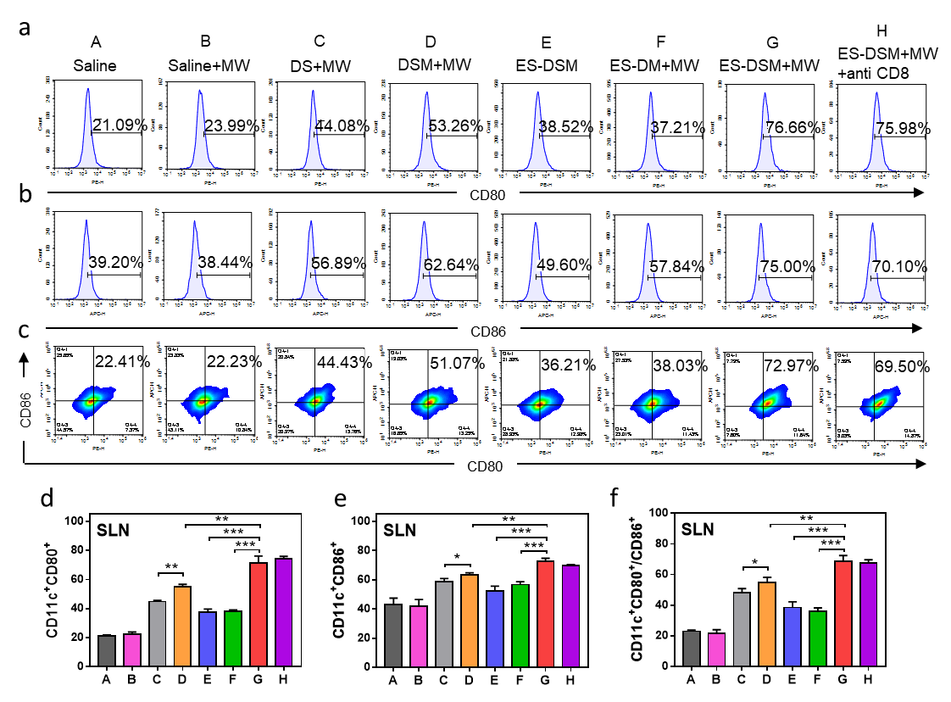
Figure S15. Evaluation of the mature DCs in sentinel lymph nodes (SLNs) after different treatments in 4T1 tumor models. Flow cytometry analysis of the ratios of a) CD80⁺, b) CD86⁺ and c) CD80⁺CD86⁺ DCs in SLN. The percentages of d) CD80⁺, e) CD80⁺ and f) CD80⁺CD86⁺ DCs calculated based on a), b) and c), respectively.

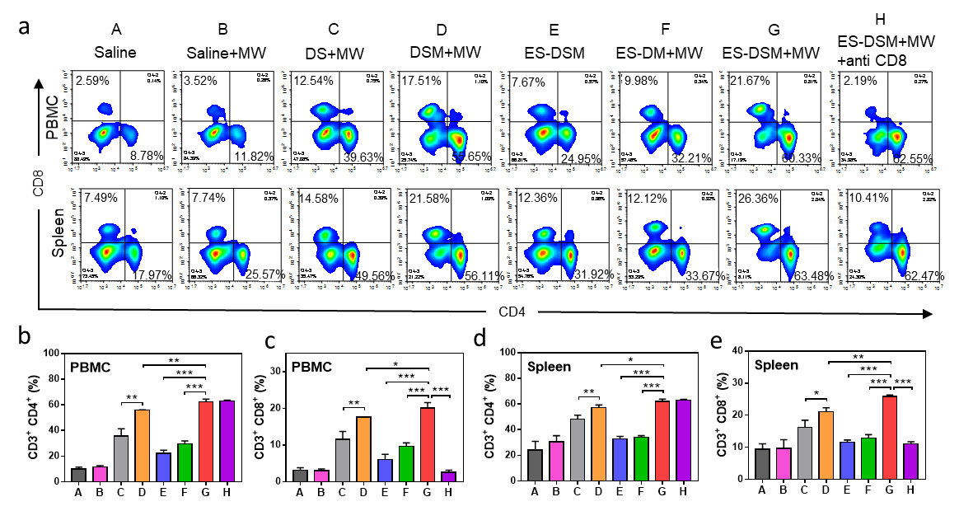
Figure S16. Evaluation of T cells in PBMC and spleen after different treatments in 4T1 tumor models. (a) Flow cytometry analysis of the ratios of CD3⁺CD4⁺ and CD3⁺CD8⁺ T cells in PBMC and spleen. The percentages of b) CD3⁺ CD4⁺ and c) CD3⁺ CD8⁺ T cells in PBMC were calculated based on a). The percentages of d) CD3⁺ CD4⁺ and e) CD3⁺ CD8⁺ T cells in spleen were calculated based on a).

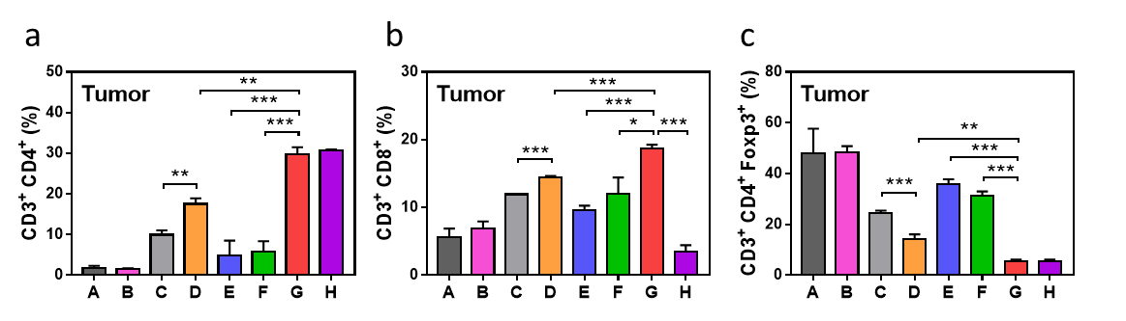
Figure S17. Positive percentage of T cells in tumor calculated based on Figure 6a and b. The percentages of a) CD3⁺ CD4⁺, b) CD3⁺ CD8⁺ and CD4⁺ Foxp3⁺ T cells in tumor.

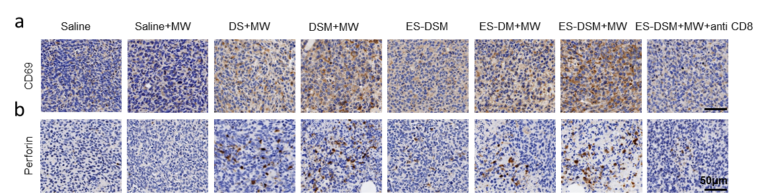
Figure S18. Immunohistochemistry was used to examine the levels of CD69 and perforin in 4T1 tumor sections.

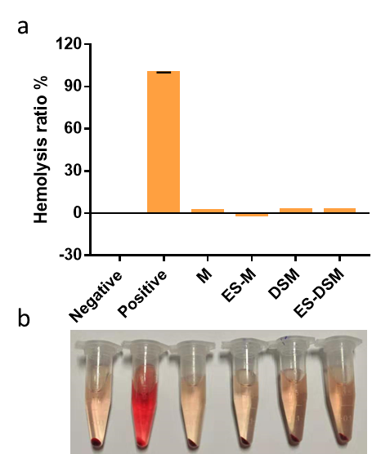
Figure S19. Hemolysis assay. (a) The hemolysis ratios of RBCs after treated with different agents. (b) The images of the mixture of RBCs and different agents after centrifugation.

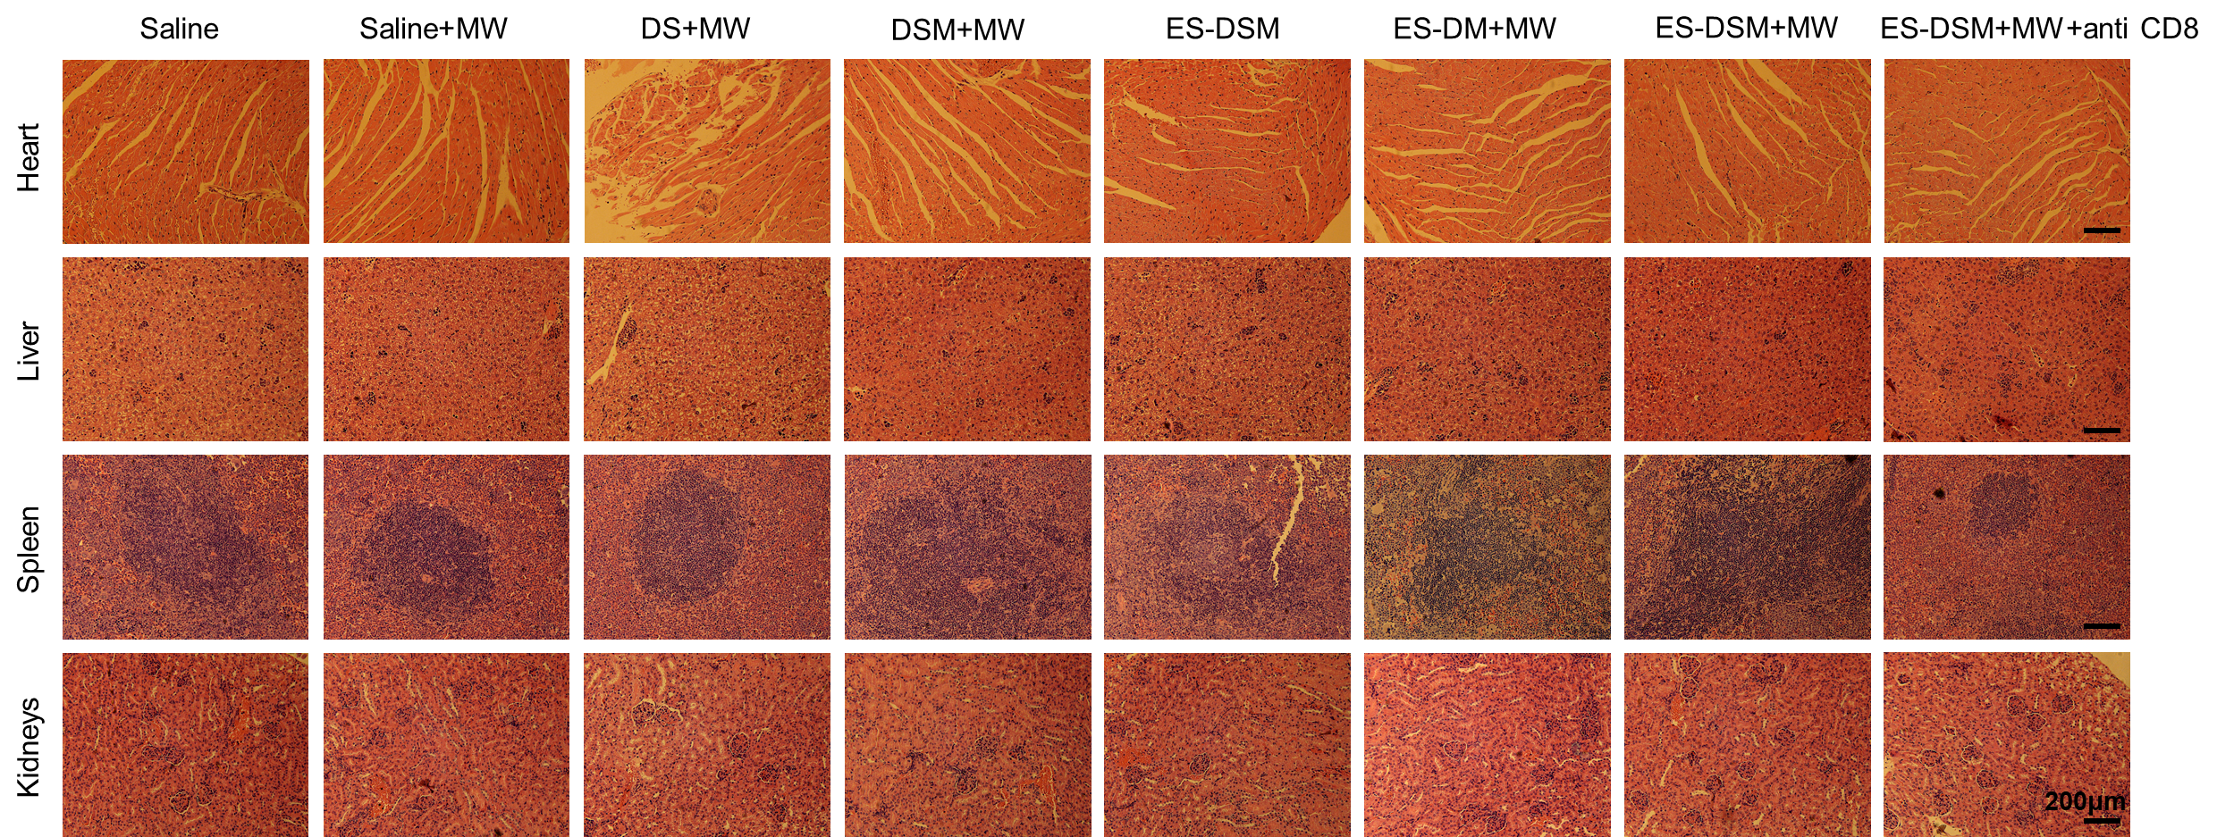
Figure S20. Microscopic images of H&E-stained cross-sections of major organs at the end of observation.

Reference
1. Liu, L. et al. Integrated Nanovaccine with MicroRNA-148a Inhibition Reprograms Tumor-Associated Dendritic Cells by Modulating miR-148a/DNMT1/SOCS1 Axis. J. Immunol. 197, 1231-1241 (2016).
2. Chen, Z. et al. Bioinspired Hybrid Protein Oxygen Nanocarrier Amplified Photodynamic Therapy for Eliciting Anti-tumor Immunity and Abscopal Effect. ACS nano 12, 8633-8645 (2018).
3. Beavis, P. A. et al. Targeting the adenosine 2A receptor enhances chimeric antigen receptor T cell efficacy. J. Clin. Invest. 127, 929-941 (2017).
4. Liu, Z. et al. Non-toxic lead sulfide nanodots as efficient contrast agents for visualizing gastrointestinal tract. Biomaterials 100, 17-26 (2016).
5. Xu, X. L. et al. Endogenous sialic acid-engineered micelles: a multifunctional platform for on-demand methotrexate delivery and bone repair of rheumatoid arthritis. Nanoscale 10, 2923-2935 (2018).

