Supplement information

Revolutionary High-entropy Zr-Y-Yb-Ta-Nb-O Oxides for Next Generation Thermal Barrier Coating Applications
Yao Yao ª, Fan Yang ^{b}, Xiaofeng Zhao ^{a,}∗, Ping Xiao ª
ª Shanghai Key Laboratory of High Temperature Materials and Precision Forming, Shanghai Jiao Tong University, 800 Dongchuan Road, Shanghai 200240, China
^{b} School of Mechanical Engineering, Shanghai Jiao Tong University, 800 Dongchuan Road, Shanghai 200240, China

Section 1: Methods
Section 2: Microstructure and element distributions
Section 3: Thermal diffusivity and heat capacity
Section 4: High-temperature thermal stability
Section 5: CMAS resistance
Section 6: Fracture patterns
Section 7: Fracture toughening by stress-induced ferroelastic and martensitic transformation

Section 1: Methods
Materials and sample preparation.
Multicomponent medium- and high-entropy Zr_{1-4x}Y_{x}Yb_{x}Ta_{x}Nb_{x}O₂ tetragonal oxides with designed compositions (Table S1) were fabricated by solid-reaction using zirconia (99.99 %), yttria (99.99 %), ytterbia (99.99 %), neodymia (99.99 %) and tantalum oxide (99.5 %). These powders (purchased from Macklin, China) were massed and milled for 12 h using a high-energy ball milling and isopropanol as milling media to ensure adequate mixing. Mixed powders were then pressed into pellets under pressure of 300 MPa for 5 min. The pellets were free-sintered in air for 20 h at 1600 ºC (10 ºC/min ramp rate) and furnace cooled, where the cooling rate was approximately 40 ºC/min at 1600 ºC and 10 ºC/min at 1100 ºC. The samples fabricated for measuring thermal conductivity, CTE and CMAS resistance were annealed for 40 h at 1600 ºC to reduce porosity. HEOs with cubic fluorite structure were prepared at the same conditions for comparison.

Table S1: The designed composition of all Zr_{1-4x}Y_{x}Yb_{x}Ta_{x}Nb_{x}O₂ oxides, along with densities, grain sizes, Vicker’s hardness, Young’s modulus, and configurational entropy (ΔS), compared with c-HEOs.
Sample # | Composition | Density (g/cm³) | Grain size  (μm) | Hardness  (GPa) | Young’s modulus  (GPa) | ΔS  (k_{B})
t-1 | Zr_{0.2}Y_{0.2}Ta_{0.2}Nb_{0.2}Yb_{0.2} | 6.46 | 1.11±0.75 | 8.11±2.19 | 138.04±17.48 | 1.61
t-2 | Zr_{0.312}Y_{0.172}Ta_{0.172}Nb_{0.172}Yb_{0.172} | 6.38 | 10.55±6.42 | 6.50±1.03 | 125.11±6.13 | 1.57
t-3 | Zr_{0.432}Y_{0.142}Ta_{0.142}Nb_{0.142}Yb_{0.142} | 6.30 | 7.67±5.09 | 5.92±1.44 | 112.58±11.82 | 1.47
t-4 | Zr_{0.544}Y_{0.114}Ta_{0.114}Nb_{0.114}Yb_{0.114} | 6.22 | 7.36±6.51 | 7.32±2.23 | 130.51±15.83 | 1.32
t-5 | Zr_{0.668}Y_{0.083}Ta_{0.083}Nb_{0.083}Yb_{0.083} | 6.12 | 16.32±7.20 | 8.71±0.98 | 123.33±5.11 | 1.10
c-1 | (Zr_{0.2}Hf_{0.2}Y_{0.2})Gd_{0.2}La_{0.2} | 6.44 | 2.26±1.05 | 10.88±2.10 | 172.25±8.01 | 1.61
c-2 | (Zr_{0.2}Hf_{0.2}Y_{0.2})Gd_{0.2}Nd_{0.2} | 6.71 | 1.97±1.04 | 12.67±0.98 | 197.24±5.69 | 1.61

Characterization.
Phase composition analysis
The phase constitution of the sintered bulk was analyzed using X-ray diffraction (XRD, Ultima IV, Rigaku) with a Cu K_{α} source. Diffraction patterns were obtained in the rage of 10° ≤ 2θ ≤ 80° at a scan rate of 5°/min using the standard Bragg-Brentano geometry. The Raman spectroscopy coupled with a 532 nm laser (LabRAM HR Evolution; Horiba, France) was also employed to evaluate the phase transformation.
Microstructure characterization
A scanning electron microscope (SEM, Mira3 LHM, Tescan) coupled with the energy dispersive X-ray spectroscopy (EDS) was employed to analyze the morphology and element distribution of the sintered bulk materials. Back-scattered electron imaging (BSE) was used to investigate the phase and microstructure of the Zr_{1-4x}Y_{x}Yb_{x}Ta_{x}Nb_{x}O₂ oxides. The average grain size of the sintered samples was calculated based on at least 100 grains on the published surface after thermal etching. The ferroelastic domain state was observed by the atomic force microscope (AFM, Fastscan, Bruker). Microstructural characterization was performed using aberration-corrected scanning transmission electron microscopy (AC STEM, JEM-ARM200F, JEOL). TEM lamellae were extracted from the polished cross sections using a focused ion beam (FIB, Gaia3, Tescan) system. Selective area electron diffraction (SAED) in TEM (TEM, Talos F200X, FEI) was used for diffraction analyses.
Mechanical properties
Mechanical properties, including the Young’s modulus and the hardness, were measured using a micro-indenter (Anton Paar, CPX MHT, Austria) with a diamond Vickers indenter tip. The indentation measurements were performed on the polished cross-sections and the modulus measured from the unloading curve following the Oliver-Pharr method [1]. At least 10 indentations per sample were made to a maximum load of 5 N with a holding time of 10 seconds. The fracture toughness (K_{IC}) was evaluated according to Eq. (S1):
Eq. (S1)
where E is the Young’s modulus (GPa); H is the hardness (GPa); P is the applied load (N) and c is the sum of crack length and one half of the indenter imprint diagonal (m). At least 10 indentations were performed to obtain the average value at a constant load of 10 N.
Thermal properties
The thermal conductivity (κ) was calculated from the following equation:
Eq. (S2)
where ρ is the density of the bulk specimen measured using the Archimedes method, $λ$ is the thermal diffusivity, and C_{p} is the thermal capacity determined in the temperature range 40-300 °C at a scanning rate 10 °C/min by differential scanning calorimetry (DSC 2500, NETZSCH, Germany). C_{p} from 300 °C to 900 °C was calculated by empirical equation:
Eq. (S3)
where a, b and c are constants. The thermal diffusivity ($λ$) was obtained by the laser-flash method (LFA 427, NETZSCH, Germany) from room temperature to 900 °C at an interval of 100 °C. The dimensions of samples were 10×10×2 mm.
The linear thermal expansion coefficient (CTE) was measured using a high temperature dilatometer (DIL 402 Expedis Select/Supreme, NETZSCH, Germany). The specimen was cut into a cuboid 15×5×5 mm³ in size, and the measurement was conducted in air from 20 °C to 1400 °C at a heating rate of 5 °C/min.
The phase stability at high temperature over long-term thermal exposure was evaluated by comparing the XRD patterns of the Zr_{1-4x}Y_{x}Yb_{x}Ta_{x}Nb_{x}O₂ oxides before and after heat treatment at 1600 °C for 100 h.
CMAS resistance
The composition of the CMAS powders was 33CaO-9MgO-13AlO_{1.5}-45SiO2 mol %, which was prepared by mixing the individual oxides and mixed in isopropanol to form a slurry. Then, the CMAS slurry was applied on the polished surfaces of the YSZ and the t-4 samples and dried. The area density of the CMAS is 20 ± 1 mg/cm². The CMAS covered specimens were heat-treated in a chamber furnace at 1300 °C for 1, 4, 25, 50 h and quenched to room temperature.

Section 2: Microstructure and element distributions
The microstructures of the thermal etched Zr_{1-4x}Y_{x}Yb_{x}Ta_{x}Nb_{x}O₂ oxides were shown in Fig.S1a~e. The average grain size of equal-molar high-entropy composition t-1, c-1, and c-2 are significantly smaller than other compositions (see Table S1). This could be attributed to the high-entropy effects reducing both the driving force (grain-boundary energy) and kinetics (grain-boundary migration rate) of grain growth. EDS elemental mapping in Fig.S1 showed that all elements were homogenously distributed for the high-entropy t-2 and low-entropy t-5 samples, while a Zr-enriched second phase was detected in the medium-entropy compositions oxides t-3 and t-4. BSE images of t-3 and t-4 showed that the secondary phase was uniformly distributed. t-2 with 31.2 mol % ZrO₂ content was single phase as can be seen from both the EDX and BSE results, whereas oxides in the ZrO₂-YO_{1.5}-TaO_{2.5} ternary system with the Zr contents from 28 mol % to 65 mol % were tetragonal and monoclinic mixed phases according to the phase diagram.
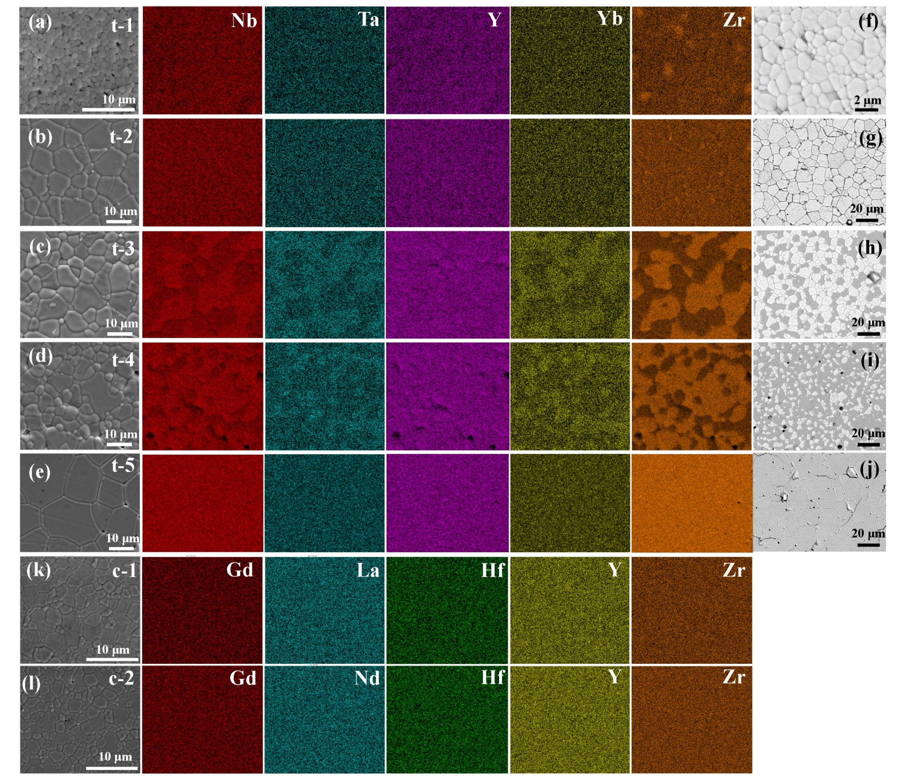
Figure. S1│Microstructure and element distributions. (a)~(e) Microstructures and EDXS element distribution of the sintered Zr_{1-4x}Y_{x}Yb_{x}Ta_{x}Nb_{x}O₂ oxides, compared with cubic phase HEOs (k) and (l); (f)~(j) phase distribution characterized by the BSE images of Zr_{1-4x}Y_{x}Yb_{x}Ta_{x}Nb_{x}O₂ oxides.

Section 3: Thermal diffusivity and heat capacity
The variations of thermal diffusivities with temperature for Zr_{1-4x}Y_{x}Yb_{x}Ta_{x}Nb_{x}O₂ oxides were shown in Fig.S2a. These thermal diffusivities seem to be temperature-independent for all samples up to 600 °C. The increase of thermal diffusivities at temperature exceed 600 °C may be attributed to the buildup of thermal radiation inside the material. t-2 sample with single T-ABO₄(ZrO₂) phase showed a highest thermal diffusivity. The thermal diffusivity gradually decreased with the increasing content of t-ZrO₂(ABO₄) phase from t-2 to t-5 sample.
Specific heat capacity of Zr_{1-4x}Y_{x}Yb_{x}Ta_{x}Nb_{x}O₂ oxides were plotted in Fig.S2b. The values of tetragonal oxides increased with the temperature from 100 °C to 900 °C, while an inversely proportional relationship was found between heat capacity and temperature of cubic high-entropy oxides. The decrease of heat capacity of cubic HEOs with temperature led to a comparatively lower thermal conductivity (~0.83 W mK⁻¹). There seems to be a trend that heat capacity increases with increasing number of light ions (Zr), consistent with the YO_{1.5}-TaO_{2.5}-ZrO₂ system [2].
Figure. S2│Thermal diffusivity and heat capacity. (a) Experimental thermal diffusivities of Zr_{1-4x}Y_{x}Yb_{x}Ta_{x}Nb_{x}O₂ oxides; (b) calculated heat capacity of Zr_{1-4x}Y_{x}Yb_{x}Ta_{x}Nb_{x}O₂ oxides.

Section 4: High-temperature thermal stability
XRD patterns of Zr_{1-4x}Y_{x}Yb_{x}Ta_{x}Nb_{x}O₂ oxides after heat treatment at 1600 ºC for 100 h were shown in Fig.S3 to evaluate their long-term thermal phase stability. No obvious second phase or phase transition was observed during heat treatment (except the lowest entropy composition t-5 sample). Little tetragonal ABO₄ phase was segregated from the ZrO₂(ABO₄) solid solution in t-5 sample. The improved high-temperature stability could be explained by the high-entropy effects that a higher mixing configuration entropy and lattice distortion might cooperativity enhance the formation of simple compounds with multiphase elements.
Figure. S3│High-temperature thermal stability. Long-term thermal phase stability of Zr_{1-4x}Y_{x}Yb_{x}Ta_{x}Nb_{x}O₂ oxides after heat treatment at 1600 ºC for 100 h.

Section 5: CMAS resistance
Fig.S4 showed the cross-sectional BSE images of t-4 sample after CMAS corrosion at 1300 °C for 1 h, 4 h, 25 h and 50 h. The total CMAS infiltration depth was calculated as the distance from the original surface to the infiltration front (red dash lines in Fig.S4). The CMAS infiltration layer was uniform during the whole CMAS corrosion process. In addition, the dissolution rate slightly increased with the corrosion time. The CMAS melt deposition was not fully absorbed into the samples even after 50 h corrosion. The calculated CMAS infiltration rate (~ 2.9 μm/h in Fig.2e) proved an outstanding CMAS resistance of medium entropy t-4 composition.
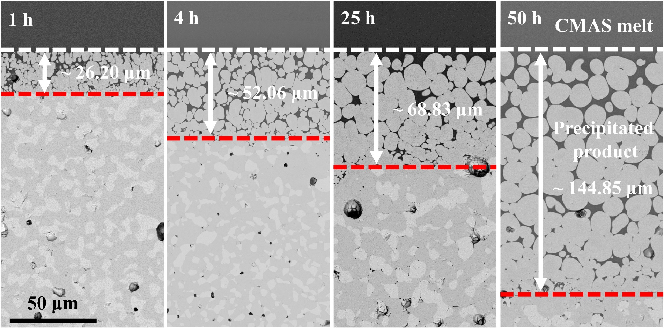
Figure. S4│CMAS resistance. The cross-sectional BSE images of CMAS-corroded t-4 sample following 1 h, 4 h, 25 h and 50 h CMAS corrosion at 1300 °C. Total infiltration depth was measure from the cross-section BSE images.

Section 6: Fracture patterns
Fracture patterns of Zr_{1-4x}Y_{x}Yb_{x}Ta_{x}Nb_{x}O₂ oxides were characterized by the indentations under stresses (5N and 20N) as shown in Fig.S5. t-2 and t-5 with the stable single tetragonal phase demonstrated mainly transgranular fracture associated with much lower fracture toughness. The crack types of t-2 and t-5 were radial-median while high-toughness materials usually have Palmqvist cracks. Under the same indent stress, t-3 and t-4 with double tetragonal phases showed mainly intergranular fractures and enhanced fracture toughness. Besides, t-4 sample, with a highest fracture toughness (~4.59 MPa∙m^{1/2}), had nearly no tip cracks .
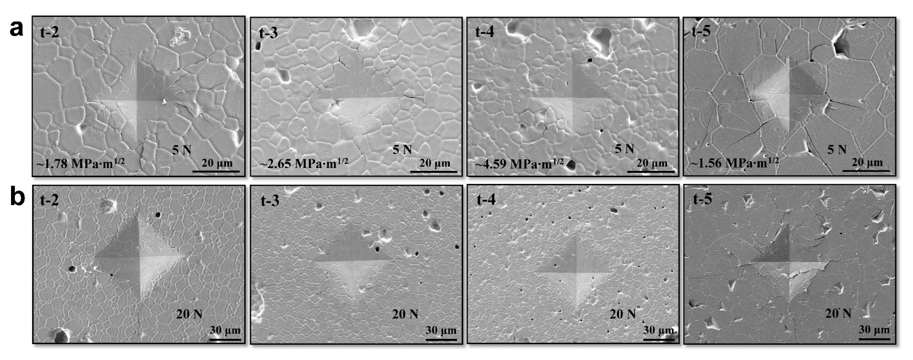
Figure. S5│Fracture patterns. SEM images of indentations made at the thermal etched surface of the sintered Zr_{1-4x}Y_{x}Yb_{x}Ta_{x}Nb_{x}O₂ oxides under 5N (a) and 20N (b) stress.

Section 7: Fracture toughening by stress-induced ferroelastic and martensitic transformation
Transcrystalline crack deflection was observed from the bright field TEM image of T-ABO₄(ZrO₂) near the indent crack (Fig.S6a), indicating that the crack required more energy for propagation in the grain. The [111]_{ZAP} SAD pattern of the T-ABO₄(ZrO₂) ferroelastic domain process zone (Fig.S6b) was used to calculate the number of ferroelastic twin variants. Two orthogonal variants were formed in the ferroelastic domain process zone in response to the stress concentrations at the crack front. The variations of T-ABO₄(ZrO₂) domain state were less than that of t-ZrO₂(ABO₄), indicating that ferroelastic domain switch was more easily stress-induced for t-ZrO₂(ABO₄).
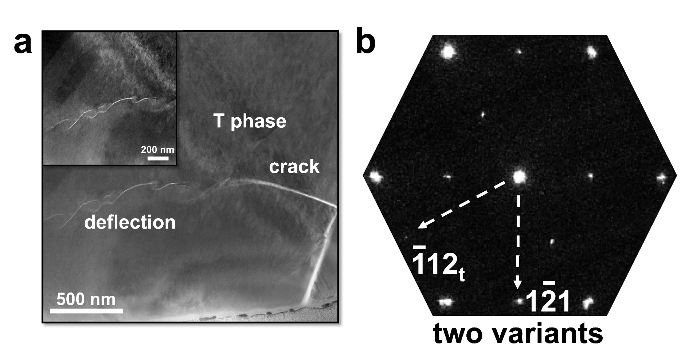
Figure. S6│Stress-induced ferroelastic toughening. (a) Bright field TEM image of T-ABO₄(ZrO₂) near the indent crack (the insert is enlarged dark field TEM image of crack tip); (b) The [111]_{ZAP} SAD pattern of the T-ABO₄(ZrO₂) ferroelastic domain process zone adjacent to the indent crack.

To estimate the crack-induced t→m martensitic phase transformation, Raman spectra were used around the indentation. Three locations had been focused on (Fig.S7a), including the crack tip (Place 1), the corner of the indentation (Place 2) and place away from indentation (Place 3). Raman peak of the monoclinic ZrO₂ at ~182 cm⁻¹ (Fig.S7b) was found at the crack tip (Place 1), indicating the occurrence of the martensitic transformation in the Zr-enriched phase. Besides, the tetragonal ABO₄(ZrO₂) seemed more stable under the stress since no monoclinic ABO₄ was observed at all locations.
Figure. S7│Martensitic transformation. (a) BSE images of indentation (10 N) imprint on the cross-section of thermal etched t-4 sample; (b) Raman spectrum obtained from the corresponding zone in the figure a.

References
- W.C. Oliver, G.M.J. Pharr, J. Mater. Res. 7 (1992) 1564-1583.
- Y. Shen, R.M. Leckie, C.G. Levi, D.R. Clarke, Acta. Mater. 58 (2010) 4424-4431.

∗ Corresponding author: Xiaofeng Zhao, E-mail: xiaofengzhao@sjtu.edu.cn.

