Title
Coral co-culture alters bacterial community structure by altering rare bacterial species
Authors
Keigo Ide1,2, Yoshikatsu Nakano3,4, Michihiro Ito3, Yohei Nishikawa2,5 and Haruko Takeyama1,2,5,6
Affiliations
1. Department of Life Science and Medical Bioscience, Waseda University, Japan
2. Computational Bio Big-Data Open Innovation Laboratory (CBBD-OIL), National Institute of Advanced Industrial Science and Technology, Japan
3. Tropical Biosphere Research Center, University of the Ryukyus, Japan
4. Marine Science Section, Research Support Division, Okinawa Institute of Science and Technology Graduate University, Japan
5. Research Organization for Nano and Life Innovation, Waseda University, Japan
6. Institute for Advanced Research of Biosystem Dynamics, Waseda Research Institute for Science and Engineering, Japan

Corresponding author: Haruko Takeyama (haruko-takeyama@waseda.jp)

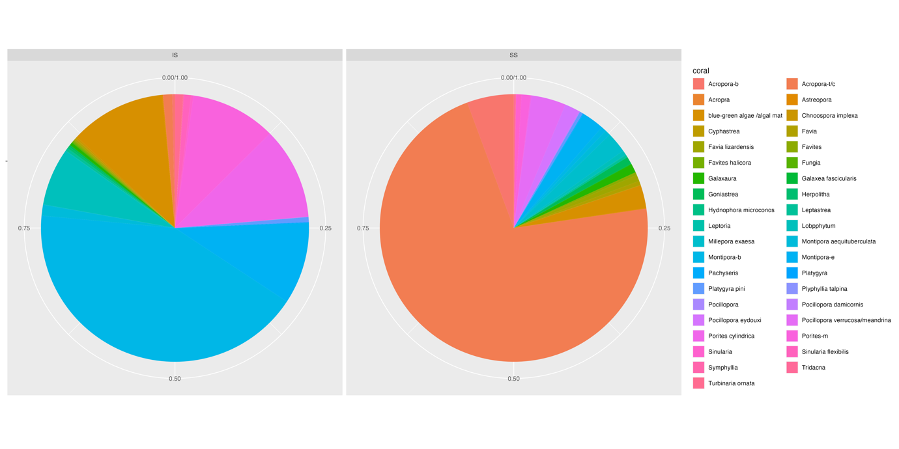
Supplemental figure 1. Coral cover in Ishikawabaru and Sesoko Minami
The abbreviations for each coral are as follows. Acropora-b: Acropora branching corals (spp.); Acropora-t/c: Acropora table/colymbose corals (spp.); Montipora-b: Montipora branching corals (spp.); Montipora-e: Montipora encrusting corals (spp.); Porites-m: Porites massive corals (spp. ) A: Coral cover in Ishikawabaru (IS); occupied by Montipora corals
B: Coral cover in SesokoMinami (SS); occupied by Acropora corals

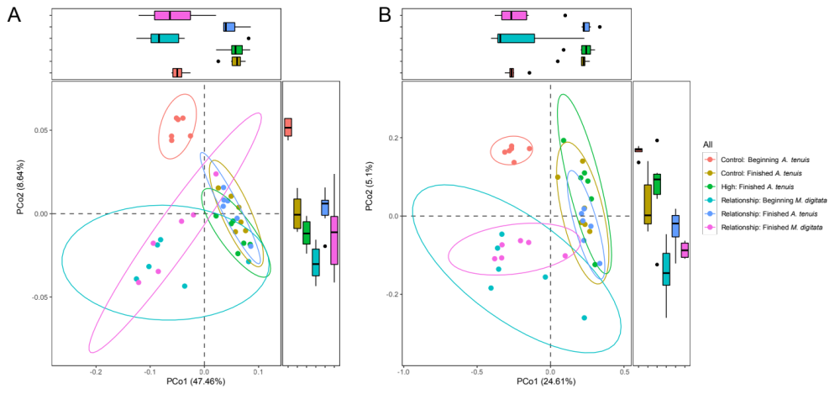
Supplemental figure 2. Principal Coordinates analysis on all coral samples
A: Weighted Unifrac distance
B: Unweighted Unifrac distance

