Endoscopic vacuum therapy in patients with transmural defects of the upper gastrointestinal tract: A systematic review with meta-analysis
Da Hyun Jung, MD¹, Hae-Ryong Yun, MD, PhD², Se Joon Lee, MD, PhD², Na Won Kim, Ms³, Cheal Wung Huh, MD, PhD²

¹Department of Internal Medicine, Severance Hospital, Yonsei University College of Medicine, Seoul, Republic of Korea
²Department of Internal Medicine, Yongin Severance Hospital, Yonsei University College of Medicine, Seoul, Republic of Korea
³Medical Library, Yonsei University College of Medicine, Seoul, Republic of Korea
*Da Hyun Jung and Hae-Ryong Yun contributed equally to this work.

Short title: EVT in the management of UGI transmural defects
Abstract word count: 245
Text Word count: 2868

Corresponding Author: Cheal Wung Huh, MD, PhD
Department of Internal Medicine, Yongin Severance Hospital, Yonsei University College of Medicine, 363 Dongbaekjukjeon-daero, Giheung-gu, Yongin, Gyeonggi-do 16995, Republic of Korea
Tel.: +82-31-5189-8968
E-mail: huhcw@yuhs.ac
Supplementary Table 1. Methodological quality
Authors | Selection  Representativeness | Selection  Selection | Selection  Ascertainment | Selection  Outcome of  interest | Comparability  Comparability | Outcome  Assessment of  outcome | Outcome  Duration of  follow-up | Outcome  Adequacy of  follow-up | Total Score  (maximum:  9 stars)
Palmes 2020 | 0 | NA | * | * | NA | * | NA | NA | 3
Jung 2019 | * | NA | * | * | NA | * | * | 0 | 5
Jeon 2019 | * | NA | * | * | NA | * | * | 0 | 5
Watson 2019 | 0 | NA | * | * | NA | * | 0 | 0 | 3
Pinto 2019 | 0 | NA | * | * | NA | * | 0 | 0 | 3
Morell 2019 | 0 | NA | * | * | NA | * | 0 | 0 | 3
Min 2019 | * | NA | * | * | NA | * | * | 0 | 5
Loske 2019 | 0 | NA | * | * | NA | * | 0 | 0 | 3
Leeds 2019 | * | NA | * | * | NA | * | 0 | 0 | 4
Walsh 2019 | 0 | NA | * | * | NA | * | 0 | 0 | 3
Alakkari 2019 | 0 | NA | * | * | NA | * | 0 | 0 | 3
Berlth 2018 | * | NA | * | * | 0 | * | 0 | 0 | 4
Valli 2018 | 0 | NA | * | * | NA | * | 0 | 0 | 3
Still 2018 | 0 | NA | * | * | NA | * | 0 | 0 | 3
Pournaras 2018 | * | NA | * | * | NA | * | 0 | 0 | 4
Ooi 2018 | 0 | NA | * | * | NA | * | 0 | 0 | 3
Noh 2018 | * | NA | * | * | NA | * | * | * | 6
Loske 2018 | 0 | NA | * | * | NA | * | 0 | 0 | 3
Laukoetter 2017 | * | NA | * | * | NA | * | * | * | 6
Kuehn 2016 | * | NA | * | * | NA | * | * | * | 6
Hwang 2016 | * | NA | * | * | 0 | * | 0 | 0 | 4
Möschler 2015 | 0 | NA | * | * | NA | * | 0 | 0 | 3
Mennigen 2015 | * | NA | * | * | 0 | * | 0 | 0 | 4
Loske 2015 | 0 | NA | * | * | NA | * | 0 | 0 | 3
Heits 2014 | 0 | NA | * | * | NA | * | 0 | 0 | 3
Liu 2014 | 0 | NA | * | * | NA | * | 0 | 0 | 3
Schorsch 2013 | * | NA | * | * | NA | * | 0 | 0 | 4
Schniewind 2013 | * | NA | * | 0 | * | * | 0 | 0 | 4
Brangewitz 2013 | * | NA | * | * | 0 | * | 0 | 0 | 4

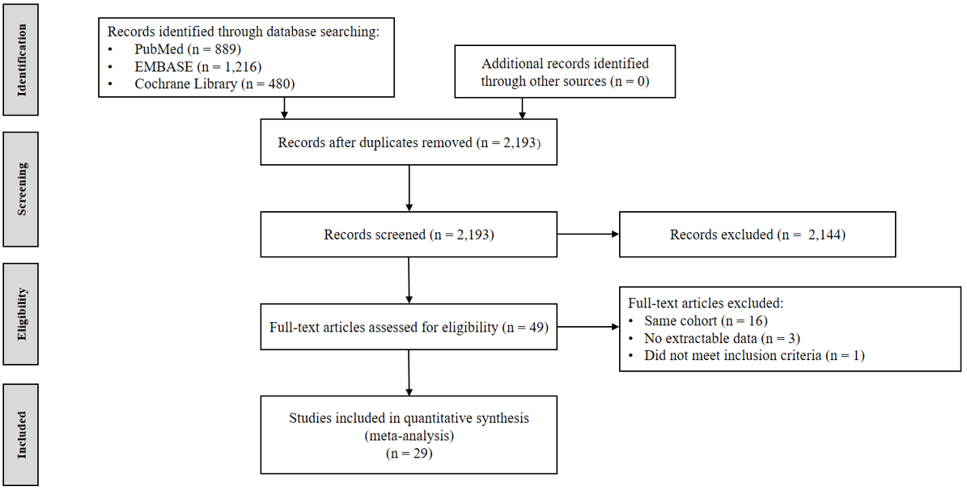
Supplementary Fig. 1. Flowchart of the studies included in the meta-analysis

