Supplementary Tables
Supplementary Table S1: Primers of PCR productors for mutagenesis and RT-PCR
Primer | Sequence
K-RAS_G60E | ﻿CTCGACACAGCAGAGCAAGAGGAGTAC(F)
K-RAS_G60E | ﻿GTACTCCTCTTGCTCTGCTGTGTCGAG (R)
K-RAS_M67L | ﻿GAGTACAGTGCACTGAGGAGGGACCAG (F)
K-RAS_M67L | ﻿CTGGTCCCTCCTCAGTGCACTGTACTC (R)
K-RAS_G12D | ﻿CTTGTGGTGGTTGACGCTGGTGGCGTA (F)
K-RAS_G12D | ﻿TACGCCACCAGCGTCAACCACCACAAG (R)
K-RAS_His | ﻿ATGCACCACCACCACCACCACACTGAGTATAAA (F)
K-RAS_His | ﻿TCACATAACTGTACACCTTGTCCTTGACTT (R)
GST-K-RAS | GACGGTACCACTGAGTATAAACTTGTGGTG (F)
GST-K-RAS | ﻿TCGGCGCGCCCTACATAACTGTACACCTTGTCCT (R)
GST-B-RAF-RBD | ﻿GACGGTACCCCTCCAAATGTAGAATCTTCACCAGAA(F)
GST-B-RAF-RBD | ﻿TCGGCGCGCCCTATGTAAGTGGAACATTCTCCAACACTTCCAC (R)
GST-p110a-RBD | ﻿GACGGTACCTCCTCCAAATGTAGAATCTTCACCAGA (F)
GST-p110a-RBD | TCGGCGCGCCCTATGTAAAACAGTCCATTGGCAGAGATTG (R)
GST-RA (RAPGEF6) | ﻿GTTGGTACCAGTATGTTGGATTTTTCCAATCCT(F)
GST-RA (RAPGEF6) | CCCGCGGCCGCTCAAGCATCTTCATCTGAACATAAGGTTTCTGTTTC (R)
Actin_RT-PCR | TCCCTGGAGAAGAGCTACGA (F)
Actin_RT-PCR | GTACTTGCGCTCAGGAGGAG (R)
RB1-RT_PCR | TTGGATCACAGCGATACAAACTT (F)
RB1-RT_PCR | AGCGCACGCCAATAAAGACAT (R)
c-MYC_RT-PCR | TCCCTCCACTCGGAAGGAC (F)
c-MYC_RT-PCR | CTGGTGCATTTTCGGTTGTTG (R)
EPCAM_RT-PCR | TGATCCTGACTGCGATGAGAG (F)
EPCAM_RT-PCR | CTGGTGCATTTTCGGTTGTTG (R)

Supplementary Table S2: KRAS M67 or G60 equivalent mutations of RAS superfamily in various tumor types
Gene name | Sample name | Tumor Types | Mutation CDS | Mutation AA | Mutation Status | Sample Type | Source
KRAS | 90879 | myeloma | c.199A>C | p.M67L | Missense | Bone Marrow | COSMIC
KRAS | CA86 | pancreas | c.199A>C | p.M67L | Missense | Solid Tumor | COSMIC
KRAS | B-ALL_REL_249 | leukemia | c.199A>C | p.M67L | Missense | Bone Marrow | COSMIC
KRAS | 2754373 | myeloma | c.201G>A | p.M67I | Missense | Bone Marrow | COSMIC
NRAS | P-0000055-T01-IM3 | endometrium | c.201G>A | p.M67I | Missense | Solid Tumor | COSMIC
RAP1B | CAL27 | head and neck | c.201G>A | p.M67I | Missense | Cell Line | COSMIC
RAP2B | TCGA-AY-6197-01 | colon | c.200T>C | p.M67T | Missense | Solid Tumor | COSMIC
RAB6B | TCGA-AP-A051-01 | endometrium | c.232C>A | p.L78M | Missense | Solid Tumor | COSMIC
RAB19 | TCGA-MP-A4TC-01 | lung AD | c.244delA | p.I82Sfs*34 | Frameshift_Del | Solid Tumor | GDC TCGA
RAB23 | TCGA-VQ-A94U-01 | stomach | c.222T>G | p.I74M | Missense | Solid Tumor | GDC TCGA
RAB34 | TCGA-AG-A01J-01 | rectum | c.350T>C | p.I117T | Missense | Solid Tumor | GDC TCGA
RAB38 | BZ04 | bone | c.224T>C | p.M75T | Missense | Solid Tumor | COSMIC
RAB40C | 1N31-VS-1T31 | esophagus | c.237C>G | p.I79M | Missense | Solid Tumor | COSMIC
RASEF/RAB45 | TCGA-GN-A8LK-06 | melanoma | c.1817T>G | p.I606S | Missense | Solid Tumor | COSMIC
RAC1 | P-0008226-T02-IM5 | colon | c.199T>A | p.L67I | Missense | Solid Tumor | COSMIC
KRAS | P-0003809-T01-IM5 | bladder | c.179G>A | p.G60D | Missense | Solid Tumor | COSMIC
KRAS | 2754479 | cervix | c.179G>A | p.G60D | Missense | Solid Tumor | COSMIC
KRAS | 1470 | colon | c.179G>A | p.G60D | Missense | Solid Tumor | COSMIC
KRAS | 2651999 | colon | c.179G>A | p.G60D | Missense | Solid Tumor | COSMIC
KRAS | WGC067127 | colon | c.179G>A | p.G60D | Missense | Solid Tumor | COSMIC
KRAS | CSCC-32-T | head and neck | c.179G>A | p.G60D | Missense | Solid Tumor | COSMIC
KRAS | SJTALL002 | leukemia | c.179G>A | p.G60D | Missense | Bone Marrow | COSMIC
KRAS | CLL7 | lymphoma | c.179G>A | p.G60D | Missense | Bone Marrow | COSMIC
KRAS | CA88 | pancreas | c.179G>A | p.G60D | Missense | Circulating Tumor | COSMIC
KRAS | 1507704 | leukemia | c.179G>A | p.G60D | Missense | Bone Marrow | COSMIC
KRAS | 60 | stomach | c.179G>A | p.G60D | Missense | Solid Tumor | COSMIC
KRAS | nai-9 | thyroid | c.179G>C | p.G60A | Missense | Solid Tumor | COSMIC
KRAS | PD6876a | leukemia | c.178G>C | p.G60R | Missense | Solid Tumor | COSMIC
KRAS | P-0003834-T01-IM5 | genital tract | c.178G>A | p.G60S | Missense | Solid Tumor | COSMIC
KRAS | 2007868 | colon | c.179G>T | p.G60V | Missense | Solid Tumor | COSMIC
KRAS | P-0003994-T01-IM3 | genital tract | c.179G>T | p.G60V | Missense | Solid Tumor | COSMIC
KRAS | 10532X18 | leukemia | c.179G>T | p.G60V | Missense | Bone Marrow | COSMIC
KRAS | AML_14 | leukemia | c.179G>T | p.G60V | Missense | Bone Marrow | COSMIC
KRAS | 2755730 | brain | c.178_198dup | p.G60_A66dup | Insertion In Frame | Solid Tumor | COSMIC
KRAS | 2750050 | leukemia | c.178_198dup | p.G60_A66dup | Insertion In Frame | Bone Marrow | COSMIC
KRAS | AMCPAC05 | pancreas | c.181_182insTAC | p.G60_Q61insL | Insertion In Frame | Cell Line | COSMIC
KRAS | 2297346 | brain | c.177dup | p.G60Rfs*27 | Frameshift Insert | Solid Tumor | COSMIC
NRAS | 218R | leukemia | c.179G>A | p.G60E | Missense | Bone Marrow | COSMIC
NRAS | 1494677 | leukemia | c.179G>A | p.G60E | Missense | Bone Marrow | COSMIC
NRAS | 1169711 | leukemia | c.179G>A | p.G60E | Missense | Bone Marrow | COSMIC
NRAS | SJERG020304_D1 | leukemia | c.179G>A | p.G60E | Missense | Bone Marrow | COSMIC
NRAS | 1507657 | leukemia | c.179G>A | p.G60E | Missense | Bone Marrow | COSMIC
NRAS | 1507655 | leukemia | c.179G>A | p.G60E | Missense | Bone Marrow | COSMIC
NRAS | 1494676 | leukemia | c.179G>A | p.G60E | Missense | Bone Marrow | COSMIC
NRAS | AML_602 | leukemia | c.179G>A | p.G60E | Missense | Bone Marrow | COSMIC
NRAS | PATJZK | leukemia | c.179G>A | p.G60E | Missense | NS | COSMIC
NRAS | 2579578 | leukemia | c.179G>A | p.G60E | Missense | Solod Tumor | COSMIC
NRAS | P-0003580-T01-IM5 | lung | c.179G>A | p.G60E | Missense | Solod Tumor | COSMIC
NRAS | 2838744 | MDS | c.179G>A | p.G60E | Missense | Bone Marrow | COSMIC
NRAS | PD8937a | MDS | c.179G>A | p.G60E | Missense | NS | COSMIC
NRAS | 1136669 | skin | c.? | p.G60E | Missense | Solod Tumor | COSMIC
NRAS | AML_332 | leukemia | c.180_181insGCTTCC | p.G60_Q61insAS | Insertion In frame | Bone Marrow | COSMIC
NRAS | 2585232 | colon | c.? | p.G60D | Missense | Solod Tumor | COSMIC
NRAS | 93-C-275 | leukemia | c.? | p.G60R | Missense | Bone Marrow | COSMIC
NRAS | 2584882 | rectum | c.? | p.G60R | Missense | Solod Tumor | COSMIC
NRAS | 2579364 | melanoma | c.178G>C | p.G60R | Missense | Solod Tumor | COSMIC
NRAS | 1658 | leukemia | c.179G>T | p.G60V | Missense | Bone Marrow | COSMIC
NRAS | 10 | leukemia | c.179G>T | p.G60V | Missense | Bone Marrow | COSMIC
NRAS | SJTALL017 | leukemia | c.179G>T | p.G60V | Missense | Bone Marrow | COSMIC
NRAS | P-0008534-T01-IM5 | rectum | c.179G>T | p.G60V | Missense | Solod Tumor | COSMIC
HRAS | 2815634 | stomach | c.178G>A | p.G60S | Missense | Solid Tumor | COSMIC
HRAS | 2815636 | stomach | c.179G>A | p.G60D | Missense | Solid Tumor | COSMIC
HRAS | P-0001614-T01-IM3 | head and neck | c.179G>A | p.G60D | Missense | Solid Tumor | COSMIC
HRAS | TCGA-CM-6161-01 | colon | c.178G>A | p.G60S | Missense | Solid Tumor | COSMIC
RALA | TCGA-DD-AADD-01 | liver | c.212G>A | p.G71E | Missense | Solid Tumor | COSMIC
RALB | UM-SCC-17B | head and neck | c.211G>A | p.G71R | Missense | Cell Line | COSMIC
RRAS | P-0016773-T01-IM6 | breast | c.256G>A | p.G86S | Missense | Solid Tumor | COSMIC
RHEB | Pat_41_B | melanoma | c.188G>A | p.G63E | Missense | Solid Tumor | COSMIC
RHEB | TCGA-66-2783-01 | lung SC | c.187G>T | p.G63W | Missense | Solid Tumor | COSMIC
RIT2 | IGC-02-1054 | lung | c.230G>T | p.G77V | Missense | Solid Tumor | COSMIC
RIT2 | TCGA-O2-A5IB-01 | lung SC | c.229G>A | p.G77S | Missense | Solid Tumor | COSMIC
RAB11B | 2834129 | melanoma | c.206G>A | p.G69D | Missense | Solid Tumor | COSMIC
RAB14 | TCGA-C5-A1BK-01 | cervix | c.206G>C | p.G69A | Missense | Solid Tumor | COSMIC
RAB17 | TCGA-94-A4VJ-01 | lung SC | c.227G>A | p.G76D | Missense | Solid Tumor | COSMIC
RAB18 | TCGA-97-8174-01 | lung AD | c.196G>C | p.G66R | Missense | Solid Tumor | GDC TCGA
RAB1A | TCGA-AZ-6608-01 | colon | c.206G>A | p.G69D | Missense | Solid Tumor | COSMIC
RAB21 | 7 | skin | c.229G>A | p.G77S | Missense | Solid Tumor | COSMIC
RAB33B | TCGA-B5-A3FA-01 | endometrium | c.271G>A | p.G91R | Missense | Solid Tumor | GDC TCGA
RAB39A | Pat_06_B | melanoma | c.211G>A | p.G71R | Missense | Solid Tumor | COSMIC
RAB39A | Pat_14_B | melanoma | c.211G>A | p.G71R | Missense | Solid Tumor | COSMIC
RAB43 | PD13163a | breast | c.226_229del | p.G76Rfs*40 | Frameshift Del | Solid Tumor | COSMIC
RAB5A | GBM20-R1 | brain | c.233G>A | p.G78D | Missense | Solid Tumor | COSMIC
RAB5A | GBM20-R2 | brain | c.233G>A | p.G78D | Missense | Solid Tumor | COSMIC
RAB5A | GBM20-R3 | brain | c.233G>A | p.G78D | Missense | Solid Tumor | COSMIC
RAB5A | TCGA-64-5781-01 | lung AD | c.232G>C | p.G78R | Missense | Solid Tumor | COSMIC
RAB7A | CHG-13-09220T | liver | c.196G>T | p.G66* | Nonsense | Solid Tumor | COSMIC
RAB7A | Pat_41_B | melanoma | c.197G>A | p.G66E | Missense | Solid Tumor | COSMIC
RAB8B | PT27 | skin | c.196G>A | p.G66S | Missense | Solid Tumor | COSMIC
RAN | TCGA-AC-A8OS-01 | breast | c.203G>A | p.G68D | Missense | Solid Tumor | COSMIC
RAC1 | GBM20-R1 | brain | c.178G>A | p.G60R | Missense | Solid Tumor | COSMIC
RAC1 | GBM20-R2 | brain | c.178G>A | p.G60R | Missense | Solid Tumor | COSMIC
RAC1 | GBM20-R3 | brain | c.178G>A | p.G60R | Missense | Solid Tumor | COSMIC
RAC3 | T3263 | colon | c.178G>A | p.G60S | Missense | Solid Tumor | COSMIC

Supplementary Table S3: Data (K-RAS structures bound to GDP; 101 structures) visually checked with Mol* Viewer (Sehnal et al. Nucleic Acids Res 49: W431-W437, 2021) at Protein Data Bank in Europe (PDBe; https://www.ebi.ac.uk/pdbe/) (August 10, 2021)
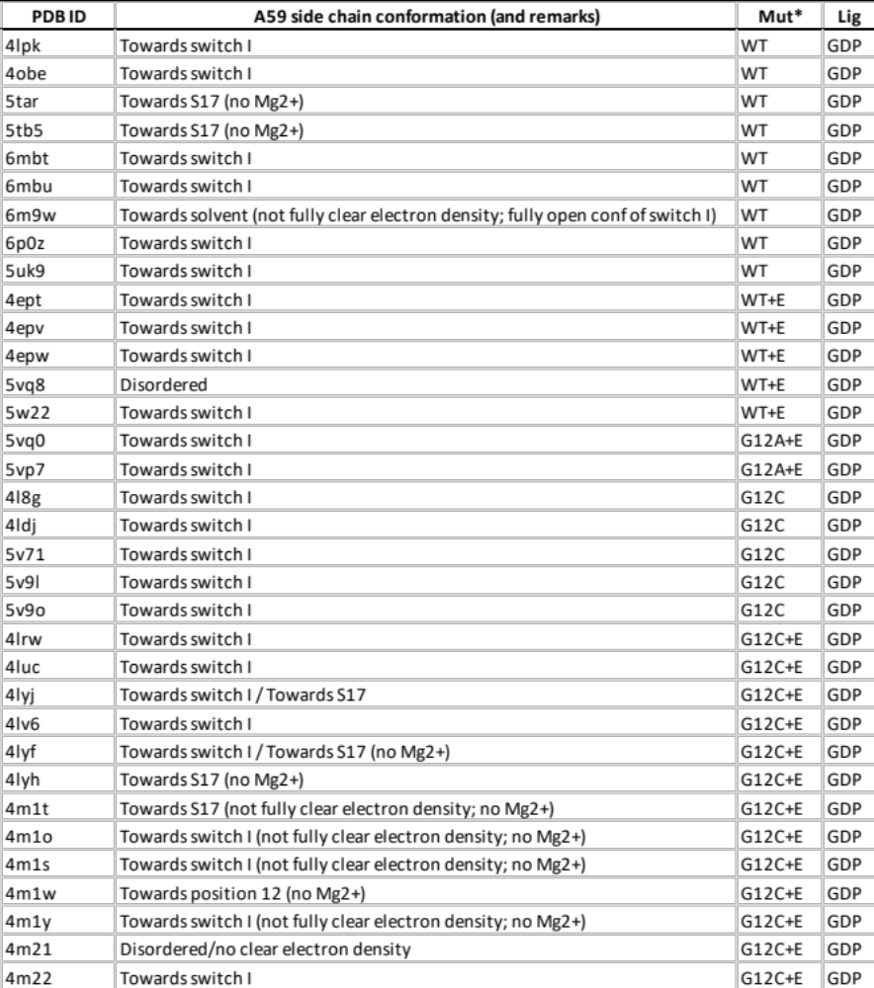
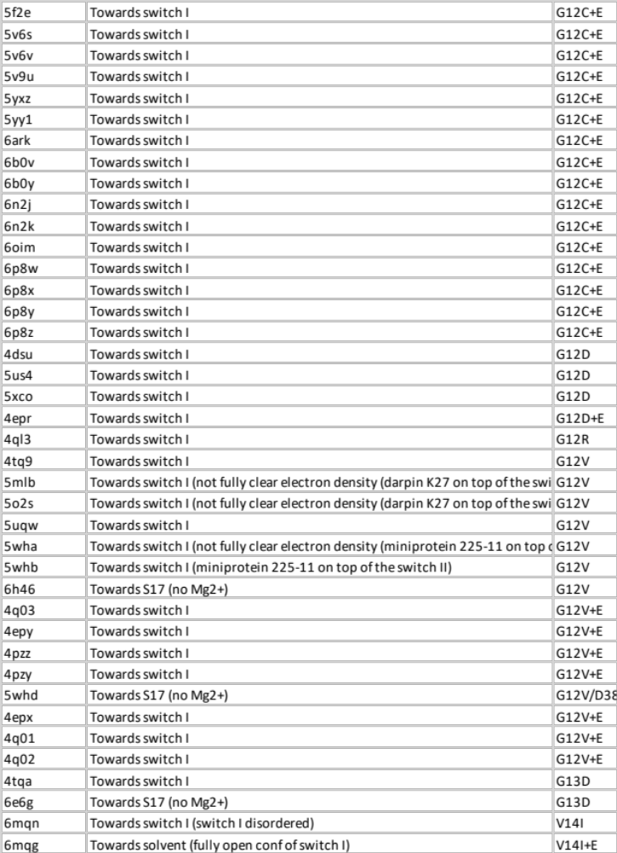
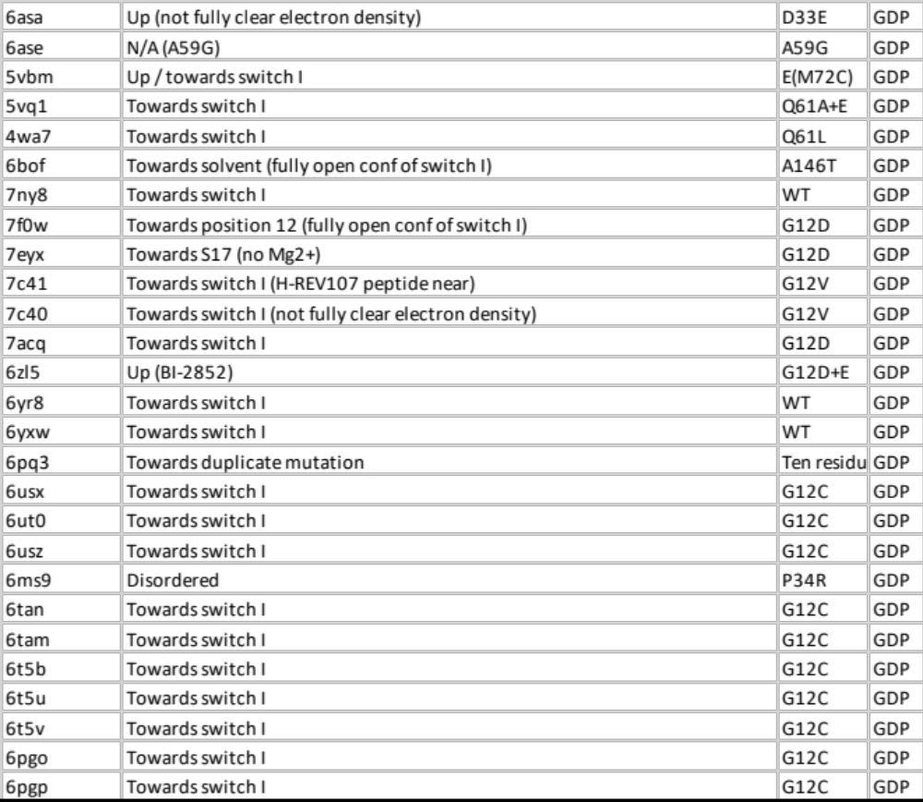

*Notable mutations in structure; E= biologically nonrelevant engineered mutation(s)

