Supplementary Figure 1. Forest plot of univariate analysis on progression-free survival of selected subgroups

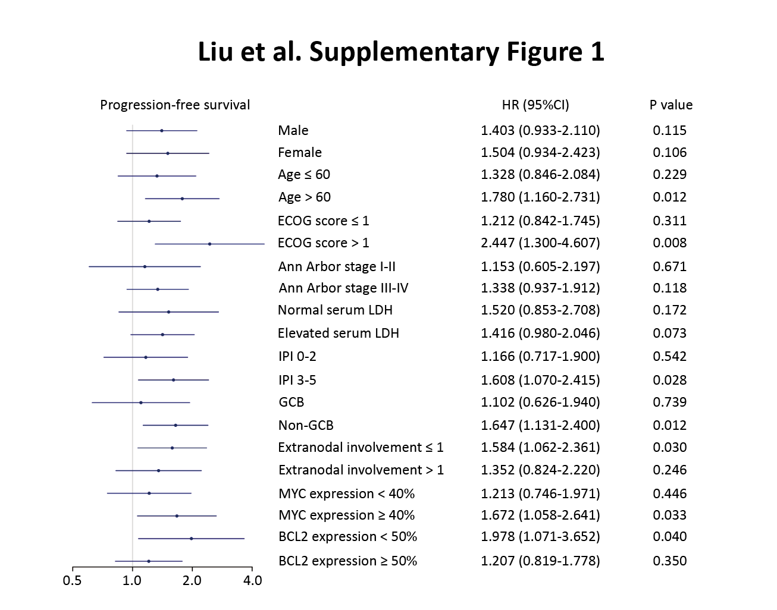

Supplementary Figure 2. KMT2D mutations induced Treg cell activation by Gene Set Enrichment Analysis (GSEA)
GSEA showing association of Treg cells gene signatures with KMT2D mutations in diffuse large B-cell lymphoma (DLBCL) patients. Enrichment scores were listed with p-value. NES, normalized enrichment score; FDR, false discovery rate.
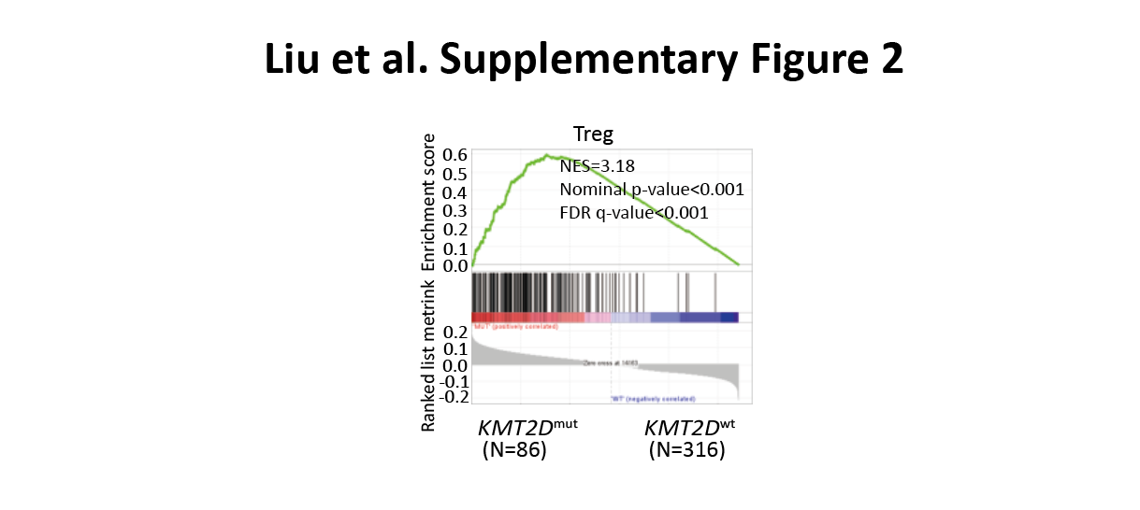

Supplementary Figure 3. Schematic representation of KMT2D mutations identified in patients
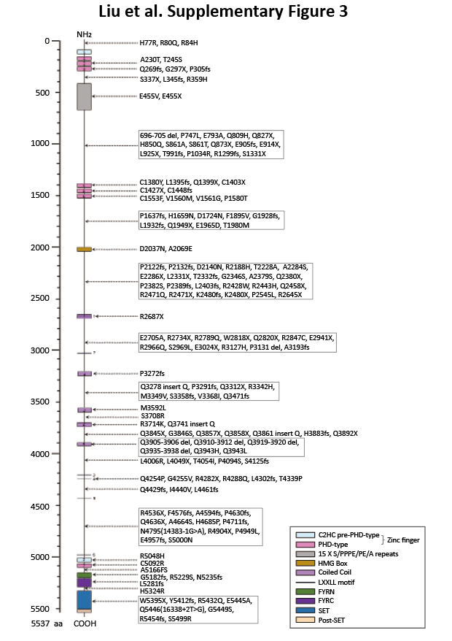

Supplementary Figure 4. KMT2D mutations inhibited FBXW7 expression
(a). Normalized mRNA expression of FBXW7 in tumor samples of DLBCL patients with or without KMT2D mutations as revealed by RNA sequencing.
(b). Relative gene expression of FBXW7 in KMT2D^{R5432Q} or KMT2D^{kd} SU-DHL-4 and OCI-LY7 cells, as compared to KMT2D^{wt} or Scramble cells by quantitative real-time PCR.
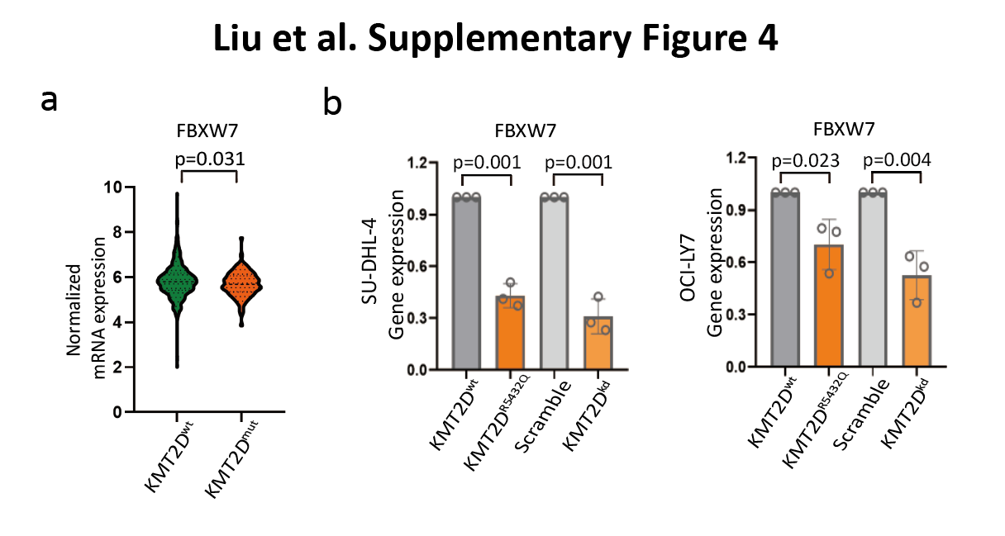

Supplementary Figure 5. Normalized mRNA expression of IL10 in tumor samples of DLBCL patients with or without KMT2D mutations as revealed by RNA sequencing
