SUPPLEMENTARY INFORMATION
A novel method for the synthesis of 2-chloro-3-[trans-4-(4-chlorophenyl) cyclohexyl]-1,4-naphthoquinone: an intermediate of Atovaquone, with systematic studies towards reaction optimization, recovery and reuse aspects
SANJAY S S ^{* 1, 6}, SHASHIPRABHA ^{2, 6}, SHRIDHARA K ^{3, 6}, NAGARAJAN K ^{4, 6}, RANGANATHAN K R⁵
¹Assistant Professor, Department of Chemistry, Sri Dharmasthala Manjunatheshwara Institute of Technology (SDM IT-Affiliated to Visvesvaraya Technological University, Belagavi), Ujire-574 240, Karnataka, India.
²Assistant Professor, PG Department of Chemistry, Sri Dharmasthala Manjunatheshwara College (Autonomous), Ujire-574 240, Karnataka, India.
³Technical Coordinator, ArkGen Pharma Private Limited, Peenya Industrial Area, Bangalore-560 058, Karnataka, India.
⁴#1, 1st Floor, House No.007, Serene Urbana, Ozone Urbana, Southegowdanahalli, Bangalore-562 110, Karnataka, India.
⁵#102, K.T. Appartments-1, 8th Main Road, 9th Cross, Malleswaram, Bangalore-560003, Karnataka, India.
⁶Alkem Laboratories Limited, Research & Development Centre, Peenya, Bangalore-560 058, Karnataka, India.
E mail: sanjayss@sdmit.in; Mobile: 91-9964209055
* For Correspondence
Running Title: Studies on the synthesis of 2-chloro-3-[trans-4-(4-chlorophenyl) cyclohexyl]-1,4-naphthoquinone.

List of Figures | Description | Page No.
Fig S1 | IR spectrum of 1 | 3
Fig S2 | ¹H NMR spectrum of 1 | 4
Fig S3 | Expanded ¹H NMR spectrum of 1 | 5

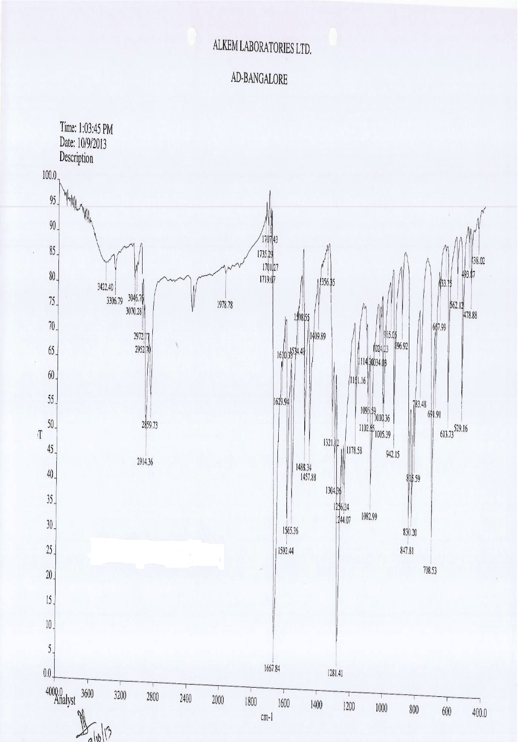
Fig S1. Mass spectrum of 1

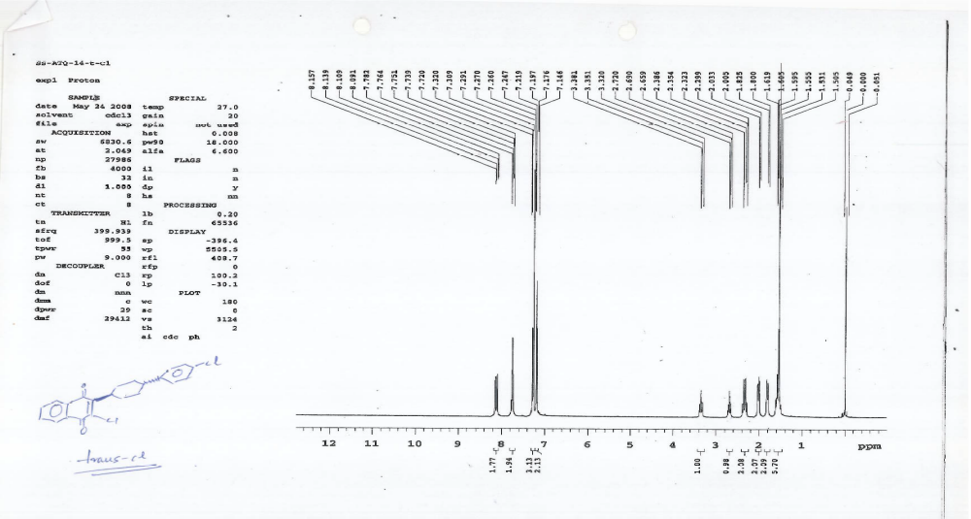
Fig S2. ¹H NMR spectrum of 1

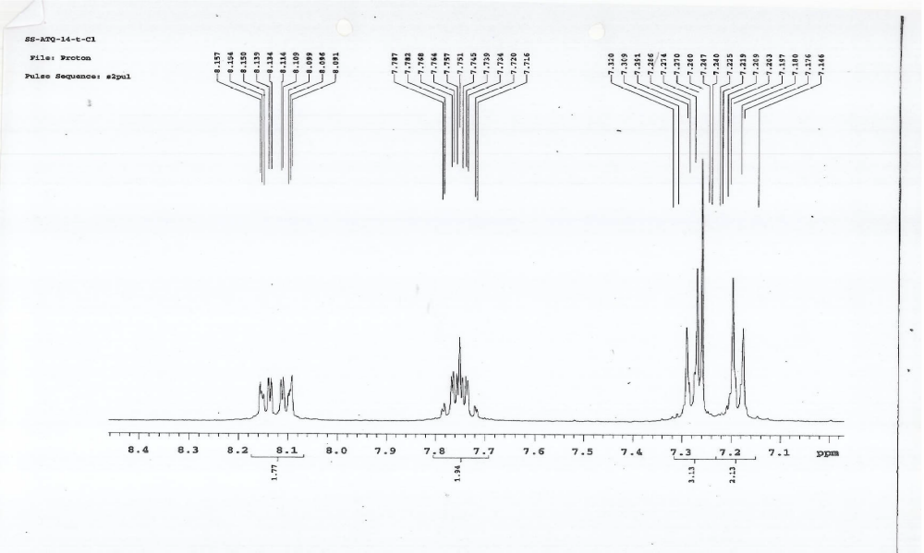

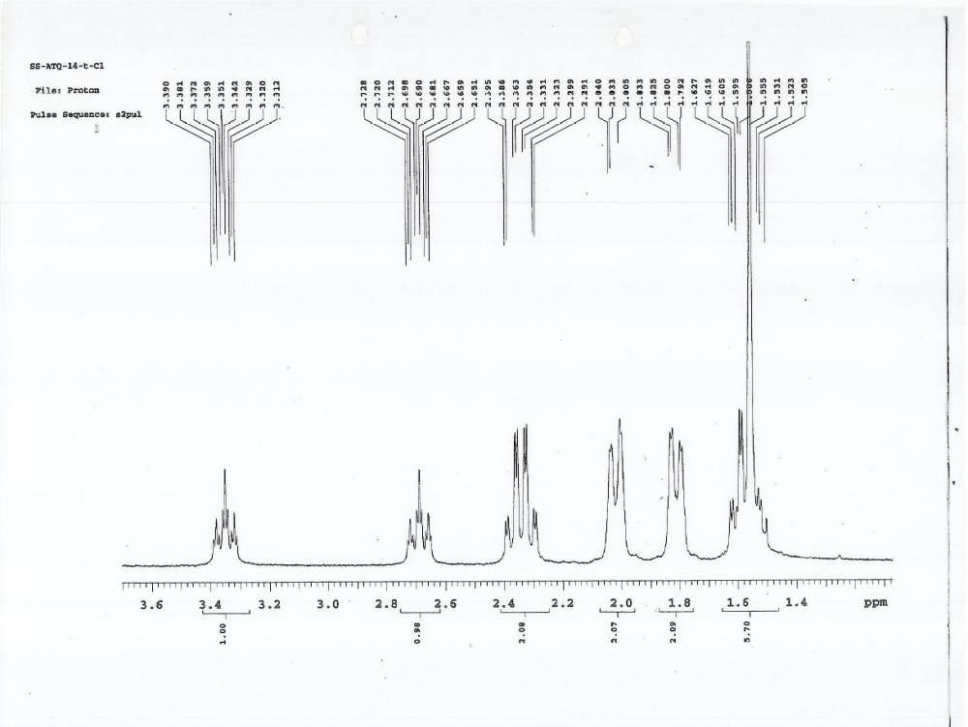
Fig S3: Expanded ¹H NMR spectrum of 1

