Figure 3. Agarose gel electrophoresis showing the clear band on 345bp length of PCR product of tested sample showing positivity for B.bigemina
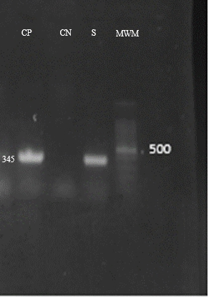
Figure 4 Agarose gel electrophoresis showing the clear band on 460bp length of PCR product of tested sample showing positivity for T. annulata
