Research tables:
Table 2: Average Variance Extracted (AVE)
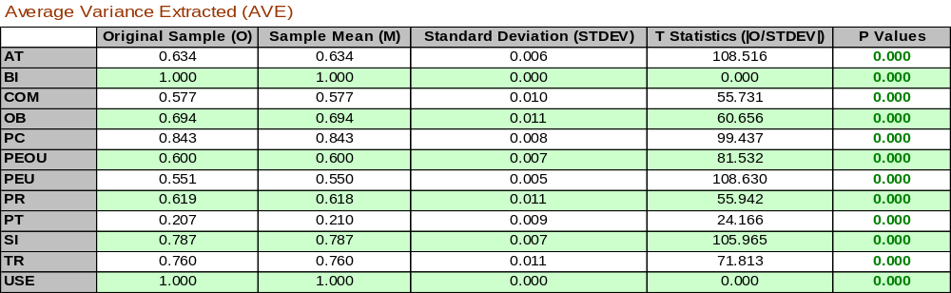

Table 3: Composite Reliability
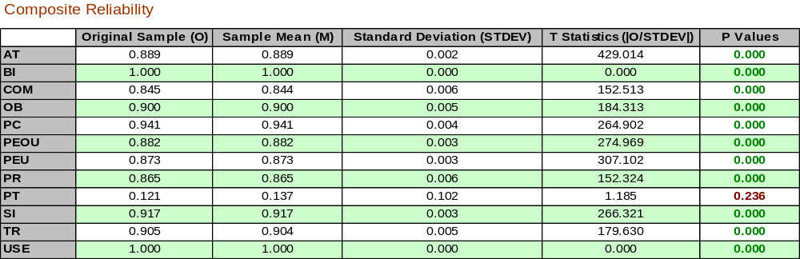

Table 4: Cronbach's Alpha
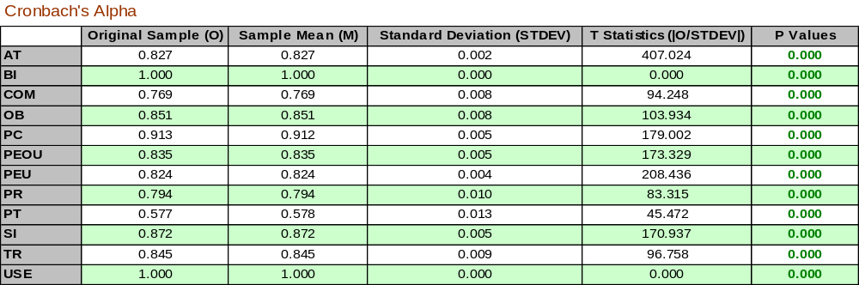
Table 5: Heterotrait-Monotrait Ration (HTMT)
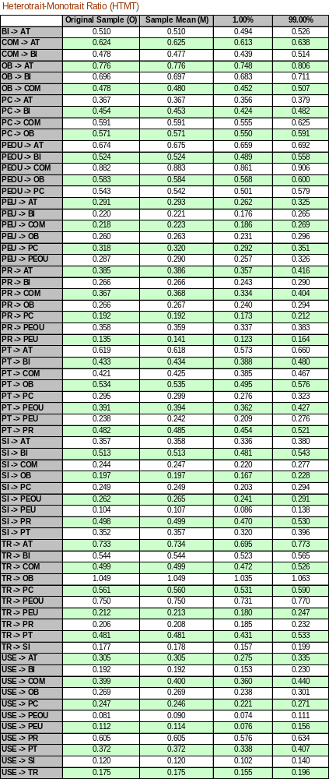

Table 6: Model_ Fit
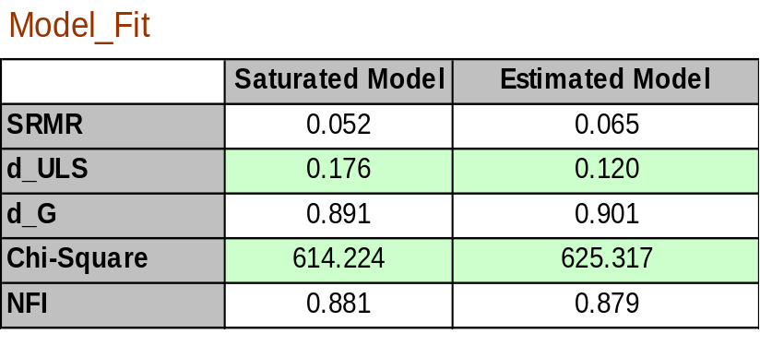

Table 7: Collinearity Statistics (VIF)
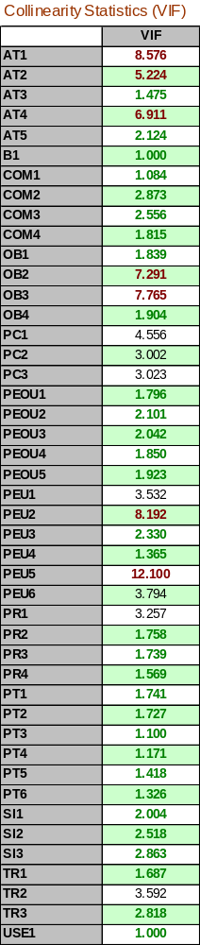

Table 8: R Square
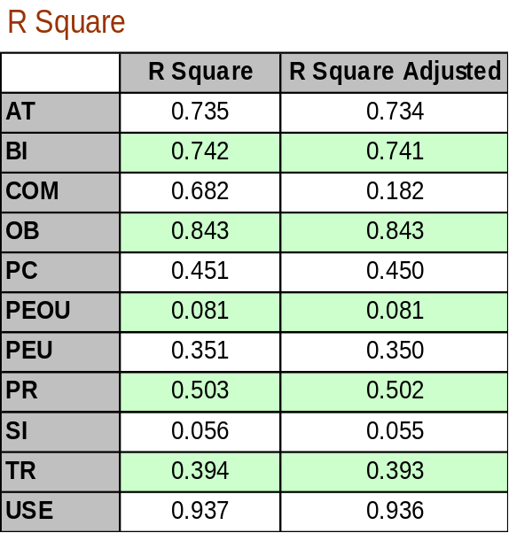

Table 9: rho_A
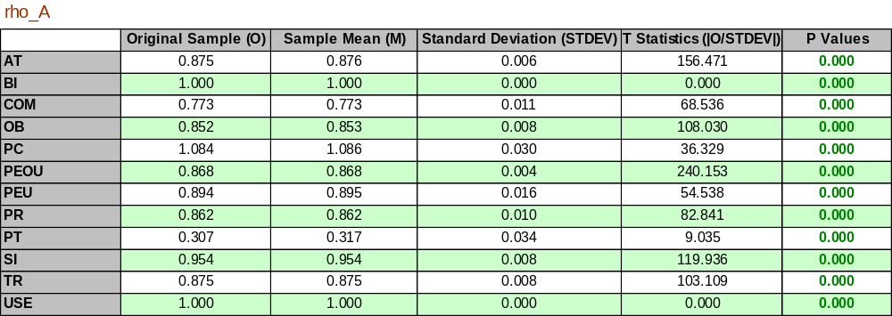

Table 10: Reflective measures using Outer loading
