Supplementary material
The datasets used and/or analysed during the current study available from the corresponding author on reasonable request
Figures
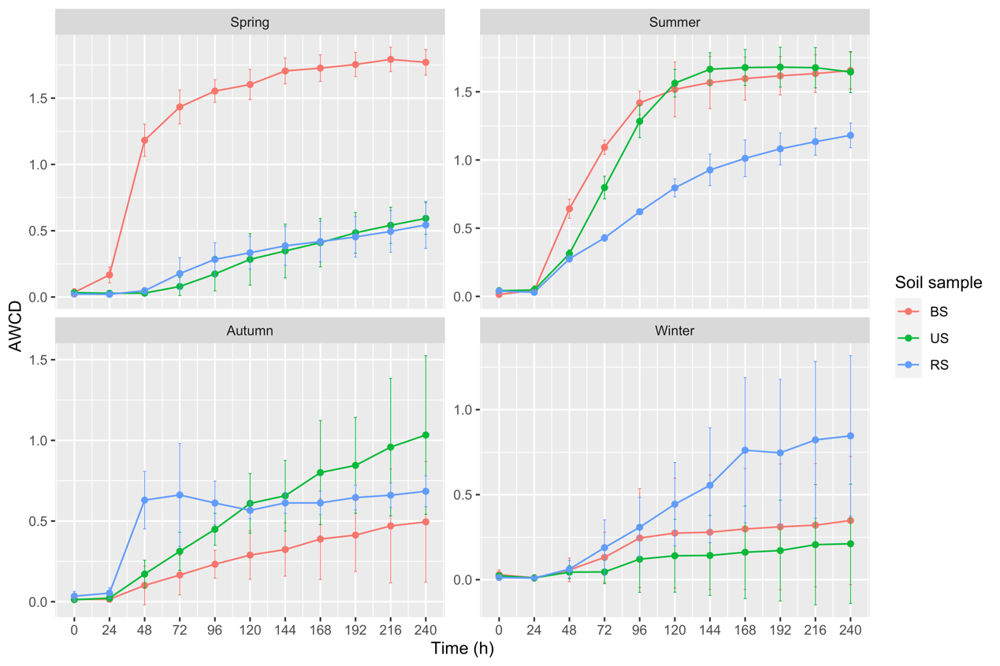
Figure S1. The variation of average well color development (AWCD) of carbohydrates in three types of soil collected in different seasons within incubation time. Error bar represented the mean ± SD (n=3). Abbreviations: BS- bulk soil; RS- Rhizosphere soil; US- uncultivated soil.

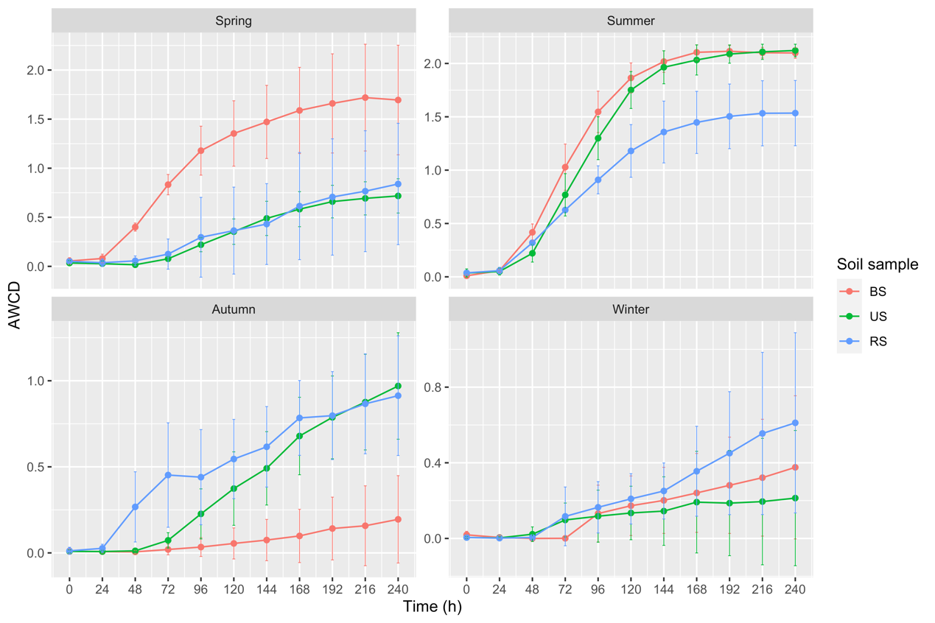
Figure S2. The variation of average well color development (AWCD) of polymers in three types of soil collected in different seasons within incubation time. Error bar represented the mean ± SD (n=3). Abbreviations: BS- bulk soil; RS- Rhizosphere soil; US- uncultivated soil.

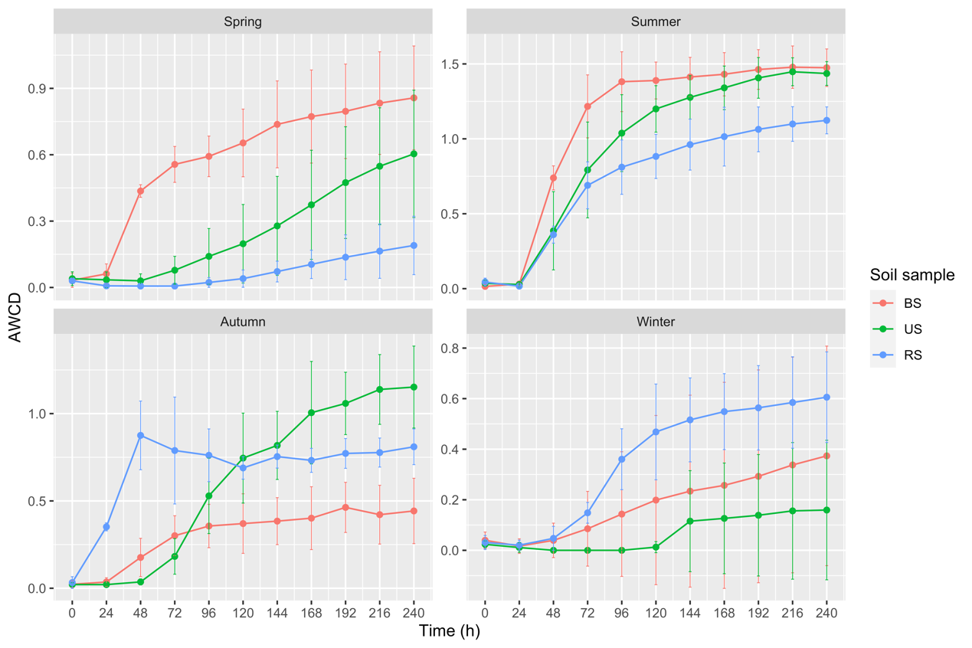
Figure S3. The variation of average well color development (AWCD) of carboxylic and acetic acids in three types of soil collected in different seasons within incubation time. Error bar represented the mean ± SD (n=3). Abbreviations: BS- bulk soil; RS- Rhizosphere soil; US- uncultivated soil.

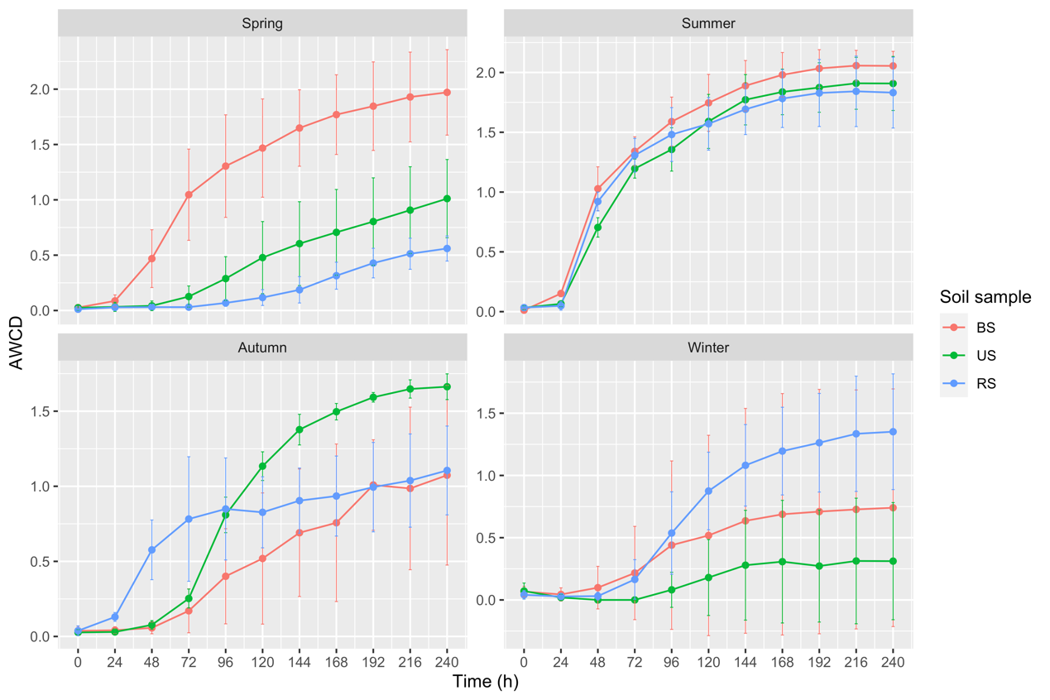
Figure S4. The variation of average well color development (AWCD) of amino acids in three types of soil collected in different seasons within incubation time. Error bar represented the mean ± SD (n=3). Abbreviations: BS- bulk soil; RS- Rhizosphere soil; US- uncultivated soil.

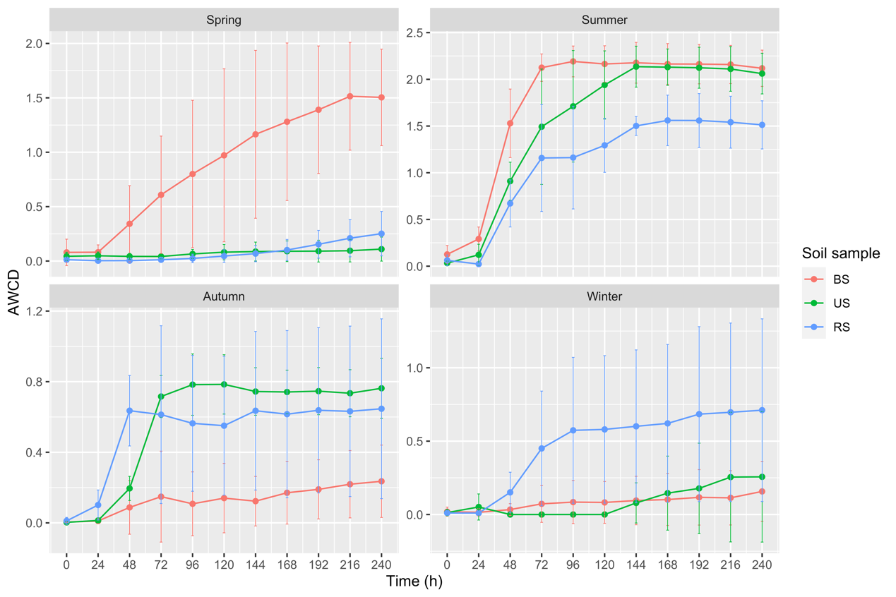
Figure S5. The variation of average well color development (AWCD) of amines and amides in three types of soil collected in different seasons within incubation time. Error bar represented the mean ± SD (n=3). Abbreviations: BS- bulk soil; RS- Rhizosphere soil; US- uncultivated soil.

