Supplementary information

Supplementary Figures 1-5 and Supplementary Table 1.

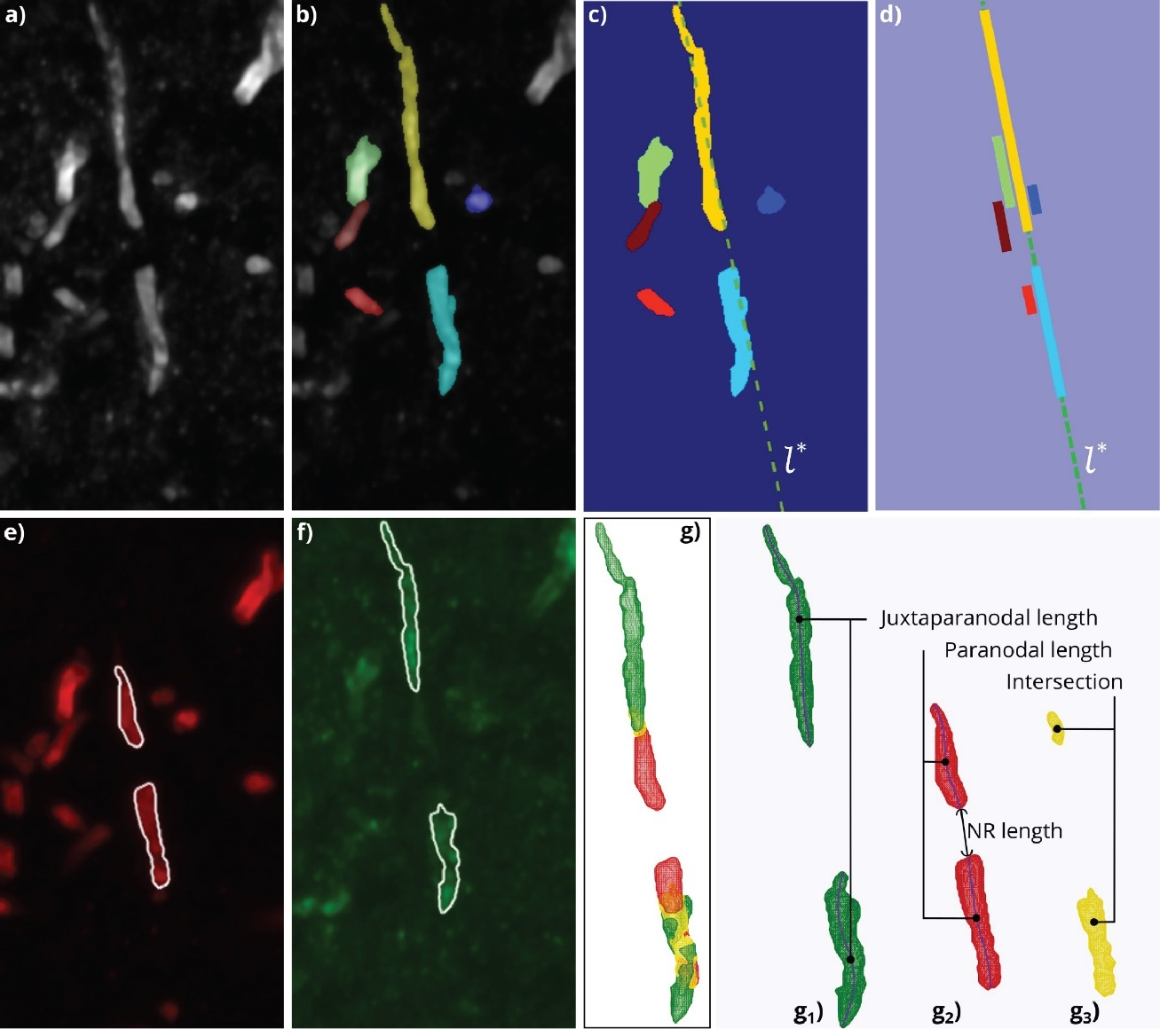

Supplementary Figure 1. Automated segmentation and 3D morphometry of paranodes and juxtaparanodes in confocal microscopy images. a A maximum projection image of paranodes (red channel) and juxtaparanodes (green channel). b A preliminary segmentation of paranodes and juxtaparanodes using the Chan-Vese active surface model. c The slope of the longest detected line segment, which associates with the main orientation of the segmented components, was used to draw a line l* (dashed line) that expanded to the image borders. d Projection of the segmented components on l*. Colors correspond with the segmented components in panel c. e Segmentation of paranodes visualized on the maximum projection image of the red channel. f Segmentation of juxtaparanodes visualized on the maximum projection image of the green channel. g 3D rendering of juxtaparanodes (green, g₁, paranodes (red, g₂, and their intersection (yellow, g₃). The extracted skeletons of the paranodes and juxtaparanodes are overlaid on their corresponding rendering. NR=node of Ranvier.

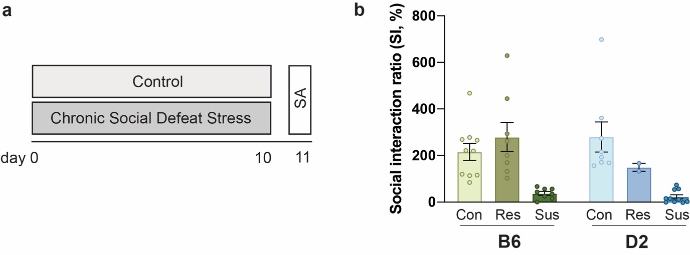
Supplementary figure 2. Grouping of mice to stress-susceptible and -resilient based on social interaction ratio. a Experimental timeline. b Grouping of mice into stress-resilient and -susceptible individuals, similar as in³⁰. SA=Social approach test. SI ratio=time spent in interaction zone when a social target present / time spent in interaction zone when no social target present. Error bars represent ±SEM.

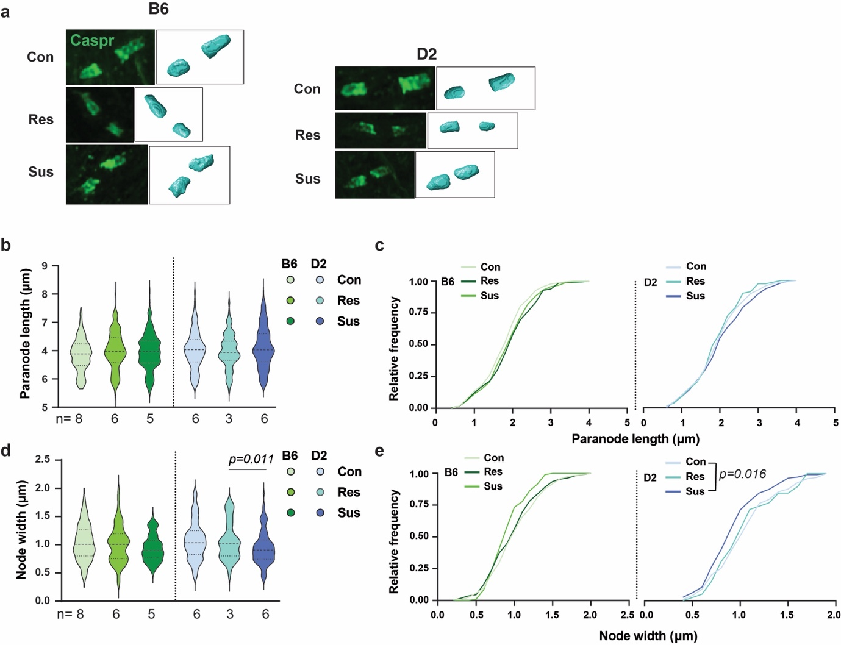

Supplementary Figure 3. Shorter white matter node gaps in stress-susceptible D2 mice.
a 3D reconstruction of paranodes in the forceps minor. b-e Quantification of paranode length (b,c) node width (d,e) in the white matter. (b B6: Con=234 nodes from 8 mice, Res=197 nodes from 6 mice, Sus=188 nodes from 5 mice; Generalized estimating equation (GEE), p=0.056. D2: Con=272 nodes from 6 mice, Res=80 nodes from 3 mice, Sus=219 nodes from 6 mice; GEE, p=0.252. c Cumulative paranode length distribution. Kolmogorov-Smirnov (KS), B6: Con vs. Res p=0.088; Con vs. Sus p=0.149; Res vs. Sus p=0.767. D2: Con vs. Res p=0.634; Con vs. Sus p=0.304; Res vs. Sus p=0.339. d B6: Con=122 nodes from 8 mice, Res=110 nodes from 9 mice, Sus=94 nodes from 5 mice; GEE, p=0.164. D2: Con=136 nodes from 6 mice, Res=39 nodes from 3 mice, Sus=112 nodes from 6 mice; GEE, p=0.037, pairwise comparisons: Con vs. Res, p=0.465; Con vs. Sus, p=0.336; Res vs. Sus, p=0.011. e Cumulative paranode length distribution. Kolmogorov-Smirnof (KS), B6: Con vs. Res p=0.491; Con vs. Sus p=0.031; Res vs. Sus p=0.054. D2: Con vs. Res p=0.767; Con vs. Sus p=0.016; Res vs. Sus p=0.196). Nominal p-values surviving Bonferroni correction (α = 0.0167) are shown.

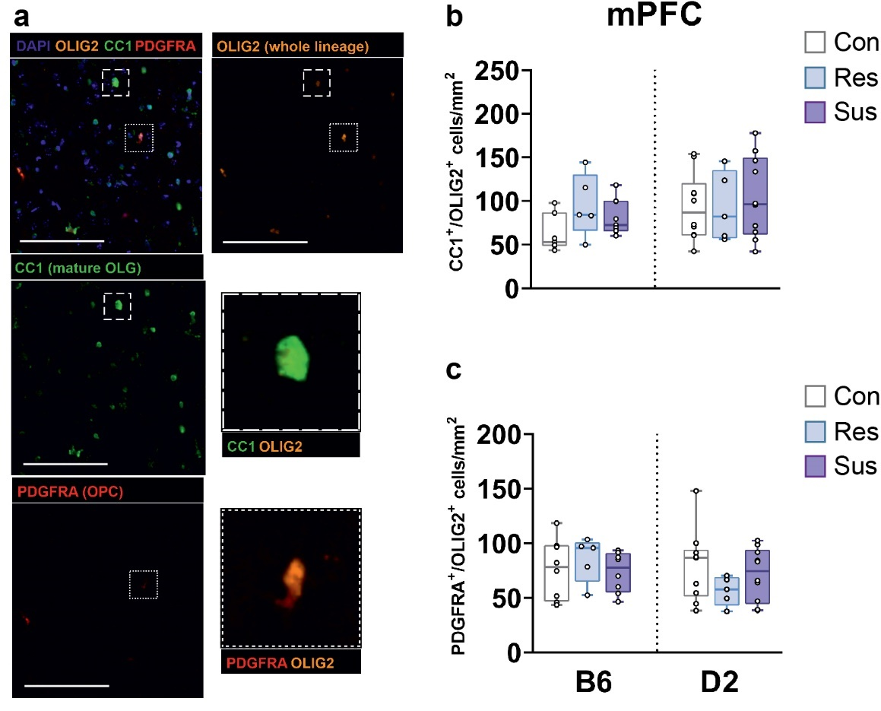

Supplementary Figure 4. No difference in the density of oligodendrocyte lineage cells 1 week after chronic social defeat stress
a Oligodendrocyte precursor cells (OPCs) identified with platelet-derived growth factor receptor α (PDGFRA) and differentiated oligodendrocytes (OLGs) labeled with adenomateous polyposis coli clone 1 (CC1) antibody. These markers were co-stained with OLIG2 to restrict the analysis to OLG lineage. b,c Box plots of OLGs (b) and OPCs (c) in the mPFC. Each data point represents one animal’s average number of cells across 3-14 images.

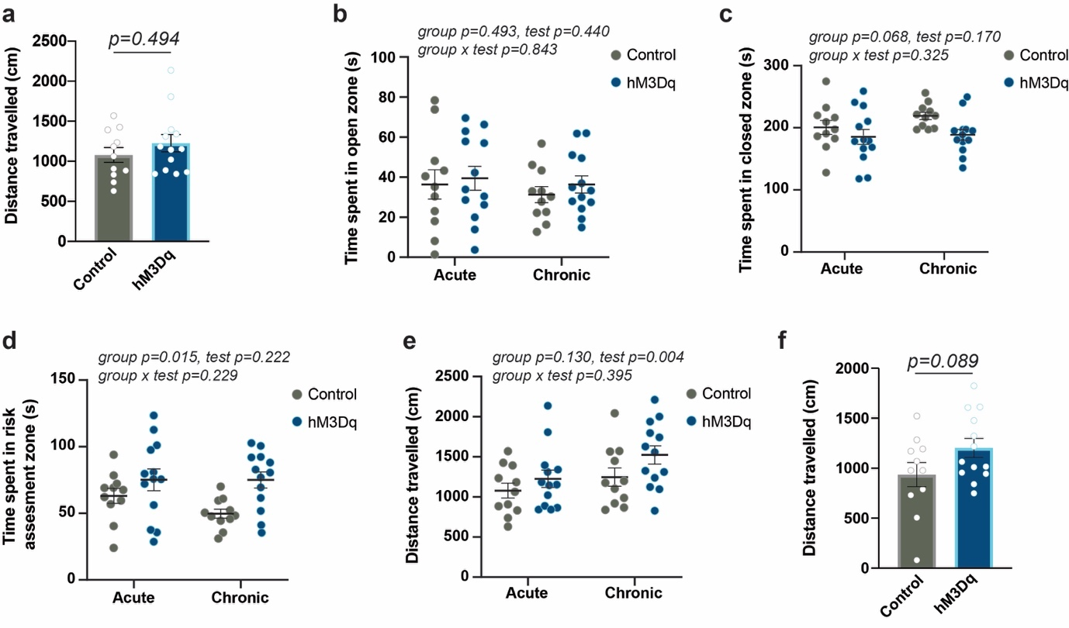

Supplementary Figure 5. Behavior in the EZM and EPM tests after an acute and chronic manipulation of vHPC-to-mPFC projection.
a No differences in locomotor activity after an acute CNO injection in the elevated zero maze (EZM) test (two-sided student’s t-test). b-e Comparison of time spent in the open (b), closed (c), risk assessment (d) zones and distance travelled (e) in the EZM tests after an acute (EZM1) and chronic (EZM2) CNO administration (Two-way repeated ANOVA). f No differences in locomotor activity after chronic CNO injections in the elevated plus maze (EPM) test (two-sided student’s t-test). Control n=11; hM3Dq n=13. Error bars represent ±SEM.

Supplementary table 1. List of Node of Ranvier genes
Gene | Nodal component
Ank3 | Paranode
Cldn5 | Paranode
Cntnap1 | Paranode
Kif13b | Paranode
Gjc2 | Paranode
Mag | Paranode
Ncmap | Paranode (not detected in our RNA-seq data)
Nfasc | Paranode
Scn2a | Paranode
Sptan1 | Paranode
Stbn4 | Paranode (not detected in our RNA-seq data)
Cntn2 | Juxtaparanode
Cntnap2 | Juxtaparanode
Dlg2 | Juxtaparanode
Dlg4 | Juxtaparanode
Epb41l3 | Juxtaparanode
Kcna1 | Juxtaparanode
Kcna2 | Juxtaparanode
Kcnab1 | Juxtaparanode
Kcnab2 | Juxtaparanode
Sirt2 | Juxtaparanode
Bcan | Node
Bin1 | Node
Cdh1 | Node
Dag1 | Node
Dlg1 | Node
Schip1 | Node
Kcnq2 | Node
Kcnq3 | Node
Myoc | Node
Nrcam | Node
Scn1a | Node
Scna1b | Node (not detected in our RNA-seq data)
Scn8a | Node
Spock1 | Node
Sptbn4 | Node
Ermn | Internode
Mbp | Internode
Pard3 | Internode
Tubb4a | Internode

