Deletion of Bak1 alleviates microglial necroptosis and neuroinflammation after experimental subarachnoid hemorrhage
Xiancheng Qiu^{1,2,6†}, Qianke Tao^{1,2†}, Lihan Zhang^{1,2}, Chenghao Kuang^{1,2,3}, Yuke Xie^{1,2,3}, Lifang Zhang⁴, Shigang Yin^{2,3,5*}, Jianhua Peng^{1,2,3,5*}, Yong Jiang^{1,2,3,5*}
- Department of Neurosurgery, the Affiliated Hospital of Southwest Medical University, Luzhou 646000, China.
- Laboratory of Neurological Diseases and Brain Function, the Affiliated Hospital of Southwest Medical University, Luzhou 646000, China.
- Institute of Epigenetics and Brain Science, Southwest Medical University, Luzhou 646000, China.
- Sichuan Clinical Research Center for Neurosurgery, the Affiliated Hospital of Southwest Medical University, Luzhou 646000, China.
- Academician (Expert) Workstation of Sichuan Province, the Affiliated Hospital of Southwest Medical University, Luzhou 646000, China.
- Department of Neurosurgery, Shifang City People's Hospital, Shifang 618400, China.

*Corresponding author:
Sigang Yin, Ph.D.
Laboratory of Neurological Diseases and Brain Function, The Affiliated Hospital of Southwest Medical University, No.25 of Taiping Street, Luzhou, Sichuan 646000, China.
Email: sgyin@swmu.edu.cn

Jianhua Peng, M.D.
Department of Neurosurgery, The Affiliated Hospital of Southwest Medical University,
No.25 of Taiping Street, Luzhou, Sichuan 646000, China.
Email: pengjianhua@swmu.edu.cn

Yong Jiang, MD, Ph.D.
Department of Neurosurgery, The Affiliated Hospital of Southwest Medical University,
No.25 of Taiping Street, Luzhou, Sichuan 646000, China.
Email: jiangyong@swmu.edu.cn

†Xiancheng Qiu and Qianke Tao contributed equally.

Original images for the gel and blots
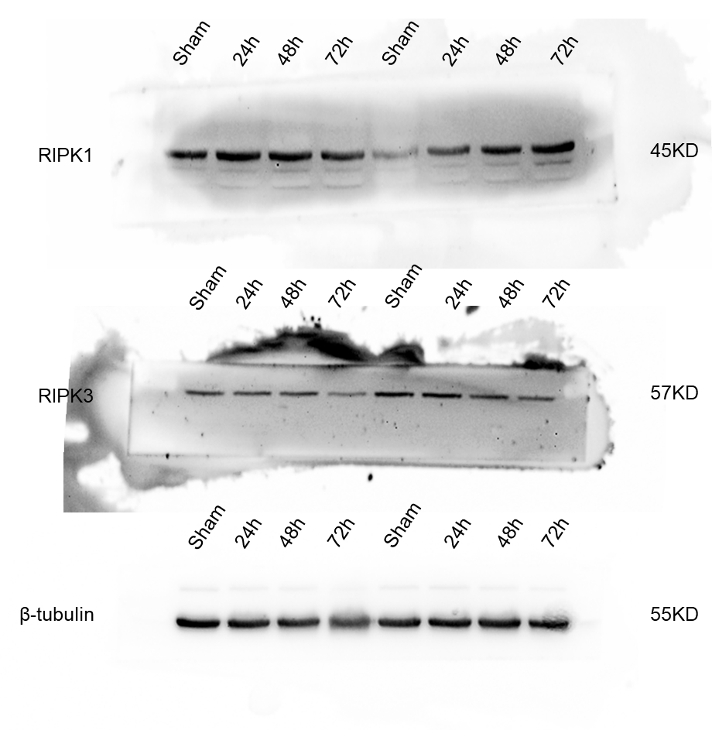
Original WB blot for Figure.1 B Time course of RIPK1, RIPK3 expression in the brain following SAH.
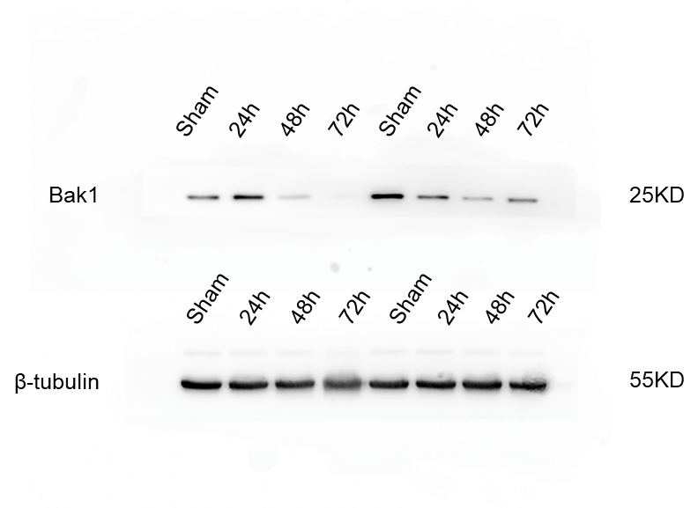
Original WB blot for Figure.2 A Bak1 expression in the brain following SAH.
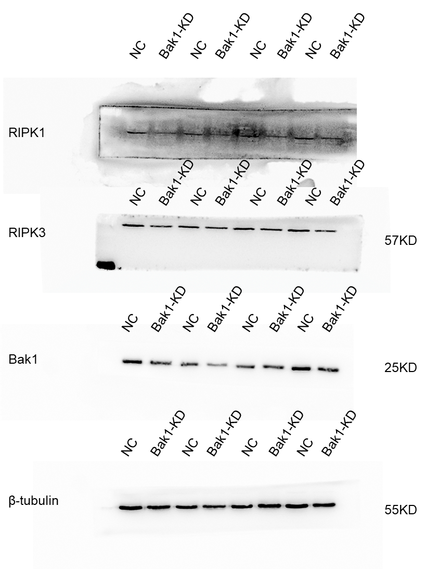
Original WB blot for Figure.2 E 24 hours of SAH, the level of Bak1, RIPK1, RIPK3 in AAV-NC group and AAV-Bak1-KD group.

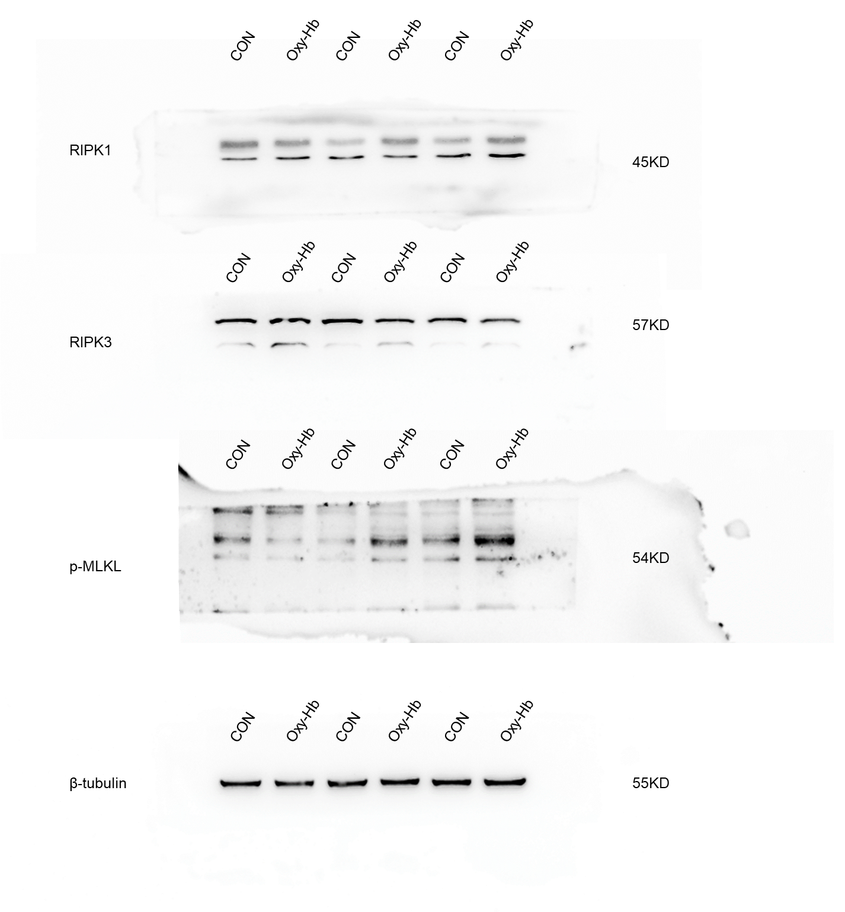
Original WB blot for Figure.3 B RIPK1, RIPK3, p-MLKL level after BV2 microglia treated with 10uM oxyhemoglobin.

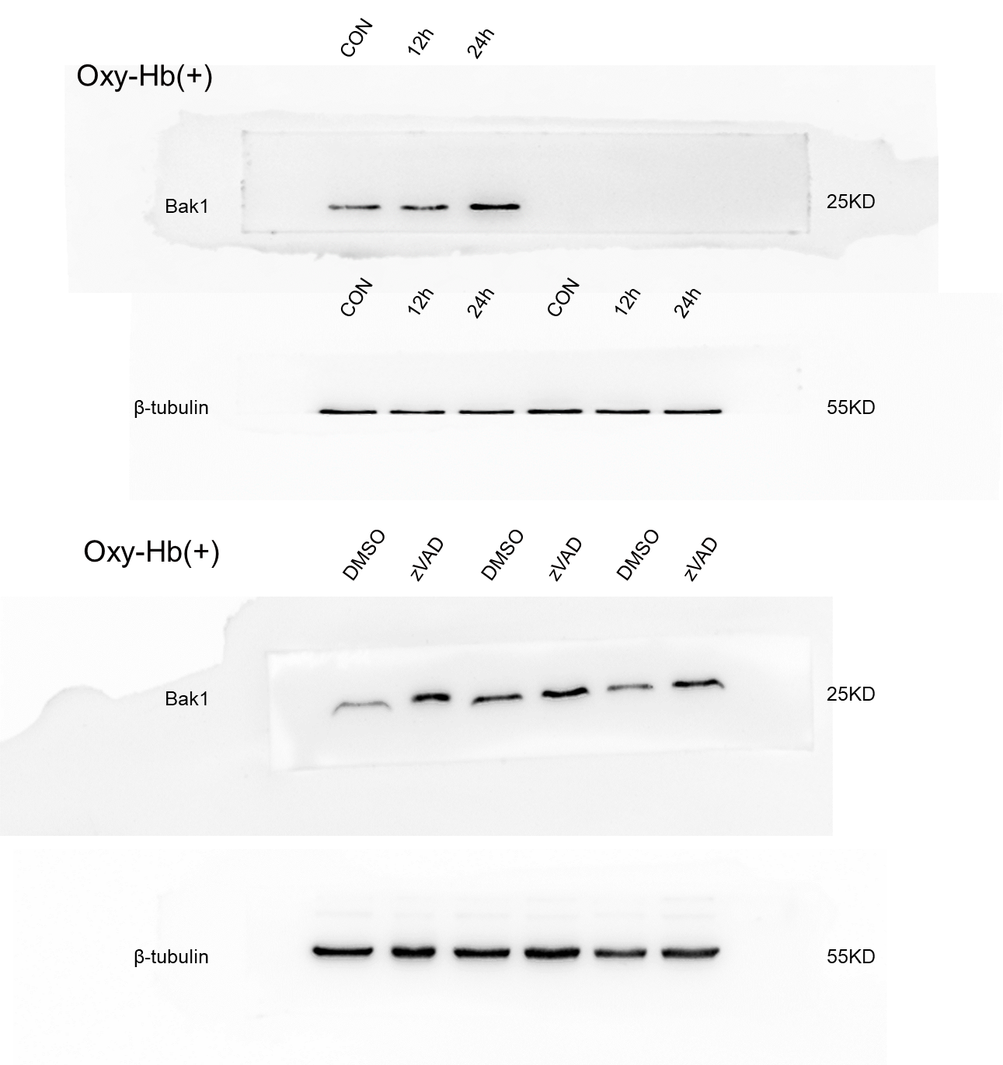

Original WB blot for Figure.5 A Bak1 level after BV2 microglia treated with 10uM oxyhemoglobin and 10uM oxyhemoglobin+30uM zVAD-FMK

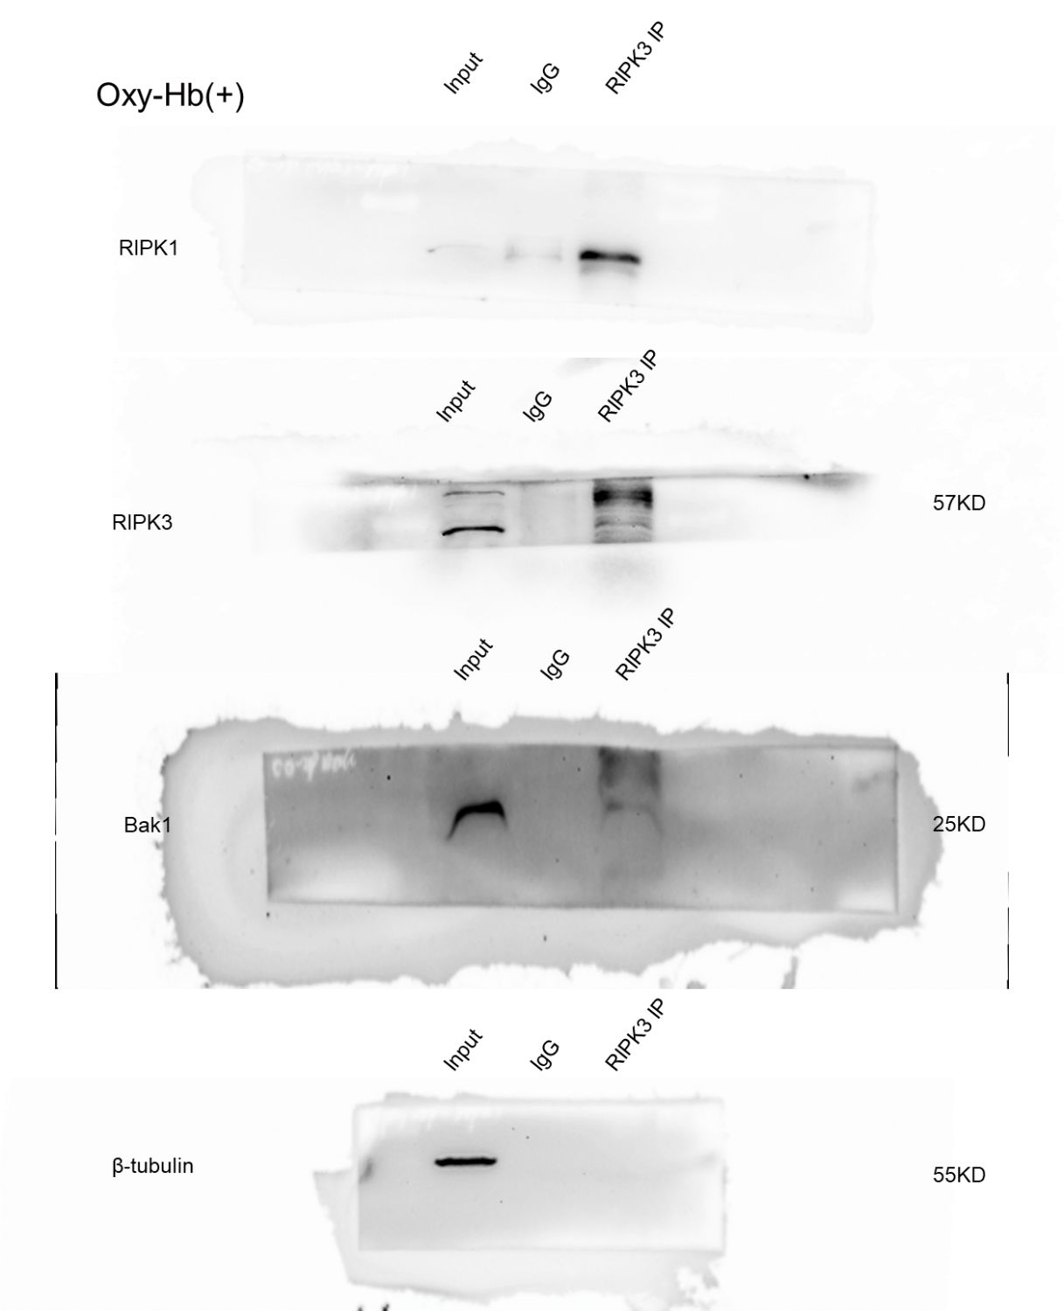

Original WB blot for Figure.5 B Co-immunoprecipitation (Co-IP) of RIPK3 was then subjected to western blot analysis with mouse anti-RIPK1, anti-Bak1.

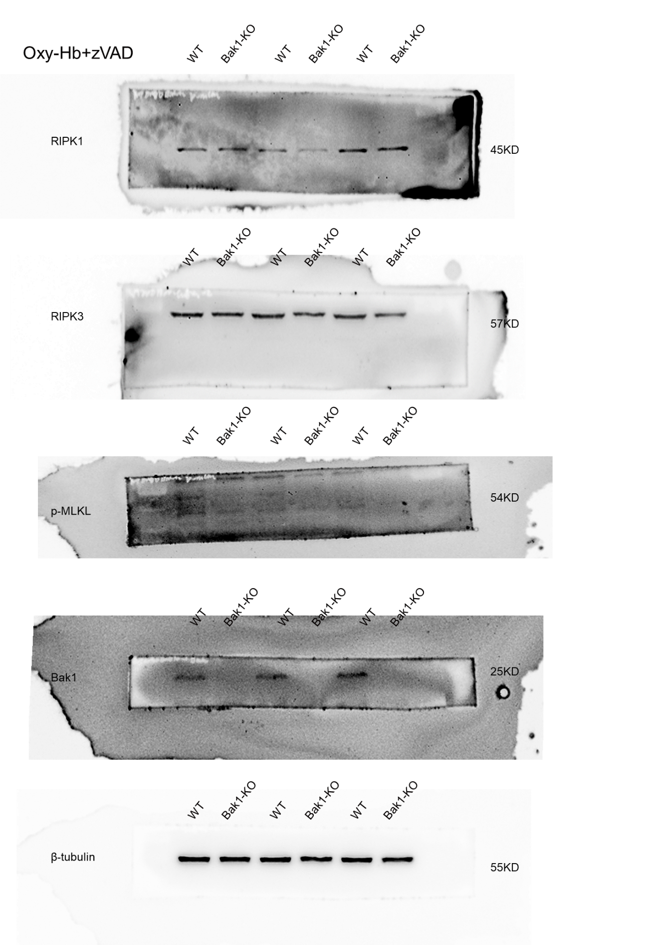
Original WB blot for Figure.5 F RIPK1, RIPK3, p-MLKL level after WT BV2 and Bak1-KO BV2 treated with 10uM oxyhemoglobin+30uM zVAD-FMK

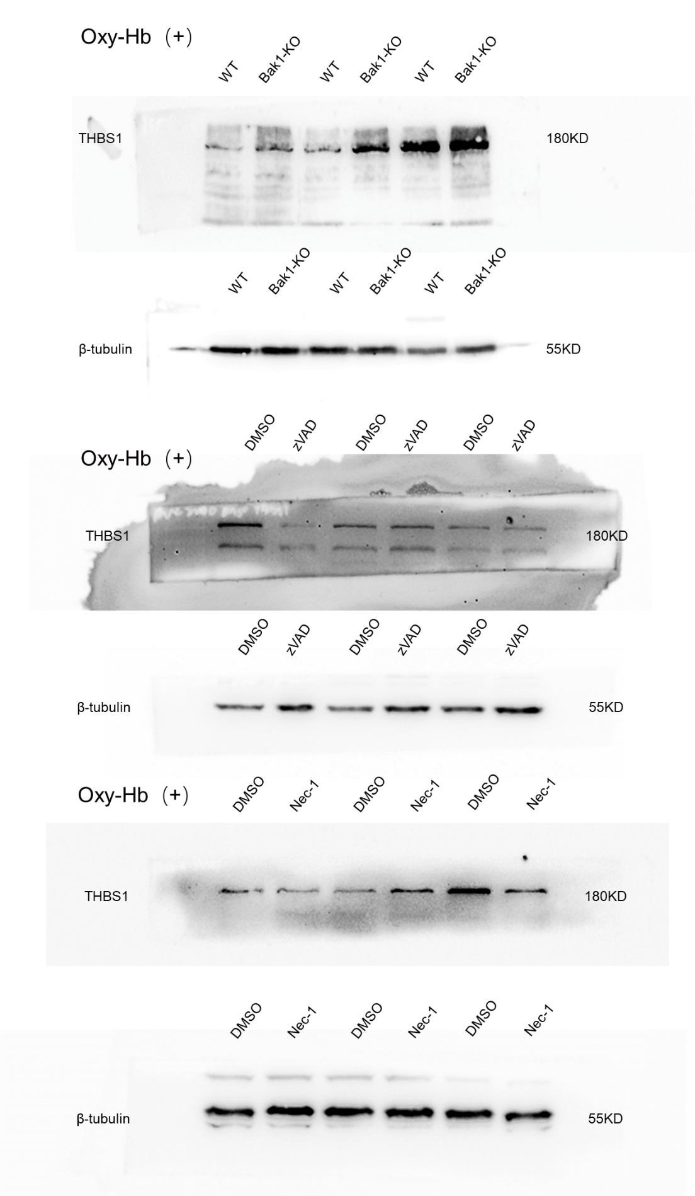

Original WB blot for Figure.7 D THBS1 levels in Bak1-KO, zVAD-FMK, and Nec-1 after 24 hours of oxyhemoglobin stimulation.

