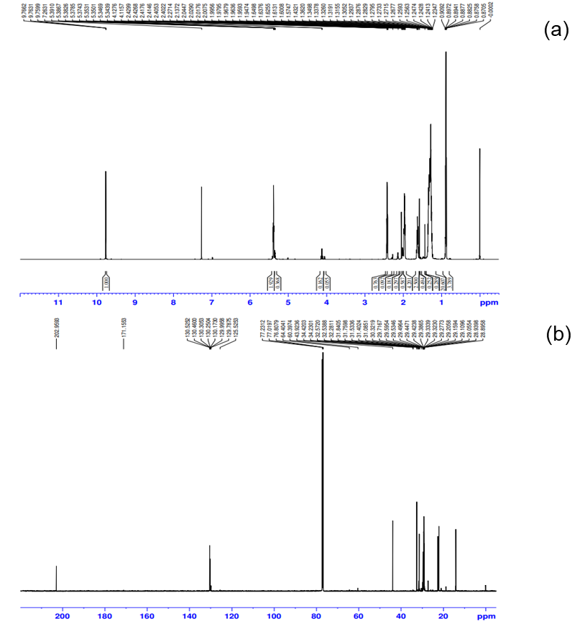
Fig. S1 NMR of (E)-10-hexadecenal: (a) ¹H NMR and (b) ¹³C NMR spectra.

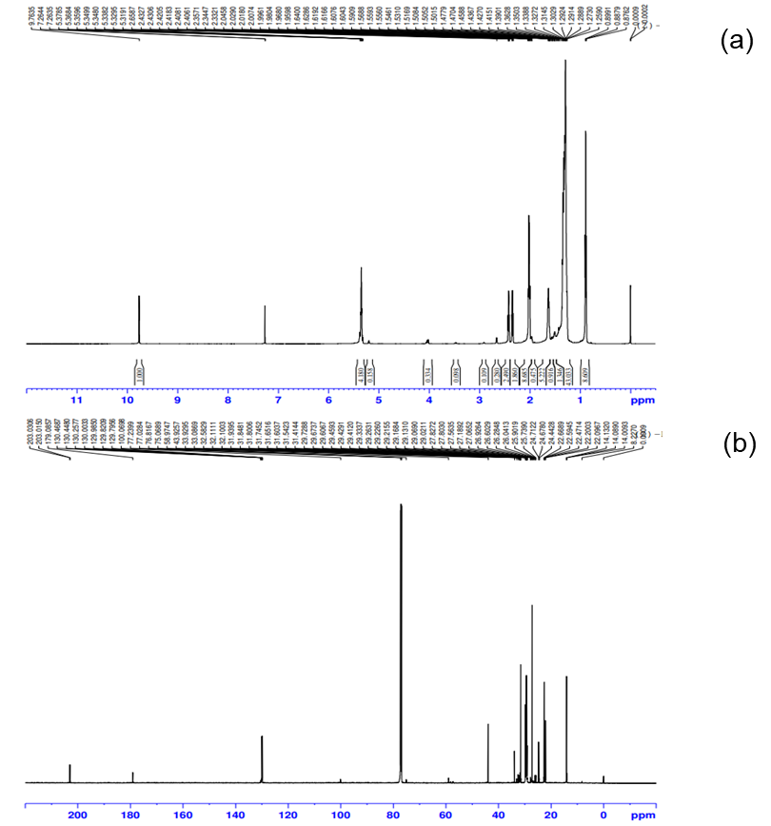
Fig. S2 NMR of (Z)-10-hexadecenal: (a) ¹H NMR and (b) ¹³C NMR spectra.

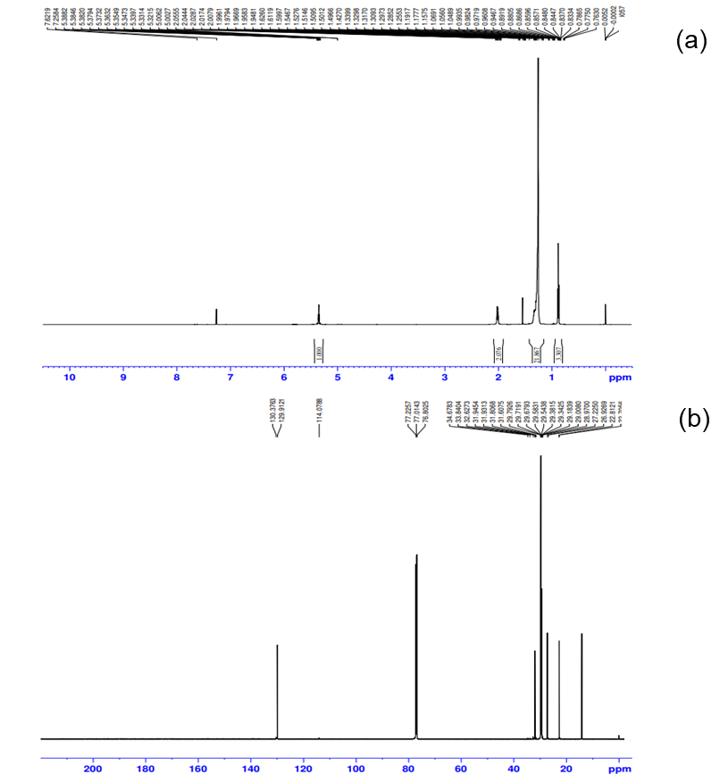
Fig. S3 NMR of (Z)-9-heptacosene: (a) ¹H NMR and (b) ¹³C NMR spectra.

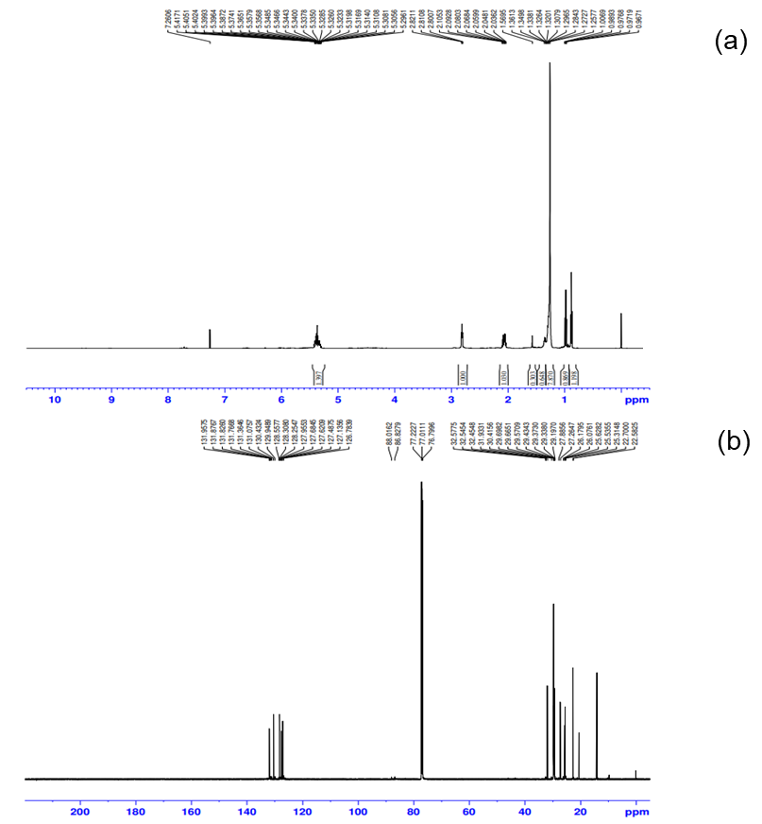
Fig. S4 NMR of (3Z,6Z,9Z)-tricosatriene: (a) ¹H NMR and (b) ¹³C NMR spectra.

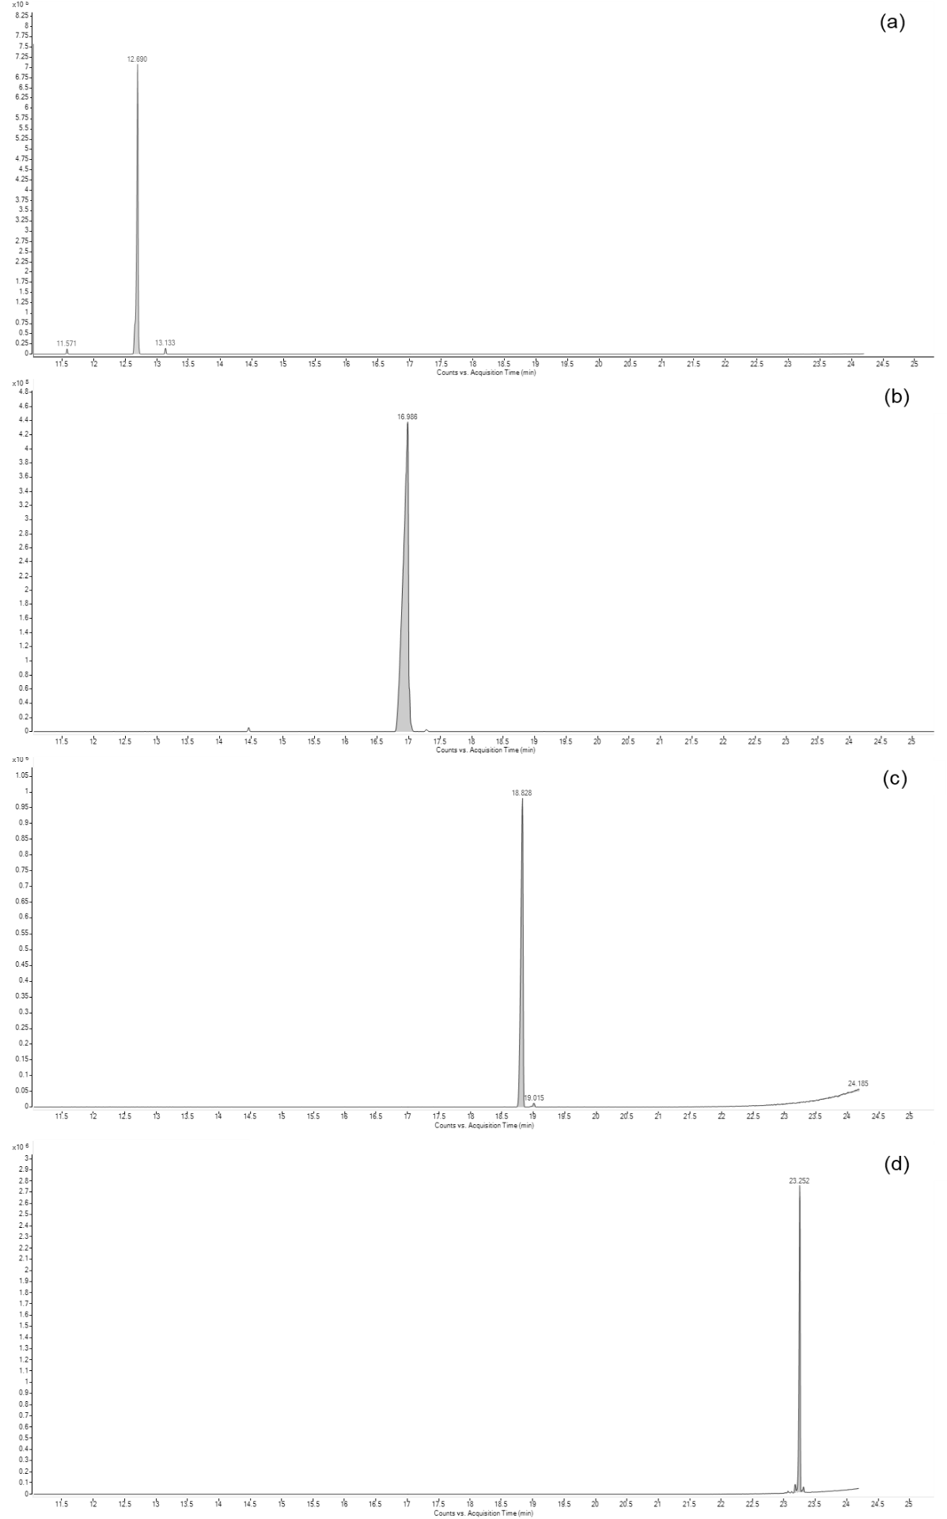
Fig. S5 Gas chromatography-mass spectrometry analyses of synthetic sex pheromones: (a) (E)-10-hexadecenal, (b) (Z)-10-hexadecenal, (c) (3Z,6Z,9Z)-tricosatriene, and (d) (Z)-9-heptacosene.

