Impact of antibiotic usage on extended-spectrum ß-lactamase producing Escherichia coli prevalence: a time-series analysis of tertiary hospital implementing stewardship program

Jeong Yeon Kim^{#1}, Yun Jin Yum^{#2}, Hyung Joon Joo^{3,4}, Hyonggin An^{2,3}, Jong Hun Kim^{#5*}, Jang Wook Sohn^{#1,3*}

¹Division of Infectious Diseases, Department of Internal Medicine, Korea University College of Medicine, Seoul, Republic of Korea
²Department of Biostatistics, Korea University College of Medicine, Seoul, Republic of Korea
³Korea University Research Institute for Medical Bigdata Science, Korea University, Seoul, Republic of Korea
⁴Department of Cardiology, Cardiovascular Center, Korea University College of Medicine, Seoul, Republic of Korea
⁵Division of Infectious Diseases, Department of Internal Medicine, CHA Bundang Medical Center, CHA University, Seongnam, Republic of Korea

# Contributed equally
*Corresponding authors

Figure S1. Cross correlations function of ESBL-producing E.coli proportion and AUD. AUD of (A) ciprofloxacin (B) cefepime (C) piperacillin-tazobactam (D) third generation cephalosporin. CCF, cross correlation function.

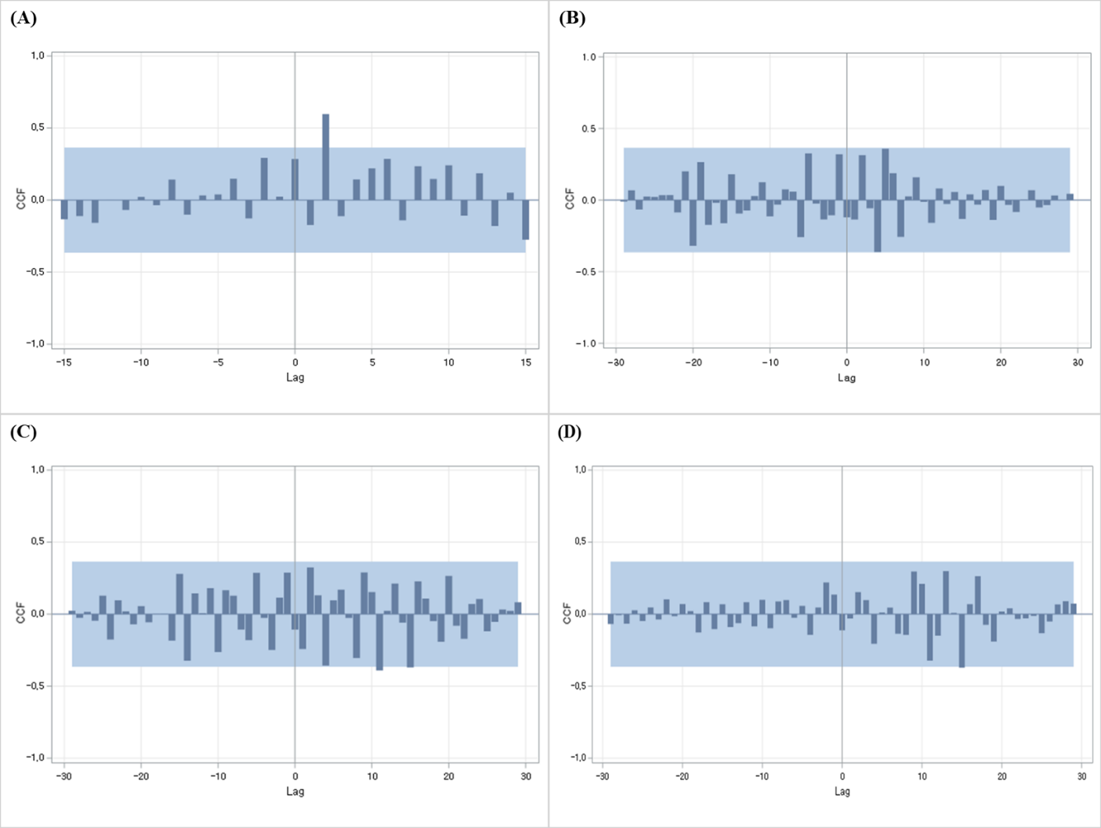
Figure S2. Autocorrelation function and partial autocorrelation function of the ESBL-producing E.coli proportion and ciprofloxacin consumption model. (A) ACF (B) PACF. ACF, autocorrelation function; PACF, partial autocorrelation function.

