SUPPLEMENTAL MATERIALS
S1. Methods
S1.1 Subjects
We studied AD subjects obtained through the brain bank of the Alzheimer Disease Research Center (ADRC) at the University of Pittsburgh, using protocols approved by the University of Pittsburgh Institutional Review Board and Committee for Oversight of Research and Clinical Training Involving Decedents. Cases with a primary neuropathologic diagnosis of Alzheimer’s disease and a Braak stage between 3-5 were included in the study. End-stage cases, as defined by a Braak stage of 6, were excluded.

Subjects underwent comprehensive evaluations by experienced clinicians in the ADRC, including neurologic, neuropsychological, and psychiatric assessments as previously described [1-3]. Using this information, information obtained from clinical records, and structured interviews with surviving relatives, an independent committee of experienced clinicians made consensus DSM-IV diagnoses for each subject. Psychosis was defined as the presence of delusions or hallucinations at any visit. Subjects with a preexisting psychotic disorder (e.g. schizophrenia) were excluded from the study.

Fixed and frozen tissue samples from 19 elderly cognitively normal comparison subjects from the Religious Order Study (ROS) were obtained from the Rush Alzheimer’s Disease Center, along with basic demographic and neuropathologic information [4]. Mild neurodegenerative pathologic changes were accepted, up to a Braak stage of 2 for tau pathology, presence of sparse neuritic plaques or early TDP-43 pathology.

All subject samples were identified by a code number, and staff were blind to diagnosis group at all stages of sample preparation, data generation, and data extraction.

S1.2 Sample collection and neuropathologic assessment
For ADRC subjects, postmortem interval (PMI) was recorded at the time of brain removal. At autopsy, the brain was removed intact, examined grossly, and divided in the midsagittal plane. Gray matter samples from the right superior frontal gyrus of the dorsolateral prefrontal cortex (DLPFC) were dissected and frozen at −80 °C. The left hemibrain was immersion fixed in 10% buffered formalin for at least one week, sectioned into 1.0 cm coronal slabs, and sampled according to Consortium to Establish a Registry for Alzheimer’s Disease (CERAD) protocol for neuropathological diagnosis of AD [5] or, since 2012, following National Institute of Aging – Alzheimer’s Association (NIA-AA) guidelines [6]. AD pathology was evaluated using the modified Bielschowsky silver stain [7] and immunohistochemical staining for tau and amyloid β. Neuritic plaque density was assessed according to CERAD criteria [5]; distribution of tau pathology was classified according to Braak stages [8]. Lewy body pathology was assessed by alpha-synuclein immunohistochemistry, and positive cases were classified into amygdala-predominant, limbic/neocortical-predominant, or other categories, a modified scheme based on consensus criteria [6, 9]. For analysis in this study, all alpha-synuclein positive categories were combined into one Lewy body positive group. Immunohistochemical staining for phospho-TDP-43 was performed on sections of amygdala, hippocampus, mesial temporal cortex and middle frontal gyrus as previously described [10]. Sections were evaluated for the absence or presence of TDP-43 positive neuronal cytoplasmic inclusions, neuronal intranuclear inclusions and dystrophic neurites. Based on the distribution of TDP-43 pathology, positive cases were classified into amygdala-predominant, mesial temporal, neocortical, or in cases when amygdala sections were not available, but all other sections were TDP-43 negative, indeterminate categories. For analysis in this study, all TDP-43 positive categories were combined into one TDP-43 positive group.

Assessment of vascular pathology included atherosclerosis of the circle of Willis, arteriolosclerosis in frontal white matter and cerebral amyloid angiopathy in DLPFC. Each was rated as none (0), mild (1), moderate (2) or severe (3), and a sum score was generated by adding the three individual scores. Microvascular lesions (MVL) were defined as remote microinfarcts/microhemorrhages not seen on gross examination and less than 1.0 cm in size. MVLs were enumerated in standardized sections [6] of middle frontal gyrus (DLPFC), superior and middle temporal gyrus, inferior parietal lobule, occipital cortex (BA 17/18), basal ganglia at level of anterior commissure, and thalamus at the level of the subthalamic nucleus to create MVL counts.

Neuropathologic diagnoses of Alzheimer disease were made according to CERAD criteria [5], although all AD subjects also met NIA-Reagan criteria [11] for intermediate to high probability that their dementia was due to AD lesions.

For the 19 elderly cognitively normal comparison subjects from the ROS, the same variables were provided to us, including Braak stage, CERAD neuritic plaque scores, presence/absence of TDP-43 and Lewy body pathologies, severity of vascular pathologies, and diagnostic classification based on modified CERAD and NIA-Reagan criteria (applying criteria in the absence of a diagnosis of dementia) [12].

S1.3 Quantitative Immunohistochemistry
Serial 5 μm thick formalin-fixed, paraffin-embedded tissue sections were immunostained on an automated stainer (Discovery Ultra, Ventana, Tucson, AZ) using the following primary antibodies: PHF-1 (1:1000, kindly provided by Peter Davies), beta-amyloid NAB228 (1:4000 (Cell Signaling Technology, Danvers, MA), after 40 min pretreatment with 90% formic acid), and microglial markers Iba1 (1:500, Wako, Richmond, VA) and HLA-DR (1:100, Dako, Agilent Technologies, Santa Clara, CA). Except for beta-amyloid, slides for all other stains were pretreated with Discovery CC1 solution, a Tris based buffer with a slightly basic pH (Ventana Medical Systems, Tucson, AZ). All slides were developed using a multimeric HRP/DAB detection system (Ventana Medical Systems, Tucson, AZ). No counterstaining was performed to ease signal quantification.
S1.4 Microscopy
Whole slide digital images of the immunostained sections were created using a Mirax MIDI slide scanner (Zeiss, Jena, Germany) or Aperio AT2 slide scanner (Leica, Deer Park, IL) at 40x resolution. A subset of cases was scanned on both scanners to confirm very high concordance of digital image analysis results. Digital image analysis was performed using NearCyte software (Andrew Lesniak, University of Pittsburgh). For each section, 4 rectangular regions of interest (ROI) of 4mm² were created. These ROIs were defined to span the entire cortical thickness and were preferentially placed midway along the gyral axis to avoid tangentially cut cortical regions. Minor manual adjustments were made to adapt to curvatures and irregularities in the cortical ribbon. Once placed for the first analyzed stain (PHF-1), the same ROIs were re-used for all subsequent stains. If tissue folds or other artifacts prevented placement in the same location, the ROI was moved to an acceptable site as close as possible to the original location. For quantitative image analysis, thresholds for signal positivity were optimized manually for each stain and then maintained constant throughout the analysis of all slides. Signals from all four ROIs were integrated into two outcome variables: area ratio (= positive area/entire field area) and mean signal intensity. For HLA-DR and Iba1 stains, an additional variable, the HLA-DR/Iba1 ratio was derived to normalize microglial activation (HLA-DR) to microglial density (Iba1). All analyses were done blinded to psychosis status.
S1.5 Statistical Analysis
Sample size was determined by power analysis of data from our prior publication [2]. Power was a function of sample size and pi, where pi is the proportion of altered protein ratios between AD-P and AD+P. Assumptions for the power analysis were that the average ratio for the pi proteins would be = 1.17 (and for the 1-pi proteins would = 1.0), SD (on log2 protein level) = 1.0, and one-sided alpha=0.05. Based on these criteria, we projected a sample size between 90-120 AD subjects would yield power of 0.75-0.84.
We performed rigorous QC and normalization on all quantified peptides. First, we performed sample loading normalization to make the total abundance the same across all samples. Second, peptides that were missing in both pooled control samples in at least half of the plexes were removed. We also removed peptides that were mapped to multiple proteins or genes. Three subjects who were included in the assay were deemed as outliers based on their total abundances (Figure S1) and they were excluded from the subsequent data normalization steps and analyses. Next, an internal reference scaling (IRS) normalization[13] was performed for each peptide, where the scaling factor (for each plex) was calculated as the ratio of the overall mean of all pooled samples to the mean of the within-plex pooled samples. Finally, a median normalization was performed to make the median of each sample equal to the overall median of all samples. One additional subject who was included in the above normalizations was discovered, prior to statistical analysis, to have not met inclusion criteria (did not meet neuropath criteria for AD) and was excluded from all subsequent analyses, leaving a final cohort of 125 subjects (Table 1).
To compare the PSD yield among three diagnosis groups, we performed linear regression adjusting for age, PMI, and sex in the remaining N=106 AD subjects. When comparing PSD yield among the two AD groups we additionally covaried for APOE*ε4 carrier status (which we have previously shown impacts the synaptic proteome in AD[14]) and for Lewy body positivity and tau area fraction (log2 transformed) as preliminary analyses revealed these two neuropathologies differed between the two AD groups. Then, for each sample, we multiplied the PSD yield to the normalized peptide abundance to account for the PSD yield variation in samples. Next, we performed PeCorA[15] analysis to identify “uncorrelated” peptides within each protein. In the end, we rolled up yield-adjusted peptide data to protein level by averaging the z-score of each peptide (on the log2 scale) that is mapped to the same protein. The “uncorrelated” peptides were treated as separate proteins and were not rolled up. We use different present call thresholds (e.g., 100%, 80%) when selecting peptides in the roll-up step.
Then we performed Limma[16, 17] analysis using R (version 4.1.0) for each yield-adjusted protein for our primary comparison between AD+P and AD-P. These analyses adjusted for age, PMI, sex, APOE*ε4 carrier status, Lewy body positivity, and tau intensity (log2 transformed). As a secondary analysis we compared AD+P, AD-P, and control, including age, PMI, and sex as covariates. APOE*ε4 carrier status and neuropathology variables were excluded from these comparisons as they are highly associated with diagnosis comparing AD and control. In all analyses two-group model-based log2 of fold change between any two groups was calculated for each protein. All statistical tests performed in this paper are two-sided. The Benjamini-Hochberg method was used to yield FDR adjusted p-values from Limma analysis.
Functional annotation clustering analysis of differentially expressed proteins was performed with DAVID[18], using the default settings. In each analysis the differentially expressed proteins were tested for enrichment relative to a background of the 1613 proteins quantified in all samples.

S2. Results and Discussion

S2.1 PSD enrichment Validation. We first undertook to validate our approach to PSD enrichment in DLPFC of 4 AD cases drawn from the current cohort. PSD preparation was as described in Biochemical Fractionation and LC-MS/MS, with the following minor differences. 8 µg total PSD and corresponding homogenate protein were digested, TMT labeled in a single block, and separated into 9 fractions prior to LC-MS injection. Enrichment (and depletion) relative to homogenate of canonical PSD (GRIA2, GRIN1, DLG4), presynaptic (VAMP2, SNAP25), and cytosolic (GLUL, DPYSL2) constituents are shown (Figure S2).

S2.2 Comparison of AD+P and AD-P with elderly cognitively normal subjects
The reduction in PSD protein abundance in AD+P relative to AD-P reflected a reduction of PSD protein levels in AD+P relative to elderly cognitively normal subjects, as PSD protein levels were also significantly reduced in AD-P relative to the elderly cognitively normal group (Figure S5A-B). The protein whose abundance was most altered between the AD and comparison subjects was APP, due solely to the increased levels of two peptides found within the Aβ sequence (RHDSGYEVHHQK and KLVFFAEDVGSNK, Table S3 and noted as Aβ in Figure S5C). Overall, the protein alterations present in the two AD groups relative to elderly cognitively normal subjects were highly correlated (Figure S3C). As a consequence, both groups showed enrichment of differentially expressed proteins involved in protein translation and of glycoproteins. Nevertheless, functional annotation of the proteins that differentiated AD+P or AD-P from elderly cognitively normal subjects also revealed some differential patterns of enrichment. PSD proteins that differentiated AD+P from elderly cognitively normal subjects included enrichment for proteins involved in calcium signaling, synaptic function, and cytoskeletal proteins. PSD proteins that differentiated AD-P from elderly cognitively normal subjects were enriched for proteins involved in protein quality control, ion channels, and small GTPases (Table S4).
We also undertook to contrast the PSD signature of AD+/-P relative to elderly cognitively normal subjects to the most extensive prior examination of the functional enrichment of proteins in total gray matter homogenates of individuals with AD and elderly controls subjects, reported in [19]. This contrast is summarized in Figure S6. The differentially expressed proteins in the PSDs of both AD+P and AD-P shared with the overall gray matter homogenate enrichment for ribosomal proteins and glycoproteins. Other gray matter functional enrichments shared with either AD+P (Synapse, Mitochondria) or AD-P (Cell-ECM interactions, Ubiquitination) may indicate that some of the overall signal detected in AD homogenate derives primarily from subgroups of individuals with or without psychosis. Finally, enrichments detected only in the PSD preparations (e.g. impacting Calcium signaling, ion transport, and the cytoskeleton) may reflect pathologic cascades that are most prominent within PSDs and not as readily detected in the multicellular, multicompartmental, gray matter homogenate. As such, these functions may represent postsynaptic-specific targets for intervention for cognitive impairment more generally.

S2.3 Additional considerations regarding repurposing the identified candidate drugs.
Repurposing a drug developed for treating other conditions makes it likely that off-target effects will be present and these may be detrimental. Ultimately any medication used will be applied to frail elderly individuals with multiple comorbidities, so preferred agents would be documented to be well-tolerated in such a population. Some of the medications we identified, e.g., fostamatinib, which was developed for chronic use in populations with serious autoimmune disease, and maraviroc, which was developed for chronic treatment of HIV infection, may well meet the tolerability benchmark [20, 21]. For other agents, such as CTSK inhibitors, it should be noted that development of some such agents, including odanacatib, has been discontinued due to adverse events [22].

S2.4 Overlap with GWAS findings
We additionally identified an enrichment of genes encoding actin binding proteins, SYNPO, SYNE1, ALDOA, and VPS16, when we examined the overlap of the AD+P PSD proteome signature with genes nominated by our GWAS of AD+P. Two of these, SYNPO and SYNE1, are implicated in processes serving dendritic spine plasticity and maintenance, providing a link between the genetics of AD+P and its biologic signature of post-synaptic deficits. SYNPO encodes the protein synaptopodin, a dendritic spine protein that contributes to maintaining the long-term stability of large dendritic spines [23]. SYNE1 encodes multiple actin-binding proteins via extensive alternative splicing. One of these proteins, candidate plasticity gene 2 (CPG2), which is transcribed from the region of SYNE1 associated with risk for bipolar disorder [24], serves as a bridge between the dendritic spine endocytic machinery and the actin cytoskeleton necessary for activity dependent endocytosis of glutamate receptors [25]. ALDOA encodes the glycolytic enzyme Aldolase, Fructose-Bisphosphate A protein. While shown to promote lung cancer metastasis by interacting with gamma-actin [26], its role in neuronal function remans obscure. Of interest, however, given our computational predictions, ALDOA protein is found in actin rods [27]. VPS16 encodes the VPS16 Core Subunit of CORVET and HOPS Complexes protein, which contributes to autophagosome-lysosome fusion. Mutations in VPS16 cause dystonia syndromes, though the functions of VPS16 in neurons, and the functional consequences of the identified mutations for neuronal and postsynaptic function are not currently established [28]. TBC1D10B encodes a GTPase-activating protein for members of the Rab family,[29] where it participates in an endosomal-lysosome pathway that is important in the clearance of tau protein.[30]
In our recent genome-wide association meta-analysis of over 12,000 AD subjects with or without psychosis, the most significant genetic locus associated with psychosis in AD was contained in a gene encoding ectonucleotide pyrophosphatase/phosphodiesterase 6 (ENPP6) [31]. One other locus, in SUMF1, also reached genome-wide significance. We observed a reduced level of ENPP6 in AD+P relative to AD-P [Log₂(AD+P/AD-P) = -0.40] that was just outside the 240 PSD proteins with nominally reduced abundance (P=0.051, Table S1). Formylglycine generating enzyme, the protein product of SUMF1, was not detected in our assay, The expression of ENPP6 is selective for the oligodendrocyte lineage [32], peaking as oligodendrocyte precursor cells (OPCs) differentiate into mature oligodendrocytes [33]. It has been established for some time that presynaptic terminals of excitatory neurons containing synaptic vesicles and release machinery align at electron-dense synaptic clefts abutting the processes of OPCs, and that the latter closely resemble the PSDs of dendritic spines, containing a postsynaptic membrane specialization and glutamate receptors (reviewed in[34]). Though not established, it is likely that these OPC PSDs are co-isolated with neuronal PSDs in our enrichment procedure. Others have demonstrated that synaptic input from glutamatergic neurons onto AMPA and NMDA receptors within the “PSDs” of oligodendrocytes regulate OPC proliferation and differentiation of OPCs to mature oligodendrocytes [35, 36], a process during which ENPP6 expression is at its peak, and which is required for learning complex tasks [33]. Our finding of reduced ENPP6 abundance in the PSDs of AD+P would therefore suggest that activity dependent maturation of OPCs is impaired in AD+P relative to AD-P, and may contribute to the greater cognitive impairment in AD+P. Whether, and by what mechanism, this may relate to the genetic association of ENPP6 with AD+P risk remains an open question.
S3. Supplemental Figures
Figure S1. Identification of subject outliers excluded prior to peptide intensity normalization and statistical analysis. Left shows box plot of total peptide abundance for each TMT plex. Three extreme outlying subjects are denoted by the blue arrows, which indicate their corresponding locations in the multidimensional scaling plot, where they are also seen to separate from the main cluster of subjects (Right).
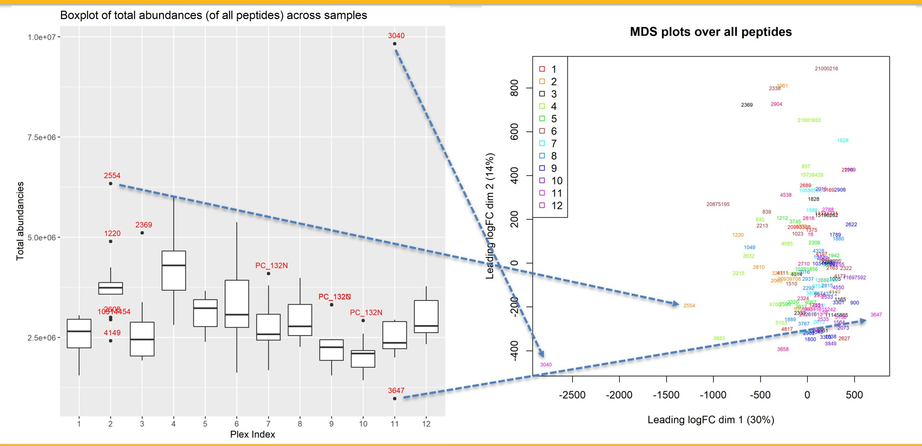

Figure S2. PSD Enrichment in AD. We validated our approach to PSD enrichment in DLPFC of 4 AD cases drawn from the current cohort. PSD preparation was as described in Biochemical Fractionation and LC-MS/MS, with the following minor differences. 8 µg total PSD and corresponding homogenate protein were digested, TMT labeled in a single block, and separated into 9 fractions prior to LC-MS injection. Enrichments (and depletions) relative to homogenate of canonical PSD (GRIA2, GRIN1, DLG4), presynaptic (VAMP2, SNAP25), and cytosolic (GLUL, DPYSL2) constituents are shown. Dashed line indicates no change (Log2 scale) relative to the homogenate.

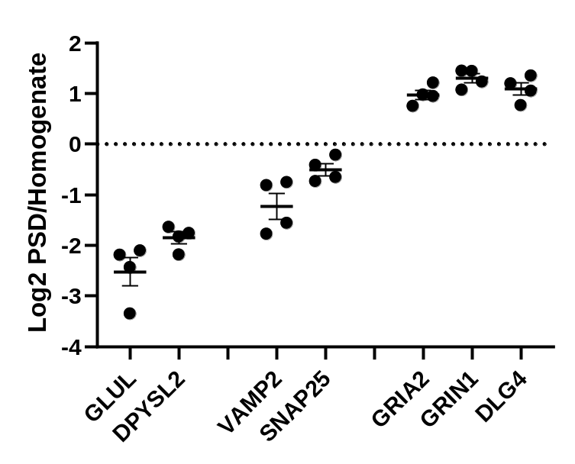

Figure S3. PSD Yields of AD+P, AD-P, and cognitively normal elderly comparison subjects. Yields are shown as µg of PSD protein per µg of gray matter protein. Mean yield of AD+P group is lower than mean yield of AD-P group (t = -2.17, df = 119, p = 0.032) and lower than elderly cognitively normal controls (t = -2.36, df = 119, p = 0.020). Mean yield of AD-P subjects is not significantly lower than control (t = -0.78, df = 119, p = 0.433).
Group | Min | Mean | SD | Max
Control | 0.240 | 0.526 | 0.201 | 0.896
AD-P | 0.120 | 0.513 | 0.241 | 1.294
AD+P | 0.135 | 0.421 | 0.192 | 1.058

Figure S4. Follow up tests of distribution of levels of PSD proteins quantified in DLPFC of AD+P and AD-P subjects. A. Distribution of levels of 4025 PSD proteins quantified in DLPFC of AD+P and AD-P subjects using a peptide present call threshold of 80%. B. Distribution of levels of 1613 PSD proteins quantified in DLPFC of 51 AD+P and AD-P subjects reported in Krivinko et al, 2018. C. Distribution of levels of 1613 PSD proteins quantified in DLPFC of 55 AD+P and AD-P subjects not included in Krivinko et all, 2018. D. Correlation of Log₂ fold change of protein levels between the subjects shown in B and C. E. Distribution of levels of 1613 PSD proteins quantified in DLPFC of 76 AD+P and AD-P subjects for which estimates of excitatory neuron proportion were available as reported in DeChellis-Marks[1]. F. Distribution of levels of 1613 PSD proteins quantified in DLPFC of the 76 AD+P and AD-P subjects shown in E, controlling for excitatory neuron proportion. Distributions of log₂ ratios are shown for all proteins, adjusted for covariates, Age, PMI, Sex, APOE*E4, Lewy Body presence, and phospho-Tau area fraction. The dashed vertical line represents no difference in the ratio of protein levels between groups. In all panels AD+P is characterized by a significant shift towards lower PSD protein levels compared to AD-P
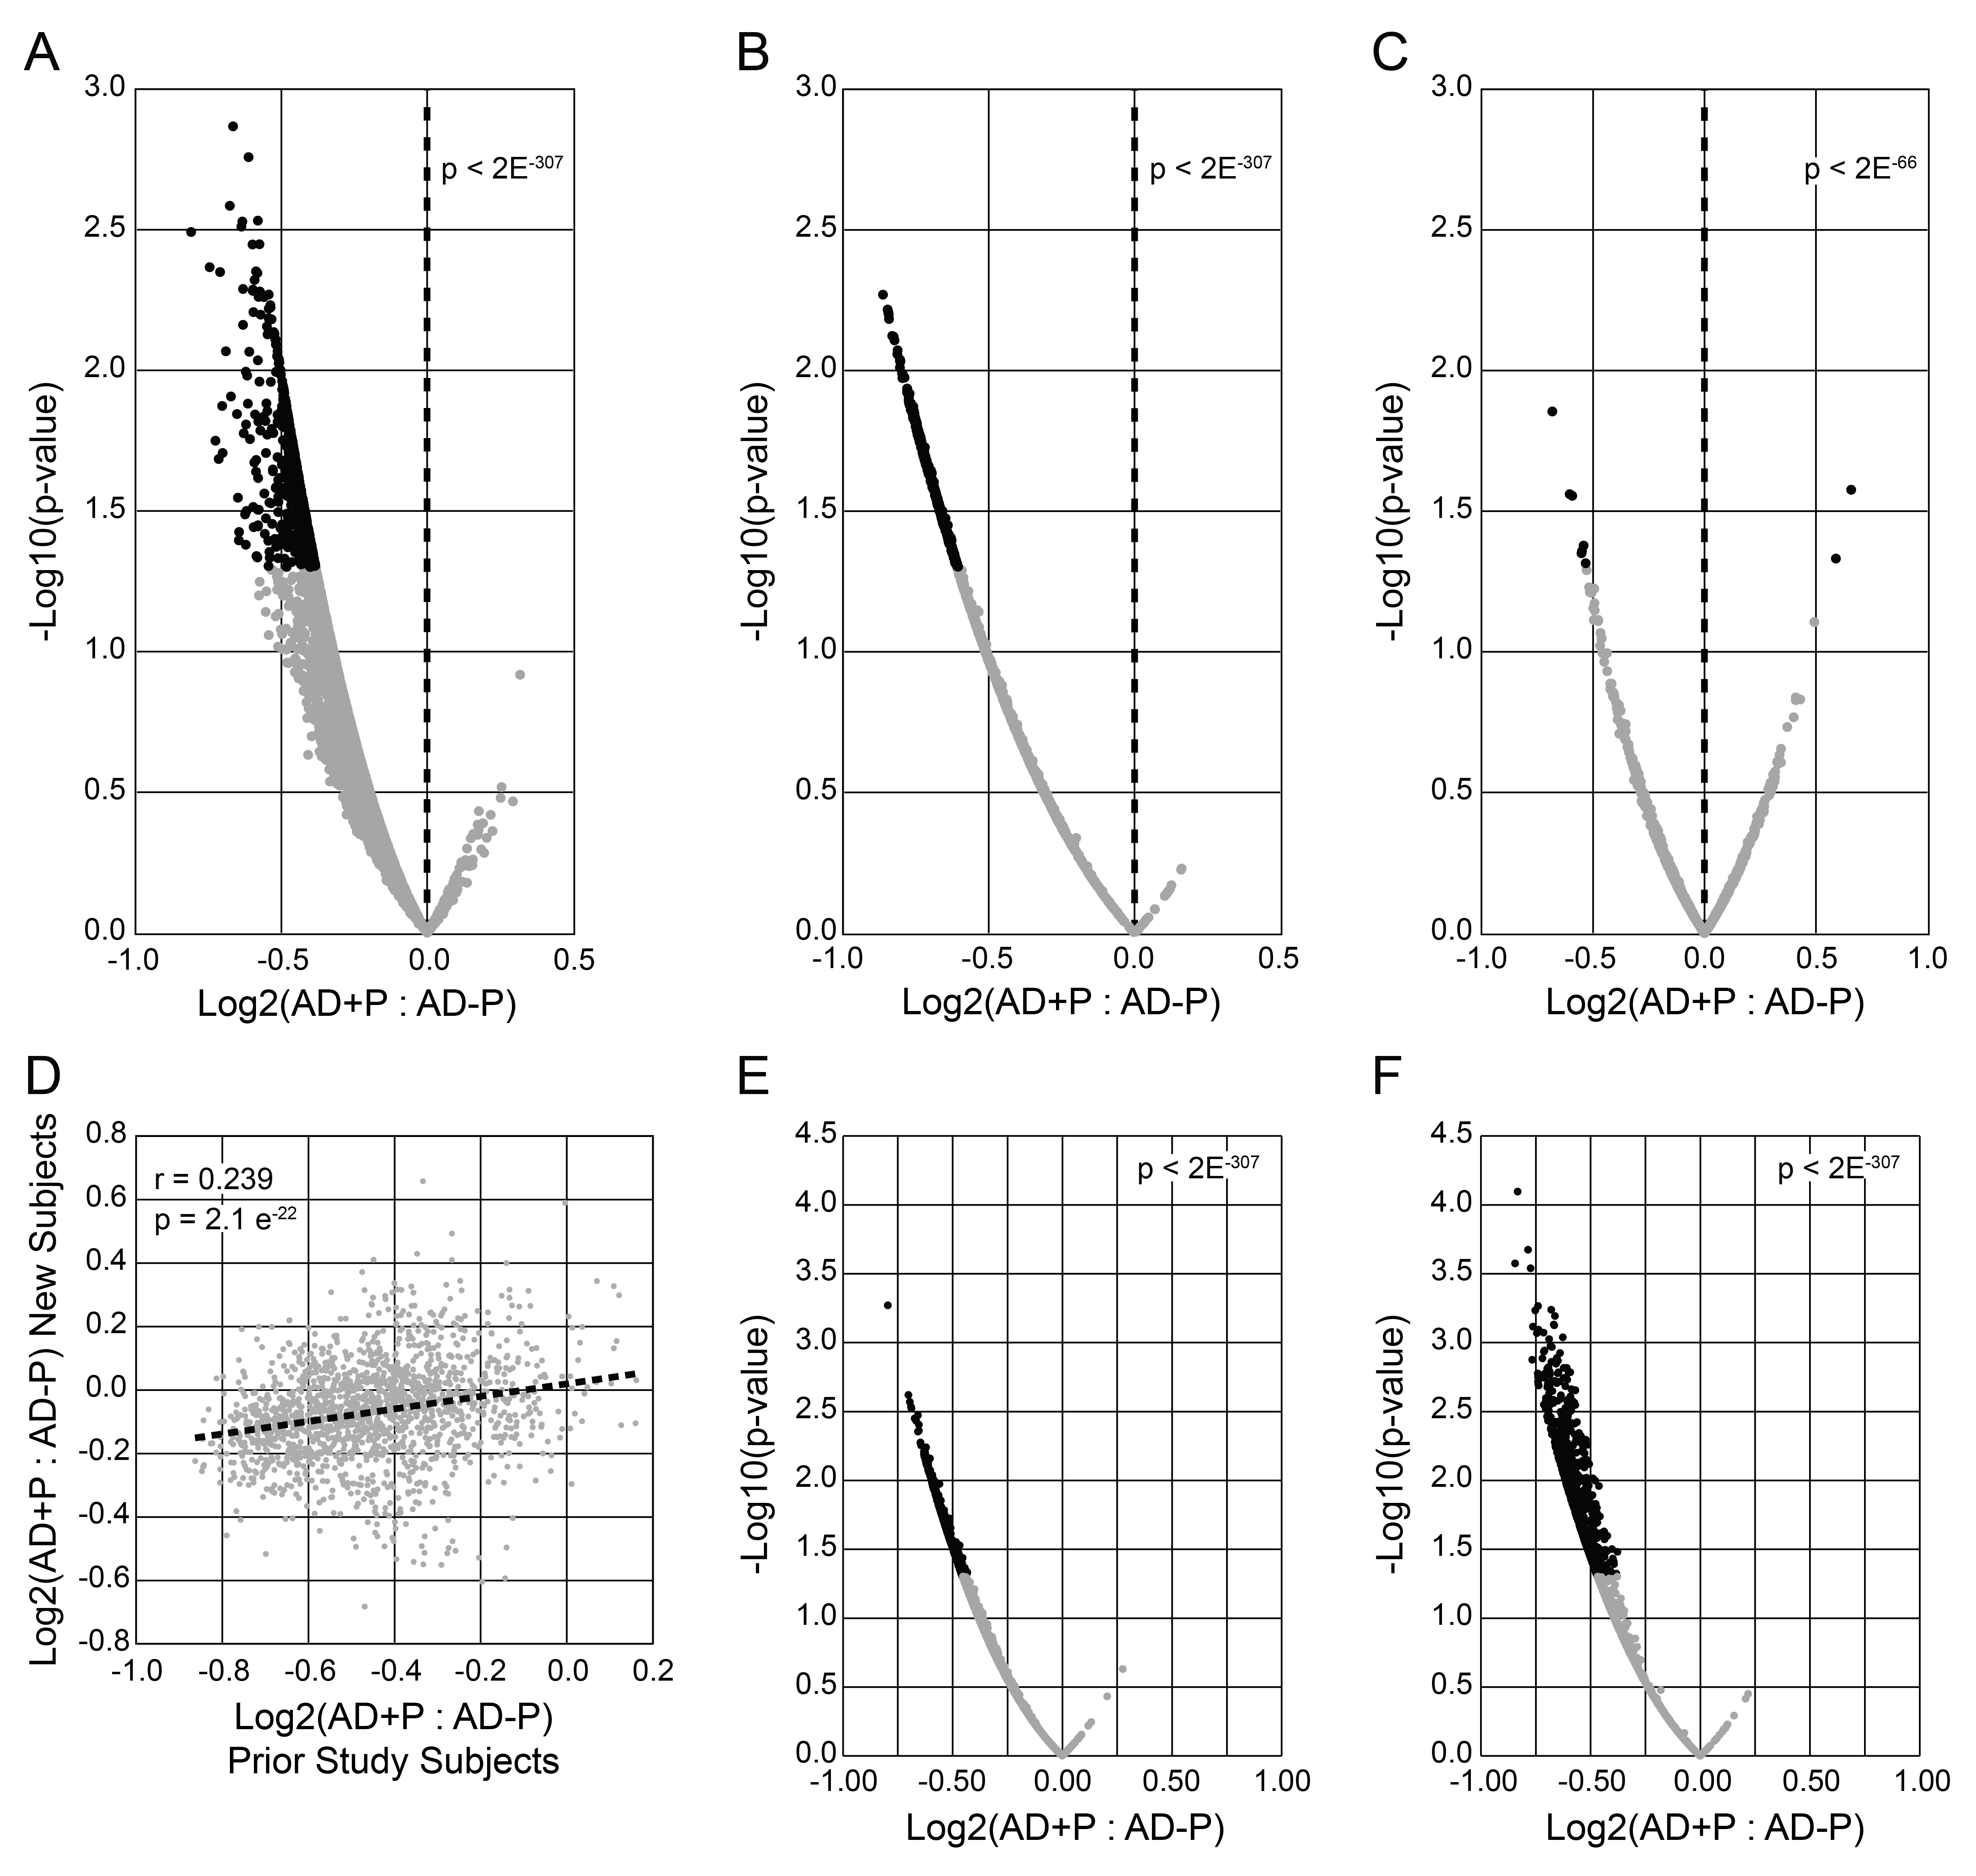
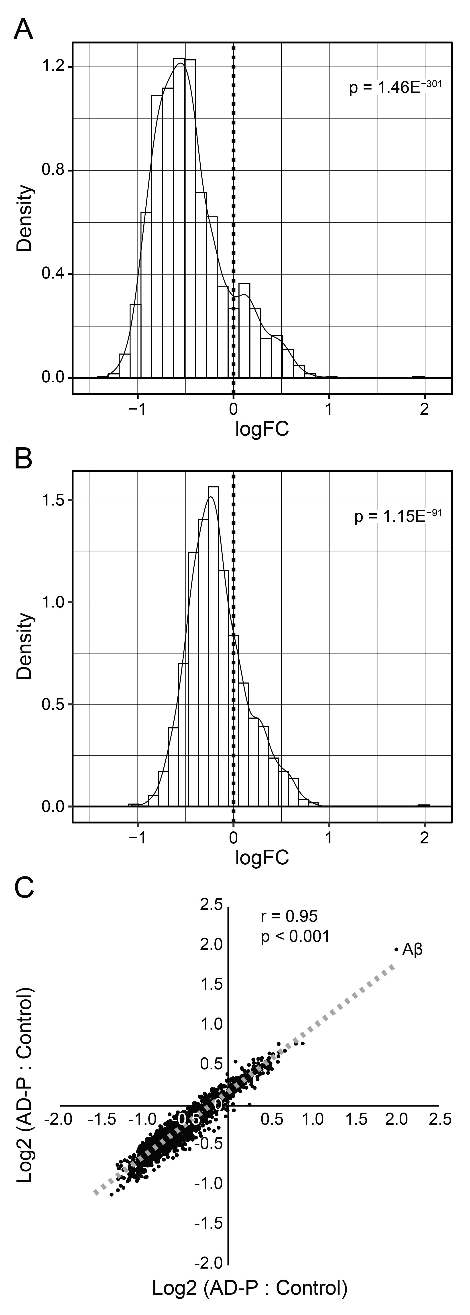
Figure S5. Distribution of levels of 1613 PSD proteins quantified in DLPFC using peptides present in 100% of AD+P and AD-P subjects relative to cognitively normal elderly comparison subjects. A&B. Distributions of Log2 ratios are shown for all proteins, adjusted for covariates, Age, PMI, and Sex. The dashed vertical line represents no difference in the ratio of protein levels between groups. Both AD groups are characterized by a significant shift towards lower PSD protein levels compared to cognitively normal elderly controls, with greater reductions in AD+P (as shown in Figure 2). C. The PSD alterations in the two AD groups relative to control are highly correlated (r=0.95, p<0.001). The protein most elevated in both AD+P and AD-P relative to comparison subjects was APP, due solely to the increased levels of two peptides (RHDSGYEVHHQK and KLVFFAEDVGSNK) found within the Aβ sequence (noted as Aβ).

Figure S6. Comparison of functional enrichment of differentially expressed PSD proteins in AD+P and AD-P relative to cognitively normal elderly comparison subjects with prior report of functional enrichment of AD gray matter homogenate relative to control. Protein co-expression modules from[19] were selected if they demonstrated a nominally significant (p<0.05) correlation with NIA Reagan Score. Functional characterization of each module was as per[19], modules with redundant or ambiguous functional characterizations are not shown. From the current report, all AD+P and AD-P PSD functional enrichment clusters relative to controls with enrichment score >=1 were included (see Tables S4A and S4B).

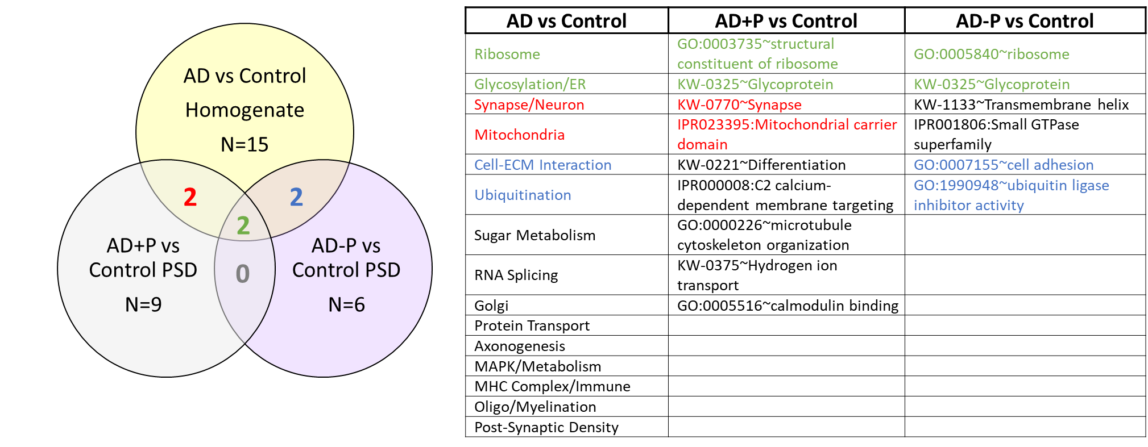
S4. Supplemental References

1. DeChellis-Marks, M.R., et al., Psychosis in Alzheimer's Disease Is Associated With Increased Excitatory Neuron Vulnerability and Post-transcriptional Mechanisms Altering Synaptic Protein Levels. Frontiers in Neurology, 2022. 13.
2. Krivinko, J.M., et al., Synaptic Proteome Compensation and Resilience to Psychosis in Alzheimer's Disease. Am J Psychiatry, 2018. 175(10): p. 999-1009.
3. Murray, P.S., et al., Hyperphosphorylated tau is elevated in Alzheimer's disease with psychosis. J. Alzheimers. Dis, 2014. 39(4): p. 759-773.
4. Bennett, D.A., et al., Religious Orders Study and Rush Memory and Aging Project. J Alzheimers Dis, 2018. 64(s1): p. S161-S189.
5. Mirra, S.S., et al., The consortium to establish a registry for Alzheimer's disease (CERAD). Part II. Standardization of the neuropathologic assessment of Alzheimer's disease. Neurology, 1991. 41: p. 479-486.
6. Montine, T.J., et al., National Institute on Aging-Alzheimer's Association guidelines for the neuropathologic assessment of Alzheimer's disease: a practical approach. Acta Neuropathol, 2012. 123(1): p. 1-11.
7. Yamamoto, T. and A. Hirano, A comparative study of modified Bielschowsky, Bodian and thioflavin S stains on Alzheimer's neurofibrillary tangles. Neuropathol. Appl. Neurobiol, 1986. 12(1): p. 3-9.
8. Braak, H., et al., Staging of Alzheimer disease-associated neurofibrillary pathology using paraffin sections and immunocytochemistry. Acta Neuropathol, 2006. 112(4): p. 389-404.
9. McKeith, I.G., et al., Diagnosis and management of dementia with Lewy bodies: third report of the DLB Consortium. Neurology, 2005. 65(12): p. 1863-1872.
10. Vatsavayi, A.V., et al., TAR DNA-binding protein 43 pathology in Alzheimer's disease with psychosis. Int. Psychogeriatr, 2014: p. 1-8.
11. Hyman, B.T. and J.Q. Trojanowski, Consensus recommendations for the postmortem diagnosis of Alzheimer disease from the National Institute on Aging and the Reagan Institute Working Group on diagnostic criteria for the neuropathological assessment of Alzheimer disease. J. Neuropathol. Exp. Neurol, 1997. 56(10): p. 1095-1097.
12. Bennett, D.A., et al., Neuropathology of older persons without cognitive impairment from two community-based studies. Neurology, 2006. 66(12): p. 1837-44.
13. Plubell, D.L., et al., Extended Multiplexing of Tandem Mass Tags (TMT) Labeling Reveals Age and High Fat Diet Specific Proteome Changes in Mouse Epididymal Adipose Tissue. Mol Cell Proteomics, 2017. 16(5): p. 873-890.
14. Sweet, R.A., et al., Apolipoprotein E*4 (APOE*4) Genotype Is Associated with Altered Levels of Glutamate Signaling Proteins and Synaptic Coexpression Networks in the Prefrontal Cortex in Mild to Moderate Alzheimer Disease. Mol. Cell Proteomics, 2016. 15(7): p. 2252-2262.
15. Dermit, M., et al., Peptide Correlation Analysis (PeCorA) Reveals Differential Proteoform Regulation. J Proteome Res, 2021. 20(4): p. 1972-1980.
16. Smyth, G.K., Linear models and empirical bayes methods for assessing differential expression in microarray experiments. Stat Appl Genet Mol Biol, 2004. 3: p. Article3.
17. Ritchie, M.E., et al., limma powers differential expression analyses for RNA-sequencing and microarray studies. Nucleic Acids Res, 2015. 43(7): p. e47.
18. Huang, d.W., B.T. Sherman, and R.A. Lempicki, Systematic and integrative analysis of large gene lists using DAVID bioinformatics resources. Nat Protoc, 2009. 4(1): p. 44-57.
19. Johnson, E.C.B., et al., Large-scale deep multi-layer analysis of Alzheimer's disease brain reveals strong proteomic disease-related changes not observed at the RNA level. Nat Neurosci, 2022. 25(2): p. 213-225.
20. Weehuizen, J.M., et al., Efficacy and safety of long-term maraviroc use in a heterogeneous group of HIV-infected patients: A retrospective cohort study. Int J Antimicrob Agents, 2019. 54(2): p. 215-222.
21. Tong, S., et al., Long-Term Safety Profile of the Oral Spleen Tyrosine Kinase Inhibitor Fostamatinib in Immune Thrombocytopenia (ITP) and Other Diseases. Blood, 2020. 136(Supplement 1): p. 35-36.
22. Mullard, A., Merck &Co. drops osteoporosis drug odanacatib. Nat Rev Drug Discov, 2016. 15(10): p. 669.
23. Yap, K., et al., The actin-modulating protein synaptopodin mediates long-term survival of dendritic spines. Elife, 2020. 9.
24. Rathje, M., et al., Genetic variants in the bipolar disorder risk locus SYNE1 that affect CPG2 expression and protein function. Mol Psychiatry, 2021. 26(2): p. 508-523.
25. Loebrich, S., et al., CPG2 Recruits Endophilin B2 to the Cytoskeleton for Activity-Dependent Endocytosis of Synaptic Glutamate Receptors. Curr Biol, 2016. 26(3): p. 296-308.
26. Chang, Y.C., et al., Therapeutic Targeting of Aldolase A Interactions Inhibits Lung Cancer Metastasis and Prolongs Survival. Cancer Res, 2019. 79(18): p. 4754-4766.
27. Walter, L.M., et al., Profilin2 regulates actin rod assembly in neuronal cells. Sci Rep, 2021. 11(1): p. 10287.
28. Steel, D., et al., Loss-of-Function Variants in HOPS Complex Genes VPS16 and VPS41 Cause Early Onset Dystonia Associated with Lysosomal Abnormalities. Ann Neurol, 2020. 88(5): p. 867-877.
29. Ishibashi, K., et al., Identification and characterization of a novel Tre-2/Bub2/Cdc16 (TBC) protein that possesses Rab3A-GAP activity. Genes Cells, 2009. 14(1): p. 41-52.
30. Lin, H., C.A. Deaton, and G.V.W. Johnson, Commentary: BAG3 as a Mediator of Endosome Function and Tau Clearance. Neuroscience, 2022.
31. DeMichele-Sweet, M.A.A., et al., Genome-wide association identifies the first risk loci for psychosis in Alzheimer disease. Mol Psychiatry, 2021. 26(10): p. 5797-5811.
32. Zhang, Y., et al., An RNA-sequencing transcriptome and splicing database of glia, neurons, and vascular cells of the cerebral cortex. J Neurosci, 2014. 34(36): p. 11929-47.
33. Xiao, L., et al., Rapid production of new oligodendrocytes is required in the earliest stages of motor-skill learning. Nat Neurosci, 2016. 19(9): p. 1210-1217.
34. Kula, B., T.J. Chen, and M. Kukley, Glutamatergic signaling between neurons and oligodendrocyte lineage cells: Is it synaptic or non-synaptic? Glia, 2019. 67(11): p. 2071-2091.
35. Gallo, V., et al., Oligodendrocyte progenitor cell proliferation and lineage progression are regulated by glutamate receptor-mediated K+ channel block. J Neurosci, 1996. 16(8): p. 2659-70.
36. Li, C., et al., A functional role of NMDA receptor in regulating the differentiation of oligodendrocyte precursor cells and remyelination. Glia, 2013. 61(5): p. 732-49.

