Supplementary Data:
Methodology:
Transwell Assays: Control-transfected and HBx-CRISPR transfected hepatoma cells were detached, harvested by centrifugation and resuspended in DMEM (without serum), and then placed in the upper chamber of a modified Boyden chamber consisting of uncoated polycarbonate filter membranes of 8 µm pore size. For invasion, transwell inserts were first coated with matrigel, then the chamber was placed in a 24-well culture dish containing DMEM with FBS in lower chamber. After 24 h (for chemotaxis) and 48 h (for invasion) incubation at 37⁰C, the lower side of the filter was washed with PBS and fixed with 4% paraformaldeyde for 2 min. Then cells were washed and permeabilized by 100% methanol for 20 min. For quantification, cell nuclei were stained with 0.5% crystal violet. The upper side of the filter containing the non-migrating cells was scraped with a cotton swab. Cells migrating towards the lower chamber were counted manually at 4X objective in random microscopic fields.
Scratch assays: Control-transfected and HBx-CRISPR transfected hepatoma cells were plated in 12-well plates (3x10⁶cells/well). After 6 h of serum starved condition, a scratch was made on the cell layer using a 100 µl sterile micropipette tip to create a wound. The cells were photographed using a phase-contrast microscope, to determine the wound width at time 0 h. The cultures were continued, and the cells were photographed again after 24 h of wounding the cell layer. Wound healing was visualized by comparing photographs taken at 0 h with 24 h later and analyzed for the distance migrated by the leading edge of the wound at each time point in all the study groups. The relative wound width (μm) was measured as wound width at the time 24 h divided by wound width at time point 0 h. The measurements were done by Software NIS Elements from NIKON Eclipse Ti (Nikon Instruments Inc.).
Colony formation assay: Control-transfected and HBx-CRISPR transfected hepatoma cells were plated in 6-well plates (500 cells/well) and incubated in complete medium for two weeks. Following fixation by 4 % paraformaldehyde, cells were stained with 0.1 % crystal violet and stained colonies were counted under the microscope.
ELISA Assay: HepG2.2.15 and HepG2-HBV cells (Control-transfected and HBx-CRISPR transfected) were cultured with serum-free medium at different time points. The supernatant was collected and ELISA for HBsAg were performed using ELISA kits (Thermofisher Scientific) as per manufacturer’s protocol. The optical density values were measured at 450 nm wavelength using microplate reader (Synergy /H1 Hybrid Multimode Plate Reader).
Immunophenotyping Assay: Control-transfected and HBx-CRISPR transfected hepatoma cells were fixed with permeabilizing solution containing Triton-X and ethyl alcohol for 20 min and incubated with primary antibodies CD133, VIM, and CDH1 for an hour followed by secondary antibody FITC, at 4◦C in the dark for 45 min and then analyzed using a flow cytometer (BD FACs Calibur). All experiments were performed in triplicates.
Quantitative RT-PCR (qRT-PCR) analysis: Control-transfected and HBx-CRISPR transfected hepatoma cells were harvested by using trypsin-EDTA solution (0.25%). Total RNA was isolated by using Trizol method and quantified at 260/280 nm with Thermo Scientific Nanodrop 2000 Spectrophotometer. A260 nm/A280 nm between 1.90 and 2 was considered for cDNA preparation. cDNA was synthesized from 1µg of RNA using reverse transcriptase (Thermo Scientific Verso cDNA synthesis kit) according to manufacturer instructions. Quantitative PCR was carried with SYBR green PCR master mix (Fermentas Life Sciences) using the ViiA7 instrument system (Applied Biosystems, USA). The following cycling parameters were used: start at 95℃ for 5 min, denaturing at 95℃ for 30s, annealing at 60℃ for 30s, elongation at 72℃ for 30s, and a final 5 min extra extension at the end of the reaction and repeated for 40 amplification cycles. The primer pairs used in the study are given in Table S1.
RNA Seq Studies: Control-transfected and HBx-CRISPR transfected hepatoma cells were harvested and proceeded for RNA extraction. The RNA quality was checked by nanodrop. Two independent samples for each treatment were collected and their RNA expression profiles were analyzed by Illumina NextSeq Platform. For transcriptomics analysis all processing of RNA samples (cDNA synthesis and labelling hybridization) was performed by DNA Xperts Pvt Ltd. The Illumina transcriptome data was mapped to the reference genome GRCh37.p13 (accession no. GCF_000001405.25). The edgeR software was used for calculating transcript abundance which is represented as CPM (Counts per minute). The heatmaps were constructed using the log-transformed and normalized value of genes based on Pearson uncentered correlation distance and average linkage method. Significant differentially expressed genes (DEGs) were identified and enriched using gene set enrichment analysis (GSEA) website for pathways in Kyoto Encyclopedia of Genes and Genomes (KEGG), Reactome, GSEA hallmarks, Wikipathway, and Gene Ontology (GO) biological processes (BP) and molecular function (MF) (False Discovery Rate (FDR) <0.05).
Hanging drop cultures: Control-transfected and HBx-CRISPR transfected hepatoma cells were seeded in a hanging-drop plate at a concentration of 1000 cells/μl in growth medium. Images of drops were taken at 24 and 72 h post-treatment. Tumor spheroid adhesion property was scored on a 0–2 scale, with a 0 score no spheroid formation, a 1 means formation of a loose spheroid, and a 2 signifies compact spheroid formation. For migration assessment, migration was visualized by comparing photographs taken at 0 h with 24 h and 72 h later and analyzed for the distance migrated by cells to aggregate at each time point in all the study groups. The relative migration percentage was measured as migrated cell area at the time 24 h and 72 h divided by total area covered by seeded cell at time point 0 h. The measurements were done by Software NIS Elements from NIKON Eclipse Ti and final assessment done with the help of ImageJ software. The unit for measurement was μm.
Results
HBx knockdown resulted in downregulation of genes significantly associated with cell proliferation and stemness (contd.): The top downregulated genes were associated with metabolism (UGT1A9, DPYS, LDHB), histone modifications (ISY1-RAB43, H2AW, H2BU1), viral infection (RPL17-C18orf32), cellular processes (S100A6, CHI3L1, ADAMTS1, VIM), and signal transduction (IRS4, CD81, PTPN13, CDCA7L) (Fig S4 and Table S2).
The Gene ontology analysis showed that the significantly downregulated genes had DNA, kinase, and transcription factor binding activity and were mainly components of the plasma membrane, golgi apparatus, and endoplasmic reticulum. The upregulated genes were not significantly enriched for any GOMF (Gene Ontology in Molecular Function) and GOCC (Gene Ontology in Cellular Components) (Fig S6B and S6D).
Specifically, the driver genes of Wnt signaling (LEF1, MMP7, WNT5A, WNT5B, WNT6, FZD2, and TCF4), PI3K signaling (ARAP3, AKT3, IRS4, and IRS2), Hedgehog signaling (LRP2, GLI3, GAS1, ZIC2, BMP2, and BMP7), Notch signaling (DLL1, HES5, JAG2, and NUMB), and MAPK signaling (RAC2, ELK1, FGF9, FGF2, PLA2G2A, MAP3K5, PLA2G4A PAK1, MEF2C and FLNC) which might promote the invasion and metastasis of tumor cells were downregulated in HBx-CRISPR group (Fig S4A-E). Further, the downregulated genes showed GSEA hallmarks for WNT and Hedgehog signaling, inflammatory responses, and EMT (Fig S6C). FGF2, SOX2, PBX1, ZIC3, FOXD3, GSC, and CDX2 which are known for transcriptional regulation of stemness-related genes were also significantly downregulated in the HBx-CRISPR group (Fig S7). In addition, downregulation of various transcription factors like HEY2, DACH1, TCF4, SOX2, and SP9 in the HBx-CRISPR group was observed as compared to the controls. (Fig S7). Furthermore, 14 Zinc finger nucleases (ZNF302, 35, 239, 467, 717, 681, 418, 532, 676, 215, 521, 320, 736 and 518B) were downregulated and ZNF763 was upregulated in HBx-CRISPR group in comparison to the controls (Fig S7) .
Supplementary Figures:
Figure S1:
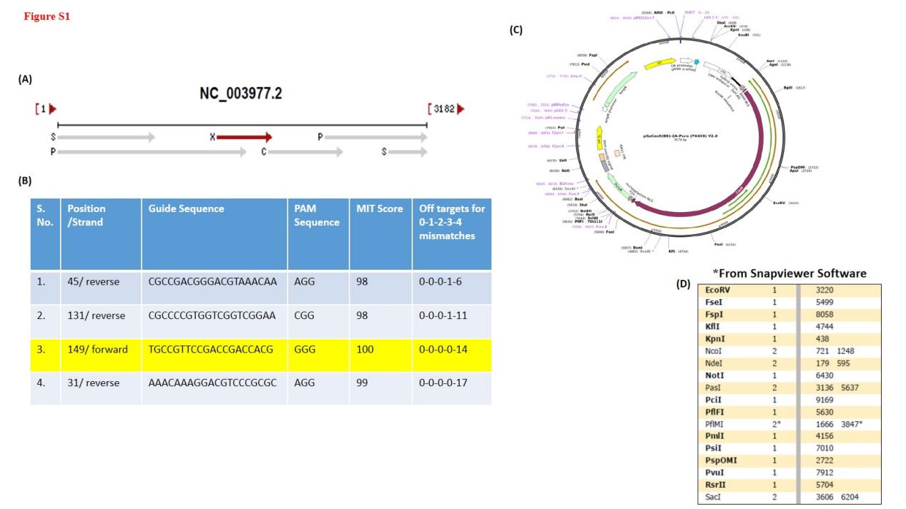
(A) Representation of HBx ORF position in the linear genome of HBV (B) Table containing best possible sgRNAs against the HBx gene for designing HBx specific CRISPR/Cas9 (C) Vector map of eSpCas9-2A-Puro (PX459)V2.0 (D) Restriction sites in vector elucidated from Snapgene viewer.
Figure S2:
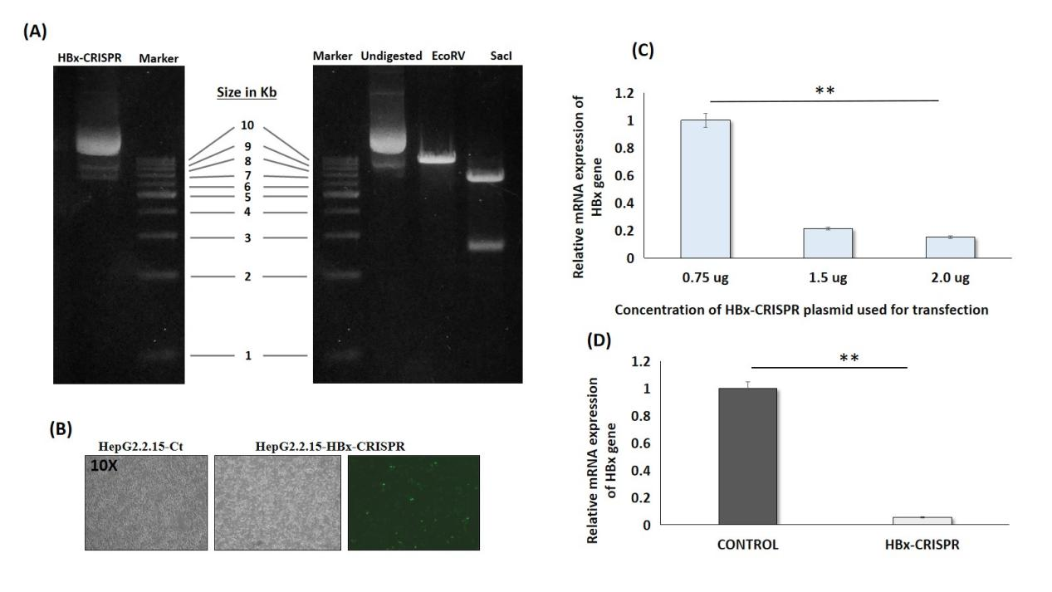
(A) Gel image of undigested and digested products (B) Images (Phase contrast and fluorescent) of HepG2.2.15 cells transfected with control and HBx-CRISPR (C) Related HBx gene expression at indicated plasmid concentration (D) Relative HBx gene expression in HepG2.2.15-HBx-CRISPR and HepG2.2.15-Ct cells. Data is represented as mean + standard deviation. ‘*’represents p< 0.05.

Figure S3:
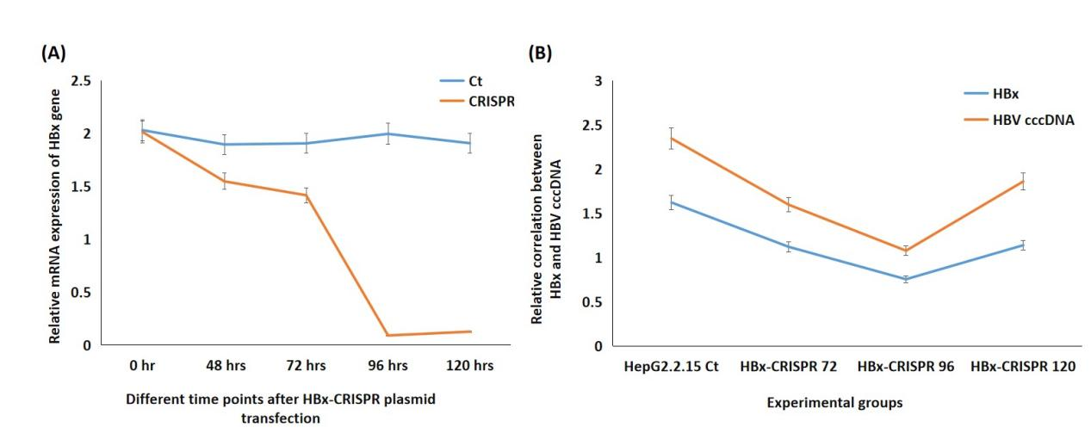
- Relative HBx gene expression in HepG2.2.15-HBx-CRISPR and HepG2.2.15-Ct cells in at various time points (0, 48,72,96 and 120 hrs) (B) Line graph between HBx expression and HBV cccDNA expression in HepG2.2.15-HBx-CRISPR and HepG2.2.15-Ct cells in at various time points (0,72,96 and 120 hrs).

Figure S4:
List of top 20 significantly downregulated and upregulated genes with their logFc and p value.

Figure S5:
(A-E) List of significantly downregulated genes with their logFc and p value plays important role in various oncogenic pathways (Wnt, notch, Hedgehog, Mapk and transcripional regulation of pluripotent stemness in HepG2.2.15 samples after HBx knockdown.

Figure S6:
Gene enrichment analysis for differential genes in various pathways (Reactome, Molecular function, GSEA Hallmark, Cellular component and Transcriptional factors) in HepG2.2.15 samples after HBx knockdown.

Figure S7:
List of significantly downregulated and upregulated transcription factors genes with their logFc and p value HepG2.2.15 samples after HBx knockdown. (Highlighted factors are mentioned in manuscript with their roles).

Table S1: Primer sequences used for the study:
Genes | Forward sequence | Reverse sequence
18s | GTAACCCGTTGAACCCCATT | CCATCCAATCGGTAGTAGCG
Thy-1 | GCTGCTTCTGTCTGGTTTAT | ACTCCTCATCCAAGTCTCTC
VIM | CAGATGCGTGAAATGGAAGA | TGGAAGAGGCAGAGAAATCC
CDH1 | CCCCCTGTTGGTGTCTTTATT | ATTCGGGCTTGTTGTCATTC
CDH2 | GCTCCCTTAATTCCTCAAGTAG | TCATCACCTCCACCATACA
CD133 | CCACATGCTACATCCAGATAC | CCAGGACACAGCATAGAATAAT
CD44 | GGTGAACAAGGAGTCGTC | TTCCAAGATAATGGTGTAGGTG
CD24 | TGAAGAACATGTGAGAGGTTTGAC | GAAAACTGAATCTCCATTCCACAA
β- catenin | TGGTGACAGGGAAGACATCA | CGAATCAATCCAACAGTAGCC
TGF-β | GAGGTGACCTGGCCACCATTCAT | TCCGCAAGGACCTCGGCTGG
Fibronectin | TGCGATGACGTGATCTGTGA | GCTGAGACCCAGGAGACCAC
Alpha SMA | GGCTATTCCTTCGTTACTACTG | GGCAACTCGTAACTCTTCTC
MMP2 | GTTCATTTGGCGGACTGT | AGGGTGCTGGCTGAGTAG
MMP9 | GTCCCTTCATCCACAGGAATAC | GGAAGGAGGTCAGAAGTGAAAG
MMP14 | ATCATGGCACCCTTTTACCA | TGGGGTTTTTGGGTTTATC
HBx | AATCTTGCCCAAGGTCTTAC | AACCTCCACTCACTCTTCTA

Table S2: Top 20 differentially expressed genes in Control vs CRISPR and their functions

- No. | Gene | Gene Symbol | Fold change | P-Value | Function
 | Lactate dehydrogenase B chain | LDHB | -14.80459382 | 4.72E-08 | Synthesizes (S)-lactate from pyruvate
 | Insulin receptor substrate 4 | IRS4 | -13.63444375 | 3.57E-07 | Belongs to a family of cytoplasmic docking proteins mediating signals from cell surface receptors to downstream effectors
 | Vimentin | VIM | -13.49002029 | 4.59E-07 | Class-III intermediate filaments found in various non-epithelial cells, especially mesenchymal cells
 | Glutathione S-transferase P | GSTP1 | -13.18001593 | 7.84E-07 | Involved in the formation of glutathione conjugates of both prostaglandin A2 (PGA2) and prostaglandin J2 (PGJ2)
 | Dihydropyrimidinase | DPYS | -13.15492768 | 8.19E-07 | Catalyzes the second step of the reductive pyrimidine degradation
 | X-inactive specific transcript | XIST | -12.95488333 | 1.16E-06 | It is an RNA Gene affiliated with the lncRNA class
 | Pre-MRNA-Splicing Factor ISY1 Homolog | ISY1-RAB43 | -12.83213502 | 1.43E-06 | Component of the spliceosome C complex required for the selective processing of microRNAs
 | A disintegrin and metalloproteinase with thrombospondin motifs1 | ADAMTS1 | -12.78774709 | 1.54E-06 | Active metalloprotease, associated with various inflammatory processes as well as development of cancer
 | UDP Glucuronosyltransferase Family 1 Member A9 | UGT1A9 | -12.77211866 | 1.59E-06 | This gene encodes a UDP-glucuronosyltransferase, an enzyme of the glucuronidation pathway.
 | Chitinase 3 Like 1 | CHI3L1 | -12.76424049 | 1.61E-06 | Catalyze the hydrolysis of chitin and thought to play a role in the process of inflammation and tissue remodeling.
 | SMAD Specific E3 Ubiquitin Protein Ligase 2 (SMURF2) | LOC107984974 | 9.075247287 | 2.06E-06 | Pseudogene 3.

