Supplementary Information for: “Confronting the double burden of malnutrition yields health and environmental benefits”.
${Emiliano Lopez Barrera}^{*}$, Thomas Hertel.

List of Figures
Figure S1. Region-specific fixed effects in BMI derived from Model 1 7
Figure S2. Historical validation of the BMI module in SIMPLE for the period 2005 to 2015. 8
Figure S3. Baseline projections of the PoO towards 2050. 9
Figure S4. Baseline projections of average adult BMI towards 2050 10
Figure S5. Projected changes in BMI for men and women. 10
Figure S6. Shifting towards healthy dietary intake levels reduce caloric undernutrition and land use. 11
Figure S7. Shifting towards healthy dietary intake levels reduce Green House Emissions. 12
Figure S8. BMI across cohorts and over time at different income levels for adult women. 13
Figure S9. BMI across cohorts and over time at different income levels for adult men. 14
Figure S10. Projections of the age-specific average adult BMI. 15
Figure S11. Graphical description of the SIMPLE model. 18

List of Tables
Table S1. Results for LSDV regressions on Model 1 for adult women and men. 5
Table S2. Sensitivity of ECA and BMI correlation under different scenarios of PAL. 6
Table S3. Summary of regression results for model 2 under different model specifications 6
Table S3. Assumed growth rates of exogenous variables (in % per annum rates). 19
Table S4. Shocks on per capita consumption in grams by type of food (i.e., crops, livestock, and processed food) in SIMPLE. 21
Table S5. Shocks on per capita consumption in grams by type of food (i.e., crops, livestock, and processed food) in SIMPLE. 22

FAO PoU’s Extension: Excessive Acquisition of Calories and the Malnutrition Double Burden
The Food and Agriculture Organization’s (FAO) prevalence of undernourishment indicator (PoU) monitors the proportion of people suffering from hunger. Estimates of the number of undernourished (NoU) are calculated by multiplying the PoU by the size of the reference population. The PoU is defined as the probability that a randomly selected individual from the reference population is found to consume less than his/her calorie requirement for an active and healthy life. It is calculated as follows (green area in Figure 7a):
$$PoU=\int_{0}^{MDER}{f\left(x\right) dx}$$
In this equation f(x) is the probability density function of per capita calorie consumption. The country-specific parameters involved in the estimation are: The mean level of dietary energy consumption (DEC) annually updated based on FAO food balance sheets; a threshold Minimum Dietary Energy Requirement (MDER) also annually update based on demographics (age, sex, PAL) using UN population data; the coefficient of variation (CV) as a parameter accounting for inequality in food consumption updated when information from National Household Surveys (NHS) is available; and a skewness (SK) parameter accounting for asymmetry in the distribution, also updated when NHS data is available. In its standard version and in recent refinements, the methodology assumes a lognormal density function for the caloric distribution among the population of reference ¹. Here we extend this approach to look at the high levels of caloric availability – excess acquisition– to focus on prevalence of overweight and obesity and food waste (Figure 7a):
$$PoO=\int_{ADER}^{∞}{f\left(x\right) dx}$$
In this equation f(x) is the probability density function of per capita calorie consumption. Similarly, to the PoU’s the proposed estimation for the population overconsumption (PoO) is defined as the probability that a randomly selected individual from the reference population is found to consume (purchase) more calories than his/her Average Dietary Energy Requirement (ER) which is defined as the calorie intake (kcal/cap/day) required to provide energy balance in a given individual of a healthy weight for their sex, age, and activity levels. The PoO is calculated as follows, we start by defining a maximum threshold, in this case the ER which is calculated based on country specific energy requirements, constructed from country-specific basal metabolic rate (BMR) and physical activity level (PAL) using country-specific demographics (age and sex). Also, similarly to the PoU methodology, the number of people over consuming calories (NoO) is calculated by multiplying the PoO by the size of the reference population².
We then split the over-acquisition of calories into excessive intake of calories and food waste based on previous estimations of the share of calories purchased in excess that end up uneaten (Figure 7b) ³. This second step enables to differentiate whether the excessive acquisition of calories is indeed intake or ends up uneaten by the average consumer. This is a very important distinction since consumer behavior with respect to those are responsive to complete different sets of policies. Moreover, previous studies have emphasized that the potential environmental benefits of reducing from current food consumption levels towards healthier and more sustainable diets. However, while the excessive intake of calories influences health through affecting body weight, the excessive purchasing of food that ends up uneaten does not affect body weight.

A pseudo-panel data set on average daily excessive consumption of calories
In this study we define, compute, and track over time and across countries excess calorie availability (ECA) as the difference between the average daily supply of calories (SC) and average dietary energy requirements (ER), i.e., $ECA=SC-ER$, where both measures evolve over time. Here we follow a similar strategy but adapting and framing the analysis into a global partial equilibrium framework, therefore we equate the supply of calories (from FAO’s FBS) to the demand (average daily demand of calories). As a result, we define the Average Daily Excessive Consumption of calories (EC) as follows:
$${{EC}_{i,j,t}=ECA}_{i,j,t}={SC}_{i,j,t}-{ER}_{i,j,t}$$
We construct the pseudo-panel dataset from repeated cross-sections⁴, where age groups and cohorts are spaced at five-year intervals. The dataset allows us to track changes in BMIs and their correlations with the EC for 21 country-specific age-sex cohorts born between 1890 and 1995 and observed between 1975 and 2015. The dataset covers 156 countries which together represented 95% of the global population in 2015. In anticipation to the projections to the economic projections to be undertaken using the framework of a partial equilibrium framework, we aggregate countries into 15 major geographic regions. This allows us to capture the long-run underlying systematic relationship between the EC and adult BMI while also dealing with potential eccentricities of individual countries and potential reporting errors to the FAO. This particular aggregation into 15 regions has the additional advantage of matching with the global model Simplified International Model of Crop Prices, Land Use and the Environment (SIMPLE) ⁵ that we use in the economic projections towards 2050.
The underlying assumption on the long-run relationship between EC and adult BMI is that the changes in EC carry on information on the intertemporal effects of the excessive intake of calories on the observed changes in adult body weight. This assumption is consistent with the principle of the energy balance equation. However, authors recognize potential limitations on this approach when working with an average individual as reference and with a high level of aggregation. Firstly, even in healthy individuals (with no difficulty to absorbing nutrients) not all energy intake from food ends up absorbed in their bodies. In fact, the absorption is determined by the amount of metabolizable energy in the food and its digestibility. This varies among individuals and also depends on the specific food items eaten and on how those are cooked, implying that when working at an aggregated level and for the average individual, we might lose information on individual specifics. Secondly, the EE includes energy expended during biological processes, any physical activity performed, heat lost due to thermoregulation (radiant, conductive, and convective), and latent heat losses due to evaporation. The rate of energy expenditure (REE) accounts for most energy expended – roughly two-thirds ⁶. Hence, we follow the usual approximation for the total EE that is adjusting the basal metabolic rate (BMR) by different ratios of physical activity level (PAL). However, as in the case of the EI, variations at the individual level on EE during the different biological processes might be lost when working with an average individual as reference and at a highly aggregated level.
Moreover, it should be noticed that the FAO reports are not free of criticism ^{7,8}. One recurrent criticism is that FBS likely underestimate food availability at consumers level in developing countries. This particularly important in rural based economies, where unreported subsistence production represents a substantial share of the households’ consumption bundle ⁹. Another recurrent criticism is that one of the components of the FBS (often stocks) frequently take an outstanding unbalanced amount cause by inheriting all the statistical errors (including measurement errors, inaccuracies due to imprecise metrics on food losses within the different stages of supply chain, and on food waste at consumers level). Attending to these concerns, the FBS underwent some changes in methodology for data reported after 2017. The revised methodology reported by FAO mitigates some of those inaccuracies ¹⁰ by improving the estimates of the specific modules through the supply chain (e.g., stocks, food, feed, loss, etc.). Additionally, in the new methodology, imputations for the FBS components not reported by countries are generated by dedicated modules. The new approach implies a balancing mechanism to proportionally distribute the imbalances out among all the components ¹⁰. Furthermore, the revisited methodology incorporates a food loss module. This novel module reports essential information on food losses occurring across the different stages if the food supply chain up to and excluding the retail level. However, the availability of food at consumers level under the previous and also under the revisited methodology cannot be equated to food intake since the food waste imputations at the consumer level is still under review ¹⁰. This study is consistent with the latter, since equate the SC to the consumption of calories understood as the purchasing of calories; ergo the over-consumption of calories carries on information not only regarding the excessive intake of food but also regarding the calories that end up uneaten at the consumers’ level ³.
In the empirical estimations, we introduce regional, age, and cohort fixed effects to avoid omitted variable bias when measuring changes within cohorts across time ¹¹. We estimate the regression models using Least Squares Dummy Variable (LSDV) methods. The regression to test the correlation between EC and adult BMI are described in Model 1:
Model 1. ${BMI}_{i,j,t}=θ_{0}+α_{i,j,t}{EC}_{i,j,t}+β_{i,j.t}{Age}_{i,j.t}+γ_{i,j.t}{Cohort}_{i,j,t}+R_{i,j}+ ϵ_{i,j,t}$
Model 2. ${BMI}_{i,j,t}=θ_{0}+α_{i,j,t}{ECA}_{i,j,t}+β_{i,j.t}{Age}_{i,j.t}+γ_{i,j.t}{Cohort}_{i,j,t}{+ λ}_{i,j.t}X_{i,j.t}+R_{i,j}+ ϵ_{i,j,t}$
In these models, subscript i corresponds to males and females, j indexes countries, and t corresponds to year; $R$ represents region-specific fixed effects that embody relevant but unobserved historical and institutional features of a region that are highly likely to be correlated with explanatory variables in the models; and $ϵ$ represents an error term. In this model, BMI is the age- and sex-specific body mass index (BMI). Age represents a vector of variables controlling age-related unobservable effects, Cohort is the year of birth, and EC represents the average daily excess of consumption of calories. Results for regressions on Model 1are presented in Table S1, Table S2, and Figure S1.
In the model 2 we further investigate the specific role of ECA as driver of adult BMI in recent years incorporating a vector of controls for the changes in the food environment (i.e., income, rural population, health expenditure, etc.). Data for variables related to the changes in the food environment by country and year for the period 2000 2015, that is used in the different specifications of the models 4 and 5, come from the World Bank’s DataBank (https://databank.worldbank.org/home.aspx). DataBank is an analysis and visualization tool that contains collections of time series data on a variety of topics. This online web resource provides easy and quick access to collections of time series data for most countries in the world. In addition, it has advanced functions for selecting and displaying data, performing customized queries, downloading data, and creating charts and maps which makes this web platform an ideal tool to create dynamic custom reports based on a selection of countries, indicators, and years.

Table S1. Results for LSDV regressions on Model 1 for adult women and men.
Variable |  | women |  |  | men
Variable |  | coefficient | p_value |  | coefficient | p-value
EC |  | 0.0002158* | 0.055 |  | 0.0003725*** | 0.000
Age group | 25 | 1.102923*** | 0.000 |  | 1.195964*** | 0.000
Age group | 30 | 2.198653*** | 0.000 |  | 2.182427*** | 0.000
Age group | 35 | 3.249096*** | 0.000 |  | 2.992504*** | 0.000
Age group | 40 | 4.216125*** | 0.000 |  | 3.660322*** | 0.000
Age group | 45 | 5.062172*** | 0.000 |  | 4.220509*** | 0.000
Age group | 50 | 5.759925*** | 0.000 |  | 4.686155*** | 0.000
Age group | 55 | 6.302513*** | 0.000 |  | 5.0587*** | 0.000
Age group | 60 | 6.684201*** | 0.000 |  | 5.338898*** | 0.000
Age group | 65 | 6.908474*** | 0.000 |  | 5.533227*** | 0.000
Age group | 70 | 6.981457*** | 0.000 |  | 5.649988*** | 0.000
Age group | 75 | 6.918327*** | 0.000 |  | 5.700924*** | 0.000
Age group | 80 | 6.734975*** | 0.000 |  | 5.696918*** | 0.000
Age group | 85 | 6.240975*** | 0.000 |  | 5.521108*** | 0.000
Year of birth | 1895 | 0.3308762 | 0.264 |  | 0.2753695* | 0.063
Year of birth | 1900 | 0.6829636** | 0.016 |  | 0.6058509*** | 0.000
Year of birth | 1905 | 1.050823*** | 0.000 |  | 0.9673373*** | 0.000
Year of birth | 1910 | 1.434808*** | 0.000 |  | 1.35364*** | 0.000
Year of birth | 1915 | 1.83895*** | 0.000 |  | 1.755655*** | 0.000
Year of birth | 1920 | 2.260583*** | 0.000 |  | 2.168493*** | 0.000
Year of birth | 1925 | 2.697693*** | 0.000 |  | 2.587819*** | 0.000
Year of birth | 1930 | 3.146643*** | 0.000 |  | 3.009341*** | 0.000
Year of birth | 1935 | 3.652658*** | 0.000 |  | 3.46876*** | 0.000
Year of birth | 1940 | 4.171914*** | 0.000 |  | 3.918437*** | 0.000
Year of birth | 1945 | 4.69702*** | 0.000 |  | 4.361493*** | 0.000
Year of birth | 1950 | 5.220159*** | 0.000 |  | 4.798399*** | 0.000
Year of birth | 1955 | 5.735278*** | 0.000 |  | 5.230721*** | 0.000
Year of birth | 1960 | 6.168471*** | 0.000 |  | 5.620699*** | 0.000
Year of birth | 1965 | 6.575035*** | 0.000 |  | 6.000606*** | 0.000
Year of birth | 1970 | 6.951683*** | 0.000 |  | 6.368141*** | 0.000
Year of birth | 1975 | 7.293686*** | 0.000 |  | 6.720973*** | 0.000
Year of birth | 1980 | 7.590093*** | 0.000 |  | 7.049327*** | 0.000
Year of birth | 1985 | 7.832624*** | 0.000 |  | 7.349038*** | 0.000
Year of birth | 1990 | 8.014414*** | 0.000 |  | 7.612211*** | 0.000
Year of birth | 1995 | 8.127946*** | 0.000 |  | 7.83018*** | 0.000
Constant |  | 17.27239*** | 0.000 |  | 18.41231*** | 0.000
R-squared |  | 0.9041 |  |  | 0.9672
Observations |  | 1,890 |  |  | 1,890
Note: All regressions include country fixed effects. *** Significantly different from zero at the 1% level, ** Significantly different from zero at the 5% level, * Significantly different from zero at the 10% level P-values within parentheses. Values for the “Year of birth” variables represent changes with respect to 1890 (omitted). For the EC imputation we assumed moderate physical activity levels.
Table S2. Sensitivity of ECA and BMI correlation under different scenarios of PAL.
 |  | Model 1
PAL | Variable | women | men
Light | EC | 0.0002419 | 0.0003787
Light | EC | (0.032)** | (0.001)***
Moderate | EC | 0.0002158 | 0.0003725
Moderate | EC | (0.055)* | (0.000)***
Vigorous | EC | 0.0001551 | 0.0003578
Vigorous | EC | (0.168)*** | (0.000)***
Note: All regressions include country fixed effects. *** Significantly different from zero at the 1% level, ** Significantly different from zero at the 5% level, * Significantly different from zero at the 10% level P-values within parentheses.
Table S3. Summary of regression results for model 2 under different model specifications
 | Model 2-a |  |  | Model 2-b |  |  | Model 2-c |  |  | Model 2-d
 | men | women |  | men | women |  | men | women |  | men | women
Excessive calories | + *** | + *** |  | + *** | + *** |  | + *** | - |  | + | -
Age FE | + *** | + *** |  | + *** | + *** |  | + *** | + *** |  | + *** | + ***
Cohort FE | + *** | + *** |  | + *** | + *** |  | + *** | + *** |  | + *** | + ***
GDP_pc | n.a. | n.a. |  | + *** | - |  | + ** | - *** |  | - | - ***
Rural population | n.a. | n.a. |  | n.a. | n.a. |  | - *** | - *** |  | - *** | - ***
Health expenditure | n.a. | n.a. |  | n.a. | n.a. |  | n.a. | n.a. |  | + *** | + ***
Note: All regressions include country fixed effects. *** indicates the estimated coefficient is significantly different from zero at the 1% test level; ** indicates the estimated coefficient is significantly different from zero at the 5% test level; * indicates the estimated coefficient is significantly different from zero at the 10% test level; + (-) indicates a positive (negative) correlation between the explained and the explanatory variable; n/a indicates the variable is not included in the model.
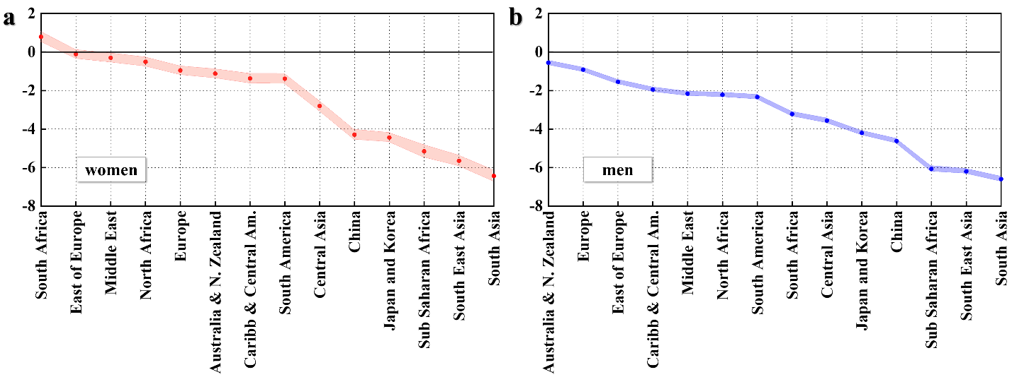
Figure S1. Region-specific fixed effects in BMI derived from Model 1
Moving from left to right, the countries are listed from largest to smallest fixed effect with respect to the US (omitted). For women (red dots, panel a) and for men (blue dots, panel b) region labels appear at the bottom. The shaded areas represent 95% confidence bands for the estimated coefficients.

Model Validation, Uncertainties, and Baseline Projections Towards 2050
Following Baldos and Hertel (2014) and Lopez Barrera and Hertel (2020) who used the SIMPLE framework to examine the evolution of undernourishment and food waste respectively, we start our analysis by evaluating how well the model projects changes in adult BMI over an historical period: 2005–2015.
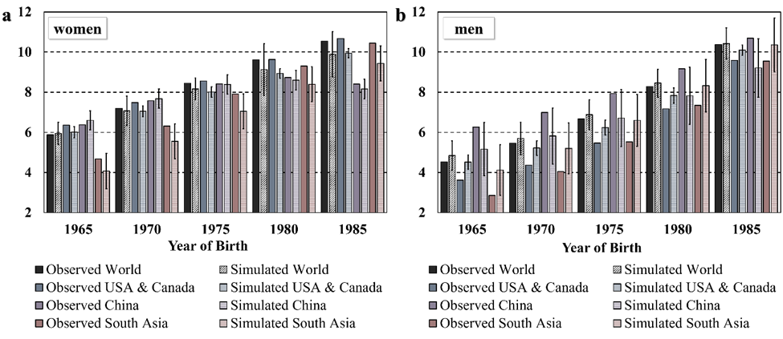
Figure S2. Historical validation of the BMI module in SIMPLE for the period 2005 to 2015.
Solid (pattern) colored bars represent observed (projected) percentage changes in adult BMI for cohorts matched by the birth year (x-axis) for women (a) and men (b). The error bars represent 95% confidence intervals in the projected values. Consistently with previous studies ^{3,5,12,13}, the model does a fair job globally and the projections lose precision with higher levels of resolution. The uncertainties are heterogeneous across regions, those already in the later stages of the nutritional transition (higher EC levels and BMI levels) (as in the US and Canada) present lower uncertainties as BMI is expected to have relatively smaller changes in adult BMI. On the other hand, regions that are in earlier stages of the nutritional transition - a lower EC and BMI level - (such as South Asia), present greater uncertainties.
Often studies that use economic models to project future outcomes are not validated against history, yet this is a critical step. Additionally, this historical assessment provides valuable inputs for examining future changes. The model’s historical projections in (Figure S2) perform best at the global level; projections are less accurate at the regional level, but still capture the broad trends. This is consistent with previous studies attempting to validate global agricultural models ^{3,14,15}. Also consistent with previous literature, there is considerable regional variation in the model uncertainties. Regions already at higher levels of excessive calorie availability and BMI (such as the US) present lower uncertainties. On the other hand, regions at earlier stages in the nutrition transition, such as South Asia, present larger uncertainties.
Following model validation, we turn to business-as-usual (BAU) projections of adult BMI from 2015 to 2050. The SIMPLE model is projected forward with exogenous shocks to population, per capita incomes, total factor productivity (TFP) growth in agriculture, and biofuel consumption. Growth rates for population and income were derived from the Shared Socioeconomic Pathways ¹⁶. The baseline follows the BAU Shared Socioeconomic Pathway (SSP2) which is widely used to evaluate climate change and environmental outcomes. This provides a natural starting point from which to explore integrated solutions for achieving societal objectives to reduce pressure on environmental resources ¹⁶. Projected TFP growth rates are based on the historical estimates from previous literature ^{17,18}. Future growth in global biofuel consumption is from the International Energy Agency ¹⁹. For a detailed description of these inputs see the Section “Overview of the SIMPLE Model” below in the Supplementary Information.
The projections of PoO to 2050 (Figure S3) rely on the incorporation of the FAO PoU’s extension--albeit with the regionally calibrated parameters–into the SIMPLE model which produces estimates of total caloric availability (acquisition) ^{2,12}. Following projected increases in global average per-capita availability of calories, the share of population over consuming calories is projected to increase in virtually every region and at the global level. Additionally, those that regions that are already at latter stages in the nutrition transition --projected to have relatively lower growth in SC-- are the ones that are projected to have relatively lower growth in PoO (i.e., Canda & US and Europe). In the other hand, those regions that are at earlier stages in the nutrition transition --projected to have relatively larger growth in SC-- are the ones that are projected to have relatively lower growth in PoO (i.e., South Asia and Sub-Saharan Africa). When this is combined with the projected growth in population, the millions of adults overconsuming calories are projected to more than double towards 2050 and regions already dealing with malnutrition, such as South Asia, double burden are projected to dominate excessive acquisition of calories towards 2050.
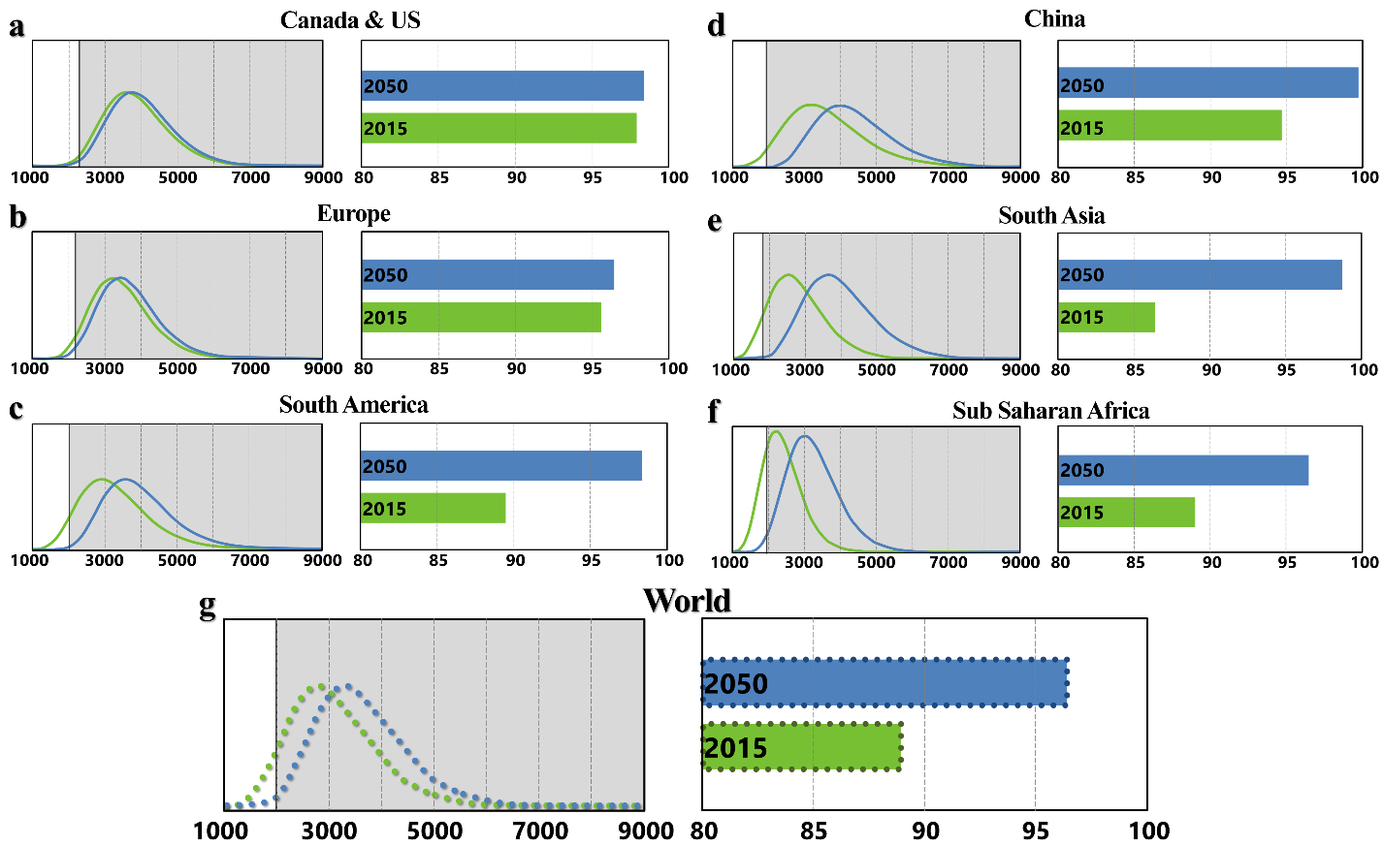
Figure S3. Baseline projections of the PoO towards 2050.
The green and blue curves in panel a-g represent the probability distribution of habitual (i.e., annual average) daily energy consumption (purchasing) projected to 2015 and 2050 respectively. Gray shaded areas delimit the region were purchasing of calories are greater than the average daily energy requirements (ER). The green and blue bars represent the Prevalence of Overconsumption (over-acquisition) of calories projected to 2015 and 2050 respectively. Regions are ordered across the income spectrum (from higher to lower income according to World Bank 2019 classification) through panels a to f. Panel g presents projected results at the global level.
The average daily excessive consumption of calories (EC=SC-ER) is projected to increase around 58% women and 60% in men at the global level. Consistently with the findings on the PoO projections, the projected growth in EC is especially large in regions such us South Asia and China, where the EC is project to growth around 98% (105%) and 82% (84%) respectively, in adult women (men). We rely on the incorporation of the Model 1 into a global partial equilibrium of the food sector (SIMPLE) for projecting average adult BMI (Figure S3) and age-specific adult BMI (Figure 2 a-c and Figure S10) towards 2050, for both, men and women.

Baseline projections of average adults BMI.
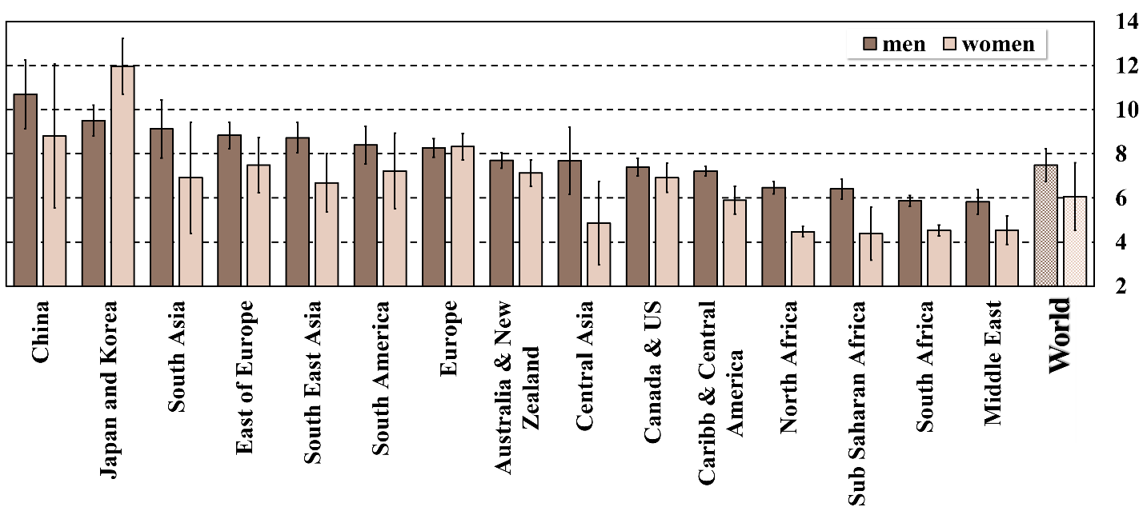
Figure S4. Baseline projections of average adult BMI towards 2050
The bars represent the percentage change in average BMI projected from 2015 to 2050 in the baseline scenario, for both, adult men and women. Error bars represent 95% confidence intervals.

Flexitarian Diets results.
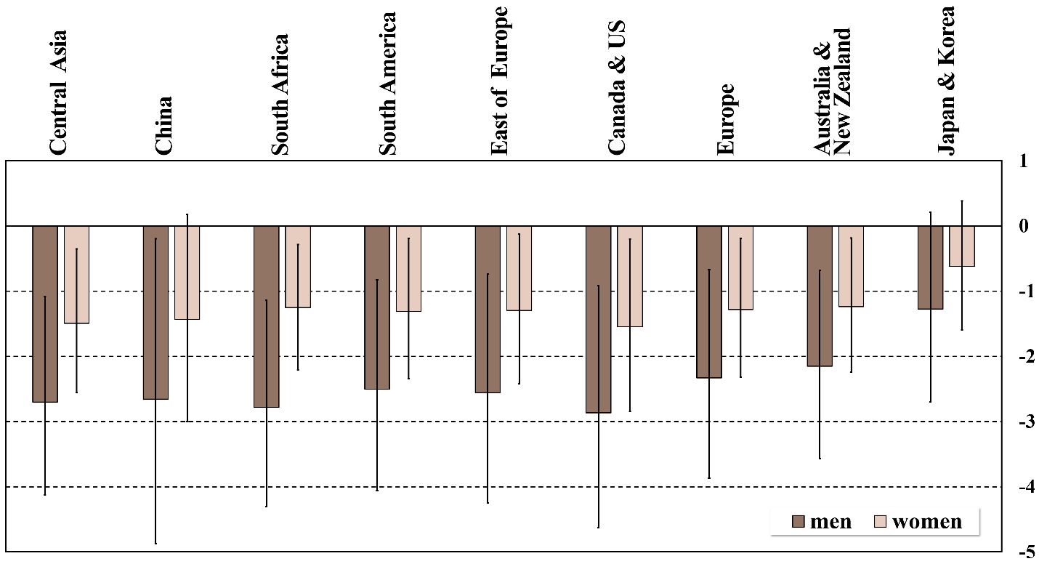
Figure S5. Projected changes in BMI for men and women.
The bars represent the projected percentage changes with respect to the 2050 baseline case caused by shifting towards diets following intake recommended in the flexitarian diets pathway (FLX) in those regions. Omitted regions are not subjected to the diet changes. Error bars represent 95% confidence intervals.
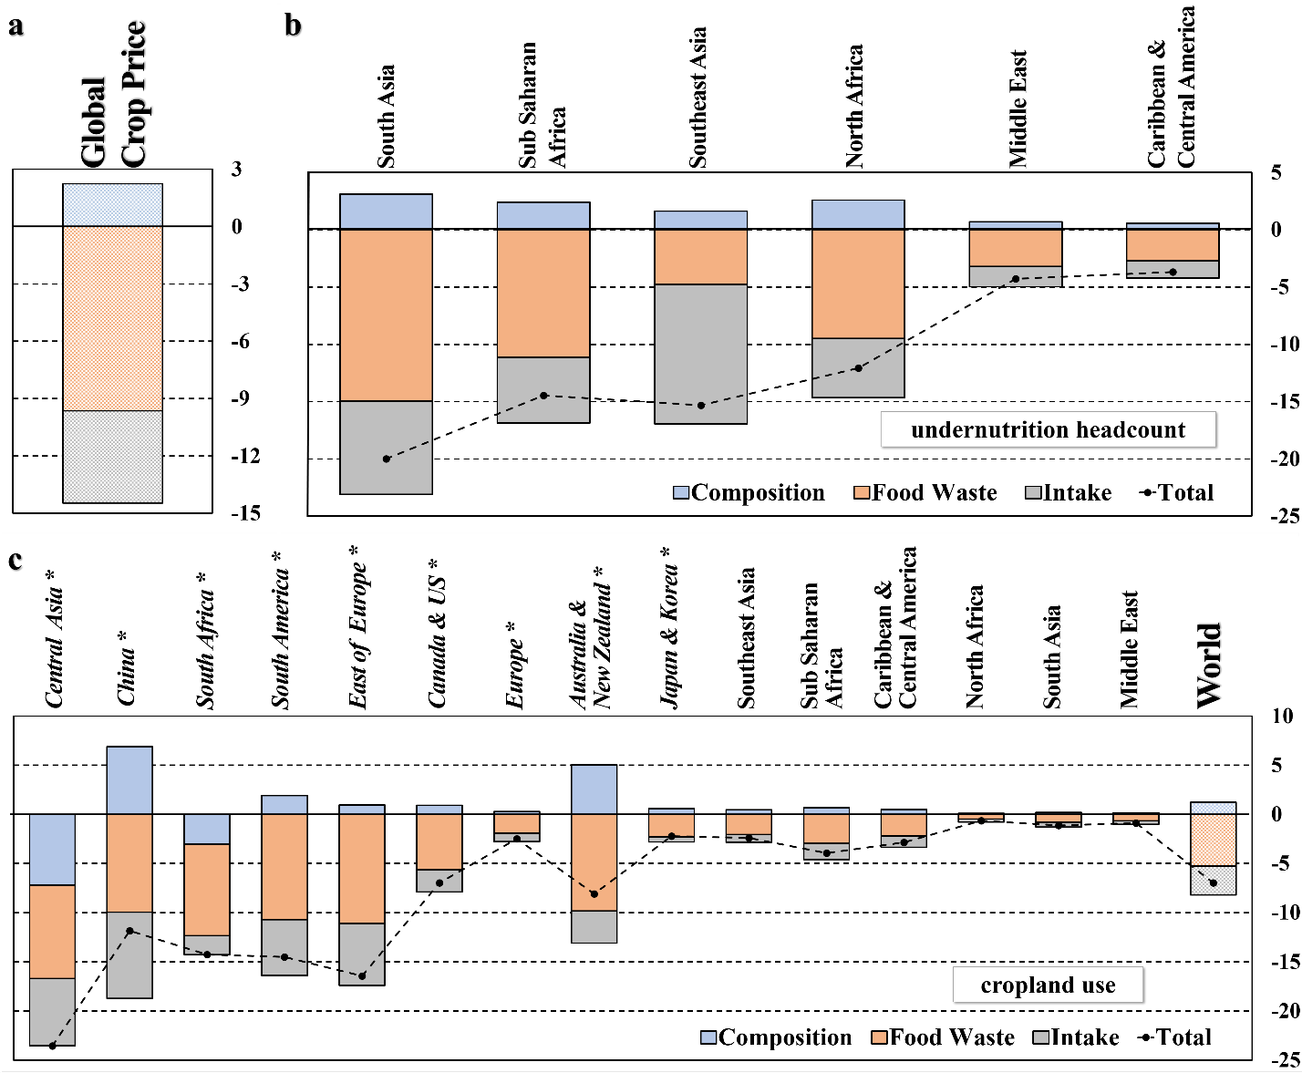
Figure S6. Shifting towards healthy dietary intake levels reduce caloric undernutrition and land use.
Bars represent percentage changes in 2050 baseline outcomes caused by shifting towards diets following flexitarian diets pathway (FLX) in the regions in italic and marked with asterisk starting with Central Asia and ending with Japan and Korea. Regions exogenously shifted to the FLX are in italic and marked with an asterisk, consumption patterns in the remaining regions are endogenous. Panel a represents the percentage change in global crop price, panel b represents reductions in undernutrition headcounts in those regions where diets are endogenously determined as a function of prices, and panel c represents changes in cropland use. Colored segments of each bar decompose the total change into three different components of the shift from current consumption levels: the change within the food basket composition (i.e., the FLX scenario implies reductions in livestock consumption with respect to the baseline case), reductions in food intake, and reductions in food waste ³.
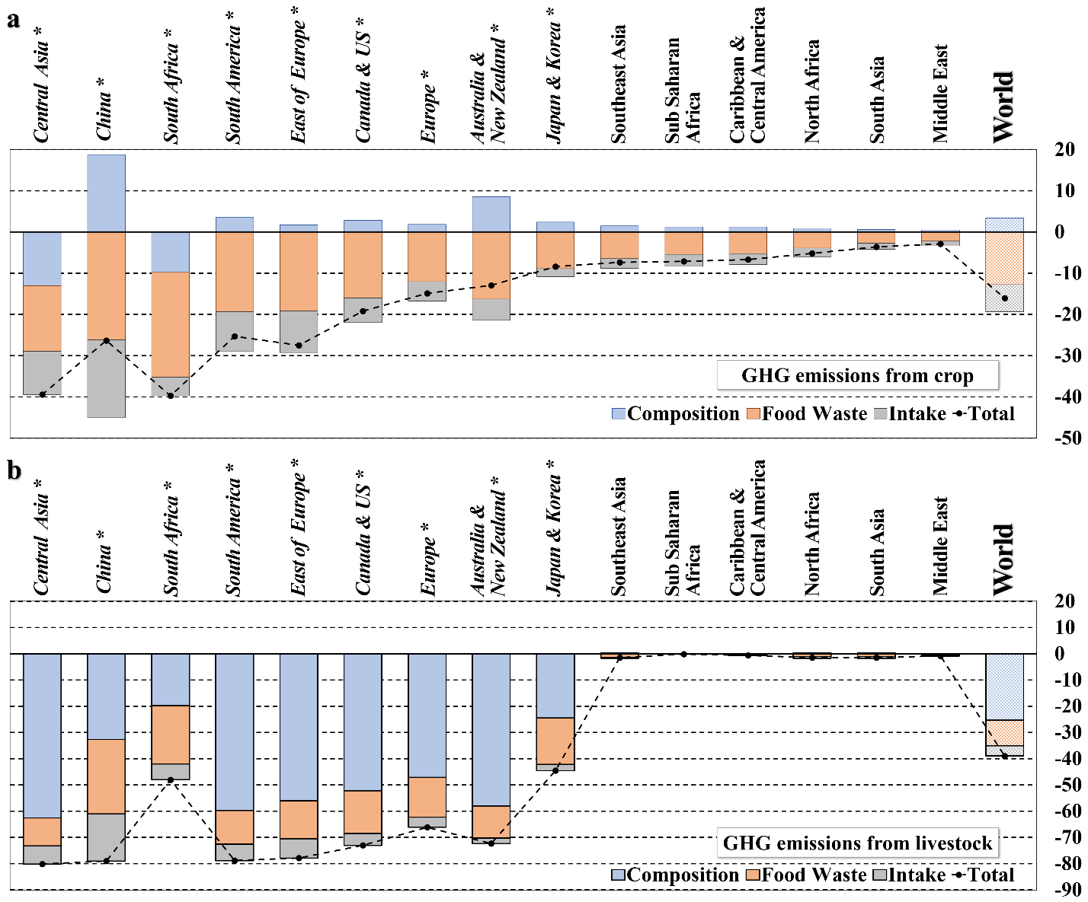
Figure S7. Shifting towards healthy dietary intake levels reduce Green House Emissions.
Bars represent percentage changes with respect to the 2050 baseline case, caused by shifting towards diets following flexitarian diets pathway (FLX) in the regions in italic and marked with an asterisk. Results represent the breakout between three different components within the shifts in diets: the change within the food basket composition (i.e., the FLX scenario implies reductions in livestock consumption with respect to the baseline case), reductions in food intake, and reductions in food waste ³.

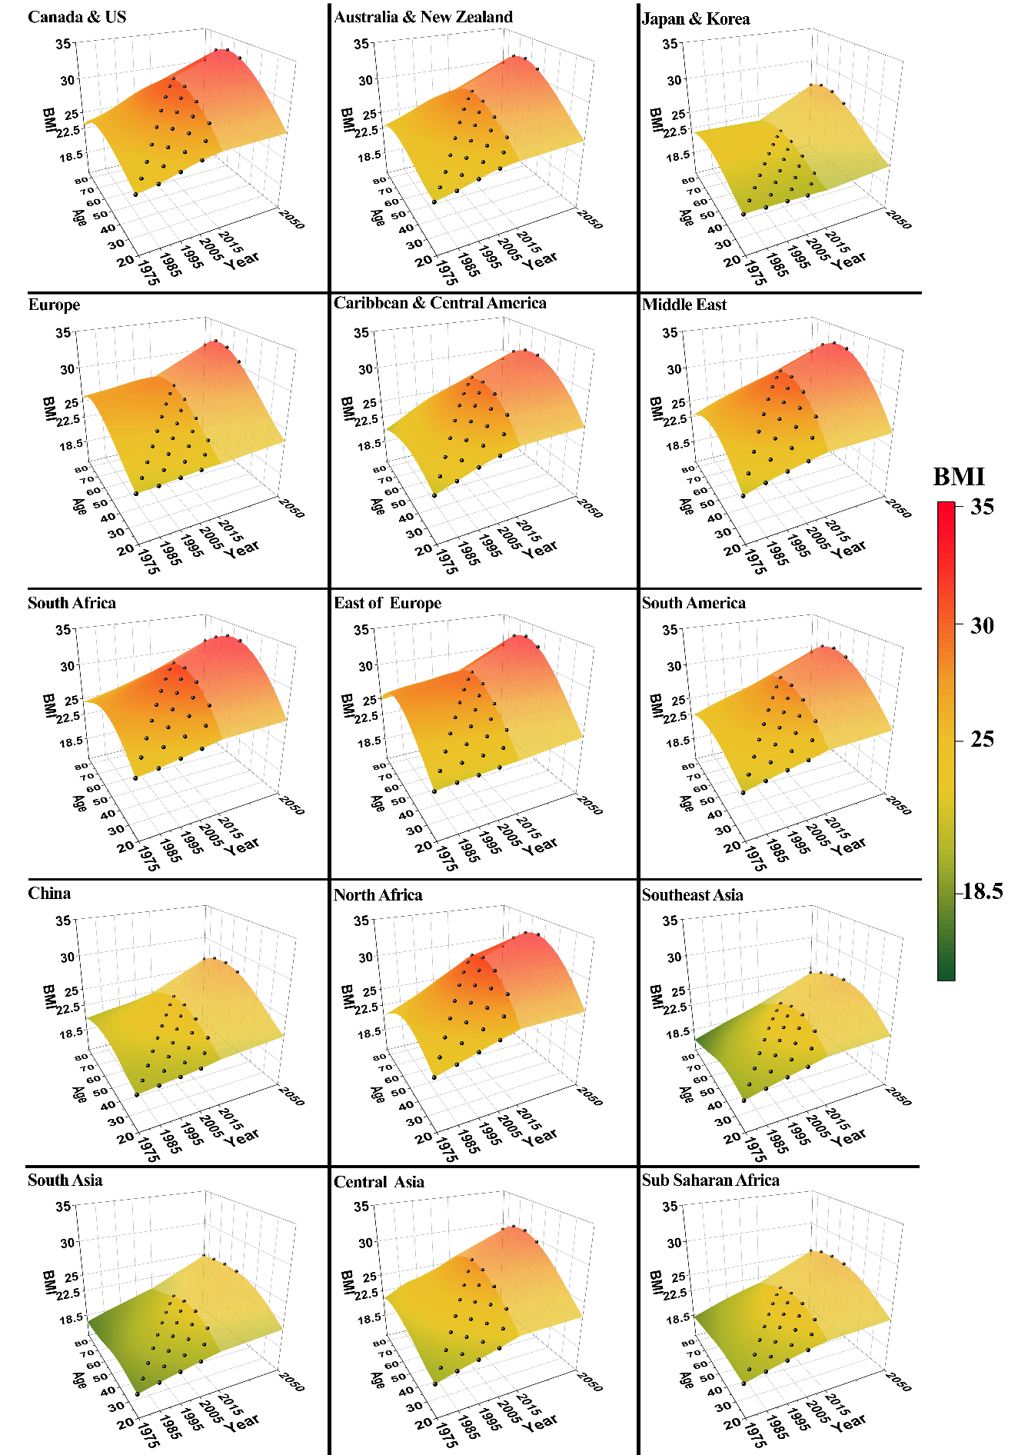
Figure S8. BMI across cohorts and over time at different income levels for adult women.
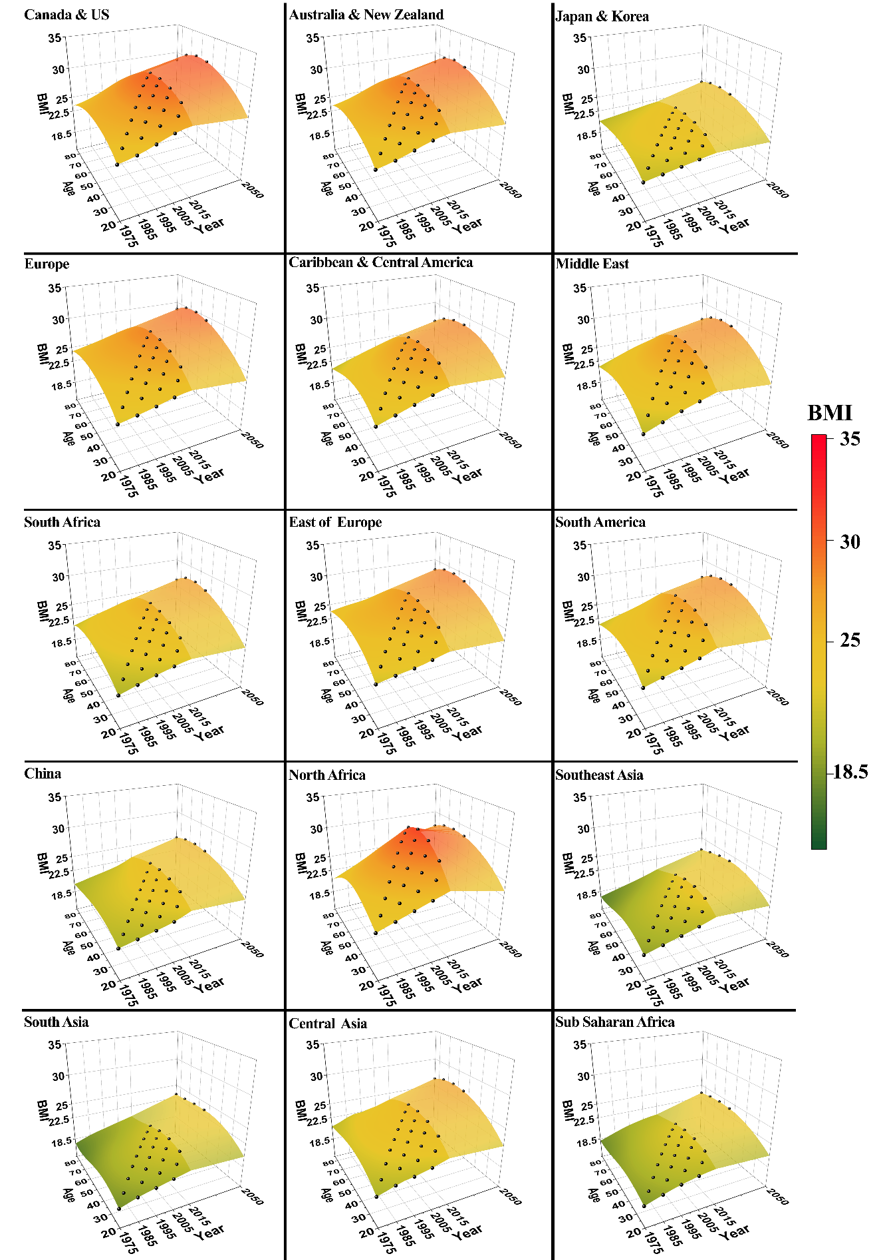
Figure S9. BMI across cohorts and over time at different income levels for adult men.
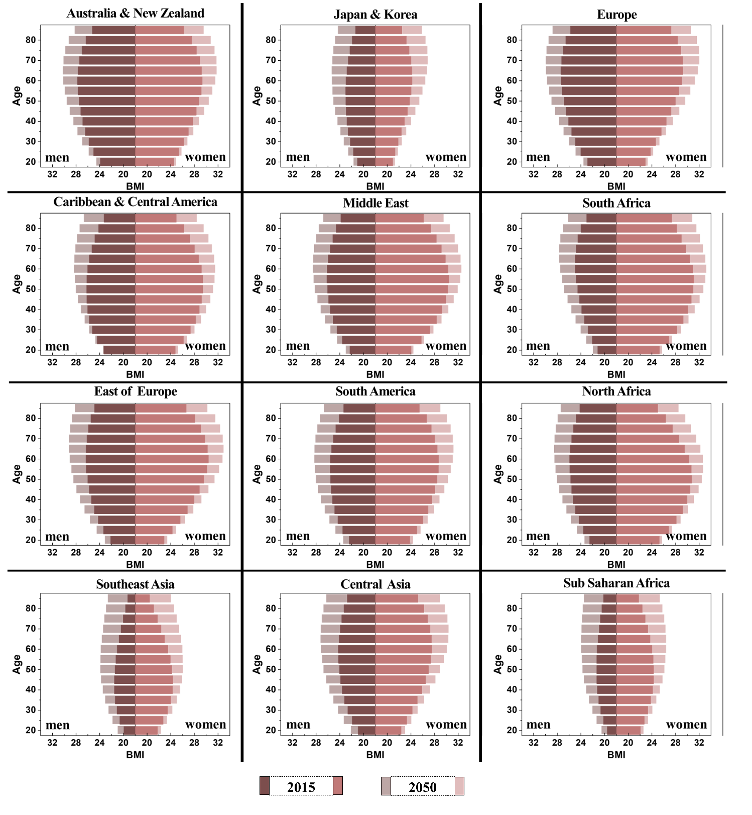
Figure S10. Projections of the age-specific average adult BMI.

The Disease Burden Attributable to Weight-Related Risk Factors: Population Attributable Fractions (PAFs)
The projected growth in average adult BMI (Figure S4) will boost already worrisome trends in adult obesity. Additionally, also by reaching higher levels of BMI at younger ages (Figure 2a-c and Figure S10) individuals will increase the number of years that they are exposed to the health risks related to overweight and obesity. We estimate the disease burden attributable to weight-related risk factors by calculating population attributable fractions (PAFs). The PAFs represent the proportions of disease cases that would be avoided when the risk exposure is changed from a baseline situation to a counterfactual situation and are calculated using the following general formula:
$$PAF=\frac{\int{RR\left(x\right)P\left(x\right)dx-\int{RR\left(x\right)P^{'}}}\left(x\right)d(x)}{\int{RR\left(x\right)P\left(x\right)dx}}$$
In this equation RR (x) is the relative risk of disease for risk factor level x, P(x)is the number of people in the population with risk factor level x in the baseline scenario, and P’(x) is the number of people in the population with the risk factor level x in the counterfactual scenario. We assume that changes in relative risks follow a dose-response relationship ²⁰ and that PAFs combine multiplicatively ^{20,21}. Therefore, it can be shown that ${PAF}_{TOT}=1-π_{i}(1-{PAF}_{i})$ where the i’s denote independent risk factors.
We rely on publicly available data from different sources to parameterize the comparative risk analysis. We use two large-pooled analyses of prospective cohort studies ^{22,23} to infer the parameters describing disease attributable to weight-related relative risks. We adopted the relative risk parameters linking weight-related disease factors and BMI from previous studies, focusing in 4 categories: coronary heart disease (CHD), stroke, type-2 diabetes mellitus (T2DM) ²³, and some type of cancers ²². The weight-related relative risk parameters were aggregated to the BMI categories used in this study and normalized to a risk-neutral normal weight category consistent with the epidemiological evidence ^{22,23}. For the purposes of the analyses on this chapter, the PAFs a based on a comparison of the relative risk exposures caused by the average adult BMI levels projected towards 2050 with the counterfactual hypothesis of BMI levels fixed at 2015 levels (Figure 2d and Figure S10). Therefore, PAFs in this study represent the proportion of disease cases that would be avoided if average adult BMI, for adult men and women, did not increase as expected towards 2050.
We find that the PAFs attributable to projected changes in adult BMI are substantial for many major non-communicable diseases related to overweight and obesity ²⁴, likely impacting mortality paths towards 2050 ²⁵. This expected increase in major disease burdens will further stress national health care systems ²⁶. These results will also be associated with many economic and health costs ²⁶, which is particularly relevant in developing countries, characterized by weak institutions with highly differentiated access to good quality health systems ²⁷.

Limitations on the FAO’s PoU methodology and the proposed extension
It is important to acknowledge that the FAO’s PoU methodology for estimating undernourishment suffers from several limitations, which need to be considered when analyzing the results presented in chapter 4. A key set of limitations are related to the scope and capability of the indicator to capture food insecurity. It is stated that the indicator focuses and captures only the yearly average per capita deficit in dietary caloric consumption which is a very specific aspect of the food insecurity ²⁸. Another important limitation is that the PoU indicator does not capture within-year fluctuations in the acquisition of calories. As it was observed during disruptions throughout the food supply chain due to the pandemic outbreak in recent months, within-year fluctuations on food consumption play an important role in food security ²⁸. Fluctuations in the accessibility and affordability of food can result in lower quality diets and/or short periods of lack of access to an adequate level of calorie consumption ^{29,30}. Moreover, the methodology does not allow for any biases that may exist in intra-household distribution of foods ²⁸. An additional significant limitation is that it does not provide information on the degree of severity of the food insecurity conditions experienced by a population. The FAO’s PoU only computes the share of the undernourished in a population but does not information report about the composition of undernourishment within that part of the population which might be valuable for policy makers.
Another group of limitations and criticism to the FAO’s PoU methodology, that are more directly related and are more relevant to the results and extension presented in this chapter, are the ones regarding the choice of the probabilistic model to represent the distribution of dietary intake across the population. It is argued that some of this criticism arises from the misinterpretation of the probability distribution as the empirical distribution of the actual food consumption in the population (i.e.: the distribution that could be obtained through a food consumption census of the population) ^{1,31,32}. However, the correct interpretation of the distribution is as the level of dietary energy consumption that would be observed on a randomly selected individual in the population ^{31,32}. It follows that the PoU attempts to report the probability that a random selected individual from a given population would be found to be undernourished. In addition to this, the variability on the individual’s energy requirements implies an extra challenge on choosing the appropriate “minimum” caloric threshold ^{8,31,32}. This is also relevant when considering the extension proposed in this chapter to compute the share of population that overconsumes calories ^{31,32}.
Following most recent advances in FAO’s methodology it is possible to simultaneously estimate the prevalence of undernourishment and over consumption based on information the average and the distribution of daily average energy requirements ³¹. In this chapter, consistently with FAO’s PoU recent advances ^{1,31,32}, we impute the lower caloric threshold in order to minimize the risk of overestimate the prevalence of undernourishment (i.e., choosing the minimum of the range of dietary energy requirement indicated by nutritionists as compatible with good health and normal physical activity for that group) ^{32,33}. Similarly, we chose an upper bound, the average daily energy requirement—ER--, that avoids the over estimation of the overconsumption of calories (i.e., choosing the upper bound of the range of ER indicated by nutritionists as compatible with good health and normal physical activity for that group) (Naiken 2021).
Finally, there are certain limitations related to the choice of the functional form to represent the probabilistic distribution of calorie consumption of a representative individual in a given region. Historically, due to data restrictions, FAO’s has reported the PoU under the assumption a lognormal distribution ^{1,32}. While this representation convenient for the purposes of analysis, is has limited flexibility, especially in capturing the skewness of the distribution ¹. Hence, some reservation may be legitimate on the historical report as well as on future projections, especially for regions where the mean of the distribution present large growth in recent decades and/or is projected to considerably increase in the incoming decades. Future refinements on the approach presented in this chapter may include more flexible functional forms (e.g., three-parameter Skew-Normal, Skew-Log Normal, or the four-parameter Skew –T models) as viable alternatives to the previous lognormal ¹.

Overview of the SIMPLE model
In the Simplified International Model of Crop Prices, Land Use and the Environment (SIMPLE) ³⁴, per capita consumer demands for three food types: crops, livestock and processed foods are log-linear functions of price and income, with these food demand elasticities varying as a function of per capita income in each region. Based on international cross-section estimates by ³⁵, the absolute values of the income and price elasticities for all food types fall as incomes grow. Regional food demand is obtained by multiplying per capita demand by regional population.
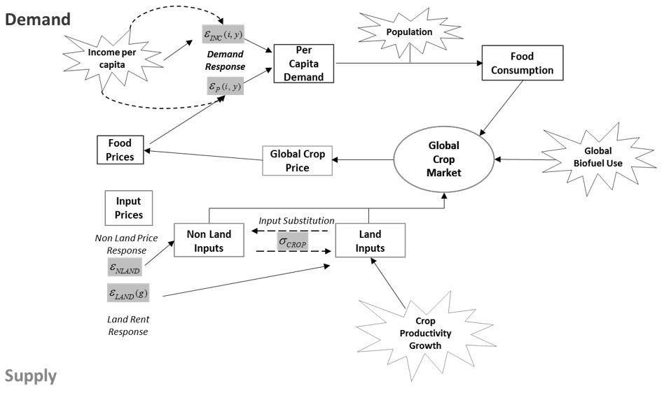
Figure S11. Graphical description of the SIMPLE model.
SIMPLE is a global partial equilibrium model of the food sector. In this model, the per capita consumer demands for three food types: crops, livestock and processed foods are log-linear functions of price and income, and regional food demand is obtained by multiplying per capita demand by regional population. Global crop production is specified for each of the 15 model regions represented in the model as a constant elasticity of substitution function of land and non-land inputs, each with different yields and potentially differing rates of technological progress.
Since livestock and processed foods are valued-added products, these are produced within the consuming region using crop and non-crop inputs and therefore have region- specific prices. A substantial share of crop demands in the model is derived demands, obtained from the consumer demands for value-added food products. This is important since technological change and factor substitution in the livestock and processed food industries can lead to varying intensities of crop use in these food products. The global demand for crops is the summation of final demands and derived demands summed over all regions. The global demand for crop feedstocks in biofuels is exogenously specified and serves as an addition to global crop demand.
Global crop production is specified for each of the 15 model regions as a constant elasticity of substitution function of land and non-land inputs, each with different yields and potentially differing rates of technological progress. Cropland supply elasticities, which vary by region, are based on the estimates of Gurgel et al. (2007) and Ahmed et al. (2009). Non-land factor supplies to agriculture are also less than perfectly elastic supply, but are more price responsive than land supply, based on the estimates offered by OECD (2001). Equilibrium in SIMPLE is attained when global crop supply equals global demand where the equilibrating variable is the global price of crops.
Description of database and growth rate assumptions
We construct separate base data for the years 2001 and 2006. Data from external sources include income, population, consumption expenditures and crop production and their sources are as follows. Information on GDP in constant 2000 USD and population are obtained from the World Development Indicators (2011) and from the World Population Prospects (2013), respectively. Data on cropland cover and production, utilization and prices of crops are derived from FAOSTAT (2011). We further converted the crop quantities into corn- equivalent quantities using weights constructed from world crop prices and the world price of corn. We then combined the data above with additional information on industry cost and sales shares in order to construct the rest of the database. The amount of crop feedstock used by the global biofuel sector is constructed using the sales shares by the global crop sector taken from GTAPBIO V.6 ³⁸.Shares constructed from the crop utilization data were then used to split the remaining corn-equivalent crop quantities across 15 geographic regions and across different uses (i.e. food, feed and raw materials for processed food).
We then calculated the global crop price from the value and corn-equivalent quantity data of crop production. Using the global price and the allocated corn-equivalent crop quantities, we then derived the value of crop input use in the livestock and processed food industries. Under the assumption of zero profits, we calculated the total value of land and non-land input costs in the regional crop sectors using GTAP v.6 cost shares as our guide. We again used GTAP v.6 cost shares and the value of crop input usage in the livestock and process food industries to impute the value of non-crop inputs used in these sectors. Under the assumption of zero profits, we then derive consumer expenditures and price indices for livestock and processed food commodities. Land rents and crop yields for each geographic region were derived using the value of land inputs, corn-equivalent crop production and cropland areas.
Key growth rates in the baseline scenarios
We start by simulating the model over the historical period 2005 to 2015 (10-years) and then projecting towards 2050. For this experiment, we implement shocks in population, per capita incomes, total factor productivity (TFP) growth, and biofuel consumption. We then compare the simulated changes for the period 2005 to 2015 with the actual changes from our data base on average adult BMI for men and women. Growth rates for population and income were derived from the Shared Socioeconomic Pathway 2 ¹⁶. TFP growth were based on the historical estimates ³⁹ and by ¹⁷. The growth in global biofuel consumption from the “Current policies” scenario published in the World Energy Outlook ¹⁹. These forecasts are based on the results of a detailed world energy model given exogenous growths in GDP and population as well as assumptions on future energy prices and technology. We also calculate the growth in global biofuel consumption from the “Current policies” scenario published in the World Energy Outlook ¹⁹. These forecasts are based on the results of a detailed world energy model given exogenous growths in GDP and population as well as assumptions on future energy prices and technology. TFP growth rates for the crop and the livestock sectors are based on the projections from ³⁹ which are generated under the assumption of gradual convergence in productivity across regions. Growth rates of each driver for the period 2005 to 2015 (2050) are listed in Table S3.

Table S3. Assumed growth rates of exogenous variables (in % per annum rates).
Region | Population | Per Capita Income | Biofuels | TFP
Region | Annual rate | Annual rate | Biofuels | Annual rate
Eastern Europe | -0.35 | 3.23 |  | 1.45
North Africa | 1.06 | 3.25 |  | 1.35
Sub Saharan Africa | 2.46 | 4.43 |  | 0.69
South America | 0.78 | 2.85 |  | 1.44
Australia/New Zealand | 0.88 | 1.39 |  | 0.89
European Union | 0.03 | 1.23 |  | 1.03
South Asia | 0.99 | 5.70 |  | 0.84
Central America | 0.98 | 2.37 |  | 1.43
Southern Africa | 0.45 | 3.24 |  | 1.25
Southeast Asia | 0.80 | 4.26 |  | 1.40
Canada/US | 0.64 | 1.10 |  | 1.28
China | -0.13 | 5.77 |  | 1.75
Middle East | 1.46 | 1.89 |  | 1.10
Japan/Korea | -0.39 | 1.74 |  | 1.40
Central Asia | 1.18 | 4.72 |  | 1.45
World |  |  | 6.96
Note: From left to right – Population and per capita Income growths from SSP2 ¹⁶. The increase in demand for biofuels from ¹⁹. Future TFP growth rates from Ludena et al. (2007) using ¹⁷ as regional scalars.

Model implementation and systematic examination of uncertainties
We implement SIMPLE and the double burden of malnutrition module using the GEMPACK program ⁴⁰ (http://www.monash.edu.au/policy/gempack.htm) which has many useful features for purposes of analysis. One of these is the subtotals feature developed by Harrison, Horridge, and Pearson (2000). The authors note that estimating the contribution of exogenous shocks in general equilibrium models will depend on the assumed path from one equilibrium point to another. They propose a numerical integration technique that exactly partitions the impacts of different exogenous shocks on endogenous variables of interest under the assumption that the assumed path is a straight line. This tool is critical in our analysis of the relative contribution of each key driver of global food security.
Results of simulations often hinge critically on values of key exogenous inputs (parameters and/or shocks applied to exogenous variables) ⁴². GEMPACK is equipped with practical methods for systematic investigation of the impacts of variations in these key inputs conducting for any model solved using GEMPACK ^{42,43}. In this process instead of projecting the endogenous variables within the model from a baseline to a projected period by solely “shocking” the key exogeneous variables and/or modifying parameters by their mean expected changes, the “shocks” on key exogenous inputs are drawn from a pool of potential expected changes, usually a triangular approximation for a normal distribution around the media of their respective expected changes. As a result, the procedure reports estimations of the mean and standard deviation for any endogenous variable in the model, resulting in a projection of future distributions of endogenous variables rather than just an average expected projection.

Specification of the Counterfactual Scenarios
The Healthy Dietary Guidelines (HDG) and the Flexitarian (FLX) Diets Scenarios
We adapt the counterfactual scenarios in previous studies ⁴⁴ regarding shifting towards healthier and more sustainable diets. The counterfactual diet scenarios analyzed in this chapter include diets aligned with global dietary guidelines (HDG), and more plant-based flexitarian diets (FLX) that are reflective of present evidence on healthy eating. The HGD scenario is based on global guidelines on healthy eating issued by WHO/FAO Expert Consultations on diet, nutrition ⁴⁵ and human energy requirements ³³ and the FLX is a more ambitious dietary change that implies larger levels of substitution of animal source proteins for vegetable source proteins. We start by comparing the BAU projections on food consumption from Springmann et al.’s (2018) with the ones in this study obtained with SIMPLE, under the SSP2 scenarios. we do so by aggregating across food groups from Springmann et al. into “crop” and “livestock” categories. We find that baseline projections from both studies are very similar, and global averages of per capita consumption of crops and livestock are around 1130 grams and 412-425 grams, respectively.
In Springmann et al. (2018) authors develop two different counterfactual scenarios regarding shifting towards healthier and more sustainable diets. One in which average consumers follow the Healthy Dietary Guidelines (HDG) and another one in which the average consumers follow a flexitarian style diet (FLX). In both scenarios, regional diets maintain their character of preferred foods but are restricted to an intake of 2100-2300 kcal per person per day, with specified grams per person per day servings of food categories such as red meat, dairy, fruits and vegetables, and staple crops. The flexitarian diet pathway is a more ambitious dietary change projection, in the sense that it implies a larger restriction in the consumption of livestock products and a boost in the nut and legume intake.
To calculate the necessary shocks to simulate Springmann et al.’s (2018) two dietary change scenarios, regional per capita food consumption in grams is obtained from the QCONS_GRAM variable. Because this information is separated into “crops,” “livestock,” and “processed food” categories, the food groups in Springmann et al. are aggregated for comparison. Thus, wheat, rice, maize, legumes, vegetables, nut & seeds, et cetera are summed for “crops,” while “livestock” included such categories as beef, poultry, and eggs. For the healthy diets’ scenario, this corresponds to 1093.6 g of crops and 369 grams of livestock products per person per day, while the flexitarian diet consists of 1110.3 grams of crops and 240.6 grams of livestock products. To translate these values into shocks, the percentage change necessary in per capita consumption to meet the scenario values was calculated.
In order to better understand the dynamics of the malnutrition double burden, we restrict the exogenous changes in food consumption to those regions that are already at latter stages in the nutrition transition ⁴⁶. This allows us to project endogenous changes in caloric undernutrition in those regions that host most of the current and projected hunger individuals. So doing, we observe the potential multiple dividends (i.e., health and environmental benefits) derived from the shift towards healthier dietary intake levels in those regions that project higher levels on adult BMI. Table S4 lists the shocks in food consumption with respect to the baseline case, for the HDG and the FLX diets scenarios.

Table S4. Shocks on per capita consumption in grams by type of food (i.e., crops, livestock, and processed food) in SIMPLE.
 | HDG |  |  |  | FLX
 | Crops | Livestock | Proc_Food |  | Crops | Livestock | Proc_Food
East of Europe | -15.9 | -46.2 | -35.3 |  | -14.6 | -64.9 | -22.0
South America | 12.0 | -39.2 | -60.5 |  | 13.7 | -60.3 | -45.8
Aust& N. Zealand | 10.3 | -52.7 | -31.5 |  | 12.0 | -69.1 | -18.4
Europe | -3.8 | -42.4 | -49.5 |  | -2.3 | -62.4 | -33.1
South Africa | 31.3 | 16.1 | -140.1 |  | 33.3 | -24.3 | -123.9
Canada & US | -3.7 | -54.1 | -48.9 |  | -2.3 | -70.1 | -41.7
China | -37.2 | -3.4 | -40.8 |  | -36.2 | -37.0 | 77.0
Japan and Korea | 11.5 | 6.3 | -77.6 |  | 13.2 | -30.7 | -58.3
Central Asia | -14.2 | -35.7 | 6.6 |  | -12.9 | -58.1 | 33.8
Note: Shocks on per capita consumption in grams by type of food (i.e., crops, livestock, and processed food) in SIMPLE. These shocks imply exogenous shifts for the average consumer, to move from the projected baseline diets towards 2050 to more healthy and sustainable intake levels. we develop the counterfactual diets scenarios following healthy dietary guidelines scenario (HDG) and the flexitarian (FLX) diets scenario from Springmann et al. 2018.
Extending the Counterfactual Scenarios: Splitting the Excessive Consumption Between Excessive Intake and Food Waste
Much of the previous literature has just looked at total calories from the FAO’s FBS and concluded that reducing them to a healthy level would greatly benefit the environment. However, the FBS calories have included food waste at consumers’ level– although recently some adjustments have been made the inaccuracy persists ¹⁰. Therefore, the excessive consumption of food in current diets, understood as the gap between current food consumption levels (equated to FAO FBS’s) and healthy dietary intake levels, really includes both food waste and excessive intake. Additionally, since shifting towards healthier diets usually imply not only the reduction in food consumption, but also shifting towards more plant-based diets, there is also a third contributor – the composition of these calories. Here, we decompose, for the first time, these three elements (composition of diets, excessive intake, and food waste) of the linkage from food purchasing behavior and the environment to analyze their relative contribution to environmental sustainability. In order to decompose the relative environmental benefits of each of the subcomponents, we design a 3-steps complementary experiments to decompose the overall environmental benefits of shifting towards healthier diets, in both HDG and FLX, dietary scenarios described in the previous sub-section.
We start by isolating the relative contribution of the changes in the composition of diets (i.e., shifting towards more plant-based food consumption bundle) when shifting towards HDG and FLX diets. We do so by imposing shifts in food consumption that imply the necessary changes in dietary composition in the HDG and FLX (i.e., relatively more calories from direct crop consumption and less from livestock) but maintaining the overall calories purchased as in the BAU towards 2050 scenario. This first step allows us to isolate the environmental benefits of changes in dietary composition by comparing the GHG emission and resource use resulting from this scenario with the ones resulting from the BAU. In the second step, in addition to the changes in the dietary composition, we impose a restrictions in food purchasing mimicking reductions in consumers’ food waste based on imputed values of uneaten calories art consumers’ level from previous studies ³. The second step allows us to isolate the environmental benefits of reducing food waste by comparing the by comparing the GHG emission and resource use resulting from this scenario with the ones resulting of changes in dietary composition (results from step 1). In the third step of these complementary experiments, we isolate the environmental benefits of the reductions in excessive intake of food by comparing the resulting GHG emissions and result use from the HDG and FLX diets scenarios (Table S4) with the ones resulting from the second step (food reduction + change in dietary composition) in these complementary experiments. Table S5 lists the shocks in food consumption with respect to the baseline case, for the steps 1 and 2, that complements the HDG and the FLX diets scenarios.
Table S5. Shocks on per capita consumption in grams by type of food (i.e., crops, livestock, and processed food) in SIMPLE.
 | Step 1 |  |  |  |  | Step 2
HDG | Crops |  | Livestock | Proc_Food |  | Crops | Livestock | Proc_Food
East of Europe | 53.8 | -1.6 |  | 18.3 |  | 7.7 | -31.1 | -17.2
South America | 102.7 | 10.1 |  | -28.5 |  | 41.9 | -22.9 | -49.9
Aust. & N. Zealand | 61.3 | -30.8 |  | 0.2 |  | 16.1 | -50.2 | -27.9
Europe | 46.5 | -12.2 |  | -23.1 |  | 5.5 | -36.8 | -44.6
South Africa | 89.2 | 67.3 |  | -157.8 |  | 43.8 | 27.2 | -144.0
Canada & US | 62.3 | -22.6 |  | -13.8 |  | 8.8 | -48.2 | -42.2
China | 37.0 | 110.8 |  | 29.2 |  | -4.1 | 47.5 | -9.6
Japan and Korea | 40.4 | 33.9 |  | -71.7 |  | 15.4 | 10.0 | -76.8
Central Asia | 62.4 | 21.7 |  | 101.8 |  | 16.2 | -12.9 | 44.3
FLX | Crops | Livestock |  | Proc_Food |  | Crops | Livestock | Proc_Food
East of Europe | 57.8 | -35.2 |  | 44.2 |  | 10.5 | -54.6 | 0.9
South America | 107.1 | -27.8 |  | -1.3 |  | 45.0 | -49.4 | -30.9
Aust & N. Zealand | 66.1 | -54.2 |  | 21.0 |  | 19.6 | -67.0 | -12.9
Europe | 50.5 | -42.1 |  | 3.0 |  | 8.3 | -58.3 | -25.8
South Africa | 93.6 | 10.0 |  | -134.6 |  | 47.1 | -16.4 | -126.3
Canada & US | 68.5 | -48.4 |  | 0.5 |  | 12.9 | -65.4 | -32.6
China | 37.5 | 35.9 |  | 281.8 |  | -3.7 | -4.9 | 167.3
Japan and Korea | 40.9 | -13.7 |  | -48.1 |  | 15.7 | -29.1 | -57.4
Central Asia | 64.0 | -21.1 |  | 151.8 |  | 17.3 | -43.5 | 80.1
Note: These shocks imply exogenous shifts for the average consumer, to move from the projected baseline diets towards healthier diets. Columns corresponding to Step 1 present shocks in per capita consumption that implies shifts in dietary composition that follows healthier diets (i.e., HDG and FLX) but respect the overall calorie consumption levels from BAU scenario. Columns corresponding to Step 2 to shocks that imply reductions on consumers food waste ³ accompanying the changes in dietary composition necessary to achieve healthier diets (i.e., HDG and FLX).

Supplementary Information References
1. Wanner, N., Cafiero, C., Troubat, N. & Conforti, P. Refinements to the FAO methodology for estimating the prevalence of undernourishment indicator. Documento de trabajo 14–05 (2014).
2. Barrera, E. L. Hunger and Obesity: the “double burden” of malnutrition in a SIMPLE framework. (2018).
3. Barrera, E. L. & Hertel, T. Global food waste across the income spectrum: Implications for food prices, production and resource use. Food Policy 101874 (2020).
4. Deaton, A. Panel data from time series of cross-sections. Journal of Econometrics 30, 109–126 (1985).
5. Baldos, U. L. C. & Hertel, T. W. Looking back to move forward on model validation: insights from a global model of agricultural land use. Environ. Res. Lett. 8, 034024 (2013).
6. Hall, K. D. et al. Energy balance and its components: implications for body weight regulation. The American Journal of Clinical Nutrition 95, 989–994 (2012).
7. Hall, K. D., Guo, J., Dore, M. & Chow, C. C. The progressive increase of food waste in America and its environmental impact. PLoS One 4, e7940 (2009).
8. Svedberg, P. Undernutrition Overestimated. Economic Development and Cultural Change 51, 5–36 (2002).
9. Hawkesworth, S. et al. Feeding the world healthily: the challenge of measuring the effects of agriculture on health. Philosophical Transactions of the Royal Society B: Biological Sciences 365, 3083–3097 (2010).
10. FAO. Key differences between new and old Food Balance Sheet (FBS) methodology. (2019).
11. Wooldridge, J. M. Econometric analysis of cross section and panel data. (MIT Press, 2010).
12. Baldos, U. L. C. & Hertel, T. W. Global food security in 2050: the role of agricultural productivity and climate change. Aust J Agric Resour Econ 58, 554–570 (2014).
13. McCalla, A. F. & Revoredo, C. L. Prospects for global food security: a critical appraisal of past projections and predictions. vol. 35 (Intl Food Policy Res Inst, 2001).
14. Baldos, U. L. C. & Hertel, T. W. Global food security in 2050: the role of agricultural productivity and climate change. Australian Journal of Agricultural and Resource Economics 58, 554–570 (2014).
15. McCalla, A. F. & Revoredo, C. L. Prospects for global food security: a critical appraisal of past projections and predictions. vol. 35 (Intl Food Policy Res Inst, 2001).
16. Fricko, O. et al. The marker quantification of the Shared Socioeconomic Pathway 2: A middle-of-the-road scenario for the 21st century. Global Environmental Change 42, 251–267 (2017).
17. Fuglie, K. O. 16 Productivity Growth and Technology Capital in the Global Agricultural Economy. Productivity growth in agriculture: An international perspective 335 (2012).
18. Ludena, C. E., Hertel, T. W., Preckel, P. V., Foster, K. & Nin, A. Productivity growth and convergence in crop, ruminant, and nonruminant production: measurement and forecasts. Agricultural Economics 37, 1–17 (2007).
19. International Energy Agency. World Energy Outlook 2019. (OECD, 2019). doi:10.1787/caf32f3b-en.
20. Lim, S. S. et al. A comparative risk assessment of burden of disease and injury attributable to 67 risk factors and risk factor clusters in 21 regions, 1990–2010: a systematic analysis for the Global Burden of Disease Study 2010. The Lancet 380, 2224–2260 (2012).
21. Murray, C. J. et al. GBD 2010: design, definitions, and metrics. The Lancet 380, 2063–2066 (2012).
22. Berrington de Gonzalez, A. et al. Body-Mass Index and Mortality among 1.46 Million White Adults. N Engl J Med 363, 2211–2219 (2010).
23. Prospective Studies Collaboration. Body-mass index and cause-specific mortality in 900 000 adults: collaborative analyses of 57 prospective studies. The Lancet 373, 1083–1096 (2009).
24. Springmann, M. et al. Options for keeping the food system within environmental limits. Nature 562, 519–525 (2018).
25. Preston, S. H., Vierboom, Y. C. & Stokes, A. The role of obesity in exceptionally slow US mortality improvement. Proceedings of the National Academy of Sciences 115, 957–961 (2018).
26. Springmann, M., Godfray, H. C. J., Rayner, M. & Scarborough, P. Analysis and valuation of the health and climate change cobenefits of dietary change. Proc Natl Acad Sci USA 113, 4146–4151 (2016).
27. Leatherman, S., Ferris, T. G., Berwick, D., Omaswa, F. & Crisp, N. The role of quality improvement in strengthening health systems in developing countries. International Journal for Quality in Health Care 22, 237–243 (2010).
28. Cafiero, C., Melgar-Quinonez, H. R., Ballard, T. J. & Kepple, A. W. Validity and reliability of food security measures. Annals of the New York Academy of Sciences 1331, 230–248 (2014).
29. Headey, D. et al. Impacts of COVID-19 on childhood malnutrition and nutrition-related mortality. The Lancet 396, 519–521 (2020).
30. Roberton, T. et al. Early estimates of the indirect effects of the COVID-19 pandemic on maternal and child mortality in low-income and middle-income countries: a modelling study. The Lancet Global Health 8, e901–e908 (2020).
31. Naiken, L. The Probaility Distribution Framework For Estimating The Prevalence of Undernourishment: Exploding the Myth of the Bivariate Distribution. Working Paper Series, FAO, Statistical Division 53 (2021).
32. Cafiero, C. Advances in hunger measurement: traditional FAO methods and recent innovations. Food and Agriculture Organization of the United Nation, Rome (2014).
33. FAO/WHO. Human energy requirements. Report of a Joint FAO/WHO/UNU Expert Consultation, Rome, 17-24 October. (2001).
34. Hertel, T. W. & Baldos, U. L. C. Global Change and the Challenges of Sustainably Feeding a Growing Planet. (Springer International Publishing, 2016). doi:10.1007/978-3-319-22662-0.
35. Muhammad, A., Seale, J. L., Meade, B. & Regmi, A. International evidence on food consumption patterns: an update using 2005 international comparison program data. USDA-ERS technical bulletin (2011).
36. Gurgel, A., Reilly, J. M. & Paltsev, S. Potential land use implications of a global biofuels industry. Journal of Agricultural & Food Industrial Organization 5, (2007).
37. Ahmed, S. A., Hertel, T. & Lubowski, R. Calibration of a land cover supply function using transition probabilities. (2009).
38. Taheripour, F., Birur, D., Hertel, T. & Tyner, W. Introducing liquid biofuels into the GTAP data base. (2007).
39. Ludena, C. E., Hertel, T. W., Preckel, P. V., Foster, K. & Nin, A. Productivity growth and convergence in crop, ruminant, and nonruminant production: measurement and forecasts. Agricultural Economics 37, 1–17 (2007).
40. Harrison, W. J. & Pearson, K. R. Computing solutions for large general equilibrium models using GEMPACK. Computational Economics 9, 83–127 (1996).
41. Harrison, W. J., Horridge, J. M. & Pearson, K. R. Decomposing simulation results with respect to exogenous shocks. Computational Economics 15, 227–249 (2000).
42. DeVuyst, E. A. & Preckel, P. V. Sensitivity analysis revisited: A quadrature-based approach. Journal of policy modeling 19, 175–185 (1997).
43. Pearson, K. & Arndt, C. Implementing systematic sensitivity analysis using GEMPACK. (2000).
44. Springmann, M. et al. Options for keeping the food system within environmental limits. Nature 562, 519 (2018).
45. WHO. Diet, nutrition, and the prevention of chronic diseases: report of a joint WHO/FAO expert consultation. vol. 916 (World Health Organization, 2003).
46. Bodirsky, B. L. et al. The ongoing nutrition transition thwarts long-term targets for food security, public health and environmental protection. Sci Rep 10, 19778 (2020).

