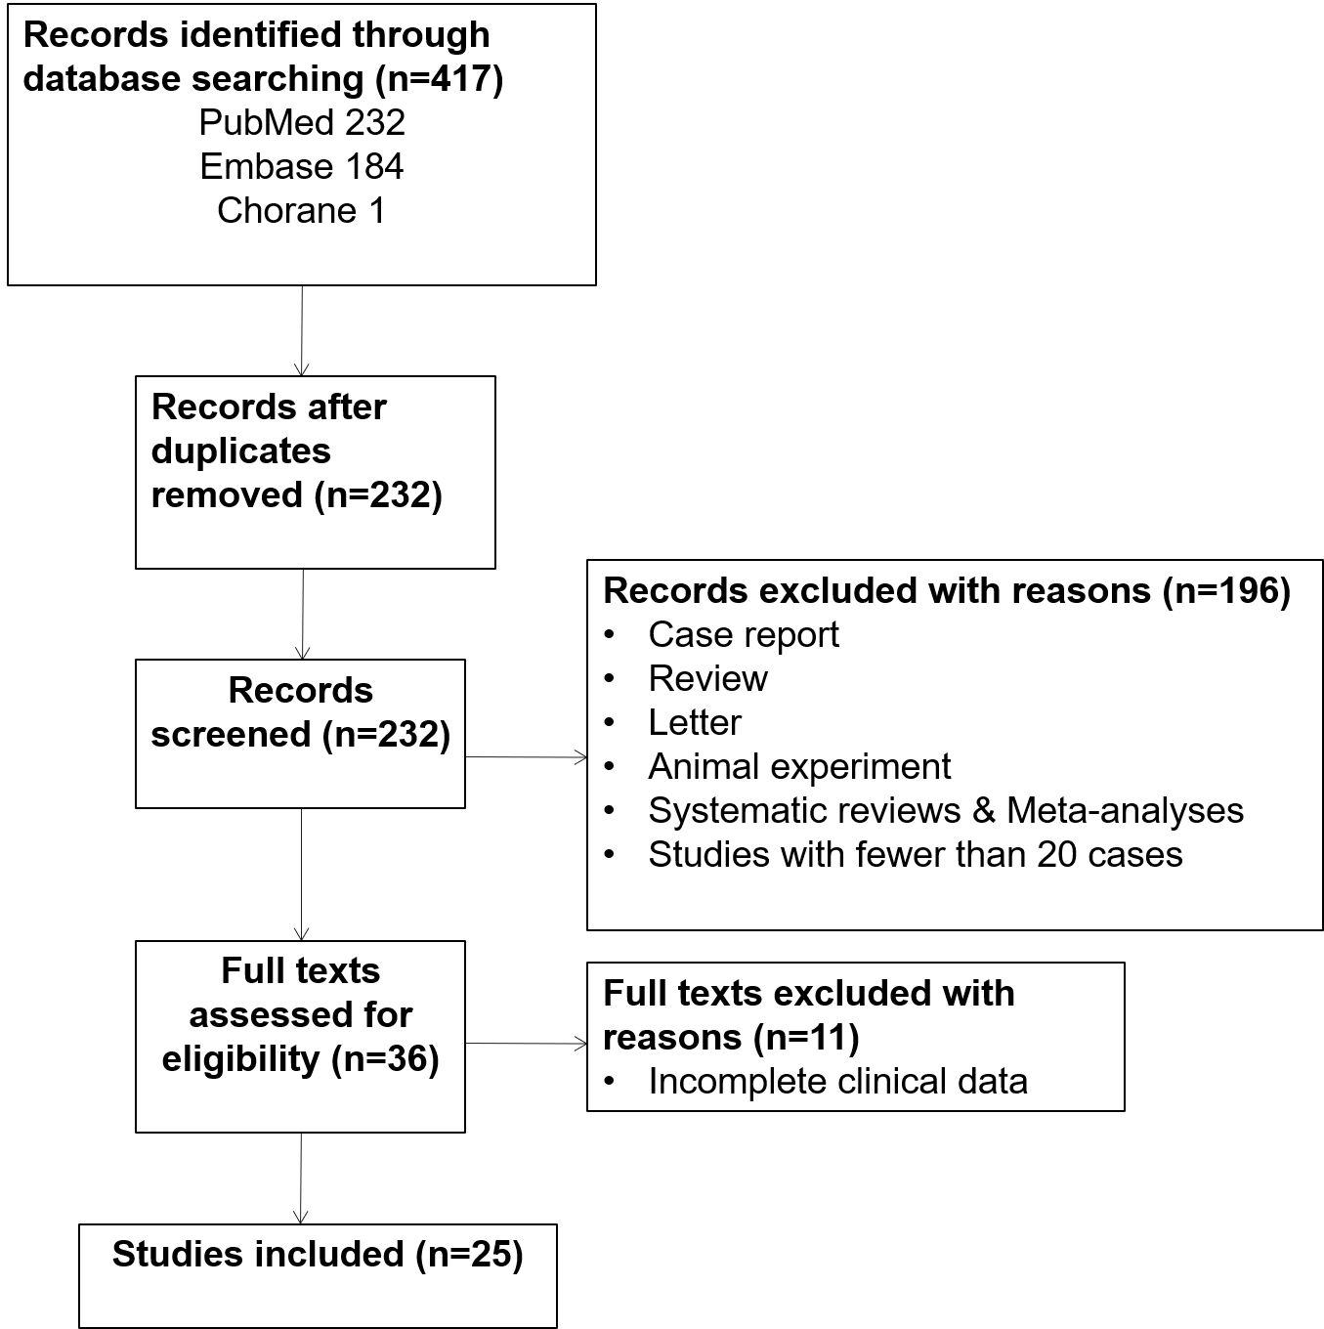
Figure 1. Literature screening flow chart.

Table 1. Basic information of studies included in the literature review.
Author, year | N | FU (Year) | Age |  |  | IPI |  | B symptoms |  | 5-year OS | 5-year PFS | Treatment (N)
Author, year | N | FU (Year) | < 60 |  | ≥ 60 | 0-1 | 2-5 | Absent | Present | 5-year OS | 5-year PFS | Surgery | R+ChT | ChT | RT
Ryan, 2008[1] | 204 | 5.5 | 81 |  | 123 | 129 | 37 | 195 | 9 | 46% | 36% | 9 | 0 | 143 | 130
Ludmir, 2019[2] | 11 | 8 | 62 (42-75) |  |  | 5 | 6 | 11 | 0 | NA | NA | 1 | NA | NA | 8
Hu, 2018[3] | 108 | 3.2 | 47 (16-85) |  |  | 78 | 13 | 103 | 5 | 77.3% | 61.2% | 21 | 66 | 108 | 39
Zhang, 2021[4] | 36 | 2.8 | 18 |  | 11 | 3 | 15 | 14 | 15 | NA | NA | 0 | 8 | 8 | 14
Luo, 2019[5] | 46 | 3.4 | 28 |  | 18 | 33 | 13 | 44 | 2 | 36.2% | 29.1% | 38 | 16 | 46 | 12
Ludmir, 2018[2] | 25 | 4.5 | 55 (26–83) |  |  | 16 | 6 | 24 | 1 | 71.9% | 42.4$ | 5 | 16 | 24 | 13
Niitsu, 2008[6] | 30 | 5.5 | 57 (24–77) |  |  | 23 | 7 | 27 | 3 | 87.0% | 77.0% | NA | 11 | 30 | 18
Yhim, 2020*[7] | 33 | 3.8 | 50(29-75) |  |  | 28 | 5 | 31 | 2 | 93.5% | 81.3% | NA | 32 | 32 | NA
Zhang, 2016[8] | 24 | 5.0 | 50 (24-69) |  |  | 19 | 5 | 23 | 1 | 78.9% | 79.2% | 17 | 10 | 23 | 12
Hosein, 2014[9] | 76 | 4.5 | 62 (17-87) |  |  | 54 | 22 | 74 | 2 | 75.0% | 66.0% | NA | 47 | 65 | 48
Ou, 2015[10] | 23 | 3.8 | 16 |  | 5 | 21 | 2 | 22 | 1 | 57.1% | 57.1% | 3 | 7 | 19 | 1
Zhao, 2020[11] | 64 | 5 | 51 |  | 13 | 54 | 5 | 53 | 11 | 73.4% | 62.5% | 29 | 39 | 59 | 39
Zhang, 2017[12] | 29 | 5.5 | 50 (24-69) |  |  | 21 | 8 | 27 | 2 | 78.1% | 78.4% | 21 | 11 | 27 | 13
Shao, 2015[13] | 30 | 2.7 | 45 (18-74) |  |  | 17 | 13 | 25 | 5 | 48.0% | 32.0% | NA | 13 | 24 | 5
Avilés, 2007*[14] | 32 | 5.4 | 16 |  | 16 | 32 | 0 | NA | NA | 63.0% | 75.0% | NA | 0 | 32 | NA
Aviles, 2012[15] | 104 | NA | NA |  | NA | 104 | 0 | NA | NA | 52.0% | 66.0% | NA | 49 | 55 | 0
Martinelli, 2009[16] | 60 | 4 | 25 |  | 35 | 36 | NA | 56 | 4 | 92.0% | 56.0% | 40 | NA | 25 | 36
Yhim, 2012[17] | 26 | 2.9 | 56 (21-79) |  |  | 20 | 5 | 24 | 1 | 82.2% | 70.0% | NA | 6 | 25 | 10
Liu, 2020[18] | 370 | 5.7 | 114 | 256 |  | NA | NA | NA | NA | 81.2% | 95.4% | 71 | NA | 63 | 142
Lalani, 2018[19] | 35 | 5.8 | 66 (35-86) |  |  | NA | NA | 31 | 4 | 70.0% | NA | 15 | 10 | 15 | 30
Franco, 2016[20] | 55 | 4.7 | 28 | 25 |  | NA | NA | 51 | 2 | 76.0% | 73.0% | 14 | 39 | 35 | 20
Radkan, 2014[21] | 28 | NA | 67.5 (35-95) |  |  | NA | NA | NA | NA | 82.0% | 75.0% | 17 | NA | 15 | 16
Jeanneret-Sozzi, 2008[22] | 84 | 4.7 | 42 | 12 |  | NA | NA | NA | NA | 53.0% | 59.0% | 21 | 0 | 59 | 51
Lin, 2006[23] | 32 | 6.3 | 43 (22-76) |  |  | NA | NA | NA | NA | 63.9% | 58.6% | 32 | NA | 28 | 20
Jennings, 2007[24] | 465 | 4.0 | 54 (17-95) |  |  | NA | NA | NA | NA | NA | 44.5% | 156 | 0 | 323 | 218
*Prospective studies
FU, follow-up; IPI, International Prognostic Index; PFS, progression-free survival; OS, overall survival; ChT, chemotherapy; R, rituximab; NA, not available

Table 2. Comparisons of patient survival outcomes with/without rituximab.
Author, year | N | Rituximab+ ChT |  |  | ChT
Author, year | N | N | PFS | OS | N |  | PFS | OS
Aviles, 2012[15] | 104 | 49 | 61.0% | 53.0% | 55 |  | 66.0% | 52.0%
Franco, 2017[20] | 55 | 39 | 74.8% | 81.6% | 35 |  | 62.5% | 62.5%
Hu, 2018*[3] | 108 | 66 | 24.0%* | NA | 42 |  | 57.0%* | 77.3%
Hosein, 2014[9] | 76 | 47 | NA | NA | 65 |  | NA | NA
Luo, 2019[5] | 46 | 16 | 29.8% | 34.4% | 30 |  | 28.0% | 35.7%
Ludmir, 2019[2] | 25 | 19 | NS | NA | 6 | NS |  | NA
Niitsu, 2008[6] | 30 | 11 | NA | NA | 19 | NA |  | NA
Ou, 2014[10] | 23 | 7 | 57.1% | 57.1% | 16 |  | 50.0% | 58.3%
Shao, 2015[13] | 30 | 13 | NA | NA | 29 |  | NA | NA
Shen, 2018*¹[25] | 19 | 12 | 74.4%* | 76.1%* | 7 |  | 44.3%* | 42.1%*
Zhao, 2011*[26] | 31 | 6 | 67.5%* | 82.4%* | 21 |  | NA | 67.5%*
Zhang, 2016[8] | 24 | 10 | 68.8% | 77.9% | 23 |  | 68.2% | 68.2%
* indicates a significant difference at P < 0.05
¹ contains data from primary extra‑nodal DLBCL, including PBL.
ChT, chemotherapy; PFS, progression-free survival; OS, overall survival; NA, not available; NS, insignificant differences;

1. Ryan G, Martinelli G, Kuper-Hommel M et al. Primary diffuse large B-cell lymphoma of the breast: prognostic factors and outcomes of a study by the International Extranodal Lymphoma Study Group. Ann Oncol 2008; 19: 233-241.
2. Ludmir EB, Milgrom SA, Pinnix CC et al. Emerging Treatment Strategies for Primary Breast Extranodal Marginal Zone Lymphoma of Mucosa-associated Lymphoid Tissue. Clin Lymphoma Myeloma Leuk 2019; 19: 244-250.
3. Hu S, Song Y, Sun X et al. Primary breast diffuse large B-cell lymphoma in the rituximab era: Therapeutic strategies and patterns of failure. Cancer Sci 2018; 109: 3943-3952.
4. Zhang T, Zhang Y, Fei H et al. Primary breast double-hit lymphoma management and outcomes: a real-world multicentre experience. Cancer Cell Int 2021; 21: 498.
5. Luo H, Yi P, Wang W et al. Clinicopathological Features, Treatment, and Prognosis in Primary Diffuse Large B Cell Lymphoma of the Breast: A Retrospective Study of 46 Patients. Med Sci Monit 2019; 25: 8671-8682.
6. Niitsu N, Okamoto M, Nakamine H, Hirano M. Clinicopathologic features and treatment outcome of primary breast diffuse large B-cell lymphoma. Leuk Res 2008; 32: 1837-1841.
7. Yhim HY, Yoon DH, Kim SJ et al. First-Line Treatment for Primary Breast Diffuse Large B-Cell Lymphoma Using Immunochemotherapy and Central Nervous System Prophylaxis: A Multicenter Phase 2 Trial. Cancers (Basel) 2020; 12.
8. Zhang N, Cao C, Zhu Y et al. Primary breast diffuse large B-cell lymphoma in the era of rituximab. Onco Targets Ther 2016; 9: 6093-6097.
9. Hosein PJ, Maragulia JC, Salzberg MP et al. A multicentre study of primary breast diffuse large B-cell lymphoma in the rituximab era. Br J Haematol 2014; 165: 358-363.
10. Ou CW, Shih LY, Wang PN et al. Primary breast lymphoma: a single-institute experience in Taiwan. Biomed J 2014; 37: 321-325.
11. Zhao P, Zhu L, Song Z et al. Combination of baseline total metabolic tumor volume measured on FDG-PET/CT and β2-microglobulin have a robust predictive value in patients with primary breast lymphoma. Hematol Oncol 2020; 38: 493-500.
12. Zhang N, Cao C, Zhu Y et al. Primary breast lymphoma: A single center study. Oncol Lett 2017; 13: 1014-1018.
13. Shao YB, Sun XF, He YN et al. Clinicopathological features of thirty patients with primary breast lymphoma and review of the literature. Med Oncol 2015; 32: 448.
14. Avilés A, Castañeda C, Neri N et al. Rituximab and dose dense chemotherapy in primary breast lymphoma. Haematologica 2007; 92: 1147-1148.
15. Aviles A, Neri N, Nambo MJ. The role of genotype in 104 cases of diffuse large B-cell lymphoma primary of breast. Am J Clin Oncol 2012; 35: 126-129.
16. Martinelli G, Ryan G, Seymour JF et al. Primary follicular and marginal-zone lymphoma of the breast: clinical features, prognostic factors and outcome: a study by the International Extranodal Lymphoma Study Group. Ann Oncol 2009; 20: 1993-1999.
17. Yhim HY, Kim JS, Kang HJ et al. Matched-pair analysis comparing the outcomes of primary breast and nodal diffuse large B-cell lymphoma in patients treated with rituximab plus chemotherapy. Int J Cancer 2012; 131: 235-243.
18. Liu H, Zhang J, Quan L et al. Conventional Treatments Cannot Improve Outcomes of Early-Stage Primary Breast Marginal Zone Lymphoma. Front Oncol 2020; 10: 609512.
19. Lalani N, Winkfield KM, Soto DE et al. Management and outcomes of women diagnosed with primary breast lymphoma: a multi-institution experience. Breast Cancer Res Treat 2018; 169: 197-202.
20. Franco Pérez F, Lavernia J, Aguiar-Bujanda D et al. Primary Breast Lymphoma: Analysis of 55 Cases of the Spanish Lymphoma Oncology Group. Clin Lymphoma Myeloma Leuk 2017; 17: 186-191.
21. Radkani P, Joshi D, Paramo JC, Mesko TW. Primary breast lymphoma: 30 years of experience with diagnosis and treatment at a single medical center. JAMA Surg 2014; 149: 91-93.
22. Jeanneret-Sozzi W, Taghian A, Epelbaum R et al. Primary breast lymphoma: patient profile, outcome and prognostic factors. A multicentre Rare Cancer Network study. BMC Cancer 2008; 8: 86.
23. Lin Y, Guo XM, Shen KW et al. Primary breast lymphoma: long-term treatment outcome and prognosis. Leuk Lymphoma 2006; 47: 2102-2109.
24. Jennings WC, Baker RS, Murray SS et al. Primary breast lymphoma: the role of mastectomy and the importance of lymph node status. Ann Surg 2007; 245: 784-789.
25. Shen H, Wei Z, Zhou D et al. Primary extra‑nodal diffuse large B‑cell lymphoma: A prognostic analysis of 141 patients. Oncology Letters 2018.
26. Zhao S, Zhang QY, Ma WJ et al. Analysis of 31 cases of primary breast lymphoma: the effect of nodal involvement and microvascular density. Clin Lymphoma Myeloma Leuk 2011; 11: 33-37.

