SUPPLEMENTARY MATERIALS

Supplementary RT Results
The raw LOG RTs was subjected into a 2 (administration: placebo vs. lorazepam) x 3 (scenario: harming vs. helping vs. neutral) repeated ANOVA to test the lorazepam effect on the speed of moral behaviors under coercion. There was a main effect of scenario (F_{2, 152} = 18.19, P < .001, η² = 0.19) as well as an interaction between administration and scenario (F_{2, 152} = 3.64, P = .03, η² = .05). Follow-up analyses indicated that the reaction time in helping (2.97 ± 0.02, mean ± SE) was shorter, as compared to neutral (3.02 ± 0.02, P < .001) and harming (3.00 ± 0.02, P < .001). The lorazepam effect had opposite directions depending on the factor of scenario. Lorazepam administration slowed down the harming (lorazepam vs. placebo: 3.02 ± 0.02 vs. 2.99 ± 0.02), whereas it accelerated the helping (2.96 ± 0.02 vs. 2.98 ± 0.02) and did not affect the neutral actions (3.02 ± 0.02 vs. 3.02 ± 0.02). The reaction times of harming and helping were significantly different after lorazepam administration (t₇₆ = 4.86, P < .001), whereas it did not reach significance after the placebo (t₇₆ = 1.62, P = .11).

Supplementary Figure 1: The Box and Whisker Plots indicating the outliers in head motion during lorazepam condition.
A. Head displacement along the z axis
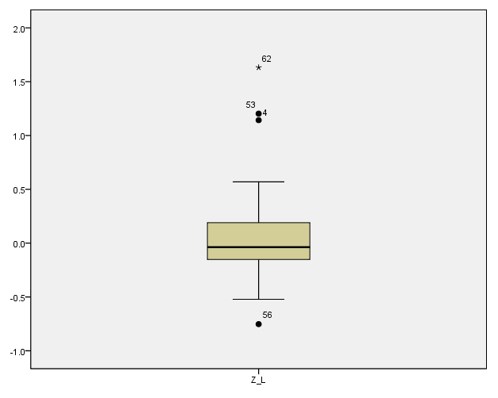
B. Roll movements of head rotation around the y axis
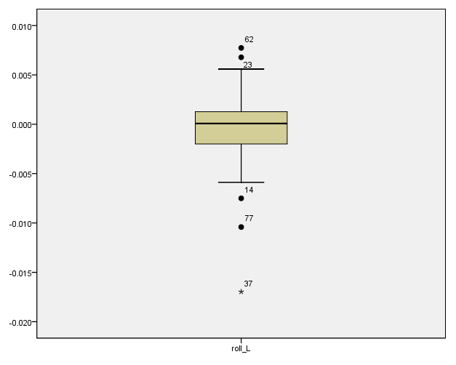

Supplementary Figure 2: The Q-Q plots for reaction time data.
A. Q-Q plot of harming RT in the placebo condition.
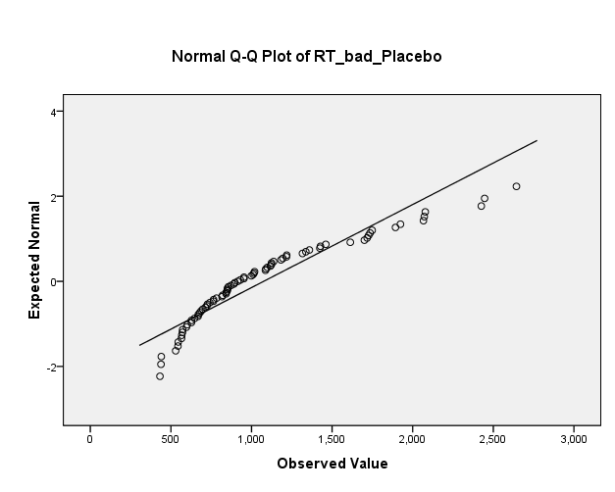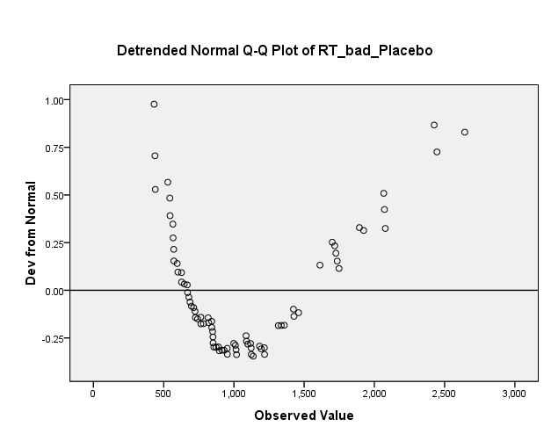

B. Q-Q plot of helping RT in the placebo condition.
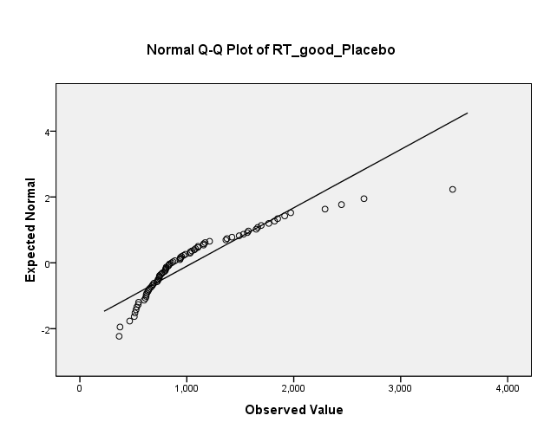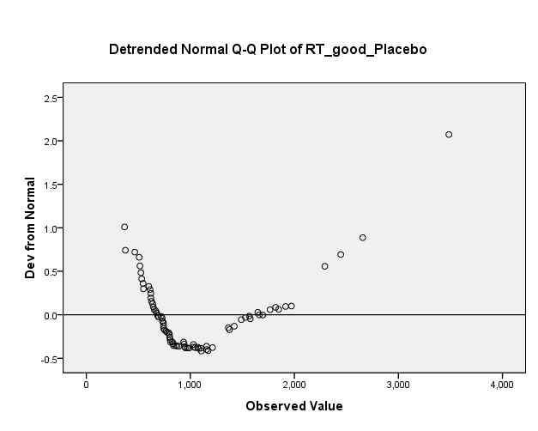

C. Q-Q plot of neutral RT in the placebo condition.
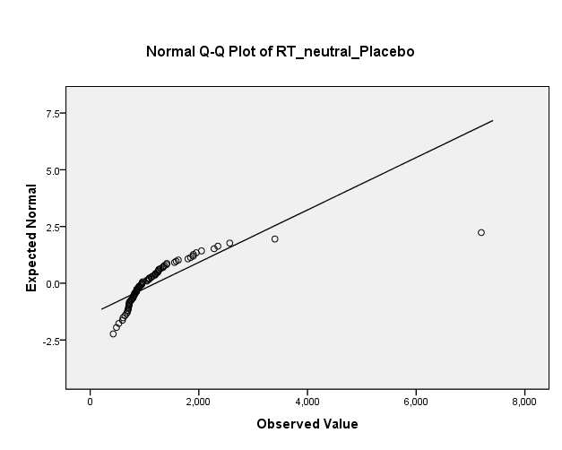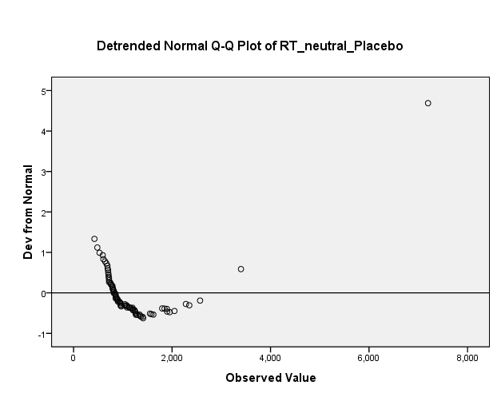

D. Q-Q plot of harming RT in the lorazepam condition.
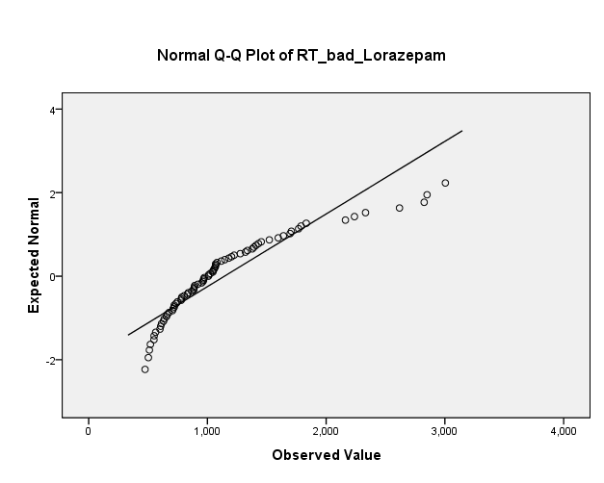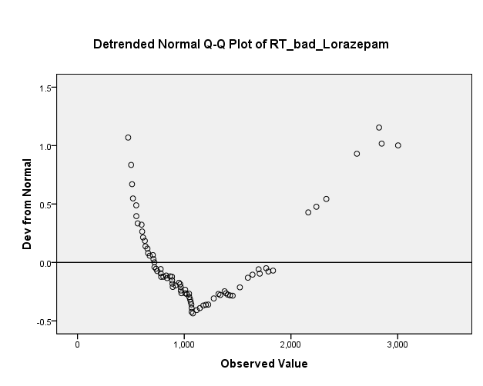

E. Q-Q plot of helping RT in the lorazepam condition.
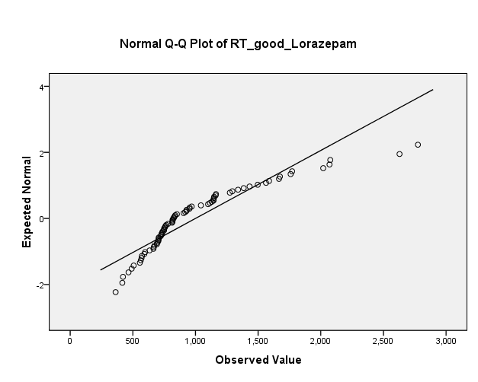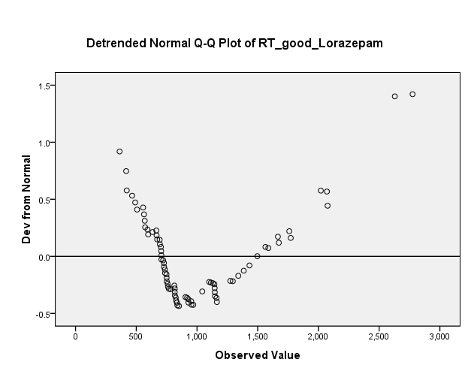

F. Q-Q plot of neutral RT in the lorazepam condition.
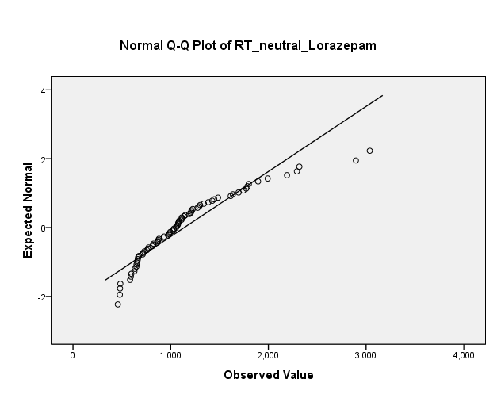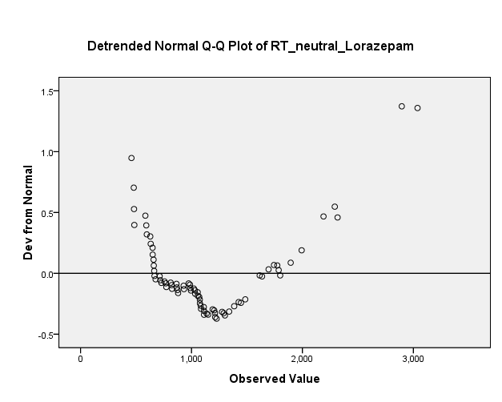
Supplementary Table 1. Participant head movement during fMRI scanning. Notes: SE = standard error; the six motion parameters (translation: x, y and z in mm and rotation: pitch, roll and yaw in degrees) were obtained from head movement correction for each participant.
N=77 (after removing 2 outliers) | Lorazepam  condition |  | Placebo condition
Motion  Parameters | Mean ± SE |  | Mean ± SE |  | T value | df | P value
x | 0.0399 ± 0.0134 |  | 0.036 ± 0.0133 |  | 0.22 | 76 | 0.827
y | 0.1713 ± 0.0133 |  | 0.1495 ± 0.0126 |  | 1.378 | 76 | 0.172
z | 0.0308 ± 0.0352 |  | -0.0285 ± 0.0337 |  | 1.525 | 76 | 0.131
Pitch | -0.0009 ± 0.0009 |  | 0.0014 ± 0.0008 |  | -1.456 | 76 | 0.15
Roll | -0.0004 ± 0.0003 |  | 0.0001 ± 0.0004 |  | -1.060 | 76 | 0.293
Yaw | 0.0009 ± 0.0003 |  | 0.0013 ± 0.0004 |  | -0.924 | 76 | 0.358
N=79 (without removing 2 outliers)
x | 0.0412 ± 0.0133 |  | 0.0354 ± 0.013 |  | 0.335 | 78 | 0.299
y | 0.1703 ± 0.0133 |  | 0.1477 ± 0.0125 |  | 1.421 | 78 | 0.041
z | 0.0474 ± 0.0401 |  | -0.0301 ± 0.0329 |  | 1.802 | 78 | 0.004
Pitch | 0.0001 ± 0.0009 |  | 0.0014 ± 0.0008 |  | -1.275 | 78 | 0.044
Roll | -0.0005 ± 0.0004 |  | 0.0001 ± 0.0004 |  | -1.149 | 78 | 0.062
Yaw | 0.0009 ± 0.0003 |  | 0.0013 ± 0.0004 |  | -0.775 | 78 | 0.4

Supplementary Table 2. Normality tests for the raw reaction-time (RTs) data before log-transformation
 | Kolmogorov-Smirnovª
 | Statistic | df | Sig.
RT_harming_Placebo | .141 | 77 | .001
RT_helping_Placebo | .167 | 77 | .000
RT_neutral_Placebo | .223 | 77 | .000
RT_harming_Lorazepam | .180 | 77 | .000
RT_helping_Lorazepam | .179 | 77 | .000
RT_neutral_Lorazepam | .148 | 77 | .000

Supplementary Table 3. Normality tests for reaction time (RT) difference scores before and after log-transformation. P, placebo; L, lorazepam.
Before log | Kolmogorov-Smirnovª
transformation | Statistic | df | Sig.
RT_P_ harm vs neutral | .248 | 77 | .000
RT_P_ help vs neutral | .230 | 77 | .000
RT_L_ harm vs neutral | .173 | 77 | .000
RT_L_ help vs neutral | .130 | 77 | .002
After log | Kolmogorov-Smirnovª
transformation | Statistic | df | Sig.
log_RT_P_ harm vs neutral | .076 | 77 | .200*
log_RT_P_ help vs neutral | .047 | 77 | .200*
log_RT_L_ harm vs neutral | .097 | 77 | .071
log_RT_L_ help vs neutral | .066 | 77 | .200*

Supplementary Table 4. The descriptive statistics of reaction time data (RTs) during each condition before and after log-transformation. P, placebo; L, lorazepam.
 | N | Minimum | Maximum | Mean | Std. Deviation
Before log transformation
RT_harm Placebo | 77 | 432.20 | 2643.50 | 1075.4902 | 512.27855
RT_help Placebo | 77 | 367.30 | 3485.20 | 1056.6815 | 564.21262
RT_neutral Placebo | 77 | 423.40 | 7198.10 | 1201.5341 | 866.50093
RT_harm Lorazepam | 77 | 474.70 | 3003.50 | 1143.5273 | 575.25154
RT_help Lorazepam | 77 | 362.50 | 2775.20 | 1000.4405 | 485.90332
RT_neutral Lorazepam | 77 | 458.90 | 3037.60 | 1138.2397 | 529.05697
After log transformation
log_RT_ harm Placebo | 77 | 2.64 | 3.42 | 2.9884 | .19141
log_RT_ help Placebo | 77 | 2.57 | 3.54 | 2.9749 | .20067
log_RT_ neutral Placebo | 77 | 2.63 | 3.86 | 3.0235 | .19941
log_RT_ harm Lorazepam | 77 | 2.68 | 3.48 | 3.0152 | .19403
log_RT_ help Lorazepam | 77 | 2.56 | 3.44 | 2.9577 | .18585
log_RT_ neutral Lorazepam | 77 | 2.66 | 3.48 | 3.0171 | .18472

Supplementary Table 5. The descriptive statistics of reaction time (RT) difference scores before and after log-transformation. P, placebo; L, lorazepam.
 | N | Minimum | Maximum | Mean | Std. Deviation
Before log transformation
RT_Placebo_ harm vs neutral | 77 | -4554.60 | 660.70 | -126.0439 | 586.20012
RT_ Placebo _ help vs neutral | 77 | -3712.90 | 760.70 | -144.8525 | 544.75665
RT_ Lorazepam_ harm vs neutral | 77 | -1841.00 | 1154.80 | 5.2876 | 412.80258
RT_ Lorazepam_ help vs neutral | 77 | -1750.30 | 735.90 | -137.7991 | 365.34177
After log transformation
log_RT_ Placebo_ harm vs neutral | 77 | -.44 | .17 | -.0351 | .10293
log_RT_ Placebo_ help vs neutral | 77 | -.36 | .16 | -.0486 | .11172
log_RT_ Lorazepam_ harm vs neutral | 77 | -.44 | .36 | -.0019 | .12966
log_RT_ Lorazepam_ help vs neutral | 77 | -.40 | .33 | -.0594 | .12431

